Southampton Solent University
Computing | Science & Engineering

[Your degree title, e.g. BSc (Hons) Computer Science]
Academic year 2025/26
Ogechukwu Adama (10440379)
TradeMind Academy: an intelligent tutoring system for trading education

Supervisor : Prashant Bikram Shah
Date of submission : September 2026
Word count : 9,892 (main body, Chapters 1 to 8, excluding tables, figures, references and appendices)

Acknowledgements
I'd like to thank my supervisor, Prashant Bikram Shah, for steady guidance through the whole project, and in particular for pushing me at the progress report stage to define success criteria up front rather than after the fact. That one piece of advice shaped the evaluation chapter more than anything else. Thanks also to Dr Edita Gashi and the module team for the project support lectures, and to the friends who sat through early versions of the curriculum videos and told me honestly which ones didn't make sense. Finally, thanks to my family for their patience during a summer that mostly disappeared into a text editor.

Acronyms
Abbreviations used in this report
Abbreviation | Meaning
AE1 / AE2 | Assessment Element 1 (progress report) / Assessment Element 2 (this report)
API | Application Programming Interface
BCS | British Computer Society, the Chartered Institute for IT
BKT | Bayesian Knowledge Tracing
CFD | Contract for Difference
CI | Continuous Integration
CISD | Change in State of Delivery (a curriculum concept)
CSV | Comma-Separated Values
DKT | Deep Knowledge Tracing
E2E | End-to-end (testing)
ESMA | European Securities and Markets Authority
FCA | Financial Conduct Authority
FVG | Fair Value Gap (a curriculum concept)
GDPR | General Data Protection Regulation
ICT | Inner Circle Trader (the practitioner methodology the curriculum teaches)
ITS | Intelligent Tutoring System
KC | Knowledge Component
LCP / CLS | Largest Contentful Paint / Cumulative Layout Shift (web performance metrics)
MCQ | Multiple-Choice Question
MLE | Maximum Likelihood Estimation
MoSCoW | Must, Should, Could, Won't (prioritisation)
RMSE | Root Mean Squared Error
RQ | Research Question
SDK | Software Development Kit
SUS | System Usability Scale
WCAG | Web Content Accessibility Guidelines

Abstract
Trading education online is mostly video with no model of what the learner actually knows. Everyone gets the same content in the same order, in a domain where the market itself is a poor teacher and most retail traders lose money. This project asked whether a Bayesian Knowledge Tracing (BKT) student model can drive a genuinely adaptive learning loop for trading concepts, and whether such a system can produce interaction data good enough to evaluate that adaptation. The answer was built rather than argued. TradeMind Academy is a working web application: a nine-module, 33-lesson curriculum written from four hours of original video, 72 assessment items across six question types, a pure BKT engine that updates a per-concept mastery estimate after every answer, a rule-based router that decides whether to teach, practise or remediate, and an append-only response log recording the model's estimate before and after each response. The learner can inspect the model at any time, including a "why this question?" explanation. Ethics is enforced structurally: simulated data only, an 18+ gate in the database rules, real consent with a working decline, and strict separation between development and research databases. Verification covers 54 unit tests against hand-computed BKT arithmetic, 14 security-rule tests, 24 browser journeys including one that survives a network cut, and a 200-learner simulation confirming the three mastery behaviours committed to at the progress-report stage. The simulation also exposed a real limit: the prior parameter is barely identifiable from 40 responses, which is reported rather than hidden. The planned study with human learners was not completed inside the project window, because the curriculum only reached its final form in September, so learning gain and usability remain the recommended next step. The artefact, its instruments and its dataset design are ready for it.

Table of Contents
Acknowledgements
Acronyms
Abstract
1. Introduction and Background
1.1 The problem
1.2 Research questions
1.3 Aim and objectives
1.4 Scope
1.5 Key terms
1.6 Structure of the report
2. Literature Survey
2.1 Approach
2.2 Retail trading as a learning problem
2.3 Does financial education work?
2.4 Intelligent tutoring systems
2.5 Student modelling and Bayesian Knowledge Tracing
2.6 Mastery thresholds and open learner models
2.7 Teaching an ill-structured domain
2.8 Content delivery and engagement
2.9 Generative AI tutors
2.10 Evaluating adaptive learning systems
2.11 Regulation and ethics
2.12 The gap and the traceability of decisions
3. Project Specification and Requirements
3.1 Users and context
3.2 Functional requirements
3.3 Non-functional requirements
3.4 Platform and technology
3.5 Guardrails
3.6 Deliberately out of scope
4. Methodology
4.1 Research approach
4.2 Development method
4.3 Evaluation design
4.4 Technical testing method
4.5 Simulated-learner method
4.6 Planned human study design
4.7 Professional, Legal and Ethical issues
4.8 Project Management
5. Design and Implementation
5.1 Architecture
5.2 Data model and security rules
5.3 The BKT engine
5.4 Routing
5.5 The response logger
5.6 Curriculum and content pipeline
5.7 The assessment engine
5.8 Interface, the open learner model and accessibility
5.9 Testing
5.10 Issues and how they were resolved
6. Results
6.1 The artefact delivered
6.2 Technical verification
6.3 BKT engine behaviour
6.4 Simulated-learner validation
6.5 Audits
6.6 Guardrail sweep
6.7 What was not collected
7. Conclusions
7.1 Against the objectives
7.2 Against the research questions
7.3 Evaluation of the product
7.4 Evaluation of the process
8. Recommendations for Further Work
9. Reference List
10. Bibliography
11. Appendices
Appendix A: Ethical Release
Appendix B: Artefact access and reproduction
Appendix C: BKT worked example and unit-test fixtures
Appendix D: Firestore security rules
Appendix E: Curriculum map
Appendix F: Simulation harness output
Appendix G: Decisions log
Appendix H: Parked designs
Appendix I: Planned evaluation instruments
Appendix J: Traceability from literature to design decisions

List of Figures
Figure 4.1: The consent screen: what is recorded, the lawful basis, and a working Decline
Figure 4.2: Actual project timeline reconstructed from git history and document dates
Figure 5.1: System architecture: six components and the adaptive loop
Figure 5.2: Routing rules: from mastery map to next action and item
Figure 5.3: A lesson: video, structured text and the module's lesson list
Figure 5.4: The model-initialisation moment after placement: "Your starting map"
Figure 5.5: The dashboard: the routed next action, mastery per module and mastery over time
Figure 5.6: The skill constellation: nine modules on one route, lit to the learner's mastery
Figure 5.7: A practice question with the live mastery HUD and the "why this question?" popover
Figure 5.8: Post-session answer review: the learner's answer against the key, with explanations
Figure 5.9: Settings: colour-blind candles, font scale, reduced motion, download and delete
Figure 6.1: BKT engine output for three answer patterns, thresholds shown
Figure 6.2: Parameter recovery for 200 simulated learners: learn rate recovers, the prior collapses to the grid edges

List of Tables
Table 2.1: Student model selection against this project's constraints
Table 3.1: Functional requirements with MoSCoW priority and outcome
Table 3.2: Non-functional requirements
Table 4.1: Evaluation strands, success criteria and completion
Table 5.1: The nine-module curriculum
Table 5.2: Problems encountered and their resolution
Table 6.1: Test and check results on the final build
Table 6.2: Simulated-learner harness output (seed 42, reproducible)
Table 7.1: Evaluation against the five objectives
Table B.1: The three run modes and where their data goes
Table E.1: Lessons by module, with source video and duration
Table G.1: Decisions log
Table H.1: Designed, deliberately not built
Table J.1: Traceability from literature to design decisions

1. Introduction and Background

1.1 The problem
Learning to trade has a starting problem, and it's one I've lived. The information isn't hard to find. There's far too much of it, almost none of it is in any order, and a beginner has no reliable way to tell a credible source from a confident stranger. Much of what's free comes from self-styled gurus, and the Financial Conduct Authority has flagged firms using influencers to push high-risk products with unrealistic promises (FCA, 2022). So a learner is left guessing what to study, in what order, and who to trust, and that's where most people give up or pick up habits they later have to unlearn.
The wider evidence base is uncomfortable. Retail traders as a group underperform the market, and the most active ones underperform it most (Barber and Odean, 2000). Among people who trade intraday, fewer than one in a hundred earn reliably positive returns after costs (Barber et al., 2014), and one large study found no evidence that traders improve with experience at all (Chague, De-Losso and Giovannetti, 2020). That last finding is the important one for an education project. It says the market itself is a bad teacher. Its feedback is delayed, noisy and confounded, so a sound decision can lose money and a poor one can be paid. Deliberate practice, the thing that actually builds expertise, needs structured tasks and immediate diagnostic feedback (Ericsson, Krampe and Tesch-Römer, 1993), and live markets supply neither.
Existing trading courses don't fix this. They present identical videos and quizzes in an identical order to every learner, whatever that learner already knows. There's no model of the student, nothing adapts, and the learner never finds out whether they've understood a concept until they've lost money on it. Intelligent tutoring systems were built to address exactly this shape of problem, and they have a mature evidence base showing they come reasonably close to one-to-one human tutoring (VanLehn, 2011).

1.2 Research questions
The literature survey in Chapter 2 identified a gap. Knowledge tracing has been applied to mathematics, language and programming, but I could find no published tutoring system that applies a formal student model to trading education. So the questions this project set out to answer are:
• RQ1. Can a trading curriculum be decomposed into knowledge components clean enough for Bayesian Knowledge Tracing to trace, and does the engine behave as the design requires when it does?
• RQ2. Can a BKT-driven routing policy run a complete adaptive learning loop end to end, while recording the data a learning-gain study would need?
• RQ3. Can the learner see and understand the model that's making decisions about them?
• RQ4. What constraints does the regulatory and ethical context impose on an educational trading artefact, and can they be built in without degrading the learning experience?
RQ2 originally included measuring learning gain with human participants. That part wasn't completed, for reasons set out in Chapters 4 and 7, so the question as answered here concerns whether the loop works and whether it produces the right data.

1.3 Aim and objectives
The aim was to design, build and evaluate an intelligent tutoring system for trading education whose adaptation is driven by a Bayesian student model. The five objectives were fixed in the AE1 progress report and haven't been changed since, because moving the goalposts after the fact would make the evaluation meaningless:
1. Review the literature on intelligent tutoring, student modelling and trading education to ground the design.
2. Design the architecture and content structure for a mastery-gated trading curriculum.
3. Build a vertical slice of the system end to end, with BKT student modelling and rule-based routing.
4. Validate the adaptive engine technically through unit tests and simulated-learner checks.
5. Evaluate the built slice with real users for learning gain and usability.
Chapter 7 reports on each of these honestly. Four were met. The fifth was not.

1.4 Scope
The artefact is a web application, TradeMind Academy, covering one complete curriculum level. A learner signs up, gives informed consent, sits a short placement test, and is then routed by the model through lessons and practice sessions until each module is mastered. Everything is on simulated or historical data. There is no broker connection, no live pricing, no trade signals and no payment code. Three larger features from the original product design (a mentor marketplace, a trading terminal simulator and a generative AI tutor) were cut deliberately and are documented as future work rather than half-built.

1.5 Key terms
A knowledge component (KC) is a single teachable skill or concept, small enough to be assessed on its own. Bayesian Knowledge Tracing (BKT) maintains, for each KC, the probability that a learner has learned it, updated after every observed answer (Corbett and Anderson, 1994). Mastery is a threshold on that probability, set here at 0.8, above which a module counts as learned and the next unlocks. Remediation is the band below 0.4, where the system stops pushing forward and re-teaches. An open learner model shows the learner the system's model of them (Bull and Kay, 2010). The ICT methodology is the practitioner framework the curriculum is drawn from. It's grey literature, and this report makes no claim about whether it makes money; what's studied is whether it can be taught adaptively.

1.6 Structure of the report
Chapter 2 surveys the literature the design rests on and Chapter 3 states the requirements. Chapter 4 covers methodology, evaluation design, the professional and ethical framing, and project management. Chapter 5 documents design and implementation, including the problems that came up and how each was resolved. Chapter 6 presents the results, Chapter 7 evaluates the outcome against the objectives, and Chapter 8 recommends what should happen next. The artefact is public at https://github.com/OGSOLENT/TradeMind_Academy, with running instructions in Appendix B.

2. Literature Survey

2.1 Approach
This survey condenses a longer literature review chapter written mid-project. Searches ran between February and July 2026 across the ACM Digital Library, IEEE Xplore, ScienceDirect, SpringerLink, Google Scholar, SSRN and the Journal of Educational Data Mining archive, with snowballing from three anchor papers (Corbett and Anderson, 1994; VanLehn, 2011; Abdelrahman, Wang and Nunes, 2023). Roughly 240 records were screened. Peer-reviewed empirical work, formal models and systematic syntheses were kept; blog posts and vendor material were excluded, with regulatory publications cited only as evidence of the policy context. Screening was by one researcher and limited to English, both stated limitations. The survey covers five strands: the problem domain, intelligent tutoring, student modelling, content and engagement, and evaluation and ethics. Appendix J traces each major design decision back to its evidence.

2.2 Retail trading as a learning problem
The empirical record on retail trading is consistent across markets and decades. Barber and Odean (2000) studied 66,000 US households and found the most active traders earned about six percentage points below the market each year. Barber et al. (2014) analysed every day trader on the Taiwan Stock Exchange over fifteen years and found that skill differences are real and persistent, but fewer than one per cent earned reliably positive returns after fees. Chague, De-Losso and Giovannetti (2020) used regulator data from Brazil and found that of individuals who persisted past 300 trading days, 97 per cent lost money, and performance didn't improve with experience.
That absence of learning is what makes this a pedagogy problem and not only a finance one. Ericsson, Krampe and Tesch-Römer (1993) describe expertise as the product of deliberate practice: structured tasks at the edge of ability, with immediate diagnostic feedback. Live markets offer none of that, and Kirschner, Sweller and Clark (2006) add that minimally guided discovery is inefficient for novices because it leaves them to infer structure from unreliable signals. So the case for this project is narrower than the one the trading education industry makes. It isn't that education produces profitable traders. It's that if any part of trading competence is learnable, unstructured exposure is a poor way to learn it, and decomposed skills with immediate feedback are the standard remedy.

2.3 Does financial education work?
The answer has shifted. Lusardi and Mitchell (2014) established that financial literacy is low and correlates with consequential behaviour. But Fernandes, Lynch and Netemeyer (2014) meta-analysed 201 studies and found education explained about 0.1 per cent of the variance in later behaviour, with effects decaying within months. Kaiser et al. (2022) then meta-analysed 76 randomised trials covering over 160,000 people and found positive, economically meaningful effects on knowledge and behaviour that survived correction for publication bias. The two reconcile once you notice the later studies used stronger designs and more interactive delivery: the earlier null was about intervention quality, not education itself.
Two things carry into the design. The decay finding argues for what a tutoring system provides by default: spaced retrieval, remediation when mastery slips, and per-learner sequencing. Roediger and Karpicke (2006) show repeated retrieval produces far better long-term retention than repeated study, which is what a mastery-gated question loop implements. And almost none of this literature is about trading. The trials measure budgeting, saving and credit; peer-reviewed evaluation of instruction in chart-based trading skills is essentially absent, even though a large industry sells it.

2.4 Intelligent tutoring systems
The conventional ITS architecture has four parts: a domain model, a student model, a pedagogical model and an interface (Nwana, 1990). The landmark implementations were the Carnegie Mellon cognitive tutors, deployed at classroom scale (Anderson et al., 1995). Bloom (1984) set the field's target with the two sigma problem: one-to-one mastery tutoring moved students about two standard deviations above conventional teaching.
The effectiveness evidence is consistent in direction and varied in size. VanLehn (2011) found intelligent tutors nearly as effective as human tutors (0.76 against 0.79); Ma et al. (2014) found 0.41 against large-group instruction; Kulik and Fletcher (2016) a median 0.66 across 50 evaluations. The counterweight is Pane et al. (2014), a two-year randomised trial of Cognitive Tutor Algebra with around 18,700 students, which found roughly 0.20 in the second year. So tutoring systems reliably beat static instruction, the margin is moderate, and implementation quality dominates. A dissertation claiming large gains from a small evaluation would be contradicted by the strongest study in its own supporting literature.
One further argument shapes the design philosophy. Baker (2016) observes that the systems succeeding at scale are markedly simpler than the research prototypes, drawing their value from solid student modelling and transparent pedagogy rather than elaborate AI. That supports pairing a well-understood probabilistic model with rules a person can read, instead of a learned policy nobody can inspect.

2.5 Student modelling and Bayesian Knowledge Tracing
The student model is what makes a tutor intelligent, and knowledge tracing is the standard formulation: given a learner's response history, estimate their current knowledge and predict future performance (Abdelrahman, Wang and Nunes, 2023). The foundational model is BKT (Corbett and Anderson, 1994). Each knowledge component is a two-state hidden Markov model. The learner either knows it or doesn't, and that hidden state is inferred from observed answers through four parameters: the prior probability of knowing, P(L0); the probability of learning at each opportunity, P(T); the probability of guessing correctly while not knowing, P(G); and the probability of slipping while knowing, P(S). After each answer the posterior is updated by Bayes' rule, then the learning transition is applied.
BKT's appeal here is threefold. Its parameters have pedagogical meaning, so the model can be explained to a marker, a learner or an examiner. Its per-KC probability maps directly onto routing decisions and onto a display. And it starts cold gracefully, because the parameter space is small and well characterised, so a system with no data can adopt literature defaults and refit later (Badrinath, Wang and Pardos, 2021; Bulut et al., 2023).
The limitations are well documented. Beck and Chang (2007) showed an identifiability problem: different parameter sets can fit the same responses equally well while implying different knowledge states, though Doroudi and Brunskill (2017) argue its practical severity depends on how the model is used. Model degeneracy, where fitted guess or slip exceed 0.5 and the semantics invert, was characterised by Baker, Corbett and Aleven (2008). Individualised parameters (Yudelson, Koedinger and Gordon, 2013) and per-item difficulty (Pardos and Heffernan, 2011) each improve accuracy. For this project the consequence is procedural: fitted parameters must be checked against bounds and reported, thresholds treated as design decisions, and claims about what the model "knows" hedged.
BKT isn't the only option. Deep Knowledge Tracing (Piech et al., 2015) trains a recurrent network on raw sequences and dominates publication volume, but the accuracy picture is more balanced than that implies. Khajah, Lindsey and Mozer (2016) found BKT with modest extensions largely matches DKT. Gervet et al. (2020), across nine datasets, concluded that deep models lead only on very large corpora, that logistic regression leads on moderate ones, and that calibration matters more than headline accuracy for a system that acts on its predictions. Pelánek (2017) reaches a similar conclusion about choosing by purpose rather than fashion. Table 2.1 makes the trade-off explicit.
Table 2.1: Student model selection against this project's constraints
Model | Interpretable | Cold start | Data needed | Verdict
BKT | High | Strong, literature defaults | Low | Selected
BKT with forgetting | High | Strong | Low to medium | Extension candidate
Logistic (PFA) | Medium | Weak | Medium | Rejected, weaker cold start
DKT and successors | Low | Poor | Very high | Rejected, data regime and opacity

A dissertation-scale deployment produces a small dataset, exactly the regime where deep models are inappropriate and interpretability is worth more than a marginal gain in accuracy.

2.6 Mastery thresholds and open learner models
Knowledge tracing only matters because of what the tutor does with it. Corbett (2001) showed that mastery learning driven by BKT recovers a meaningful share of Bloom's two sigma advantage inside a computer tutor. The threshold is a design parameter: the original cognitive tutors used 0.95 with large item banks and compulsory classroom use (Corbett and Anderson, 1994), and Pelánek (2018) argues mastery criteria conflate the system's uncertainty with the learner's knowledge and should be treated as consequential decisions. This project uses 0.8 to unlock and 0.4 to remediate, because a voluntary consumer context with smaller item banks punishes over-strict gating with attrition rather than compliance.
A separate strand supports a distinctive interface decision. Bull and Kay (2010) review open learner models, which expose the student model to the student, and report benefits for reflection, self-assessment and trust. TradeMind makes the mastery probabilities visible elements that update after every answer and lets the learner ask why a question was chosen, which is an open learner model in the literature's sense. Doroudi and Brunskill (2019) add an equity argument: mastery-based adaptation narrows but doesn't close the gap between fast and slow learners, which suggests reporting the distribution of gains and not only the mean.

2.7 Teaching an ill-structured domain
Nearly every ITS success story comes from a well-structured domain. Algebra, geometry, programming. Trading isn't like that. Lynch et al. (2006) describe what makes domains ill-defined for tutoring: contested correctness, multiple defensible solutions, weak formal theory. Whether a given trade was correct is often unknowable even in hindsight. The response is to decompose the curriculum into components that are individually well-structured even where the whole activity isn't. Reading a candle, classifying a swing sequence, computing a position size: each is objectively checkable. Live trade decision-making is deliberately excluded from what the tutor assesses.
The content needs honest positioning. The curriculum teaches the ICT methodology, a practitioner framework with no peer-reviewed validation. The nearest academic anchor, the technical analysis literature, is mixed: Lo, Mamaysky and Wang (2000) found several chart patterns carry statistically significant information, while Park and Irwin (2007) found profitability evidence concentrated in earlier periods and vulnerable to data snooping. So the framing throughout is that ICT is a structured, teachable body of knowledge whose delivery is the research object. Nothing here claims it's profitable, and that separation is what lets the project be evaluated as computing research rather than as an unregistered financial claim.

2.8 Content delivery and engagement
Lessons are short narrated videos paired with the same material as on-page text. Mayer's multimedia principles support that pairing: narration with relevant visuals beats text alone, segmenting into learner-paced units reduces load, and stripped-back presentation beats decoration (Mayer and Moreno, 2003; Mayer, 2021). Guo, Kim and Rubin (2014) found MOOC video engagement dropping sharply beyond about six minutes. Sweller's (1988) cognitive load theory adds a sequencing argument: a populated price chart overwhelms a novice because element interactivity is so high, so the curriculum moves from isolated elements to integrated ones.
On engagement, the system layers mastery rings, unlock ceremonies and badges over the adaptive core. Sailer and Homner (2020) found small to medium positive effects of gamification on learning, and Duolingo shows a game-like surface can sit over a serious statistical learner model (Settles and Meeder, 2016). The constraint is that game mechanics mustn't override pedagogy, so progression here is gated by BKT mastery and the game layer decorates it.

2.9 Generative AI tutors
Any tutoring dissertation written in 2026 has to face the obvious challenge: why build a structured tutor when a chatbot can answer any trading question? The strongest evidence for LLM tutoring is Kestin et al. (2025), a randomised trial with 194 physics undergraduates where a purpose-built AI tutor roughly doubled the gains of an already strong active-learning class. It would be dishonest to minimise that. But the tutor wasn't a general chatbot; it was engineered with expert scaffolds and guardrails, in a domain with unambiguous correctness. Letourneau et al. (2025) found evaluation quality across AI tutoring systems uneven, with many assessed on engagement rather than learning. The specific concern for trading is factual reliability: a tutor that hallucinates in a leveraged-trading lesson produces a wrong answer a learner might act on financially. And a conversation doesn't by itself maintain a calibrated, auditable per-skill probability that can gate progression or be exported. So the position taken is complementarity: an inspectable model governs progression and produces the dataset, and generative assistance is designed but deferred.

2.10 Evaluating adaptive learning systems
A system like this has to be assessed on three axes. Learning effect is conventionally measured with pre-test and post-test designs using Hake's (1998) normalised gain, which corrects for ceiling effects among learners with higher prior knowledge, with effect sizes judged against realistic education benchmarks (Kraft, 2020) such as the 0.20 in Pane et al. (2014). Model quality is separate from learning gain, because a system can improve learning while its model is poorly calibrated, or the reverse; the convention is prediction accuracy plus calibration, and reporting fitted parameters against degeneracy bounds (Baker, Corbett and Aleven, 2008; Gervet et al., 2020). Usability is assessed with the System Usability Scale (Brooke, 1996) against the published average of 68 (Bangor, Kortum and Miller, 2008), with free-text feedback analysed thematically (Braun and Clarke, 2006). A small voluntary cohort is underpowered for confident inference, which is why the planned evaluation was framed as feasibility evidence rather than a hypothesis test.

2.11 Regulation and ethics
The regulatory record imposes obligations an algebra tutor wouldn't face. When ESMA intervened in the retail CFD market it cited analyses showing 74 to 89 per cent of retail CFD accounts lose money, and imposed leverage caps, negative balance protection and standardised risk warnings (ESMA, 2018). The FCA made near-identical restrictions permanent in the UK (FCA, 2019) and continues to warn about influencer promotion of high-risk products (FCA, 2022). An academic artefact teaching trading therefore has to be designed so it can't be mistaken for, or drift into, a financial promotion. In TradeMind that's a product feature: education only, simulated data only, 18+, no signals, no live accounts, no broker links, and risk framing in the interface rather than a footer. The interaction log is personal data about learner performance, so collection is minimised, consent is informed, exports are pseudonymised, and the design follows UK GDPR data minimisation and purpose limitation. As a computing project it sits under the BCS Code of Conduct and its public-interest duty (BCS, 2022).

2.12 The gap and the traceability of decisions
Read together, these literatures give a coherent picture. Retail trading outcomes are poor and markets teach badly. Well-designed financial education works, but its evidence covers budgeting and saving rather than trading. Intelligent tutors reliably outperform static instruction by a moderate margin, and BKT is mature, interpretable and workable at small scale. What doesn't exist is the intersection. The knowledge tracing literature is built almost entirely on mathematics, language and programming datasets (Abdelrahman, Wang and Nunes, 2023), and this survey found no tutoring system applying a formal student model to trading education. That's where this project sits. Appendix J links each design decision to its evidence so nothing in Chapters 3 to 5 is asserted without a source.

3. Project Specification and Requirements

3.1 Users and context
The primary user is an adult beginner in trading who wants a structured path and honest feedback about what they've understood. The secondary user is me as the researcher, who needs an analysable record of every learning interaction. The two mostly pull in the same direction, but where they conflict the progress report committed the project to protecting the dataset, and that rule decided several of the choices below.

3.2 Functional requirements
Requirements were prioritised with MoSCoW at the progress-report stage and are restated in Table 3.1 with their outcome. The Must items define the vertical slice: the adaptive loop from sign-up to routed practice, with the model updating live and every answer logged. The Should items are the learner-support features that make the slice usable for a study. The Won't items, a mentor marketplace, a terminal simulator and a generative tutor, were cut deliberately (Section 3.6).
Table 3.1: Functional requirements with MoSCoW priority and outcome
ID | Requirement | Priority | Outcome
F1 | Sign up and sign in (email or Google) with an 18+ attestation | Must | Delivered
F2 | Informed GDPR consent screen with a working Decline | Must | Delivered
F3 | Placement test, one item per module, that initialises the model | Must | Delivered
F4 | Lessons: video, on-page text, described figures, inline checks | Must | Delivered, 33
F5 | Items across six question types, one KC each | Must | Delivered, 72
F6 | BKT mastery estimate per KC, updated after every answer | Must | Delivered
F7 | Rule-based routing with prerequisite unlock and difficulty ladder | Must | Delivered
F8 | Append-only response log with model state before and after each answer | Must | Delivered
F9 | Dashboard with next action, mastery per module and over time; skill map with locked, available and mastered states | Must | Delivered
F10 | "Why this question?" explanation showing the real routing decision | Should | Delivered
F11 | Answer review, review queue for fading skills, mistake bank for re-drill | Should | Delivered
F12 | Settings: accessibility modes, download my data, delete account | Should | Delivered
F13 | CSV export of the response log for analysis | Should | Delivered

3.3 Non-functional requirements
Table 3.2: Non-functional requirements
ID | Requirement and target | Outcome
N1 | BKT engine pure, dependency-free, all update maths unit tested against hand-computed values | Met
N2 | Thresholds exactly 0.8 and 0.4, defined once | Met
N3 | Response log never silently drops an event, across refresh and network loss; verified by a network-cut test | Met
N4 | Rules deny by default; responses create-only even for the owner; rules tested in the emulator | Met, 14 tests
N5 | Accessibility: keyboard operable, visible focus, 44 px targets, live announcements, chart text alternatives; Lighthouse at least 95 | Met, 95 to 100
N6 | Dashboard Lighthouse performance at least 85 | Met, 86
N7 | Reduced-motion and colour-blind modes from the OS setting or an in-app toggle | Met
N8 | Responsive to phone width, tested on desktop and Pixel 7 | Met
N9 | Development can never write to the research database, enforced by configuration | Met after one incident, 5.10
N10 | Every design decision recorded with its reason | Met, 49 entries

3.4 Platform and technology
The stack was fixed at the progress-report stage so the novelty budget went on the engine rather than infrastructure: Next.js 14 with the App Router and strict TypeScript; Tailwind with tokens extracted from the design prototype; Framer Motion for interface animation; react-three-fiber for the landing hero only; lightweight-charts for all financial charts. Firebase provides authentication and Firestore, with the Emulator Suite for all local development and testing. Vitest covers unit tests, Playwright the browser journeys, and the Firebase rules testing library the security rules. ESLint, Prettier, a pre-commit hook and GitHub Actions run the same checks on every commit.

3.5 Guardrails
Eight guardrails were written into the specification as hard constraints, meaning work that violated one was wrong however well it otherwise worked: education and simulation only, with no live data, broker links, signal language or profitability claims anywhere in copy; a create-only, queued, retried and exportable response log; BKT thresholds of exactly 0.8 and 0.4; accessibility gates from the first phase, not a final pass; secrets in ignored environment files and deny-by-default rules; prototype HTML as reference only; no dependencies beyond the fixed stack without justification; and every number in the interface in tabular figures, animated by rolling. Chapter 6 reports a sweep against the first of these.

3.6 Deliberately out of scope
The original product design, a set of 43 high-fidelity prototype screens, included a mentor marketplace, a trading terminal simulator and mentor-review dashboards. All were cut before implementation began. The marketplace contributed nothing to the research question and introduced paid-guidance risks that the progress report had explicitly warned against, so no payment code of any kind ships. The terminal simulator is a product in itself, and the chart-annotation question type already covers visual assessment. The prototype designs are retained in the repository as evidence of the full vision (Appendix H) and are discussed in Chapter 8.

4. Methodology

4.1 Research approach
The project is design science research. It addresses a problem by building an artefact and evaluating it, in the sense set out by Hevner et al. (2004), and it follows the process Peffers et al. (2007) describe: identify the problem, define objectives for a solution, design and develop, demonstrate, evaluate, communicate. That framing fits because the research question can't be answered by argument. Whether BKT can drive an adaptive loop for trading concepts is something you find out by building the loop and instrumenting it.
The alternative, an empirical study on an existing platform, wasn't available because no existing platform applies a student model to this domain, which is the gap itself. A survey-based needs analysis was considered and rejected as adding little beyond what the regulatory and finance literature already establishes, so the justification for the aims came from the literature rather than from primary survey data.

4.2 Development method
Development was iterative and phased, building the whole vertical slice end to end before adding anything around it, so the loop worked early and was then refined. Six phases mirrored the milestone order set in the progress report: foundations and design tokens; authentication, data layer and content layer; assessment engine and question bank; the BKT engine, routing and the visible model; learner-support features; and landing, polish and audits. Each phase had a written done-criterion, and each ended with the verification checklist actually run and its output recorded in the evaluation log before the phase was tagged in version control. The riskiest component, the engine, was reached only once the plumbing around it already worked, which meant every mistake in the engine showed up in a working interface rather than in isolation.
Two practices ran through every phase. Every significant decision was appended to a decisions log with its reason, so the rationale in Chapter 5 comes from a record kept at the time rather than from memory. And "measured, not assumed" was applied wherever it could be: animation costs profiled in frames per second, accessibility audited with Lighthouse rather than eyeballed, the model validated with simulated learners rather than by watching a few numbers go up.
Implementation used an agentic coding tool as an AI pair-programmer under my direction, as declared in the progress report. The research question, the choice of model and thresholds, the curriculum, the evaluation design and every decision in the log are mine. The distinction matters for academic integrity and it's also why the decisions log exists: it records the reasoning, including cases where something was built, measured and removed.

4.3 Evaluation design
The progress report fixed the evaluation on three strands, with success criteria stated in advance so they couldn't be adjusted to fit the results. Table 4.1 restates them and records which were completed.
Table 4.1: Evaluation strands, success criteria and completion
Strand | Method | Success criterion (fixed at AE1) | Completed
Technical correctness | Unit tests on BKT and routing; rules tests; E2E journeys | All tests pass; engine maths matches hand-computed values | Yes
Model behaviour | Simulated-learner harness, N = 200 | Correct streak crosses 0.8 in a few items; wrong streak stays below 0.4; improving learners climb | Yes
Learning gain | Pre-test and post-test with participants; Hake normalised gain | Mean score improves from pre to post | No
Usability | SUS with 5 to 8 participants plus open feedback | SUS at or above 68 | No

The first two strands are what a computing dissertation can verify unambiguously, and they're reported in full in Chapter 6. The third and fourth needed human participants. Ethical clearance for that study was obtained through the Solent University ethics application and signed off by my supervisor (Appendix A). The study was not run, and the reason is a matter of record in the decisions log. The curriculum content, 33 lessons written from four hours of original video, only reached its final form between 8 and 10 September 2026. Before that the platform ran on placeholder lessons that existed to exercise the structure. A learning-gain study on placeholder content would have measured the placeholders, not the tutor, and usability feedback on lessons about to be replaced would have been feedback on the wrong thing. So the choice was between a study whose results would be meaningless and completing the content the study needed, and I chose the content. Chapter 7 evaluates that decision and Chapter 8 sets out the study as the immediate next step.

4.4 Technical testing method
Testing followed a pyramid. At the base, Vitest unit tests cover the BKT update mathematics against fixtures I computed by hand from the equations (Appendix C), the threshold crossings, the routing decision table, the difficulty ladder, non-repetition within a session, the remediation trigger, grading per question type, and the logger's queue, retry, persistence and backoff. Hand-computed fixtures test the maths rather than the code's opinion of itself; if the implementation drifts, it fails against arithmetic. The security rules have their own suite inside the Firestore emulator that attempts every forbidden operation and asserts refusal. At the top, Playwright drives a real browser through the journeys on desktop and Pixel 7 profiles: sign-up through consent to a lesson; a ten-question mixed-type session with the network cut halfway; placement through routing to mastery and an unlock; the learner-support screens; and keyboard and reduced-motion accessibility. A pre-commit hook and CI run lint, typecheck and unit tests on every commit.

4.5 Simulated-learner method
The simulation harness validates the engine against learners whose true state is known, which no human study can do. It generates 200 synthetic learners with ground-truth parameters drawn from ranges (prior uniform on 0.05 to 0.45, learn rate uniform on 0.05 to 0.25, guess and slip fixed at 0.2 and 0.1), has each answer 40 opportunities through the true generative model, and runs the real engine over those responses. It then checks three behaviours committed to at AE1: that a streak of correct answers crosses 0.8 within a few items, that a streak of wrong answers stays below 0.4, and that learners whose true state improves are tracked upward. It also recovers each learner's prior and learn rate by maximum-likelihood grid search over the response sequence, and reports root mean squared error and bias against ground truth. The run is seeded, so it reproduces to the digit, and its output is written straight into the evaluation log. This mirrors the sanity-check approach the pyBKT authors use (Badrinath, Wang and Pardos, 2021).

4.6 Planned human study design
Because it's the recommended next step, the approved design is as follows. Five to eight adult participants recruited by convenience sampling. Each completes the placement test, which doubles as a pre-test since its items come from the pre-test-eligible subset of the bank, works through the first module or two in one session, and sits a post-test from the same subset. Learning gain is Hake's normalised gain per participant, reported with the spread and not only the mean, following Doroudi and Brunskill's (2019) equity argument. Usability is the ten-item SUS compared with the 68 average, plus a short open questionnaire analysed thematically. Every logged response carries the model's estimate before the answer, and the predicted probability of a correct answer is a fixed function of that estimate and the parameters, so calibration can be computed from the log. The sample is a known limitation, and the study was framed as feasibility evidence, not a powered trial.

4.7 Professional, Legal and Ethical issues
Teaching trading carries real responsibility, and this weighed more heavily than in most software projects. Around 80 per cent of retail CFD customers lose money (FCA, 2022), and the regulator's restrictions on leverage, incentives and promotion (FCA, 2019; ESMA, 2018) draw a line the artefact must never approach. So the constraints were built as features rather than disclaimers. Every chart is simulated or historical and says so in a pill on the chart itself. There's no live market data, no broker connection, no affiliate links, no trade signals and no profitability language anywhere in the copy, and Chapter 6 reports a sweep for exactly those things. The landing page carries a full risk disclaimer, the sign-up form states the education-only purpose above the fields, and the curriculum is honest that the methodology it teaches is contested. The mentor marketplace was cut specifically because paid guidance from strangers is the mechanism the FCA warns about.
Under UK GDPR the lawful basis for collecting learning data is consent. The consent screen (Figure 4.1) states what's recorded, why, and that the learner can withdraw, and Decline is a real button that signs the learner out with nothing stored beyond the account. The 18+ requirement is enforced in the database security rules and not only in the interface, so a profile can't be created without the attestation whichever route a learner takes, including Google sign-in. Data is minimised to what the model and evaluation need. Learners can download all of their data as CSV and delete their account from settings. The response log is append-only by rule, which protects the research dataset from tampering and also protects learners from accidental loss; deletion of that log on request is done by an administrator so it can't happen silently. Development and testing run on a local emulator that's wiped on restart, and the live project is reserved for participants, with the split enforced by configuration after an early incident described in Section 5.10.
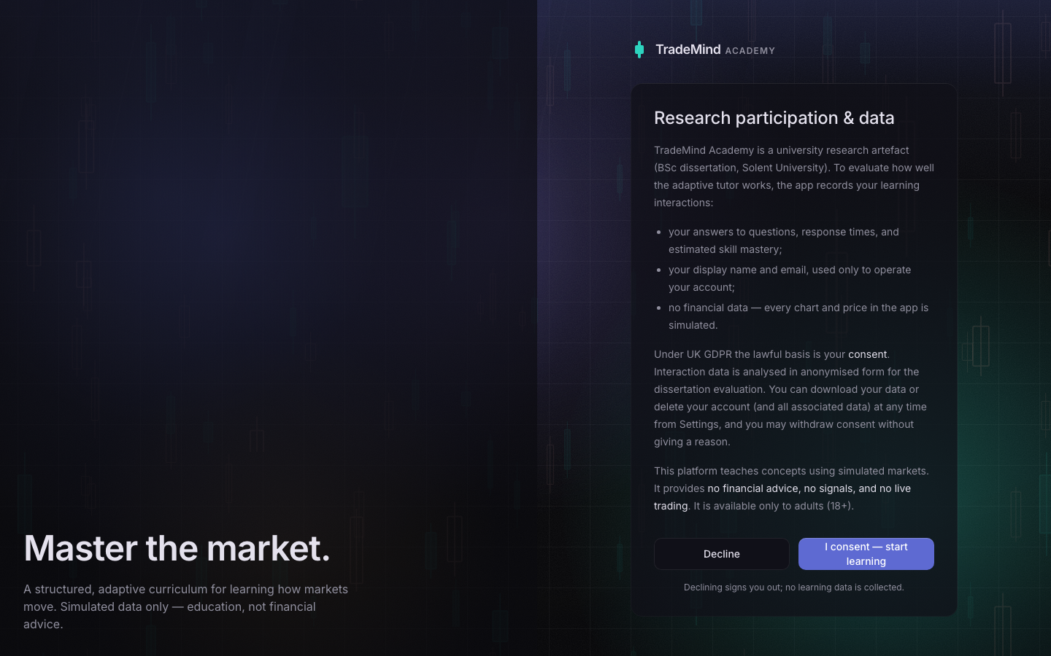
Figure 4.1: The consent screen: what is recorded, the lawful basis, and a working Decline
As a computing project the work sits under the BCS Code of Conduct (BCS, 2022), in particular its duties to the public interest and to professional competence, and under the university's ethics policy. The ethics release for the human study was signed off by my supervisor through the ethics application on the portal and is reproduced in Appendix A. All third-party libraries are open source under permissive licences, the prototype designs were produced for this project, and the video lessons were generated from my own source notes.

4.8 Project Management
The progress report planned an indicative ten-week build in milestone order, working toward the 400-hour total, with contingencies for the main risks. Figure 4.2 shows what actually happened, reconstructed from version-control history and document dates.
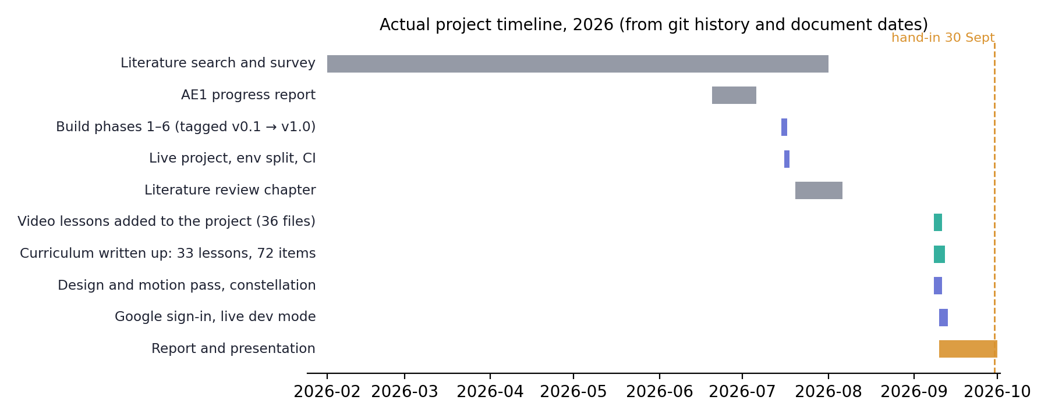
Figure 4.2: Actual project timeline reconstructed from git history and document dates
The largest deviation from plan was in shape rather than content. Because implementation was AI-assisted, the six build phases planned across ten weeks were completed and tagged in two intensive days in mid-July, each with its verification checklist run and recorded. The time the plan had allocated to writing code went instead into what turned out to be the real constraints: producing 36 video lessons, writing them up as 33 structured text lessons of about 30,000 words with 72 authored items, and a design and motion pass in September. The build order was kept exactly as planned, so the engine was integrated into a working interface from the start.
The risks identified at AE1 mostly behaved as predicted. The cold-start risk was handled by the planned contingency of literature defaults, and Section 6.4 reports what fitting would look like. Scope creep from content production was the risk the plan flagged as biggest, and it's the one that materialised: content took longer than anything else and pushed the human study out of the window. Two risks weren't anticipated: a leak of test users into the live database, resolved the same day by an environment split (Section 5.10), and misleading performance numbers from two development servers running at once, fixed by re-measuring everything against a clean server. Both are in the decisions log.

5. Design and Implementation

5.1 Architecture
The architecture follows the six-component design fixed at AE1 and the ITS structure from the literature. A content layer holds lessons and items. An assessment engine serves and grades questions. A student model estimates mastery per knowledge component. A control layer of routing rules reads that estimate and decides what happens next. A progress interface shows the learner the model and its decisions. And an authentication and data layer holds accounts and the research log. Figure 5.1 shows the components and the single loop they form.
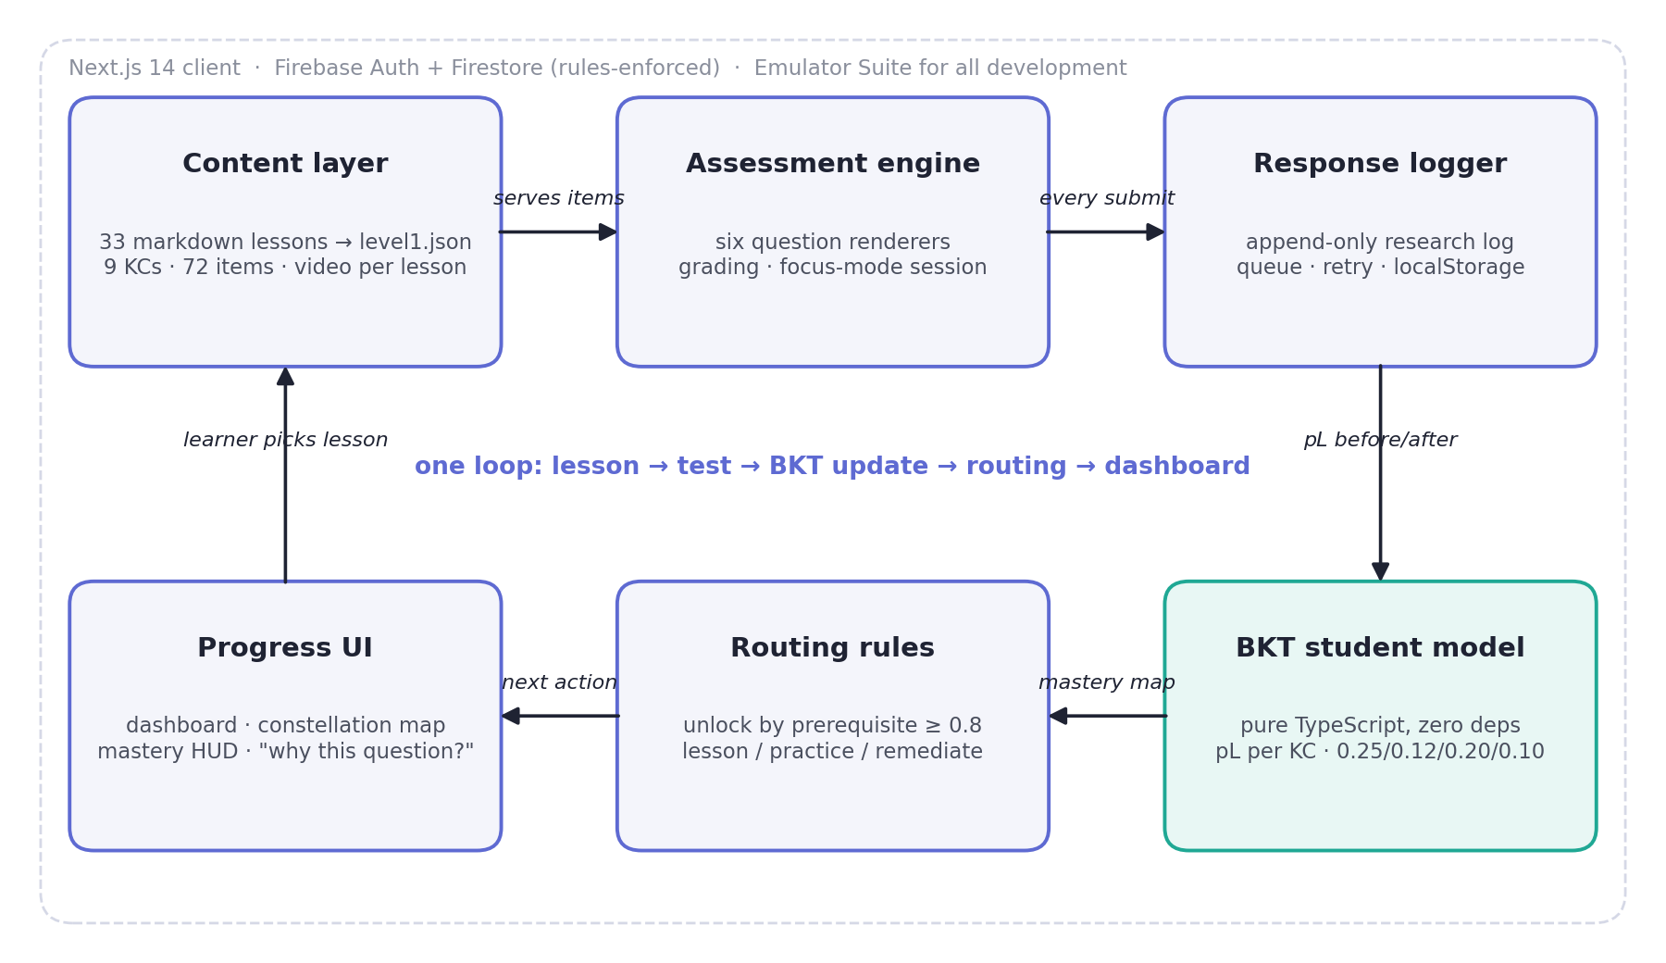
Figure 5.1: System architecture: six components and the adaptive loop
Two boundaries were treated as inviolable. The BKT engine and the routing rules are pure TypeScript modules with no framework or database imports, so they're trivially unit-testable and portable. And the response logger is the only path by which an answer reaches the database, so there's exactly one place where the research log can be got right or wrong.

5.2 Data model and security rules
Firestore holds a user document per learner with consent state, the 18+ flag and settings; one mastery document per course containing the per-KC estimates, attempts and timestamps; a session document per placement, practice or review session; and beneath each session, one response document per answer. That last collection is the research dataset. Each response carries the item, its KC, the question type, whether it was correct, what was selected, the latency in milliseconds, and the model's estimate before and after the update. Content lives in four collections: courses, KCs (with prerequisite lists), lessons and items (with answer keys and explanations).
The security rules (Appendix D) deny everything by default. Learners can read and write only their own subtree. A user document can only be created with the adult flag set to true, which is the 18+ gate. Sessions can't be deleted. Responses can be created and read by their owner and can never be updated or deleted by anyone through the client, including the owner. Content is readable by any signed-in user and writable only with an administrator claim, which the seed script holds and the client never does. Fourteen rules tests cover both the permitted operations and every forbidden one.

5.3 The BKT engine
The engine implements classic BKT (Corbett and Anderson, 1994) as a pure function. Given a current estimate and an observed answer, it conditions on the evidence and then applies the learning transition:
• After a correct answer: P(L | correct) = P(L)(1 − P(S)) / [P(L)(1 − P(S)) + (1 − P(L))P(G)]
• After a wrong answer: P(L | wrong) = P(L)P(S) / [P(L)P(S) + (1 − P(L))(1 − P(G))]
• Learning step: P(L′) = P(L | evidence) + (1 − P(L | evidence))P(T)
• Prediction: P(correct) = P(L)(1 − P(S)) + (1 − P(L))P(G)
Default parameters are the literature-standard 0.25, 0.12, 0.20 and 0.10 for prior, learn, guess and slip, held in one constants object and configurable per KC. The mastery threshold of 0.8 and the remediation threshold of 0.4 are exported constants, so the same numbers the report cites are the numbers the code uses, and nothing else in the codebase is allowed to restate them. The engine also exposes a placement initialiser that runs the update sequence over the placement answers from the default prior, so a learner's starting map reflects what they already know rather than a flat 0.25 everywhere. The whole file is about a hundred lines, of which fifteen are the mathematics.
Placement responses are logged with the estimate before and after set equal, because no learning step is applied during measurement. That keeps placement evidence separately analysable in the dataset.

5.4 Routing
Routing is the pedagogical model, and it's deliberately a set of rules a person can read rather than a learned policy. Figure 5.2 shows the decision flow. A KC is unlocked when every prerequisite is at or above 0.8. The target KC is the lowest-mastery unlocked one that isn't yet mastered. If it has never been practised, the action is to teach: the learner is sent to the lesson first. Otherwise the mastery band decides: below 0.4 remediate, between 0.4 and 0.8 practise, at or above 0.8 advance. Item selection follows a difficulty ladder (easy below 0.4, medium below 0.7, hard above), forces an easy item after two consecutive wrongs on a KC, and never repeats an item within a session. When a KC crosses 0.8 the router reports which KCs have newly unlocked so the interface can run the ceremony.
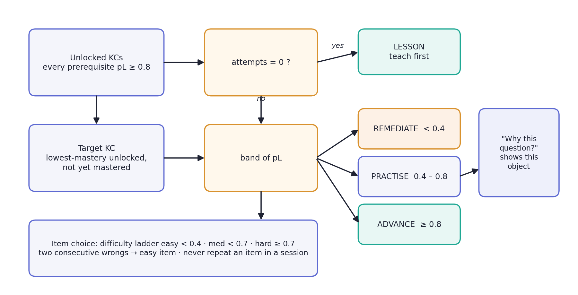
Figure 5.2: Routing rules: from mastery map to next action and item
The router returns the reason for its choice alongside the item: the current estimate, its band, the difficulty chosen and the predicted probability of a correct answer. That object is what the "why this question?" popover displays, with no translation layer, so the explanation can't drift out of sync with the decision.

5.5 The response logger
The logger was designed to behave like a payments system: it must never silently fail. Every submit enqueues an event, persists the queue to local storage, returns immediately so the interface stays responsive, and flushes in the background with exponential backoff from one second to a cap of thirty. A failed write surfaces a toast and re-queues the event. Unflushed events survive a refresh and flush on the next start or on the browser's online event.
One detail deserves explanation because it's the kind of bug that never shows in a demo. The Firebase SDK has its own internal write queue. If the transport was allowed to accept a write while the browser was offline, both queues would hold the same event and both would deliver it on reconnect, producing duplicate rows in the research log months later. So the transport fails fast when the browser reports itself offline, which makes my queue the single retry authority. The E2E suite verifies this by cutting the network halfway through a ten-question session and then counting the responses that reach the emulator's Firestore against the answers actually given.

5.6 Curriculum and content pipeline
The curriculum is nine modules in a strict prerequisite chain (Table 5.1), each a knowledge component with its own lessons and eight assessment items. It was built from 36 original video lessons by extracting each video's slides with scene detection and writing each lesson up as structured text with definitions, worked examples, tables, common mistakes and check questions. The written lessons are markdown files that a generator script parses into the seed JSON, so the markdown is the single source of truth. Videos stream over HTTP range requests rather than loading whole.
Table 5.1: The nine-module curriculum
Module | Knowledge component | Prerequisite | Lessons | Items
1 | The Candle | none | 2 | 8
2 | Liquidity and Wicks | 1 | 2 | 8
3 | Risk and Position Sizing | 2 | 3 | 8
4 | Reversal Patterns | 3 | 2 | 8
5 | Confirmation and Structure | 4 | 7 | 8
6 | Daily Bias | 5 | 7 | 8
7 | The Fractal Model | 6 | 4 | 8
8 | SMT Divergence | 7 | 1 | 8
9 | Weekly Profiles | 8 | 5 | 8

Sequencing was decided by building the actual dependency graph of the concepts rather than keeping the recording order, and that changed things. Several videos quoted risk multiples such as "2R" before position sizing had been taught, so Risk and Position Sizing was inserted as Module 3 rather than appended at the end, and three videos covering the same topic were consolidated. This is the decomposition from Section 2.7 done in practice: each module's items are objectively checkable even though the whole activity isn't.
A lesson as delivered is shown in Figure 5.3, with the video, the on-page text and the module's lesson list.
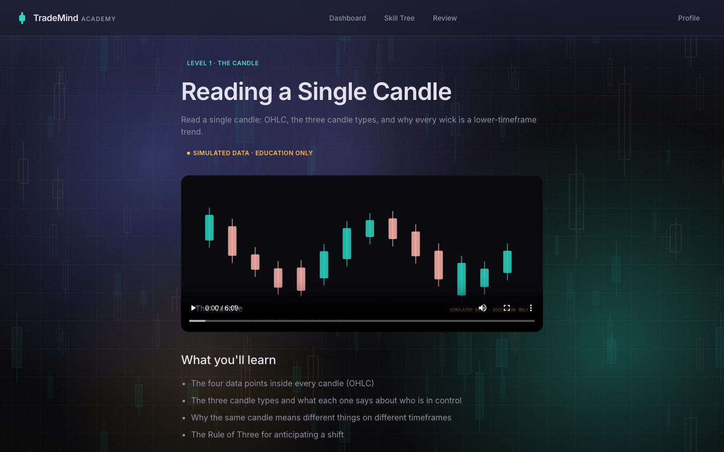
Figure 5.3: A lesson: video, structured text and the module's lesson list
The item bank holds 72 questions across six types: 37 multiple choice, 9 multi-select, 9 numeric, 9 ordering, 7 true/false with a confidence slider and 1 chart annotation, with 14 easy, 37 medium and 21 hard so the difficulty ladder has rungs to climb. Every item has an explanation shown in feedback and review. Twenty-one items are flagged eligible for the pre-test and post-test.

5.7 The assessment engine
Each question type has its own renderer and grader. Numeric items accept a tolerance, ordering grades the sequence, the annotation type renders a real chart and grades a tapped marker against a correct zone that's then revealed, and true/false records a confidence value alongside the answer. The quiz runs in a focus-mode shell with a segmented progress bar, keyboard operation (number keys select, Enter submits), and a session store persisted to local storage so a mid-session refresh resumes at the same question. Feedback is deliberate about tone: correct answers animate with a spring, wrong answers are shown in amber, slower and softer, and never flash red or shake, because a wrong answer in a learning system shouldn't feel like punishment. The quiz background is static, because anything drifting beside a question would confound the response latency the log records.

5.8 Interface, the open learner model and accessibility
The interface was built from a 43-screen high-fidelity prototype, with palette, radii and motion constants extracted into design tokens. The parts that matter for the research question are the ones that make the model visible. After placement, the constellation assembles and each node fills to its starting estimate under the caption "Your starting map", so the learner sees the model that's about to make decisions for them (Figure 5.4). The dashboard leads with the routed next action and the reason for it (Figure 5.5). The skill constellation draws the curriculum as one route with the lit portion clipped to overall mastery and a travelling light at the learner's position, so mastery reads as distance covered, which is the thing BKT actually estimates (Figure 5.6). In practice, a live mastery bar updates after every answer and the "why this question?" popover exposes the router's real decision object (Figure 5.7). When a module crosses 0.8, the ceremony fires and the next node opens.
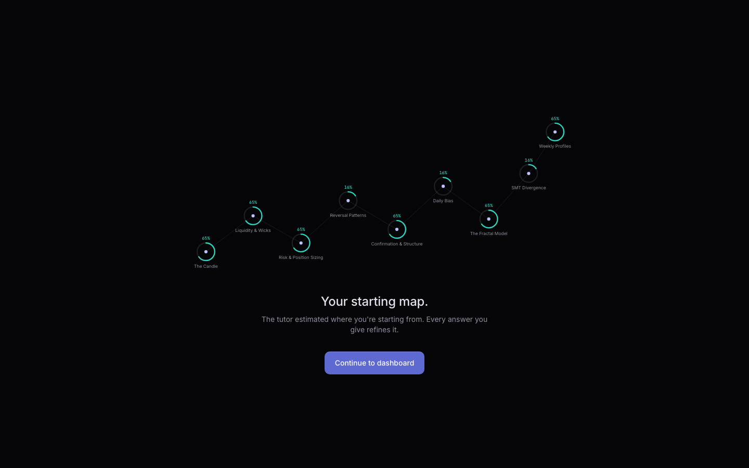
Figure 5.4: The model-initialisation moment after placement: "Your starting map"
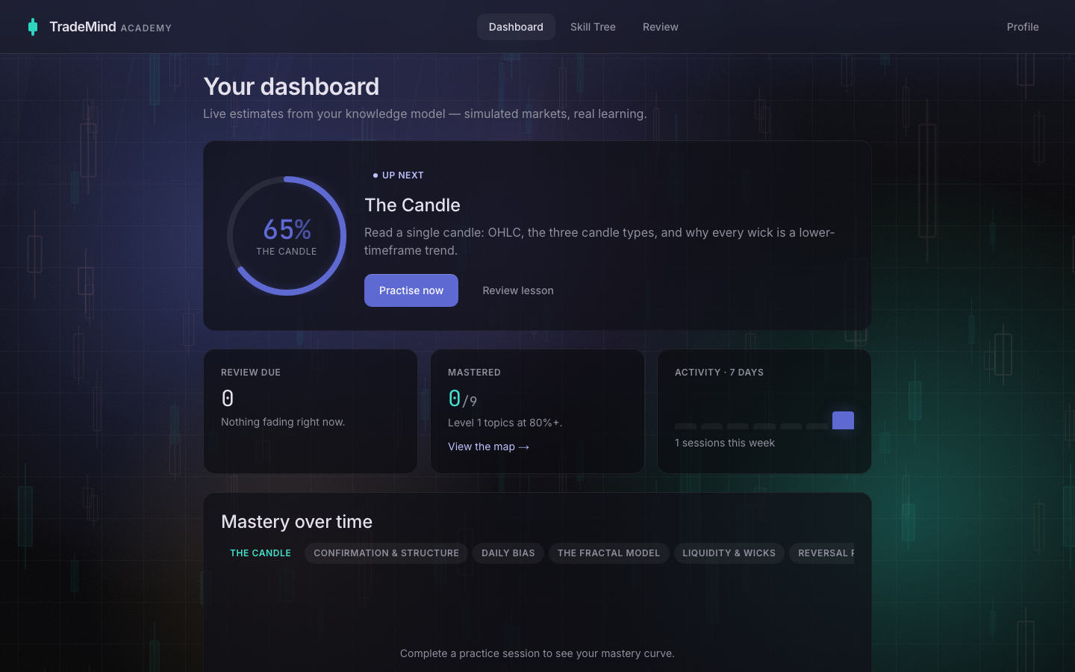
Figure 5.5: The dashboard: the routed next action, mastery per module and mastery over time
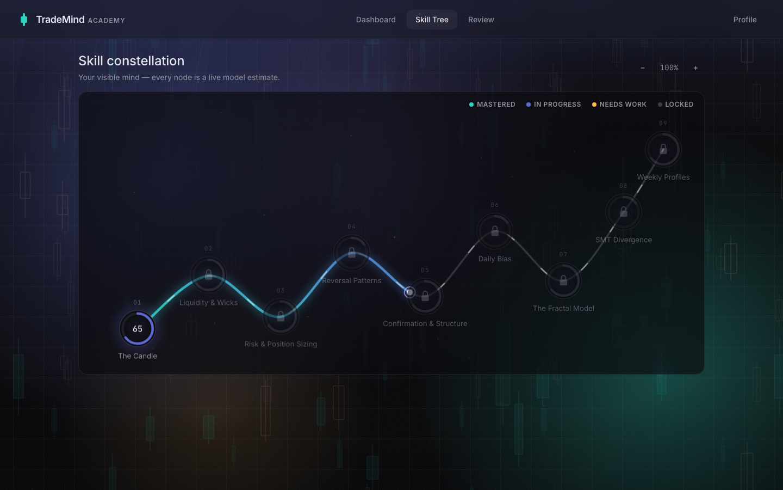
Figure 5.6: The skill constellation: nine modules on one route, lit to the learner's mastery
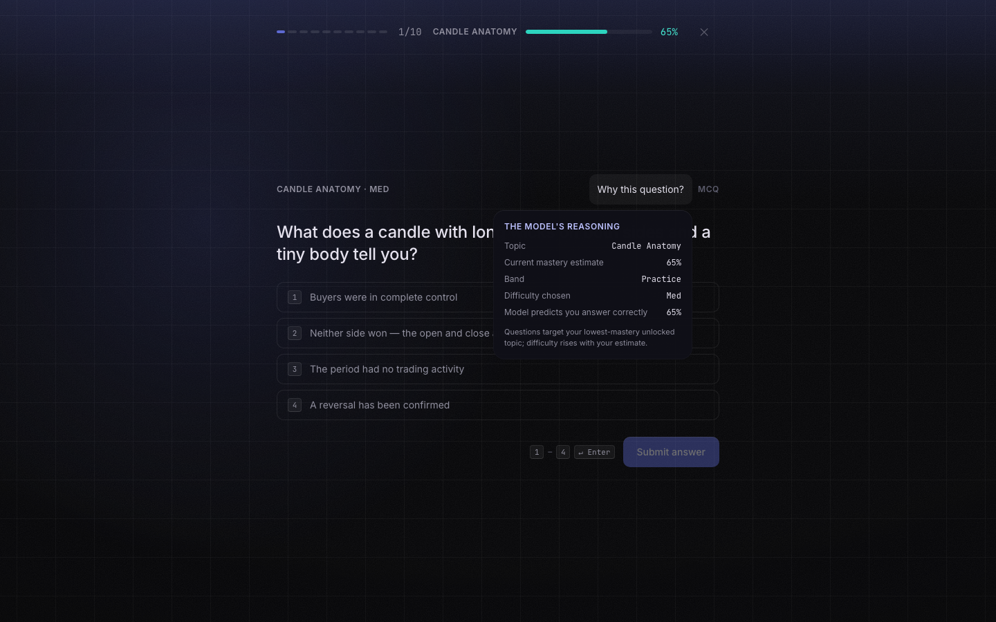
Figure 5.7: A practice question with the live mastery HUD and the "why this question?" popover
Accessibility was a gate from the first phase. Every interactive element is keyboard reachable with a visible focus ring; targets are at least 44 pixels; mastery changes are announced through a live region; every chart has a "describe this chart" text alternative; a colour-blind mode swaps the bull and bear palette; and reduced motion, from the operating system or the in-app toggle, collapses transforms to short fades and renders the landing hero as one static frame. The token policy reserves the muted foreground colour for decorative text because it fails WCAG AA contrast at body size. Learner-support screens (answer review, review queue, mistake bank, profile and settings) complete the slice a participant would use (Figures 5.8 and 5.9).
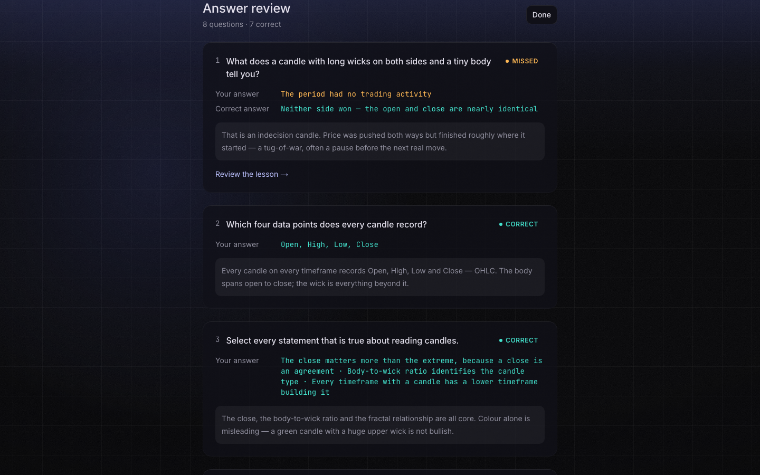
Figure 5.8: Post-session answer review: the learner's answer against the key, with explanations
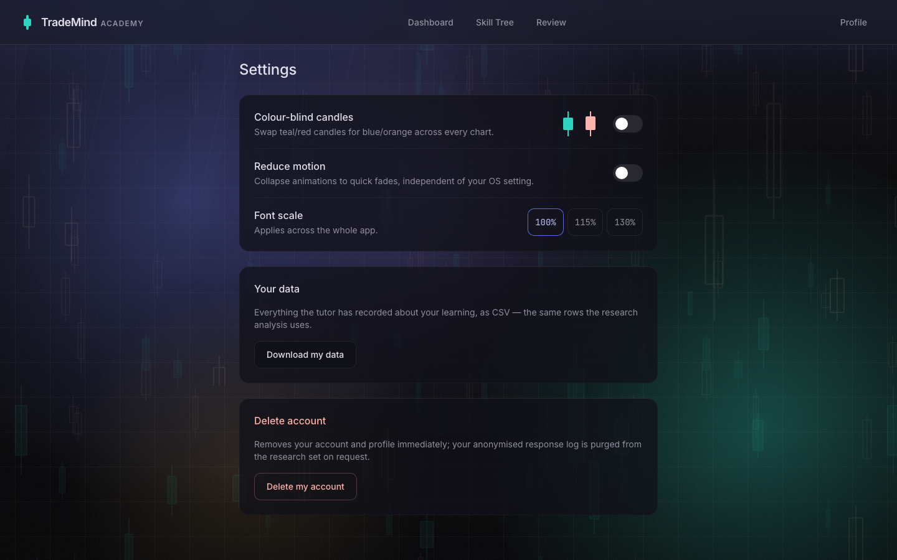
Figure 5.9: Settings: colour-blind candles, font scale, reduced motion, download and delete

5.9 Testing
The test suites are described in Section 4.4 and their results in Chapter 6. Two engineering choices are worth recording. The E2E tests answer questions by reading the current item's identifier from the page and fetching its answer key from the emulator, rather than hard-coding "option B", so the tests survived the curriculum being replaced wholesale in September. And the mobile browser project was switched from an iPhone profile on WebKit to a Pixel 7 profile on Chromium, because WebKit's long-polling to the Firestore emulator failed intermittently in a way that had nothing to do with the application. WebKit was checked manually in the final audit instead. The trade-off, deterministic tests over a second engine, was recorded at the time.

5.10 Issues and how they were resolved
Table 5.2 lists the significant problems that arose, in order. Each is in the decisions log with its date, along with smaller ones omitted here.
Table 5.2: Problems encountered and their resolution
Problem | Cause | Resolution
Consented users bounced back to consent | Stale profile in the client cache | Cache written synchronously before navigating; E2E test added
Duplicate response rows possible on reconnect | SDK queue and my queue holding the same event | Transport fails fast offline; my queue is the single authority; network-cut test
Mobile E2E flaky on WebKit | WebKit long-polling to the emulator failing | Mobile project moved to Chromium Pixel 7; WebKit audited by hand
Profile-cache race only on real latency | The emulator's 2 ms round trips hid a read-before-write | Sign-up primes the cache after writing
Seven test users leaked into the live database | Playwright auto-started a production build with the live config | Users deleted and verified; dev/live split enforced by configuration
Dashboard performance score 68 | Sequential fetches; heavy chart bundle; layout shift | Parallel fetch; chart lazy-loaded (389 to 333 kB); skeletons mirror layout. Score 86
Skill map route drawn in the wrong order | Sorting by prerequisite count, and every module has exactly one | Replaced with a walk of the prerequisite chain from the root
Background effect dropped the dashboard from 120 to 19 fps | Rotating blurred layer, pure GPU cost | Measured and removed; static gradients instead
Eight animated layers cost 120 to 48 fps | About 18 fps per animated full-screen layer | One layer animated, the rest static at zero cost; 105 fps
WCAG contrast failure on small text | Muted token at 3.05:1 on 14 px text | Secondary token; accessibility 95 to 100
"Continue with Google" appeared broken | Checker read a field the API no longer returns; no Google on sign-up; dev mode is emulator-only | Checker rewritten; Google added to sign-up behind the 18+ gate; live dev mode with an on-screen badge

The pattern is that the problems that mattered most were invisible in normal use: duplicate writes on reconnect, a race that only appears on real latency, a leak into the wrong database. Each was caught by a check that existed because the specification said the dataset comes first.

6. Results

6.1 The artefact delivered
TradeMind Academy is a working application of about 11,800 lines of TypeScript across 17 routes, with 33 lessons, 72 items, nine knowledge components, a live BKT model, rule-based routing, an append-only research log, five learner-support screens and a design system of twelve primitives. It's public at https://github.com/OGSOLENT/TradeMind_Academy with six tagged phases and 49 recorded decisions; Appendix B gives the running instructions. The live Firebase project holds the seeded curriculum and, at the time of writing, no participant accounts.

6.2 Technical verification
Every suite passes on the final commit. Table 6.1 summarises them; the phase-by-phase record is in the repository's evaluation log.
Table 6.1: Test and check results on the final build
Suite | What it covers | Result
Vitest unit | BKT maths against hand-computed fixtures and threshold crossings; routing decisions, gating, difficulty ladder, non-repetition, remediation trigger; grading per type; logger queue, retry, persistence, backoff | 54 of 54 pass
Firestore rules | Owner-only subtree, 18+ create gate, create-only responses even for the owner, content read/write boundaries | 14 of 14 pass
Playwright E2E, desktop and Pixel 7 | Sign-up to lesson; ten-question offline-tolerant session; placement to mastery to unlock; learner support; accessibility | 24 of 24 pass
Lint and typecheck | ESLint (Next core web vitals rules), strict TypeScript | Clean
CI | Same checks on every push | Green

The single most important test is the network-cut journey. It starts a ten-question mixed-type session, disables the network partway through, finishes the session, restores the network, then reads the emulator's Firestore directly and asserts that exactly as many responses arrived as answers were given, each carrying the estimates and the latency. The adaptive journey test goes from placement through the initialisation moment, a routed lesson, a practice session with the popover showing real model values, the mastery ceremony, the session summary and the unlocked next module on the map.

6.3 BKT engine behaviour
Figure 6.1 plots the engine's output for three ten-answer patterns, computed by calling the real engine with the default parameters. A learner who answers correctly every time moves from 0.25 to 0.648 after one answer and 0.905 after two, crossing the 0.8 unlock line on the second correct answer. A learner who is wrong every time falls to 0.155 and settles at a floor of 0.137, never leaving the remediation band. A learner who is wrong four times and then right six times sits on the same floor, then jumps to 0.487 and 0.833 on the next two correct answers, crossing the line on the sixth response. These are the same three trajectories sketched at AE1, now produced by the shipped code rather than a prototype, and the numbers match the hand-computed unit-test fixtures (0.25 to 0.648 to 0.905).
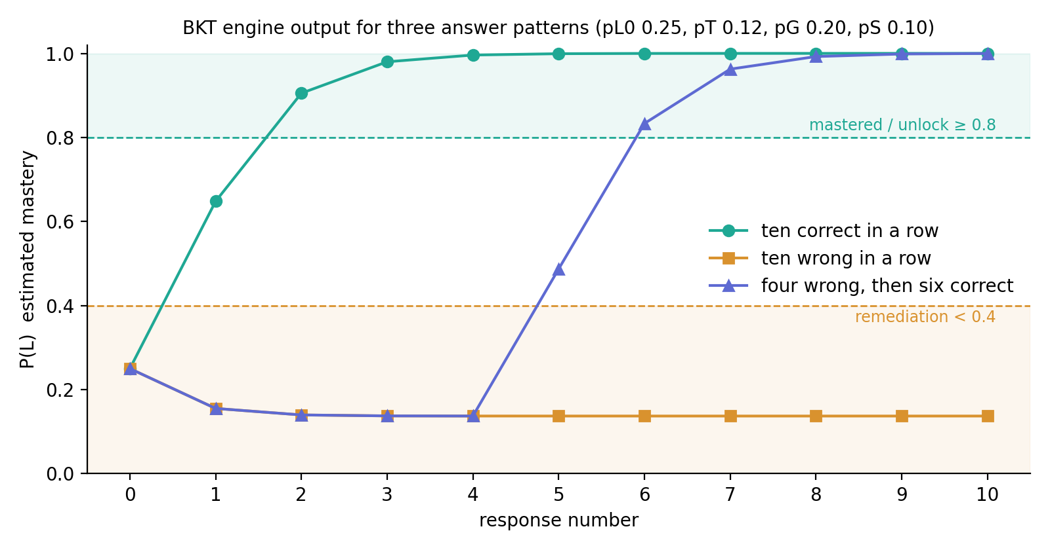
Figure 6.1: BKT engine output for three answer patterns, thresholds shown
The speed of the climb is worth a comment. With guess at 0.2 and slip at 0.1, two correct answers are strong evidence, so mastery can be reached in two or three items once a learner is competent. That's a consequence of the literature defaults, and one of the things fitted parameters would change (Section 6.4).

6.4 Simulated-learner validation
Table 6.2 reports the harness output for 200 learners over 40 opportunities with seed 42. All three behaviours committed to at AE1 hold. A correct streak crosses 0.8 in two items. A wrong streak never rises above 0.155. And 99 per cent of the cohort scores higher in the last quarter of their sequence than the first, which is what the generative model should produce and what the engine should track.
Table 6.2: Simulated-learner harness output (seed 42, reproducible)
Metric | Value
Learners | 200
Opportunities per learner | 40
Sanity 1: correct streak crosses 0.8 | 2 items, pass
Sanity 2: wrong streak stays below 0.4 | maximum 0.1552, pass
Sanity 3: improving learners climb | 99.0% of cohort, pass
RMSE of recovered prior P(L0) | 0.2348 (bias −0.1023)
RMSE of recovered learn rate P(T) | 0.1139 (bias +0.0609)
Ground truth ranges | P(L0) uniform 0.05 to 0.45; P(T) uniform 0.05 to 0.25; P(G) 0.2, P(S) 0.1 fixed

The parameter recovery result is the honest part of this table, and Figure 6.2 shows why a single RMSE understates it. The learn rate recovers reasonably: fitted values track the truth with a positive bias and a cluster at the top of the search grid. The prior barely recovers at all. Its fitted values collapse to the two edges of the grid, 0.025 or 0.475, almost regardless of the true value, giving the bimodal band in the left panel. That's the identifiability problem Beck and Chang (2007) described, appearing exactly where the theory predicts: once a few opportunities have passed and the learn rate has lifted the estimate, the response sequence carries very little information about where it started, and 40 binary observations aren't enough to pin it down. The practical implication is that per-KC priors shouldn't be fitted from short sequences; they should come from the placement test, which is what the engine already does, and the learn rate is the parameter worth fitting from logged data.
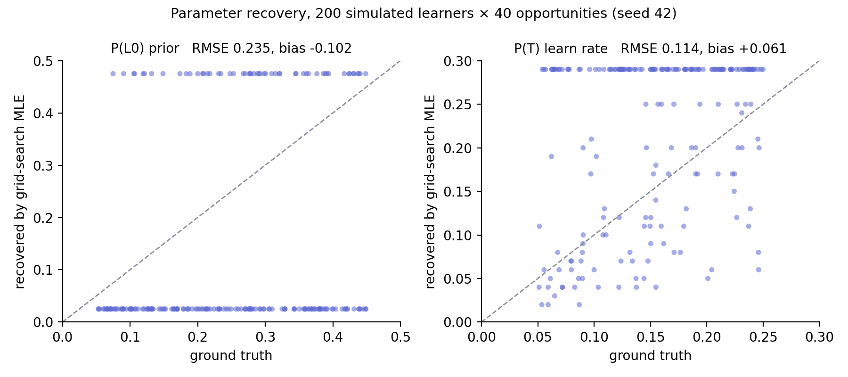
Figure 6.2: Parameter recovery for 200 simulated learners: learn rate recovers, the prior collapses to the grid edges

6.5 Audits
Lighthouse accessibility scored 95 to 100 on every page at the July audit against a gate of 95, the landing and legal pages held back by a colour-contrast failure; after the September token fix both score 100. Dashboard performance is 86 against a gate of 85, up from 68 after the changes in Table 5.2; the landing page scores 88. Keyboard and reduced-motion behaviour are asserted by tests rather than audited by hand: the quiz is fully keyboard operable with correct ARIA states and live announcements, skill map nodes are focusable and open their panel with Enter, and under reduced motion the landing and dashboard render completely with the focus ring visible on the primary action.
The animation work was measured rather than assumed. A rotating blurred layer cost 120 to 19 frames per second on the dashboard and was removed. Each animated full-screen layer cost about 18 frames of compositor budget, while identical layers held static cost nothing measurable, so the final design keeps every visual layer and animates one, at 105 frames per second against a 120 baseline. Visual richness is close to free; continuous animation is expensive.

6.6 Guardrail sweep
A final sweep of every string in the interface found no live data, no broker links, no signal language and no profitability claims, and every chart surface carries a simulated-data pill. The 18+ gate and the create-only response log are enforced by rules and covered by the rules tests. Decline is covered by an E2E test confirming the learner is signed out and bounced from the learning area. Download-my-data produces a CSV with the same rows the research export uses, and Delete-account is gated by typing DELETE with a five-second undo.

6.7 What was not collected
No human learning-gain or usability data was collected. The live database holds zero participant accounts and zero responses, which I state here rather than leave to be inferred, and the reason is given in Section 4.3. The consequence for the research questions is that RQ1, RQ2 as narrowed, RQ3 and RQ4 are answered by the evidence above, and the learning-gain half of the original RQ2 is not answered. Chapter 8 sets out how it can be, with the instruments and data design already in place.

7. Conclusions

7.1 Against the objectives
Table 7.1 evaluates each objective against the criteria fixed at AE1.
Table 7.1: Evaluation against the five objectives
Objective | Outcome | Evidence
1. Review the literature to ground the design | Met | Chapter 2; about 240 records screened and 61 retained in the full review; every design decision traced to evidence in Appendix J
2. Design the architecture and content structure | Met | Six-component architecture (5.1); nine-module prerequisite chain with 33 lessons and 72 items (5.6); data model and rules (5.2)
3. Build the vertical slice end to end with BKT and routing | Met and exceeded | The full loop works and is exercised by a browser test from placement to unlock; learner-support features beyond the slice were also delivered
4. Validate the engine technically | Met | 54 unit tests against hand-computed maths; 200-learner harness passing all three committed behaviours; identifiability limit found and reported
5. Evaluate with real users for learning gain and usability | Not met | Ethics approved and instruments ready; study not run because content reached final form in September (4.3)

Objective 5 is the one that failed, and it's worth being precise about why, because "ran out of time" would be the easy and slightly dishonest answer. The time went somewhere specific. The progress report identified content production as the biggest scope risk, and it was right: turning 36 videos into 33 rigorous written lessons with authored items took the final weeks the study would have needed, and a study on placeholder content would have produced a number that meant nothing. Given that choice again I'd make the same one, but earlier. The content should have been the first milestone, not the last, because the study depended on it and the engine didn't.

7.2 Against the research questions
RQ1 asked whether a trading curriculum decomposes cleanly enough for BKT and whether the engine behaves as required. The decomposition worked: nine components, each objectively assessable, in a prerequisite chain that had to be re-sequenced once because the recording order violated it. The engine behaves exactly as the design requires on every committed check. What the simulation added is a limit the design hadn't anticipated in that form: the prior is not recoverable from short sequences, so the placement test is doing more of the modelling work than the specification originally assumed, and that's a finding rather than a failure.
RQ2 as narrowed asked whether a BKT-driven policy can run the complete loop while producing the right data. It can. The loop runs end to end under test, survives a network cut, and every response carries the fields a learning-gain and calibration analysis needs: the estimate before and after, correctness and latency. The learning-gain half remains open.
RQ3 asked whether the learner can see and understand the model. The system exposes its estimates after every answer, explains each routing decision with the actual decision object, and shows the whole curriculum as a route lit to mastery. Whether learners find that understandable is a usability question that needs participants, so RQ3 is answered on the design side only.
RQ4 asked what constraints the regulatory context imposes and whether they can be met without degrading the experience. The constraints are set out in Section 4.7 and every one is enforced structurally. Nothing in the test results or audits suggests the experience suffered for it; the accessibility and performance gates were met with the constraints in place.

7.3 Evaluation of the product
The artefact goes beyond what a taught module delivers in several respects. The engine is pure and hand-verified rather than imported. The research log is designed with the care of a financial ledger, and its hardest failure mode was found and closed before any participant could hit it. Security is by rule and tested. Accessibility met its gate on every page, as a gate rather than a finish, and scores full marks on the pages re-audited in September. And the design decisions were recorded as they were made, including the ones reversed, which is the part of a codebase that usually goes missing.
The weaknesses are real too. The parameters are literature defaults, not fitted, and the simulation shows the climb to mastery is fast under those defaults; a fitted learn rate would likely slow it and make the gating more conservative. The item bank has eight items per module, which is thin for repeated practice and for a pre-test and post-test drawn from the same pool. One question type, chart annotation, has only a single item. And the curriculum, for all the work in it, teaches a contested methodology, which the interface says clearly but which limits how far any learning-gain result would generalise beyond it.
The supporting products hold up. The specification, decisions log, evaluation log, parked-features record and running guide together let a reader reconstruct why the system is the way it is, and the presentation script written for the demonstration draws on the same sources.

7.4 Evaluation of the process
The phased method worked as intended: every phase ended with its checks actually run, and the engine was integrated into a working interface from the start. Keeping the decisions log was the single most valuable practice, because the implementation chapter is reconstructed from it rather than remembered. "Measured, not assumed" earned its keep when it removed an effect that looked good and cost eighty per cent of the frame budget.
The process failed in one way and was lucky in another. It failed on sequencing, as above. And it was lucky that the leak of test users into the live database happened before any real participant existed; the environment split should have been there from the day the live project was created. AI-assisted development compressed the build far below the planned ten weeks, and that changed the shape of the project more than anything else. It moved the constraint from writing code to writing content and running evaluation, and a plan written with that in mind would have looked very different.

8. Recommendations for Further Work
The recommendations are in priority order, and the first is the one that matters.
Run the human study. Everything it needs exists: ethics approval, a consent flow, a placement test that doubles as a pre-test, 21 pre-test-eligible items, a response log carrying the model's estimate before and after every answer, a CSV export, and the SUS. Five to eight participants over one session each would produce feasibility evidence for learning gain, calibration and usability, and the analysis plan in Section 4.6 is ready. This should happen before any further feature work, because it's the only thing that turns the artefact into an answered research question.
Fit the learn rate from real data and leave the prior to placement. The simulation showed which parameter is identifiable from short sequences and which isn't. Once logged data exists, fitting per-KC learn rates with pyBKT (Badrinath, Wang and Pardos, 2021), checking them against degeneracy bounds (Baker, Corbett and Aleven, 2008), and reporting them would replace the defaults with something defensible, and would probably slow the climb to mastery to a more conservative pace.
Deepen the item bank before scaling participants. Eight items per module is enough to demonstrate the loop and thin for repeated practice. Sixteen per module, with more annotation items, would let the difficulty ladder and the review queue work as designed and would separate pre-test and post-test pools properly.
Add forgetting and spacing. Standard BKT assumes no forgetting. The review queue already flags fading skills after three days by heuristic; a BKT variant with a forgetting transition (Khajah, Lindsey and Mozer, 2016) would put that on a modelled footing and give the spaced-retrieval mechanism from Section 2.3 a principled schedule.
Complete the curriculum's gaps. The most valuable missing topic is backtesting, because it's the thing that would let a learner turn the methodology into their own evidence. Trade journaling, trading psychology and a market-structure vocabulary lesson are the next candidates.
Add a constrained generative tutor. The design deferred this for the reasons in Section 2.9. The right shape is now clearer: an assistant that can only speak to the KC currently being studied, grounded in that lesson's text, with the BKT model unchanged as the sole authority over progression. That keeps the auditable model and adds free-text help where it's useful.
Deploy for remote participants. The live project is configured and Google sign-in is enabled; hosting is a short job. The parked designs, a mentor marketplace and a terminal simulator, should stay parked until the research question is answered, and the marketplace should probably stay parked for good, for the regulatory reasons that cut it.

9. Reference List
Abdelrahman, G., Wang, Q. and Nunes, B., 2023. Knowledge tracing: a survey. ACM Computing Surveys, 55(11), pp.1–37. https://doi.org/10.1145/3569576
Anderson, J.R., Corbett, A.T., Koedinger, K.R. and Pelletier, R., 1995. Cognitive tutors: lessons learned. The Journal of the Learning Sciences, 4(2), pp.167–207. https://doi.org/10.1207/s15327809jls0402_2
Badrinath, A., Wang, F. and Pardos, Z.A., 2021. pyBKT: an accessible Python library of Bayesian Knowledge Tracing models. In: Proceedings of the 14th International Conference on Educational Data Mining (EDM 2021). International Educational Data Mining Society, pp.468–474. Available at: https://arxiv.org/abs/2105.00385 [Accessed 2 July 2026].
Baker, R.S., 2016. Stupid tutoring systems, intelligent humans. International Journal of Artificial Intelligence in Education, 26(2), pp.600–614. https://doi.org/10.1007/s40593-016-0105-0
Baker, R.S.J.d., Corbett, A.T. and Aleven, V., 2008. More accurate student modeling through contextual estimation of slip and guess probabilities in Bayesian Knowledge Tracing. In: Intelligent Tutoring Systems (ITS 2008). Berlin: Springer, pp.406–415. https://doi.org/10.1007/978-3-540-69132-7_44
Bangor, A., Kortum, P.T. and Miller, J.T., 2008. An empirical evaluation of the System Usability Scale. International Journal of Human–Computer Interaction, 24(6), pp.574–594. https://doi.org/10.1080/10447310802205776
Barber, B.M. and Odean, T., 2000. Trading is hazardous to your wealth: the common stock investment performance of individual investors. The Journal of Finance, 55(2), pp.773–806. https://doi.org/10.1111/0022-1082.00226
Barber, B.M., Lee, Y.-T., Liu, Y.-J. and Odean, T., 2014. The cross-section of speculator skill: evidence from day trading. Journal of Financial Markets, 18, pp.1–24. https://doi.org/10.1016/j.finmar.2013.05.006
BCS, 2022. BCS Code of Conduct for members. [online] Available at: https://www.bcs.org/membership-and-registrations/become-a-member/bcs-code-of-conduct/ [Accessed 2 July 2026].
Beck, J.E. and Chang, K.-m., 2007. Identifiability: a fundamental problem of student modeling. In: User Modeling 2007 (UM 2007). Berlin: Springer, pp.137–146. https://doi.org/10.1007/978-3-540-73078-1_17
Bloom, B.S., 1984. The 2 sigma problem: the search for methods of group instruction as effective as one-to-one tutoring. Educational Researcher, 13(6), pp.4–16. https://doi.org/10.3102/0013189X013006004
Braun, V. and Clarke, V., 2006. Using thematic analysis in psychology. Qualitative Research in Psychology, 3(2), pp.77–101. https://doi.org/10.1191/1478088706qp063oa
Brooke, J., 1996. SUS: a "quick and dirty" usability scale. In: P.W. Jordan, B. Thomas, B.A. Weerdmeester and I.L. McClelland, eds. Usability Evaluation in Industry. London: Taylor and Francis, pp.189–194. https://doi.org/10.1201/9781498710411-35
Bull, S. and Kay, J., 2010. Open learner models. In: R. Nkambou, J. Bourdeau and R. Mizoguchi, eds. Advances in Intelligent Tutoring Systems. Berlin: Springer, pp.301–322. https://doi.org/10.1007/978-3-642-14363-2_15
Bulut, O., Shin, J., Yildirim-Erbasli, S.N., Gorgun, G. and Pardos, Z.A., 2023. An introduction to Bayesian knowledge tracing with pyBKT. Psych, 5(3), pp.770–786. https://doi.org/10.3390/psych5030050
Chague, F., De-Losso, R. and Giovannetti, B., 2020. Day trading for a living? SSRN Working Paper 3423101. https://doi.org/10.2139/ssrn.3423101
Corbett, A.T., 2001. Cognitive computer tutors: solving the two-sigma problem. In: User Modeling 2001 (UM 2001). Berlin: Springer, pp.137–147. https://doi.org/10.1007/3-540-44566-8_14
Corbett, A.T. and Anderson, J.R., 1994. Knowledge tracing: modeling the acquisition of procedural knowledge. User Modeling and User-Adapted Interaction, 4(4), pp.253–278. https://doi.org/10.1007/BF01099821
Doroudi, S. and Brunskill, E., 2017. The misidentified identifiability problem of Bayesian Knowledge Tracing. In: Proceedings of the 10th International Conference on Educational Data Mining (EDM 2017). International Educational Data Mining Society, pp.143–149. Available at: https://eric.ed.gov/?id=ED596593 [Accessed 20 June 2026].
Doroudi, S. and Brunskill, E., 2019. Fairer but not fair enough: on the equitability of knowledge tracing. In: Proceedings of the 9th International Conference on Learning Analytics and Knowledge (LAK19). New York: ACM, pp.335–339. https://doi.org/10.1145/3303772.3303838
Ericsson, K.A., Krampe, R.T. and Tesch-Römer, C., 1993. The role of deliberate practice in the acquisition of expert performance. Psychological Review, 100(3), pp.363–406. https://doi.org/10.1037/0033-295X.100.3.363
ESMA, 2018. ESMA agrees to prohibit binary options and restrict CFDs to protect retail investors. [online] Paris: European Securities and Markets Authority. Available at: https://www.esma.europa.eu/press-news/esma-news/esma-agrees-prohibit-binary-options-and-restrict-cfds-protect-retail-investors [Accessed 20 June 2026].
FCA, 2019. PS19/18: Restricting contract for difference products sold to retail clients. [online] London: Financial Conduct Authority. Available at: https://www.fca.org.uk/publications/policy-statements/ps19-18-restricting-contract-difference-products-sold-retail-clients [Accessed 20 June 2026].
FCA, 2022. FCA highlights continuing concerns about problem firms in the CFD sector. [online] London: Financial Conduct Authority. Available at: https://www.fca.org.uk/news/press-releases/fca-highlights-continuing-concerns-about-problem-firms-cfd-sector [Accessed 2 July 2026].
Fernandes, D., Lynch, J.G. and Netemeyer, R.G., 2014. Financial literacy, financial education, and downstream financial behaviors. Management Science, 60(8), pp.1861–1883. https://doi.org/10.1287/mnsc.2013.1849
Gervet, T., Koedinger, K., Schneider, J. and Mitchell, T., 2020. When is deep learning the best approach to knowledge tracing? Journal of Educational Data Mining, 12(3), pp.31–54. https://doi.org/10.5281/zenodo.4143614
Guo, P.J., Kim, J. and Rubin, R., 2014. How video production affects student engagement: an empirical study of MOOC videos. In: Proceedings of the First ACM Conference on Learning @ Scale. New York: ACM, pp.41–50. https://doi.org/10.1145/2556325.2566239
Hake, R.R., 1998. Interactive-engagement versus traditional methods: a six-thousand-student survey of mechanics test data for introductory physics courses. American Journal of Physics, 66(1), pp.64–74. https://doi.org/10.1119/1.18809
Heffernan, N.T. and Heffernan, C.L., 2014. The ASSISTments ecosystem: building a platform that brings scientists and teachers together for minimally invasive research on human learning and teaching. International Journal of Artificial Intelligence in Education, 24(4), pp.470–497. https://doi.org/10.1007/s40593-014-0024-x
Hevner, A.R., March, S.T., Park, J. and Ram, S., 2004. Design science in information systems research. MIS Quarterly, 28(1), pp.75–105. https://doi.org/10.2307/25148625
Kaiser, T., Lusardi, A., Menkhoff, L. and Urban, C., 2022. Financial education affects financial knowledge and downstream behaviors. Journal of Financial Economics, 145(2), pp.255–272. https://doi.org/10.1016/j.jfineco.2021.09.022
Kestin, G., Miller, K., Klales, A., Milbourne, T. and Ponti, G., 2025. AI tutoring outperforms in-class active learning: an RCT introducing a novel research-based design in an authentic educational setting. Scientific Reports, 15, 17458. https://doi.org/10.1038/s41598-025-97652-6
Khajah, M., Lindsey, R.V. and Mozer, M.C., 2016. How deep is knowledge tracing? In: Proceedings of the 9th International Conference on Educational Data Mining (EDM 2016). International Educational Data Mining Society, pp.94–101. Available at: https://arxiv.org/abs/1604.02416 [Accessed 20 June 2026].
Kirschner, P.A., Sweller, J. and Clark, R.E., 2006. Why minimal guidance during instruction does not work: an analysis of the failure of constructivist, discovery, problem-based, experiential, and inquiry-based teaching. Educational Psychologist, 41(2), pp.75–86. https://doi.org/10.1207/s15326985ep4102_1
Kraft, M.A., 2020. Interpreting effect sizes of education interventions. Educational Researcher, 49(4), pp.241–253. https://doi.org/10.3102/0013189X20912798
Kulik, J.A. and Fletcher, J.D., 2016. Effectiveness of intelligent tutoring systems: a meta-analytic review. Review of Educational Research, 86(1), pp.42–78. https://doi.org/10.3102/0034654315581420
Letourneau, A., Martineau, M.D., Charland, P., Karran, J.A., Boasen, J. and Léger, P.M., 2025. A systematic review of AI-driven intelligent tutoring systems (ITS) in K-12 education. npj Science of Learning, 10. https://doi.org/10.1038/s41539-025-00320-7
Lo, A.W., Mamaysky, H. and Wang, J., 2000. Foundations of technical analysis: computational algorithms, statistical inference, and empirical implementation. The Journal of Finance, 55(4), pp.1705–1765. https://doi.org/10.1111/0022-1082.00265
Lusardi, A. and Mitchell, O.S., 2014. The economic importance of financial literacy: theory and evidence. Journal of Economic Literature, 52(1), pp.5–44. https://doi.org/10.1257/jel.52.1.5
Lynch, C., Ashley, K., Aleven, V. and Pinkwart, N., 2006. Defining ill-defined domains: a literature survey. In: Proceedings of the Workshop on Intelligent Tutoring Systems for Ill-Defined Domains, 8th International Conference on Intelligent Tutoring Systems. Jhongli, Taiwan, pp.1–10.
Ma, W., Adesope, O.O., Nesbit, J.C. and Liu, Q., 2014. Intelligent tutoring systems and learning outcomes: a meta-analysis. Journal of Educational Psychology, 106(4), pp.901–918. https://doi.org/10.1037/a0037123
Mayer, R.E., 2021. Multimedia learning. 3rd ed. Cambridge: Cambridge University Press. https://doi.org/10.1017/9781316941355
Mayer, R.E. and Moreno, R., 2003. Nine ways to reduce cognitive load in multimedia learning. Educational Psychologist, 38(1), pp.43–52. https://doi.org/10.1207/S15326985EP3801_6
Nwana, H.S., 1990. Intelligent tutoring systems: an overview. Artificial Intelligence Review, 4(4), pp.251–277. https://doi.org/10.1007/BF00168958
Pane, J.F., Griffin, B.A., McCaffrey, D.F. and Karam, R., 2014. Effectiveness of Cognitive Tutor Algebra I at scale. Educational Evaluation and Policy Analysis, 36(2), pp.127–144. https://doi.org/10.3102/0162373713507480
Pardos, Z.A. and Heffernan, N.T., 2011. KT-IDEM: introducing item difficulty to the knowledge tracing model. In: User Modeling, Adaption and Personalization (UMAP 2011). Berlin: Springer, pp.243–254. https://doi.org/10.1007/978-3-642-22362-4_21
Park, C.-H. and Irwin, S.H., 2007. What do we know about the profitability of technical analysis? Journal of Economic Surveys, 21(4), pp.786–826. https://doi.org/10.1111/j.1467-6419.2007.00519.x
Peffers, K., Tuunanen, T., Rothenberger, M.A. and Chatterjee, S., 2007. A design science research methodology for information systems research. Journal of Management Information Systems, 24(3), pp.45–77. https://doi.org/10.2753/MIS0742-1222240302
Pelánek, R., 2017. Bayesian knowledge tracing, logistic models, and beyond: an overview of learner modeling techniques. User Modeling and User-Adapted Interaction, 27(3–5), pp.313–350. https://doi.org/10.1007/s11257-017-9193-2
Pelánek, R., 2018. Conceptual issues in mastery criteria: differentiating uncertainty and degrees of knowledge. In: Artificial Intelligence in Education (AIED 2018). Cham: Springer, pp.450–461. https://doi.org/10.1007/978-3-319-93843-1_33
Piech, C., Bassen, J., Huang, J., Ganguli, S., Sahami, M., Guibas, L.J. and Sohl-Dickstein, J., 2015. Deep knowledge tracing. Advances in Neural Information Processing Systems, 28, pp.505–513. Available at: https://arxiv.org/abs/1506.05908 [Accessed 2 July 2026].
Roediger, H.L. and Karpicke, J.D., 2006. Test-enhanced learning: taking memory tests improves long-term retention. Psychological Science, 17(3), pp.249–255. https://doi.org/10.1111/j.1467-9280.2006.01693.x
Sailer, M. and Homner, L., 2020. The gamification of learning: a meta-analysis. Educational Psychology Review, 32(1), pp.77–112. https://doi.org/10.1007/s10648-019-09498-w
Settles, B. and Meeder, B., 2016. A trainable spaced repetition model for language learning. In: Proceedings of the 54th Annual Meeting of the Association for Computational Linguistics. Stroudsburg, PA: ACL, pp.1848–1858. https://doi.org/10.18653/v1/P16-1174
Sweller, J., 1988. Cognitive load during problem solving: effects on learning. Cognitive Science, 12(2), pp.257–285. https://doi.org/10.1207/s15516709cog1202_4
VanLehn, K., 2011. The relative effectiveness of human tutoring, intelligent tutoring systems, and other tutoring systems. Educational Psychologist, 46(4), pp.197–221. https://doi.org/10.1080/00461520.2011.611369
Yudelson, M.V., Koedinger, K.R. and Gordon, G.J., 2013. Individualized Bayesian knowledge tracing models. In: Artificial Intelligence in Education (AIED 2013). Berlin: Springer, pp.171–180. https://doi.org/10.1007/978-3-642-39112-5_18

10. Bibliography
Brusilovsky, P. and Millán, E., 2007. User models for adaptive hypermedia and adaptive educational systems. In: P. Brusilovsky, A. Kobsa and W. Nejdl, eds. The Adaptive Web: Methods and Strategies of Web Personalization. Berlin: Springer, pp.3–53. https://doi.org/10.1007/978-3-540-72079-9_1
Cen, H., Koedinger, K. and Junker, B., 2006. Learning factors analysis: a general method for cognitive model evaluation and improvement. In: Intelligent Tutoring Systems (ITS 2006). Berlin: Springer, pp.164–175. https://doi.org/10.1007/11774303_17
Cohen, J., 1988. Statistical power analysis for the behavioral sciences. 2nd ed. Hillsdale, NJ: Lawrence Erlbaum. https://doi.org/10.4324/9780203771587
Davis, F.D., 1989. Perceived usefulness, perceived ease of use, and user acceptance of information technology. MIS Quarterly, 13(3), pp.319–340. https://doi.org/10.2307/249008
Deterding, S., Dixon, D., Khaled, R. and Nacke, L., 2011. From game design elements to gamefulness: defining gamification. In: Proceedings of the 15th International Academic MindTrek Conference. New York: ACM, pp.9–15. https://doi.org/10.1145/2181037.2181040
Doignon, J.-P. and Falmagne, J.-C., 1985. Spaces for the assessment of knowledge. International Journal of Man-Machine Studies, 23(2), pp.175–196. https://doi.org/10.1016/S0020-7373(85)80031-6
Hamari, J., Koivisto, J. and Sarsa, H., 2014. Does gamification work? A literature review of empirical studies on gamification. In: Proceedings of the 47th Hawaii International Conference on System Sciences. IEEE, pp.3025–3034. https://doi.org/10.1109/HICSS.2014.377
Harter, C. and Harter, J.F.R., 2010. Is financial literacy improved by participating in a stock market game? Journal for Economic Educators, 10(1), pp.21–32.
Hinojosa, T., Miller, S., Swanlund, A., Hallberg, K., Brown, M. and O'Brien, B., 2010. The impact of the Stock Market Game on financial literacy and mathematics achievement: results from a national randomized controlled trial. Society for Research on Educational Effectiveness. Available at: https://eric.ed.gov/?id=ED513109 [Accessed 2 July 2026].
Jordan, D.J. and Diltz, J.D., 2003. The profitability of day traders. Financial Analysts Journal, 59(6), pp.85–94. https://doi.org/10.2469/faj.v59.n6.2578
Kitchenham, B. and Charters, S., 2007. Guidelines for performing systematic literature reviews in software engineering. EBSE Technical Report EBSE-2007-01. Keele University and University of Durham.
Nickow, A., Oreopoulos, P. and Quan, V., 2020. The impressive effects of tutoring on PreK-12 learning: a systematic review and meta-analysis of the experimental evidence. NBER Working Paper 27476. https://doi.org/10.3386/w27476
Pardos, Z.A. and Heffernan, N.T., 2010. Modeling individualization in a Bayesian networks implementation of knowledge tracing. In: User Modeling, Adaptation, and Personalization (UMAP 2010). Berlin: Springer, pp.255–266. https://doi.org/10.1007/978-3-642-13470-8_24
Pavlik, P.I., Cen, H. and Koedinger, K.R., 2009. Performance factors analysis: a new alternative to knowledge tracing. In: Proceedings of the 14th International Conference on Artificial Intelligence in Education (AIED 2009). Amsterdam: IOS Press, pp.531–538.
Ritter, S., Anderson, J.R., Koedinger, K.R. and Corbett, A., 2007. Cognitive Tutor: applied research in mathematics education. Psychonomic Bulletin and Review, 14(2), pp.249–255. https://doi.org/10.3758/BF03194060
Webster, J. and Watson, R.T., 2002. Analyzing the past to prepare for the future: writing a literature review. MIS Quarterly, 26(2), pp.xiii–xxiii.
Wilson, K.H., Karklin, Y., Han, B. and Ekanadham, C., 2016. Back to the basics: Bayesian extensions of IRT outperform neural networks for proficiency estimation. In: Proceedings of the 9th International Conference on Educational Data Mining (EDM 2016). International Educational Data Mining Society. Available at: https://arxiv.org/abs/1604.02336 [Accessed 20 June 2026].
Woolf, B.P., 2009. Building intelligent interactive tutors: student-centered strategies for revolutionizing e-learning. Burlington, MA: Morgan Kaufmann.

11. Appendices

Appendix A: Ethical Release
Ethical clearance for this project, including the planned participant study described in Section 4.6, was obtained through the Southampton Solent University ethics application on the student portal and signed off by my supervisor, Prashant Bikram Shah, before the progress report was submitted. The approved application covers convenience sampling of adult participants, informed consent with the right to withdraw, pseudonymised handling of interaction data, and the education-only, simulated-data framing of the artefact. The signed release is reproduced on the following page.
[INSERT: scan or PDF export of the signed ethics release from the ethics app]

Appendix B: Artefact access and reproduction
The artefact is public at https://github.com/OGSOLENT/TradeMind_Academy. The repository contains the application, the curriculum source, the seed and export scripts, the simulation harness, all test suites, the design prototype, and the documentation referred to in this report: the build specification (docs/BUILD_PROMPT.md), the decisions log (docs/DECISIONS.md), the evaluation log (docs/EVALUATION.md), the parked-features record (docs/PARKED.md), the Google sign-in guide (docs/GOOGLE_SIGNIN.md) and the demonstration script (docs/PRESENTATION_SCRIPT.md).
To run it locally with Node 22 and npm 10:
1. Clone the repository and run npm install.
2. In one terminal run npm run emulators to start the Firebase Emulator Suite.
3. In a second terminal run npm run seed to load the curriculum, then npm run dev. Open http://localhost:3000.
4. npm run test runs the unit suite; npm run test:rules the security-rule suite inside the emulator; npm run test:e2e the browser journeys; npx tsx scripts/simulate.ts the simulated-learner harness.
Table B.1: The three run modes and where their data goes
Command | Firebase target | Google sign-in | Data goes to
npm run dev | Local emulator | Emulator's fake page | Local machine, wiped on restart
npm run dev:live | Live project, with hot reload and an on-screen badge | Real Google | The cloud, permanent
npm run live | Live project, production build | Real Google | The cloud, permanent

A learner's own data can be exported from Settings as CSV. The researcher export, scripts/export.ts, pulls every response for one user or all users into a tidy CSV with one row per response and the columns of the response schema.

Appendix C: BKT worked example and unit-test fixtures
The unit tests assert the engine against values computed by hand from the update equations with the default parameters (P(L0) 0.25, P(T) 0.12, P(G) 0.20, P(S) 0.10). The first two steps of a correct streak:
• Prior 0.25. Correct answer. Evidence: 0.25 × 0.9 / (0.25 × 0.9 + 0.75 × 0.2) = 0.225 / 0.375 = 0.6. Learning step: 0.6 + 0.4 × 0.12 = 0.648.
• Prior 0.648. Correct answer. Evidence: 0.648 × 0.9 / (0.648 × 0.9 + 0.352 × 0.2) = 0.5832 / 0.6536 = 0.8923. Learning step: 0.8923 + 0.1077 × 0.12 = 0.9052.
So the estimate crosses the 0.8 threshold on the second correct answer, which is the "Sanity 1: 2 items" result in Table 6.2. The first step of a wrong streak: evidence 0.25 × 0.1 / (0.25 × 0.1 + 0.75 × 0.8) = 0.025 / 0.625 = 0.04; learning step 0.04 + 0.96 × 0.12 = 0.1552, which is the "maximum 0.1552" in the same table. The full trajectories for the three patterns in Figure 6.1 are: strong 0.25, 0.648, 0.905, 0.980, 0.996, 0.999, 1.000; struggling 0.25, 0.155, 0.140, 0.138, 0.137, 0.137; improving 0.25, 0.155, 0.140, 0.138, 0.137, 0.487, 0.833, 0.962, 0.992, 0.999, 1.000.

Appendix D: Firestore security rules
The complete rules file as deployed, with the fourteen tests that cover it listed beneath.
rules_version = '2';

// TradeMind Academy — deny-by-default (BUILD_PROMPT §4, §7.5).
// The response log is a research dataset: responses are CREATE-ONLY, ever.
service cloud.firestore {
match /databases/{database}/documents {

function signedIn() {
return request.auth != null;
}

function isOwner(uid) {
return signedIn() && request.auth.uid == uid;
}

function isAdmin() {
return signedIn() && request.auth.token.admin == true;
}

// ---- User subtree: owner-only -------------------------------------
match /users/{uid} {
allow read: if isOwner(uid);
allow create: if isOwner(uid)
&& request.resource.data.isAdult == true; // 18+ is a hard gate
allow update: if isOwner(uid);
allow delete: if isOwner(uid);

match /mastery/{courseId} {
allow read, write: if isOwner(uid);
}

match /sessions/{sid} {
allow read, create, update: if isOwner(uid);
allow delete: if false;

// APPEND-ONLY research log (guardrail §7.2)
match /responses/{rid} {
allow read: if isOwner(uid);
allow create: if isOwner(uid);
allow update, delete: if false;
}
}
}

// ---- Content: authed read, admin-claim write ----------------------
match /courses/{courseId} {
allow read: if signedIn();
allow write: if isAdmin();
}
match /kcs/{kcId} {
allow read: if signedIn();
allow write: if isAdmin();
}
match /lessons/{lessonId} {
allow read: if signedIn();
allow write: if isAdmin();
}
match /items/{itemId} {
allow read: if signedIn();
allow write: if isAdmin();
}
}
}

The fourteen rules tests, by name: owner can create their profile with isAdult=true; create is rejected without the 18+ flag; another user cannot read or write my profile; unauthenticated access is denied; owner reads and writes own mastery doc; stranger cannot touch my mastery; sessions cannot be deleted; owner can create a response; responses can never be updated, even by the owner; responses can never be deleted, even by the owner; stranger cannot read my responses; authed users can read content and unauthenticated cannot; regular users cannot write content; admin custom claim can write content.

Appendix E: Curriculum map
Table E.1: Lessons by module, with source video and duration
Module | Lesson | Source video | Length
The Candle | Reading a Single Candle | Decoding Market Candles | 6:10
The Candle | Wicks, Fractals & the Market Story | Decoding Candlesticks | 6:43
Liquidity & Wicks | Liquidity: The Invisible Magnet | Liquidity Wick Size | 7:55
Liquidity & Wicks | Wick Size, the Opposing Run & the Filter of Time | Wick Size Matters | 6:59
Risk & Position Sizing | The Math of Consistency | The Math of Consistency Proper Position Sizing | 5:29
Risk & Position Sizing | Position Sizing in Practice | Perfect Position Sizing in TradingView | 4:06
Risk & Position Sizing | Risk Under Evaluation Rules | Cracking Prop Firms | 10:43
Reversal Patterns | The Candle 2 Closure | Candle 2 Closures | 8:02
Reversal Patterns | The Candle 3 Closure | Candle 3 Closure Strategy | 7:13
Confirmation & Structure | CISD: Change in State of Delivery | Mastering the CISD | 6:41
Confirmation & Structure | How Fair Value Gaps Work | How Fair Value Gaps Work | 8:35
Confirmation & Structure | Drill: Validating a Swing Point with CISD | How to Validate Swing Points with CISD | 1:12
Confirmation & Structure | Protected Swings & Trend Structure | Decoding Market Trends | 8:25
Confirmation & Structure | The Ideal Swing Point | Ideal Swing Points | 7:17
Confirmation & Structure | Order Blocks & the Mean Threshold | Order Blocks Wicks | 7:52
Confirmation & Structure | The Point of Interest Hierarchy | Trading Point Hierarchy | 7:01
Daily Bias | Daily Anchor Points: PDH, PDL and Equilibrium | Decoding Daily Bias | 7:22
Daily Bias | Draw on Liquidity & the Next Day Model | Daily Bias Liquidity | 8:20
Daily Bias | Kill Zones & the Daily Cycle | Mastering ICT Killzones | 8:41
Daily Bias | Confirming the Daily Wick | Confirming the Daily Wick | 7:41
Daily Bias | Let the Wick Form | Let the Wick Form | 8:08
Daily Bias | Relevant Swings & Failure Swings | Confirming Daily Wicks | 8:09
Daily Bias | When Your Bias Is Wrong | Trade Bias Failures | 7:39
The Fractal Model | The Fractal Model & the T-Spot | Decoding the Fractal Model | 6:43
The Fractal Model | Standard Deviation Projections | Fractal Model Projections | 9:25
The Fractal Model | Fractal Price Targets | Fractal Price Targets | 7:18
The Fractal Model | The TTFM Playbook | TTFM Trading Strategy | 7:04
SMT Divergence | SMT Divergence | SMT Divergence Explained | 6:48
Weekly Profiles | The Weekly Profile & Intraweek Reversal | The Weekly Profile | 7:47
Weekly Profiles | The Classic Expansion Week | Classic Expansion Week | 7:19
Weekly Profiles | The Midweek Reversal Playbook | Midweek Reversal Playbook | 8:21
Weekly Profiles | The Thursday Counter | The Thursday Counter | 8:33
Weekly Profiles | The Consolidation Reversal | Consolidation Reversal | 7:51

Appendix F: Simulation harness output
The verbatim output of npx tsx scripts/simulate.ts on the final commit, seed 42. The per-learner recovery data behind Figure 6.2 is committed as docs/simulation-recovery.csv.

━━━ TradeMind simulated-learner harness — N=200, 40 opportunities ━━━

Sanity 1 — correct streak crosses 0.8: 2 items ✅
Sanity 2 — wrong streak stays < 0.4: max 0.1552 ✅
Sanity 3 — learners climb (last quarter > first quarter): 99.0% ✅

Parameter recovery: RMSE(pL0)=0.2348 RMSE(pT)=0.1139

| Metric | Value |
| --- | --- |
| Learners (N) | 200 |
| Opportunities per learner | 40 |
| Sanity 1 — correct streak crosses 0.8 | 2 items ✅ |
| Sanity 2 — wrong streak stays < 0.4 | max pL 0.1552 ✅ |
| Sanity 3 — improving learners climb | 99.0% of cohort ✅ |
| RMSE(pL0) — recovery vs ground truth | 0.2348 (bias -0.1023) |
| RMSE(pT) — recovery vs ground truth | 0.1139 (bias 0.0609) |
| Ground-truth priors | pL0 ~ U(0.05, 0.45) · pT ~ U(0.05, 0.25) · pG=0.2 · pS=0.1 fixed |

Written to docs/EVALUATION.md.

Appendix G: Decisions log
The complete decisions log from docs/DECISIONS.md, 49 entries with dates.
Table G.1: Decisions log
Date | Decision
2026-07-15 | Body background token bg-deep #050507, not the #13131b used by the landing-page prototype HTML — the design-system doc (trademind_design_system/DESIGN.md prose, "Level 0 Base: #050507") and the dashboard prototype body both use #050507; the landing screen's #13131b is the Stitch Material-theme default, treated as a prototype inconsistency.
2026-07-15 | Mastery colour #2DD4BF canonical (per DESIGN.md prose + build prompt); prototype's brighter #44E2CD kept as mastery-bright for text/data on dark surfaces where it dominates the dashboard screen.
2026-07-15 | JetBrains Mono replaces the prototype's Geist Mono — build prompt Section 1 tech stack is fixed and the dashboard prototype itself comments "JetBrains Mono fallback".
2026-07-15 | Two glass tokens: surface-glass rgba(255,255,255,0.04) (build prompt, cards/overlays) and glass-nav rgba(19,19,27,0.4) (landing prototype nav) — both always paired with blur(20px).
2026-07-15 | Next.js 14.2 + React 18 + Tailwind 3.4 (not Next 15/Tailwind 4) — build prompt mandates tailwind.config.ts token config (Tailwind 3 idiom) and this is the stable, battle-tested combo for Framer Motion/r3f; "Next.js 14+" satisfied.
2026-07-15 | Phase approval gates skipped at user's explicit instruction ("GO FULL AGENT MODE", 2026-07-15) — plans and verification evidence are still presented per phase in the summary instead.
2026-07-15 | fg-primary = #E4E1ED, not the build prompt's #EDEDF2 — the prototype uses #E4E1ED uniformly (DESIGN.md on-surface + body colour of every sampled screen); prototype wins on conflict per §3.
2026-07-15 | fg-muted #5B5B6B reserved for decorative/large text only — it fails WCAG AA small-text contrast on bg-deep (≈3:1); hints and captions use fg-secondary instead (Lighthouse contrast audit, Phase 1).
2026-07-15 | r3f pinned to @react-three/fiber@8 + drei@9 — v9/v10 require React 19; project is React 18 (Next 14.2).
2026-07-15 | firebase-tools not vendored as a devDependency (300MB+); emulator config committed (firebase.json, deny-all rules) and the suite is exercised from Phase 2 via npx firebase-tools.
2026-07-15 | firebase-admin added as a devDependency — seed script needs rules-bypassing writes; treated as part of the fixed Firebase platform (dev-only, never shipped to the client). The script defaults to the emulator and refuses production without --allow-prod, protecting the research dataset.
2026-07-15 | Level-1 curriculum generated by scripts/generate-content.ts (committed JSON output) — placeholder copy is programmatic so the author can regenerate/replace wholesale; KC ids and structure are canonical.
2026-07-15 | Google-first-time users attest 18+ on the consent screen (profile doc is created there), since they skip the sign-up form; rules require isAdult == true at create either way.
2026-07-15 | Playwright "mobile" project switched iPhone 13 (WebKit) → Pixel 7 (Chromium) — WebKit long-poll channels to the Firestore emulator fail intermittent "access control checks"; the mobile project exists to verify layout, and deterministic tests protect the evaluation timeline. WebKit checked manually in the Phase 6 audit.
2026-07-15 | Account deletion (Phase 5) removes auth user + profile client-side; the create-only response log is purged via admin tooling on request — client code physically cannot destroy research data, which also protects learners from accidental loss.
2026-07-16 | Production Firebase project (trademind-academy) wired for participant sessions: env split .env.development.local (emulators) / .env.production.local (live) so npm run dev can never touch real data; rules deployed; curriculum seeded via service-account (--allow-prod); email/password enabled via Admin API (Google provider needs the console toggle — API requires an OAuth client_id the console auto-creates).
2026-07-16 | Fixed a profile-cache race that only appears on real-network latency: the root SettingsApplier shares the ["profile", uid] query key and read before sign-up's profile write landed, caching null for 60s — sign-up now primes the cache after writing (emulator's ~2ms round-trips had hidden this; caught by the production pipeline test).
2026-07-16 | Playwright webServer now starts the DEV server locally (CI keeps the prod-style build): the prod build reads .env.production.local, and one auto-start against it leaked 7 E2E test users into the live research database (all deleted, verified 0 accounts remain). Local E2E must be emulator-only by construction, not by discipline.
2026-09-08 | Real curriculum replaces placeholder content: 8 KCs = the 8 modules of the video-derived curriculum (not the original 8 topic guesses), 25 lessons distributed across them, 64 authored questions. KC ids changed accordingly; lib/constellation.ts positions remapped.
2026-09-08 | content/lessons/*.md is the single source of truth for lesson copy; scripts/generate-content.ts parses it into content/level1.json. Editing a lesson means editing markdown and re-running the generator — no lesson prose lives in TypeScript.
2026-09-08 | A KC now owns MULTIPLE lessons, so /lesson/[id] accepts either a lesson id or a KC id (resolving to that module's first lesson), and the lesson footer lists every lesson in the module. Previous ${kcId}-lesson convention retired.
2026-09-08 | public/videos is a symlink to ../Lessons rather than an 800MB copy; lesson videoUrl points at the real NotebookLM MP4s and streams via HTTP range requests.
2026-09-08 | Markdown renderer extended with tables, blockquotes, h3, numbered lists and inline code — the curriculum's definitions and matrices depend on all five.
2026-09-08 | E2E answering is now content-independent: the quiz exposes data-item-id and tests/e2e/helpers.ts fetches the answer key from the emulator, so tests survive future curriculum edits instead of hardcoding "option B".
2026-09-08 | Ambient "Aurora Blobs" background (DESIGN.md) extended from the landing hero to every surface — app shell, auth, marketing, 404 — via components/shell/ambient-background.tsx. CSS-only and transform-animated so it stays on the compositor; the dashboard already runs charts and the quiz runs a BKT update per submit, and a canvas loop would compete for the main thread.
2026-09-08 | Quiz focus mode gets a calm variant (static, half strength): anything drifting beside a question is a confound in the response-latency we record as research data.
2026-09-08 | Page-level surfaces moved to translucent veil tokens (--bg-base-veil, --bg-elevated-veil) so the aurora reads through the composition instead of only in the gutters. Overlays (drawer, modal, toast, popover) and controls stay opaque — they must remain legible over arbitrary content.
2026-09-08 | A rotating filter: blur(90px) aurora sweep was built, measured, and REMOVED: it cost 120fps → 19fps on the dashboard (pure GPU; zero long tasks). Replaced with a fourth radial-gradient blob — gradients are soft by construction and need no filter. Final cost 111fps vs 120 baseline.
2026-09-08 | Fixed a pre-existing WCAG AA contrast failure (NOT caused by the background work): fg-muted #5B5B6B was used for 14px footer links, review labels and captions at 3.05:1, violating the Phase 1 token policy. Moved to fg-secondary. Lighthouse a11y 95 → 100 on / and /legal, color-contrast now PASS.
2026-09-08 | Ambient background reworked to a candlestick field: a drifting graph-paper grid, four aurora blobs (indigo / violet / teal / amber) and three parallax layers of candle silhouettes. A gradient could belong to any product; a market behind the glass belongs to this one.
2026-09-08 | Measured, not assumed: each animated full-screen ambient layer costs ~18fps of compositor budget (8 layers took the dashboard 120fps → 48fps). The identical layers held STATIC cost nothing at all (120fps, same as no background). Final design keeps every visual layer and animates exactly one blob → 105fps. The motion budget goes where it is perceptible — entrance choreography, hover, counters, scroll reveals — not into a 40s drift nobody can see.
2026-09-08 | Candle layers are emitted as SVG data-URI background images rather than live <svg>: ~100 vector nodes re-rasterise per frame when animated. (Kept even though the field is now static, since it also cuts DOM size.)
2026-09-08 | Entrance choreography added app-wide via components/motion/stagger.tsx (Stagger/StaggerItem/Reveal), implementing the design system's "fade + 12–24px rise, stagger 0.06" rule. Stagger auto-wraps its children because framer-motion variants only propagate to child motion components.
2026-09-08 | Card gained an optional pointer-tracking spotlight. The glow uses a negative z-index inside an isolate context rather than a wrapper element — a wrapper broke the flex layouts callers set on the card (caught visually on the dashboard hero).
2026-09-08 | Two next dev servers were running simultaneously for part of this session, producing intermittent 404s and unreliable fps numbers. All perf figures above were re-measured against a single clean server.
2026-09-09 | Skill constellation rebuilt as a climb: one Catmull-Rom spline through all modules in chain order, a dim full route plus a bright path clipped to overall mastery, energy flowing along the covered stretch and a travelling light at its head. Mastery is now legible as distance covered — the thing BKT actually estimates — instead of eight disconnected dots.
2026-09-09 | Constellation ordering was sorting by prerequisite count; every module after the first has exactly one prerequisite, so the route came out arbitrary (01, 05, 02, 06…). Replaced with a walk of the prerequisite chain from the root.
2026-09-09 | Four new videos processed. Risk & Position Sizing added as Module 3, not appended at the end: modules 5+ quote R multiples ("2R", "risk 1 unit to make 2.55") that are meaningless before sizing is taught, and a learner should know what they are risking before learning entries. Curriculum is now 9 KCs / 29 lessons / 72 items.
2026-09-09 | generate-content.ts now keys lessons by filename prefix ("07", "07a") rather than a parsed integer, so lessons can be inserted mid-module without renumbering the whole corpus.
2026-09-09 | Ambient background gained static light rays and a film-grain layer. Grain is the standard cure for the banding that makes large dark gradients read as flat, and being static it costs nothing.
2026-09-10 | Two more videos processed. Confirming_Daily_Wicks.mp4 contributed genuinely new material — relevant swings vs failure swings (valid separation as the quality filter) and the 9:00/9:30/10:00 New York timeline — written as Lesson 14b. Confirm_Daily_Reversals.mp4 substantially re-covers Lesson 14 (session matrix, mechanical confirmation, SMT) and is logged as an alternative take rather than a new lesson; the author should pick one canonical version.
2026-09-10 | Live project content was stale (8 KCs / 8 lessons from the July placeholder seed). Content collections cleared and reseeded to 9 KCs / 30 lessons / 72 items. User data untouched — the reseed only touches courses/kcs/lessons/items.
2026-09-10 | Google sign-in confirmed NOT enabled on the live project (idpConfig: []). The Admin API cannot enable it: defaultSupportedIdpConfigs requires an OAuth client_id, which the Firebase console auto-provisions. It is therefore a manual console step, documented in docs/GOOGLE_SIGNIN.md.
2026-09-10 | Dev server degrades after long uptime (curl returns 200 but page loads time out; 10/12 E2E failed). Restarting it cleanly returned 12/12. Not a code fault — worth restarting the dev server before trusting any local E2E run.
2026-09-11 | Google sign-in extracted to lib/firebase/google.ts with the SDK error codes mapped to plain reasons (cancelled / popup blocked / provider not enabled / domain not authorised) — the old catch-all reported a disabled provider as "cancelled", which hid the real cause for a day. Both auth pages share it so the messages can't drift.
2026-09-11 | "Sign up with Google" added to the sign-up page behind the same 18+ checkbox as the email form: the Firestore rule refuses a profile without isAdult == true, and the gate must be identical whichever way a learner arrives. A returning Google user skips profile creation.
2026-09-11 | npm run dev:live added as the one sanctioned way to hot-reload against the live project: loads .env.production.local before Next reads its env files (Next never overwrites a pre-set variable), builds into .next-live so it can run beside the emulator server, prints a warning, and renders a "Live project. Real data." badge that exists only when NODE_ENV=development and the emulator flag is off. REJECTED: Auth on live + Firestore on emulator (works because the emulator skips signature checks, but mixes environments and undermines the dev/live split the research dataset depends on).
2026-09-11 | scripts/check-google.ts rewritten to call createAuthUri (what the popup handler does). It had been reading getProjectConfig.idpConfig, which Identity Toolkit no longer returns, and reported Google as disabled after the author had enabled it. Admin API confirms google.com ENABLED with OAuth client 975617023857-qktm….
2026-09-11 | Returning sign-in lands on /dashboard (where the router decides) rather than the lesson hard-coded in Phase 2.

Appendix H: Parked designs
The prototype screens designed for the full product vision and deliberately not built, with the reason each was cut, from docs/PARKED.md.
Table H.1: Designed, deliberately not built
Feature | Prototype screens | Why it was cut
Mentor marketplace | Six mentor booking, checkout, schedule and profile screens | No contribution to the research question; introduces paid-guidance and signals risks the progress report warned against; no payment code ships
Terminal simulator and order flow | Terminal simulator desktop and mobile, animated order-flow dashboard | A bar-by-bar replay engine is a product in itself; the chart-annotation item type covers visual assessment
Trade review with mentor call-to-action | Trade review analysis, mobile and mentor variants | Superseded by the simpler post-session answer review; presumes the simulator exists
Mentor response dashboards | Desktop and mobile | Depend on the marketplace
Generative AI tutor | No dedicated screen; feedback panels are rule-based | Accuracy and ethics stakes the evaluation cannot carry; rule-based explanations are auditable; documented future work

Appendix I: Planned evaluation instruments
The System Usability Scale (Brooke, 1996), ten statements each rated from 1 (strongly disagree) to 5 (strongly agree), scored by the standard method to give a value out of 100 and compared with the published average of 68:
1. I think that I would like to use this system frequently.
2. I found the system unnecessarily complex.
3. I thought the system was easy to use.
4. I think that I would need the support of a technical person to be able to use this system.
5. I found the various functions in this system were well integrated.
6. I thought there was too much inconsistency in this system.
7. I would imagine that most people would learn to use this system very quickly.
8. I found the system very cumbersome to use.
9. I felt very confident using the system.
10. I needed to learn a lot of things before I could get going with this system.
Open questions to follow: What did you understand the mastery numbers to mean? Did the "why this question?" explanation make sense to you? Was there a moment where the system's choice of what to do next felt wrong? Is there anything you would change?
Learning gain: the placement test (one pre-test-eligible item per module, nine items) serves as the pre-test; the post-test draws a different pre-test-eligible item per module from the remaining twelve. Eight modules have at least two eligible items; Liquidity and Wicks currently has one, so a second would need authoring before the study (Chapter 8). Normalised gain per participant is (post − pre) / (maximum − pre) following Hake (1998), reported individually and as a distribution. Calibration is computed from the response log: the predicted probability of a correct answer follows from the logged pre-answer estimate as P(L)(1 − P(S)) + (1 − P(L))P(G), and is compared with the observed outcome, binned by predicted probability.

Appendix J: Traceability from literature to design decisions
Each significant design decision in Chapters 3 to 5, the primary evidence behind it, and where it's implemented.
Table J.1: Traceability from literature to design decisions
Design decision | Primary evidence | Where implemented
Build an adaptive tutor rather than a static course | VanLehn (2011); Ma et al. (2014); Kulik and Fletcher (2016) | Ch. 5 architecture
BKT rather than DKT for the student model | Gervet et al. (2020); Khajah, Lindsey and Mozer (2016); Baker (2016) | Section 5.3
Literature-default parameters at cold start, refit later | Corbett and Anderson (1994); Badrinath, Wang and Pardos (2021) | Section 5.3
Check fitted parameters against bounds and report them | Baker, Corbett and Aleven (2008); Beck and Chang (2007) | Section 6.4
Unlock at 0.8, remediate at 0.4 | Corbett (2001); Pelánek (2018) | Section 5.4
Expose mastery estimates and decisions in the interface | Bull and Kay (2010) | Section 5.8
Decompose ICT into checkable knowledge components | Lynch et al. (2006); Corbett and Anderson (1994) | Section 5.6
Short videos paired with on-page text | Mayer and Moreno (2003); Guo, Kim and Rubin (2014) | Section 5.6
Sequence from isolated to integrated elements | Sweller (1988); Kirschner, Sweller and Clark (2006) | Section 5.6
Game layer subordinate to mastery gating | Sailer and Homner (2020); Settles and Meeder (2016) | Section 5.8
Log every response as a research dataset | Heffernan and Heffernan (2014); Gervet et al. (2020) | Section 5.5
Report normalised gain and calibration, not only accuracy | Hake (1998); Kraft (2020) | Section 4.3
Education-only framing enforced structurally | ESMA (2018); FCA (2019); Chague, De-Losso and Giovannetti (2020) | Section 4.7
Defer generative tutoring to future work | Kestin et al. (2025); Letourneau et al. (2025); Baker (2016) | Chapter 8

