Homework 3

Odile Gabbiani

Table of contents

## Quarto

Quarto enables you to weave together content and executable code into a finished document. To learn more about Quarto see <https://quarto.org>.

## Running Code

When you click the **Render** button a document will be generated that includes both content and the output of embedded code. You can embed code like this:

library(tidyverse)  
library(readxl)  
library(here)  
library(janitor)  
library(GGally)  
library(MuMIn)  
library(ggeffects)  
library(gtsummary)  
library(flextable)  
library(modelsummary)  
  
drought_exp <- read_xlsx(path = here("data",   
 "Valliere_etal_EcoApps_Data.xlsx"),  
 sheet = "First Harvest")  
  
# quick look at data   
str(drought_exp)

tibble [70 × 13] (S3: tbl_df/tbl/data.frame)  
 $ Species : chr [1:70] "ENCCAL" "ENCCAL" "ENCCAL" "ENCCAL" ...  
 $ Water : chr [1:70] "WW" "WW" "WW" "WW" ...  
 $ Rep # : num [1:70] 1 2 3 4 5 1 2 3 4 5 ...  
 $ Height (cm) : num [1:70] 5.8 4.9 8.4 6.5 7.1 3.2 4.4 4.2 4.5 3.9 ...  
 $ Leaf # : num [1:70] 11 8 11 12 10 7 7 10 8 6 ...  
 $ Leaf dry weight (g): num [1:70] 0.0294 0.0185 0.0177 0.0178 0.0164 0.017 0.0193 0.0153 0.0159 0.0133 ...  
 $ Leaf area (cm2) : num [1:70] 5.01 3.98 3.69 3.84 3.63 3.06 3.1 2.94 2.73 2.61 ...  
 $ SLA : num [1:70] 170 215 209 216 222 ...  
 $ Total LA : num [1:70] 55.1 31.8 40.6 46.1 36.3 ...  
 $ Shoot (g) : num [1:70] 0.253 0.164 0.241 0.213 0.232 ...  
 $ Root (g) : num [1:70] 0.202 0.165 0.209 0.146 0.12 ...  
 $ Total (g) : num [1:70] 0.455 0.329 0.45 0.359 0.352 ...  
 $ R:S : num [1:70] 0.8 1 0.9 0.7 0.5 0.8 1.2 3.1 0.9 1.2 ...

class(drought_exp)

[1] "tbl_df" "tbl" "data.frame"

You can add options to executable code like this

drought_exp_clean <- drought_exp %>%   
 clean_names() %>% # nicer column names  
 mutate(species_name = case_when( # adding column with species scientific names  
 species == "ENCCAL" ~ "Encelia californica", # bush sunflower  
 species == "ESCCAL" ~ "Eschscholzia californica", # California poppy  
 species == "PENCEN" ~ "Penstemon centranthifolius", # Scarlet bugler  
 species == "GRICAM" ~ "Grindelia camporum", # great valley gumweed  
 species == "SALLEU" ~ "Salvia leucophylla", # Purple sage  
 species == "STIPUL" ~ "Nasella pulchra", # Purple needlegrass  
 species == "LOTSCO" ~ "Acmispon glaber" # deerweed  
 )) %>%   
 relocate(species_name, .after = species) %>% # moving species_name column after species  
 mutate(water_treatment = case_when( # adding column with full treatment names  
 water == "WW" ~ "Well watered",  
 water == "DS" ~ "Drought stressed"  
 )) %>%   
 relocate(water_treatment, .after = water) # moving water_treatment column after water

ggpairs(drought_exp_clean, # data frame  
 columns = c("leaf_dry_weight_g", # columns to visualize  
 "sla",   
 "shoot_g",   
 "root_g",   
 "total_g"),   
 upper = list(method = "pearson")) + # calculating Pearson correlation coefficient  
 theme_bw() + # cleaner theme  
 theme(panel.grid = element_blank()) # getting rid of gridlines

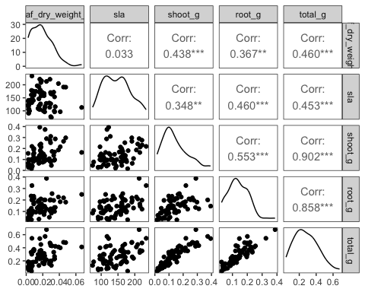

ggplot(data = drought_exp_clean, # data frame  
 aes(x = reorder(species_name, # reordering x-axis  
 -total_g, # in reverse order of mean total mass  
 fun = mean), # calculating mean to reorder  
 y = total_g)) + # y-axis  
 geom_jitter(width = 0.1, # narrow jitter  
 height = 0) # not jittering points up and down

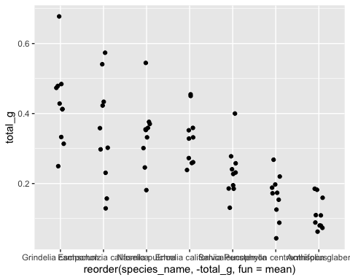

ggplot(data = drought_exp_clean, # data frame  
 aes(x = water_treatment, # x-axis  
 y = total_g)) + # y-axis  
 geom_jitter(width = 0.1, # narrow jitter  
 height = 0) # not jittering points up and down

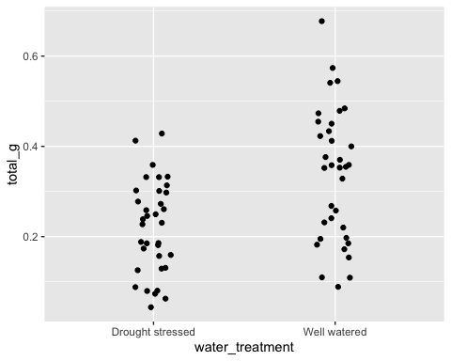

ggplot(data = drought_exp_clean, # data frame  
 aes(x = sla, # x-axis  
 y = total_g)) + # y-axis  
 geom_point() # scatterplot

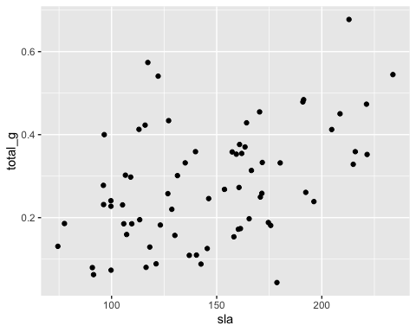

model0 <- lm(total_g ~ 1, # formula  
 data = drought_exp_clean) # data frame

model1 <- lm(total_g ~ sla + water_treatment + species_name,  
 data = drought_exp_clean)  
  
par(mfrow = c(2, 2))  
plot(model1)

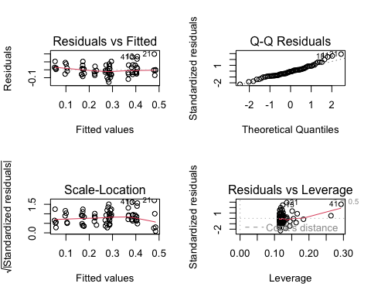

# you might get a warning when you run this code - that is ok!

model2 <- lm(total_g ~ sla + water_treatment,  
 data = drought_exp_clean)  
  
plot(model2)

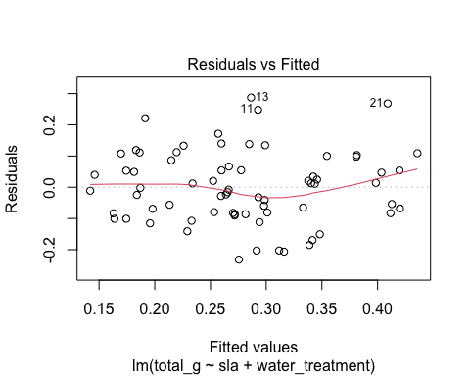

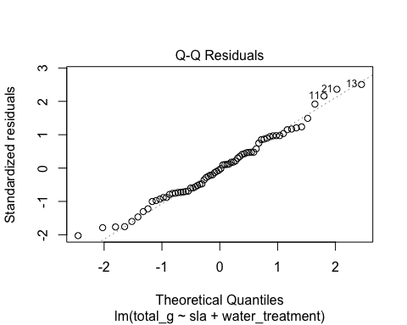

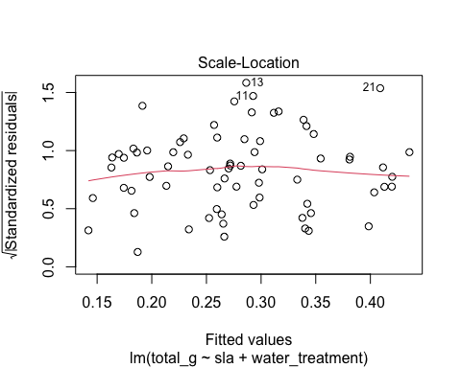

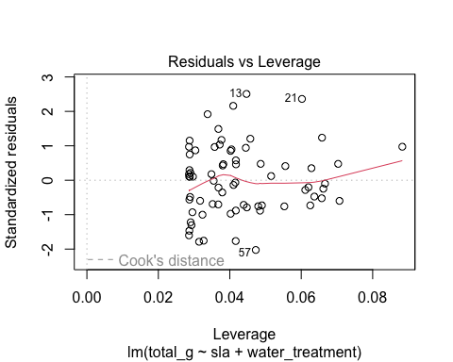

model3 <- lm(total_g ~ sla + species_name,  
 data = drought_exp_clean)  
  
plot(model3)

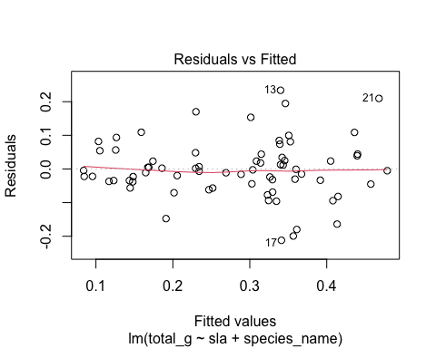

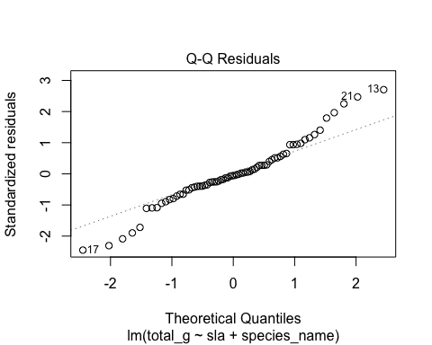

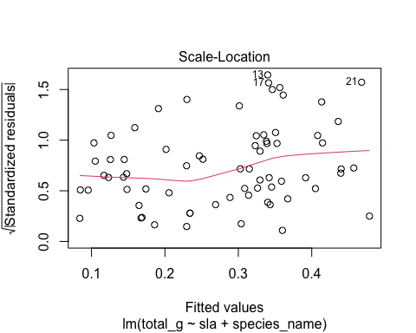

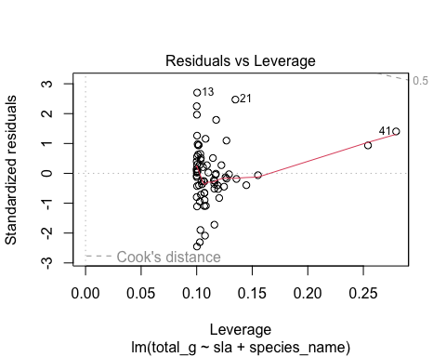

model4 <- lm(total_g ~ water_treatment + species_name,   
 data = drought_exp_clean)  
plot(model4)

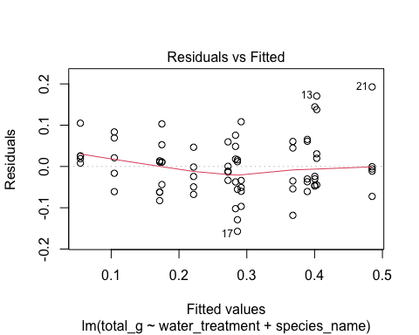

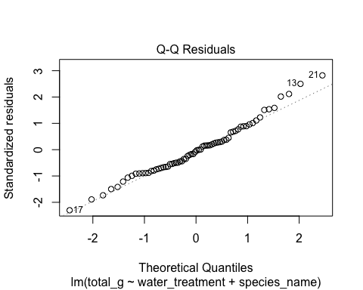

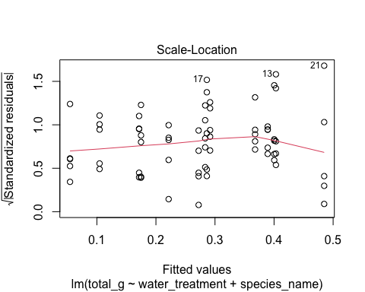

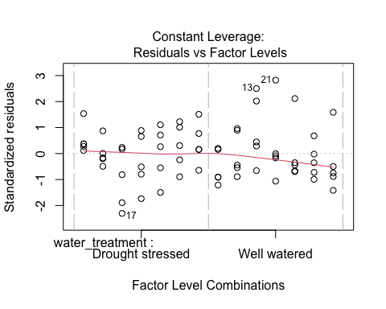

model.sel <- model.sel(model0,  
 model1,   
 model2,   
 model3,   
 model4)  
  
flextable::as_flextable(model.sel)

| (Intercept) | sla | species_name | water_treatment | df | logLik | AICc | delta | weight |
| --- | --- | --- | --- | --- | --- | --- | --- | --- |
| numeric | numeric | factor | factor | integer | numeric | numeric | numeric | model.weights |
| 0.1 |  | + | + | 9 | 88.6 | -156.2 | 0.0 | 0.8 |
| 0.1 | -0.0 | + | + | 10 | 88.7 | -153.8 | 2.4 | 0.2 |
| -0.0 | 0.0 | + |  | 9 | 72.5 | -124.1 | 32.1 | 0.0 |
| 0.0 | 0.0 |  | + | 4 | 52.2 | -95.8 | 60.4 | 0.0 |
| 0.3 |  |  |  | 2 | 39.6 | -75.0 | 81.2 | 0.0 |
| n: 5 | | | | | | | | |

modelsummary::modelsummary( # this function takes a list of models  
 list(   
 "null" = model0, # "model name" = model object  
 "model 1" = model1,  
 "model 2" = model2,  
 "model 3" = model3,   
 "model 4" = model4),   
 title = "Table 1: Model Comparison",   
 gof_map = c("aic")  
)

Table 1: Model Comparison

|  | null | model 1 | model 2 | model 3 | model 4 |
| --- | --- | --- | --- | --- | --- |
| (Intercept) | 0.279 | 0.080 | 0.047 | -0.033 | 0.055 |
|  | (0.017) | (0.056) | (0.054) | (0.067) | (0.025) |
| sla |  | 0.000 | 0.001 | 0.001 |  |
|  |  | (0.000) | (0.000) | (0.001) |  |
| water_treatmentWell watered |  | 0.122 | 0.090 |  | 0.117 |
|  |  | (0.020) | (0.029) |  | (0.017) |
| species_nameEncelia californica |  | 0.238 |  | 0.115 | 0.218 |
|  |  | (0.051) |  | (0.059) | (0.032) |
| species_nameEschscholzia californica |  | 0.234 |  | 0.222 | 0.232 |
|  |  | (0.033) |  | (0.041) | (0.032) |
| species_nameGrindelia camporum |  | 0.330 |  | 0.226 | 0.313 |
|  |  | (0.047) |  | (0.054) | (0.032) |
| species_nameNasella pulchra |  | 0.241 |  | 0.168 | 0.229 |
|  |  | (0.040) |  | (0.048) | (0.032) |
| species_namePenstemon centranthifolius |  | 0.061 |  | -0.006 | 0.050 |
|  |  | (0.039) |  | (0.047) | (0.032) |
| species_nameSalvia leucophylla |  | 0.117 |  | 0.139 | 0.120 |
|  |  | (0.033) |  | (0.041) | (0.032) |
| AIC | -75.2 | -157.5 | -96.4 | -127.1 | -159.2 |

model_preds <- ggpredict(model4,   
 terms = c("water_treatment",   
 "species_name"))

plot(model_preds, # model predictions  
 limit_range = TRUE, # limit the range of predictions to the range of predictor values  
 show_data = TRUE) + # show the underlying data  
 # everything below this is ggplot() stuff  
 theme_classic() + # classic theme  
 labs(title = "Preliminary model visualization") + # plot title  
 theme(panel.grid = element_blank()) # getting rid of gridlines

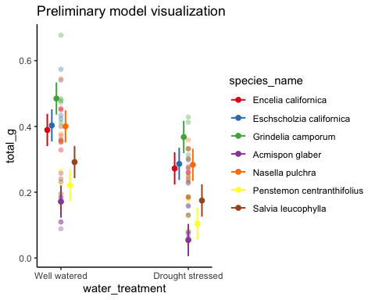

model_preds_for_plotting <- model_preds %>%   
 rename(water_treatment = x,  
 species_name = group)  
  
# use View(model_preds_for_plotting)   
# to compare this to the original model_preds data frame  
  
ggplot() +  
 # underlying data  
 geom_point(data = drought_exp_clean,  
 alpha = 0.3,  
 aes(x = water_treatment,  
 y = total_g,  
 color = water_treatment)) +  
 # model prediction 95% CI ribbon  
geom_errorbar(data = model_preds_for_plotting,  
 aes(x = water_treatment,   
 y = predicted,  
 ymin = conf.low,  
 ymax = conf.high,  
 fill = water_treatment),  
 alpha = 0.2, width = 0.2) +  
 # model prediction lines  
 geom_point(data = model_preds_for_plotting,  
 aes(x = water_treatment,   
 y = predicted,  
 color = water_treatment)) +  
 # cleaner theme  
 theme_classic() +  
 # creating different panels for species  
 facet_wrap(~species_name) +   
 theme(legend.position = "none") +   
 labs(x = "Water Treatment",   
 y = "Total Biomass (g)",   
 title = "Figure 1: Total Biomass (g) as predicted by Water Treatment and Plant Species") +   
 scale_color_manual(values = c("Well watered" = "orchid3",   
 "Drought stressed" = "olivedrab4"))

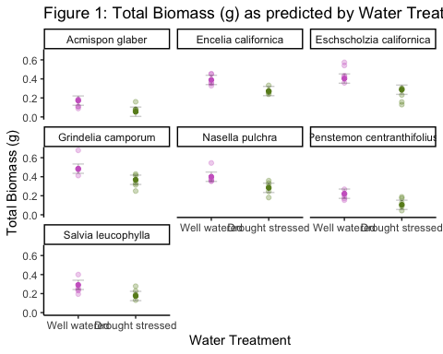

1. Affective Visualization
2. The data I took over the course of this class describes the number and species of birds seen perching on an artificial floating wetland island (FWI) on the UCSB Lagoon. An affectively visualization of my data could consist of birds sitting on pilings of different heights to represent how often each bird species was seen. Each piling would correspond to a different bird and that would be represented by having that specific species sitting atop it. While the pilings don’t represent exactly where the birds were seen perching, they do give an idea of how many birds of each species were seen.
3. UCSB Lagoon Birds: this piece shows the number of bird species seen perching on an artificial floating wetland island (FWI) at the UCSB Lagoon over a period of five months, from January to May 2024. Each piling represents a different observed bird species and the piling’s heights represent how many of those birds were seen. This piece is a Caran D’ache color pencil drawing that also incorporates Archival Ink pens to outline certain aspects of the visualization. To make this, I first made a sketch of what I wanted it to look like, which I transferred onto paper. I found images of the six bird species seen on the UCSB Lagoon and I drew them on top of the pilings. I did everything in pencil first, then added color, and finished by adding touches of ink.
4. Statistical Critique
5. To address their main research question (are CFWs effective in removing N and P from aquatic systems?), the authors used a variety of tests including Levene’s Test, Kruskall Wallis Test, Spearman’s R Correlation Coefficient, and Linear Regression. The authors did not include a visualization of their data in the article but they do have tables listing data points and showing the relationship between different variables. This is the table they included for the Spearman’s R Correlation Coefficient.
6. To visualize their data, I would suggest the authors use