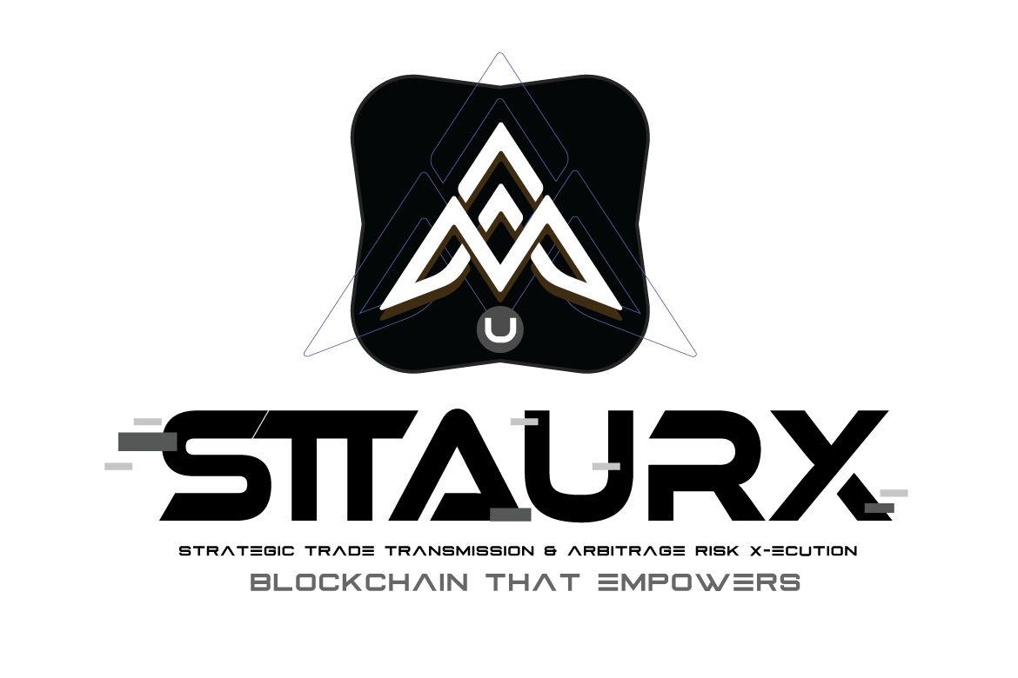
EXECUTIVE SUMMARY
Strategic Trade Transmission & Arbitrage Risk X-ecution Solutions

Introduction
STTAURX introduces the world's first gold-backed stablecoin designed specifically for international trade finance. By combining the stability of physical gold with blockchain efficiency, we eliminate the friction, delays, and currency risk that plague $18 trillion in annual cross-border trade.

The Problem
International trade finance is fundamentally broken:
- 5-10 days settlement time through correspondent banking
- 3-7% fees to intermediaries (SWIFT, banks, agents)
- 20+ paper documents per transaction
- $1.7 trillion trade finance gap for SMEs
- Currency volatility during settlement period

Our Solution: GOLD Token
The GOLD token maintains a strict 1:1 backing with physical gold stored in audited vaults:
Specification | Details
Backing Ratio | 1 GOLD = 1 gram physical gold
Storage | LBMA-certified vaults (Brinks, Loomis)
Audit Frequency | Monthly third-party verification
Redemption | Physical gold or fiat at spot price

Smart Letter of Credit
Our revolutionary Smart LC automates milestone-based payments:
Stage | Payment | Trigger
1. Shipment | 30% | Bill of Lading verified on-chain
2. Customs | 50% | Import clearance documentation verified
3. Delivery | 20% | Delivery confirmation + quality inspection

Staking & Yield Model
GOLD holders earn yield from trade finance fees through our tiered staking system:
Lock Period | APY | Bonus
Flexible | 5.0% | 1.0x
30 Days | 7.5% | 1.5x
60 Days | 10.0% | 2.0x
90 Days | 12.5% | 2.5x

Fee Structure
Service | Fee
GOLD Minting/Redemption | 0.1%
Smart LC Creation | 0.5%
Milestone Payment Release | 0.05%
Peer-to-peer Transfer | 0.02%
Total Trade Finance | < 1% (vs 3-7% traditional)

Market Opportunity
- $18 trillion annual cross-border trade volume
- $1.7 trillion unmet trade finance demand
- 80% of SME trade finance applications rejected
- $200B+ tokenized gold market by 2028

Competitive Advantage
- First-mover: Only gold-backed stablecoin with integrated trade finance
- Real backing: Physical gold vs algorithmic alternatives
- Smart LCs: Automated milestone payments reduce fraud
- Yield generation: Sustainable returns from real economic activity

Contact & Resources
Website: https://sttaurx.io
Documentation: https://docs.sttaurx.io
Explorer: https://explorer.sttaurx.io
Contact: info@sttaurx.io

