v

**EDUCATION**

**Bachelor in Computer Engineering**

June 2021 – April 2025

*Pashchimanchal Campus, Tribhuvan University, IOE*

**+2 in Science**

April 2018 – July 2020

*Pokhara Secondary School, Gandaki*

**INTERESTS**

* **Web Development**
* **App Development**
* **UI/UX Design**

**HOBBIES**

* **Video Games**
* **Music**

**LANGUAGES**

* **English: Proficient**
* **Nepali: Proficient**

**SKILLS**

* Python
* Javascript
* HTML & CSS
* Git
* NodeJS

**CONTACT**

+977 9845533201



 glacticoanish@gmail.com

 Milanchowk, Pokhara-25, Kaski

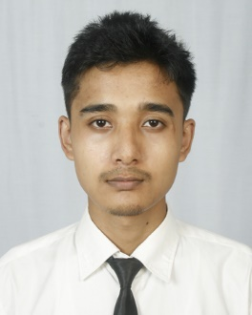

**Anish**

**Dahal**

**WORK EXPPERIENCE**

**Web Developer Intern**

Dhaulagiri School, MilanChowk, Pokhara-25 Sep 2024 – Present

* Assisted in building responsive websites for school events.
* Developed and maintained the school’s official website
* Collaborated with the design team to ensure smooth UI/UX integration.

**PROFILE**

I am a computer engineering student with passion for continuous learning. I am skilled in problem-solving and have strong background in computer science. I am a strong communicator and enjoy working collaboratively with others.