v

**INTERESTS**

* **Web Development**
* **App Development**
* **Graphics Design**

**HOBBIES**

* **Drawing**
* **Video Games**
* **Music**

**LANGUAGES**

* **English: Proficient**
* **Nepali: Proficient**

**SKILLS**

* Python
* Javascript
* HTML & CSS
* Photoshop
* Ms. Word
* English Typing (65 wpm)

**CONTACT**

+977 9846602320



 sentake101@gmail.com

 Kahunkhola, Pokhara-13, Kaski

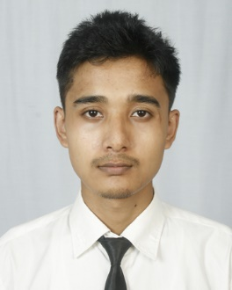

**Saujanya Shrestha**

**WORK EXPPERIENCE**

**Graphics Designer**

Pinnacle Academy, Phoolbari, Pokhara-11 Sep 2024 – Present

* Designed posters for the school’s facebook page
* Designed banners for the school’s parent’s day
* Worked closely with the client to meet their needs

**Studio Assistant**

Photo Pratibimba, Kahunkhola, Pokhara-13 2018 – Present

* Worked in a photo studio to capture, edit and develop professional photographs.

**EDUCATION**

**Bachelor in Computer Engineering**

June 2021 – April 2025

*Pashchimanchal Campus, Tribhuvan University, IOE*

**+2 in Science**

April 2018 – July 2020

*SOS Hermann Gmeiner Secondary School, Gandaki*

**PROFILE**

I am a computer student with passion for continuous learning. I am skilled in problem-solving and have strong background in computer science. I am a strong communicator and enjoy working collaboratively with others.