Name: Dipak Poudel

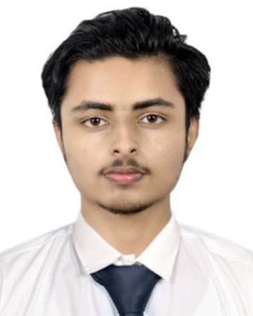

Email: pas077bct019@wrc.edu.np

Linkedin: linkedin.com/in/dipakpoudel.10

Phone: +9779819191534

DOB: June 26, 2001

**Experience:**

1. **Freelance Data Projects (JUN 2024 - Present)**

Conducted exploratory data analysis on Kaggle datasets. Built a recommendation system for a mock e-commerce platform using collaborative filtering.

1. **Internship at Dishhome (SEP 2023 – JAN 2024)**Assisted in cleaning and preprocessing large datasets using Python (Pandas, NumPy). Built predictive models using Scikit-learn to forecast customer churn. Created dashboards in Tableau for client reporting.

**Education**:

1. Bachelor in Computer Engineering
2. +2 in Science

**Skills**:

1. **Hard Skills**: Python, SQL, Pandas, Numpy, Scikit-learn, Matplotlib, Seaborn, Tensorflow, Tablea, Github
2. **Soft Skills**: Problem-Solving, Leadership, Collaboration, Communication

**Languages**:

1. English (Proficient)
2. Nepali (Proficient)

**Interests**:

1. Machine Learning & AI
2. Data Storytelling
3. Open-source Contributions
4. Chess and Logical Puzzles
5. Reading Tech Blogs