v

**INTERESTS**

* **Digital Art**
* **App Development**
* **Graphics Design**

**HOBBIES**

* **Drawing**
* **Video Games**
* **Music**

**LANGUAGES**

* **English: Proficient**
* **Nepali: Proficient**

**SKILLS**

* Kotlin
* Java
* Android Studio
* XML
* Firebase
* Git

**CONTACT**

+977 9846602254



 saroj101@gmail.com

 Parsayang, Pokhara-5, Kaski

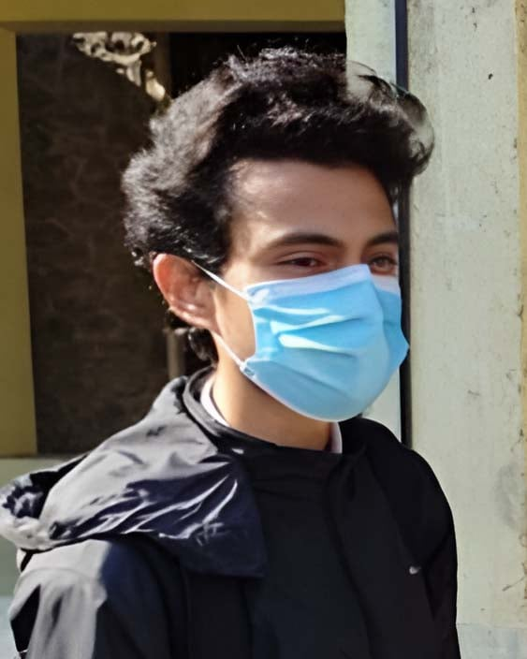

**Saroj**

**Adhikari**

**WORK EXPPERIENCE**

**Android Developer Intern**

Parsyang , Pokhara-5 Jan 2025 – Apr 2025

1. Built basic Android applications using Java and Kotlin in Android Studio.
2. Integrated Firebase for real-time database and authentication.
3. Participated in code reviews and collaborated in agile development teams.

**Studio Assistant**

Parsyang, Pokhara-5 2023 – Present

1. Developed a to-do list app and a budget tracker using XML UI and SQLite for local data storage
2. Published a basic weather app using OpenWeatherMap API
3. Uploaded source code on GitHub with proper documentation

**EDUCATION**

**Bachelor in Computer Engineering**

June 2021 – April 2025

*Pashchimanchal Campus, Tribhuvan University, IOE*

**+2 in Science**

April 2018 – July 2020

*Motherland Secondary School, Gandaki*

**PROFILE**

I am a computer student with passion for continuous learning. I am skilled in problem-solving and have strong background in computer science. I am a strong communicator and enjoy working collaboratively with others.