Untitled
Marc A. Suchard
8/15/2021

R Markdown
This is an R Markdown document. Markdown is a simple formatting syntax for authoring HTML, PDF, and MS Word documents. For more details on using R Markdown see http://rmarkdown.rstudio.com.
When you click the Knit button a document will be generated that includes both content as well as the output of any embedded R code chunks within the document. You can embed an R code chunk like this:

Including Plots
You can also embed plots, for example:
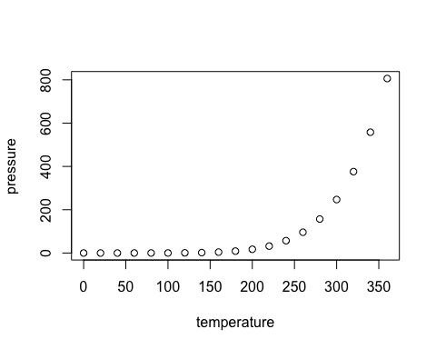
Note that the echo = FALSE parameter was added to the code chunk to prevent printing of the R code that generated the plot.

Including Tables
CDM | Common data model
DPP4 | Dipeptidyl peptidase-4
GLP1 | Glucagon-like peptide-1
IRB | Institutional review board
LEGEND | Large-scale Evidence Generation and Evaluation across a Network of Databases
MACE | Major adverse cardiovascular event
MDRR | Minimum detectable risk ratio
OHDSI | Observational Health Data Science and Informatics
OMOP | Observational Medical Outcomes Partnership
PS | Propensity score
RCT | Randomized controlled trial
SGLT2 | Sodium-glucose co-transporter-2
T2DM | Type 2 diabetes mellitus

