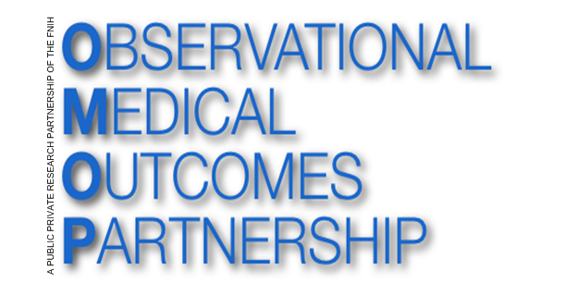
OMOP Common Data Model (CDM V4.0)
ETL Mapping Specification Premier

Version 2.0
07- Oct-2014

Rupa Makadia

Table of Contents
1.0 Introduction 3
2.0 Source Data Mapping Approach 4
3.0 Source Data Mapping 6
3.1.1 Table Name: PERSON 7
3.1.2 Table Name: VISIT_OCCURRENCE 10
3.1.3 Table Name: OBSERVATION_PERIOD 15
3.1.4 Table Name: PAYER_PLAN_PERIOD 17
3.1.5 Table Name: DEATH 19
3.1.6 Table Name: OBSERVATION 22
3.1.7 Table Name: DRUG_EXPOSURE 24
3.1.8 Table Name: DRUG_COST 28
3.1.9 Table Name: CONDITION_OCCURRENCE 30
3.1.10 Table Name: PROCEDURE_OCCURRENCE 34
3.1.11 Table Name: PROCEDURE_COST 38
3.1.12 Table Name: PROVIDER 41
3.1.13 Table Name: CARE_SITE 43
3.1.14 3.1.12 Table Name: LOCATION 44
3.1.15 Table Name: ORGANIZATION 45
3.1.16 Table Name: COHORT 45
3.2 Source Independent Data Mapping 46
3.2.1 Table Name: DRUG_ERA 46
3.2.2 Table Name: CONDITION_ERA 48
4.0 Appendix 49
4.1 Premier mapping to CDM fields 49
4.2 STD_CHG_CODE to SOURCE_TO_CONCEPT_MAP table 49
4.3 Provider Specialty mapping table 49
4.4 STD_CHG_CODE to HOSP_CHG_ID Mapping table 49

Introduction

This document reflects the requirements, assumptions, business rules and transformations for the implementation of the Common Data Model Version 4.0 (CDM) as implemented by Rupa Makadia, Epidemiology Analytics, Janssen Research and Development.

The purpose of this document is to describe the ETL mapping of the proprietary or licensed data from Premier into the OMOP Common Data Model. All references made to the source database, Premier will be referenced in bold and italic.

Premier is a hospital based system that houses inpatient and outpatient visits from 619 hospitals with over 62 million discharges. Premier is a hospital based system that captures visits and is not a claims database. Each visit is linked to billing records. The data captures 1 in every 5 inpatient stays in the US.

The document is composed of two main sections:
- Source Data Mapping. Describes major tables of the CDM schema and special data handling required for each table.
- Source Independent Data Mapping. Describes mapping process of the Drug and Condition Era’s.

In each section, the tables and their mapping are individually reviewed along with any source specific rules and exceptions.

The intended audience for this document will include both researchers that want to use the experience and learning in order to incorporate them into their own CDM construction.

Source Data Mapping Approach

The figure below represents the general approach to mapping the source data tables that are available in Premier to the CDM data schema. Additional ancillary tables and look up tables are included in the chart. The following tables are null: ORGANIZATION, and COHORT. The blue boxes represent the input tables in Premier and the green boxes represent the resulting CDM tables. For example, the pat table results in the PERSON table, the OBSERVATION_PERIOD table and the VISIT_OCCURRENCE table.

In addition to the high level table mapping that is represented below. A review was conducted of each source data field that is available in all of the following tables: PAT, PATBILL, PATICD, and PATCPT. The mapping at the field level and justification of why selected fields are not included is located in the appendix.

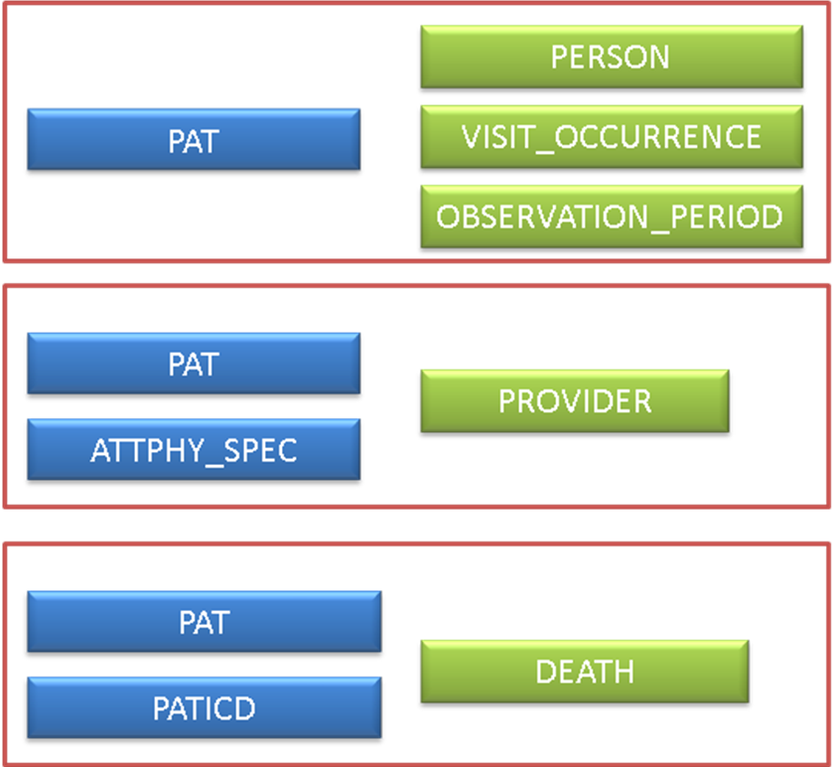

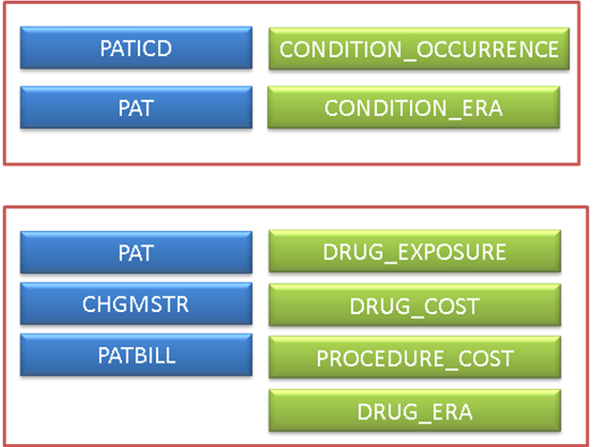

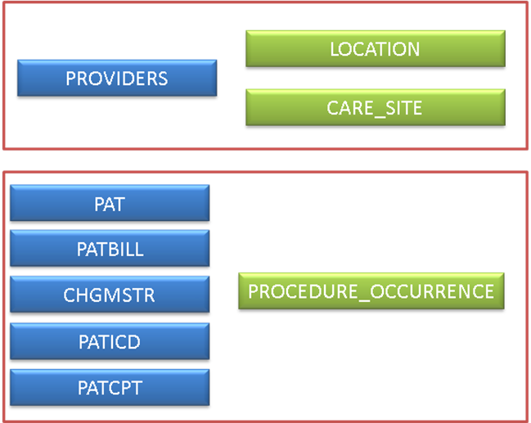

Source Data Mapping
The figure below illustrates the order in which the CDM tables should be generated. The visit table must generated first because the start dates and end date of each visit are derived from the maximum number of service days. The service days for each visit is located in PATBILL table, for each visit, the maximum value in this field is obtained. The start dates for the DRUG_EXPOSURE and PROCEDURE_OCCURRENCE rely on the visit start date in order to calculate the correct DRUG_EXPOSURE_START_DATE and PROCEDURE_OCCURRENCE_START_DATE. The logic transformation for these dates is explained in the sections for each respective table.

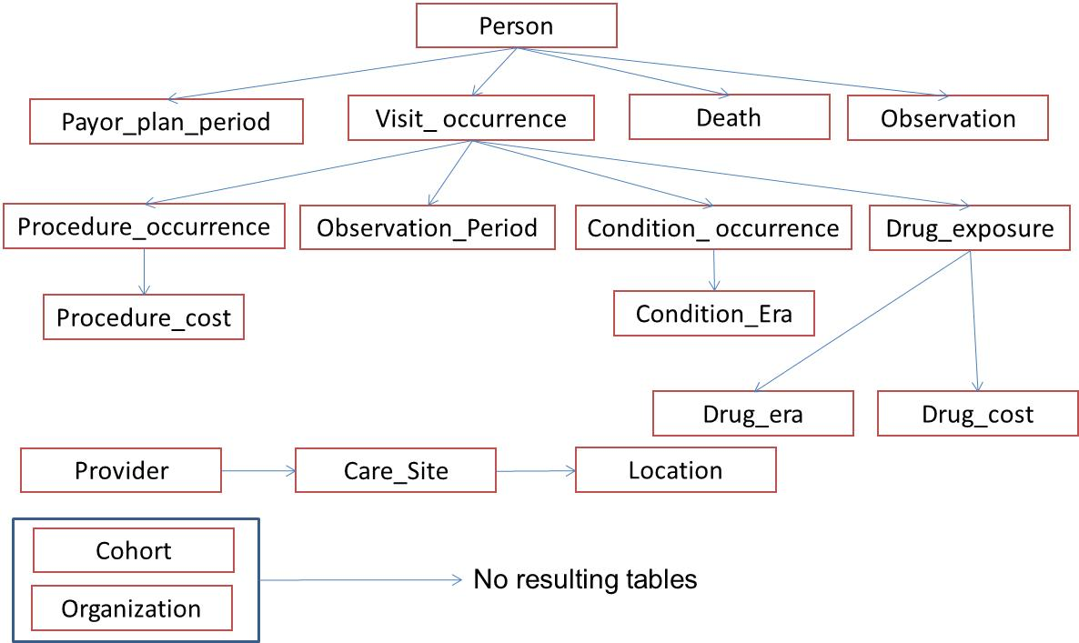

Table Name: PERSON
Describe how the Person mapping and transformations are designed.

In Premier, the PAT table contains all demographic, admission and total cost data for each visit. There are multiple entries per person, thus a single record needs to be created to populate the PERSON table. MONTH_OF_BIRTH and DAY_OF_BIRTH are not available in Premier, because age is the only available field. YEAR_OF_BIRTH is calculated from the first transformed admission date. The admission year minus the age results in the YEAR_OF_BIRTH. Since no address information is available in Premier for each person, LOCATION_ID is null. Primary care providers for each person are not known, thus PROVIDER_ID is null and CARE_SITE is null. Race could vary amongst records in the PAT table, thus logic is used to take the maximum value of race for people that have multiple values in the PAT table. Ethnicity is available in the race field; this logic is applied to parse out the ethnicity from each record. Hispanic is the only ethnicity available in Premier, thus those with an ethnicity as Hispanic the race is considered ‘Other’. For the population of the ethnicity field, if the race is Hispanic then the ethnicity is assigned Hispanic otherwise the ethnicity is coded as NULL.
Delete any patients that have invalid birth years < 1900 or > the current year. After birth year has been determined delete any individual that has an OBSERVATION_PERIOD that is >= 2 years prior to the YEAR_OF_BIRTH. Due to data discrepancies in Premier additional logic has been applied to generation of the gender and age. If a person has YEAR_OF_BIRTH that varies over two years then those records are eliminated. Also, if a person has multiple genders that are specified then those records are eliminated. The exclusion criterion for the PERSON table removes about 1% of the population in the database.

The field mapping is performed as follows:
Destination Field | Source Field | Applied Rule | Comment
PERSON_ID | PAT.MEDREC_KEY | Field is a randomly generated identifier that is available in Premier
GENDER_CONCEPT_ID | PAT.GENDER | When PAT.GENDER=M then GENDER_CONCEPT_ID=8507  When PAT.GENDER=F then GENDER_CONCEPT_ID=8532  When PAT.GENDER=U then GENDER_CONCEPT_ID=8551 | CONCEPT_ID’s are VOCABULARY_ID=12
YEAR_OF_BIRTH | VISIT_OCCURRENCE.VISIT_START_DATEPAT.AGE | Year(VISIT_OCCURRENCE.VISIT_START_DATE)-age  Year_of_birth needs to be > 1900 and <=current year | See code for logic to take the min (adm_date) to generate the year of birth
MONTH_OF_BIRTH | - | NULL | Premier only provides age
DAY_OF_BIRTH | - | NULL | Premier only provides age
RACE_CONCEPT_ID | PAT.RACE | When PAT.RACE=1 then RACE_CONCEPT_ID=8527  When PAT.RACE=2 then RACE_CONCEPT_ID =8516  When PAT.RACE=9 or PAT.RACE=3 then RACE_CONCEPT_ID =8522 | Premier combines both race and ethnicity into one field. Ethnicity is removed from race. If multiple race records per person, see logic to obtain the max value of race that occurs in all records.
ETHNICITY_CONCEPT_ID | PAT.RACE | When PAT.RACE=3 then  ETHNICITY_CONCEPT_ID=38003563 else NULL | If race is not Hispanic set ethnicity to null
LOCATION_ID | - | NULL
PROVIDER_ID | - | NULL
CARE_SITE_ID | - | NULL
PERSON_SOURCE_VALUE | PAT.MEDREC_KEY
GENDER_SOURCE_VALUE | PAT.GENDER
RACE_SOURCE_VALUE | PAT.RACE
ETHNICITY_SOURCE_VALUE | PAT.RACE

SAMPLE CODE:

select distinct person_id,GENDER_CONCEPT_ID=
case gender
when 'M' then 8507
when 'F' then 8532
when 'U' then 8551
else 8551
end,
min(year_of_birth) as YEAR_OF_BIRTH,
month_of_birth, day_of_birth,
race_concept_id=
case race
when 1 then 8527
when 2 then 8516
when 9 then 8522
when 3 then 8522
else 8522
end,ethnicity_concept_id=
case race
when 3 then 38003563
else NULL
end, location_id, provider_id, care_site_id, person_source_value, gender_source_value, race_source_value, ETHNICITY_SOURCE_VALUE
from (
select distinct pat.medrec_key as PERSON_ID,
year(visit_start_date) - age as year_of_birth,
null as month_of_birth,
null as day_of_birth,
r.race as race,
gender as gender,
null as location_id,
null as provider_id,
null as care_site_id,
pat.medrec_key as person_source_value,
gender as gender_source_value,
r.race as race_source_value,
r.race as ETHNICITY_SOURCE_VALUE
from (select * from [RNDUSRDHIT02].[Premier].[dbo].[pat] where medrec_key
in (select medrec_key from scratch.dbo.persons_premier_6k)) pat
join (select distinct person_id, min(visit_start_date) as visit_start_date
from scratch.dbo.rm_visit_occurrence2
group by person_id) vo on vo.person_id=pat.medrec_key
join

(
select medrec_key, min(race) as race from [RNDUSRDHIT02].[Premier].[dbo].[pat]
where medrec_key in (select medrec_key from scratch.dbo.persons_premier_6k)
group by medrec_key

) r on r.medrec_key=pat.medrec_key

group by pat.medrec_key, pat.gender, pat.age, visit_start_date, r.race )

a
group by person_id, gender, gender_source_value, month_of_birth, day_of_birth, location_id,provider_id,
race, care_site_id, person_source_value, race_source_value, ETHNICITY_SOURCE_VALUE

Table Name: VISIT_OCCURRENCE
Describe how the Visit_Occurrence mapping and transformation are designed.

Premier data is visit oriented, thus each visit has its own unique visit identifier. The PAT table has admission date and discharge date for each visit. Each visit is stored as a date but the day of the stay is always coded as the first of the month. Thus, a person could have more than one visit in the same year-month combination and an additional field is included to preserve the order of visits because the day of month is lost. The field PAT.DISC_MON_SEQ has been included in Premier to preserve the order of visits based on unique discharge dates. The LOS field on the PAT table is populated for inpatient stays, and is recorded as 24 hour increments of time that a patient spends within the hospital. Thus, the LOS field is usually off by one calendar day for inpatient visits. Outpatient visits have a LOS of 0 and are typically only one day in length which is represented in the billing tables. For about 6% of outpatient visits, a single visit is comprised of multiple procedures that occur on different days, procedures such as chemotherapy or dialysis. The Premier billing system does not separate these out into individual visits and for purposes of the ETL these will be considered as one continuous visit. The PATBILL table houses the billing records that occur each calendar day during the visit, some visits may include a day of zero which are considered to be pre-visit tests or procedures, for the purposes of the ETL, this information is considered as the first day of the visit, which can occur for inpatient and outpatient stays. The length of the stay is determined via the PAT.PAT_BILL table using the field SERV_DAY. The max service day is determined for each person. Logic is defined to take each person, visit, sequence order and add the maximum number of service days to their stay starting with the first of the month. Each visit that occurs after the first will use the previous end date +1 as the visit start date, and then the service days are added to the start date to determine to end date. The same logic is repeated until all observations have a valid start date and end date that do not overlap. For those visits that have an admission date and discharge date in different months, the logic works backward to obtain the visit start date from the max service days and visit end date. If there are multiple visits that occur in the same admission month that span over months, the records may overlap. There are 89,408 patients or roughly 0.10% of patients that are affected by this issue. For those records that have service days greater than the number of days in the month, the remaining days are truncated to the last day of the month. Logic guarantees that length of visits is preserved and the order of visits. The specific day of the month in start date or end date is not necessary accurate, and the time between to two visits is not necessary accurate. The algorithm will always set the new visit start date plus 1 day or use the backward logic and assume that the visit end date is the first day of the new month.

An example for both sets of logic is displayed below:
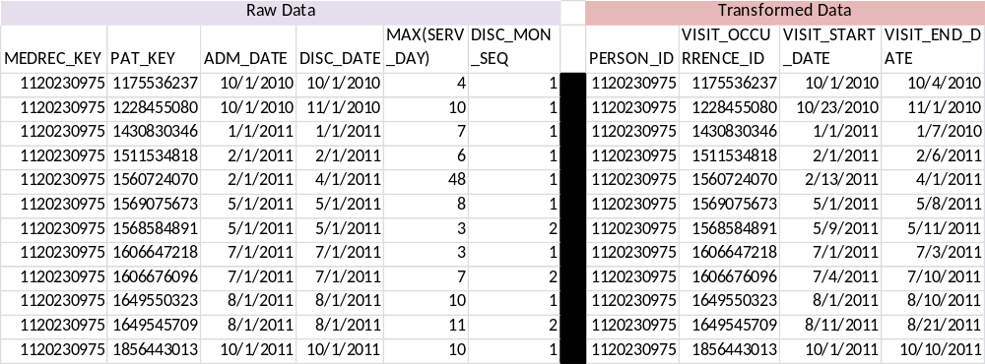

Logic for ER stays is varied due to data changes from Premier in identifying ER visits. ER Visits in Premier are identified through point of origin or admission source and those visits are identified as an outpatient stay if a person enters the ER and then leaves. If an inpatient stay is resulted from an ER visit, that is identified as an Inpatient stay. The additional logic that has been added to constraint dates and fields which reflects changes in Premier’s classification of emergency room visits. In Premier, the value in admission source that designated emergency room was discontinued 7/1/2010 because it no longer was a required variable for CMS.

Point of origin represents where the last physical locations a patient came from prior to entering the hospital. This field is populated in Premier after 7/1/2010 with emergency room visits. Thus, a combination of point of origin, admission source and admission type is used to determine if a patient had a valid ER stay for Premier.

LOS, the length of stay field is not used because each billing record corresponds to a service day in the PATBILL table.

The field mapping is performed as follows:

Destination Field | Source Field | Applied Rule | Comment
VISIT_OCCURRENCE_ID | PAT.PAT_KEY
PERSON_ID | PAT.MEDREC_KEY
VISIT_START_DATE | PAT.ADM_DATE  PATBILL.SERV_DAY  PAT.DISC_MON_SEQ | See logic in code and explanation above
VISIT_END_DATE | PAT.DISC_DATE  PATBILL.SERV_DAY  PAT.DISC_MON_SEQ | See logic in code and explanation above
PLACE_OF_SERVICE_CONCEPT_ID |  | When PAT.ADM_DATE <= ‘6/1/2010’ and ADM_SOURCE=7 and I_O_IND =’O’ then concept_id=9203  When PAT.ADM_DATE >= ‘7/1/2010’ and (POINT_OF_ORIGIN=7 or ADM_SOURCE =1) and I_O_IND =’O’ then concept_id=9203  When I_O_IND =’I’ then concept_id=9201  When I_O_IND =’O’ then concept_id=9202 | Logic is in the following order:  - Patient enters through the ER but doesn’t result in an inpatient stay will be identified as an ER visit.  - Patients who may have entered through the ER but get admitted will be identified as an Inpatient visit.
CARE_SITE_ID | PAT.PROV_ID
PLACE_OF_SERVICE_SOURCE_VALUE | PAT.I_O_IND

SAMPLE CODE: T-SQL logic

--sort table by adm_date and dis_mon_seq, make sure to pick up max_serv_day
DECLARE visit_cursor CURSOR FOR
select pat.pat_key as id,
pat.medrec_key as person_id,
pat.adm_date as StartDate,
pat.disc_date as EndDate,
pat.disc_mon_seq,
case when max(patbill.serv_day)=0 then 1 else max(patbill.serv_day)
end as max_serv_day
from pat
inner join patbill
on pat.pat_key = patbill.pat_key
where pat.medrec_key in {0}
group by pat.patkey, pat.medrec_key, pat.adm_date, pat.disc_date, pat.dis_mon_seq
order by pat.disc_date asc, pat.dis_mon_seq asc
;

--create temp variables for cursoring

DECLARE @lastenddate date
DECLARE @laststartdate date
DECLARE @lastendmonth date
DECLARE @currentid int
DECLARE @oldpersonid int
DECLARE @currentpersonid int
DECLARE @currentstartdate date
DECLARE @currentenddate date
DECLARE @currentdismonseq int
DECLARE @currentmaxservday int

SET @laststartdate = '1/1/1900'
SET @lastenddate = '1/1/1900'
SET @lastendmonth = '1/1/1900'
SET @oldpersonid=0

OPEN visit_cursor

FETCH NEXT FROM visit_cursor INTO @currentid, @currentpersonid, @currentstartdate, @currentenddate, @currentdismonseq, @currentmaxservday

WHILE @@FETCH_STATUS = 0

BEGIN
IF @oldpersonid <> @currentpersonid
BEGIN

SET @laststartdate = '1/1/1900'
SET @lastenddate = '1/1/1900'
SET @lastendmonth = '1/1/1900'

set @oldpersonid=@currentpersonid

END

IF @currentstartdate = @currentenddate

BEGIN
IF @lastendmonth < @currentstartdate --should only fire on first record or when dis_mon_seq = 1
BEGIN

SET @currentenddate = case when dateadd(dd,@currentmaxservday,@currentstartdate) < dateadd(mm,1,@currentstartdate)
then dateadd(dd,@currentmaxservday-1,@currentstartdate) --if endate falls in month, use it
else dateadd(dd,-1, dateadd(mm,1,@currentstartdate)) --otherwise, set to last day of the month
end
SET @laststartdate = @currentstartdate
SET @lastendmonth = @currentstartdate
SET @lastenddate = @currentenddate

END

ELSE --IF @lastendmonth = @currentstartdate
BEGIN

SET @currentstartdate = dateadd(dd, case when @lastenddate < dateadd(dd,-1,dateadd(mm,1,@lastendmonth)) then 1 else 0 end , @lastenddate) --increment prior visit by 1 unless you're already at the end of the month
SET @currentenddate = case when dateadd(dd,@currentmaxservday,@lastenddate) < dateadd(dd,-1,dateadd(mm,1,@lastendmonth))
then dateadd(dd,@currentmaxservday,@lastenddate)
else dateadd(dd,-1,dateadd(mm,1,@lastendmonth)) end
--use prior visit + 1 and add the maxsrvdate, unless either date exceeds the end of the month, or else just use the end of te month
SET @laststartdate = @currentstartdate
SET @lastenddate = @currentenddate

END

END
ELSE --startdate <> enddate, which means the visit spans across months
BEGIN
IF @lastendmonth = @currentstartdate
BEGIN
SET @currentstartdate = case when datediff(dd, dateadd(dd, case when @lastenddate < dateadd(dd,-1,dateadd(mm,1,@lastendmonth)) then 1 else 0 end , @lastenddate) ,@currentenddate) > @currentmaxservday
then dateadd(dd, -1*(@currentmaxservday-1), @currentenddate)
else dateadd(dd, 1, @lastenddate)
end

SET @lastendmonth = @currentenddate

SET @currentenddate = case when dateadd(dd,@currentmaxservday-1,@currentstartdate) < DATEADD(mm,1,@currentenddate)

then dateadd(dd,@currentmaxservday-1,@currentstartdate)
else dateadd(dd,-1,DATEADD(mm,1,@currentenddate))
end

SET @lastenddate = @currentenddate

END
ELSE --@lastendmonth < @currentstartdate --if the visit spanning months is the first visit in the month, start it on first day of adm month and let it go through into the disc month
BEGIN
SET @lastendmonth = @currentenddate
SET @currentstartdate =DATEADD(dd,-1*(@currentmaxservday-1), @currentenddate)
SET @lastenddate = @currentenddate

END

END

INSERT INTO scratch.dbo.VISIT_OCCURRENCE (VISIT_OCCURRENCE_ID, PERSON_ID, VISIT_START_DATE, VISIT_END_DATE)
VALUES (@currentid, @currentpersonid, @currentstartdate, @currentenddate)

FETCH NEXT FROM visit_cursor INTO @currentid, @currentpersonid, @currentstartdate, @currentenddate, @currentdismonseq, @currentmaxservday

END

CLOSE visit_cursor
DEALLOCATE visit_cursor
Adding mapping logic for PLACE_OF_SERVICE

select
visit_occurance_id,
person_id,
visit_start_date,
visit_end_Date,
case when adm_date <= '06/01/2010' and pat.adm_source='7' and pat.i_o_ind='O' then 9203
when adm_date >= '07/01/2010' and (pat.point_of_origin='7' OR pat.adm_source='1') and pat.i_o_ind='O' then 9203
when pat.i_o_ind='I' then 9201
when pat.i_o_ind='O' then 9202
end as place_of_service_concept_id,
PAT.PROV_ID AS care_Site_id,
PAT.i_o_ind as place_of_service_source_value
from visit_occurrence
join pat on visit_occurrence.visit_occurrence_id=pat.pat_key

Table Name: OBSERVATION_PERIOD
Describe how the Observation_Period mapping and transformation are designed.

Due to the lack of enrollment data in Premier the observation period for each patient will be defined by unique visits from the VISIT_OCCURRENCE table, for each unique patient. Derived admission and discharge dates are created using the number of service days and the sequence of visits as defined by the field PAT.DISC_MON_SEQ if the visits occurred twice in the same discharge month/year.

All overlapping visits will be collapsed into one observation period. An overlapping visit is defined by a visit that has an admit date that is within 31 days of the previous discharge date. For example a patient has an admission date of ‘2011-02-01’ and a discharge date of ‘2011-02-05’ and the next visit occurs in ‘2011-02-19’ and a discharge date of ‘2011-03-01’. These records would be collapsed into a single observation period.

The field mapping is as follows:

Destination Field | Source Field | Applied Rule | Comment
OBSERVATION_PERIOD_ID | - | System generated
PERSON_ID | PAT.MEDREC_KEY
OBSERVATION_PERIOD_START_DATE | VISIT_OCCURRENCE.VISIT_START_DATE
OBSERVATION_PERIOD_END_DATE | VISIT_OCCURRENCE.VISIT_END_DATE

SAMPLE CODE:

First select all admission date, and discharge dates for all persons in the VISIT_OCCURRENCE table:

SELECT distinct PERSON_ID, VISIT_START_DATE, VISIT_END_DATE from VISIT_OCCURRENCE

Then using logic check the discharge dates and admission dates to check for overlapping records.

DATA OBSERVATION_PERIOD1 (KEEP= PERSON_ID visit_start_date visit_end_date
RENAME=(
Visit_start_date = OBSERVATION_PERIOD_START_DATE
Visit_end_date = OBSERVATION_PERIOD_END_DATE));
RETAIN SFLAG EFLAG;
SET VISIT_OCCURRENCE2;
BY PERSON_ID VISIT_START_DATE VISIT_END_DATE;

IF FIRST.PERSON_ID THEN DO;
SFLAG = VISIT_START_DATE;
EFLAG = VISIT_END_DATE;
END;
ELSE IF VISIT_START_DATE <= EFLAG+31 THEN EFLAG = VISIT_END_DATE; /* 31 DAY GAP*/

ELSE DO; /*IF THERE IS A GAP*/
C1 = VISIT_START_DATE;
C2 = VISIT_END_DATE;

VISIT_START_DATE = SFLAG;
VISIT_END_DATE = EFLAG;
OUTPUT;

SFLAG = C1;
EFLAG = C2;
END;
IF LAST.PERSON_ID THEN DO;
VISIT_START_DATE = SFLAG;
VISIT_END_DATE = EFLAG;
OUTPUT;
END;
RUN;

Table Name: PAYER_PLAN_PERIOD
Describe how the PAYER_PLAN_PERIOD mapping and transformation are designed.

Payer information presented in Premier exists in the PAT table, in the field PAT.STD_PAYOR which represents standard payer categories. Since information about how long the patient remains with a payer or is enrolled is not available, the PAYER_PLAN_PERIOD_START_DATE and PAYER_PLAN_PERIOD_END_DATE are the same as the calculated OBSERVATION_PERIOD for each patient. If a patient changes payer within an observation period, then the payer plan period will be segmented to reflect the change in payers, if multiple payers are attributed to one observation period, use visit start and visit end to determine the payer.

The field mapping is as follows:

Destination Field | Source Field | Applied Rule | Comment
PAYER_PLAN_PERIOD_ID | - | System- generated value
PERSON_ID | PAT.MEDREC_KEY
PAYER_PLAN_PERIOD_START_DATE | OBSERVATION_PERIOD.OBSERVATION_PERIOD_START_DATE
PAYER_PLAN_PERIOD_END_DATE | OBSERVATION_PERIOD.OBSERVATION_PERIOD_START_DATE
PAYER_SOURCE_VALUE | PAYOR.STD_PAYER_DESC
PLAN_SOURCE_VALUE | - | NULL
FAMILY_SOURCE_VALUE | - | NULL

SAMPLE CODE:
Select distinct persons, visit start date, visit end date and payer

select distinct person_id, visit_start_date, visit_end_date, payor.std_payor_desc
from visit_occurrence vs
join pat on vs.visit_occurrence_id=pat.pat_key
join payor on pat.std_payor=payor.std_payor
order by person_id, visit_start_date, visit_end_date, payor

Use ERA logic to combine the observation periods if the payer is the same. If the payers change, the dates are checked to ensure only no overlapping payers are created. The first payers end date is greater than or equal to the second payer then those records are dropped.

If a person has different payers with plan 1 end date that is less than plan 2 end date and if plan 2 start date is less than or equal to plan 1 end date then plan 2 visit start date will equal plan 1 visit end +1. This will ensure that we don’t have two overlapping periods by starting the second plan after the first plan ends.

An example is represented below:

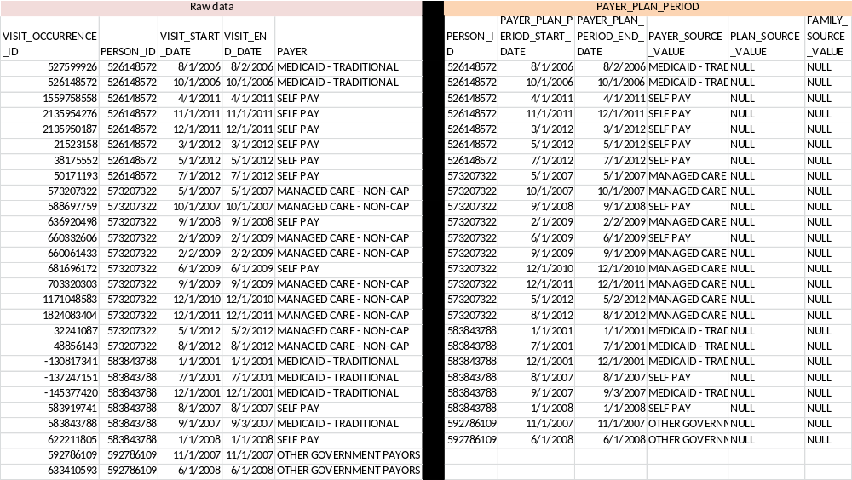

Table Name: DEATH
Describe how the DEATH mapping and transformation are designed.

Death is mapped from discharge status and ICD9 codes. The cause of death is not available in Premier. Discharge status from the PAT table should be used first, if no codes are found, then ICD9 codes are used. The ICD9 codes are obtained from the vocabulary and identified in the code below. Keep only one record for each patient, if both discharge status and ICD9 codes indicate death, use discharge status first. No records should be populated for that person 32 days after the death date.

The field mapping is as follows:

Destination Field | Source Field | Applied Rule | Comment
PERSON_ID | PAT.MEDREC_KEY
DEATH_DATE | VISIT_OCCURRENCE.VISIT_END_DATE |  | The exact date of death cannot be determined thus the VISIT_END date is used.
DEATH_TYPE_CONCEPT_ID | - | Logic based on discharge status or ICD9 diagnosis code, see below
CAUSE_OF_DEATH_CONCEPT_ID | - | NULL
CAUSE_OF_DEATH_SOURCE_VALUE | - | NULL

SAMPLE CODE:

select distinct person_id, death_date, min(death_type_concept_id) as death_type_concept_id, 0 as cause_of_death_concept_id,
null as cause_of_death_source_value from (

select * from
(
select person_id, death_date, death_type_concept_id from (

select distinct a.MEDREC_KEY as person_id, ROW_NUMBER() OVER(PARTITION BY a.medrec_key ORDER BY visit_end_date) AS Rownum,
visit_end_date as death_date,
38003566 as death_type_concept_id
from (select * from pat where disc_status in (20, 40, 41, 42)) a
join cdm_premier.dbo.visit_occurrence vo on vo.person_id=a.medrec_key and a.pat_key=vo.visit_occurrence_id
--order by a.medrec_key

) x
where rownum=1 ) y

--remove those that have visits after this date.

--Add any from conditions, but discharge status gets first priority
union all
(
select distinct p.medrec_key, min(visit_end_date) as death_date, 38003567 as death_type_concept_id from pat p
join paticd icd on icd.pat_key=p.pat_key
join cdm_premier.dbo.visit_occurrence vo on vo.visit_occurrence_id=p.pat_key
where icd_code in (
'798.1',
'761.6',
'798',
'E913.1',
'798.2',
'E978',
'798.9',
'798.0') group by medrec_key

) )z
group by person_id, death_date, death_type_concept_id

Table Name: OBSERVATION
Describe how the Observation mapping and transformation are designed.

The observation table houses additional demographic and visit data that is housed in Premier. Marital status, discharge and admission status information is captured in the observation table.
The information is populated for each visit, from the PAT table. The observation start date is assigned the VISIT_START_DATE. The ASSOCIATED_PROVIDER_ID that is provided is the randomly generated key provided by Premier for the provider that admitted the patient. There are two providers that exist in Premier, the admitting and attending. This ETL makes the decision to use admitting because it is unknown whether or not the admitting provider, attending provider or another person diagnosed the person.

The field mapping is performed as follows:

Destination Field | Source Field | Applied Rule | Comment
OBSERVATION_ID | - | System-generated
PERSON_ID | PAT.MEDREC_KEY
OBSERVATION_CONCEPT_ID |  | Marital status: 3046344  Admission status: 40757183  Discharge status: 40757177
OBSERVATION_DATE | VISIT_OCCURRENCE.VISIT_START_DATE | NULL
OBSERVATION_TIME | - | NULL
VALUE_AS_NUMBER | - | NULL
VALUE_AS_STRING | PAT.MART_STATUS  PAT.POINT_OF_ORIGIN  PAT.DISC_STATUS | Marital status: PAT.MART_STATUS  Admission information: PAT.POINT_OF_ORIGIN  Discharge information : PAT.DISC_STATUS | Use look up values in the text fields.
VALUE_AS_CONCEPT_ID | - | NULL
UNIT_CONCEPT_ID | - | NULL
RANGE_LOW | - | NULL
RANGE_HIGH | - | NULL
OBSERVATION_TYPE_CONCEPT_ID | - | 38000281 Observation recorded from EHR with text result
ASSOCIATED_PROVIDER_ID | PAT.ADMPHY_SPEC
VISIT_OCCURRENCE_ID | PAT.PAT_KEY
RELEVANT_CONDITION_CONCEPT_ID | - | NULL
OBSERVATION_SOURCE_VALUE | - | NULL
UNITS_SOURCE_VALUE | - | NULL

SAMPLE CODE:

select distinct person_id, observation_concept_id, observation_date, observation_time, value_as_number,
value_as_string, null as value_as_concept_id, unit_concept_id, range_low, range_high, observation_type_concept_id,
associated_provider_id, visit_occurrence_id ,relevent_condition_concept_id, observation_source_value, units_source_value
from (

select distinct pat.medrec_key as person_id, 3046344 as observation_concept_id, vs.visit_start_date as observation_date, null as observation_time, null as value_as_number,
martstat.mart_status_desc as value_as_string, null as value_as_concept_id, null as unit_concept_id, null as range_low, null as range_high, 38000281 as observation_type_concept_id,
pat.admphy_spec as associated_provider_id, pat.pat_key as visit_occurrence_id ,null as relevent_condition_concept_id, null as observation_source_value, null as units_source_value from
(select * from rndusrdhit02.premier.dbo.pat where medrec_key in (select * from scratch.dbo.persons_premier_6k) )pat
join scratch.dbo.rm_visit_occurrence2 vs on vs.visit_occurrence_id=pat.pat_key
join martstat on pat.mart_status=martstat.mart_status

union

select distinct pat.medrec_key as person_id, 40757183 as observation_concept_id, vs.visit_start_date as observation_date, null as observation_time, null as value_as_number,
po.point_of_origin_desc as value_as_string, null as value_as_concept_id, null as unit_concept_id, null as range_low, null as range_high, 38000281 as observation_type_concept_id,
pat.admphy_spec as associated_provider_id, pat.pat_key as visit_occurrence_id, null as relevent_condition_concept_id, null as observation_source_value, null as units_source_value from
(select * from rndusrdhit02.premier.dbo.pat where medrec_key in (select * from scratch.dbo.persons_premier_6k) )pat
join scratch.dbo.rm_visit_occurrence2 vs on vs.visit_occurrence_id=pat.pat_key
join poorigin po on po.point_of_origin=pat.point_of_origin

union

select distinct pat.medrec_key as person_id, 40757177 as observation_concept_id, vs.visit_start_date as observation_date, null as observation_time, null as value_as_number,
ds.disc_status_desc as value_as_string, null as value_as_concept_id, null as unit_concept_id, null as range_low, null as range_high, 38000281 as observation_type_concept_id,
pat.admphy_spec as associated_provider_id, pat.pat_key as visit_occurrence_id, null as relevent_condition_concept_id, null as observation_source_value, null as units_source_value from
(select * from rndusrdhit02.premier.dbo.pat where medrec_key in (select * from scratch.dbo.persons_premier_6k) )pat
join scratch.dbo.rm_visit_occurrence2 vs on vs.visit_occurrence_id=pat.pat_key
join disstat ds on ds.disc_status=pat.disc_status ) a

Table Name: DRUG_EXPOSURE
Describe how the Drug_Exposure mapping and transformation are designed.

Premier does not provide NDC codes for drugs that are administered during a visit. Procedure drugs reside in the PATCPT table, and PATICD table. Administrations of drugs are recorded in the PATBILL table as standard charges. Premier captures the day of administration in the SERV_DAY field thus, the DRUG_EXPOSURE_START_DATE is determined from the VISIT_START_DATE from VISIT_OCCURRENCE and PATBILL.SERV_DAY or unless the start date is greater than the end of the month, then it’s truncated to the end of month. DRUG_EXPOSURE_START_DATE for procedures is the last day of visit or VISIT_END_DATE, since dates for the administration of procedure drugs is not recorded, the assumption is made that the procedure occurred sometime before the end of the visit. DRUG_EXPOSURE_END_DATE cannot be determined because the patient is not followed after each stay and days supply information is not available. The PRESCRIBING_PROVIDER_ID is determined from the visit using the admitting provider id of the visit. In Premier the admitting and attending providers are provided and due to the similarity of both the fields, the admitting provider id is used. The determination cannot be made if the admitting provider was the provider that prescribed the medication but that is the only information that is available. Drug type is considered inpatient administration for all drugs, except those drugs that are procedures and come from PATCPT or PATICD. Both HCPCS codes and CPT codes are available in PATCPT. The quantity of drugs administered as captured from the QTY field in PATBILL.
Each standard charge from PATBILL maps to the CHGMSTR table that houses additional information regarded the department, and descriptions about the item. In order to map each drug to an appropriate concept, fuzzy string matching was done on the STD_CHG_DESC to map the value to an RxNorm concept. The CHGMSTR table is segmented by the department STD_DEPT_DESC. The drug records represented in this table are captured from the Pharmacy department. The mapping was obtained through the use of fuzzy logic string matching using Perl. The input files consist of all records in the CHGMSTR with a STD_DEPT_DESC of ‘PHARMACY’ and a subset of the CONCEPT table of all RxNorm concepts was created as the two input files. The Perl program runs uses the two input files and generates a single output file that contains the standard charge code, charge code description, concept id, concept name and a score. A score is assigned to each record to determine the accuracy of the match. Any record with a score of 400 and below is manually reviewed for accuracy. Any mapping that cannot be correctly identified is mapped to a CONCEPT_ID of zero. All charges are loaded into the SOURCE_TO_CONCEPT_MAP table, and the table is attached in the appendix. The STD_CHG_CODE is mapped to a HOSP_CHG using the table HOSPCHG, and each HOSP_CHG has a description that is displayed in the CDM as the source value. A mapping table of STD_CHG_CODE to HOSP_ID is included in the appendix.
Only records that fall within an OBSERVATION_PERIOD are available for each person. The VISIT_OCCURRENCE table must be created before the DRUG_EXPOSURE table is created.
The field mapping is performed as follows:

Destination Field | Source Field | Applied Rule | Comment
DRUG_EXPOSURE_ID | - | System generated
PERSON_ID | PAT.MEDREC_KEY
DRUG_CONCEPT_ID | CHGMSTR.STD_CHG_DESC | See logic in sample code | Use mapping table in combination with standard charges to obtain DRUG_CONCEPT_ID
DRUG_EXPOSURE_START_DATE | PATBILL.SERV_DAY  VISIT_OCCURRENCE.VISIT_START_DATE  Or  VISIT_OCCURRENCE.VISIT_END_DATE | If drug is from PATBILL use a combination of service day and visit start date unless the service day is greater than the end of the month  If drug comes from PATCPT or PATICD then use visit end date
DRUG_EXPOSURE_END_DATE | - | NULL
DRUG_TYPE_CONCEPT_ID |  | When SOURCE_CONCEPT_MAP. SOURCE_VOCABULARY_ID=3 then 38000179- Physician administered drug (identified as procedure)  Else, 38000180- Inpatient administration
STOP_REASON | - | NULL
REFILLS | - | NULL
QUANTITY | PATBILL.STD_QTY |  | Value is applied only to records that come from PATBILL, else records from PATCPT or PATICD are NULL
DAYS_SUPPLY | - | NULL
SIG | - | NULL
PRESCRIBING_PROVIDER_ID | PAT.ADMPHY_SPEC
VISIT_OCCURRENCE_ID | PAT.PAT_KEY
RELEVANT_CONDITION_CONCEPT_ID | - | NULL
DRUG_SOURCE_VALUE | HOSPCHG.HOSP_CHG_DESC

SAMPLE CODE:
select distinct b.person_id, b.drug_concept_id, b.drug_exposure_start_date, b.drug_exposure_end_date,
b.drug_type_concept_id, b.stop_reason, b.refills, b.quantity, b.days_supply, b.sig, b.prescribing_provider_id,
b.visit_occurrence_id, b.relevant_condition_concept_id, case when a.drug_source is not null then a.drug_source
else b.drug_source end as drug_source_value from

(SELECT distinct
PAT.MEDREC_KEY as person_id,
a.TARGET_CONCEPT_ID as drug_concept_id,
case when bill.serv_day in (0, 1) then vs.visit_start_date
when bill.serv_day <> 1 and dateadd(d, (bill.serv_day-1), vs.VISIT_START_DATE) <
vs.VISIT_END_DATE then dateadd(d, (bill.serv_day-1), vs.VISIT_START_DATE)
else vs.VISIT_END_DATE END AS drug_Exposure_start_date,

/*case when dateadd(d, bill.serv_day, vs.VISIT_START_DATE) <
--vs.VISIT_END_DATE then dateadd(d, bill.serv_day, vs.VISIT_START_DATE)
--else vs.VISIT_END_DATE END AS drug_Exposure_start_date, */
null as drug_exposure_end_Date,
38000180 as drug_type_concept_id /*inpatient administration*/ ,
null as stop_Reason,
null as refills,
cast(round(bill.std_qty, 0) as int) as quantity,
null as days_supply,
null as sig,
PAT.admphy_spec as prescribing_provider_id,
PAT.PAT_KEY as visit_occurrence_id,
null as relevant_condition_concept_id,
a.SOURCE_CODE_DESCRIPTION as drug_source
FROM rndusrdhit06.vocabulary.dbo.source_to_concept_map a
join rndusrdhit02.premier.dbo.patbill bill on a.SOURCE_CODE=bill.std_chg_code
join rndusrdhit02.premier.dbo.pat pat on PAT.PAT_KEY=bill.pat_key
join scratch.dbo.rm_visit_occurrence2 vs on vs.visit_occurrence_id=pat.pat_key
where a.source_vocabulary_id=101 and a.target_vocabulary_id=8
) b
left join
(SELECT distinct
PAT.MEDREC_KEY as person_id,
a.TARGET_CONCEPT_ID as drug_concept_id,
case when bill.serv_day in (0, 1) then vs.visit_start_date
when bill.serv_day <> 1 and dateadd(d, (bill.serv_day-1), vs.VISIT_START_DATE) <
vs.VISIT_END_DATE then dateadd(d, (bill.serv_day-1), vs.VISIT_START_DATE)
else vs.VISIT_END_DATE END AS drug_Exposure_start_date,
null as drug_exposure_end_Date,
38000180 as drug_type_concept_id /*inpatient administration*/ ,
null as stop_Reason,
null as refills,
cast(round(bill.std_qty, 0) as int) as quantity,
null as days_supply,
null as sig,
PAT.admphy_spec as prescribing_provider_id,
PAT.PAT_KEY as visit_occurrence_id,
null as relevant_condition_concept_id,
hosp.hosp_chg_desc as drug_source
FROM rndusrdhit06.vocabulary.dbo.source_to_concept_map a
join rndusrdhit02.premier.dbo.patbill bill on a.SOURCE_CODE=bill.std_chg_code
left join rndusrdhit02.premier.dbo.hospchg hosp on bill.hosp_chg_id=hosp.hosp_chg_id
join rndusrdhit02.premier.dbo.pat pat on PAT.PAT_KEY=bill.pat_key
join scratch.dbo.rm_visit_occurrence2 vs on vs.visit_occurrence_id=pat.pat_key
where a.source_vocabulary_id=101 and a.target_vocabulary_id=8 and hosp.hosp_chg_desc is not null

) a
on
a.person_id=b.person_id and a.drug_exposure_start_date=b.drug_exposure_start_date and a.drug_concept_id=b.drug_concept_id
and a.drug_type_concept_id=b.drug_type_concept_id and a.quantity=b.quantity and a.prescribing_provider_id=b.prescribing_provider_id
and a.visit_occurrence_id=b.visit_occurrence_id

union

select distinct
PAT.MEDREC_KEY as person_id,
proc_concept.TARGET_CONCEPT_ID as drug_concept_id,
vs.visit_end_date as drug_Exposure_start_date,
null as drug_exposure_end_Date,
38000179 as drug_type_concept_id /*procedure administration*/ ,
null as stop_Reason,
null as refills,
null as quantity,
null as days_supply,
null as sig,
PAT.admphy_spec as prescribing_provider_id,
PAT.PAT_KEY as visit_occurrence_id,
null as relevant_condition_concept_id,
icd.icd_code as drug_source_value
from (select *, CAST(pat_key as int) as pat_key1 from pat) pat
join scratch.dbo.rm_visit_occurrence2 vs on vs.visit_occurrence_id=pat.pat_key1
join paticd icd on PAT.PAT_KEY=icd.pat_key
join icdcode icd1 on icd.icd_code=icd1.icd_code and icd1.icd_diag_proc='P'
join rndusrdhit06.vocabulary.dbo.source_to_concept_map proc_concept on icd.icd_code=proc_concept.source_code
WHERE proc_concept.SOURCE_VOCABULARY_ID IN (3) AND proc_concept.TARGET_VOCABULARY_ID = 8
AND proc_concept.PRIMARY_MAP = 'Y'
AND (proc_concept.INVALID_REASON IS NULL or proc_concept.INVALID_REASON = '')
AND GETDATE() BETWEEN proc_concept.VALID_START_DATE and proc_concept.VALID_END_DATE

union

/*CPT codes*/
select
distinct
PAT.MEDREC_KEY as person_id,
proc_concept.TARGET_CONCEPT_ID as drug_concept_id,
vs.visit_end_date as drug_Exposure_start_date,
null as drug_exposure_end_Date,
38000179 as drug_type_concept_id /*procedure administration*/ ,
null as stop_Reason,
null as refills,
null as quantity,
null as days_supply,
null as sig,
PAT.admphy_spec as prescribing_provider_id,
PAT.PAT_KEY as visit_occurrence_id,
null as relevant_condition_concept_id,
cpt.cpt_code drug_source_value
from (select *, CAST(pat_key as int) as pat_key1 from pat) pat
join scratch.dbo.rm_visit_occurrence2 vs on vs.visit_occurrence_id=pat.pat_key1
join patcpt cpt on PAT.PAT_KEY=cpt.pat_key
join rndusrdhit06.vocabulary.dbo.source_to_concept_map proc_concept on cpt.cpt_code=proc_concept.source_code
where proc_concept.SOURCE_VOCABULARY_ID IN (4,5) AND proc_concept.TARGET_VOCABULARY_ID = 8
AND proc_concept.PRIMARY_MAP = 'Y'
AND (proc_concept.INVALID_REASON IS NULL or proc_concept.INVALID_REASON = '')
AND GETDATE() BETWEEN proc_concept.VALID_START_DATE and proc_concept.VALID_END_DATE

Table Name: DRUG_COST
Describe how the DRUG_COST mapping and transformation are designed.

Cost in Premier is captured in the PATBILL table. Each STD_CHG_CODE has an associated cost, which is represented as the total paid or BILL_CHARGES. Additional cost variables in Premier that represent fixed and variable costs are available but not used to populate the CDM. Copays, and amounts paid by the payer are not included in Premier. Drugs that come from the PATBILL table will have costs attributed to them, drugs that come from PATICD or PATCPT will not have a cost represented. Using the mapping from standard charge codes to drugs will identify total drug costs. In Premier each visit, is associated with a standard payer, and the PAYER_PLAN_PERIOD_ID is populated for each cost record. The DRUG_EXPOSURE_START_DATE must be between the PAYER_PLAN_PERIOD_START_DATE and PAYER_PLAN_PERIOD_END_DATE to ensure only one standard payer is populated per record.

Only drug costs that are not procedure drugs will be included as in the DRUG_COST table, all procedure drugs are included in the PROCEDURE_COST table.

The field mapping is as follows:

Destination Field | Source Field | Applied Rule | Comment
DRUG_COST_ID | - | Same as drug_exposure_id
DRUG_EXPOSURE_ID | - | Same as drug_exposure_id
PAID_COPAY | - | NULL
PAID_COINSURANCE | - | NULL
PAID_TOWARD_DEDUCTIBLE | - | NULL
PAID_BY_PAYER | - | NULL
PAID_BY_COORDINATION_BENEFITS | - | NULL
TOTAL_OUT_OF_POCKET | - | NULL
TOTAL_PAID | PATBILL.BILL_CHARGES |  | Use mapping table to map standard charges to drugs
INGREDIENT_COST | - | NULL
DISPENSING_FEE | - | NULL
AVERAGE_WHOLESALE_PRICE | - | NULL
PAYER_PLAN_PERIOD_ID | PAYOR_PLAN_PERIOD.PAYER_PLAN_PERIOD_ID | Use PAYER_PLAN_PERIOD table and join by person. Include filtering to assure that the visit start date falls within the payer start date and payer end date

SAMPLE CODE: (Code includes the DRUG_EXPOSURE table)
select distinct b.person_id, b.drug_concept_id, b.drug_exposure_start_date, case when a.drug_source is not null then a.drug_source
else b.drug_source end as drug_source_value, b.charges payer_plan.payer_plan_period_id from

(SELECT distinct
PAT.MEDREC_KEY as person_id,
a.TARGET_CONCEPT_ID as drug_concept_id,
case when bill.serv_day in (0,1) then vs.visit_start_date
when bill.serv_day <> 1 and dateadd(d, (bill.serv_day-1), vs.VISIT_START_DATE) <
vs.VISIT_END_DATE then dateadd(d, (bill.serv_day-1), vs.VISIT_START_DATE)
else vs.VISIT_END_DATE END AS drug_Exposure_start_date,

38000180 as drug_type_concept_id /*inpatient administration*/ ,
null as stop_Reason,
null as refills,
bill.std_qty as quantity,
null as days_supply,
null as sig,
bill.bill_charges as charges,
PAT.adm_phy as prescribing_provider_id,
PAT.PAT_KEY as visit_occurrence_id,
null as relevant_condition_concept_id,
a.SOURCE_CODE_DESCRIPTION as drug_source
FROM rndusrdhit06.vocabulary.dbo.source_to_concept_map a
join rndusrdhit02.premier.dbo.patbill bill on a.SOURCE_CODE=bill.std_chg_code
join rndusrdhit02.premier.dbo.pat pat on PAT.PAT_KEY=bill.pat_key
join scratch.dbo.premier_visit_occurrence vs on vs.visit_occurrence_id=pat.pat_key
where a.source_vocabulary_id=101 and a.target_vocabulary_id=8
) b
left join
(SELECT distinct
PAT.MEDREC_KEY as person_id,
a.TARGET_CONCEPT_ID as drug_concept_id,
case when bill.serv_day in (0,1 ) then vs.visit_start_date
when bill.serv_day <> 1 and dateadd(d, (bill.serv_day-1), vs.VISIT_START_DATE) <
vs.VISIT_END_DATE then dateadd(d, (bill.serv_day-1), vs.VISIT_START_DATE)
else vs.VISIT_END_DATE END AS drug_Exposure_start_date,
null as drug_exposure_end_Date,
38000180 as drug_type_concept_id /*inpatient administration*/ ,
null as stop_Reason,
null as refills,
bill.std_qty as quantity,
null as days_supply,
null as sig,
bill.bill_charges as charges,
PAT.adm_phy as prescribing_provider_id,
PAT.PAT_KEY as visit_occurrence_id,
null as relevant_condition_concept_id,
hosp.hosp_chg_desc as drug_source
FROM rndusrdhit06.vocabulary.dbo.source_to_concept_map a
join rndusrdhit02.premier.dbo.patbill bill on a.SOURCE_CODE=bill.std_chg_code
left join rndusrdhit02.premier.dbo.hospchg hosp on bill.hosp_chg_id=hosp.hosp_chg_id
join rndusrdhit02.premier.dbo.pat pat on PAT.PAT_KEY=bill.pat_key
join scratch.dbo.premier_visit_occurrence vs on vs.visit_occurrence_id=pat.pat_key
where a.source_vocabulary_id=101 and a.target_vocabulary_id=8 and hosp.hosp_chg_desc is not null

) a
on
a.person_id=b.person_id and a.drug_exposure_start_date=b.drug_exposure_start_date and a.drug_concept_id=b.drug_concept_id
and a.drug_type_concept_id=b.drug_type_concept_id and a.quantity=b.quantity and a.prescribing_provider_id=b.prescribing_provider_id
and a.visit_occurrence_id=b.visit_occurrence_id
) a
join PAYER_PLAN_PERIOD payer_plan on a.person_id=payer_plan.person_id

((visit_occurrence.visit_start_date >= payer_plan.payer_plan_period_start_date) and
(visit_occurrence.visit_start_date <= payer_plan.payer_plan_period_end_date))

Table Name: CONDITION_OCCURRENCE
Describe how the Condition_Occurrence mapping and transformation are designed.

The conditions in Premier are stored in PATICD. The table houses admitting, primary and secondary diagnosis by visit. Procedure codes and diagnosis codes are stored in the same table. By using the mapping table, ICDCODE, the diagnosis codes can be separated. The CDM transformation captures all 3 types of diagnoses. In many cases patients will have the same admitting and primary diagnosis. The condition start date is determined as the visit start date from the VISIT_OCCURRENCE table. The exact day of diagnosis is not recorded in Premier, thus the assumption is made that the diagnosis is made on the VISIT_START_DATE. The CONDITION_END_DATE is null because in Premier we are unaware of when the condition is not longer relevant to the patient. The ASSOCIATED_PROVIDER_ID that is provided is the randomly generated key provided by Premier for the provider that admitted the patient. There are two providers that exist in Premier, the admitting and attending. This ETL makes the decision to use admitting because it is unknown whether or not the admitting provider, attending provider or another person diagnosed the person.

The field mapping is performed as follows:

Destination Field | Source Field | Applied Rule | Comment
CONDITION_OCCURRENCE_ID | - | System-generated
PERSON_ID | PAT.MEDREC_KEY
CONDITION_CONCEPT_ID | PATICD.ICD_CODE |  | ICD9 diagnosis codes are mapped to concept via the SOURCE_TO_CONCEPT_MAP table
CONDITION_START_DATE | VISIT_OCCURRENCE.VISIT_START_DATE
CONDITION_END_DATE | - | NULL
CONDITION_TYPE_CONCEPT_ID | - | when PAT.I_O_IND ='I' and ICD.PRI_SEC ='P' then 38000183  when PAT.I_O_IND='I' and ICD.PRI_SEC ='S' then 38000185  when PAT.I_O_IND='O' and ICD.PRI_SEC ='P' then 38000215  when PAT.I_O_IND='O' and ICD.PRI_SEC ='S' then 38000216  when PAT.I_O_IND=’I’ and ICD.PRI_SEC =’A’ then 4203942
STOP_REASON | - | NULL
ASSOCIATED_PROVIDER_ID | PAT.ADMPHY_SPEC | NULL
VISIT_OCCURRENCE_ID | PAT.PAT_KEY
CONDITION_SOURCE_VALUE | PATICD.ICD_CODE
SAMPLE CODE:
select distinct person_id, case when map.target_concept_id is not null then map.target_concept_id else 0 end as condition_concept_id
, condition_Start_Date, condition_end_Date, condition_Type_concept_id, stop_reason, associated_provider_id, visit_occurrence_id,
condition_source_value
from(
select PAT.MEDREC_KEY as person_id,
vs.visit_Start_date as condition_Start_Date,
Null as condition_end_Date,
case when PAT.i_o_ind='I' and icd.icd_pri_sec='P' then 38000183
when PAT.i_o_ind='I' and icd.icd_pri_sec='S' then 38000185
when PAT.i_o_ind='O' and icd.icd_pri_sec='P' then 38000215
when PAT.i_o_ind='O' and icd.icd_pri_sec='S' then 38000216
when PAT.i_o_ind='I' and icd.icd_pri_sec='A' then 4203942
when PAT.i_o_ind='O' and icd.icd_pri_sec='A' then 4203942
end as condition_Type_concept_id,
null as stop_reason,
pat.admphy_spec as associated_provider_id,
PAT.PAT_KEY as visit_occurrence_id,
icd.icd_code as condition_source_value
from (select * from rndusrdhit02.premier.dbo.pat where medrec_key in (select * from scratch.dbo.persons_premier_6k) )pat
join scratch.dbo.rm_visit_occurrence2 vs on vs.visit_occurrence_id=pat.pat_key
join paticd icd on PAT.PAT_KEY=icd.pat_key
join icdcode code on icd.icd_code=code.icd_code
where code.icd_diag_proc='D' and icd.icd_pri_sec in ('P', 'S', 'A')
) condition
left join rndusrdhit06.vocabulary.dbo.source_to_concept_map map on condition.condition_source_value=map.source_code
and map.target_vocabulary_id=1 and map.source_vocabulary_id=2 and map.primary_map='Y' and invalid_reason is null

Table Name: PROCEDURE_OCCURRENCE
Describe how the Procedure_Occurrence mapping and transformation are designed.

Procedures for patients come from three source tables: PATCPT, PATICD and PATBILL. PATCPT houses the HCPCS and CPT codes by visit, and it is unknown when the procedure was performed. PATICD holds both diagnosis codes and procedure codes. The mapping table ICDCODE identifies the two different code types. Procedure drugs are recorded as procedure drugs and in the DRUG_EXPOSURE table. The procedure start date is identified as the VISIT_END_DATE from VISIT_OCCURRENCE. The PATBILL table holds all charges that were consumed within a visit. For the purpose of our CDM, the drugs are separated and inserted into the DRUG_EXPOSURE table, and all other billing records are entered into the PROCEDURE_OCCURRENCE table. For records that are obtained through PATBILL, the start date is determined from the service day in PATBILL and VISIT_START_DATE. If the combination of start date and service day records result in a date greater than the end of the month, the VISIT_END_DATE is assigned. Laboratory tests that are administered are available through the PATBILL table and those records are recorded with a PROCEDURE_TYPE_CONCEPT_ID reflecting “Procedure recorded as lab test” and for the remaining records, procedure type is determined by the indicator of whether or not it was an inpatient stay or outpatient stay. The ASSOCIATED_PROVIDER_ID that is provided is the randomly generated key provided by Premier for the provider that admitted the patient. There are two providers that exist in Premier, the admitting and attending. This ETL makes the decision to use admitting because it is unknown whether or not the admitting provider, attending provider or another person diagnosed the person.

In order to map each drug to an appropriate concept, fuzzy string matching was done on the STD_CHG_DESC to map the value to SNOMED procedure concept. The charge master records from the following STD_DEPT_DESC are included: ANESTHESIA, AUDIOLOGY, BLOOD BANK, CARDIOLOGY, CHEMOTHERAPY, DIAGNOSTIC IMAGING, DIALYSIS, EMERGENCY ROOM, ENDOSCOPY, IV THERAPY, LABOR AND DELIVERY, NEURODIAGNOSTICS, NUCLEAR MEDICINE, NURSING LABOR, LABORATORY, OTHER DIAGNOSTIC SERVICES, OTHER THERAPEUTIC SERVICES, OUTPATIENT SURGERY, PATHOLOGY, PHYSICAL MEDICINE/PT/OT/REHAB, PSYCHIATRY, PULMONARY FUNCTION, RADIATION THERAPY, RESPIRATORY THERAPY, SPEECH THERAPY, SURGERY, ULTRASOUND, PHARMACY. The remaining charge codes belonging to the following departments are mapped CONCEPT_ID of zero, which are : ADMINISTRATIVE FEES, AMBULANCE, CENTRAL SUPPLY, CLINIC, DURABLE MEDICAL EQUIPMENT, EKG,HOME HEALTH, HOSPICE, OBSERVATION/TREATMENT ROOM, PERIPHERAL VASCULAR LAB, PROFESSIONAL FEES, RECOVERY ROOM, ROOM AND BOARD
The mapping was obtained through the use of fuzzy logic string matching using Perl. The input files consist of all records in the CHGMSTR with a STD_DEPT_DESC listed above and a subset of the CONCEPT table of all SNOMED procedure concepts was created as the input files. The Perl program runs uses the two input files and generates a single output file that contains the standard charge code, charge code description, concept id, concept name and a score. A score is assigned to each record to determine the accuracy of the match. Any record with a score of 400 and below is manually reviewed for accuracy. Any mapping that cannot be correctly identified is mapped to a CONCEPT_ID of zero. All charges are loaded into the SOURCE_TO_CONCEPT_MAP, and the table is attached in the appendix. The STD_CHG_CODE is mapped to a HOSP_CHG using HOSPCHG, and each HOSP_CHG has a description that is displayed in the CDM. A mapping table of STD_CHG_CODE to HOSP_ID is included in the appendix.

Records that have a valid OBSERVATION_PERIOD for each patient are included.

The field mapping is performed as follows:

Destination Field | Source Field | Applied Rule | Comment
PROCEDURE_OCCURRENCE_ID | - | System-generated
PERSON_ID | PAT.MEDREC_KEY
PROCEDURE_CONCEPT_ID | See code below |  | Using the source_to_concept_map the valid drugs that are procedures are mapped to concepts, and the billing records are mapping to SNOMED codes.
PROCEDURE_DATE | VISIT_OCCURRENCE.VISIT_END_DATE or  VISIT_OCCURRENCE.VISIT_START_DATE  PATBILL.SERV_DAY |  | If the procedure is a CPT code or ICD9 procedure code then discharge date is used as procedure date because the exact date is unknown. If the row is coming from PATBILL then a combination or admit date and service date is used.
PROCEDURE_TYPE_CONCEPT_ID | - | When CHGMSTR.STD_DEPT_DESC=’LABORATORY’ then procedure_type_concept_id=38003621  When PAT.I_O_IND =’I’ then 38000249When PAT.I_O_IND =’O’ then 38000267 | All CHGMSTR procedures will be assigned a PROCEDURE_TYPE_CONCEPT_ID indicating 1st position.
ASSOCIATED_PROVIDER_ID | PAT.ADMPHY_SPEC
VISIT_OCCURRENCE_ID | PAT.PAT_KEY
RELEVANT_CONDITION_CONCEPT_ID | - | NULL
PROCEDURE_SOURCE_VALUE | PATICD.ICD CODE  Or  PATCPT.CPT_CODE  For all other procedures:  HOSP_CHG.HOSP_CHG_DESC  or  CHGMSTR.STD_CHG_CODE_DESC |  | To preserve the most detailed description of procedures, if hospital charge descriptions are available, they are to be used, otherwise standard charge code description is displayed

SAMPLE CODE:
select distinct a.Person_ID, a.procedure_type_concept_id, a.Procedure_Date, a.procedure_concept_id,
a.associated_provider_id, a.source_value as procedure_source_value,
a.visit_occurrence_id,
null as relevant_condition_concept_id from (
select PAT.MEDREC_KEY as 'Person_ID', proc_concept.target_concept_id as procedure_concept_id, vs.visit_end_date as 'Procedure_Date',
case when PAT.i_o_ind='I' then 380000249
when PAT.i_o_ind='O' then 380000267
end as procedure_type_concept_id,
pat.admphy_spec as associated_provider_id,
PAT.PAT_KEY as visit_occurrence_id,
icd1.icd_code as source_value,
null as relevant_condition_concept_id
from pat
join paticd icd on PAT.PAT_KEY=icd.pat_key
join icdcode icd1 on icd.icd_code=icd1.icd_code and icd1.icd_diag_proc='P'
join rndusrdhit06.vocabulary.dbo.source_to_concept_map proc_concept on icd.icd_code=proc_concept.source_code
join scratch.dbo.rm_visit_occurrence2 vs on pat.pat_key=vs.visit_occurrence_id
and proc_concept.source_vocabulary_id=3 and proc_concept.target_vocabulary_id=3
and proc_concept.primary_map='Y'

)
a

union
/*CPT codes*/

select distinct a.Person_ID, a.procedure_type_concept_id, a.Procedure_Date, a.procedure_concept_id,
a.associated_provider_id, a.source_value as procedure_source_value,
a.visit_occurrence_id,
null as relevant_condition_concept_id from (
select PAT.MEDREC_KEY as 'Person_ID', case when proc_concept.target_concept_id IS NULL then 0 else proc_concept.target_concept_id end as procedure_concept_id,
vs.visit_end_date as 'Procedure_Date',
case when PAT.i_o_ind='I' then 380000249
when PAT.i_o_ind='O' then 380000267
end as procedure_type_concept_id,
pat.admphy_spec as associated_provider_id,
PAT.PAT_KEY as visit_occurrence_id,
cpt.cpt_code as source_value
from pat
join patcpt cpt on PAT.PAT_KEY=cpt.pat_key
join scratch.dbo.rm_visit_occurrence2 vs on pat.pat_key=vs.visit_occurrence_id
left join rndusrdhit06.vocabulary.dbo.source_to_concept_map proc_concept on cpt.cpt_code=proc_concept.source_code
and proc_concept.source_vocabulary_id in (4, 5) and proc_concept.TARGET_VOCABULARY_ID in (4, 5)
and proc_concept.primary_map='Y'

)
a

union

/*all other standard charges*/

select distinct a.Person_ID, a.procedure_type_concept_id, a.Procedure_Date, a.procedure_concept_id,
a.associated_provider_id, a.source_value as procedure_source_value,
a.visit_occurrence_id,
null as relevant_condition_concept_id from (

select PAT.MEDREC_KEY as 'Person_ID',
case when concept.TARGET_CONCEPT_ID is null then 0 else concept.target_concept_id end as procedure_concept_id ,
case when bill.serv_day in (0,1 ) then vs.visit_start_date
when bill.serv_day <> 1 and dateadd(d, (bill.serv_day-1), vs.VISIT_START_DATE) <
vs.VISIT_END_DATE then dateadd(d, (bill.serv_day-1), vs.VISIT_START_DATE)
else vs.VISIT_END_DATE END as 'Procedure_Date',
case
When CHG.STD_DEPT_DESC='LABORATORY' then 38003621
when PAT.i_o_ind='I' then 38000249
when PAT.i_o_ind='O' then 38000267
end as procedure_type_concept_id,
pat.admphy_spec as associated_provider_id,
PAT.PAT_KEY as visit_occurrence_id,
case when hosp_chg_desc IS not null then hosp_chg_desc else chg.std_chg_desc end as source_value,
null as relevant_condition_concept_id
from pat
join scratch.dbo.rm_visit_occurrence2 vs on pat.pat_key=vs.visit_occurrence_id
join patbill bill on PAT.PAT_KEY=bill.pat_key
join chgmstr chg on chg.std_chg_code=bill.std_chg_code
left join hospchg hosp on hosp.hosp_chg_id=bill.hosp_chg_id
join rndusrdhit06.vocabulary.dbo.source_to_concept_map concept on bill.std_chg_code=concept.source_code
where concept.source_vocabulary_id=101 and concept.target_vocabulary_id=1

Table Name: PROCEDURE_COST
Describe how the PROCEDURE_COST mapping and transformation are designed.

Cost in Premier is captured in the PATBILL table. Each STD_CHG_CODE has an associated cost, which is represented as the total paid or BILL_CHARGES. Additional cost variables in Premier that represent fixed and variable costs are available but not used to populate the CDM. Copays, and amounts paid by the payer are not included in Premier. Procedures that come from the PATBILL table will have costs attributed to them; procedures that come from PATCPT will not have a cost represented. The DISEASE_CLASS_CONCEPT_ID is calculated using the DRG and mapping the DRG back to medical disease class or MDC. A restriction that the visit date is between start and end of the valid DRG code is added to ensure only one DRG is populated per record. The PROCEDURE_OCCURRENCE_START_DATE must be between the PAYER_PLAN_PERIOD_START_DATE and PAYER_PLAN_PERIOD_END_DATE to ensure only one standard payer is populated per record.

The field mapping is as follows:

Destination Field | Source Field | Applied Rule | Comment
PROCEDURE_COST_ID | - | Same as procedure_occurance_id
PROCEDURE_OCCURRENCE_ID | - | Same as procedure_occurance_id
PAID_COPAY | - | NULL
PAID_COINSURANCE | - | NULL
PAID_TOWARD_DEDUCTIBLE | - | NULL
PAID_BY_PAYER | - | NULL
PAID_BY_COORDINATION_BENEFITS | - | NULL
TOTAL_OUT_OF_POCKET | - | NULL
TOTAL_PAID | PATBILL.BILL_CHARGES | See logic below | Uses the drug mapping table to map procedure drugs to associated costs
DISEASE_CLASS_CONCEPT_ID | PAT.DRG | SELECT distinct A1.CONCEPT_CODE AS DRG, A1.CONCEPT_NAME AS DRG_NAME,  A1.CONCEPT_ID AS DRG_CONCEPT_ID,  A1.VALID_START_DATE, A1.VALID_END_DATE,  A3.CONCEPT_ID /*MDC CONCEPT_ID*/  FROM CONCEPT A1  JOIN CONCEPT_ANCESTOR A2  ON A1.CONCEPT_ID = A2.DESCENDANT_CONCEPT_ID  JOIN CONCEPT A3  ON A2.ANCESTOR_CONCEPT_ID = A3.CONCEPT_ID  WHERE A1.CONCEPT_VOCABULARY_ID =40 /*DRG*/  AND A3.CONCEPT_VOCABULARY_ID =41 /*MDC*/ | Use logic to map DRG codes to MDC’s. Patients are assigned single DRG’s for each visit
REVENUE_CODE_CONCEPT_ID | - | NULL
PAYER_PLAN_PERIOD_ID | PAYOR_PLAN_PERIOD.PAYER_PLAN_PERIOD_ID | Use PAYER_PLAN_PERIOD table and join by person. Include filtering to assure that the visit start date falls within the payer start date and payer end date
DISEASE_CLASS_SOURCE_VALUE | PAT.DRG
REVENUE_CODE_SOURCE_VALUE | - | NULL
SAMPLE CODE: (Code includes the PROCEDURE_OCCRRENCE table)
select a.Person_ID,
a.procedure_concept_id,
a.Procedure_Date,
a.visit_occurance_id,
a.associated_provider_id,
a.total_charges,
a.drg,
case when map.target_concept_id IS null then 0 else map.target_concept_id end as diease_class_concept_id,
b.payer_plan_period_id
from (

select cast(PAT.MEDREC_KEY as varchar) as 'Person_ID',
case when concept.TARGET_CONCEPT_ID is null then 0 else concept.target_concept_id end as procedure_concept_id ,
case when bill.serv_day in (0,1 ) then vs.visit_start_date
when bill.serv_day <> 1 and dateadd(d, (bill.serv_day-1), vs.VISIT_START_DATE) <
vs.VISIT_END_DATE then dateadd(d, (bill.serv_day-1), vs.VISIT_START_DATE)
else vs.VISIT_END_DATE END as 'Procedure_Date',
case
When CHG.STD_DEPT_DESC='LABORATORY' then 38003621
when PAT.i_o_ind='I' then 380000249
when PAT.i_o_ind='O' then 380000267
end as procedure_type_concept_id,
pat.adm_phy as associated_provider_id,
PAT.PAT_KEY as visit_occurance_id,
bill.bill_charges as total_charges,
drg,
b.payer_plan_period_id
from pat
join scratch.dbo.premier_visit_occurrence vs on pat.pat_key=vs.visit_occurrence_id
join patbill bill on PAT.PAT_KEY=bill.pat_key
join chgmstr chg on chg.std_chg_code=bill.std_chg_code
left join hospchg hosp on hosp.hosp_chg_id=bill.hosp_chg_id
left join rndusrdhit06.vocabulary.dbo.source_to_concept_map concept on cast(bill.std_chg_code as varchar)=concept.source_code
and concept.source_vocabulary_id=101 and concept.target_vocabulary_id=1

) a
left join rndusrdhit06.vocabulary.dbo.source_to_concept_map map on cast(a.drg as varchar)=map.source_code
and
(a.procedure_date >= map.valid_start_date and a.procedure_date <= map.valid_end_date) and map.source_vocabulary_id=40
and
map.target_vocabulary_id=40
join scratch.dbo.rm_payer_plan_period b on cast(b.person_id as varchar)=a.person_id and (payer_plan_period_start_date <= procedure_date and payer_plan_period_end_date >=procedure_date)

Table Name: PROVIDER
Describe how the PROVIDER mapping and transformation are designed.

Premier does provide individual providers for each visit, and it houses the admitting and attending provider specialty for each visit. For Premier, each hospital will have a set of providers which will be identified with a unique key generated by Premier. Two providers will be indicated for each visit, an admitting provider, and an attending provider. In most cases these fields are the same, thus the assumption is made to use admitting provider for each stay. Each provider is linked to a specialty. In addition, each provider will be linked to a Premier hospital through the PROV_ID. The mapping for the specialties from the ATTSPEC table to valid concepts is located in the mapping table in the appendix. Any providers that are not listed in the look up tables, are added manually and associated to an unknown provider. The mapping table uses the most closely matching concept value.

The field mapping is as follows:

Destination Field | Source Field | Applied Rule | Comment
PROVIDER_ID | PAT.ADM_PHY | System generated unique code
NPI | - | NULL
DEA | - | NULL
SPECIALTY_CONCEPT_ID |  | Use mapping table to generate the concept_id
CARE_SITE_ID | PAT.PROV_ID
PROVIDER_SOURCE_VALUE | PAT.ADMPHY_SPEC
SPECIALTY_SOURCE_VALUE | ATTSPEC.ADMPHY_SPEC_DESC
SAMPLE CODE:

SELECT distinct a.admphy_spec as Provider_ID , null as npi, null as dea,
map.concept_id as specialty_concept_id, max(a.prov_id) as care_site_id,
a.admphy_spec as provider_source_value,
MAX(b.admphy_spec_desc) as speciality_source_value
FROM [Premier].[dbo].[pat] a
join admspec b on a.admphy_spec=b.admphy_spec
join scratch.dbo.Provider_map map on b.admphy_spec_desc=map.admphy_spec_desc
group by a.admphy_spec, map.concept_id;
Insert the PAT.ADMPHY_SPEC=900 into table:
INSERT INTO provider
VALUES (900, null, null, 38004514,57824101,900, 'Unknown Physician')

Table Name: CARE_SITE
Describe how the CARE_SITE mapping and transformation are designed.

In Premier each CARE_SITE is considered a hospital. Premier has additional information about the whether or not the hospital is in an urban area versus a rural area, if it’s a teaching hospital, and the number of beds. The information is inserted as a concatenated field in the PLACE_OF_SERVICE_SOURCE_VALUE field. Each PAT_KEY or visit, a PAT.PROV_ID is assigned as the hospital. The PROVIDER table provides the additional information about the hospital.

The field mapping is as follows:

Destination Field | Source Field | Applied Rule | Comment
CARE_SITE_ID | PROVIDERS.PROV_ID
LOCATION_ID |  | Link to LOCATION_ID using LOCATION table
ORGANIZATION_ID | - | NULL
PLACE_OF_SERVICE_CONCEPT_ID | - | NULL
CARE_SITE_SOURCE_VALUE | PROVIDERS.PROV_ID | NULL
PLACE_OF_SERVICE_SOURCE_VALUE | PROVIDERS.TEACHING and  PROVIDERS.URBAN_RURAL  and  PROVIDERS.BEDS | Provides the values for the additional place of service variables, in the specified format below:  Urban_rural: <value> Teaching: < value> Beds: <value>
SAMPLE CODE:

SELECT distinct a.prov_id as care_site_id,
b.location_id,
0 as organization_id,
0 as place_of_service_concept_id,
prov_id as care_site_source_value,
('Urban_Rural:' + urban_rural + ' ' + 'Teaching:' + teaching + ' ' + 'Beds:' + cast(beds as varchar(5))) as place_of_service_source_value
FROM (SELECT A.*, PROV_AREA + ' ' + PROV_DIVISION AS LOCATION_SOURCE_VALUE FROM rndusrdhit02.Premier.dbo.providers A) a
Join rndusrdhit02.cdm_Premier.dbo.LOCATION b on a.LOCATION_SOURCE_VALUE=b.location_source_value

3.1.12 Table Name: LOCATION
Describe how the LOCATION mapping and transformation are designed.

Premier has the census values for the location of each Premier hospital. The region that the hospital or CARE_SITE is in, one of 4 valid values is: Northeast, Midwest, South, and West.

The field mapping is as follows:

Destination Field | Source Field | Applied Rule | Comment
LOCATION_ID |  | System generated
ADDRESS_1 | - | NULL
ADDRESS_2 | - | NULL
CITY | - | NULL
STATE | - | NULL
ZIP | - | NULL
COUNTY | - | NULL
LOCATION_SOURCE_VALUE | PROVIDERS.PROV_AREA |  | Only 4 values are valid in Premier
SAMPLE CODE:
select distinct prov_area from providers

Table Name: ORGANIZATION
Describe how the ORGANIZATION mapping and transformation are designed.

The field mapping is as follows:

Destination Field | Source Field | Applied Rule | Comment
ORGANIZATION_ID | - | NULL
PLACE_OF_SERVICE_CONCEPT_ID | - | NULL
LOCATION_ID | - | NULL
ORGANIZATION_SOURCE_VALUE | - | NULL
PLACE_OF_SERVICE_SOURCE_VALUE | - | NULL

Table Name: COHORT
Describe how the COHORT mapping and transformation are designed.

The field mapping is as follows:

Destination Field | Source Field | Applied Rule | Comment
COHORT_ID
COHORT_CONCEPT_ID
COHORT_START_DATE
COHORT_END_DATE
SUBJECT_ID
STOP_REASON

Source Independent Data Mapping

Table Name: DRUG_ERA

A Drug Era is defined as a span of time when the Person is assumed to be exposed to a particular drug. Successive periods of Drug Exposures are combined under certain rules to produce continuous Drug Eras. The DRUG_ERA table is populated by pulling from the DRUG_EXPOSURE table within the CDM. Drug eras are consolidated to their respective ingredient off the DRUG_EXPOSURE table. A drug era is therefore understood as exposure to a certain compound over a certain period of time. There will only be one type of persistence window (duration that is allowed to elapse between drug exposures) applied to this CDM, which is 30 days.

Drugs that are mapped to a DRUG_CONCEPT_ID=0 should not be mapped. The logic below is used to map DRUG_CONCEPT_ID’s to ingredients.

SELECT DISTINCT ca.ANCESTOR_CONCEPT_ID /*ingredient level*/,
ca.DESCENDANT_CONCEPT_ID /*this is where you set the DRUG_EXPOSURE.DRUG_CONCEPT_ID to*/
FROM CONCEPT c1
JOIN CONCEPT_ANCESTOR ca
ON ca.DESCENDANT_CONCEPT_ID = c1.CONCEPT_ID
JOIN CONCEPT c2
ON c2.CONCEPT_ID = ca.ANCESTOR_CONCEPT_ID
AND c2.CONCEPT_VOCABULARY_ID = 8
AND c2.CONCEPT_LEVEL = 2
WHERE c1.CONCEPT_VOCABULARY_ID = 8

Do not include records that cannot be mapped to the ingredient level. The DRUG_EXPOSURE_END_DATE is the DRUG_EXPOSURE_START_DATE.

Destination Field | Source Field | Applied Rule | Comment
DRUG_ERA_ID |  | System generated
PERSON_ID | PERSON_ID
DRUG_CONCEPT_ID | DRUG_CONCEPT_ID | Do no create DRUG_ERAs where the DRUG_EXPOSURE.DRUG_CONCEPT_ID is 0.  Use the map above to map DRUG_EXPOSURE.DRUG_CONCEPT_ID to the ingredient level DRUG_CONCEPT_ID used in the DRUG_ERA.
DRUG_ERA_START_DATE | DRUG_EXPOSURE_START_DATE |  | The start date for the drug era constructed from the individual instances of drug exposures. It is the start date of the very first chronologically recorded instance of utilization of a drug.
DRUG_ERA_END_DATE | DRUG_EXPOSURE.START_DATE
DRUG_TYPE_CONCEPT_ID | - | Apply a 30 day persistence window and label as CONCEPT_ID 38000182 (Drug era - 30 days persistence window). | Falls under CONCEPT_VOCABULARY_ID = 36 as a Drug Exposure Type.
DRUG_EXPOSURE_COUNT | - | Sum up the number of DRUG_EXPOSURES for this PERSON_ID and this CONCEPT_ID during the exposure window being built.

Table Name: CONDITION_ERA
CONDITION_ERAs are chronological periods of condition occurrence. There will only be one type of persistence window (duration that is allowed to elapse between condition occurrences) applied to this CDM, which is 30 days. CONDITION_END_DATE will be the CONDITION_START_DATE.

Exclude records with a CONDITION_CONCEPT_ID=0.
All Condition Eras are recorded in the CONDITION_ERA table based on the following field mapping:

Destination Field | Source Field | Applied Rule | Comment
CONDITION_ERA_ID |  | System-generated
PERSON_ID | PERSON_ID
CONDITION_CONCEPT_ID | CONDITION_CONCEPT_ID | Do not build condition_era where the condition_occurance_condition_concept_id=0
CONDITION_ERA_START_DATE | CONDITION_START_DATE |  | The start date for the condition era constructed from the individual instances of condition occurrences. It is the start date of the very first chronologically recorded instance of the condition.
CONDITION_ERA_END_DATE | CONDITION_START_DATE |  | The end date for the condition era constructed from the individual instances of condition occurrences. It is the end date of the final continuously recorded instance of the condition.
CONDITION_TYPE_CONCEPT_ID |  | Apply a 30 day persistence window and label as CONCEPT_ID 38000247 (Condition era - 30 days persistence window). | Falls under CONCEPT_VOCABULARY_ID = 37 - OMOP Condition Occurrence Type.
CONDITION_OCCURRENCE_COUNT |  | Sum up the number of CONDITION_OCCURRENCEs for this PERSON_ID and this CONCEPT_ID during the exposure window being built.

.

Appendix

Premier mapping to CDM fields
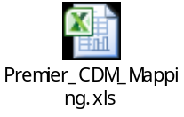

STD_CHG_CODE to SOURCE_TO_CONCEPT_MAP table

See additional files

Provider Specialty mapping table

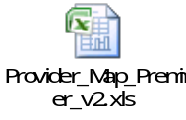

STD_CHG_CODE to HOSP_CHG_ID Mapping table

