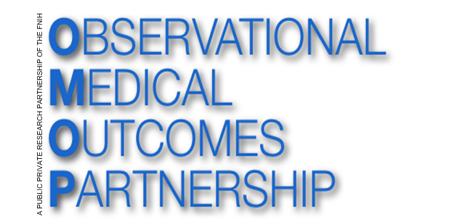
OMOP Common Data Model (CDM V5.0)
ETL Mapping Specification Premier

Version 1.0
June 2015

Rupa Makadia & Jamie Weaver

Table of Contents
1.0 Introduction 4
2.0 Source Data Mapping Approach 5
3.0 Source Data Mapping 8
3.1.1 Table Name: CDM_SOURCE 9
3.1.2 Table Name: PERSON 10
3.1.3 Table Name: VISIT_OCCURRENCE 13
3.1.4 Table Name: VISIT_COST 19
3.1.5 Table Name: OBSERVATION_PERIOD 20
3.1.6 Table Name: PAYER_PLAN_PERIOD 22
3.1.7 Table Name: DEATH 23
3.1.8 Table Name: OBSERVATION 25
3.1.9 Table Name: SPECIMEN 27
3.1.10 Table Name: MEASUREMENT 28
3.1.11 Table Name: DRUG_EXPOSURE 30
3.1.12 Table Name: DRUG_COST 33
3.1.13 Table Name: CONDITION_OCCURRENCE 35
3.1.14 Table Name: PROCEDURE_OCCURRENCE 38
3.1.15 Table Name: PROCEDURE_COST 42
3.1.16 Table Name: DEVICE_EXPOSURE 43
3.1.17 Table Name: DEVICE_COST 45
3.1.18 Table Name: NOTE 47
3.1.19 Table Name: PROVIDER 47
3.1.20 Table Name: CARE_SITE 49
3.1.21 Table Name: FACT_RELATIONSHIP 50
3.1.22 Table Name: LOCATION 50
3.1.23 Table Name: COHORT 51
3.2 Source Independent Data Mapping 52
3.2.1 Table Name: DRUG_ERA 52
3.2.2 Table Name: CONDITION_ERA 54
3.2.3 table name: DOSE_ERA 55
4.0 Appendix 56
4.1 Premier mapping to CDM fields 57
4.2 STD_CHG_CODE to SOURCE_TO_CONCEPT_MAP table 57
4.3 Provider Specialty mapping table 57
4.4 STD_CHG_CODE to HOSP_CHG_ID Mapping table 57

Introduction

This document reflects the requirements, assumptions, business rules, and transformations for the implementation of the Common Data Model Version 5.0 (CDM) as implemented by Rupa Makadia, Epidemiology Analytics, Janssen Research and Development.

The purpose of this document is to describe the ETL mapping of the proprietary or licensed data from Premier into the OMOP Common Data Model. All table references made to the source database, Premier, will be referenced in bold and italic.

Premier is a hospital based system that houses inpatient and outpatient visits from 619 hospitals with over 62 million discharges. Premier is a hospital based system that captures visits and is not a claims database. Each visit is linked to billing records. The data captures 1 in every 5 inpatient stays in the US.

The document is composed of two main sections:
- Source Data Mapping. Describes major tables of the CDM schema and special data handling required for each table.
- Source Independent Data Mapping. Describes mapping process of the drug and condition eras.

In each section, the tables and their mapping are individually reviewed along with any source-specific rules and exceptions.

The intended audience for this document is researchers wishing to use the experience and learning in their own CDM construction.

Source Data Mapping Approach

The figure below represents the general approach to mapping the source data tables that comprise Premier to the CDM data schema. Additional ancillary tables and look up tables are included in the chart. The following tables are null: ORGANIZATION and COHORT. The blue boxes represent the input tables in Premier and the green boxes represent the resulting CDM tables. For example, information in the PAT source table maps to the CDM PERSON table, the VISIT_OCCURRENCE table, , the OBSERVATION_PERIOD table, the PAYER_PLAN_PERIOD_TABLE, and the OBSERVATION_TABLE.

In addition to the high level table mapping that is represented below, a review was conducted of each source data field that is available in all of the following tables: PAT, PATBILL, PATICD, and PATCPT. The mapping at the field level and justification of why selected fields are not included is located in the appendix.

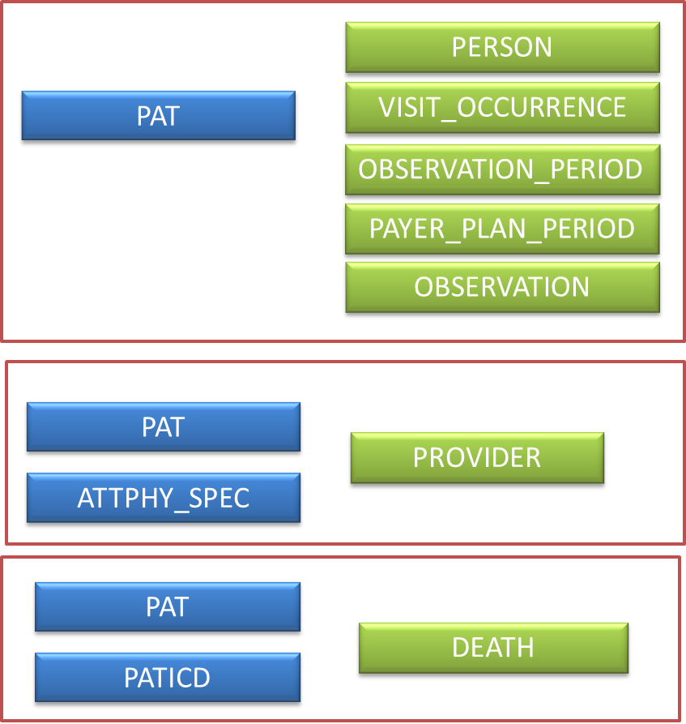

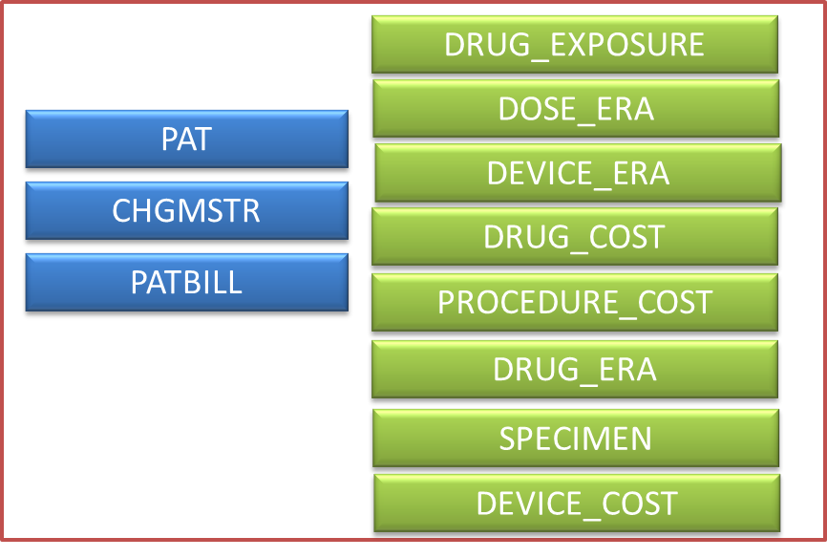

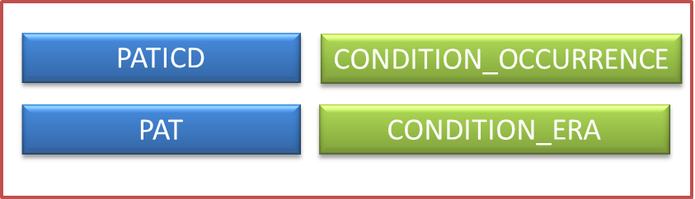

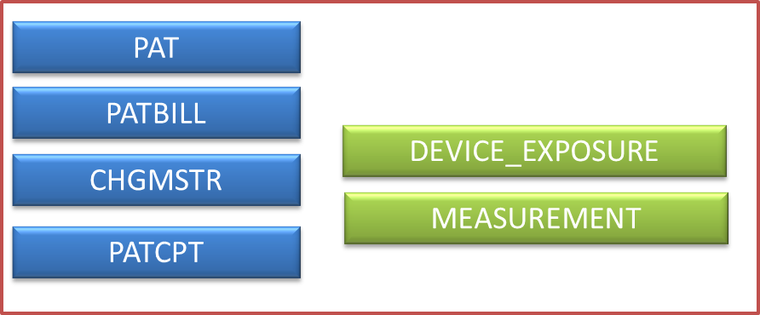

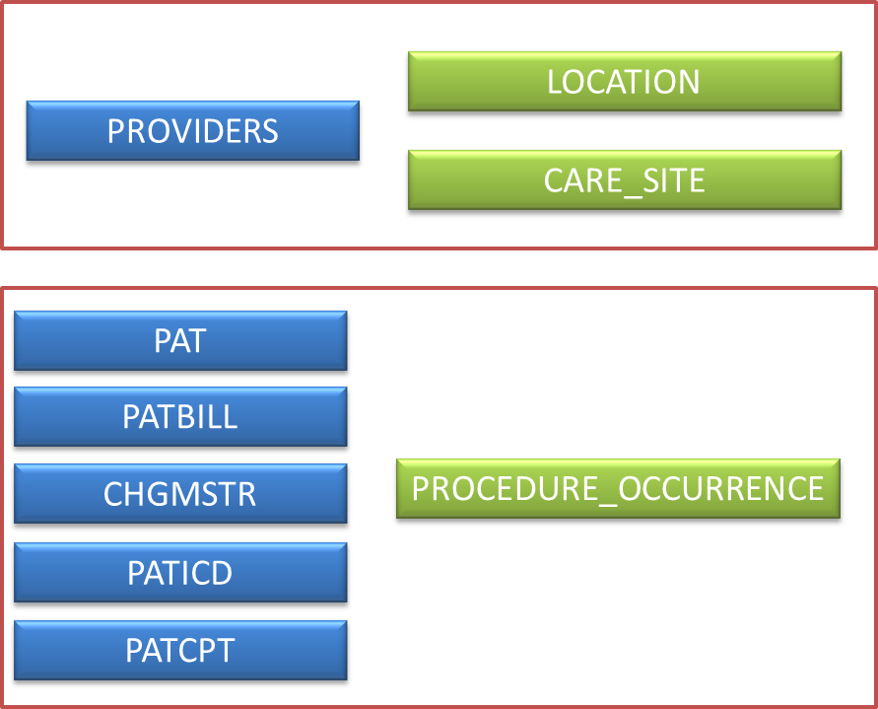

Source Data Mapping
The figure below illustrates the order in which the CDM tables are generated. The VISIT_OCCURRENCE table must generated first because procedure occurrence, device exposure, condition occurrence, and drug exposure dates are subsequently generated using visit start date. The start and end date of each visit are derived from the maximum number of service days recorded during a visit. The service days for each visit are located in PATBILL table where, for each visit, the maximum value in this field is obtained. The logic transformation for these dates is explained in the sections for each respective table.
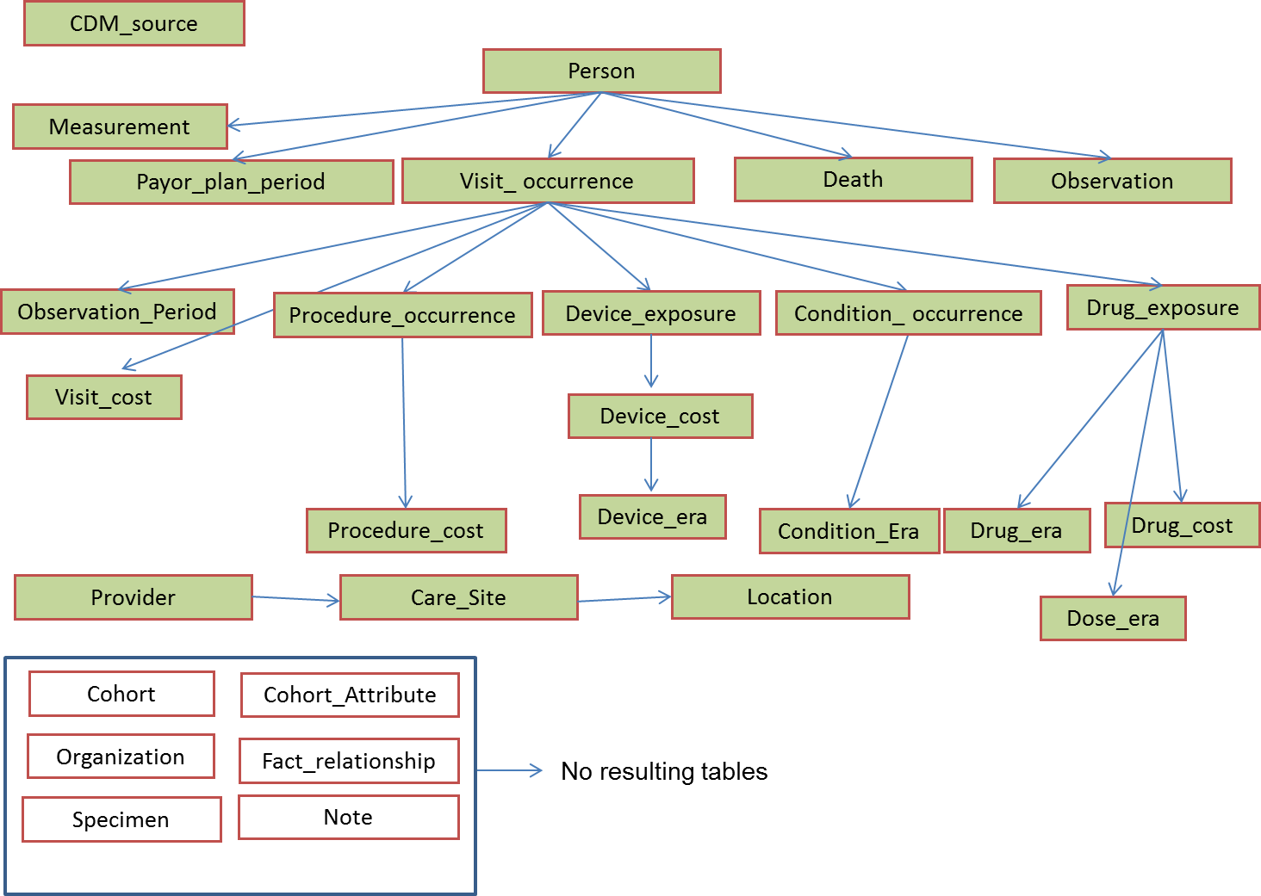

Table Name: CDM_SOURCE
Describe how the CDM_SOURCE mapping and transformations are designed.

The CDM_SOURCE table houses meta data about the version of the CDM that is populated, including key elements such as the vocabulary version used in generating the CDM.

Destination Field | Source Field | Applied Rule | Comment
CDM_SOURCE_NAME |  | Premier
CDM_SOURCE_ABBRIVIATION |  | Premier
CDM_HOLDER |  | Janssen R&D
SOURCE_DESCRIPTION |  | Anonymized hospital transactional database from over 500 hospitals from 2000-present day includes inpatient, outpatient, and emergency room visits.  The database is a visit-oriented database, with each visit having its own unique id.  Conditions are coded as ICD9 codes and procedures are coded both in ICD9, CPT, and HCPCS procedure codes. Drugs, labs, and other procedures are coded as a standard charge code and occur as a transaction.  Cost information is associated to each transaction including charges and quantity of each transaction is recorded in the billing table.
SOURCE_DOCUMENTATION_REFERENCE |  | http://hicoe.jnj.com/DataSources/Premier
CDM_ETL_REFERENCE |  | http://www.ohdsi.org/web/wiki/  doku.php?id=documentation:example_etls
SOURCE_RELEASE_DATE |  | SELECT VERSION_DATE  FROM [_Version] | Get from the raw source tables.
CDM_RELEASE_DATE |  | SELECT CONVERT(VARCHAR(10), GETDATE(),102) | Get the date the run completes.
CDM_VERSION |  | V5.0
VOCABULARY_VERSION |  | SELECT VOCABULARY_VERSION  FROM VOCABULARY  WHERE VOCABULARY_ID = 'None' | Taken from the Vocabulary loaded into the CDM.

Table Name: PERSON
Describe how the Person mapping and transformations are designed.

In Premier, the PAT table contains all demographic, admission, and total cost data for each visit. There are multiple entries per person, thus a single record needs to be created to populate the PERSON table. MONTH_OF_BIRTH and DAY_OF_BIRTH are not available in Premier, because age is the only available field. YEAR_OF_BIRTH is calculated from the first transformed admission date. The admission year minus the age results in the YEAR_OF_BIRTH. Since no address information is available in Premier for each person, LOCATION_ID is null. Primary care providers for each person are not known, thus PROVIDER_ID and CARE_SITE are NULL. Race can vary among records for the same person in the PAT table, so the most common race value is used for these people. Ethnicity is available in the race field so logic is applied to parse out the ethnicity from each record. Hispanic is the only ethnicity available in Premier so for those with ethnicity recorded as Hispanic, their race is considered ‘Other’. For populating the ETHNICITY field, if the race is Hispanic then ETHNICITY is assigned Hispanic otherwise the ethnicity is coded as NULL.
Delete any patients that have invalid birth years < 1900 or > the current year. After birth year has been determined delete any individual that has an OBSERVATION_PERIOD that is >= 2 years prior to the YEAR_OF_BIRTH. Due to data discrepancies in Premier additional logic has been applied to generating gender and age. If a person has YEAR_OF_BIRTH that varies over two years then that person is dropped. Also, if a person has multiple genders recorded then those records are dropped. The exclusion criterion for the PERSON table removes about 1% of the population in the database.
The field mapping is performed as follows:
Destination Field | Source Field | Applied Rule | Comment
PERSON_ID | PAT.MEDREC_KEY | Field is a randomly generated identifier that is available in Premier
GENDER_CONCEPT_ID | PAT.GENDER | When PAT.GENDER=M then GENDER_CONCEPT_ID=8507  When PAT.GENDER=F then GENDER_CONCEPT_ID=8532  Unknown gender mapped to 8551 | CONCEPT_ID’s are VOCABULARY_ID=Gender
YEAR_OF_BIRTH | VISIT_OCCURRENCE.VISIT_START_DATEPAT.AGE | Year(VISIT_OCCURRENCE.VISIT_START_DATE)-age  Year_of_birth needs to be > 1900 and <=current year
MONTH_OF_BIRTH | - | NULL | Premier only provides age
DAY_OF_BIRTH | - | NULL | Premier only provides age
TIME_OF_BIRTH | - | NULL | Premier only provides age
RACE_CONCEPT_ID | PAT.RACE | When PAT.RACE=1 then RACE_CONCEPT_ID=8527  When PAT.RACE=2 then RACE_CONCEPT_ID =8516  Race value of 9 and U gets mapped to 0 | Premier combines both race and ethnicity into one field. Ethnicity is removed from race. If multiple race records per person, see logic to obtain the max value of race that occurs in all records.
ETHNICITY_CONCEPT_ID | PAT.RACE | When PAT.RACE=3 then  ETHNICITY_CONCEPT_ID=38003563 else NULL | If race is not Hispanic set ethnicity to 0
LOCATION_ID | - | NULL
PROVIDER_ID | - | NULL
CARE_SITE_ID | - | NULL
PERSON_SOURCE_VALUE | PAT.MEDREC_KEY
GENDER_SOURCE_VALUE | PAT.GENDER
GENDER_SOURCE_CONCEPT_ID | - | NULL
RACE_SOURCE_VALUE | PAT.RACE
RACE_SOURCE_CONCEPT_ID | - | NULL
ETHNICITY_SOURCE_VALUE | PAT.RACE
ETHNICITY_SOURCE_CONCEPT_ID | - | NULL

Table Name: VISIT_OCCURRENCE
Describe how the Visit_Occurrence mapping and transformation are designed.

Premier data are visit oriented, thus each visit has its own unique visit identifier. The PAT table includes admission date and discharge date for each visit. Each visit is stored as a date but the day of the stay is always coded as the first of the month. Because a person can have more than one visit in the same year-month combination, an additional field is included to preserve the order of visits because the day of month is lost. The field PAT.DISC_MON_SEQ is included in Premier to preserve the order of visits based on unique discharge dates. The LOS field on the PAT table is populated for inpatient stays and is recorded as the number of 24 hour increments that a patient spends in the hospital. The LOS field is usually off by one calendar day for inpatient visits. Outpatient visits have a LOS of 0 and are typically only one day in length which is represented in the billing tables. For about 6% of outpatient visits, a single visit is comprised of multiple procedures that occur on different days for procedures such as chemotherapy or dialysis. The Premier billing system does not separate these into individual visits and for purposes of the ETL these will be considered one continuous visit. The PATBILL table houses billing records that occur each calendar day during the visit. Some visits may include a service day record of zero, which are considered to be pre-visit tests or procedures. For the purposes of the ETL, the information is considered as the first day of the visit, which can occur for inpatient and outpatient stays. The length of the stay is determined by the PAT_BILL table using the field SERV_DAY. The max service day is determined for each person. Logic is defined to take each person, visit, and sequence order and add the maximum number of service days to their stay starting with the first of the month. Each visit that occurs after the first will use the previous end date +1 as the visit start date, and then the service days are added to the start date to determine to end date. The same logic is repeated until all observations have a valid start date and end date that do not overlap. For those visits that have an admission date and discharge date in different months, the logic works backward to obtain the visit start date from the max service days and visit end date. If there are multiple visits that occur in the same admission month that span over months, the records may overlap, which affects roughly 0.10% of patients. For those records that have service days greater than the number of days in the month, the remaining days are truncated to the last day of the month. Logic guarantees that length of visits is preserved as well as the sequential order of visits. The specific day of the month in start date or end date is not necessary accurate, and the time between to two visits is not necessary accurate. The algorithm will always set the new visit start date plus 1 day or use the backward logic and assume that the visit end date is the first day of the new month.

An example for both sets of logic is displayed below:
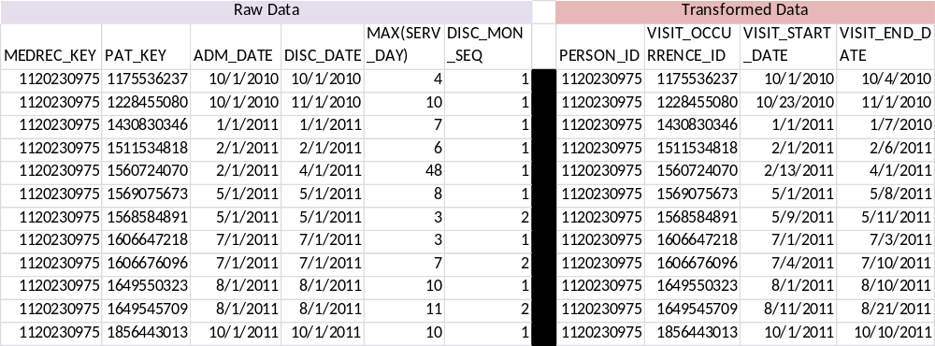

Logic for ER stays is varied due to data changes from Premier in identifying ER visits. ER Visits in Premier are identified through point of origin or admission source and those visits are identified as an outpatient stay if a person enters the ER and then leaves. If an inpatient stay results from an ER visit, that is identified as an Inpatient stay. Additional logic has been added to constrain dates and fields which reflect changes in Premier’s classification of emergency room visits. In Premier, the value of admission source that designates emergency room was discontinued 7/1/2010 because it no longer was a required variable for CMS. Point of origin represents the last physical location of a patient before entering the hospital. This field is populated in Premier after 7/1/2010 with emergency room visits. Thus, a combination of point of origin, admission source, and admission type is used to determine if a patient had a valid ER stay for Premier. LOS, the length of stay field, is not used because each billing record corresponds to a service day in the PATBILL table.

The field mapping is performed as follows:

Destination Field | Source Field | Applied Rule | Comment
VISIT_OCCURRENCE_ID | PAT.PAT_KEY
PERSON_ID | PAT.MEDREC_KEY
VISIT_CONCEPT_ID |  | When PAT.ADM_DATE <= ‘6/1/2010’ and ADM_SOURCE=7 and I_O_IND =’O’ then concept_id=9203  When PAT.ADM_DATE >= ‘7/1/2010’ and (POINT_OF_ORIGIN=7 or ADM_SOURCE =1) and I_O_IND =’O’ then concept_id=9203  When I_O_IND =’I’ then concept_id=9201  When I_O_IND =’O’ then concept_id=9202 | Logic is in the following order:  Patient enters through the ER but doesn’t result in an inpatient stay will be identified as an ER visit.  Patients who may have entered through the ER but get admitted will be identified as an Inpatient visit.
VISIT_START_DATE | PAT.ADM_DATE  PATBILL.SERV_DAY  PAT.DISC_MON_SEQ | See logic in code and explanation above
VISIT_START_TIME | - | NULL
VISIT_END_DATE | PAT.DISC_DATE  PATBILL.SERV_DAY  PAT.DISC_MON_SEQ | See logic in code and explanation above
VISIT_END_TIME | - | NULL
VISIT_TYPE_CONCEPT_ID |  | 44818517- Visit derived from encounter on claim
PROVIDER_ID | PAT.ADM_PHY
CARE_SITE_ID | PAT.PROV_ID
VISIT_SOURCE_VALUE | PAT.I_O_IND
VISIT_SOURCE_CONCEPT_ID | - | NULL

SAMPLE CODE: T-SQL logic

--sort table by adm_date and dis_mon_seq, make sure to pick up max_serv_day
DECLARE visit_cursor CURSOR FOR
select pat.pat_key as id,
pat.medrec_key as person_id,
pat.adm_date as StartDate,
pat.disc_date as EndDate,
pat.disc_mon_seq,
case when max(patbill.serv_day)=0 then 1 else max(patbill.serv_day)
end as max_serv_day
from pat
inner join patbill
on pat.pat_key = patbill.pat_key
where pat.medrec_key in {0}
group by pat.patkey, pat.medrec_key, pat.adm_date, pat.disc_date, pat.dis_mon_seq
order by pat.disc_date asc, pat.dis_mon_seq asc
;

--create temp variables for cursoring

DECLARE @lastenddate date
DECLARE @laststartdate date
DECLARE @lastendmonth date
DECLARE @currentid int
DECLARE @oldpersonid int
DECLARE @currentpersonid int
DECLARE @currentstartdate date
DECLARE @currentenddate date
DECLARE @currentdismonseq int
DECLARE @currentmaxservday int

SET @laststartdate = '1/1/1900'
SET @lastenddate = '1/1/1900'
SET @lastendmonth = '1/1/1900'
SET @oldpersonid=0

OPEN visit_cursor

FETCH NEXT FROM visit_cursor INTO @currentid, @currentpersonid, @currentstartdate, @currentenddate, @currentdismonseq, @currentmaxservday

WHILE @@FETCH_STATUS = 0

BEGIN
IF @oldpersonid <> @currentpersonid
BEGIN

SET @laststartdate = '1/1/1900'
SET @lastenddate = '1/1/1900'
SET @lastendmonth = '1/1/1900'

set @oldpersonid=@currentpersonid

END

IF @currentstartdate = @currentenddate

BEGIN
IF @lastendmonth < @currentstartdate --should only fire on first record or when dis_mon_seq = 1
BEGIN

SET @currentenddate = case when dateadd(dd,@currentmaxservday,@currentstartdate) < dateadd(mm,1,@currentstartdate)
then dateadd(dd,@currentmaxservday-1,@currentstartdate) --if endate falls in month, use it
else dateadd(dd,-1, dateadd(mm,1,@currentstartdate)) --otherwise, set to last day of the month
end
SET @laststartdate = @currentstartdate
SET @lastendmonth = @currentstartdate
SET @lastenddate = @currentenddate

END

ELSE --IF @lastendmonth = @currentstartdate
BEGIN

SET @currentstartdate = dateadd(dd, case when @lastenddate < dateadd(dd,-1,dateadd(mm,1,@lastendmonth)) then 1 else 0 end , @lastenddate) --increment prior visit by 1 unless you're already at the end of the month
SET @currentenddate = case when dateadd(dd,@currentmaxservday,@lastenddate) < dateadd(dd,-1,dateadd(mm,1,@lastendmonth))
then dateadd(dd,@currentmaxservday,@lastenddate)
else dateadd(dd,-1,dateadd(mm,1,@lastendmonth)) end
--use prior visit + 1 and add the maxsrvdate, unless either date exceeds the end of the month, or else just use the end of te month
SET @laststartdate = @currentstartdate
SET @lastenddate = @currentenddate

END

END
ELSE --startdate <> enddate, which means the visit spans across months
BEGIN
IF @lastendmonth = @currentstartdate
BEGIN
SET @currentstartdate = case when datediff(dd, dateadd(dd, case when @lastenddate < dateadd(dd,-1,dateadd(mm,1,@lastendmonth)) then 1 else 0 end , @lastenddate) ,@currentenddate) > @currentmaxservday
then dateadd(dd, -1*(@currentmaxservday-1), @currentenddate)
else dateadd(dd, 1, @lastenddate)
end

SET @lastendmonth = @currentenddate

SET @currentenddate = case when dateadd(dd,@currentmaxservday-1,@currentstartdate) < DATEADD(mm,1,@currentenddate)

then dateadd(dd,@currentmaxservday-1,@currentstartdate)
else dateadd(dd,-1,DATEADD(mm,1,@currentenddate))
end

SET @lastenddate = @currentenddate

END
ELSE --@lastendmonth < @currentstartdate --if the visit spanning months is the first visit in the month, start it on first day of adm month and let it go through into the disc month
BEGIN
SET @lastendmonth = @currentenddate
SET @currentstartdate =DATEADD(dd,-1*(@currentmaxservday-1), @currentenddate)
SET @lastenddate = @currentenddate

END

END

INSERT INTO scratch.dbo.VISIT_OCCURRENCE (VISIT_OCCURRENCE_ID, PERSON_ID, VISIT_START_DATE, VISIT_END_DATE)
VALUES (@currentid, @currentpersonid, @currentstartdate, @currentenddate)

FETCH NEXT FROM visit_cursor INTO @currentid, @currentpersonid, @currentstartdate, @currentenddate, @currentdismonseq, @currentmaxservday

END

CLOSE visit_cursor
DEALLOCATE visit_cursor

Adding mapping logic for PLACE_OF_SERVICE and PROVIDER

select
visit_occurance_id,
person_id,
visit_start_date,
visit_end_Date,
case when adm_date <= '06/01/2010' and pat.adm_source='7' and pat.i_o_ind='O' then 9203
when adm_date >= '07/01/2010' and (pat.point_of_origin='7' OR pat.adm_source='1') and pat.i_o_ind='O' then 9203
when pat.i_o_ind='I' then 9201
when pat.i_o_ind='O' then 9202
end as place_of_service_concept_id,
PAT.PROV_ID AS care_Site_id,
PAT.i_o_ind as place_of_service_source_value
from visit_occurrence
join pat on visit_occurrence.visit_occurrence_id=pat.pat_key

Table Name: VISIT_COST
Describe how the VISIT_COST mapping and transformation are designed.

Premier provides the total cost that is associated with each visit. The VISIT_COST table will house the total charge amount of the visit which includes costs from drugs, procedures, and devices including unmapped charges that are incurred during the stay. A patient can only have a single cost record for each visit.

Destination Field | Source Field | Applied Rule | Comment
VISIT_COST_ID | - | System generated
VISIT_OCCURRENCE_ID | PAT.PAT_KEY | -
CURRENCY_CONCEPT_ID | - | 44818668- American dollar - | USD
PAID_COPAY | - | -
PAID_COINSURANCE | - | -
PAID_TOWARD_DEDUCTIABLE | - | -
PAID_BY_PAYER | - | -
PAID_BY_COORDINATION_OF_BENEFITS | - | -
TOTAL_OUT_OF_POCKET | - | -
TOTAL_PAID | PAT.PAT_CHARGES | - | The total charge amount of the visit
PAYER_PLAN_PERIOD_ID | PAYOR_PLAN_PERIOD.PAYER_PLAN_PERIOD_ID | Use PAYER_PLAN_PERIOD table and join by person. Include filtering to assure that the visit start date falls within the payer start date and payer end date

Table Name: OBSERVATION_PERIOD
Describe how the Observation_Period mapping and transformation are designed.

Because of the lack of enrollment data in Premier, the observation period for each patient will be defined by unique visits from the VISIT_OCCURRENCE table for each unique patient. Derived admission and discharge dates are created using the number of service days and the sequence of visits as defined by the field PAT.DISC_MON_SEQ if the visits occurred twice in the same discharge month/year. (See VISIT_OCCURRENCE specification).

All overlapping visits will be collapsed into one observation period. An overlapping visit is defined by a visit that has an admit date that is within 31 days of the previous discharge date. For example a patient has an admission date of ‘2011-02-01’ and a discharge date of ‘2011-02-05’ and the next visit occurs in ‘2011-02-19’ and a discharge date of ‘2011-03-01’. These records would be collapsed into a single observation period.

The field mapping is as follows:

Destination Field | Source Field | Applied Rule | Comment
OBSERVATION_PERIOD_ID | - | System generated
PERSON_ID | PAT.MEDREC_KEY
OBSERVATION_PERIOD_START_DATE | VISIT_OCCURRENCE.VISIT_START_DATE
OBSERVATION_PERIOD_END_DATE | VISIT_OCCURRENCE.VISIT_END_DATE
PERIOD_TYPE_CONCEPT_ID | - | 44814725= Period inferred by algorithm

Table Name: PAYER_PLAN_PERIOD
Describe how the PAYER_PLAN_PERIOD mapping and transformation are designed.

Payer information presented in Premier exists in the PAT table, in the field PAT.STD_PAYOR, which represents standard payer categories. Since information about how long the patient remains with a payer or is enrolled is unavailable, the PAYER_PLAN_PERIOD_START_DATE and PAYER_PLAN_PERIOD_END_DATE are the same as the calculated OBSERVATION_PERIOD for each patient. If a patient changes payer within an observation period, then the payer plan period will be segmented to reflect the change in payers. If multiple payers are attributed to one observation period, use visit start and visit end to determine the payer.

The field mapping is as follows:

Destination Field | Source Field | Applied Rule | Comment
PAYER_PLAN_PERIOD_ID | - | System- generated value
PERSON_ID | PAT.MEDREC_KEY
PAYER_PLAN_PERIOD_START_DATE | OBSERVATION_PERIOD.OBSERVATION_PERIOD_START_DATE
PAYER_PLAN_PERIOD_END_DATE | OBSERVATION_PERIOD.OBSERVATION_PERIOD_START_DATE
PAYER_SOURCE_VALUE | PAYOR.STD_PAYER_DESC
PLAN_SOURCE_VALUE | - | NULL
FAMILY_SOURCE_VALUE | - | NULL

An example is represented below:

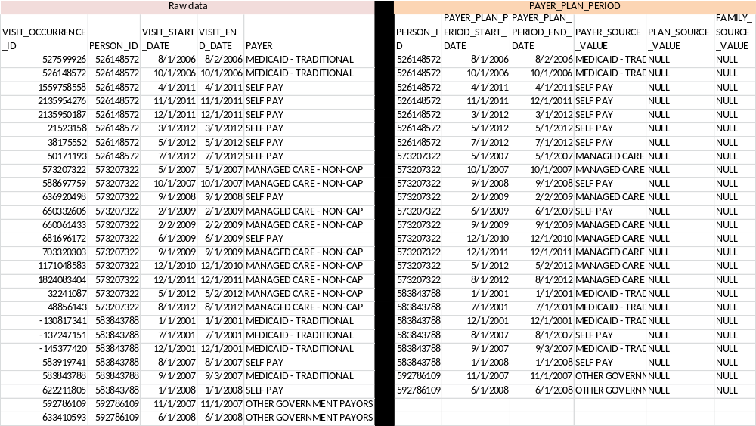

Table Name: DEATH
Describe how the DEATH mapping and transformation are designed.

Death is mapped from discharge status and ICD9 codes. The cause of death is not available in Premier. Discharge status from the PAT table should be used first, and if no codes are found, then ICD9 codes are used. The ICD9 codes are obtained from the vocabulary and identified in the code below. Keep only one record for each patient, if both discharge status and ICD9 codes indicate death, use discharge status first. No records should be populated for that person 32 days after the death date. The ICD9 diagnosis codes that indicate that a patient has died are:

Maternal death affecting fetus or newborn | 761.6
Accidental mechanical suffocation by plastic bag | E913.1
Sudden infant death syndrome | 798.0
Death occurring in less than 24 hours from onset of symptoms, not otherwise explained | 798.2
Unattended death | 798.9
Instantaneous death | 798.1
Sudden death, cause unknown | 798
Legal execution | E978

The field mapping is as follows:

Destination Field | Source Field | Applied Rule | Comment
PERSON_ID | PAT.MEDREC_KEY
DEATH_DATE | VISIT_OCCURRENCE.VISIT_END_DATE |  | The exact date of death cannot be determined thus the VISIT_END date is used.
DEATH_TYPE_CONCEPT_ID | PAT.DISC_STATUS  OR  PATICD.ICD_CODE | Logic based on discharge status or ICD9 diagnosis code. If discharge code is present then assign death, otherwise search records for ICD9 codes Discharge status of 20, 40, 41, 42 indicates death.
CAUSE_CONCEPT_ID | - | NULL
CAUSE_SOURCE_VALUE | - | NULL
CAUSE_SOURCE_CONCEPT_ID | - | NULL

Table Name: OBSERVATION
Describe how the Observation mapping and transformation are designed.

The observation table houses additional demographic and visit data that is housed in Premier. DRG codes and certain ICD9, CPT, and standard charge codes map to standardized observation table concept. Marital status, admission information, discharge status, and patient type records are specific to Premier and map to non-standard observation table concepts.

PAT.DRG, PATICD.ICD_CODE, PATCPT.CPT_CODE, and PATBILL.STD_CHG_CODE map to OBSERVATION.OBSERVATION_CONCEPT_ID using the source to standard cte_vocab_map. These records also map to OBSERVATION.OBSERVATION_SOURCE_CONCEPT_ID using the source to source cte_vocab_map.

Note: DRG codes contain 3 digits, including those codes with leading zeros (i.e. 00# and 0##). These leading zeros are missing in Premier data and must be added in the ETL process for accurate mapping using the source to standard cte_vocab_map.

PAT.MART_STATUS, PAT.POINT_OF_ORIGIN, PAT.DISC_STATUS, and PAT.PATTYPE map to set OBSERVATION_CONCEPT_ID codes described in the table below and OBSERVATION_SOURCE_CONCEPT_ID=0.

The observation start date is assigned the VISIT_START_DATE. The ASSOCIATED_PROVIDER_ID that is provided is the randomly generated key provided by Premier for the provider that admitted the patient. There are two providers that exist in Premier, the admitting and attending. This ETL makes the decision to use admitting because it is unknown whether or not the admitting provider, attending provider or another person diagnosed the person.

The field mapping is performed as follows:

Destination Field | Source Field | Applied Rule | Comment
OBSERVATION_ID | - | System-generated
PERSON_ID | PAT.MEDREC_KEY
OBSERVATION_CONCEPT_ID |  | For PAT.DRG, PATICD.ICD_CODE, PATCPT.CPT_CODE, and PATBILL.STD_CHG_CODE:  QUERY: SOURCE TO STANDARD  SELECT TARGET_CONCEPT_ID  FROM CTE_VOCAB_MAP  WHERE SOURCE_VOCABULARY_ID IN ('HCPCS', 'CPT4', 'ICD9CM', 'DRG')  AND TARGET_DOMAIN_ID ='Observation'  For PAT.MART_STATUS, OBSERVATION_CONCEPT_ID=4053609  For PAT.POINT_OF_ORIGIN, OBSERVATION_CONCEPT_ID=40757183  For PAT.DISC_STATUS, OBSERVATION_CONCEPT_ID= 40757177  For PAT.PATTYPE, OBSERVATION_CONCEPT_ID= 40769091
OBSERVATION_DATE | VISIT_OCCURRENCE.VISIT_START_DATE | NULL
OBSERVATION_TIME | - | NULL
OBSERVATION_TYPE_CONCEPT_ID | - | 38000281 Observation recorded from EHR with text result
VALUE_AS_NUMBER | - | NULL
VALUE_AS_STRING | PAT.MART_STATUS  PAT.POINT_OF_ORIGIN  PAT.DISC_STATUS  PAT.PATTYPE | Value_as_string only populated for Premier-specific fields mart_status, point_of_origin, disc_status, and pat_type  select mart_status_desc from martstat m  join pat p on p.mart_status=m.martstat  select point_of_origin_desc from poorgin po  join pat p on p.mart_status=po.point_of_origin  select disc_status from poorgin po  join pat p on p.mart_status=po.point_of_origin  select pat_type_desc from pattype p  join pat p1 on p1.pat_type=p.pat_type | Use look up values in the text fields.
VALUE_AS_CONCEPT_ID | - | NULL
QUALIFER_CONCEPT_ID | - | NULL
UNIT_CONCEPT_ID | - | NULL
PROVIDER_CONCEPT_ID | PAT.ADMPHY
VISIT_OCCURRENCE_ID | PAT.PAT_KEY
OBSERVATION_SOURCE_VALUE | PAT.DRG  PATICD.ICD_CODE  PATCPT.CPT_CODE  CHARGE CODE | Standard charge code value:  SELECT CONCAT(STD_CHG_DESC, ' / ', HOSP_CHG_DESC) AS SOURCE_VALUE FROM PATBILL A  JOIN CHGMSTR B ON A.STD_CHG_CODE=B.STD_CHG_CODE  JOIN hospchg C ON A.hosp_chg_id=C.hosp_chg_id
OBSERVATION_SOURCE_CONCEPT_ID | - | QUERY: SOURCE TO SOURCE  SELECT SOURCE_CONCEPT_ID  FROM CTE_VOCAB_MAP  WHERE SOURCE_VOCABULARY_ID IN ('ICD9CM', 'CPT4', 'HCPCS', ‘DRG’)  AND TARGET_VOCABULARY_ID IN ('ICD9CM', 'CPT4', 'HCPCS', ‘DRG’) and TARGET_DOMAIN_ID='Observation'
UNITS_SOURCE_VALUE | - | NULL
QUALIFIER_SOURCE_VALUE | - | NULL

Table Name: SPECIMEN
Describe how the Specimen mapping and transformation are designed.

Premier does not provide information for specimen’s collected during a person’s stay.

Destination Field | Source Field | Applied Rule | Comment
SPECIMEN_ID | - | NULL
PERSON_ID | - | NULL
SPECIMEN_CONCEPT_ID | - | NULL
SPECIMEN_TYPE_CONCEPT_ID | - | NULL
SPECIMEN_DATE | - | NULL
SPECIMEN_TIME | - | NULL
QUANTITY | - | NULL
UNIT_CONCEPT_ID | - | NULL
ANATOMIC_SITE_CONCEPT_ID | - | NULL
DISEASE_STATUS_CONCEPT_ID | - | NULL
SPECIMEN_SOURCE_ID | - | NULL
SPECIMEN_SOURCE_VALUE | - | NULL
UNIT_SOURCE_VALUE | - | NULL
ANATOMIC_SITE_SOURCE_VALUE | - | NULL
DISEASE_STATUS_SOURCE_VALUE | - | NULL

Table Name: MEASUREMENT
Describe how the Measurement mapping and transformation are designed.

The MEASUREMENT table will house records from PATBILL and PATCPT that have been mapped to the measurement domain.

Measurements are recorded in the PATBILL table as standard charges. Premier captures the day the measurement is made in the SERV_DAY field thus, the MEASUREMENT_DATE is determined from the VISIT_START_DATE from VISIT_OCCURRENCE and PATBILL.SERV_DAY unless the start date is greater than the end of the month, then it’s truncated to the end of month. For measurements recorded in the PATCPT table, the day the measurement was made is unknown so MEASUREMENT_DATE is recorded as VISIT_END_DATE. There are two providers that exist in Premier, the admitting and attending. This ETL makes the decision to use admitting because it is unknown whether or not the admitting provider, attending provider or another person diagnosed the person. Only records that fall within an OBSERVATION_PERIOD are available for each person. The VISIT_OCCURRENCE table must be created before the MEASUREMENT table is created.
The field mapping is performed as follows:

Destination Field | Source Field | Applied Rule | Comment
MEASUREMENT_ID | - | System generated
PERSON_ID | PAT.MEDREC_KEY
MEASUREMENT_CONCEPT_ID |  | QUERY: SOURCE TO STANDARD  SELECT TARGET_CONCEPT_ID  FROM CTE_VOCAB_MAP  WHERE SOURCE_VOCABULARY_ID IN ('JNJ_PMR_PROC_CHRG_CD', 'HCPCS', 'CPT4')  AND TARGET_DOMAIN_ID ='Measurement' | Only capture those records that have a domain map to Measurement.
MEASUREMENT_DATE | VISIT_OCCURRENCE.VISIT_START_DATE  PATBILL.SERV_DAY  Or  VISIT_OCCURRENCE.VISIT_END_DATE |  | If measurement is from PATBILL use a combination of service day and visit start date unless the service day is greater than the end of the month  If measurement comes from PATCPT then use visit end date
MEASUREMENT_TIME | - | NULL
MEASUREMENT_TYPE_CONCEPT_ID | - | 44818701-From physical examination
OPERATOR_CONCEPT_ID | - | NULL
VALUE_AS_NUMBER | - | NULL
VALUE_AS_CONCEPT_ID | - | NULL
UNIT_CONCEPT_ID | - | NULL
RANGE_LOW | - | NULL
RANGE_HIGH | - | NULL
PROVIDER_ID | PAT.ADMPHY
VISIT_OCCURRENCE_ID | PAT.PAT_KEY
MEASUREMENT_SOURCE_VALUE |  | SELECT SOURCE_VALUE FROM  (  SELECT CONCAT(STD_CHG_DESC, ' / ', HOSP_CHG_DESC) AS SOURCE_VALUE FROM PATBILL A  JOIN CHGMSTR B ON A.STD_CHG_CODE=B.STD_CHG_CODE  JOIN hospchg C ON A.hosp_chg_id=C.hosp_chg_id  ) A  UNION  (  SELECT CPT_CODE AS SOURCE_VALUE FROM PATCPT  )
MEASUREMENT_SOURCE_CONCEPT_ID | - | QUERY: SOURCE TO SOURCE  SELECT SOURCE_CONCEPT_ID  FROM CTE_VOCAB_MAP  WHERE SOURCE_VOCABULARY_ID IN ('CPT4', 'HCPCS')  AND TARGET_VOCABULARY_ID IN ('CPT4', 'HCPCS') AND DOMAIN_ID=’Measurement’ | Only populated for standard coding CPT4, and HCPCS codes
UNIT_SOURCE_VALUE | - | NULL
VALUE_SOURCE_VALUE | - | NULL

Table Name: DRUG_EXPOSURE
Describe how the Drug_Exposure mapping and transformation are designed.

The DRUG_EXPOSURE table will house records from PATBILL, PATCPT, and PATICD that have been mapped to the drug or metadata domain.

Administrations of drugs are recorded in the PATBILL table as standard charges. Premier captures the day of administration in the SERV_DAY field. DRUG_EXPOSURE_START_DATE is determined by adding the number of service days to the visit start day using VISIT_OCCURRENCE .VISIT_START_DATE and PATBILL.SERV_DAY. If the start date is greater than the end of the month, then it’s truncated to the end of month. Procedure drugs reside in the PATCPT table, and PATICD table. DRUG_EXPOSURE_START_DATE for procedures is the last day of visit or VISIT_END_DATE, since dates for the administration of procedure drugs is not recorded, the assumption is made that the procedure occurred sometime before the end of the visit. DRUG_EXPOSURE_END_DATE cannot be determined because the patient is not followed after each stay and days’ supply information is not available.

Premier does not provide NDC codes for drugs that are administered during a visit. The PRESCRIBING_PROVIDER_ID is determined from the visit using the admitting provider id of the visit. In Premier the admitting and attending providers are provided and due to the similarity of both the fields, the admitting provider id is used. The determination cannot be made if the admitting provider was the provider that prescribed the medication but that is the only information that is available. Drug type is considered inpatient administration for all drugs, except those drugs that are procedures and come from PATCPT or PATICD. Both HCPCS codes and CPT codes are available in PATCPT. The quantity of drugs administered as captured from the QTY field in PATBILL.
Each standard charge from PATBILL maps to the CHGMSTR table that houses additional information regarded the department, and descriptions about the item. In order to map each drug to an appropriate concept, USAGI was used to map STD_CHG_DESC to the value of an RxNorm concept. The CHGMSTR table is segmented by the department STD_DEPT_DESC. The drug records represented in this table are captured from the Pharmacy department. Any mapping that cannot be correctly identified is mapped to a CONCEPT_ID of zero. All drugs will be mapped and included in this table even if they don’t have a valid concept. All charges are loaded into the SOURCE_TO_CONCEPT_MAP table, and the table is attached in the appendix. The STD_CHG_CODE is mapped to a HOSP_CHG using the table HOSPCHG, and each HOSP_CHG has a description that is displayed in the CDM as the source value.
Only records that fall within an OBSERVATION_PERIOD are available for each person. The VISIT_OCCURRENCE table must be created before the DRUG_EXPOSURE table is created.
The field mapping is performed as follows:

Destination Field | Source Field | Applied Rule | Comment
DRUG_EXPOSURE_ID | - | System generated
PERSON_ID | PAT.MEDREC_KEY
DRUG_CONCEPT_ID |  | QUERY: SOURCE TO STANDARD  SELECT TARGET_CONCEPT_ID  FROM CTE_VOCAB_MAP  WHERE SOURCE_VOCABULARY_ID IN ('JNJ_PMR_DRUG_CHRG_CD', 'CPT4', 'HCPCS', 'ICD9CM')  AND TARGET_DOMAIN_ID in ('Drug', 'Metadata') | Include all concepts that map to a concept id of zero.
DRUG_EXPOSURE_START_DATE | PATBILL.SERV_DAY  VISIT_OCCURRENCE.VISIT_START_DATE  Or  VISIT_OCCURRENCE.VISIT_END_DATE | If drug is from PATBILL use a combination of service day and visit start date unless the service day is greater than the end of the month  If drug comes from PATCPT or PATICD then use visit end date
DRUG_EXPOSURE_END_DATE | - | NULL
DRUG_TYPE_CONCEPT_ID |  | 38000180- Inpatient administration
STOP_REASON | - | NULL
REFILLS | - | NULL
QUANTITY | PATBILL.STD_QTY |  | Value is applied only to records that come from PATBILL, else records from PATCPT or PATICD are NULL
DAYS_SUPPLY | - | NULL
SIG | - | NULL
ROUTE_CONCEPT_ID | - | NULL
EFFECTIVE_DRUG_DOSE | - | NULL
DOSE_UNIT_CONCEPT_ID | - | NULL
LOT_NUMBER | - | NULL
PROVIDER_ID | PAT.ADMPHY | NULL
VISIT_OCCURRENCE_ID | PAT.PAT_KEY
DRUG_SOURCE_VALUE |  | SELECT SOURCE_VALUE FROM  (  SELECT CONCAT(STD_CHG_DESC, ' / ', HOSP_CHG_DESC) AS SOURCE_VALUE FROM PATBILL A  JOIN CHGMSTR B ON A.STD_CHG_CODE=B.STD_CHG_CODE  JOIN hospchg C ON A.hosp_chg_id=C.hosp_chg_id  ) A
DRUG_SOURCE_CONCEPT_ID | - | NULL
ROUTE_SOURCE_VALUE | - | NULL
DOSE_UNIT_SOURCE_VALUE | - | NULL

Table Name: DRUG_COST
Describe how the DRUG_COST mapping and transformation are designed.

Cost in Premier is captured in the PATBILL table. Each STD_CHG_CODE has an associated cost, which is represented as the total paid in BILL_CHARGES. Additional cost variables in Premier that represent fixed and variable costs are available but not used to populate the CDM. Copays, and amounts paid by the payer are not included in Premier. Drugs that come from the PATBILL table will have costs attributed to them, drugs that come from PATICD or PATCPT will not have a cost represented. Using the mapping from standard charge codes to drugs will identify total drug costs. In Premier each visit is associated with a standard payer, and the PAYER_PLAN_PERIOD_ID is populated for each cost record. The DRUG_EXPOSURE_START_DATE must be between the PAYER_PLAN_PERIOD_START_DATE and PAYER_PLAN_PERIOD_END_DATE to ensure only one standard payer is populated per record.

Only drug costs that are not procedure drugs will be included as in the DRUG_COST table, all procedure drugs are included in the PROCEDURE_COST table.

The field mapping is as follows:

Destination Field | Source Field | Applied Rule | Comment
DRUG_COST_ID | - | Same as drug_exposure_id
DRUG_EXPOSURE_ID | - | Same as drug_exposure_id
CURRENCY_CONCEPT_ID | - | 44818668- American dollar
PAID_COPAY | - | NULL
PAID_COINSURANCE | - | NULL
PAID_TOWARD_DEDUCTIBLE | - | NULL
PAID_BY_PAYER | - | NULL
PAID_BY_COORDINATION_BENEFITS | - | NULL
TOTAL_OUT_OF_POCKET | - | NULL
TOTAL_PAID | PATBILL.BILL_CHARGES | SELECT BILL_CHARGES FROM  (  SELECT CONCAT(STD_CHG_DESC, ' / ', HOSP_CHG_DESC) AS SOURCE_VALUE, BILL_CHARGES FROM PATBILL A  JOIN CHGMSTR B ON A.STD_CHG_CODE=B.STD_CHG_CODE  JOIN hospchg C ON A.hosp_chg_id=C.hosp_chg_id  ) A | Use mapping table to map standard charges to drugs
INGREDIENT_COST | - | NULL
DISPENSING_FEE | - | NULL
AVERAGE_WHOLESALE_PRICE | - | NULL
PAYER_PLAN_PERIOD_ID | PAYOR_PLAN_PERIOD.PAYER_PLAN_PERIOD_ID | Use PAYER_PLAN_PERIOD table and join by person. Include filtering to assure that the visit start date falls within the payer start date and payer end date

Table Name: CONDITION_OCCURRENCE
Describe how the Condition_Occurrence mapping and transformation are designed.

The CONDITION_OCCURRENCE table will house records from PATICD that have been mapped to the condition domain and SNOMED vocabulary.

The conditions in Premier are stored in PATICD. The table houses admitting, primary and secondary diagnosis by visit. Procedure codes and diagnosis codes are stored in the same table. By using the mapping table, ICDCODE, the diagnosis codes can be separated. The CDM transformation captures all 3 types of diagnoses. In many cases patients will have the same admitting and primary diagnosis. The condition start date is determined as the visit start date from the VISIT_OCCURRENCE table. The exact day of diagnosis is not recorded in Premier, thus the assumption is made that the diagnosis is made on the VISIT_START_DATE. The CONDITION_END_DATE is null because in Premier we are unaware of when the condition is no longer relevant to the patient. The ASSOCIATED_PROVIDER_ID that is provided is the randomly generated key provided by Premier for the provider that admitted the patient. There are two providers that exist in Premier, the admitting and attending. This ETL makes the decision to use admitting because it is unknown whether or not the admitting provider, attending provider or another person diagnosed the person.

The field mapping is performed as follows:
Destination Field | Source Field | Applied Rule | Comment
CONDITION_OCCURRENCE_ID | - | System-generated
PERSON_ID | PAT.MEDREC_KEY
CONDITION_CONCEPT_ID | PATICD.ICD_CODE | QUERY: SOURCE TO STANDARD  SELECT TARGET_CONCEPT_ID  FROM CTE_VOCAB_MAP  WHERE SOURCE_VOCABULARY_ID IN ('ICD9CM')  AND TARGET_VOCABUALRY_ID IN ('SNOMED')  and TARGET_DOMAIN_ID = 'Condition' | ICD9 diagnosis codes are mapped to SNOMED concepts
CONDITION_START_DATE | VISIT_OCCURRENCE.VISIT_START_DATE
CONDITION_END_DATE | - | NULL
CONDITION_TYPE_CONCEPT_ID | - | when PAT.I_O_IND =’I’ and ICD.PRI_SEC =’P’ then 38000183  when PAT.I_O_IND=’I’ and ICD.PRI_SEC =’S’ then 38000185  when PAT.I_O_IND=’O’ and ICD.PRI_SEC =’P’ then 38000215  when PAT.I_O_IND=’O’ and ICD.PRI_SEC =’S’ then 38000216  when PAT.I_O_IND in (’I’ , “O”) and ICD.PRI_SEC =’A’ then 4203942
STOP_REASON | - | NULL
PROVIDER_ID | PAT.ADMPHY | NULL
VISIT_OCCURRENCE_ID | PAT.PAT_KEY
CONDITION_SOURCE_VALUE | PATICD.ICD_CODE
CONDITION_SOURCE_CONCEPT_ID |  | QUERY: SOURCE TO SOURCE  SELECT SOURCE_CONCEPT_ID  FROM CTE_VOCAB_MAP  WHERE SOURCE_VOCABULARY_ID IN ('ICD9CM')  AND TARGET_VOCABULARY_ID IN ('ICD9CM') AND DOMAIN_ID=’CONDITION’

Table Name: PROCEDURE_OCCURRENCE
Describe how the Procedure_Occurrence mapping and transformation are designed.

The PROCEDURE_OCCURRENCE table will house records from PATBILL, PATCPT, and PATICD. Procedure records from PATBILL are mapped to the procedure domain; procedure records from PATCPT and procedure records from PATICD (i.e. Vocabulary_id=’ICD9Proc’) are mapped to the SNOMED vocabulary.

The PATBILL table holds all charges that were consumed within a visit. For the purpose of our CDM, the drugs are separated and inserted into the DRUG_EXPOSURE table, and all other billing records are entered into the PROCEDURE_OCCURRENCE table. For records that are obtained through PATBILL, the start date is determined from the service day in PATBILL and VISIT_START_DATE. If the combination of start date and service day records result in a date greater than the end of the month, the VISIT_END_DATE is assigned.

PATCPT houses the HCPCS and CPT codes by visit, and it is unknown when the procedure was performed. PATICD holds both diagnosis codes and procedure codes. The mapping table ICDCODE identifies the two different code types. Procedure drugs are recorded as procedure drugs and move to the DRUG_EXPOSURE table. The procedure start date is identified as the VISIT_END_DATE from VISIT_OCCURRENCE. Procedure type is determined by the indicator of whether or not it was an inpatient stay or outpatient stay. The ASSOCIATED_PROVIDER_ID that is provided is the randomly generated key provided by Premier for the provider that admitted the patient. There are two providers that exist in Premier, the admitting and attending. This ETL makes the decision to use admitting because it is unknown whether or not the admitting provider, attending provider or another person diagnosed the person.

In order to map each drug to an appropriate concept, USAGI was used on the STD_CHG_DESC to map the value to a concept; all concepts that map into the procedure domain are included in this table. The STD_CHG_CODE is mapped to a HOSP_CHG using HOSPCHG, and each HOSP_CHG has a description that is displayed in the CDM along with the standard change code descriptions. Billing records that do not map to a target concept are moved to PROCEDURE_OCCURRENCE with CONCEPT_ID=0.

Records that have a valid OBSERVATION_PERIOD for each patient are included.
The field mapping is performed as follows:

Destination Field | Source Field | Applied Rule | Comment
PROCEDURE_OCCURRENCE_ID | - | System-generated
PERSON_ID | PAT.MEDREC_KEY
PROCEDURE_CONCEPT_ID |  | QUERY SOURCE TO STANDARD:  SELECT TARGET_CONCEPT_ID  FROM CTE_VOCAB_MAP  WHERE SOURCE_VOCABULARY_ID IN ('ICD9Proc', 'CPT', 'HCPCS')  AND TARGET_VOCABUALRY_ID IN ('SNOMED')  SELECT TARGET_CONCEPT_ID  FROM CTE_VOCAB_MAP  WHERE SOURCE_VOCABULARY_ID IN ('JNJ_PMR_PROC_CHRG_CD' AND TARGET_DOMAIN_ID ='Procedure'  SELECT TARGET_CONCEPT_ID  FROM CTE_VOCAB_MAP  WHERE SOURCE_VOCABULARY_ID IN ('JNJ_PMR_PROC_CHRG_CD' AND TARGET_CONCEPT_ID=0 | . Also mapped are any ICD9 codes, CPT codes that are mapped to the Procedure Domain. Any concepts that are mapped to zero get placed into the procedure table.
PROCEDURE_DATE | VISIT_OCCURRENCE.VISIT_END_DATE or  VISIT_OCCURRENCE.VISIT_START_DATE  PATBILL.SERV_DAY |  | If the procedure is a CPT code or ICD9 procedure code then discharge date is used as procedure date because the exact date is unknown. If the row is coming from PATBILL then a combination or admit date and service date is used.
PROCEDURE_TYPE_CONCEPT_ID | - | When PAT.I_O_IND =’I’ then 38000249  When PAT.I_O_IND =’O’ then 38000267 | All CHGMSTR procedures will be assigned a PROCEDURE_TYPE_CONCEPT_ID indicating 1st position.
MODIFIER_CONCEPT_ID | - | NULL
QUANTITY | PATBILL.STD_QTY | Quantities are populated for all records obtained from the billing record.
PROVIDER_ID | PAT.ADMPHY
VISIT_OCCURRENCE_ID | PAT.PAT_KEY
PROCEDURE_SOURCE_VALUE | PATICD.ICD CODE  Or  PATCPT.CPT_CODE  For all other procedures:  CHGMSTR.STD_CHG_CODE_DESC/ HOSP_CHG.HOSP_CHG_DESC | SELECT SOURCE_VALUE FROM  (  SELECT CONCAT(STD_CHG_DESC, ' / ', HOSP_CHG_DESC) AS SOURCE_VALUE FROM PATBILL A  JOIN CHGMSTR B ON A.STD_CHG_CODE=B.STD_CHG_CODE  JOIN hospchg C ON A.hosp_chg_id=C.hosp_chg_id  ) A  SELECT SOURCE_VALUE FROM  (  SELECT ICD_CODE FROM PATICD A  JOIN CONCEPT C ON  C.CONCEPT_CODE=A.PATICD  WHERE VOCABULARY_ID=’ICDProc’  ) A  UNION  (  SELECT CPT_CODE AS SOURCE_VALUE FROM PATCPT  ) | To preserve the most detailed description of procedures, if hospital charge descriptions are available, they are to be used, otherwise standard charge code description is displayed
PROCEDURE_SOURCE_CONCEPT_ID | - | SELECT  SOURCE_CONCEPT_ID  FROM CTE_VOCAB_MAP  WHERE SOURCE_VOCABULARY_ID IN ('ICD9Proc', 'CPT4', 'HCPCS')  AND TARGET_VOCABULARY_ID IN ('ICD9Proc', 'CPT4', 'HCPCS') AND DOMAIN_ID=’Procedure’  SELECT SOURCE_VALUE FROM  (  SELECT CONCAT(STD_CHG_DESC, ' / ', HOSP_CHG_DESC) AS SOURCE_VALUE FROM PATBILL A  JOIN CHGMSTR B ON A.STD_CHG_CODE=B.STD_CHG_CODE  JOIN hospchg C ON A.hosp_chg_id=C.hosp_chg_id  ) A
QUALIFER_SOURCE_VALUE | - | NULL

Table Name: PROCEDURE_COST
Describe how the PROCEDURE_COST mapping and transformation are designed.

Cost in Premier is captured in the PATBILL table. Each STD_CHG_CODE has an associated cost, which is represented as the total paid or BILL_CHARGES. Additional cost variables in Premier that represent fixed and variable costs are available but not used to populate the CDM. Copays, and amounts paid by the payer are not included in Premier. Procedures that come from the PATBILL table will have costs attributed to them; procedures that come from PATCPT or PATICD will not have a cost represented. The PROCEDURE_OCCURRENCE_START_DATE must be between the PAYER_PLAN_PERIOD_START_DATE and PAYER_PLAN_PERIOD_END_DATE to ensure only one standard payer is populated per record.

The field mapping is as follows:

Destination Field | Source Field | Applied Rule | Comment
PROCEDURE_COST_ID | - | Same as procedure_occurrence_id
PROCEDURE_OCCURRENCE_ID | - | Same as procedure_occurrence_id
CURRENCY_CONCEPT_ID | - | 44818668- American dollar
PAID_COPAY | - | NULL
PAID_COINSURANCE | - | NULL
PAID_TOWARD_DEDUCTIBLE | - | NULL
PAID_BY_PAYER | - | NULL
PAID_BY_COORDINATION_BENEFITS | - | NULL
TOTAL_OUT_OF_POCKET | - | NULL
TOTAL_PAID | PATBILL.BILL_CHARGES | SELECT BILL_CHARGES FROM  (  SELECT CONCAT(STD_CHG_DESC, ' / ', HOSP_CHG_DESC) AS SOURCE_VALUE, BILL_CHARGES FROM PATBILL A  JOIN CHGMSTR B ON A.STD_CHG_CODE=B.STD_CHG_CODE  JOIN hospchg C ON A.hosp_chg_id=C.hosp_chg_id  ) A
REVENUE_CODE_CONCEPT_ID | - | NULL
PAYER_PLAN_PERIOD_ID | PAYOR_PLAN_PERIOD.PAYER_PLAN_PERIOD_ID | Use PAYER_PLAN_PERIOD table and join by person. Include filtering to assure that the visit start date falls within the payer start date and payer end date
REVENUE_CODE_SOURCE_VALUE | - | NULL

Table Name: DEVICE_EXPOSURE
Describe how the DEVICE_EXPOSURE mapping and transformation are designed.

The DEVICE_EXPOSURE table will house records from PATBILL, PATCPT, and PATICD that have been mapped to the device domain.

The Premier database has information captured about the various devices in the billing table PATBILL and PATCPT includes codes that are mapped into the device domain. USAGI is used to make PATBILL records to standard concepts, and concepts that are in the Device domain are included. The ASSOCIATED_PROVIDER_ID that is provided is the randomly generated key provided by Premier for the provider that admitted the patient. There are two providers that exist in Premier, the admitting and attending. This ETL makes the decision to use admitting because it is unknown whether or not the admitting provider, attending provider or another person diagnosed the person. The STD_CHG_CODE is mapped to a HOSP_CHG using HOSPCHG, and each HOSP_CHG has a description that is displayed in the CDM along with the standard change code descriptions.

Records that have a valid OBSERVATION_PERIOD for each patient are included.
The field mapping is as follows:
Destination Field | Source Field | Applied Rule | Comment
DEVICE_EXPOSURE_ID | - | System-generated
PERSON_ID | PAT.MEDREC_KEY
DEVICE_CONCEPT_ID | - | QUERY:SOURCE To STANDARD:  SELECT TARGET_CONCEPT_ID  FROM CTE_VOCAB_MAP  WHERE SOURCE_VOCABULARY_ID IN ('ICD9Proc', 'CPT', 'HCPCS', 'JNJ_PMR_PROC_CHRG_CD')  AND TARGET_DOMAIN_ID IN ('Device')
DEVICE_EXPOSURE_START_DATE | VISIT_OCCURRENCE.VISIT_END_DATE  or  VISIT_OCCURRENCE.VISIT_START_DATE  PATBILL.SERV_DAY |  | If the device is a CPT code or HCPCS code then discharge date is used as device date because the exact date is unknown. If the row is coming from PATBILL then a combination or admit date and service date is used.
DEVICE_EXPOSURE_END_DATE
DEVICE_TYPE_CONCEPT_ID | - | 44818705 Inferred from procedure claim
UNIQUE_DEVICE_ID | - | NULL
PROVIDER_ID | PAT.ADMPHY
VISIT_OCCURRENCE_ID | PAT.PAT_KEY
DEVICE_SOURCE_VALUE | PATCPT.CPT_CODE  For all other procedures:  CHGMSTR.STD_CHG_CODE_DESC/ HOSP_CHG.HOSP_CHG_DESC | SELECT SOURCE_VALUE FROM  (  SELECT CONCAT(STD_CHG_DESC, ' / ', HOSP_CHG_DESC) AS SOURCE_VALUE FROM PATBILL A  JOIN CHGMSTR B ON A.STD_CHG_CODE=B.STD_CHG_CODE  JOIN hospchg C ON A.hosp_chg_id=C.hosp_chg_id  ) A  UNION  (  SELECT CPT_CODE AS SOURCE_VALUE FROM PATCPT  ) | To preserve the most detailed description of procedures, if hospital charge descriptions are available, they are to be used, otherwise standard charge code description is displayed
DEVICE_SOURCE_CONCEPT_ID | - | NULL

Table Name: DEVICE_COST
Describe how the DEVICE_COST mapping and transformation are designed.

Cost in Premier is captured in the PATBILL table. Each STD_CHG_CODE has an associated cost, which is represented as the total paid or BILL_CHARGES. Additional cost variables in Premier that represent fixed and variable costs are available but not used to populate the CDM. Copays, and amounts paid by the payer are not included in Premier. Devices that come from the PATBILL table will have costs attributed to them; procedures that come from PATCPT or PATICD will not have a cost represented. The DEVICE_OCCURRENCE_START_DATE must be between the PAYER_PLAN_PERIOD_START_DATE and PAYER_PLAN_PERIOD_END_DATE to ensure only one standard payer is populated per record.

The field mapping is as follows:

Destination Field | Source Field | Applied Rule | Comment
DEVICE_COST_ID |  | Same as device_concept_id
DEVICE_EXPOSURE_ID |  | Same as device concept id
CURRENCY_CONCEPT_ID | - | 44818668- American dollar
PAID_COPAY | - | NULL
PAID_COINSURANCE | - | NULL
PAID_TOWARD_DECDUCTABLE | - | NULL
PAID_BY_PAYER | - | NULL
PAID_BY_COORDINATION_BENEFITS | - | NULL
TOTAL_OUT_OF_POCKET | - | NULL
TOTAL_PAID | PATBILL.BILL_CHARGES | SELECT BILL_CHARGES FROM  (  SELECT CONCAT(STD_CHG_DESC, ' / ', HOSP_CHG_DESC) AS SOURCE_VALUE, BILL_CHARGES FROM PATBILL A  JOIN CHGMSTR B ON A.STD_CHG_CODE=B.STD_CHG_CODE  JOIN hospchg C ON A.hosp_chg_id=C.hosp_chg_id  ) A
PAYER_PLAN_ID | PAYOR_PLAN_PERIOD.PAYER_PLAN_PERIOD_ID | Use PAYER_PLAN_PERIOD table and join by person. Include filtering to assure that the visit start date falls within the payer start date and payer end date

Table Name: NOTE
Describe how the NOTE mapping and transformation are designed.

Destination Field | Source Field | Applied Rule | Comment
NOTE_ID
PERSON_ID
NOTE_DATE
NOTE_TIME
NOTE_TYPE_CONCEPT_ID
NOTE_TEXT
PROVIDER_ID
NOTE_SOURCE_VALUE
VISIT_OCCURRENCE_ID

Table Name: PROVIDER
Describe how the PROVIDER mapping and transformation are designed.

Premier does provide individual providers for each visit, and it houses the admitting and attending provider specialty for each visit. For Premier, each hospital will have a set of providers which will be identified with a unique key generated by Premier. Two providers will be indicated for each visit, an admitting provider, and an attending provider. In most cases these fields are the same, thus the assumption is made to use admitting provider for each stay. Each provider is linked to a specialty. In addition, each provider will be linked to a Premier hospital through the PROV_ID. The mapping for the specialties from the ATTSPEC table to valid concepts is located in the mapping table in the appendix. Any providers that are not listed in the look up tables are added manually and associated to an unknown provider. The mapping table uses the most closely matching concept value. Due to orphan records in the PAT table, the following record must be added manually to the provider table:

INSERT INTO provider
VALUES (900, null, null, 38004514,57824101,900, ‘Unknown Physician’)

The field mapping is as follows:

Destination Field | Source Field | Applied Rule | Comment
PROVIDER_ID | PAT.ADM_PHY | System generated unique code
PROVIDER_NAME | - | NULL
NPI | - | NULL
DEA | - | NULL
SPECIALTY_CONCEPT_ID |  | QUERY: SOURCE TO STANDARD  SELECT TARGET_CONCEPT_ID  FROM CTE_VOCAB_MAP  WHERE SOURCE_VOCABULARY_ID = 'JNJ_PMR_P_SPCLTY'
CARE_SITE_ID | PAT.PROV_ID
YEAR_OF_BIRTH | - | NULL
GENDER_CONCEPT_ID | - | NULL
PROVIDER_SOURCE_VALUE | PAT.ADMPHY_SPEC
SPECIALTY_SOURCE_VALUE | ATTSPEC.ADMPHY_SPEC_DESC
SPECIALITY_SOURCE_CONCEPT_ID | - | NULL
GENDER_SOURCE_VALUE | - | NULL
GENDER_SOURCE_CONCEPT_ID | - | NULL

Table Name: CARE_SITE
Describe how the CARE_SITE mapping and transformation are designed.

In Premier each CARE_SITE is considered a hospital. Premier has additional information about the whether or not the hospital is in an urban area versus a rural area, if it’s a teaching hospital, and the number of beds. The information is inserted as a concatenated field in the PLACE_OF_SERVICE_SOURCE_VALUE field. Each PAT_KEY or visit, a PAT.PROV_ID is assigned as the hospital. The PROVIDER table provides the additional information about the hospital.

The field mapping is as follows:

Destination Field | Source Field | Applied Rule | Comment
CARE_SITE_ID | PROVIDERS.PROV_ID
CARE_SITE_NAME | - | NULL
PLACE_OF_SERVICE_CONCEPT_ID | - | NULL
LOCATION_ID |  | Link to LOCATION_ID using LOCATION table
CARE_SITE_SOURCE_VALUE | PROVIDERS.PROV_ID | NULL
PLACE_OF_SERVICE_SOURCE_VALUE | PROVIDERS.TEACHING and  PROVIDERS.URBAN_RURAL  and  PROVIDERS.BEDS | Provides the values for the additional place of service variables, in the specified format below:  Urban_rural: <value> Teaching: < value> Beds: <value>

SAMPLE CODE:
SELECT distinct a.prov_id as care_site_id,
b.location_id,
0 as organization_id,
0 as place_of_service_concept_id,
prov_id as care_site_source_value,
('Urban_Rural:' + urban_rural + ' ' + 'Teaching:' + teaching + ' ' + 'Beds:' + cast(beds as varchar(5))) as place_of_service_source_value
FROM (SELECT A.*, PROV_AREA + ' ' + PROV_DIVISION AS LOCATION_SOURCE_VALUE FROM rndusrdhit02.Premier.dbo.providers A) a
Join rndusrdhit02.cdm_Premier.dbo.LOCATION b on a.LOCATION_SOURCE_VALUE=b.location_source_value

Table Name: FACT_RELATIONSHIP
Describe how the FACT_RELATIONSHIP mapping and transformation are designed.
Destination Field | Source Field | Applied Rule | Comment
DOMAIN_CONCEPT_ID_1 |  | System generated
FACT_ID_1 | - | NULL
DOMAIN_CONCEPT_ID_2 | - | NULL
FACT_ID_2 | - | NULL
RELATIONSHIP_CONCEPT_ID

Table Name: LOCATION
Describe how the LOCATION mapping and transformation are designed.

Premier has the census values for the location of each Premier hospital. The region that the hospital or CARE_SITE is in, one of 4 valid values is: Northeast, Midwest, South, and West.

The field mapping is as follows:
Destination Field | Source Field | Applied Rule | Comment
LOCATION_ID |  | System generated
ADDRESS_1 | - | NULL
ADDRESS_2 | - | NULL
CITY | - | NULL
STATE | - | NULL
ZIP | - | NULL
COUNTY | - | NULL
LOCATION_SOURCE_VALUE | PROVIDERS.PROV_AREA |  | Only 4 values are valid in Premier
SAMPLE CODE:
select distinct prov_area from providers

Table Name: COHORT
Describe how the COHORT mapping and transformation are designed.

The field mapping is as follows:

Destination Field | Source Field | Applied Rule | Comment
COHORT_ID
COHORT_CONCEPT_ID
COHORT_START_DATE
COHORT_END_DATE
SUBJECT_ID
STOP_REASON

Source Independent Data Mapping

Table Name: DRUG_ERA

A Drug Era is defined as a span of time when the Person is assumed to be exposed to a particular drug. Successive periods of Drug Exposures are combined under certain rules to produce continuous Drug Eras. The DRUG_ERA table is populated by pulling from the DRUG_EXPOSURE table within the CDM. Drug eras are consolidated to their respective ingredient off the DRUG_EXPOSURE table. A drug era is therefore understood as exposure to a certain compound over a certain period of time. There will only be one type of persistence window (duration that is allowed to elapse between drug exposures) applied to this CDM, which is 30 days.

Drugs that are mapped to a DRUG_CONCEPT_ID=0 should not be mapped. The logic below is used to map DRUG_CONCEPT_ID’s to ingredients.

SELECT DISTINCT ca.ANCESTOR_CONCEPT_ID /*ingredient level*/,
ca.DESCENDANT_CONCEPT_ID /*this is where you set the DRUG_EXPOSURE.DRUG_CONCEPT_ID to*/
FROM CONCEPT c1
JOIN CONCEPT_ANCESTOR ca
ON ca.DESCENDANT_CONCEPT_ID = c1.CONCEPT_ID
JOIN CONCEPT c2
ON c2.CONCEPT_ID = ca.ANCESTOR_CONCEPT_ID
AND c2.CONCEPT_VOCABULARY_ID = 8
AND c2.CONCEPT_LEVEL = 2
WHERE c1.CONCEPT_VOCABULARY_ID = 8

Do not include records that cannot be mapped to the ingredient level. The DRUG_EXPOSURE_END_DATE is the DRUG_EXPOSURE_START_DATE.

The field mapping is as follows:

Destination Field | Source Field | Applied Rule | Comment
DRUG_ERA_ID |  | System generated
PERSON_ID | PERSON_ID
DRUG_CONCEPT_ID | DRUG_CONCEPT_ID | Do no create DRUG_ERAs where the DRUG_EXPOSURE.DRUG_CONCEPT_ID is 0.  Use the map above to map DRUG_EXPOSURE.DRUG_CONCEPT_ID to the ingredient level DRUG_CONCEPT_ID used in the DRUG_ERA.
DRUG_ERA_START_DATE | DRUG_EXPOSURE_START_DATE |  | The start date for the drug era constructed from the individual instances of drug exposures. It is the start date of the very first chronologically recorded instance of utilization of a drug.
DRUG_ERA_END_DATE | DRUG_EXPOSURE.START_DATE
DRUG_TYPE_CONCEPT_ID | - | Apply a 30 day persistence window and label as CONCEPT_ID 38000182 (Drug era - 30 days persistence window). | Falls under CONCEPT_VOCABULARY_ID = 36 as a Drug Exposure Type.
DRUG_EXPOSURE_COUNT | - | Sum up the number of DRUG_EXPOSURES for this PERSON_ID and this CONCEPT_ID during the exposure window being built.

Table Name: CONDITION_ERA
CONDITION_ERAs are chronological periods of condition occurrence. There will only be one type of persistence window (duration that is allowed to elapse between condition occurrences) applied to this CDM, which is 30 days. CONDITION_END_DATE will be the CONDITION_START_DATE.

Exclude records with a CONDITION_CONCEPT_ID=0.
All Condition Eras are recorded in the CONDITION_ERA table based on the following field mapping:

Destination Field | Source Field | Applied Rule | Comment
CONDITION_ERA_ID |  | System-generated
PERSON_ID | PERSON_ID
CONDITION_CONCEPT_ID | CONDITION_CONCEPT_ID | Do not build condition_era where the condition_occurance_condition_concept_id=0
CONDITION_ERA_START_DATE | CONDITION_START_DATE |  | The start date for the condition era constructed from the individual instances of condition occurrences. It is the start date of the very first chronologically recorded instance of the condition.
CONDITION_ERA_END_DATE | CONDITION_START_DATE |  | The end date for the condition era constructed from the individual instances of condition occurrences. It is the end date of the final continuously recorded instance of the condition.
CONDITION_TYPE_CONCEPT_ID |  | Apply a 30 day persistence window and label as CONCEPT_ID 38000247 (Condition era - 30 days persistence window). | Falls under CONCEPT_VOCABULARY_ID = 37 - OMOP Condition Occurrence Type.
CONDITION_OCCURRENCE_COUNT |  | Sum up the number of CONDITION_OCCURRENCEs for this PERSON_ID and this CONCEPT_ID during the exposure window being built.

table name: DOSE_ERA

A Dose Era is defined as a span of time when the Person is assumed to be exposed to a constant dose of a specific active ingredient.

Destination Field | Source Field | Applied Rule | Comment
DOSE_ERA_ID |  | System-generated
PERSON_ID | PERSON_ID
DRUG_CONCEPT_ID | DRUG_CONCEPT_ID | Do not build dose_era where the drug_concept_id=0
UNIT_CONCEPT_ID
DOSE_VALUE |  |  | Numeric value of dose
DOSE_ERA_START_DATE | DRUG_EXPOSURE_START_DATE |  | The start date for the dose era constructed from the individual instances of drug exposures. It is the start date of the very first chronologically recorded instance of utilization of a drug.
DOSE_ERA_END_DATE

Appendix
Queries for VOCABULARY:
--SOURCE TO SOURCE
WITH CTE_VOCAB_MAP AS (
SELECT c.concept_code AS SOURCE_CODE, c.concept_id AS SOURCE_CONCEPT_ID, c.vocabulary_id AS SOURCE_VOCABULARY_ID, c.domain_id AS SOURCE_DOMAIN_ID, c.concept_class_id AS SOURCE_CONCEPT_CLASS_ID,
c.invalid_reason AS SOURCE_INVALID_REASON,
c.concept_ID as TARGET_CONCEPT_ID, c.vocabulary_id AS TARGET_VOCABULARY_ID, c.domain_id AS TARGET_DOMAIN_ID, c.concept_class_id AS TARGET_CONCEPT_CLASS_ID, c.INVALID_REASON AS TARGET_INVALID_REASON,
c.STANDARD_CONCEPT AS TARGET_STANDARD_CONCEPT
FROM CONCEPT c
UNION
SELECT source_code, SOURCE_CONCEPT_ID, source_vocabulary_id, c1.domain_id AS SOURCE_DOMAIN_ID, c2.CONCEPT_CLASS_ID AS SOURCE_CONCEPT_CLASS_ID,
stcm.INVALID_REASON AS SOURCE_INVALID_REASON,target_concept_id, target_vocabulary_id, c2.domain_id AS TARGET_DOMAIN_ID, c2.concept_class_id AS TARGET_CONCEPT_CLASS_ID,
c2.INVALID_REASON AS TARGET_INVALID_REASON, c2.standard_concept AS TARGET_STANDARD_CONCEPT
FROM source_to_concept_map stcm
LEFT OUTER JOIN CONCEPT c1
ON c1.concept_id = stcm.source_concept_id
LEFT OUTER JOIN CONCEPT c2
ON c2.CONCEPT_ID = stcm.target_concept_id
WHERE stcm.INVALID_REASON IS NULL
)

--SOURCE TO STANDARD
WITH CTE_VOCAB_MAP AS (
SELECT c.concept_code AS SOURCE_CODE, c.concept_id AS SOURCE_CONCEPT_ID, c.vocabulary_id AS SOURCE_VOCABULARY_ID,
c.domain_id AS SOURCE_DOMAIN_ID, c.CONCEPT_CLASS_ID AS SOURCE_CONCEPT_CLASS_ID, c.INVALID_REASON AS SOURCE_INVALID_REASON,
c1.concept_id AS TARGET_CONCEPT_ID, c1.VOCABULARY_ID AS TARGET_VOCABUALRY_ID, c1.domain_id AS TARGET_DOMAIN_ID, c1.concept_class_id AS TARGET_CONCEPT_CLASS_ID,
c1.INVALID_REASON AS TARGET_INVALID_REASON, c1.standard_concept AS TARGET_STANDARD_CONCEPT
FROM CONCEPT C
JOIN CONCEPT_RELATIONSHIP CR
ON C.CONCEPT_ID = CR.CONCEPT_ID_1
AND CR.invalid_reason IS NULL
AND cr.relationship_id = 'Maps To'
JOIN CONCEPT C1
ON CR.CONCEPT_ID_2 = C1.CONCEPT_ID
AND C1.INVALID_REASON IS NULL
UNION
SELECT source_code, SOURCE_CONCEPT_ID, source_vocabulary_id, c1.domain_id AS SOURCE_DOMAIN_ID, c2.CONCEPT_CLASS_ID AS SOURCE_CONCEPT_CLASS_ID,
stcm.INVALID_REASON AS SOURCE_INVALID_REASON,
target_concept_id, target_vocabulary_id, c2.domain_id AS TARGET_DOMAIN_ID, c2.concept_class_id AS TARGET_CONCEPT_CLASS_ID, c2.INVALID_REASON AS TARGET_INVALID_REASON,
c2.standard_concept AS TARGET_STANDARD_CONCEPT
FROM source_to_concept_map stcm
LEFT OUTER JOIN CONCEPT c1
ON c1.concept_id = stcm.source_concept_id
LEFT OUTER JOIN CONCEPT c2
ON c2.CONCEPT_ID = stcm.target_concept_id
WHERE stcm.INVALID_REASON IS NULL
)

Premier mapping to CDM fields
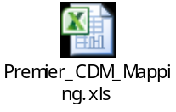

STD_CHG_CODE to SOURCE_TO_CONCEPT_MAP table

Provider Specialty mapping table

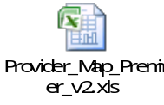

STD_CHG_CODE to HOSP_CHG_ID Mapping table

