Source Data Mapping Approach to CDMV5.0.1

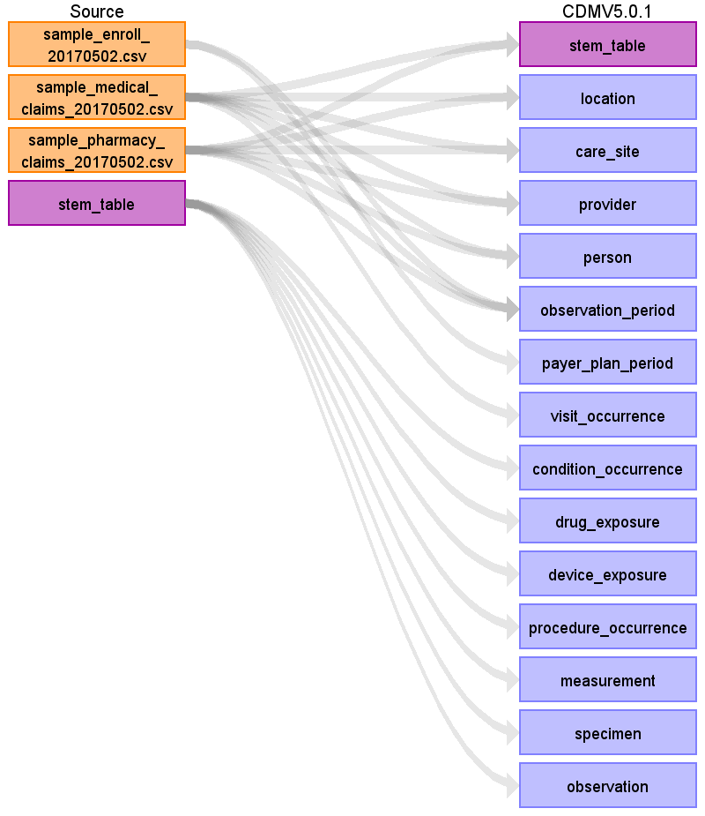

Table name: stem_table

Reading from sample_medical_claims_20170502.csv

We pull all data into the STEM and we then allow the Vocabulary to decide which CDM table the data lands in.

EXTRA COLUMNS FOR STEM

========================

In addition, create new column STEM_ID as DATA_FEED+"-"+CLAIM_ID+"-"+RECORD_ID to act as a lookup for VISIT_OCCURRENCE_ID.

We can also leverage DATA_FEED, CLAIM_ID and RECORD_ID to help with sorting.

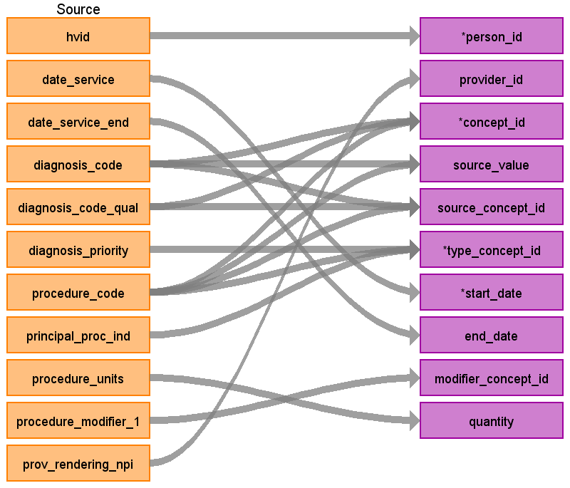

|  |  |  |  |
| --- | --- | --- | --- |
| Destination Field | Source Field | Logic | Comment |
| domain_id |  |  | =====MEDICAL_CLAIMS=====  ========================  DIAGNOSIS_CODE:  ================  Default domain = CONDITION from unless udpated by a Vocabulary mapping from CONCEPT_ID  PROCEDURE_CODE:  ================  Default domain = PROCEDURE from unless updated by a Vocabulary mapping from CONCEPT_ID  =====PHARMACY_CLAIMS=====  ==========================  Default domain = DRUG from unless updated by a Vocabulary mapping from CONCEPT_ID |
| person_id | hvid |  | Lookup in PERSON based on |
| visit_occurrence_id |  |  | TBD |
| provider_id | prov_rendering_npi |  | =====MEDICAL_CLAIMS=====  ========================  DIAGNOSIS_CODE & PROCEDURE_CODE:  ================  Lookup in the PROVIDER table leveraging NPI  =====PHARMACY_CLAIMS=====  ==========================  NDC_CODE:  ==========  Lookup in the PROVIDER table leveraging NPI |
| id |  |  | Autogenerate |
| concept_id | diagnosis_code  diagnosis_code_qual  procedure_code |  | If no map, map to 0.  =====MEDICAL_CLAIMS=====  ========================  DIAGNOSIS_CODE:  ================  01 = ICD9  02 = ICD10  Use the code in Section 3.1.2.  If diagnosis_code_qual=01 use the filter  WHERE SOURCE_VOCABULARY_ID IN ('ICD9CM')  AND TARGET_STANDARD_CONCEPT IS NOT NULL  AND TARGET_INVALID_REASON IS NULL  If diagnosis_code_qual=02 use the filter  WHERE SOURCE_VOCABULARY_ID IN ('ICD10CM')  AND TARGET_STANDARD_CONCEPT IS NOT NULL  AND TARGET_INVALID_REASON IS NULL  PROCEDURE_CODE:  ================  Use the code in Section 3.1.2.  WHERE SOURCE_VOCABULARY_ID IN ('ICD9Proc','HCPCS','CPT4', 'ICD10PCS')  AND TARGET_STANDARD_CONCEPT IS NOT NULL  AND TARGET_INVALID_REASON IS NULL  AND TARGET_CONCEPT_CLASS_ID NOT IN ('HCPCS Modifier','CPT4 Modifier','CPT4 Hierarchy', 'ICD10PCS Hierarchy')  =====PHARMACY_CLAIMS=====  ==========================  NDC_CODE  =========  Use the code in Section 3.1.2.  WHERE SOURCE_VOCABULARY_ID IN ('NDC')  AND TARGET_STANDARD_CONCEPT IS NOT NULL  AND TARGET_INVALID_REASON IS NULL  AND SVCDATE BETWEEN SOURCE_VALID_START_DATE AND SOURCE_VALID_END_DATE  When mapping prescription drug, try map the 11-digit NDC code to SOURCE_CODE in OMOP vocab first to see if you make a map. If no mapping found, try the first 9 digits of NDC code to SOURCE_CODE to see if you make a map. To be considered a valid mapping DATE_SERVICE must fall between SOURCE_VALID_START_DATE and SOURCE_VALID_END_DATE |
| source_value | diagnosis_code  procedure_code |  | =====MEDICAL_CLAIMS=====  ========================  DIAGNOSIS_CODE:  ================  DIAGNOSIS_CODE  PROCEDURE_CODE:  ================  PROCEDURE_CODE  =====PHARMACY_CLAIMS=====  ==========================  NDC_CODE:  ==========  NDC_CODE  Do not change source value if a 9 digit NDC is used over 11 digit. |
| source_concept_id | diagnosis_code  diagnosis_code_qual  procedure_code |  | If no map, map to 0.  =====MEDICAL_CLAIMS=====  ========================  DIAGNOSIS_CODE:  ================  Use the code in Section 3.1.1.  If diagnosis_code_qual=01 use the filter: WHERE SOURCE_VOCABULARY_ID IN ('ICD9CM')  AND TARGET_VOCABULARY_ID IN ('ICD9CM')  If diagnosis_code_qual=02 use the filter: WHERE SOURCE_VOCABULARY_ID IN ('ICD10CM')  AND TARGET_VOCABULARY_ID IN ('ICD10CM')  PROCEDURE_CODE:  ================  Use the code in Section 3.1.1.  WHERE SOURCE_VOCABULARY_ID IN ('ICD9Proc','HCPCS','CPT4', 'ICD10PCS')  AND TARGET_VOCABULARY_ID IN ('ICD9Proc','HCPCS','CPT4', 'ICD10PCS')  AND TARGET_CONCEPT_CLASS_ID NOT IN ('HCPCS Modifier','CPT4 Modifier', 'CPT4 Hierarchy', 'ICD10PCS Hierarchy')  =====PHARMACY_CLAIMS=====  ==========================  NDC_CODE  =========  Use the code in Section 3.1.1.  WHERE SOURCE_VOCABULARY_ID IN ('NDC')  AND TARGET_VOCABULARY_ID IN ('NDC')  AND SVCDATE BETWEEN SOURCE_VALID_START_DATE AND SOURCE_VALID_END_DATE  To be considered a valid mapping DATE_SERVICE must fall between SOURCE_VALID_START_DATE and SOURCE_VALID_END_DATE |
| type_concept_id | diagnosis_priority  procedure_code  principal_proc_ind |  | =====MEDICAL_CLAIMS=====  ========================  DIAGNOSIS_CODE:  ================  Using DIAGNOSIS_PRIORITY:  1 = 44786627 - Primary Condition  2+ = 44786629 - Secondary Condition  PROCEDURE_CODE:  ================  Using PRINCIPAL_PROC_IND  1= 44786630 Primary Procedure  NULL/'' = 44786631-Secondary Procedure  =====PHARMACY_CLAIMS=====  ==========================  NDC_CODE  =========  When DATA_VENDOR = "WebMD" then 38000175 /*Prescription dispensed in pharmacy*/  When DATA_VENDOR = "Private Source 17" then 38000177 /*Prescription written*/  ELSE 0  For "Private Source 17" we are requesting a new data type of "Drug from Claim" |
| start_date | date_service |  |  |
| end_date | date_service_end |  |  |
| start_time |  |  | NULL |
| days_supply |  |  | =====MEDICAL_CLAIMS=====  ========================  NULL  =====PHARMACY_CLAIMS=====  ==========================  NDC_CODE  =========  DAYS_SUPPLY |
| dose_unit_concept_id |  |  | 0 |
| dose_unit_source_value |  |  | NULL |
| effective_drug_dose |  |  | NULL |
| lot_number |  |  | NULL |
| modifier_concept_id | procedure_modifier_1 |  | =====MEDICAL_CLAIMS=====  ========================  DIAGNOSIS_CODE:  ================  0  PROCEDURE_CODE:  ================  Using PROCEDURE_MODIFIER_1  Use the code in Section 3.1.1.  When mapping PROCEDURE_CODE determine what the VOCABULARY_ID is, then you'll need to use the "Modifier" vocabulary for that same VOCABULARY. Example, if you the PROCEDURE_CODE's VOCABULARY_ID is CPT4 then the MODIFIER_CONCEPT_ID should use the following map:  WHERE SOURCE_CONCEPT_CLASS_ID IN ('CPT4 Modifier')  AND TARGET_CONCEPT_CLASS_ID IN ('CPT4 Modifier')  The list of modifiers are:  --CPT4 Modifier  --HCPC modifier  It is limitation that we are not pulling over PROCEDURE_MODIFIER_2-4 however they are only used about 3% of the time.  =====PHARMACY_CLAIMS=====  ==========================  0 |
| operator_concept_id |  |  | 0 |
| qualifier_concept_id |  |  | 0 |
| qualifier_source_value |  |  | NULL |
| quantity | procedure_units |  | =====MEDICAL_CLAIMS=====  ========================  DIAGNOSIS_CODE:  ================  NULL  PROCEDURE_CODE:  ================  Use PROCEDURE_UNITS as is  =====PHARMACY_CLAIMS=====  ==========================  NDC_CODE:  =========  DISPENSED_QUANTITY |
| range_high |  |  | NULL |
| range_low |  |  | NULL |
| refills |  |  | =====MEDICAL_CLAIMS=====  ========================  NULL  =====PHARMACY_CLAIMS=====  ==========================  NDC_CODE:  =========  REFILL_AUTH_AMOUNT |
| route_concept_id |  |  | 0 |
| route_source_value |  |  | NULL |
| sig |  |  | NULL |
| stop_reason |  |  | NULL |
| unique_device_id |  |  | NULL |
| unit_concept_id |  |  | 0 |
| unit_source_value |  |  | NULL |
| value_as_concept_id |  |  | 0 |
| value_as_number |  |  | NULL |
| value_as_string |  |  | NULL |
| value_source_value |  |  | NULL |
| anatomic_site_concept_id |  |  | 0 |
| disease_status_concept_id |  |  | 0 |
| specimen_source_id |  |  | NULL |
| anatomic_site_source_value |  |  | NULL |
| disease_status_source_value |  |  | NULL |

Reading from sample_pharmacy_claims_20170502.csv

=====PHARMACY_CLAIMS=====

==========================

Only keep rows where LOGICAL_DELETE_REASON NOT IN ("Reversed Claim","Reversal")

We pull all data into the STEM and we then allow the Vocabulary to decide which CDM table the data lands in.

EXTRA COLUMNS FOR STEM

========================

In addition, create new column STEM_ID as DATA_FEED+"-"+CLAIM_ID+"-"+RECORD_ID to act as a lookup for VISIT_OCCURRENCE_ID.

We can also leverage DATA_FEED, CLAIM_ID and RECORD_ID to help with sorting.

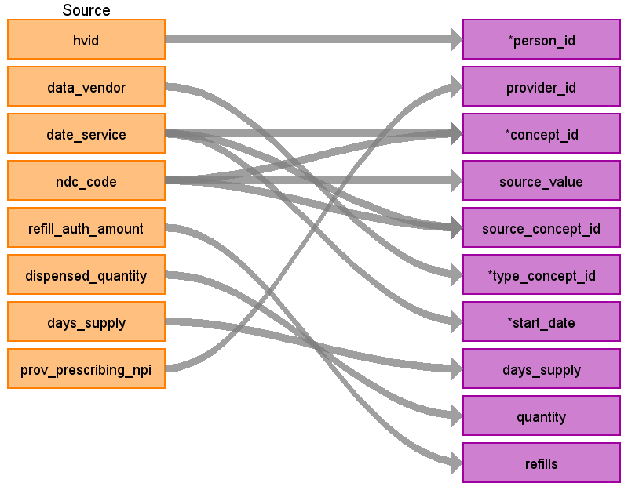

|  |  |  |  |
| --- | --- | --- | --- |
| Destination Field | Source Field | Logic | Comment |
| domain_id |  |  | =====MEDICAL_CLAIMS=====  ========================  DIAGNOSIS_CODE:  ================  Default domain = CONDITION from unless udpated by a Vocabulary mapping from CONCEPT_ID  PROCEDURE_CODE:  ================  Default domain = PROCEDURE from unless updated by a Vocabulary mapping from CONCEPT_ID  =====PHARMACY_CLAIMS=====  ==========================  Default domain = DRUG from unless updated by a Vocabulary mapping from CONCEPT_ID |
| person_id | hvid |  | Lookup in PERSON based on |
| visit_occurrence_id |  |  | TBD |
| provider_id | prov_prescribing_npi |  | =====MEDICAL_CLAIMS=====  ========================  DIAGNOSIS_CODE & PROCEDURE_CODE:  ================  Lookup in the PROVIDER table leveraging NPI  =====PHARMACY_CLAIMS=====  ==========================  NDC_CODE:  ==========  Lookup in the PROVIDER table leveraging NPI |
| id |  |  | Autogenerate |
| concept_id | ndc_code  date_service |  | If no map, map to 0.  =====MEDICAL_CLAIMS=====  ========================  DIAGNOSIS_CODE:  ================  01 = ICD9  02 = ICD10  Use the code in Section 3.1.2.  If diagnosis_code_qual=01 use the filter  WHERE SOURCE_VOCABULARY_ID IN ('ICD9CM')  AND TARGET_STANDARD_CONCEPT IS NOT NULL  AND TARGET_INVALID_REASON IS NULL  If diagnosis_code_qual=02 use the filter  WHERE SOURCE_VOCABULARY_ID IN ('ICD10CM')  AND TARGET_STANDARD_CONCEPT IS NOT NULL  AND TARGET_INVALID_REASON IS NULL  PROCEDURE_CODE:  ================  Use the code in Section 3.1.2.  WHERE SOURCE_VOCABULARY_ID IN ('ICD9Proc','HCPCS','CPT4', 'ICD10PCS')  AND TARGET_STANDARD_CONCEPT IS NOT NULL  AND TARGET_INVALID_REASON IS NULL  AND TARGET_CONCEPT_CLASS_ID NOT IN ('HCPCS Modifier','CPT4 Modifier','CPT4 Hierarchy', 'ICD10PCS Hierarchy')  =====PHARMACY_CLAIMS=====  ==========================  NDC_CODE  =========  Use the code in Section 3.1.2.  WHERE SOURCE_VOCABULARY_ID IN ('NDC')  AND TARGET_STANDARD_CONCEPT IS NOT NULL  AND TARGET_INVALID_REASON IS NULL  AND SVCDATE BETWEEN SOURCE_VALID_START_DATE AND SOURCE_VALID_END_DATE  When mapping prescription drug, try map the 11-digit NDC code to SOURCE_CODE in OMOP vocab first to see if you make a map. If no mapping found, try the first 9 digits of NDC code to SOURCE_CODE to see if you make a map. To be considered a valid mapping DATE_SERVICE must fall between SOURCE_VALID_START_DATE and SOURCE_VALID_END_DATE |
| source_value | ndc_code |  | =====MEDICAL_CLAIMS=====  ========================  DIAGNOSIS_CODE:  ================  DIAGNOSIS_CODE  PROCEDURE_CODE:  ================  PROCEDURE_CODE  =====PHARMACY_CLAIMS=====  ==========================  NDC_CODE:  ==========  NDC_CODE  Do not change source value if a 9 digit NDC is used over 11 digit. |
| source_concept_id | ndc_code  date_service |  | If no map, map to 0.  =====MEDICAL_CLAIMS=====  ========================  DIAGNOSIS_CODE:  ================  Use the code in Section 3.1.1.  If diagnosis_code_qual=01 use the filter: WHERE SOURCE_VOCABULARY_ID IN ('ICD9CM')  AND TARGET_VOCABULARY_ID IN ('ICD9CM')  If diagnosis_code_qual=02 use the filter: WHERE SOURCE_VOCABULARY_ID IN ('ICD10CM')  AND TARGET_VOCABULARY_ID IN ('ICD10CM')  PROCEDURE_CODE:  ================  Use the code in Section 3.1.1.  WHERE SOURCE_VOCABULARY_ID IN ('ICD9Proc','HCPCS','CPT4', 'ICD10PCS')  AND TARGET_VOCABULARY_ID IN ('ICD9Proc','HCPCS','CPT4', 'ICD10PCS')  AND TARGET_CONCEPT_CLASS_ID NOT IN ('HCPCS Modifier','CPT4 Modifier', 'CPT4 Hierarchy', 'ICD10PCS Hierarchy')  =====PHARMACY_CLAIMS=====  ==========================  NDC_CODE  =========  Use the code in Section 3.1.1.  WHERE SOURCE_VOCABULARY_ID IN ('NDC')  AND TARGET_VOCABULARY_ID IN ('NDC')  AND SVCDATE BETWEEN SOURCE_VALID_START_DATE AND SOURCE_VALID_END_DATE  To be considered a valid mapping DATE_SERVICE must fall between SOURCE_VALID_START_DATE and SOURCE_VALID_END_DATE |
| type_concept_id | data_vendor |  | =====MEDICAL_CLAIMS=====  ========================  DIAGNOSIS_CODE:  ================  Using DIAGNOSIS_PRIORITY:  1 = 44786627 - Primary Condition  2+ = 44786629 - Secondary Condition  PROCEDURE_CODE:  ================  Using PRINCIPAL_PROC_IND  1= 44786630 Primary Procedure  NULL/'' = 44786631-Secondary Procedure  =====PHARMACY_CLAIMS=====  ==========================  NDC_CODE  =========  When DATA_VENDOR = "WebMD" then 38000175 /*Prescription dispensed in pharmacy*/  When DATA_VENDOR = "Private Source 17" then 38000177 /*Prescription written*/  ELSE 0  For "Private Source 17" we are requesting a new data type of "Drug from Claim" |
| start_date | date_service |  |  |
| end_date |  |  |  |
| start_time |  |  | NULL |
| days_supply | days_supply |  | =====MEDICAL_CLAIMS=====  ========================  NULL  =====PHARMACY_CLAIMS=====  ==========================  NDC_CODE  =========  DAYS_SUPPLY |
| dose_unit_concept_id |  |  | 0 |
| dose_unit_source_value |  |  | NULL |
| effective_drug_dose |  |  | NULL |
| lot_number |  |  | NULL |
| modifier_concept_id |  |  | =====MEDICAL_CLAIMS=====  ========================  DIAGNOSIS_CODE:  ================  0  PROCEDURE_CODE:  ================  Using PROCEDURE_MODIFIER_1  Use the code in Section 3.1.1.  When mapping PROCEDURE_CODE determine what the VOCABULARY_ID is, then you'll need to use the "Modifier" vocabulary for that same VOCABULARY. Example, if you the PROCEDURE_CODE's VOCABULARY_ID is CPT4 then the MODIFIER_CONCEPT_ID should use the following map:  WHERE SOURCE_CONCEPT_CLASS_ID IN ('CPT4 Modifier')  AND TARGET_CONCEPT_CLASS_ID IN ('CPT4 Modifier')  The list of modifiers are:  --CPT4 Modifier  --HCPC modifier  It is limitation that we are not pulling over PROCEDURE_MODIFIER_2-4 however they are only used about 3% of the time.  =====PHARMACY_CLAIMS=====  ==========================  0 |
| operator_concept_id |  |  | 0 |
| qualifier_concept_id |  |  | 0 |
| qualifier_source_value |  |  | NULL |
| quantity | dispensed_quantity |  | =====MEDICAL_CLAIMS=====  ========================  DIAGNOSIS_CODE:  ================  NULL  PROCEDURE_CODE:  ================  Use PROCEDURE_UNITS as is  =====PHARMACY_CLAIMS=====  ==========================  NDC_CODE:  =========  DISPENSED_QUANTITY |
| range_high |  |  | NULL |
| range_low |  |  | NULL |
| refills | refill_auth_amount |  | =====MEDICAL_CLAIMS=====  ========================  NULL  =====PHARMACY_CLAIMS=====  ==========================  NDC_CODE:  =========  REFILL_AUTH_AMOUNT |
| route_concept_id |  |  | 0 |
| route_source_value |  |  | NULL |
| sig |  |  | NULL |
| stop_reason |  |  | NULL |
| unique_device_id |  |  | NULL |
| unit_concept_id |  |  | 0 |
| unit_source_value |  |  | NULL |
| value_as_concept_id |  |  | 0 |
| value_as_number |  |  | NULL |
| value_as_string |  |  | NULL |
| value_source_value |  |  | NULL |
| anatomic_site_concept_id |  |  | 0 |
| disease_status_concept_id |  |  | 0 |
| specimen_source_id |  |  | NULL |
| anatomic_site_source_value |  |  | NULL |
| disease_status_source_value |  |  | NULL |

Table name: location

The only locations we actually have are on the patient.

Pull all values from all described source tables and only keep distinct record of them.

Reading from sample_medical_claims_20170502.csv

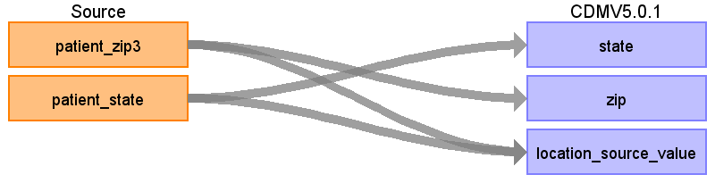

|  |  |  |  |
| --- | --- | --- | --- |
| Destination Field | Source Field | Logic | Comment |
| location_id |  |  |  |
| address_1 |  |  |  |
| address_2 |  |  |  |
| city |  |  |  |
| state | patient_state |  |  |
| zip | patient_zip3 |  |  |
| county |  |  |  |
| location_source_value | patient_zip3  patient_state |  | patient_state + '_' + patient_zip3 |

Reading from sample_pharmacy_claims_20170502.csv



|  |  |  |  |
| --- | --- | --- | --- |
| Destination Field | Source Field | Logic | Comment |
| location_id |  |  |  |
| address_1 |  |  |  |
| address_2 |  |  |  |
| city |  |  |  |
| state | patient_state |  |  |
| zip | patient_zip3 |  |  |
| county |  |  |  |
| location_source_value | patient_state  patient_zip3 |  | patient_state + '_' + patient_zip3 |

Table name: care_site

Reading from sample_medical_claims_20170502.csv

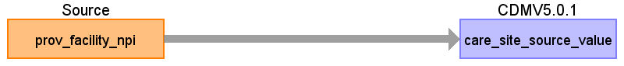

|  |  |  |  |
| --- | --- | --- | --- |
| Destination Field | Source Field | Logic | Comment |
| care_site_id |  |  | Autogenerate |
| care_site_name |  |  | NULL |
| place_of_service_concept_id |  |  | 0 |
| location_id |  |  | NULL |
| care_site_source_value | prov_facility_npi |  |  |
| place_of_service_source_value |  |  | NULL |

Reading from sample_pharmacy_claims_20170502.csv

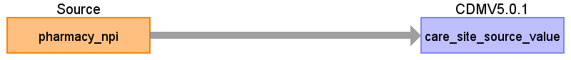

|  |  |  |  |
| --- | --- | --- | --- |
| Destination Field | Source Field | Logic | Comment |
| care_site_id |  |  | Autogenerate |
| care_site_name |  |  | NULL |
| place_of_service_concept_id |  |  | 0 |
| location_id |  |  | NULL |
| care_site_source_value | pharmacy_npi |  |  |
| place_of_service_source_value |  |  | NULL |

Table name: provider

Take the distinct NPI values from across MEDICAL_CLAIMS and PHARMACY_CLAIMS.

Reading from sample_medical_claims_20170502.csv

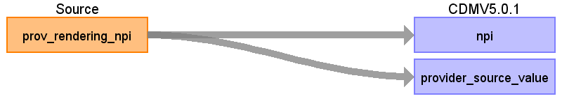

|  |  |  |  |
| --- | --- | --- | --- |
| Destination Field | Source Field | Logic | Comment |
| provider_id |  |  | Autogenerate. |
| provider_name |  |  | NULL |
| npi | prov_rendering_npi |  |  |
| dea |  |  | NULL |
| specialty_concept_id |  |  | 0 |
| care_site_id |  |  | NULL |
| year_of_birth |  |  | NULL |
| gender_concept_id |  |  | 0 |
| provider_source_value | prov_rendering_npi |  |  |
| specialty_source_value |  |  | NULL |
| specialty_source_concept_id |  |  | 0 |
| gender_source_value |  |  | NULL |
| gender_source_concept_id |  |  | 0 |

Reading from sample_pharmacy_claims_20170502.csv

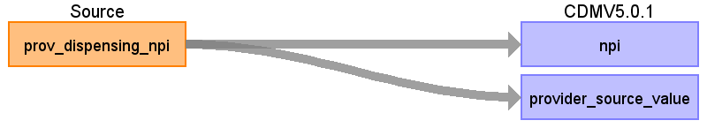

|  |  |  |  |
| --- | --- | --- | --- |
| Destination Field | Source Field | Logic | Comment |
| provider_id |  |  | Autogenerate. |
| provider_name |  |  | NULL |
| npi | prov_dispensing_npi |  |  |
| dea |  |  | NULL |
| specialty_concept_id |  |  | 0 |
| care_site_id |  |  | NULL |
| year_of_birth |  |  | NULL |
| gender_concept_id |  |  | 0 |
| provider_source_value | prov_dispensing_npi |  |  |
| specialty_source_value |  |  | NULL |
| specialty_source_concept_id |  |  | 0 |
| gender_source_value |  |  | NULL |
| gender_source_concept_id |  |  | 0 |

Table name: cdm_source

CDM_SOURCE_NAME

==================

HealthVerity WebMD and Pharmacy Section 17 Database

CDM_SOURCE_ABBREVIATION

=========================

WEBMD_PBM

CDM_HOLDER

============

Janssen R&D

SOURCE_DESCRIPTION

===================

NULL

SOURCE_DOCUMENTATION_REFERENCE

==================================

NULL

CDM_ETL_REFERENCE

===================

NULL

SOURCE_RELEASE_DATE

=====================

2017.05.26

CDM_RELEASE_DATE

==================

SELECT CONVERT(VARCHAR(10), GETDATE(),102)

CDM_VERSION

=============

5.0.1

VOCABULARY_VERSION

====================

SELECT VOCABULARY_VERSION

FROM vocabulary

WHERE VOCABULARY_ID = 'None'

Table name: person

Data about people comes from both PHARMACY_CLAIMS and MEDICAL_CLAIMS. There are multiple rows per person, so we will select one to populate the PERSON table.

row_number() over (PARTITION BY hvid order by date_service_end desc, record_id desc) as row_num

take row_num = 1

Reading from sample_medical_claims_20170502.csv

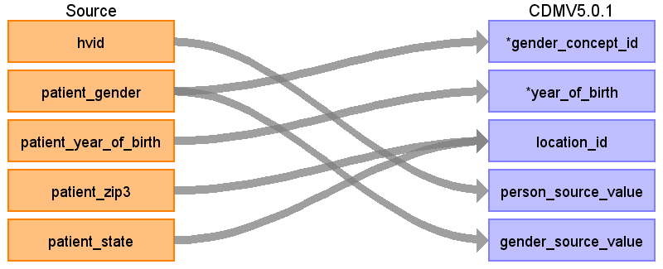

|  |  |  |  |
| --- | --- | --- | --- |
| Destination Field | Source Field | Logic | Comment |
| person_id |  |  | Autogenerate. |
| gender_concept_id | patient_gender |  | if patient_gender in ('F','M')  case  when 'F' then 8532  when 'M' then 8507  end as gender_concept_id  If gender is unknown exclude. |
| year_of_birth | patient_year_of_birth |  | Only take the first 4 digits of the as the data sometimes comes as YYYYMMDD.  When year of birth is NULL or YEAR <= 0 exclude patient. |
| month_of_birth |  |  | NULL |
| day_of_birth |  |  | NULL |
| time_of_birth |  |  | NULL |
| race_concept_id |  |  | 0 |
| ethnicity_concept_id |  |  | 0 |
| location_id | patient_zip3  patient_state |  | Look up location_id by patient_zip3 and patient_state |
| provider_id |  |  | NULL |
| care_site_id |  |  | NULL |
| person_source_value | hvid | Exclude where HVID is NULL |  |
| gender_source_value | patient_gender |  |  |
| gender_source_concept_id |  |  | 0 |
| race_source_value |  |  | NULL |
| race_source_concept_id |  |  | 0 |
| ethnicity_source_value |  |  | NULL |
| ethnicity_source_concept_id |  |  | 0 |

Reading from sample_pharmacy_claims_20170502.csv



|  |  |  |  |
| --- | --- | --- | --- |
| Destination Field | Source Field | Logic | Comment |
| person_id |  |  | Autogenerate. |
| gender_concept_id | patient_gender |  | if patient_gender in ('F','M')  case  when 'F' then 8532  when 'M' then 8507  end as gender_concept_id  If gender is unknown exclude. |
| year_of_birth | patient_year_of_birth |  | Only take the first 4 digits of the as the data sometimes comes as YYYYMMDD.  When year of birth is NULL or YEAR <= 0 exclude patient. |
| month_of_birth |  |  | NULL |
| day_of_birth |  |  | NULL |
| time_of_birth |  |  | NULL |
| race_concept_id |  |  | 0 |
| ethnicity_concept_id |  |  | 0 |
| location_id | patient_zip3  patient_state |  | Look up location_id by patient_zip3 and patient_state |
| provider_id |  |  | NULL |
| care_site_id |  |  | NULL |
| person_source_value | hvid |  |  |
| gender_source_value | patient_gender |  |  |
| gender_source_concept_id |  |  | 0 |
| race_source_value |  |  | NULL |
| race_source_concept_id |  |  | 0 |
| ethnicity_source_value |  |  | NULL |
| ethnicity_source_concept_id |  |  | 0 |

Table name: observation_period

OBSERVATION_PERIOD_START_DATE = MIN(MIN_MEDICAL_CLAIMS_DATE, MIN_PHARMACY_CLAIMS_DATE,MIN_ENROLL_DATE)

OBSERVATION_PERIOD_END_DATE = MAX(MAX_MEDICAL_CLAIMS_DATE, MAX_PHARMACY_CLAIMS_DATE,MAX_ENROLL_DATE)

Reading from sample_medical_claims_20170502.csv

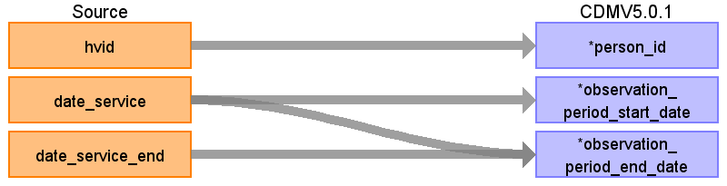

|  |  |  |  |
| --- | --- | --- | --- |
| Destination Field | Source Field | Logic | Comment |
| observation_period_id |  |  | Autogenerate |
| person_id | hvid |  | Lookup in PERSON based on |
| observation_period_start_date | date_service |  | =====MEDICAL_CLAIMS=====  ========================  MIN(DATE_SERVICE) AS MIN_MEDICAL_CLAIMS_DATE  =====PHARMACY_CLAIMS=====  ==========================  MIN(DATE_SERVICE) AS MIN_PHARMACY_CLAIMS_DATE  =====ENROLL=====  =================  MIN(DATE) AS MIN_ENROLL_DATE |
| observation_period_end_date | date_service_end  date_service |  | =====MEDICAL_CLAIMS=====  ========================  MAX(DATE_SERVICE, DATE_SERVICE_END) AS MAX_MEDICAL_CLAIMS_DATE  =====PHARMACY_CLAIMS=====  ==========================  MAX(DATE_SERVICE) AS MAX_PHARMACY_CLAIMS_DATE  =====ENROLL=====  =================  MAX(DATE) AS MAX_ENROLL_DATE |
| period_type_concept_id |  |  | 44814724-Period covering healthcare encounters |

Reading from sample_pharmacy_claims_20170502.csv

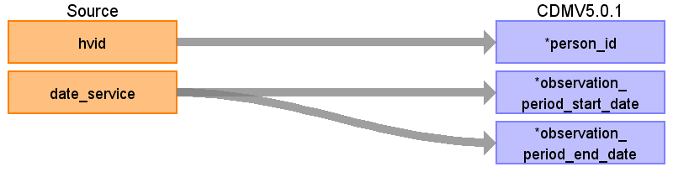

|  |  |  |  |
| --- | --- | --- | --- |
| Destination Field | Source Field | Logic | Comment |
| observation_period_id |  |  | Autogenerate |
| person_id | hvid |  | Lookup in PERSON based on |
| observation_period_start_date | date_service | WHERE DATA_VENDOR = 'WEBMD' | =====MEDICAL_CLAIMS=====  ========================  MIN(DATE_SERVICE) AS MIN_MEDICAL_CLAIMS_DATE  =====PHARMACY_CLAIMS=====  ==========================  MIN(DATE_SERVICE) AS MIN_PHARMACY_CLAIMS_DATE  =====ENROLL=====  =================  MIN(DATE) AS MIN_ENROLL_DATE |
| observation_period_end_date | date_service | WHERE DATA_VENDOR = 'WEBMD' | =====MEDICAL_CLAIMS=====  ========================  MAX(DATE_SERVICE, DATE_SERVICE_END) AS MAX_MEDICAL_CLAIMS_DATE  =====PHARMACY_CLAIMS=====  ==========================  MAX(DATE_SERVICE) AS MAX_PHARMACY_CLAIMS_DATE  =====ENROLL=====  =================  MAX(DATE) AS MAX_ENROLL_DATE |
| period_type_concept_id |  |  | 44814724-Period covering healthcare encounters |

Reading from sample_enroll_20170502.csv

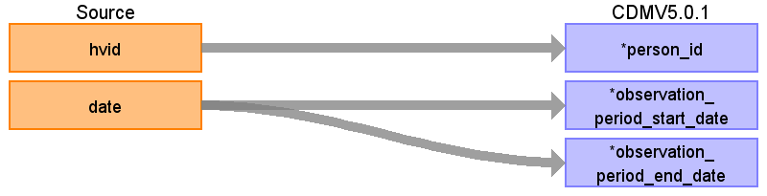

|  |  |  |  |
| --- | --- | --- | --- |
| Destination Field | Source Field | Logic | Comment |
| observation_period_id |  |  | Autogenerate |
| person_id | hvid |  | Lookup in PERSON based on |
| observation_period_start_date | date |  | =====MEDICAL_CLAIMS=====  ========================  MIN(DATE_SERVICE) AS MIN_MEDICAL_CLAIMS_DATE  =====PHARMACY_CLAIMS=====  ==========================  MIN(DATE_SERVICE) AS MIN_PHARMACY_CLAIMS_DATE  =====ENROLL=====  =================  MIN(DATE) AS MIN_ENROLL_DATE |
| observation_period_end_date | date |  | =====MEDICAL_CLAIMS=====  ========================  MAX(DATE_SERVICE, DATE_SERVICE_END) AS MAX_MEDICAL_CLAIMS_DATE  =====PHARMACY_CLAIMS=====  ==========================  MAX(DATE_SERVICE) AS MAX_PHARMACY_CLAIMS_DATE  =====ENROLL=====  =================  MAX(DATE) AS MAX_ENROLL_DATE |
| period_type_concept_id |  |  | 44814724-Period covering healthcare encounters |

Table name: payer_plan_period

Enrollment entries are consolidated by combining records that indicate continuous enrollment over a period. Consolidation is done through the following steps:

[1] ENROLL records for each person are sorted in ascending order by DATE.

[2] Periods of continuous enrollment are consolidated by combining daily records as long as the time between the end of one enrollment period and the start of the next is 32 days or less (<=32).

Reading from sample_enroll_20170502.csv

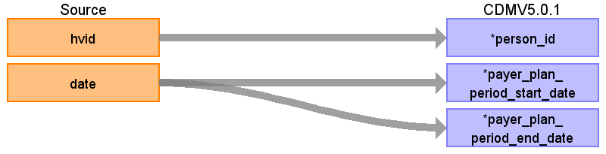

|  |  |  |  |
| --- | --- | --- | --- |
| Destination Field | Source Field | Logic | Comment |
| payer_plan_period_id |  |  | Autogenerate |
| person_id | hvid |  | Lookup in PERSON based on |
| payer_plan_period_start_date | date |  |  |
| payer_plan_period_end_date | date |  |  |
| payer_source_value |  |  | Private Source 17 |
| plan_source_value |  |  |  |
| family_source_value |  |  |  |

Table name: visit_occurrence

Reading from sample_medical_claims_20170502.csv

Note: This work will be process along with the STEM table

PART 1 - Assign IP, OP, ER, or LTC to claim lines based on REVENUE_CODE, PROCEDURE_CODE, and PLACE_OF_SERVICE_STD_ID.

* Start with PLACE_OF_SERVICE_STD_ID -> 13,31,32,34 claim line is LTC
* If PLACE_OF_SERVICE_STD_ID = 21 OR
  + REVENUE_CODE between 0100 and 0219
  + REVENUE_CODE between 0720 and 0729
  + REVENUE_CODE between 0800 and 0809
  + Then claim line is IP
* Otherwise, if PLACE_OF_SERVICE_STD_ID = 23 OR
  + REVENUE_CODE between 0450 and 0459
  + REVENUE_CODE = 0981
  + PROCEDURE_CODE = 99281, 99282, 99283, 99284, 99285
  + Then claim line is ER
* All else are OP

PART 2 - Generate visits by:

-For claim type = ‘LTCP’:

---Sort data in ascending order by PERSON_ID, VISIT_START_DATE, VISIT_END_DATE, STEM.ID

---Then by PERSON_ID, collapse lines of claim as long as the time between the VISIT_END_DATE of one line and the VISIT_START_DATE of the next is <=32. Each consolidated long term care claim is considered as one long term care visit, set

------MIN(VISIT_START_DATE) as VISIT_START_DATE

------MAX(VISIT_END_DATE) as VISIT_END_DATE

------‘LTCP’ as PLACE_OF_SERVICE_SOURCE_VALUE

---As you are collapsing records take the PROV_RENDERING_NPI from the first claim line of each visit as VISIT_PROV_RENDERING_NPI, this will be used later to assign providers associated to a visit.

-For claim type = ‘IP’:

---Sort data in ascending order by PERSON_ID, VISIT_START_DATE, VISIT_END_DATE, STEM.ID.

---Then by PERSON_ID, collapse lines of claim as long as the time between the VISIT_END_DATE of one line and the VISIT_START_DATE of the next is <=1.

---Then each consolidated inpatient claim is considered as one inpatient visit, set

------MIN(VISIT_START_DATE) as VISIT_START_DATE

------MAX(VISIT_END_DATE) as VISIT_END_DATE

------‘IP’ as PLACE_OF_SERVICE_SOURCE_VALUE

---As you are collapsing records take the PROV_RENDERING_NPI from the first claim line of each visit as VISIT_PROV_RENDERING_NPI, this will be used later to assign providers associated to a visit.

---See if any ‘OP’ or ‘ER’ records occur during an ‘IP’ visit. These should be consolidated into that ‘IP’ visit, unless it is an ‘ER’ visit that starts and ends on the first day of the ‘IP’ visit. Types of OP visits not collapsed: [1] if an OP starts before an IP but ends during an IP or [2] if an OP starts before and ends after an IP visit. If an OP is collapsed into an IP and its VISIT_END_DATE is greater than the IP's VISIT_END_DATE it does not change the IP VISIT_END_DATE.

-For claim type = ‘ER’

---Sort data in ascending order by PERSON_ID, VISIT_START_DATE, VISIT_END_DATE, STEM.ID.

---Then by PERSON_ID, collapse all ‘ER’ claims that start on the same day as one ER visit, then take VISIT_START_DATE as VISIT_START_DATE, MAX (VISIT_END_DATE) as VISIT_END_DATE, and ‘ER’ as PLACE_OF_SERVICE_SOURCE_VALUE.

---As you are collapsing records take the PROV_RENDERING_NPI from the first claim line of each visit as VISIT_PROV_RENDERING_NPI, this will be used later to assign providers associated to a visit.

-For claim type = ‘OP’

---Sort data in ascending order by PERSON_ID, VISIT_START_DATE, VISIT_END_DATE, STEM.ID.

---Then by PERSON_ID and VISIT_START_DATE, collapse all ‘OP’ claims that have the same PROV_RENDERING_NPI as one OP visit, then take VISIT_START_DATE as VISIT_START_DATE, MAX (VISIT_END_DATE) as VISIT_END_DATE, and ‘OP’ as PLACE_OF_SERVICE_SOURCE_VALUE.

---As you are collapsing records take the PROV_RENDERING_NPI from the first claim line of each visit as VISIT_PROV_RENDERING_NPI, this will be used later to assign providers associated to a visit.

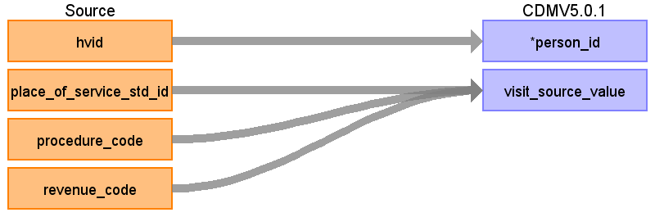

|  |  |  |  |
| --- | --- | --- | --- |
| Destination Field | Source Field | Logic | Comment |
| visit_occurrence_id |  |  | Autogenerate |
| person_id | hvid |  | Lookup in PERSON based on |
| visit_concept_id |  |  |  |
| visit_start_date |  |  |  |
| visit_start_time |  |  |  |
| visit_end_date |  |  |  |
| visit_end_time |  |  |  |
| visit_type_concept_id |  |  |  |
| provider_id |  |  |  |
| care_site_id |  |  |  |
| visit_source_value | revenue_code  place_of_service_std_id  procedure_code |  | IF (REVENUE_CODE >= '0100' AND REVENUE_CODE <= '0219') /* Room and Board Charges */  OR (REVENUE_CODE >= '0720' AND REVENUE_CODE <= '0729') /* Labor Room and Delivery */  OR (REVENUE_CODE >= '0800' AND REVENUE_CODE <= '0809') /* Inpatient Renal Dialysis */  THEN  IF PLACE_OF_SERVICE_STD_ID IN (13,31,32,34) THEN CLAIM_TYPE = 'LTC'  ELSE CLAIM_TYPE = 'IP';  ELSE IF PLACE_OF_SERVICE_STD_ID IN (23)  OR (REVENUE_CODE >= '0450' AND REVENUE_CODE <= '0459')  OR REVENUE_CODE ='0981'  OR PROCEDURE_CODE IN ('99281','99282','99283','99284','99285')  THEN CLAIM_TYPE= 'ER';  ELSE CLAIM_TYPE = 'OP'; |
| visit_source_concept_id |  |  |  |

Table name: condition_occurrence

Reading from stem_table

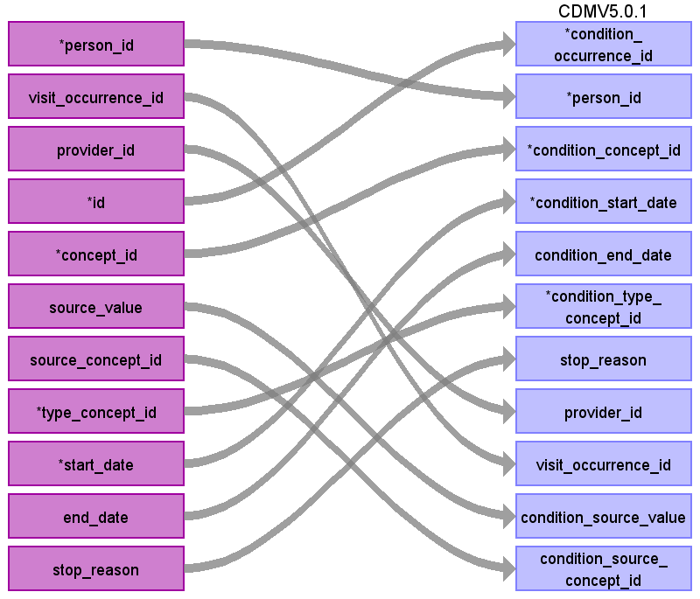

|  |  |  |  |
| --- | --- | --- | --- |
| Destination Field | Source Field | Logic | Comment |
| condition_occurrence_id | id |  |  |
| person_id | person_id |  |  |
| condition_concept_id | concept_id |  |  |
| condition_start_date | start_date |  |  |
| condition_end_date | end_date |  |  |
| condition_type_concept_id | type_concept_id |  |  |
| stop_reason | stop_reason |  |  |
| provider_id | provider_id |  |  |
| visit_occurrence_id | visit_occurrence_id |  |  |
| condition_source_value | source_value |  |  |
| condition_source_concept_id | source_concept_id |  |  |

Table name: drug_exposure

Reading from stem_table

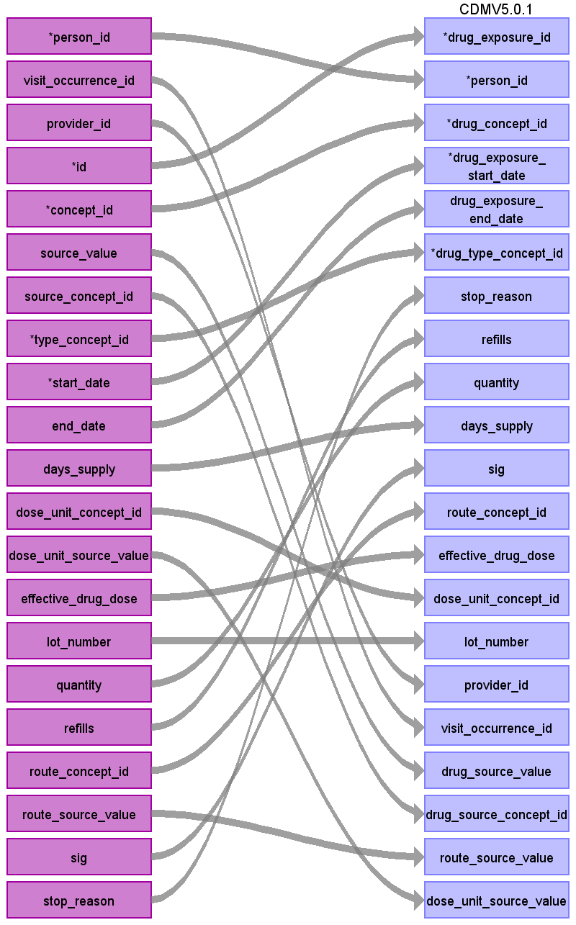

|  |  |  |  |
| --- | --- | --- | --- |
| Destination Field | Source Field | Logic | Comment |
| drug_exposure_id | id |  |  |
| person_id | person_id |  |  |
| drug_concept_id | concept_id |  |  |
| drug_exposure_start_date | start_date |  |  |
| drug_exposure_end_date | end_date |  |  |
| drug_type_concept_id | type_concept_id |  |  |
| stop_reason | stop_reason |  |  |
| refills | refills |  |  |
| quantity | quantity |  |  |
| days_supply | days_supply |  |  |
| sig | sig |  |  |
| route_concept_id | route_concept_id |  |  |
| effective_drug_dose | effective_drug_dose |  |  |
| dose_unit_concept_id | dose_unit_concept_id |  |  |
| lot_number | lot_number |  |  |
| provider_id | provider_id |  |  |
| visit_occurrence_id | visit_occurrence_id |  |  |
| drug_source_value | source_value |  |  |
| drug_source_concept_id | source_concept_id |  |  |
| route_source_value | route_source_value |  |  |
| dose_unit_source_value | dose_unit_source_value |  |  |

Table name: device_exposure

Reading from stem_table

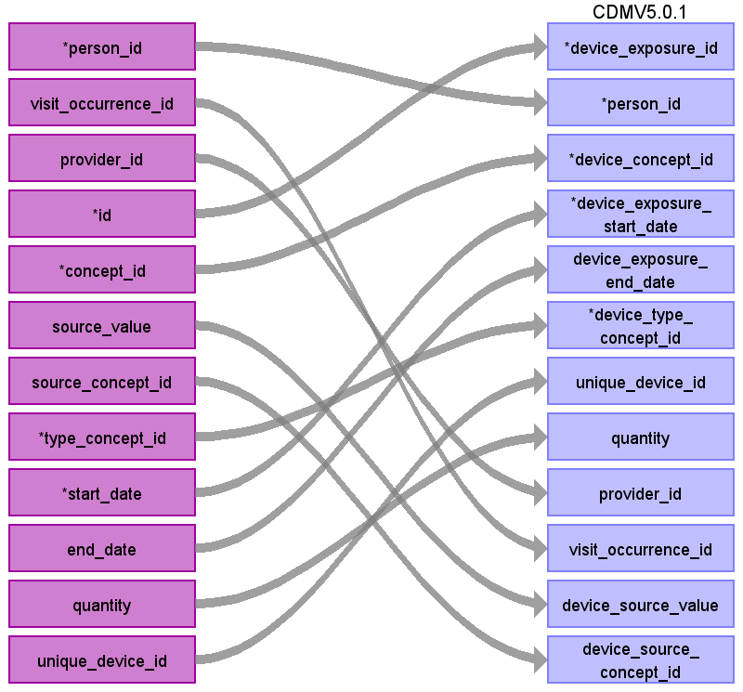

|  |  |  |  |
| --- | --- | --- | --- |
| Destination Field | Source Field | Logic | Comment |
| device_exposure_id | id |  |  |
| person_id | person_id |  |  |
| device_concept_id | concept_id |  |  |
| device_exposure_start_date | start_date |  |  |
| device_exposure_end_date | end_date |  |  |
| device_type_concept_id | type_concept_id |  |  |
| unique_device_id | unique_device_id |  |  |
| quantity | quantity |  |  |
| provider_id | provider_id |  |  |
| visit_occurrence_id | visit_occurrence_id |  |  |
| device_source_value | source_value |  |  |
| device_source_concept_id | source_concept_id |  |  |

Table name: procedure_occurrence

Reading from stem_table

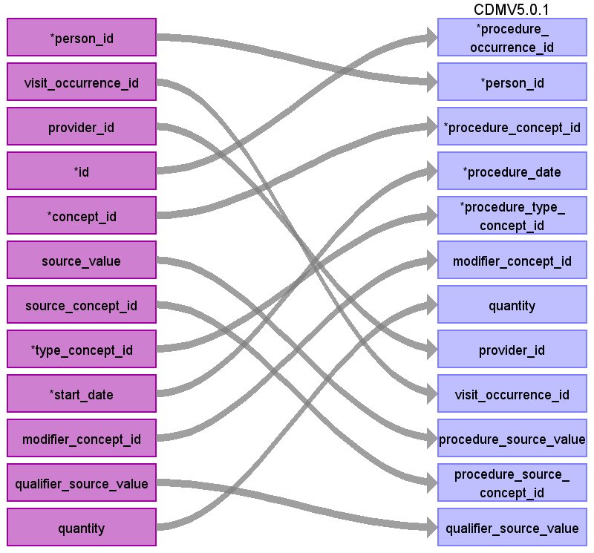

|  |  |  |  |
| --- | --- | --- | --- |
| Destination Field | Source Field | Logic | Comment |
| procedure_occurrence_id | id |  |  |
| person_id | person_id |  |  |
| procedure_concept_id | concept_id |  |  |
| procedure_date | start_date |  |  |
| procedure_type_concept_id | type_concept_id |  |  |
| modifier_concept_id | modifier_concept_id |  |  |
| quantity | quantity |  |  |
| provider_id | provider_id |  |  |
| visit_occurrence_id | visit_occurrence_id |  |  |
| procedure_source_value | source_value |  |  |
| procedure_source_concept_id | source_concept_id |  |  |
| qualifier_source_value | qualifier_source_value |  |  |

Table name: measurement

Reading from stem_table

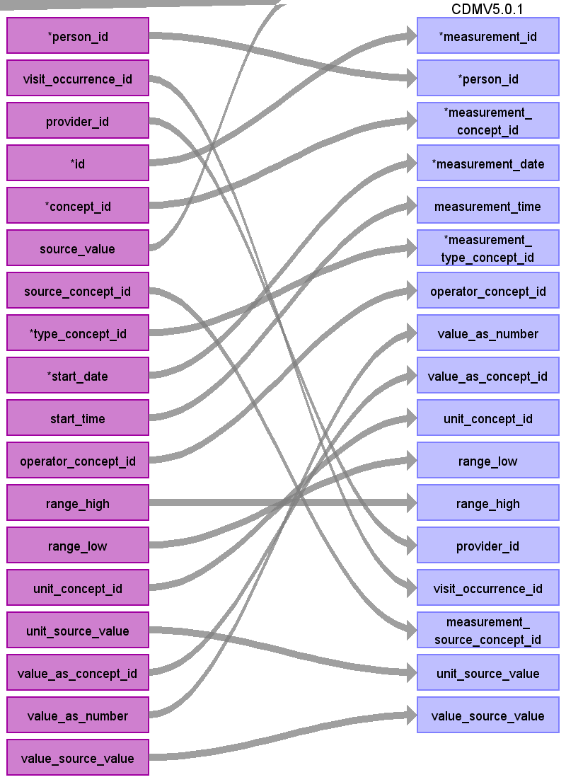

|  |  |  |  |
| --- | --- | --- | --- |
| Destination Field | Source Field | Logic | Comment |
| measurement_id | id |  |  |
| person_id | person_id |  |  |
| measurement_concept_id | concept_id |  |  |
| measurement_date | start_date |  |  |
| measurement_time | start_time |  |  |
| measurement_type_concept_id | type_concept_id |  |  |
| operator_concept_id | operator_concept_id |  |  |
| value_as_number | value_as_number |  |  |
| value_as_concept_id | value_as_concept_id |  |  |
| unit_concept_id | unit_concept_id |  |  |
| range_low | range_low |  |  |
| range_high | range_high |  |  |
| provider_id | provider_id |  |  |
| visit_occurrence_id | visit_occurrence_id |  |  |
| measurement_source_value |  |  |  |
| measurement_source_concept_id | source_concept_id |  |  |
| unit_source_value | unit_source_value |  |  |
| value_source_value | value_source_value |  |  |

Table name: specimen

Reading from stem_table

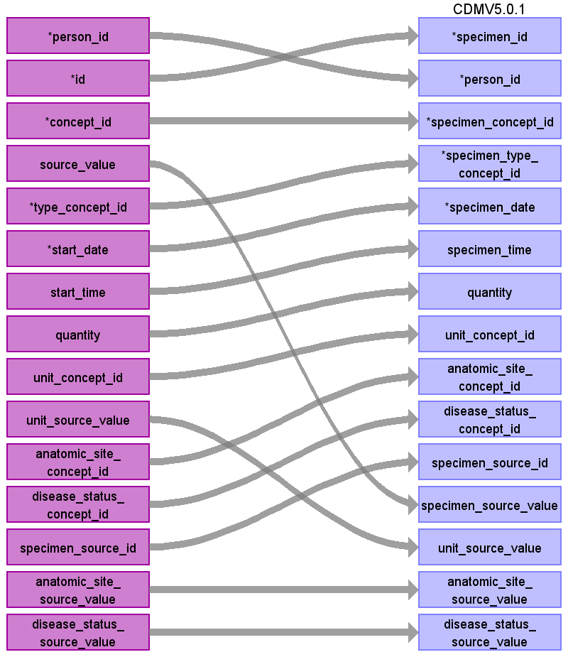

|  |  |  |  |
| --- | --- | --- | --- |
| Destination Field | Source Field | Logic | Comment |
| specimen_id | id |  |  |
| person_id | person_id |  |  |
| specimen_concept_id | concept_id |  |  |
| specimen_type_concept_id | type_concept_id |  |  |
| specimen_date | start_date |  |  |
| specimen_time | start_time |  |  |
| quantity | quantity |  |  |
| unit_concept_id | unit_concept_id |  |  |
| anatomic_site_concept_id | anatomic_site_concept_id |  |  |
| disease_status_concept_id | disease_status_concept_id |  |  |
| specimen_source_id | specimen_source_id |  |  |
| specimen_source_value | source_value |  |  |
| unit_source_value | unit_source_value |  |  |
| anatomic_site_source_value | anatomic_site_source_value |  |  |
| disease_status_source_value | disease_status_source_value |  |  |

Table name: observation

Reading from stem_table

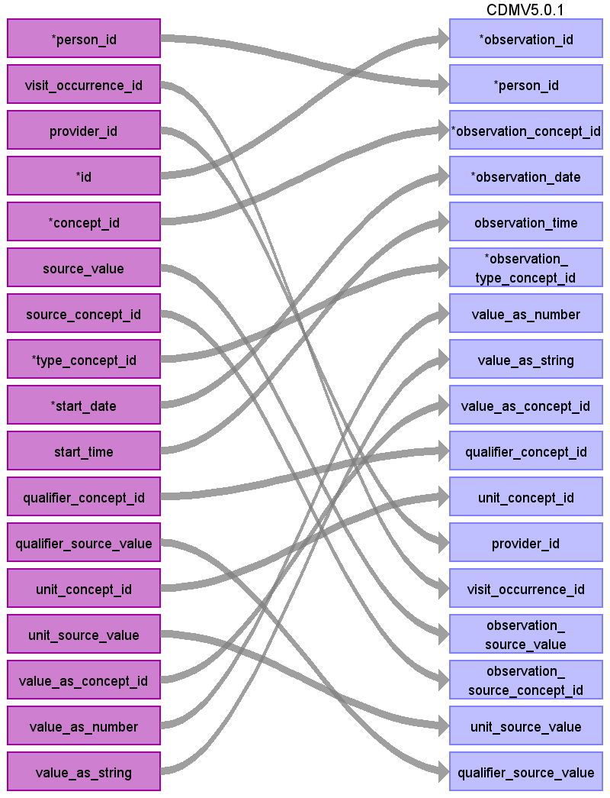

|  |  |  |  |
| --- | --- | --- | --- |
| Destination Field | Source Field | Logic | Comment |
| observation_id | id |  |  |
| person_id | person_id |  |  |
| observation_concept_id | concept_id |  |  |
| observation_date | start_date |  |  |
| observation_time | start_time |  |  |
| observation_type_concept_id | type_concept_id |  |  |
| value_as_number | value_as_number |  |  |
| value_as_string | value_as_string |  |  |
| value_as_concept_id | value_as_concept_id |  |  |
| qualifier_concept_id | qualifier_concept_id |  |  |
| unit_concept_id | unit_concept_id |  |  |
| provider_id | provider_id |  |  |
| visit_occurrence_id | visit_occurrence_id |  |  |
| observation_source_value | source_value |  |  |
| observation_source_concept_id | source_concept_id |  |  |
| unit_source_value | unit_source_value |  |  |
| qualifier_source_value | qualifier_source_value |  |  |

Table name: note

Table name: death

Table name: fact_relationship

Table name: drug_era

https://github.com/OHDSI/Era-Constructor/tree/master/v5/PostgreSQL

https://gist.github.com/chrisknoll/64da3ee06b271763d1be

https://gist.github.com/chrisknoll/c820cc12d833db2e3d1e

Table name: dose_era

Table name: condition_era

Table name: cohort

Table name: cohort_definition

Table name: cohort_attribute

Table name: attribute_definition

Table name: cost

Appendix: source tables

Table: sample_enroll_20170502.csv

|  |  |  |  |
| --- | --- | --- | --- |
| Field | Type | Most freq. value | Comment |
| data_feed | int | 16 |  |
| hvid | int | List truncated... |  |
| date | varchar | List truncated... |  |
| coverage_ind | varchar | List truncated... |  |

Table: sample_medical_claims_20170502.csv

|  |  |  |  |
| --- | --- | --- | --- |
| Field | Type | Most freq. value | Comment |
| record_id | int |  |  |
| claim_id | varchar |  |  |
| hvid | int |  |  |
| created | varchar |  |  |
| model_version | int |  |  |
| data_set | varchar |  |  |
| data_feed | int |  |  |
| data_vendor | varchar |  |  |
| source_version | varchar |  |  |
| patient_gender | varchar |  |  |
| patient_age | varchar |  |  |
| patient_year_of_birth | int |  |  |
| patient_zip3 | int |  |  |
| patient_state | varchar |  |  |
| claim_type | varchar |  |  |
| date_received | varchar |  |  |
| date_service | varchar |  |  |
| date_service_end | varchar |  |  |
| inst_date_admitted | varchar |  |  |
| inst_date_discharged | varchar |  |  |
| inst_admit_type_std_id | varchar |  |  |
| inst_admit_type_vendor_id | varchar |  |  |
| inst_admit_type_vendor_desc | varchar |  |  |
| inst_admit_source_std_id | varchar |  |  |
| inst_admit_source_vendor_id | varchar |  |  |
| inst_admit_source_vendor_desc | varchar |  |  |
| inst_discharge_status_std_id | varchar |  |  |
| inst_discharge_status_vendor_id | varchar |  |  |
| inst_discharge_status_vendor_desc | varchar |  |  |
| inst_type_of_bill_std_id | varchar |  |  |
| inst_type_of_bill_vendor_id | varchar |  |  |
| inst_type_of_bill_vendor_desc | varchar |  |  |
| inst_drg_std_id | varchar |  |  |
| inst_drg_vendor_id | varchar |  |  |
| inst_drg_vendor_desc | varchar |  |  |
| place_of_service_std_id | int |  |  |
| place_of_service_vendor_id | varchar |  |  |
| place_of_service_vendor_desc | varchar |  |  |
| service_line_number | int |  |  |
| diagnosis_code | varchar |  |  |
| diagnosis_code_qual | int |  |  |
| diagnosis_priority | int |  |  |
| admit_diagnosis_ind | varchar |  | Not currently in 5.0.1. |
| procedure_code | varchar |  |  |
| procedure_code_qual | varchar |  |  |
| principal_proc_ind | varchar |  |  |
| procedure_units | int |  |  |
| procedure_modifier_1 | varchar |  |  |
| procedure_modifier_2 | varchar |  | Not pulling in. |
| procedure_modifier_3 | varchar |  | Not pulling in. |
| procedure_modifier_4 | varchar |  | Not pulling in. |
| revenue_code | varchar |  | Will be used to determine visit type. |
| ndc_code | varchar |  | Will just use PROCEDURE_CODE mapping instead this helper. |
| medical_coverage_type | varchar |  | We don't have a key for this data so will not use. |
| line_charge | varchar |  |  |
| line_allowed | varchar |  |  |
| total_charge | varchar |  |  |
| total_allowed | varchar |  |  |
| prov_rendering_npi | varchar |  |  |
| prov_billing_npi | varchar |  |  |
| prov_referring_npi | varchar |  |  |
| prov_facility_npi | varchar |  |  |
| payer_vendor_id | varchar |  |  |
| payer_name | varchar |  |  |
| payer_parent_name | varchar |  |  |
| payer_org_name | varchar |  |  |
| payer_plan_id | varchar |  |  |
| payer_plan_name | varchar |  |  |
| payer_type | varchar |  |  |
| prov_rendering_vendor_id | varchar |  |  |
| prov_rendering_tax_id | varchar |  |  |
| prov_rendering_dea_id | varchar |  |  |
| prov_rendering_ssn | varchar |  |  |
| prov_rendering_state_license | varchar |  |  |
| prov_rendering_upin | varchar |  |  |
| prov_rendering_commercial_id | varchar |  |  |
| prov_rendering_name_1 | varchar |  |  |
| prov_rendering_name_2 | varchar |  |  |
| prov_rendering_address_1 | varchar |  |  |
| prov_rendering_address_2 | varchar |  |  |
| prov_rendering_city | varchar |  |  |
| prov_rendering_state | varchar |  |  |
| prov_rendering_zip | varchar |  |  |
| prov_rendering_std_taxonomy | varchar |  |  |
| prov_rendering_vendor_specialty | varchar |  |  |
| prov_billing_vendor_id | varchar |  |  |
| prov_billing_tax_id | varchar |  |  |
| prov_billing_dea_id | varchar |  |  |
| prov_billing_ssn | varchar |  |  |
| prov_billing_state_license | varchar |  |  |
| prov_billing_upin | varchar |  |  |
| prov_billing_commercial_id | varchar |  |  |
| prov_billing_name_1 | varchar |  |  |
| prov_billing_name_2 | varchar |  |  |
| prov_billing_address_1 | varchar |  |  |
| prov_billing_address_2 | varchar |  |  |
| prov_billing_city | varchar |  |  |
| prov_billing_state | varchar |  |  |
| prov_billing_zip | varchar |  |  |
| prov_billing_std_taxonomy | varchar |  |  |
| prov_billing_vendor_specialty | varchar |  |  |
| prov_referring_vendor_id | varchar |  |  |
| prov_referring_tax_id | varchar |  |  |
| prov_referring_dea_id | varchar |  |  |
| prov_referring_ssn | varchar |  |  |
| prov_referring_state_license | varchar |  |  |
| prov_referring_upin | varchar |  |  |
| prov_referring_commercial_id | varchar |  |  |
| prov_referring_name_1 | varchar |  |  |
| prov_referring_name_2 | varchar |  |  |
| prov_referring_address_1 | varchar |  |  |
| prov_referring_address_2 | varchar |  |  |
| prov_referring_city | varchar |  |  |
| prov_referring_state | varchar |  |  |
| prov_referring_zip | varchar |  |  |
| prov_referring_std_taxonomy | varchar |  |  |
| prov_referring_vendor_specialty | varchar |  |  |
| prov_facility_vendor_id | varchar |  |  |
| prov_facility_tax_id | varchar |  |  |
| prov_facility_dea_id | varchar |  |  |
| prov_facility_ssn | varchar |  |  |
| prov_facility_state_license | varchar |  |  |
| prov_facility_upin | varchar |  |  |
| prov_facility_commercial_id | varchar |  |  |
| prov_facility_name_1 | varchar |  |  |
| prov_facility_name_2 | varchar |  |  |
| prov_facility_address_1 | varchar |  |  |
| prov_facility_address_2 | varchar |  |  |
| prov_facility_city | varchar |  |  |
| prov_facility_state | varchar |  |  |
| prov_facility_zip | varchar |  |  |
| prov_facility_std_taxonomy | varchar |  |  |
| prov_facility_vendor_specialty | varchar |  |  |
| cob_payer_vendor_id_1 | varchar |  |  |
| cob_payer_seq_code_1 | varchar |  |  |
| cob_payer_hpid_1 | varchar |  |  |
| cob_payer_claim_filing_ind_code_1 | varchar |  |  |
| cob_ins_type_code_1 | varchar |  |  |
| cob_payer_vendor_id_2 | varchar |  |  |
| cob_payer_seq_code_2 | varchar |  |  |
| cob_payer_hpid_2 | varchar |  |  |
| cob_payer_claim_filing_ind_code_2 | varchar |  |  |
| cob_ins_type_code_2 | varchar |  |  |

Table: sample_pharmacy_claims_20170502.csv

|  |  |  |  |
| --- | --- | --- | --- |
| Field | Type | Most freq. value | Comment |
| record_id | int |  |  |
| claim_id | varchar |  |  |
| hvid | varchar |  |  |
| created | varchar |  |  |
| model_version | int |  |  |
| data_set | varchar |  |  |
| data_feed | int |  |  |
| data_vendor | varchar |  |  |
| source_version | varchar |  |  |
| patient_gender | varchar |  |  |
| patient_age | varchar |  |  |
| patient_year_of_birth | varchar |  |  |
| patient_zip3 | varchar |  |  |
| patient_state | varchar |  |  |
| date_service | varchar |  |  |
| date_written | varchar |  |  |
| date_injury | varchar |  |  |
| date_authorized | varchar |  |  |
| time_authorized | varchar |  |  |
| transaction_code_std | varchar |  |  |
| transaction_code_vendor | varchar |  |  |
| response_code_std | varchar |  |  |
| response_code_vendor | varchar |  |  |
| reject_reason_code_1 | varchar |  |  |
| reject_reason_code_2 | varchar |  |  |
| reject_reason_code_3 | varchar |  |  |
| reject_reason_code_4 | varchar |  |  |
| reject_reason_code_5 | varchar |  |  |
| diagnosis_code_qual | varchar |  |  |
| procedure_code | varchar |  |  |
| procedure_code_qual | varchar |  |  |
| ndc_code | int |  |  |
| product_service_id | varchar |  |  |
| product_service_id_qual | varchar |  |  |
| rx_number | varchar |  |  |
| rx_number_qual | varchar |  |  |
| bin_number | varchar |  |  |
| processor_control_number | varchar |  |  |
| fill_number | int |  |  |
| refill_auth_amount | int |  |  |
| dispensed_quantity | real |  |  |
| unit_of_measure | varchar |  |  |
| days_supply | int |  |  |
| pharmacy_npi | int |  |  |
| prov_dispensing_npi | varchar |  |  |
| payer_id | varchar |  |  |
| payer_id_qual | varchar |  |  |
| payer_name | varchar |  |  |
| payer_parent_name | varchar |  |  |
| payer_org_name | varchar |  |  |
| payer_plan_id | varchar |  |  |
| payer_plan_name | varchar |  |  |
| payer_type | varchar |  |  |
| compound_code | varchar |  |  |
| unit_dose_indicator | varchar |  |  |
| dispensed_as_written | varchar |  |  |
| prescription_origin | varchar |  |  |
| submission_clarification | varchar |  |  |
| orig_prescribed_product_service_code | varchar |  |  |
| orig_prescribed_product_service_code_qual | varchar |  |  |
| orig_prescribed_quantity | varchar |  |  |
| prior_auth_type_code | varchar |  |  |
| level_of_service | int |  |  |
| reason_for_service | varchar |  |  |
| professional_service_code | varchar |  |  |
| result_of_service_code | varchar |  |  |
| prov_prescribing_npi | varchar |  |  |
| prov_primary_care_npi | varchar |  |  |
| cob_count | varchar |  |  |
| usual_and_customary_charge | varchar |  |  |
| sales_tax | varchar |  |  |
| product_selection_attributed | varchar |  |  |
| other_payer_recognized | varchar |  |  |
| periodic_deductible_applied | varchar |  |  |
| periodic_benefit_exceed | varchar |  |  |
| accumulated_deductible | varchar |  |  |
| remaining_deductible | varchar |  |  |
| remaining_benefit | varchar |  |  |
| copay_coinsurance | varchar |  |  |
| basis_of_cost_determination | varchar |  |  |
| submitted_ingredient_code | varchar |  |  |
| submitted_dispensing_fee | varchar |  |  |
| submitted_incentive | varchar |  |  |
| submitted_gross_due | varchar |  |  |
| submitted_professional_service_fee | varchar |  |  |
| submitted_flat_sales_tax | varchar |  |  |
| submitted_percent_sales_tax_basis | varchar |  |  |
| submitted_percent_sales_tax_amount | varchar |  |  |
| submitted_patient_pay | varchar |  |  |
| submitted_other_claimed_qual | varchar |  |  |
| submitted_other_claimed | varchar |  |  |
| basis_of_reimbursement_determination | varchar |  |  |
| paid_ingredient_cost | varchar |  |  |
| paid_dispensing_fee | varchar |  |  |
| paid_incentive | varchar |  |  |
| paid_gross_due | varchar |  |  |
| paid_professional_service_fee | varchar |  |  |
| paid_flat_sales_tax | varchar |  |  |
| paid_percent_sales_tax_basis | varchar |  |  |
| paid_percent_sales_tax_rate | varchar |  |  |
| paid_percent_sales_tax | varchar |  |  |
| paid_patient_pay | varchar |  |  |
| paid_other_claimed_qual | varchar |  |  |
| paid_other_claimed | varchar |  |  |
| tax_exempt_indicator | varchar |  |  |
| coupon_type | varchar |  |  |
| coupon_number | varchar |  |  |
| coupon_value | varchar |  |  |
| pharmacy_other_id | varchar |  |  |
| pharmacy_other_qual | varchar |  |  |
| pharmacy_postal_code | varchar |  |  |
| prov_dispensing_id | varchar |  |  |
| prov_dispensing_qual | varchar |  |  |
| prov_prescribing_id | varchar |  |  |
| prov_prescribing_qual | varchar |  |  |
| prov_primary_care_id | varchar |  |  |
| prov_primary_care_qual | varchar |  |  |
| other_payer_coverage_type | varchar |  |  |
| other_payer_coverage_id | varchar |  |  |
| other_payer_coverage_qual | varchar |  |  |
| other_payer_date | varchar |  |  |
| other_payer_coverage_code | varchar |  |  |
| logical_delete_reason | varchar |  |  |

Table: sample_stable_panel_med_claims_20170502.csv

|  |  |  |  |
| --- | --- | --- | --- |
| Field | Type | Most freq. value | Comment |
| data_feed | int |  |  |
| prov_rendering_npi | int |  |  |
| claim_type | varchar |  |  |
| svcmonth | varchar |  |  |
| specialty | varchar |  |  |
| pct_matched | real |  |  |
| total_days | int |  |  |
| avg_daily_claims | real |  |  |
| stddev_daily_claims | real |  |  |
| total_below_pctile1 | varchar |  |  |
| total_below_pctile5 | varchar |  |  |
| total_below_pctile10 | varchar |  |  |
| total_above_pctile90 | varchar |  |  |
| total_above_pctile95 | varchar |  |  |
| total_above_pctile99 | varchar |  |  |
| spec_below_pctile1 | varchar |  |  |
| spec_below_pctile5 | varchar |  |  |
| spec_below_pctile10 | varchar |  |  |
| spec_above_pctile90 | varchar |  |  |
| spec_above_pctile95 | varchar |  |  |
| spec_above_pctile99 | varchar |  |  |

Table: sample_stable_panel_pharm_claims_20170502.csv

|  |  |  |  |
| --- | --- | --- | --- |
| Field | Type | Most freq. value | Comment |
| data_feed | int |  |  |
| prov_pharmacy_npi | int |  |  |
| svcmonth | varchar |  |  |
| specialty | varchar |  |  |
| pct_matched | real |  |  |
| total_days | int |  |  |
| avg_daily_claims | real |  |  |
| stddev_daily_claims | real |  |  |
| total_below_pctile1 | varchar |  |  |
| total_below_pctile5 | varchar |  |  |
| total_below_pctile10 | varchar |  |  |
| total_above_pctile90 | varchar |  |  |
| total_above_pctile95 | varchar |  |  |
| total_above_pctile99 | varchar |  |  |
| spec_below_pctile1 | varchar |  |  |
| spec_below_pctile5 | varchar |  |  |
| spec_below_pctile10 | varchar |  |  |
| spec_above_pctile90 | varchar |  |  |
| spec_above_pctile95 | varchar |  |  |
| spec_above_pctile99 | varchar |  |  |

Table: stem_table

|  |  |  |  |
| --- | --- | --- | --- |
| Field | Type | Most freq. value | Comment |
| domain_id | CHARACTER VARYING |  | =====MEDICAL_CLAIMS=====  ========================  DIAGNOSIS_CODE:  ================  Default domain = CONDITION from unless udpated by a Vocabulary mapping from CONCEPT_ID  PROCEDURE_CODE:  ================  Default domain = PROCEDURE from unless updated by a Vocabulary mapping from CONCEPT_ID  =====PHARMACY_CLAIMS=====  ==========================  Default domain = DRUG from unless updated by a Vocabulary mapping from CONCEPT_ID |
| person_id | INTEGER |  | Lookup in PERSON based on |
| visit_occurrence_id | INTEGER |  | TBD |
| provider_id | INTEGER |  | =====MEDICAL_CLAIMS=====  ========================  DIAGNOSIS_CODE & PROCEDURE_CODE:  ================  Lookup in the PROVIDER table leveraging NPI  =====PHARMACY_CLAIMS=====  ==========================  NDC_CODE:  ==========  Lookup in the PROVIDER table leveraging NPI |
| id | INTEGER |  | Autogenerate |
| concept_id | INTEGER |  | If no map, map to 0.  =====MEDICAL_CLAIMS=====  ========================  DIAGNOSIS_CODE:  ================  01 = ICD9  02 = ICD10  Use the code in Section 3.1.2.  If diagnosis_code_qual=01 use the filter  WHERE SOURCE_VOCABULARY_ID IN ('ICD9CM')  AND TARGET_STANDARD_CONCEPT IS NOT NULL  AND TARGET_INVALID_REASON IS NULL  If diagnosis_code_qual=02 use the filter  WHERE SOURCE_VOCABULARY_ID IN ('ICD10CM')  AND TARGET_STANDARD_CONCEPT IS NOT NULL  AND TARGET_INVALID_REASON IS NULL  PROCEDURE_CODE:  ================  Use the code in Section 3.1.2.  WHERE SOURCE_VOCABULARY_ID IN ('ICD9Proc','HCPCS','CPT4', 'ICD10PCS')  AND TARGET_STANDARD_CONCEPT IS NOT NULL  AND TARGET_INVALID_REASON IS NULL  AND TARGET_CONCEPT_CLASS_ID NOT IN ('HCPCS Modifier','CPT4 Modifier','CPT4 Hierarchy', 'ICD10PCS Hierarchy')  =====PHARMACY_CLAIMS=====  ==========================  NDC_CODE  =========  Use the code in Section 3.1.2.  WHERE SOURCE_VOCABULARY_ID IN ('NDC')  AND TARGET_STANDARD_CONCEPT IS NOT NULL  AND TARGET_INVALID_REASON IS NULL  AND SVCDATE BETWEEN SOURCE_VALID_START_DATE AND SOURCE_VALID_END_DATE  When mapping prescription drug, try map the 11-digit NDC code to SOURCE_CODE in OMOP vocab first to see if you make a map. If no mapping found, try the first 9 digits of NDC code to SOURCE_CODE to see if you make a map. To be considered a valid mapping DATE_SERVICE must fall between SOURCE_VALID_START_DATE and SOURCE_VALID_END_DATE |
| source_value | CHARACTER VARYING |  | =====MEDICAL_CLAIMS=====  ========================  DIAGNOSIS_CODE:  ================  DIAGNOSIS_CODE  PROCEDURE_CODE:  ================  PROCEDURE_CODE  =====PHARMACY_CLAIMS=====  ==========================  NDC_CODE:  ==========  NDC_CODE  Do not change source value if a 9 digit NDC is used over 11 digit. |
| source_concept_id | INTEGER |  | If no map, map to 0.  =====MEDICAL_CLAIMS=====  ========================  DIAGNOSIS_CODE:  ================  Use the code in Section 3.1.1.  If diagnosis_code_qual=01 use the filter: WHERE SOURCE_VOCABULARY_ID IN ('ICD9CM')  AND TARGET_VOCABULARY_ID IN ('ICD9CM')  If diagnosis_code_qual=02 use the filter: WHERE SOURCE_VOCABULARY_ID IN ('ICD10CM')  AND TARGET_VOCABULARY_ID IN ('ICD10CM')  PROCEDURE_CODE:  ================  Use the code in Section 3.1.1.  WHERE SOURCE_VOCABULARY_ID IN ('ICD9Proc','HCPCS','CPT4', 'ICD10PCS')  AND TARGET_VOCABULARY_ID IN ('ICD9Proc','HCPCS','CPT4', 'ICD10PCS')  AND TARGET_CONCEPT_CLASS_ID NOT IN ('HCPCS Modifier','CPT4 Modifier', 'CPT4 Hierarchy', 'ICD10PCS Hierarchy')  =====PHARMACY_CLAIMS=====  ==========================  NDC_CODE  =========  Use the code in Section 3.1.1.  WHERE SOURCE_VOCABULARY_ID IN ('NDC')  AND TARGET_VOCABULARY_ID IN ('NDC')  AND SVCDATE BETWEEN SOURCE_VALID_START_DATE AND SOURCE_VALID_END_DATE  To be considered a valid mapping DATE_SERVICE must fall between SOURCE_VALID_START_DATE and SOURCE_VALID_END_DATE |
| type_concept_id | INTEGER |  | =====MEDICAL_CLAIMS=====  ========================  DIAGNOSIS_CODE:  ================  Using DIAGNOSIS_PRIORITY:  1 = 44786627 - Primary Condition  2+ = 44786629 - Secondary Condition  PROCEDURE_CODE:  ================  Using PRINCIPAL_PROC_IND  1= 44786630 Primary Procedure  NULL/'' = 44786631-Secondary Procedure  =====PHARMACY_CLAIMS=====  ==========================  NDC_CODE  =========  When DATA_VENDOR = "WebMD" then 38000175 /*Prescription dispensed in pharmacy*/  When DATA_VENDOR = "Private Source 17" then 38000177 /*Prescription written*/  ELSE 0  For "Private Source 17" we are requesting a new data type of "Drug from Claim" |
| start_date | DATE |  |  |
| end_date | DATE |  |  |
| start_time | TIME |  | NULL |
| days_supply | INTEGER |  | =====MEDICAL_CLAIMS=====  ========================  NULL  =====PHARMACY_CLAIMS=====  ==========================  NDC_CODE  =========  DAYS_SUPPLY |
| dose_unit_concept_id | INTEGER |  | 0 |
| dose_unit_source_value | CHARACTER VARYING |  | NULL |
| effective_drug_dose | FLOAT |  | NULL |
| lot_number | CHARACTER VARYING |  | NULL |
| modifier_concept_id | INTEGER |  | =====MEDICAL_CLAIMS=====  ========================  DIAGNOSIS_CODE:  ================  0  PROCEDURE_CODE:  ================  Using PROCEDURE_MODIFIER_1  Use the code in Section 3.1.1.  When mapping PROCEDURE_CODE determine what the VOCABULARY_ID is, then you'll need to use the "Modifier" vocabulary for that same VOCABULARY. Example, if you the PROCEDURE_CODE's VOCABULARY_ID is CPT4 then the MODIFIER_CONCEPT_ID should use the following map:  WHERE SOURCE_CONCEPT_CLASS_ID IN ('CPT4 Modifier')  AND TARGET_CONCEPT_CLASS_ID IN ('CPT4 Modifier')  The list of modifiers are:  --CPT4 Modifier  --HCPC modifier  It is limitation that we are not pulling over PROCEDURE_MODIFIER_2-4 however they are only used about 3% of the time.  =====PHARMACY_CLAIMS=====  ==========================  0 |
| operator_concept_id | INTEGER |  | 0 |
| qualifier_concept_id | INTEGER |  | 0 |
| qualifier_source_value | CHARACTER VARYING |  | NULL |
| quantity | INTEGER |  | =====MEDICAL_CLAIMS=====  ========================  DIAGNOSIS_CODE:  ================  NULL  PROCEDURE_CODE:  ================  Use PROCEDURE_UNITS as is  =====PHARMACY_CLAIMS=====  ==========================  NDC_CODE:  =========  DISPENSED_QUANTITY |
| range_high | FLOAT |  | NULL |
| range_low | FLOAT |  | NULL |
| refills | INTEGER |  | =====MEDICAL_CLAIMS=====  ========================  NULL  =====PHARMACY_CLAIMS=====  ==========================  NDC_CODE:  =========  REFILL_AUTH_AMOUNT |
| route_concept_id | INTEGER |  | 0 |
| route_source_value | CHARACTER VARYING |  | NULL |
| sig | CHARACTER VARYING |  | NULL |
| stop_reason | CHARACTER VARYING |  | NULL |
| unique_device_id | CHARACTER VARYING |  | NULL |
| unit_concept_id | INTEGER |  | 0 |
| unit_source_value | CHARACTER VARYING |  | NULL |
| value_as_concept_id | INTEGER |  | 0 |
| value_as_number | DECIMAL |  | NULL |
| value_as_string | CHARACTER VARYING |  | NULL |
| value_source_value | CHARACTER VARYING |  | NULL |
| anatomic_site_concept_id | INTEGER |  | 0 |
| disease_status_concept_id | INTEGER |  | 0 |
| specimen_source_id | INTEGER |  | NULL |
| anatomic_site_source_value | CHARACTER VARYING |  | NULL |
| disease_status_source_value | CHARACTER VARYING |  | NULL |