Untitled

Marc A. Suchard

8/15/2021

## R Markdown

This is an R Markdown document. Markdown is a simple formatting syntax for authoring HTML, PDF, and MS Word documents. For more details on using R Markdown see <http://rmarkdown.rstudio.com>.

When you click the **Knit** button a document will be generated that includes both content as well as the output of any embedded R code chunks within the document. You can embed an R code chunk like this:

## Including Plots

You can also embed plots, for example:

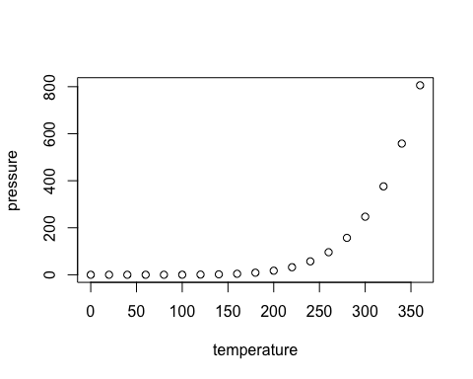

Note that the echo = FALSE parameter was added to the code chunk to prevent printing of the R code that generated the plot.

## Including Tables

|  |  |
| --- | --- |
| CDM | Common data model |
| DPP4 | Dipeptidyl peptidase-4 |
| GLP1 | Glucagon-like peptide-1 |
| IRB | Institutional review board |
| LEGEND | Large-scale Evidence Generation and Evaluation across a Network of Databases |
| MACE | Major adverse cardiovascular event |
| MDRR | Minimum detectable risk ratio |
| OHDSI | Observational Health Data Science and Informatics |
| OMOP | Observational Medical Outcomes Partnership |
| PS | Propensity score |
| RCT | Randomized controlled trial |
| SGLT2 | Sodium-glucose co-transporter-2 |
| T2DM | Type 2 diabetes mellitus |