Tourism and Recreation EWG 3.1
Table of contents

1. Tourism and Recreation EWG 3.1
Interactive website: Tourism and Recreation EWG 3.1

1.1 Early Look: Tourism & Recreation (TR)
We plan to review our current estimates of TR scores at the Expert Working Group meeting 3.1 on July 16, 2026. This document is intended to provide attendees with an overview of the goal model and its inputs, and an early look at its outputs, leading up to the meeting. If you read through this and have minor methodological concerns, please flag them and bring them to the meeting. If you have major methodological concerns, please share them with me ahead of time (my email is smanos@nceas.ucsb.edu). If you cannot make it to the meeting but would like to discuss, I am happy to meet 1:1 before or after.
Please be advised that this document is intended for internal use only and informational purposes. It should not be interpreted as the final word or of peer-review quality.
Thank you for your continued engagement with this work. We look forward to discussing these scores with you on July 16th!

1.2 About the TR Goal
The Tourism & Recreation (TR) goal measures the quantity, quality, and sustainability of experiences that people have when visiting coastal and marine areas.
To start, we must first acknowledge why Tourism & Recreation is an important benefit that we obtain through a healthy ocean. The Ocean Health Index acknowledges the reality that people are part of the ecosystem: we cannot eliminate contact, direct or indirect, between people and the ocean, nor do we want to. Ergo, the basic philosophy of the Ocean Health Index is that it measures how well ocean systems are sustainably providing people with the benefits and services they both need and desire from marine systems.
And the reality is that while there are real harms of excessive, unmanaged visitation and recreation, there are also massive benefits to having opportunities for people to connect with the Gulf, its wildlife, and local culture. These opportunities, in addition to pure enjoyment, can create a deep appreciation for marine systems and even promote conservation ideologies. Additionally, local inhabitants of the Gulf can benefit from an increase in job opportunities and the associated earned income.
This goal captures the quantity, quality, and sustainability of experiences that people have when visiting coastal and marine areas.
CORE DEFINITION
- Focus: Value that people derive from experiencing and enjoying coastal areas
- Not about: Revenue or livelihoods generated by tourism (covered under Livelihoods and Economies)
- Emphasis: Personal and cultural value of coastal recreation experiences

1.2.1 Goal model
The overall Tourism & Recreation score is the average of three components:
TR = average(Quantity, Quality, Sustainability)
Component | What it measures
Quantity | Tourist arrivals (average of domestic and international visitors from SECTUR DataTur)
Quality | Average of safety of tourists (crime index) and availability of activities (food & drink, culture & gulf related, and other recreation relative to tourist arrivals)
Sustainability | Average of hotel certifications (Distintivo S, Green Key, Green Globe), Blue Flag beaches, tourism management investment (CONANP programs), and job quality in tourism
Scores are calculated for each of the nine OHI Gulf of California regions from 2019 to 2024. A score of 100 represents the reference point (ideal sustainable state).

1.3 Overall Tourism and Recreation status
The overall Tourism and Recreation (TR) current status score summarizes how close each OHI Gulf of California region is to sustainable coastal recreation experiences. It integrates three equally weighted components: Quantity (visitor arrivals), Quality (safety and activity availability), and Sustainability (certifications, beach management, job quality, and public investment). Scores are calculated annually from 2019 to 2024 for all nine marine regions. A score of 100 represents the reference point (ideal sustainable state).
What scores mean for expert review: Higher TR scores signal that a region is closer to improved recreation conditions across visitation levels according to government targets, visitor experience quality, and long-term ability to manage tourism sustainably. Lower scores highlight where arrivals, safety, activity availability, certifications, employment quality, or public investment still fall short of reference targets. As friendly reviewers, you can use regional lines to compare trajectories and note whether gains in visitor arrivals are matched by improvements in safety and sustainability.
Data sources: Merged current status outputs from SECTUR DataTur (quantity), SESNSP and INEGI DENUE (quality), and CONANP, FEE Blue Flag, SECTUR certifications, and INEGI Censos Economicos (sustainability).
Method: For each region and year, the three component scores are averaged. Component scores themselves are built from sub-indicators described in the sections below.
$${\text{TR}}_{r,t}=\frac{Q_{r,t}+Ql_{r,t}+S_{r,t}}{3}$$
where $Q$ = Quantity, $Ql$ = Quality, and $S$ = Sustainability (each already expressed on a 0 to 100 scale, so TR is also on a 0 to 100 scale). Scores above 100 are not applied at this level because component scores are capped where noted below.
Things to note: Safety-based quality indicators have limited SESNSP coverage for Regions 2 and 6 (Western and Eastern Midriff Islands). Activity availability depends on DENUE establishment counts within 50 km of the coast and SECTUR/DENUE gap-filled arrivals. Sustainability job-quality scores use INEGI census years (2003 to 2023) interpolated to annual values for 2019 to 2024.

1.3.1 Regional trajectories for overall TR
The chart below shows the overall TR current status score by region and year. Each colored line is one OHI region; compare values across years. The dashed line at 100 marks the reference goal. Values below 100 indicate that one or more components remain below their reference targets; values at or near 100 indicate progress toward sustainable tourism and recreation across quantity, quality, and sustainability dimensions. Steeper upward slopes suggest faster improvement; flat or declining lines may warrant closer review of the underlying sub-indicators.
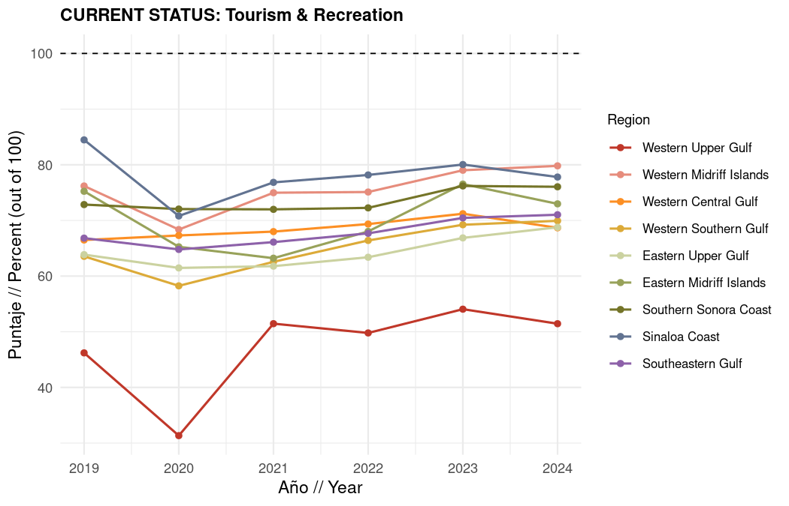

1.3.2 Gulf-wide average TR current status
What it measures: The same overall TR score averaged across all nine OHI Gulf of California regions for each year.
Data source: Merged TR current status outputs.
Method: For each year, the Gulf-wide line is the simple mean of regional TR scores:
$${\text{TR}}_{t}^{\text{GOC}}=\frac{1}{9}\sum_{r=1}^{9}{{\text{TR}}_{r,t}}$$
The chart below summarizes the average trajectory across all regions. Compare it with the regional chart above to see whether Gulf-wide patterns are driven by a few regions or shared across the coast.
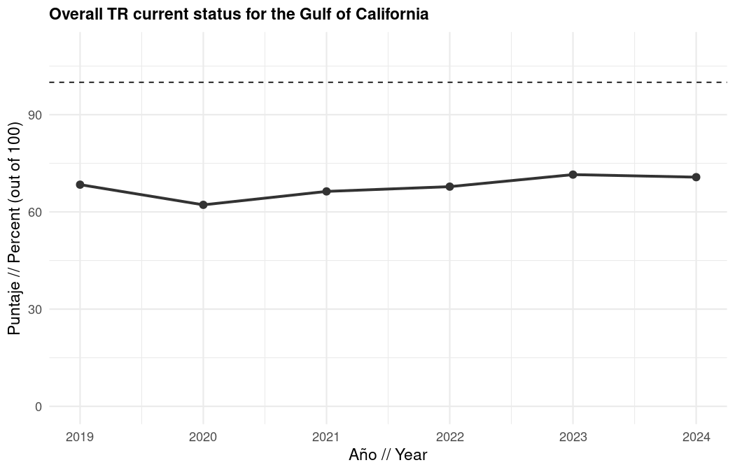

1.4 Quantity
The Quantity component measures the scale of coastal and marine visitor activity relative to Plan Mexico 2030 tourism growth targets. It reflects how close regional tourist arrivals are to planned increases in domestic and international visitation, rather than measuring revenue or economic impact (those are covered under Livelihoods and Economies).
What scores mean for expert review: A score of 100 means arrivals have reached or exceeded the 2030 Plan Mexico target for that arrival type. Scores below 100 indicate visitation still below target, gaps worth discussing as you review regional trajectories against policy goals.
Data sources: SECTUR DataTur hotel monitoring reports (llegadas de turistas residentes for domestic arrivals and llegadas de turistas no residentes for international arrivals), aggregated to OHI regions. Missing municipal arrival data are gap-filled using DENUE accommodation employee models and state-level domestic/international arrival proportions.
Data processing: Tourist centers are geocoded and intersected with OHI region boundaries. Municipal gaps are filled by scaling DENUE accommodation employment to estimated arrivals using state-level domestic/international splits. Arrivals are summed to the regional level for 2019 to 2024.
Method: Quantity is the simple average of domestic and international arrival scores. Each arrival type is compared to a fixed 2030 target based on 2024 baseline arrivals. Scores above 100 are capped at 100.
$${\text{Quantity}}_{r,t}=\frac{{\text{Domestic}}_{r,t}+{\text{International}}_{r,t}}{2}$$
Data limitations: Regions without direct SECTUR tourist-center reporting rely on DENUE gap-filling, which introduces additional uncertainty. San Ignacio has limited DataTur coverage. International and domestic targets use separate 2030 growth rates (30% and 9.8% above 2024, respectively).

1.4.1 Quantity component result
What it measures: Combined progress toward Plan Mexico 2030 arrival targets for domestic and international visitors.
Data source: SECTUR DataTur (2019 to 2024), with DENUE gap-filling for municipalities without direct reporting.
Method: Average of capped domestic and international current status scores per region and year.
$${\text{Quantity}}_{r,t}=\frac{1}{2}\left(min\left(100, \frac{A_{r,t}^{\text{dom}}}{A_{r,2024}^{\text{dom}}×1.098}×100\right)+min\left(100, \frac{A_{r,t}^{\text{int}}}{A_{r,2024}^{\text{int}}×1.30}×100\right)\right)$$
where $A^{\text{dom}}$ and $A^{\text{int}}$ are regional domestic and international tourist arrivals, and the denominators are the 2030 targets (9.8% above 2024 for domestic, 30% above 2024 for international).
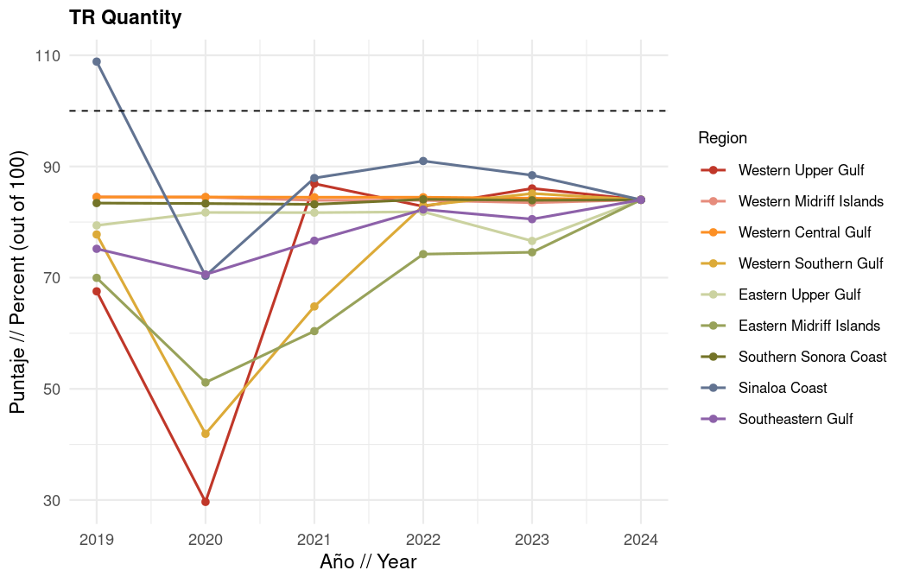

1.4.1.1 Total arrivals by state (raw counts)
This chart shows total state-level tourist arrivals after merging SECTUR DataTur reporting with DENUE gap-filled values. Use it to see absolute visitation levels underlying the Quantity current status scores.
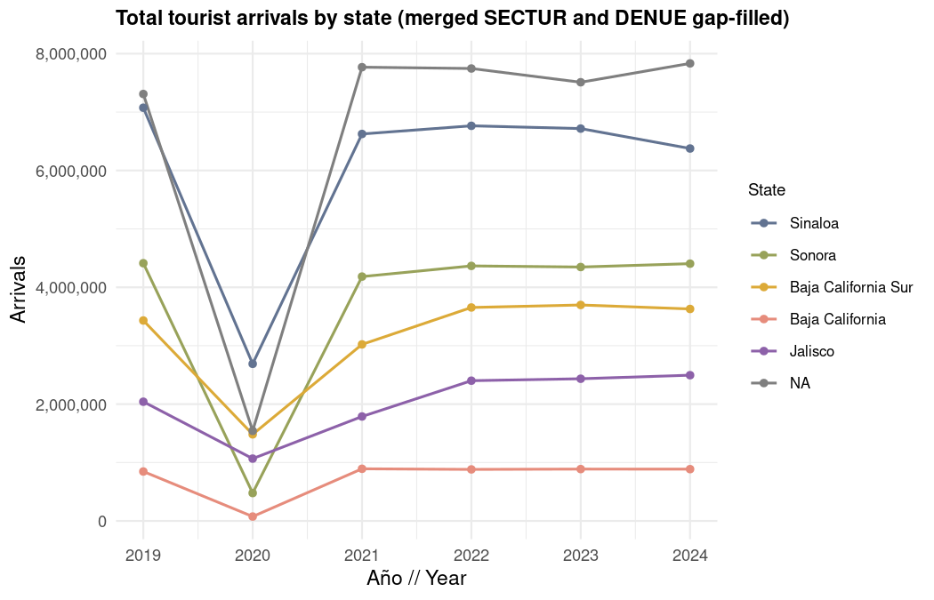

1.4.1.2 Quantity subcomponents

1.4.1.2.1 Domestic arrivals
What it measures: How close regional domestic tourist arrivals are to the Plan Mexico 2030 target of 9.8% growth above 2024 levels.
What scores mean: Higher scores indicate domestic visitation is approaching or meeting national growth targets. Lower scores suggest domestic tourism recovery or expansion is lagging, which may affect local businesses reliant on national visitors.
Data source: SECTUR DataTur llegadas de turistas residentes, assigned to OHI regions via tourist center geocoding and spatial intersection.
Data processing: Monthly DataTur hotel reports are cleaned, pivoted to annual totals, and assigned to regions. Municipalities without arrival data are gapfilled using estimated arrivals based on the number of hotel employees.
Method: Current status is the ratio of observed domestic arrivals to the 2030 target, which is a 9.8% increase by 2030, expressed as a percentage and capped at 100.
$${\text{Domestic}}_{r,t}=min\left(100, \frac{A_{r,t}^{\text{dom}}}{A_{r,2024}^{\text{dom}}×1.098}×100\right)$$

1.4.1.2.2 International arrivals
What it measures: How close regional international tourist arrivals are to the Plan Mexico 2030 target of 30% growth above 2024 levels.
What scores mean: Higher scores reflect stronger international demand relative to policy targets. Lower scores may signal barriers to international visitation such as connectivity, marketing, or perceived destination quality.
Data source: SECTUR DataTur llegadas de turistas no residentes, assigned to OHI regions via tourist center geocoding and spatial intersection.
Data processing: Same pipeline as domestic arrivals, with separate state-level international arrival proportions for gap-filling.
Method: Current status is the ratio of observed international arrivals to the 2030 target, which is a 30% increase by 2030, expressed as a percentage and capped at 100.
$${\text{International}}_{r,t}=min\left(100, \frac{A_{r,t}^{\text{int}}}{A_{r,2024}^{\text{int}}×1.30}×100\right)$$
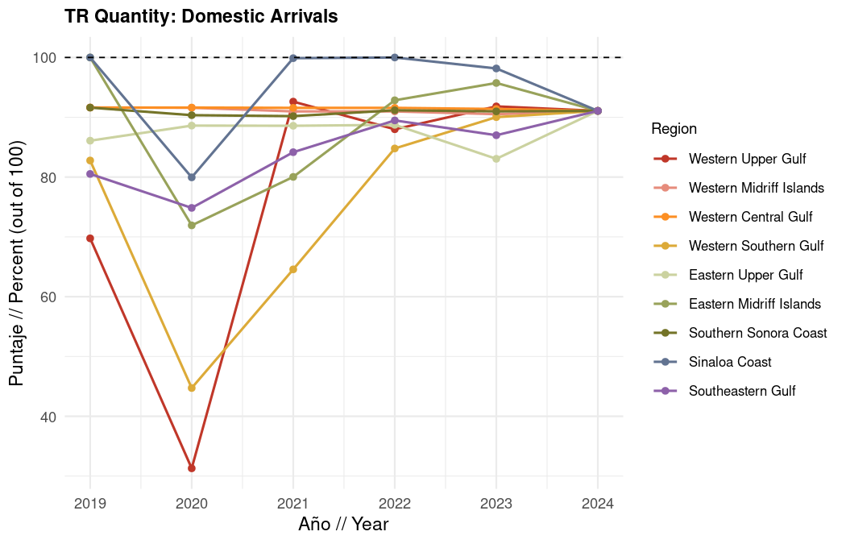
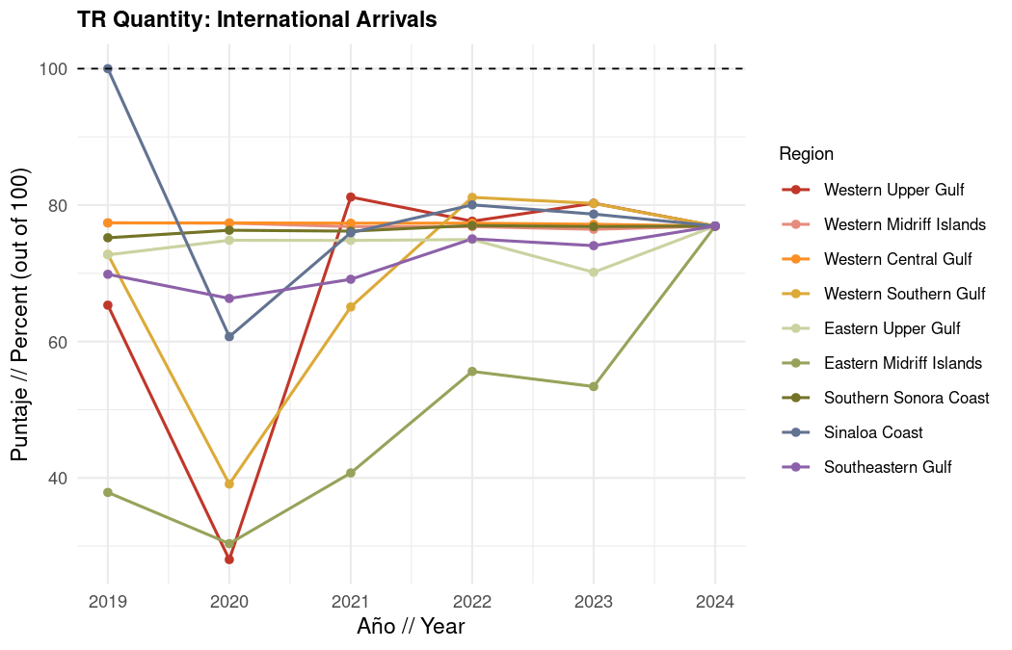

1.5 Quality
The Quality component captures how safe and enriching coastal visits are for tourists. It combines two equally weighted sub-indicators: safety of tourists (inverse crime index) and availability of activities (food and beverage, culture and Gulf-related, and other recreation services relative to tourist arrivals).
What scores mean for expert review: Higher Quality scores indicate safer destinations with more recreation services per visitor. Lower scores may reflect elevated crime rates, fewer dining and cultural options relative to arrivals, or both. Sub-indicator charts help you see whether safety or activity availability drives regional differences.
Data sources: SESNSP municipal crime statistics (weighted by crime type), INEGI municipal population (interpolated), INEGI DENUE economic units within 50 km of the coast, and SECTUR/DENUE gap-filled tourist arrivals.
Data processing: Crime counts are filtered to tourism-relevant subtypes, weighted, and divided by interpolated coastal municipal population. DENUE establishments are classified into three activity categories; employee counts are estimated from establishment size classes and divided by regional tourist arrivals. Activity scores use the 90th quantile of employees-per-arrival across all region-year observations as the reference (cross-regional comparison, not within-region).
Method: Quality is the average of the safety score and the weighted activities score.
$${\text{Quality}}_{r,t}=\frac{{\text{Safety}}_{r,t}+{\text{Activities}}_{r,t}}{2}$$

1.5.1 Quality component result
What it measures: Combined tourist safety and availability of recreation services relative to reference conditions.
Data source: SESNSP, INEGI population, INEGI DENUE, and SECTUR arrivals.
Method: Simple average of safety and activities scores.
$${\text{Quality}}_{r,t}=\frac{{\text{Safety}}_{r,t}+{\text{Activities}}_{r,t}}{2}$$
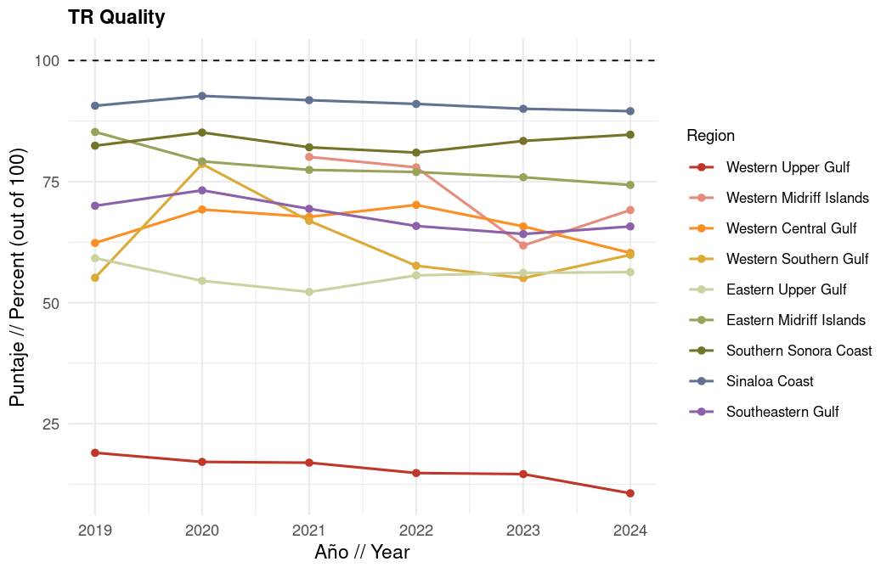

1.5.1.1 Quality subcomponents

1.5.1.1.1 Safety of tourists (crime index)
What it measures: Relative safety from crimes that plausibly alter safety, cleanliness, aesthetics, or atmosphere in spaces tourists visit, which in turn affects visit quality.
What scores mean for expert review: A score of 100 means zero weighted crimes per coastal inhabitant (the best possible outcome). A score of 0 means the region-year has the highest weighted crime rate observed across all Gulf regions and years. Intermediate values reflect proportional distance from the worst-case rate. Higher scores indicate lower weighted crime rates per coastal inhabitant.
Data source: SESNSP (Secretariado Ejecutivo del Sistema Nacional de Seguridad Publica) annual municipal crime incidence by crime subtype; INEGI population interpolated to annual estimates for Gulf-bordering municipalities. Mexicali is excluded from crime calculations because its crime profile reflects border dynamics rather than Gulf coastal tourism.
Selection rule: Crimes are included if they plausibly alter safety, cleanliness, aesthetics, or atmosphere in spaces tourists visit. Subtypes not meeting this criterion (e.g., crimes committed by public servants, prison escapes) are dropped.
Two weight categories:
Category | Weight | Rationale
Crimes against person | 2 | Direct threat to visitor safety or strong link to unsafe atmosphere
Crimes against property | 1 | Financial loss or environmental damage affecting visit quality
Crimes against person (weight = 2):
- Sexual crimes: Abuso sexual, Acoso sexual, Hostigamiento sexual, Otros delitos que atentan contra la libertad y la seguridad sexual, Violacion equiparada, Violacion simple
- Violence and bodily harm: Feminicidio, Homicidio doloso, Lesiones dolosas, Otros delitos que atentan contra la vida y la integridad corporal
- Deprivation of liberty: Otros delitos que atentan contra la libertad personal, Rapto, Secuestro, Trafico de menores
- Coercion and threats: Amenazas, Extorsion, Violencia de genero en todas sus modalidades distinta a la violencia familiar
- Robbery with personal exposure: Robo a transeunte en espacio abierto al publico, Robo a transeunte en via publica, Robo en transporte individual, Robo en transporte publico colectivo, Robo en transporte publico individual
- Society-linked crimes: Corrupcion de menores, Otros delitos contra la sociedad, Trata de personas, Narcomenudeo
Crimes against property (weight = 1):
- Dano a la propiedad, Fraude, Otros delitos contra el patrimonio, Otros robos, Robo a casa habitacion, Robo a institucion bancaria, Robo a negocio, Robo a transportista, Robo de autopartes, Robo de vehiculo automotor, Contra el medio ambiente
Weighted crimes per coastal inhabitant:
Cr,t=i​wi⋅ni,r,tPr,tcoastal
where $n_{i,r,t}$ is the count of crime subtype $i$ in region $r$ and year $t$, $w_{i}$ is the category weight (2 or 1), and $P_{r,t}^{\text{coastal}}$ is interpolated coastal municipal population summed to the region.
Method: Weighted crimes per capita are converted to a safety score where the region-year with the highest per capita crime rate receives 0 and zero crimes receives 100. Scores above 100 are capped at 100.
$${\text{Safety}}_{r,t}=min\left(100, \left(1−\frac{C_{r,t}}{C_{max}}\right)×100\right)$$
where $C_{max}$ is the maximum weighted crimes per coastal inhabitant across all regions and years.
Data limitations: Regions 2 and 6 (Western and Eastern Midriff Islands) may have limited or no documented SESNSP crime data in the municipal records used here, which can produce missing or uncertain safety scores for those regions. Population for Region 2 uses special handling because San Quintin municipality was created in 2020.

1.5.1.1.2 Availability of activities
What it measures: Availability of food and beverage, culture and Gulf-related, and other recreation services relative to tourist arrivals, using estimated DENUE employees per tourist arrival.
What scores mean: Higher scores mean a region offers more recreation employees per visitor compared to the Gulf-wide 90th quantile benchmark. Lower scores suggest thinner service provision relative to visitation, which may affect visitor satisfaction even when arrival numbers are high.
Data source: INEGI DENUE service establishment shapefiles (food and beverage, cultural and recreational services) within 50 km of the Gulf coast; gap-filled SECTUR tourist arrivals.
Data processing: Establishments are assigned employee counts from DENUE size-class midpoints, summed by category and region-year, then divided by tourist arrivals. The 90th quantile of employees-per-arrival is computed across all region-year observations (cross-regional, not within-region).
Method: Three activity categories are scored against the Gulf-wide 90th quantile reference, then combined with weights of 2/5, 2/5, and 1/5. Scores above 100 are capped at 100.
$${\text{Activities}}_{r,t}=\frac{2}{5} {\text{Food\&Bev}}_{r,t}+\frac{2}{5} {\text{Culture}}_{r,t}+\frac{1}{5} {\text{Other}}_{r,t}$$
$${\text{Category}}_{r,t}=min\left(100, \frac{\left(E_{r,t}/A_{r,t}\right)}{Q_{90}\left(E/A\text{ across all }r,t\right)}×100\right)$$
where $E_{r,t}$ is category employees, $A_{r,t}$ is tourist arrivals, and $Q_{90}$ is the 90th quantile of the employees-per-arrival ratio pooled across all regions and years for that category.
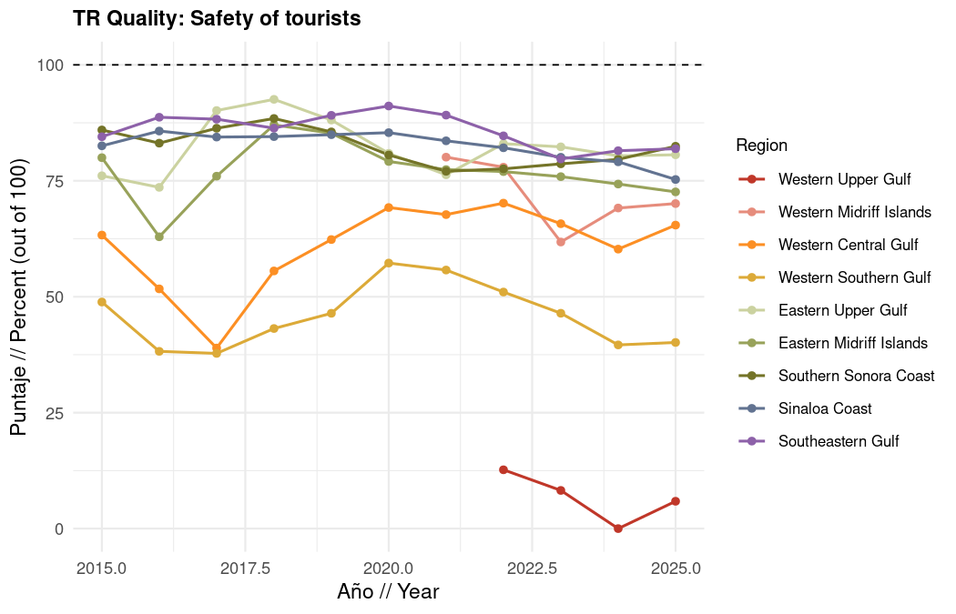
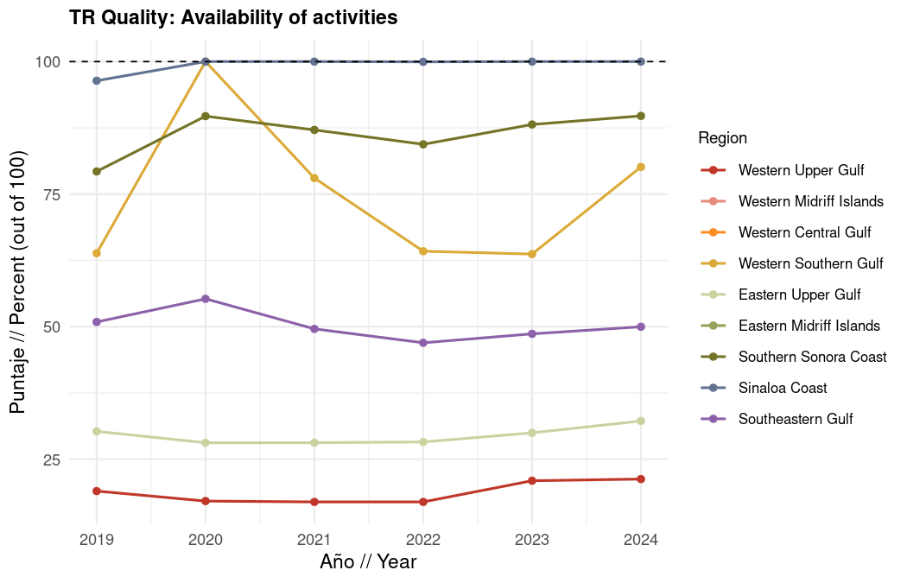

1.5.1.1.3 Quality activity categories

1.5.1.1.3.1 Food and beverage activities
What it measures: Density of food and beverage service employees relative to tourist arrivals, compared to the 90th quantile across all region-year observations.
What scores mean: Scores near 100 indicate among the highest food and beverage service density per visitor in the Gulf. Lower scores suggest fewer dining options per arrival relative to top-performing region-years.
Data source: INEGI DENUE servicios de alojamiento temporal y preparacion de alimentos y bebidas establishments within 50 km; SECTUR/DENUE arrivals.
Data processing: Employee counts estimated from DENUE establishment size classes; summed by region and year; divided by gap-filled arrivals. Reference is $Q_{90}$ of employees-per-arrival pooled across all regions and years.
Method: Employees per tourist arrival in year $t$ divided by the Gulf-wide 90th quantile reference, capped at 100.
$${\text{Food\&Bev}}_{r,t}=min\left(100, \frac{\left(E_{r,t}^{\text{fb}}/A_{r,t}\right)}{Q_{90}\left(E^{\text{fb}}/A\text{ across all }r,t\right)}×100\right)$$

1.5.1.1.3.2 Culture and Gulf activities
What it measures: Density of cultural, heritage, marine tourism, and museum service employees relative to tourist arrivals, compared to the 90th quantile across all region-year observations.
What scores mean: Higher scores reflect richer cultural and Gulf-oriented recreation per visitor. Lower scores may indicate fewer museums, heritage sites, or marine tourism services relative to visitation.
Data source: INEGI DENUE cultural and recreational service establishments (museums, historical sites, marine tourism, nature heritage) within 50 km; SECTUR/DENUE arrivals.
Data processing: Same quantile-based scoring as food and beverage, using culture-specific DENUE activity codes.
Method: Employees per tourist arrival in year $t$ divided by the Gulf-wide 90th quantile reference, capped at 100.
$${\text{Culture}}_{r,t}=min\left(100, \frac{\left(E_{r,t}^{\text{cult}}/A_{r,t}\right)}{Q_{90}\left(E^{\text{cult}}/A\text{ across all }r,t\right)}×100\right)$$

1.5.1.1.3.3 Other recreation activities
What it measures: Density of other recreational service employees (fitness centers, sports clubs, entertainment venues, etc.) relative to tourist arrivals, compared to the 90th quantile across all region-year observations.
What scores mean: Higher scores indicate more general recreation infrastructure per visitor. Lower scores suggest limited supplementary recreation beyond core dining and cultural offerings.
Data source: INEGI DENUE other recreational service establishments within 50 km; SECTUR/DENUE arrivals.
Data processing: Same quantile-based scoring pipeline; this category receives 1/5 weight in the merged activities score.
Method: Employees per tourist arrival in year $t$ divided by the Gulf-wide 90th quantile reference, capped at 100.
$${\text{Other}}_{r,t}=min\left(100, \frac{\left(E_{r,t}^{\text{oth}}/A_{r,t}\right)}{Q_{90}\left(E^{\text{oth}}/A\text{ across all }r,t\right)}×100\right)$$
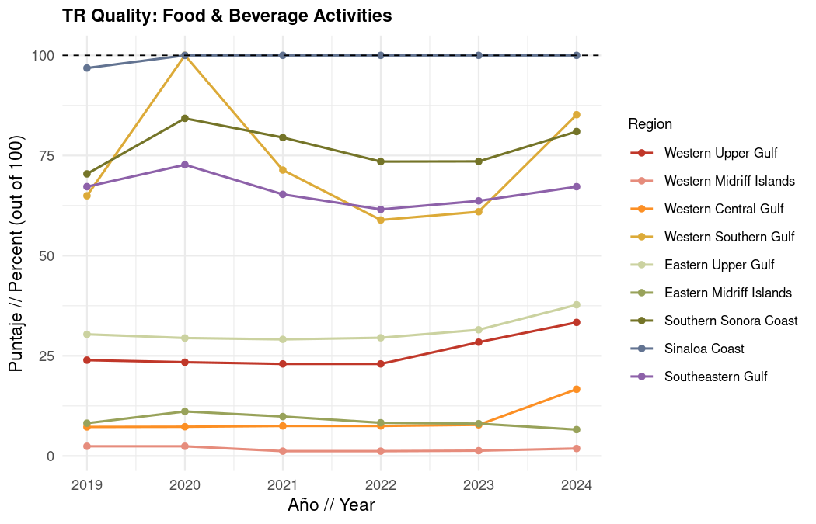
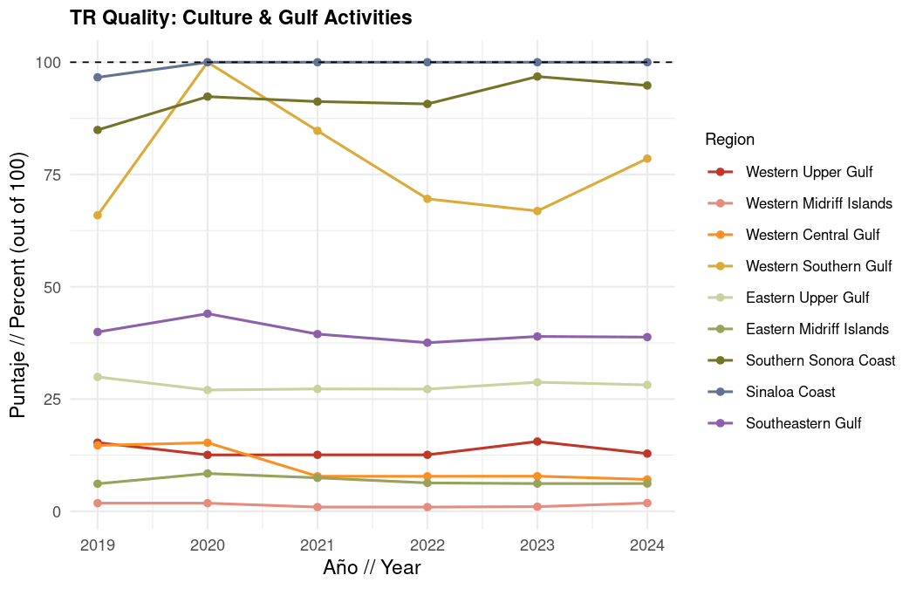
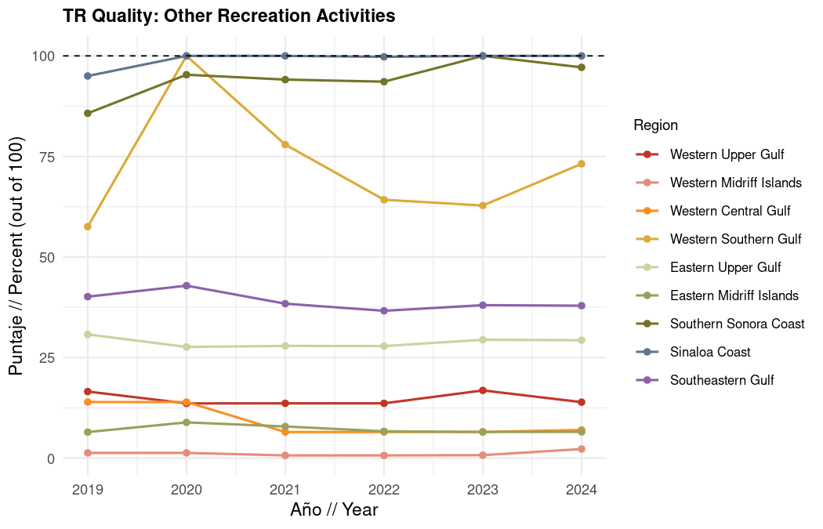

1.6 Sustainability
The Sustainability component evaluates whether tourism growth is supported by certified sustainable practices, well-managed beaches, equitable formal employment, and adequate potential public investment in coastal conservation and protected area management.
What scores mean: Higher Sustainability scores indicate stronger adoption of green certifications, better beach management, improved tourism job quality, and sustained public investment in protected areas. Lower scores highlight gaps in sustainable tourism infrastructure that may undermine long-term coastal health even when visitor numbers grow.
Data sources: SECTUR Distintivo S, Green Key, and Green Globe certification records matched to INEGI DENUE hotels; FEE Blue Flag Mexico beach registry; INEGI Censos Economicos (marine tourism employment, census years 2003, 2008, 2013, 2018, 2023); CONANP federal budget program data and SHCP fee return records (NOSSA).
Data processing: Hotel certifications are manually matched to DENUE accommodation units with 100+ employees within 50 km of the Gulf coast, because sustainability certification programs primarily target established large hotels. Blue Flag beach length is measured against total highly-visited beach length per region (see Blue Flag details below). Job quality metrics use constant 2023 pesos and coastal population multipliers, then interpolate census-year scores to annual values for 2019 to 2024. Investment programs compare current CONANP budgets to 2012 to 2018 averages in constant 2026 pesos.
Method: Sustainability is the average of four sub-components: certifications (hotel and Blue Flag), job quality, and tourism management investment.
$${\text{Sustainability}}_{r,t}=\frac{{\text{Cert}}_{r,t}+{\text{JobQual}}_{r,t}+{\text{Invest}}_{r,t}}{3}$$
Note: Certifications merges hotel sustainability certifications and Blue Flag beaches before entering the overall sustainability average alongside job quality and investment.

1.6.1 Sustainability component result
What it measures: Combined progress on sustainable certifications, tourism employment quality, and public investment in coastal management.
Data source: SECTUR, FEE, INEGI, and CONANP/SHCP as described above.
Method: Average of the certifications (hotel + Blue Flag), job quality, and investment scores.
$${\text{Sustainability}}_{r,t}=\text{mean}\left({\text{Certifications}}_{r,t}, {\text{JobQual}}_{r,t}, {\text{Invest}}_{r,t}\right)$$
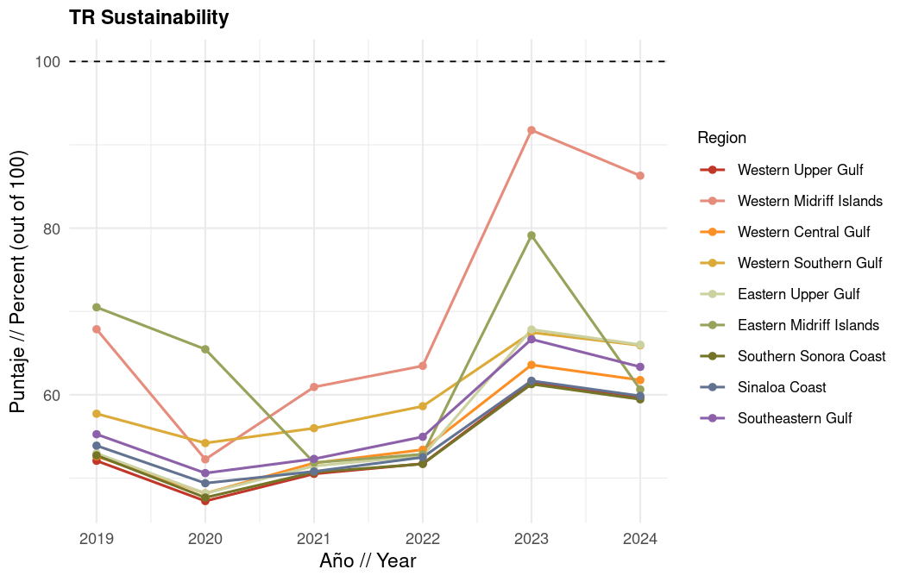

1.6.1.1 Sustainability subcomponents

1.6.1.1.1 Certifications (hotel and Blue Flag combined)
What it measures: Share of large coastal hotels with sustainability certifications (Distintivo S, Green Key, or Green Globe) and share of highly-visited beach length under Blue Flag management.
What scores mean for expert review: Higher scores reflect greater adoption of recognized sustainability standards. Rising scores indicate progress toward industry best practices; flat lines may signal certification barriers or limited program uptake worth discussing with the expert working group.
Data source: SECTUR certification databases, Green Key and Green Globe member lists, INEGI DENUE accommodation units; FEE Blue Flag Mexico and INEGI coastline beach and cliff linework.
Data processing: Hotels matched to DENUE by name/location. Blue Flag sites are intersected with the highly-visited beach network described below; a beach segment counts as certified if it hosts at least one active Blue Flag site.
Method: Hotel and Blue Flag scores are averaged for each region and year.
$${\text{Certifications}}_{r,t}=\frac{{\text{Hotels}}_{r,t}+{\text{BlueFlag}}_{r,t}}{2}$$

1.6.1.1.2 Job quality in tourism
What it measures: Quality of formal employment in marine tourism sectors across maintained compensation, job formalization, and gender pay equity in formalization rates.
What scores mean for expert review: Higher scores indicate better-paid, more formalized, and more gender-equitable tourism jobs. You can interpret sub-metrics separately: salary tracks compensation trends, formalization tracks contract coverage, and gender equity tracks whether women receive equal formalization rates as men.
Data source: INEGI Censos Economicos (2003, 2008, 2013, 2018, 2023), limited to marine tourism economic units, adjusted to constant 2023 pesos and coastal population multipliers.
Data processing: Census-year values are linearly interpolated to produce annual scores for 2019 to 2024 plotting. Coastal adjustments apply to Regions 3 and 4 and tourism-related sectors in Regions 1 to 9.
Method: Average of three sub-metrics (maintained salary, formalization, gender equity). Census-year scores are interpolated to annual values for plotting.
$${\text{JobQual}}_{r,t}=\frac{{\text{Salary}}_{r,t}+{\text{Formal}}_{r,t}+{\text{Gender}}_{r,t}}{3}$$

1.6.1.1.3 Tourism management investment
What it measures: Federal investment in CONANP protected area programs relative to the 2012 to 2018 historical average, combined with the percentage of collected protected area fees returned from SHCP.
What scores mean: Higher scores indicate federal budgets and fee returns are at or above historical levels, supporting protected-area management that underpins sustainable tourism. Because budget programs are national, these scores apply uniformly across regions; fee return reflects treasury reinvestment policy.
Data source: CONANP federal budget by program (v003 ANP management, s046 sustainable conservation, v005 protection and restoration); NOSSA/CONANP fee return data.
Data processing: Budget values converted to constant 2026 pesos; 2012 to 2018 mean used as reference for each program.
Method: Average of four program-level current status scores (three CONANP budget programs plus SHCP fee return). Budget programs use the 2012 to 2018 average as reference; fee return is expressed directly as a percentage.
$${\text{Invest}}_{r,t}=\text{mean}\left({\text{ANP}}_{r,t}, {\text{S046}}_{r,t}, {\text{V005}}_{r,t}, {\text{SHCP}}_{r,t}\right)$$
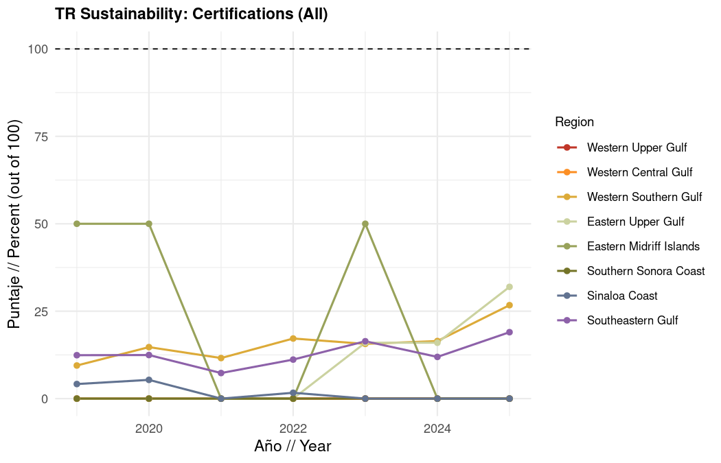
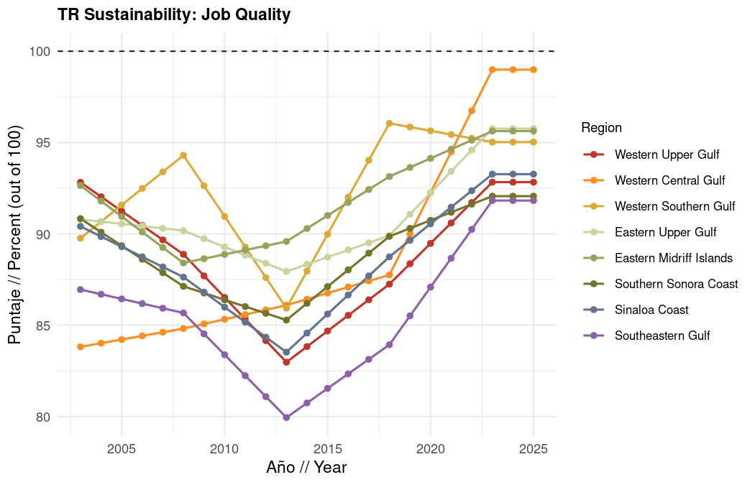
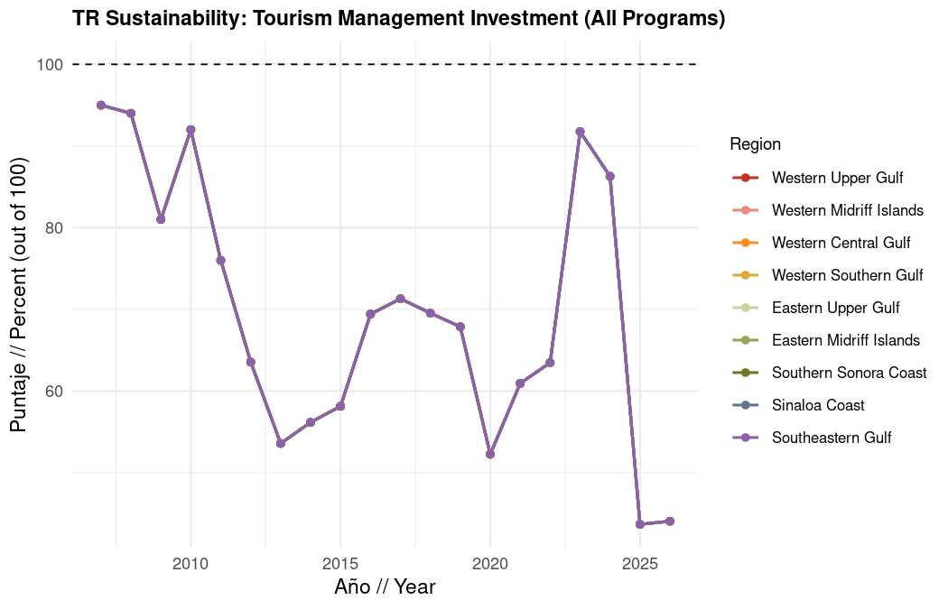

1.6.1.1.4 Certification details

1.6.1.1.4.1 Hotel sustainability certifications
What it measures: Percentage of large hotels (100+ employees within 50 km of the Gulf coast) holding at least one sustainability certification (Distintivo S, Green Key, or Green Globe).
Data source: SECTUR Distintivo S registry, Green Key Mexico, Green Globe Americas member list, manually matched to INEGI DENUE accommodation economic units.
Method: Certified large hotels divided by total large hotels, expressed as a percentage. Scores above 100 are capped at 100.
$${\text{Hotels}}_{r,t}=min\left(100, \frac{N_{r,t}^{\text{certified}}}{N_{r,t}^{\text{total large}}}×100\right)$$

1.6.1.1.4.2 Blue Flag beach certifications
What it measures: Share of highly-visited beach length in each region that holds an active Blue Flag certification.
What scores mean: Higher scores indicate that a larger share of beaches where tourists actually concentrate are managed under the Blue Flag standard (water quality, safety, access, waste management, environmental education, and related criteria). Lower scores highlight gaps in certified management at heavily used shorelines.
Data source: FEE Foundation for Environmental Education Blue Flag Mexico registry; INEGI coastline beach and cliff linework; INEGI locality boundaries; DENUE hotel employment; and manually reviewed beach segments for large coastal hotels.
Defining highly-visited beaches: The denominator is not all Gulf shoreline. Instead, highly-visited beaches are beach/cliff segments within 400 m of INEGI locality polygons where summed hotel employees total at least 100 (the threshold was set using the lowest employee total among localities with an existing Blue Flag site at the time of analysis, 56 employees, rounded up for consistency). Beach segments in front of large hotels (56+ employees) that are not already captured by a locality polygon were added manually after map review. Gulf-side port areas used by tourists were also included. Beaches associated with the federal Playas Limpias program were added to the highly-visited network because they represent regularly managed public beaches even when hotel density is lower. Beach linework is cropped to these 400 m buffers so the indicator compares certified length to the shoreline segments tourists are most likely to use, rather than entire uninterrupted INEGI beach units that may extend beyond visitation areas.
Method: Length of highly-visited beach segments with at least one active Blue Flag certification divided by total highly-visited beach length, expressed as a percentage. A beach counts as certified if it has one or more active Blue Flag sites.
$${\text{BlueFlag}}_{r,t}=\frac{L_{r,t}^{\text{blue flag}}}{L_{r,t}^{\text{tourist beaches}}}×100$$
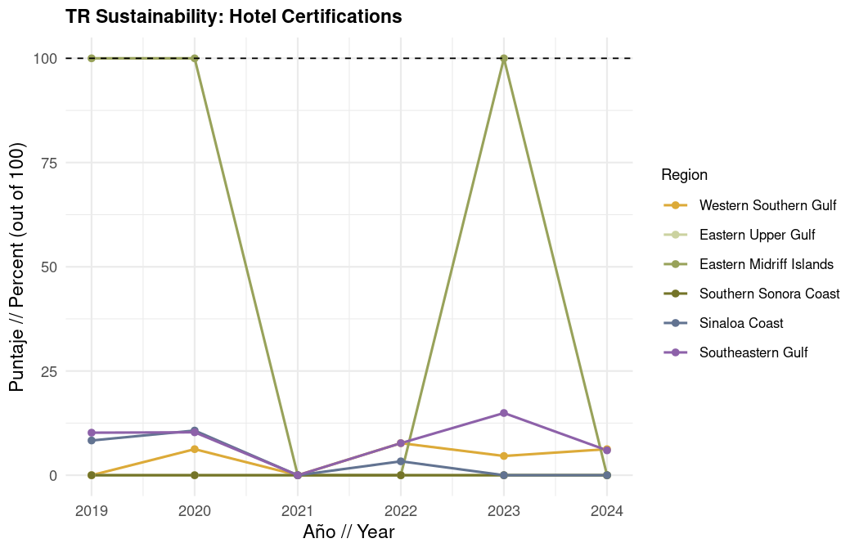
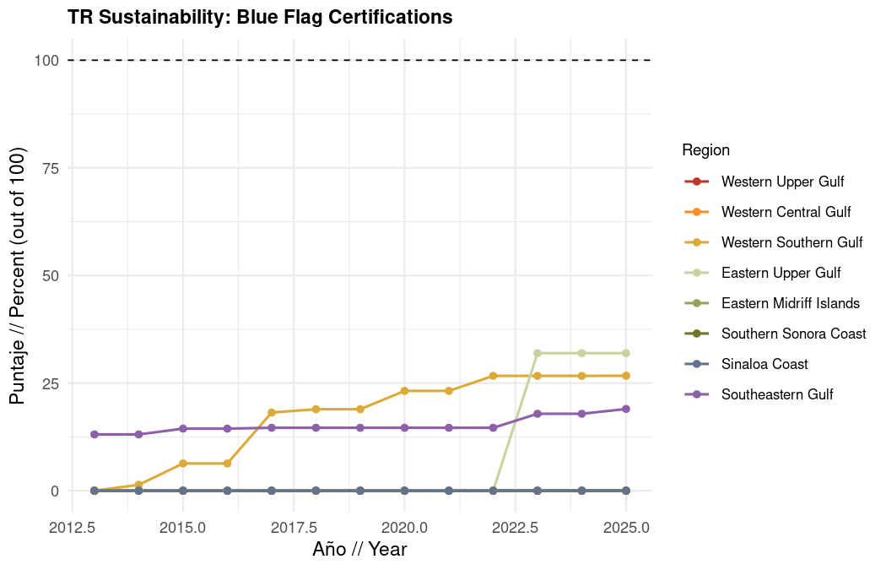

1.6.1.1.5 Job quality details

1.6.1.1.5.1 Maintained salary
What it measures: Total compensation per paid worker (J000A / H010A) in marine tourism sectors relative to the 2003 to 2018 historical regional average.
Data source: INEGI Censos Economicos remuneration and employment variables for marine tourism units, in constant 2023 pesos.
Method: Current compensation per paid worker divided by the 2003 to 2018 regional average, capped at 100.
$${\text{Salary}}_{r,t}=min\left(100, \frac{\left(J000A_{r,t}/H010A_{r,t}\right)}{{\overline{J000A/H010A}}_{r, 2003\text{-}2018}}×100\right)$$

1.6.1.1.5.2 Formal/paid workers
What it measures: Share of tourism sector workers who are paid/formalized (H010A / H000A) relative to an ideal of 90% formalization.
Data source: INEGI Censos Economicos employment variables for marine tourism units.
Method: Current formalization rate divided by the 90% ideal, capped at 100.
$${\text{Formal}}_{r,t}=min\left(100, \frac{\left(H010A_{r,t}/H000A_{r,t}\right)}{0.90}×100\right)$$

1.6.1.1.5.3 Gender pay equity (formalization equity)
What it measures: Whether the share of formalized female workers equals or exceeds the share of formalized male workers in marine tourism.
Data source: INEGI Censos Economicos gender-disaggregated employment (H010B/H000B for men, H010C/H000C for women).
Method: Ratio of female to male formalization rates. A ratio of 1 or greater scores 100; lower ratios are scaled proportionally.
$${\text{Gender}}_{r,t}=\left\{\begin{matrix}100 & \text{if }\frac{{\left(H010C/H000C\right)}_{r,t}}{{\left(H010B/H000B\right)}_{r,t}}≥1 \\ \frac{{\left(H010C/H000C\right)}_{r,t}}{{\left(H010B/H000B\right)}_{r,t}}×100 & \text{otherwise}\end{matrix}\right.$$
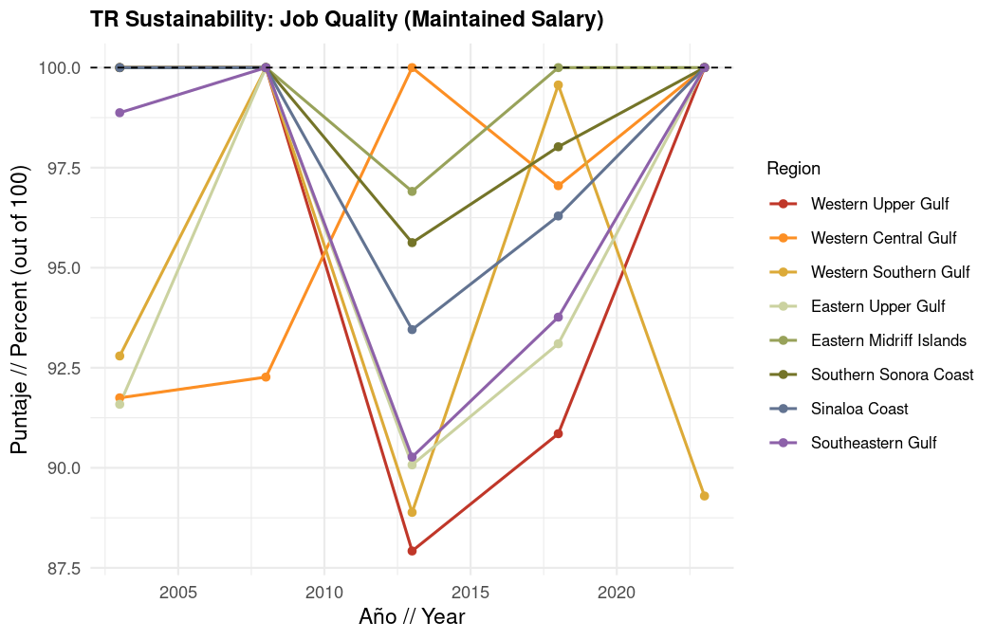
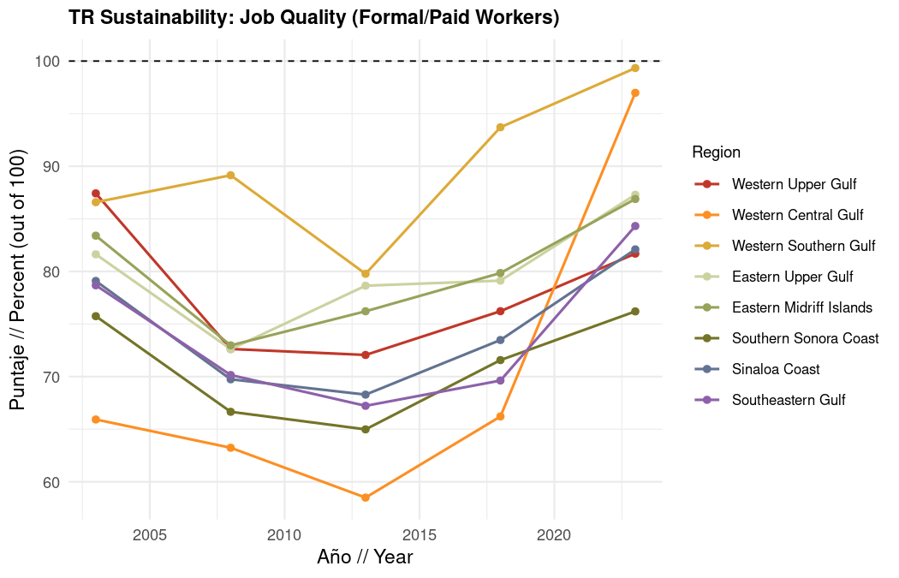
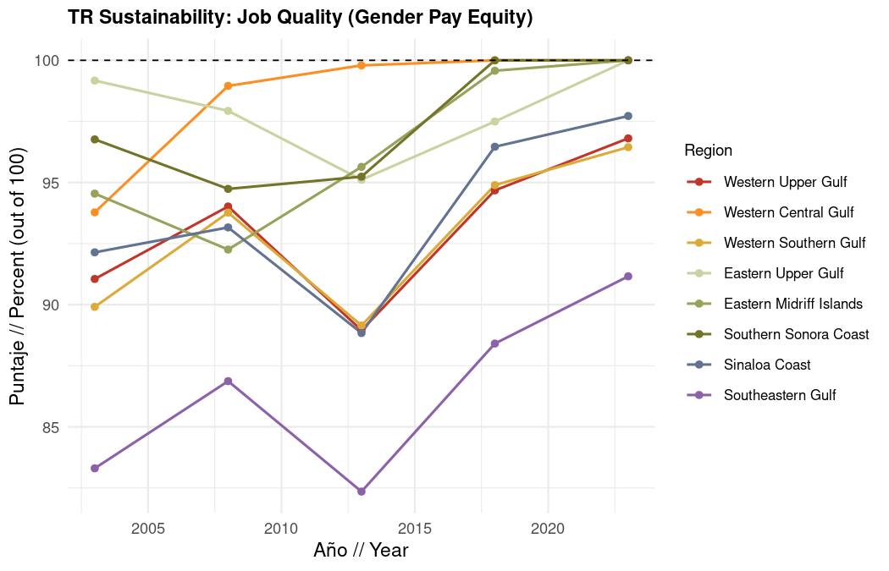

1.6.1.1.6 Investment program details

1.6.1.1.6.1 ANP management (v003)
What it measures: CONANP federal budget for Area Natural Protegida management (program v003) relative to the 2012 to 2018 historical average (constant 2026 pesos).
Data source: CONANP federal budget program data.
Method: Current year budget divided by the 2012 to 2018 average, capped at 100. This score applies uniformly across all regions because federal budget is national.
$${\text{ANP}}_{t}=min\left(100, \frac{B_{t}^{\text{v003}}}{{\overline{B^{\text{v003}}}}_{2012\text{-}2018}}×100\right)$$

1.6.1.1.6.2 Sustainable conservation (s046)
What it measures: CONANP federal budget for sustainable conservation programs (s046) relative to the 2012 to 2018 historical average.
Data source: CONANP federal budget program data.
Method: Current year budget divided by the 2012 to 2018 average, capped at 100.
$${\text{S046}}_{t}=min\left(100, \frac{B_{t}^{\text{s046}}}{{\overline{B^{\text{s046}}}}_{2012\text{-}2018}}×100\right)$$

1.6.1.1.6.3 Protection and restoration (v005)
What it measures: CONANP federal budget for ecosystem protection and species-at-risk restoration (v005) relative to the 2012 to 2018 historical average.
Data source: CONANP federal budget program data.
Method: Current year budget divided by the 2012 to 2018 average, capped at 100.
$${\text{V005}}_{t}=min\left(100, \frac{B_{t}^{\text{v005}}}{{\overline{B^{\text{v005}}}}_{2012\text{-}2018}}×100\right)$$

1.6.1.1.6.4 Returned fees from SHCP
What it measures: Percentage of protected area entrance fees (cobro de derechos) collected by CONANP that are returned from the federal treasury (SHCP) for reinvestment in protected areas.
Data source: NOSSA/CONANP fee return records.
Method: The reported percentage returned is used directly as the current status score (100 = full return).
$${\text{SHCP}}_{t}=P_{t}^{\text{return}}×100$$
where $P_{t}^{\text{return}}$ is the fraction of collected fees returned in year $t$.
