Aligning marine species range data to better serve science and conservation

Casey O'Hara1, Jamie C. Afflerbach1, Benjamin S. Halpern1, 2, 3

*Author affiliation:*

1. National Center for Ecological Analysis and Synthesis, 735 State Street Suite 300, Santa Barbara CA 93101
2. Bren School of Environmental Science and Management, University of California, Santa Barbara CA 93106
3. Department of Life Sciences, Imperial College London, Silwood Park Campus, Buckhurst Rd, Ascot, West Berkshire SL5 7PY, United Kingdom

*Corresponding author:* Casey O'Hara, National Center for Ecological Analysis and Synthesis, 735 State Street, Suite 300, Santa Barbara CA 93101; (805) 892-2500; [ohara@nceas.ucsb.edu](mailto:ohara@nceas.ucsb.edu)

*Classification:* BIOLOGICAL SCIENCES: Ecology? Environmental Sciences? Sustainability Science?

*Keywords:* TBD

## Abstract

*Abstract. Provide an abstract of no more than 250 words on page 2 of the manuscript. Abstracts should explain to the general reader the major contributions of the article. References in the abstract must be cited in full within the abstract itself and cited in the text.*

Species distribution data provide the foundation for a wide range of ecological research and conservation science and management, yet most species ranges remain unknown, and existing range maps have little overlap. AquaMaps and the International Union for Conservation of Nature (IUCN) are two distinct efforts to map marine species distributions at a global scale. Together, these two databases represent 28,847 unique species [add % in AM and % in IUCN]. These two datasets are commonly used in ecology and conservation but have just 2,046 species in common. Here we examine differences in predicted species ranges between the two datasets, propose mechanistic causes and potential solutions for such differences, and explore the implications of these differences for management and conservation decisions. We find that IUCN maps often disregard bathymetry for depth-limited species, leading to predictions of species presence at unsuitable depths, and AquaMaps ranges for data-poor species often extrapolate presence far afield from known occurrences. We illustrate the implications of these differences by repeating two recent applications - the Ocean Health Index biodiversity goal and a global analysis of gaps in coverage of marine protected areas - and find significantly different estimates of the status of global biodiversity and effectiveness of conservation depending on which dataset was used. ***Creating a single, highly accurate dataset of global marine species ranges will be difficult. Understanding the implications of dataset differences for conservation planning and decision-making is essential.***

(223 words; 1593 char with spaces)

## Significance

*Significance Statement. Authors must submit a 120-word-maximum statement about the significance of their research paper written at a level understandable to an undergraduate-educated scientist outside their field of specialty. The primary goal of the Significance Statement is to explain the relevance of the work in broad context to a broad readership. The Significance Statement appears in the paper itself and is required for all research papers.*

|  |  |  |
| --- | --- | --- |
| Section | Word # | Char # (w/spc) |
| Introduction | 512 words | 3411 char |
| Results/Discussion | 802 words | 5410 char |
| Implications (incomplete) | 532 words | 3334 char |
| Conclusions | 390 words | 2813 char |
| Methods (incomplete) | 612 words | 3889 char |
| total body | 2848 words | 18857 char |

# Introduction

Mapping species ranges and distributions is fundamental to ecology, conservation and natural resource management. This knowledge provides foundational information for understanding species ranges and diversity, predicting species responses to human impacts and climate change, and managing and protecting species effectively. Accuracy and uncertainty are inherent challenges of species range mapping. Mapping location and range of marine species are even more challenging than terrestrial species due to the nature of the habitat and data availability.

Two global-scale efforts have been made to predict marine species ranges globally – AquaMaps (Kaschner et al. 2013) and International Union for Conservation of Nature (IUCN) (REF). These two spatial datasets have been used for a wide range of purposes, including assessing marine species conservation status (Halpern et al. 2012, 2015 *both*; Selig et al. 2013 *both*), evaluating global biodiversity patterns (Coll et al. 2010 *AM*; Martin et al. 2014 *both and others*, Pimm 2014 *IUCN, mostly focusing on terrestrial but some marine*), predicting species range shifts (Molinos et al. 2015 *AquaMaps*, and setting conservation priorities (Klein et al. 2015 *AquaMaps*).

***BSH:*** *I think Julie makes this comment below, but we may need to be able to substantiate this somehow. Is there a way to quickly figure out how many studies have used AM vs. IUCN?*

***CCO:*** *What about age - AquaMaps is pretty recent (2006 at earliest); before that, would IUCN have been the dominant dataset for marine? Maybe we can track citations of AquaMaps, but citations of IUCN are generic - just cite the Red List - not referencing spatial information specifically, much less marine. Going by citation year field on the maps themselves, the oldest marine record I can find is 2004.*

*Four foundational papers relating to AquaMaps (Kaschner et al. 2006, 2011; 2013; Ready et al. 2010) have been cited a total of 379 times.*

The two datasets ostensibly describe the same information, but significant differences in methodology and intent could lead to dramatically different understandings of our marine ecosystems, with significant implications for policy and conservation. Importantly, biases in taxonomic or spatial coverage within a dataset could shift management and conservation actions away from places or species that are most in need. Inaccurate indications of presence or absence could lead to ineffective marine reserve systems and management plans (Rondinini et al. 2006) (Jetz 2008?).

To understand the implications of differences between the AquaMaps and IUCN datasets, we compare how each data source represents the global spatial and taxonomic distribution of species. Most notably, AquaMaps includes range maps for many more species (currently 22,889 species; 79.3% of total), such that most global analyses related to biodiversity to date have used AquaMaps (IUCN range map data exist for only 4,027 unique species). For the 2,013 species (7% of total) mapped in both datasets, we examine how well the maps align, determine several issues that lead to misalignment between predicted species distributions, and outline possible improvements.

We then reexamine two recent marine biodiversity studies - an assessment of the status of global biodiversity within the Ocean Health Index (Halpern et al. 2012, 2015) and a global analysis of gaps in protection afforded by marine protected areas (MPAs) (Klein et al. 2015) - as case studies to explore the implications of prioritizing one data set over the other. The results highlight the possible consequences of different data use decisions on our understanding of marine biodiversity status and protection.

# Results and Discussion

## How and why the datasets differ

The IUCN publishes species range maps, bundled by taxonomic groups (REF), based on expert input on spatial boundaries of a given species' "limits of distribution" (REF IUCN 2014) - essentially a refined extent of occurrence, based on observation records and refined by expert understanding of the species' range and habitat preferences. In contrast, AquaMaps uses a species distribution model (SDM) based on environmental preferences (e.g. temperature, depth, salinity) deduced from occurrence records, published species databases such as FishBase, and expert knowledge. The AquaMaps model overlays these environmental preferences atop a map of environmental attributes on a 0.5 degree grid, creating a global raster of probability of occurrence for each species (AquaMaps 2013).

The methodologies behind these datasets imply differences in prediction of species distribution due to errors of commission (falsely *(erroneously? less accusatory, but an annoying word)* indicating species presence) and omission (falsely indicating species absence). Geographic range data such as IUCN range maps generally include large commission errors, while predicted distribution models such as AquaMaps will likely include fewer commission errors but more omission errors. Each type of error bears different implications for conservation goals: commission errors can result in prioritizing areas not relevant to conservation goals, while omission errors may result in protected area networks that fail to include important habitat and range (Rondinini, 2006).

The two datasets have notably different taxonomic (Fig. 1A) and regional (Fig. 1B,C) coverage. IUCN-mapped species are primarily found in tropical latitudes and away from the Atlantic and Eastern Pacific compared to AquaMaps-mapped species. These differences can be mitigated by using both datasets, but the underlying methodological differences complicate such direct comparisons.

To explore differences in species ranges between the two datasets, we plotted the distribution alignment (where on the map) against the ratio of extent (how much of the map) for each shared species (Fig. 2A).

A general negative linear pattern emerges, suggesting that increasing similarity in extent correlates with decreasing distribution alignment. AquaMaps tends to extrapolate species ranges beyond known occurrences, such that the marginal range predicted by AquaMaps will fall in different locations than the marginal range predicted using IUCN methodology. For species with dissimilar extents, predicted distribution for the smaller range can more easily fall within the generous bounds of the larger range. For species with increasingly similar extents, differences in methodology become more difficult to "hide," and the distribution alignment generally becomes poorer.

By dividing the map-paired species into quadrants, we highlight different categories of relationships that in turn help further explain the general pattern. The upper right quadrant includes species (n = 399) whose described ranges agree in both spatial distribution and extent. These species tend to be well-studied and include wide-ranging pelagic organisms such as marine mammals, tunas, and billfishes (Fig. 2B). This result is not surprising, as species with very large ranges are likely to be more aligned regardless of methodology simply because of their global range.

The extent-mismatched ranges contained in the upper left quadrant (n = 624) include species whose spatial distribution is similar, but where the IUCN range is notably larger, often extending into deeper water. For example, corals dominate this quadrant (n = 221; 35.4% of all species in this quadrant) because IUCN range maps tend to extend corals into waters beyond their preferred depths, likely introducing errors of commission. Ocean depth is explicitly included in AquaMaps models, while depth is frequently overlooked as a factor in IUCN range maps. Simply restricting IUCN range maps to known depth preferences would resolve many of these mismatches.

Species found in the lower right quadrant (n = 624) often represent cases of "two wrongs make a right." For these species, IUCN ranges frequently overextend into unsuitable depths, as in the case of many upper left quadrant species, while at the same time AquaMaps ranges often aggressively extrapolate presence into locations where IUCN predicts absence, introducing additional commission errors. Consequently, area ratios are close to 100%, though similar extents are meaningless when the distributions are poorly aligned.

The most vexing cases are in the lower left quadrant (n = 399), where neither distribution nor extent match well. Data-poor species are more common in this quadrant. The median number of species occurrence records in OBIS and GBIF for this quadrant is NA, compared to a median of for species across the other three quadrants. When extrapolating from limited observations, the AquaMaps model often predicts species presence well beyond known occurrences, introducing commission errors; at the same time, IUCN range maps generally target known occurrences, possibly introducing omission errors for data-limited species.

# Implications

There are clear and significant differences in species range descriptions between AquaMaps and IUCN range maps, due to method-driven differences in errors of commission and omission. To examine the implications of these differences, we replicated two recent studies, varying only the prioritization of one data set over the other.

**Case Study: The Ocean Health Index**

The global Ocean Health Index (OHI) (Halpern et al. 2012, 2015) is a composite index comprising ten sustainable benefits provided by a healthy ocean, uses species spatial distribution data and IUCN Red List conservation status to calculate biodiversity status (scored from zero to 100) for each of the world's 221 exclusive economic zones. To maximize the number of represented species, OHI uses spatial distributions from both IUCN and AquaMaps datasets to represent species ranges for use in the Biodiversity goal. The model prioritizes IUCN data for the 2013 species included in both sources. OHI currently uses a probability threshold of 40% to determine species presence for AquaMaps data.

We recalculated the OHI species status score under several scenarios to observe the impact of toggling the prioritized between IUCN and AquaMaps, and toggling the AquaMaps presence threshold from 40% to 0% (Fig. 3). Given that only 2,013 species overlap out of 28,847, it is surprising that changing the priority from IUCN maps to AquaMaps would result in such large score shifts as seen in scenarios 2 and 3. While many country scores showed only small variation across all three scenarios, select countries gained as many as 5 points while others dropped up to 12 points. Significantly, the global score decreased by two full points in scenario 3, indicating that an arbitrary change in how the two datasets are combined results in a more dire assessment of species conservation status.

**Case Study: MPA Gap Analysis**

Klein et al. (2015) compare global distribution of marine species to the global distribution of marine protected areas to assess how well the MPAs protect key species and identify which species fall through gaps in protection. The study relied on the AquaMaps database, using a probability of occurrence threshold of 50% or greater, to determine species presence, and the World Database of Protected Areas to define zones of marine protection. The study determined that the global MPA network is inadequate in protecting marine biodiversity; 90.5% of species have less than 5% of their overall range represented within MPAs and 1.4% of species have no protection at all ("gap" species).

Figure 4 displays the results of applying this methodology under new scenarios. When comparing the conclusions based upon an IUCN-only scenario to an AquaMaps-only scenario (using 2015 data and a 0% threshold sets the most meaningful comparison) we found a five-fold increase in the proportion of gap species (6.4% vs 1.2%) and dramatically larger proportion of species with less than 2% of their range protected (73.2% vs. 47.7%). However, this comparison also indicates a larger proportion of well-protected species with greater than 10% of range protected (2.9% vs. 1.5%). Conclusions drawn from each of these datasets would paint dramatically different pictures of the protection afforded by our current global MPA network.

# Conclusions

AquaMaps and IUCN range maps provide important spatial information on marine species ranges, and show reasonable agreement for many well-studied species, but illustrate uncertainty in our understanding of spatial distribution for many others. Identifying and addressing differences in these datasets can increase their utility for ecology research and conservation actions. We have identified several likely drivers of commission errors and omission errors between these datasets, pointing toward improvements to better align the predictions of species distributions.

**Suggestions for data providers:**

* The IUCN Red List instructional materials for mapping marine species suggest that "bathymetry can be used to delineate species' ranges limited by depth in the same way as elevation is used for terrestrial species" (REF <https://www.conservationtraining.org/mod/scorm/player.php?a=1412&currentorg=M5L1_ORG&scoid=6492>). Unfortunately, this recommendation appears to be applied inconsistently. Especially for demersal communities dependent on photosynthesis, bathymetry should be a primary consideration; even a simple cutoff at the photosynthetic limit of 200 meters would minimize a likely source of commission errors.
* The AquaMaps model is a powerful tool for quickly estimating species distribution based on limited information; however, the model's output is only as good as the input data, which for marine species is often limited. AquaMaps encourages experts to review and comment on the predicted species distribution maps; lessons from the small sample of reviewed maps can be generalized, for example to other species in the same taxonomic group, to further refine the predictions. This is especially important for data-poor species.
* In addition to environmental preferences and conditions, AquaMaps mapping parameters include area restrictions to help limit over-extrapolation of AquaMaps models. Currently the area restrictions are denoted by FAO Major Fishing Areas (REF find a reference in AquaMaps somewhere); however, area restrictions based on biogeographical criteria, e.g. Marine Ecoregions of the World (REF), would likely provide better resolution and predictive power, especially for data-poor species.

**Suggestions for data users:**

* For depth-limited species and taxa, clipping IUCN range polygons to a reasonable bathymetry contour can reduce commission errors due to overprediction of species presence into unsuitable habitats.
* Using both datasets together can increase the taxonomic and spatial breadth of coverage, as long as the differences between the datasets can be reasonably minimized. Consider:
  + An AquaMaps presence threshold of 0% most closely approximates the "limits of distribution" defined by IUCN range maps.
  + Additional filters on AquaMaps distribution criteria, such as expert review status or the number of occurrence cells used to generate the species model, can help avoid overextrapolation for data poor species.

*(do we need a wrap-it-up paragraph here? I put that more at the top of the conclusions section... could shift it down here, but probably not needed in both places)*

# Methods

**Comparison of taxonomic and regional distribution:**

The proportion of species by taxonomic class was calculated across both datasets (Fig. 1A).

For range map comparison between IUCN and AquaMaps, all IUCN species polygons were rasterized to the same 0.5° grid as the AquaMaps species maps. A value of 1 was assigned to each 0.5° cell that overlapped the species range polygon. For the AquaMaps dataset, we determined per-cell species richness by counting all species with non-zero probability of occurrence, to best approximate the "extent of occurrence" generally indicated by IUCN maps. We represented relative distribution of species richness for each dataset by plotting species count against latitude and longitude (Fig. 1B, 1C).

**Comparison of paired maps:** Using genus and species binomials as a matching key, we selected the subset of marine species that have range maps in both IUCN and AquaMaps current native distribution. To avoid double-counting, we removed subpopulations and species aliases. We determined species presence within each spatial cell using the same criteria as outlined above.

Overlaying paired distribution maps for a given species, we defined and calculated *distribution alignment* and *extent alignment* and plotted these in Fig. 2:

We visually inspected a random selection of paired distribution maps from each quadrant to identify possible mechanistic causes of misalignment. To verify that IUCN predicted unsuitable habitat for depth limited species, we used QGIS (REF) to overlay a selection of IUCN and AquaMaps maps with a 200 meter bathymetry contour.

**Methods for OHI case study:**  Using methods and supplemental materials from OHI (Halpern et al. 2012, 2015), we modified the original code for OHI 2015 Species status (SPP) (REF), allowing for flexibility in prioritized data source and AquaMaps presence threshold. We ran the SPP code three times, prioritizing IUCN over AquaMaps for a 0% threshold, and prioritizing AquaMaps over IUCN for both a 40% and 0% threshold. We compared each of these to the output of the published OHI 2015 SPP model (prioritizing IUCN over AquaMaps at a 40% threshold).

**Methods for MPA Gap Analysis case study:** Based upon the methods described in Klein et al. 2015, we reconstructed the analysis using the subset of protected areas spatially covering a marine area and classified as IUCN I-IV ***(Klein paper, table 1, subset 4 - seems to be the one they focus on the most)***, converting the World Database of Protected Areas (WDPA, REF) dataset to a raster of 0.5° cells indicating proportion of protected area within the cell ***(consider also: filter on STATUS == 'Designated', and filter out those pesky fishery management areas and manatee speed zones...)***. To verify our reconstruction we ran the analysis using the AquaMaps dataset available in April 2015 (REF) at a presence threshold of 50%. We then updated the analysis using the most recent AquaMaps dataset (REF?) at 50% threshold

* Possible analyses:
  + run AquaMaps (new data) with threshold at 0%
    - already done in original paper for old data, but redo it to compare to AM + IUCN scenario below
  + run with IUCN maps only in place of AquaMaps?
  + run with AquaMaps and IUCN both, using 0% threshold; which preferred?
* Which aspects of the analysis should we focus on?:
  + overall vs broken down by taxonomic groups? (see paper, figure 1)
  + spatial distribution of gap species (see paper, figure 2) <!--

# Figures and captions

***still need work on captions; then separate captions from images***

### Fig. 1

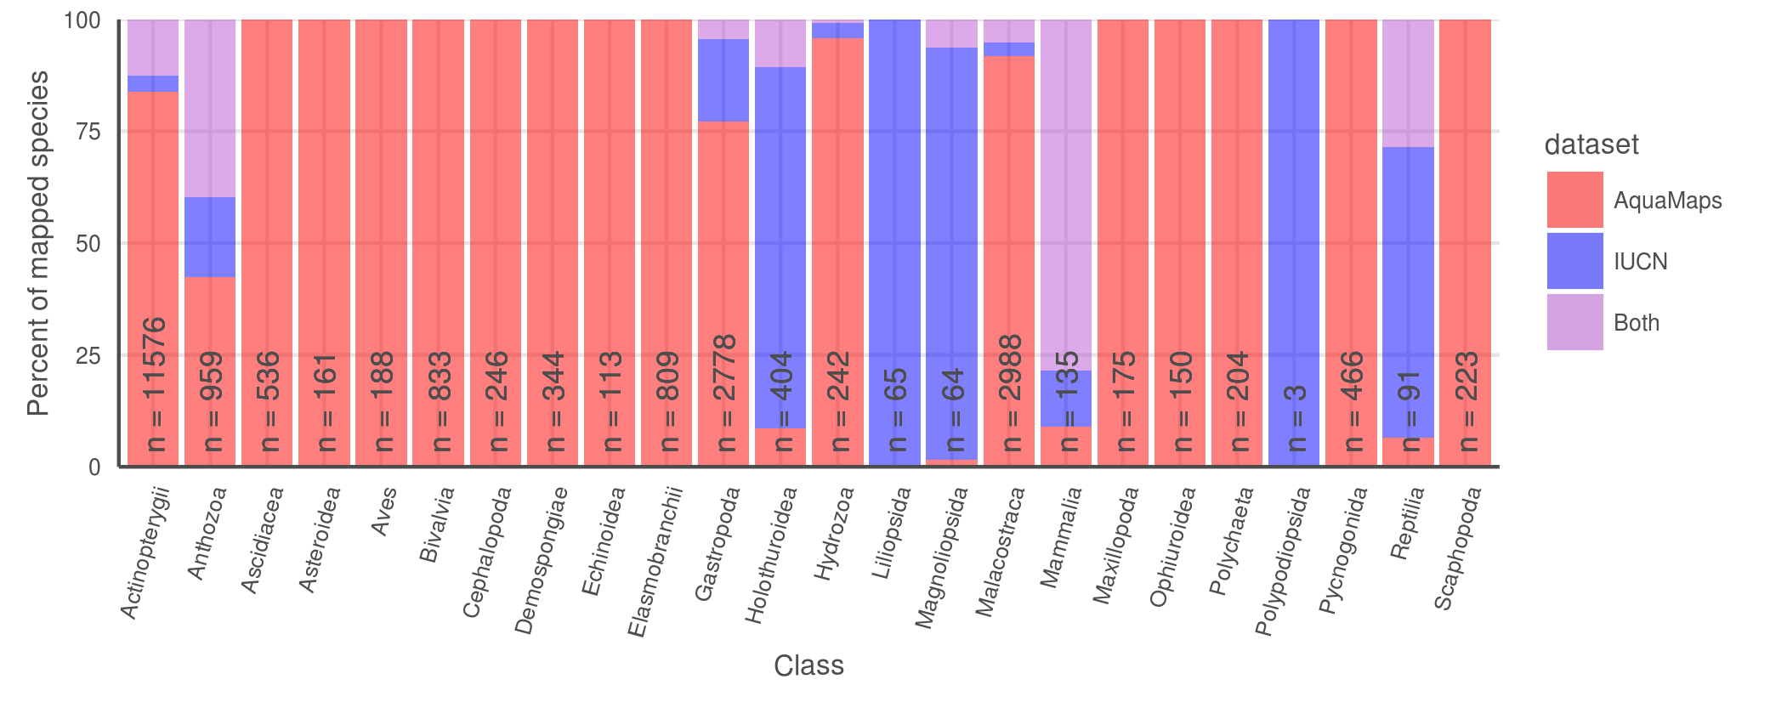

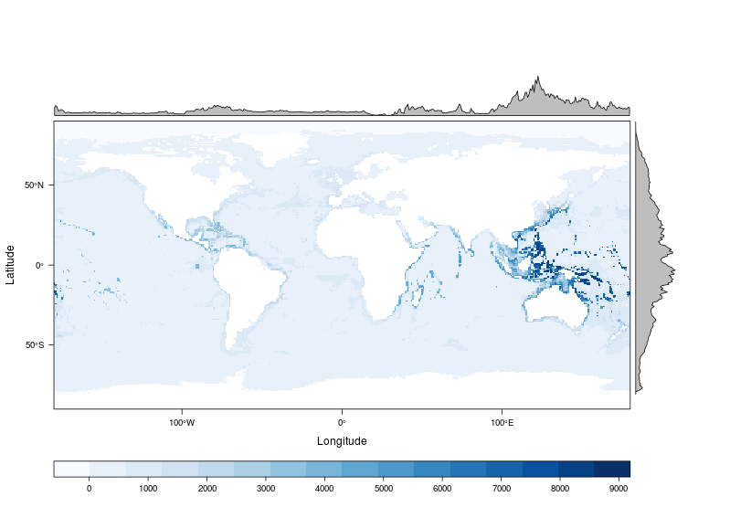

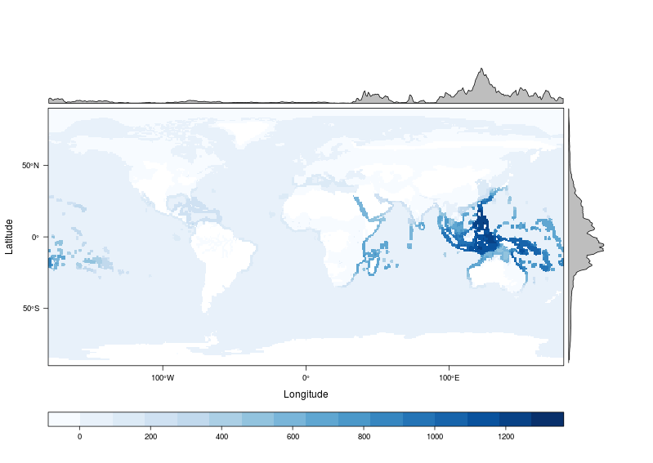

**Fig. 1.** (A) Number and proportion of species by taxa included in each dataset. AquaMaps encompasses a broader range of taxa than IUCN, while IUCN focuses on comprehensively assessing select taxonomic groups, typically at the level of order or family. Overlapping species are dominated by bony fishes (896 species, primarily tropical taxa) and corals (362 species). Global marine species richness according to (B) AquaMaps and (C) IUCN. The margin frequency plots show relative species count per cell at each latitude and longitude; while both datasets peak in tropical latitudes near the equator, the frequency for IUCN maps drops quickly beyond 30°N and 30°S, while the frequency for AquaMaps remains robust well into temperate latitudes. The longitude frequency plots show a slight bias in the IUCN dataset away from the Atlantic and eastern Pacific compared to AquaMaps.

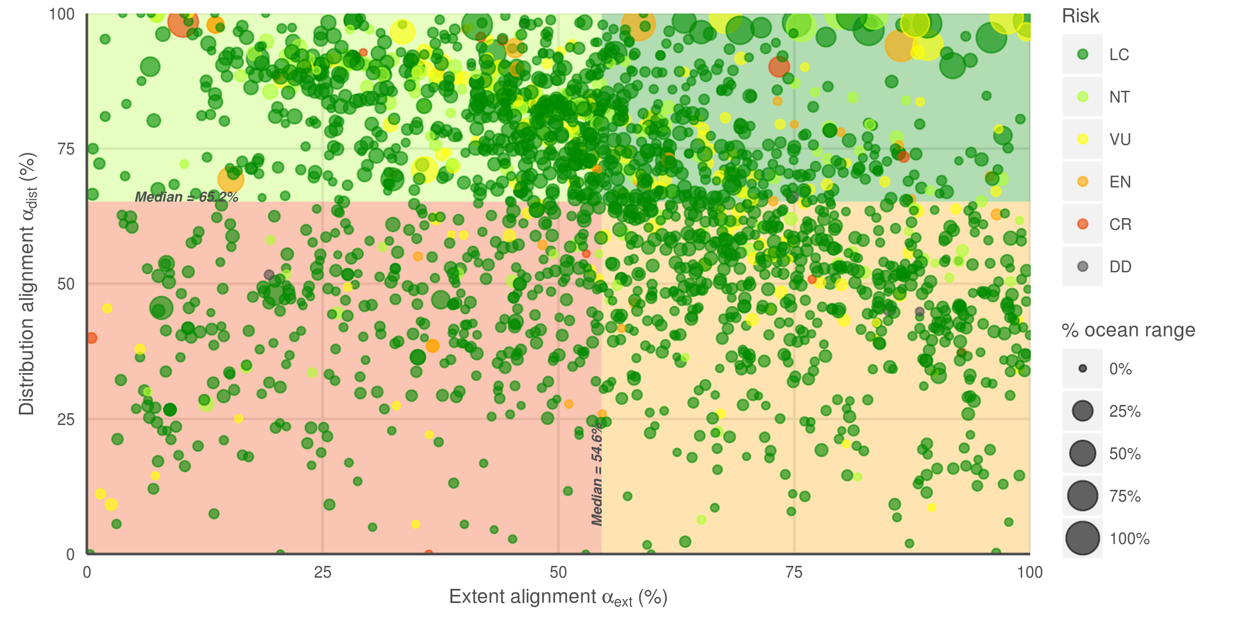 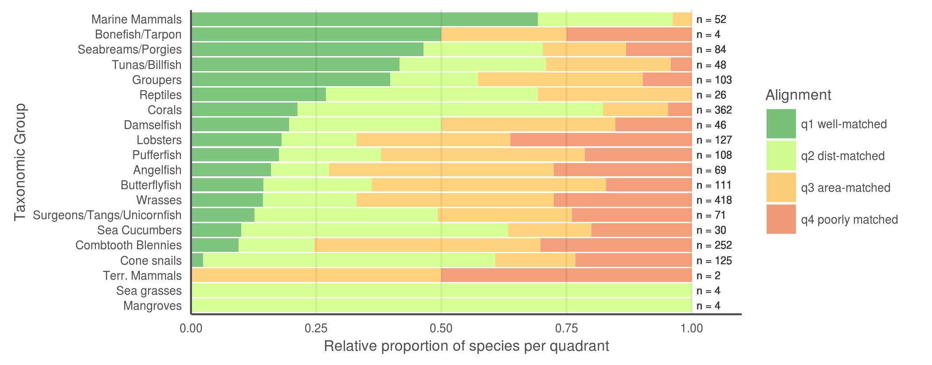

**Fig. 2.** (A) Distribution alignment (overlap of smaller range within larger) versus extent ratio (the ratio of smaller range area to the larger range area) for 2013 species included in both IUCN and AquaMaps datasets. The upper right quadrant (quadrant 1) comprises species whose maps largely agree (better than median value) in both spatial distribution and the extent of described ranges (n = 398; 19.5 %). The upper left quadrant (quadrant 2) comprises species whose maps agree well in distribution, but disagree in extent (n = 625; 30.5 %). The lower right quadrant (quadrant 3) includes species for which the paired maps generally agree in range extent, but disagree on where those ranges occur (n = 624; 30.5 %). The lower left quadrant (quadrant 4) indicates species for which the map pairs agree poorly in both area and distribution (n = 399; 19.5 %).  
(B) Alignment breakdown of paired-map species by taxonomic group.

### Figure 3

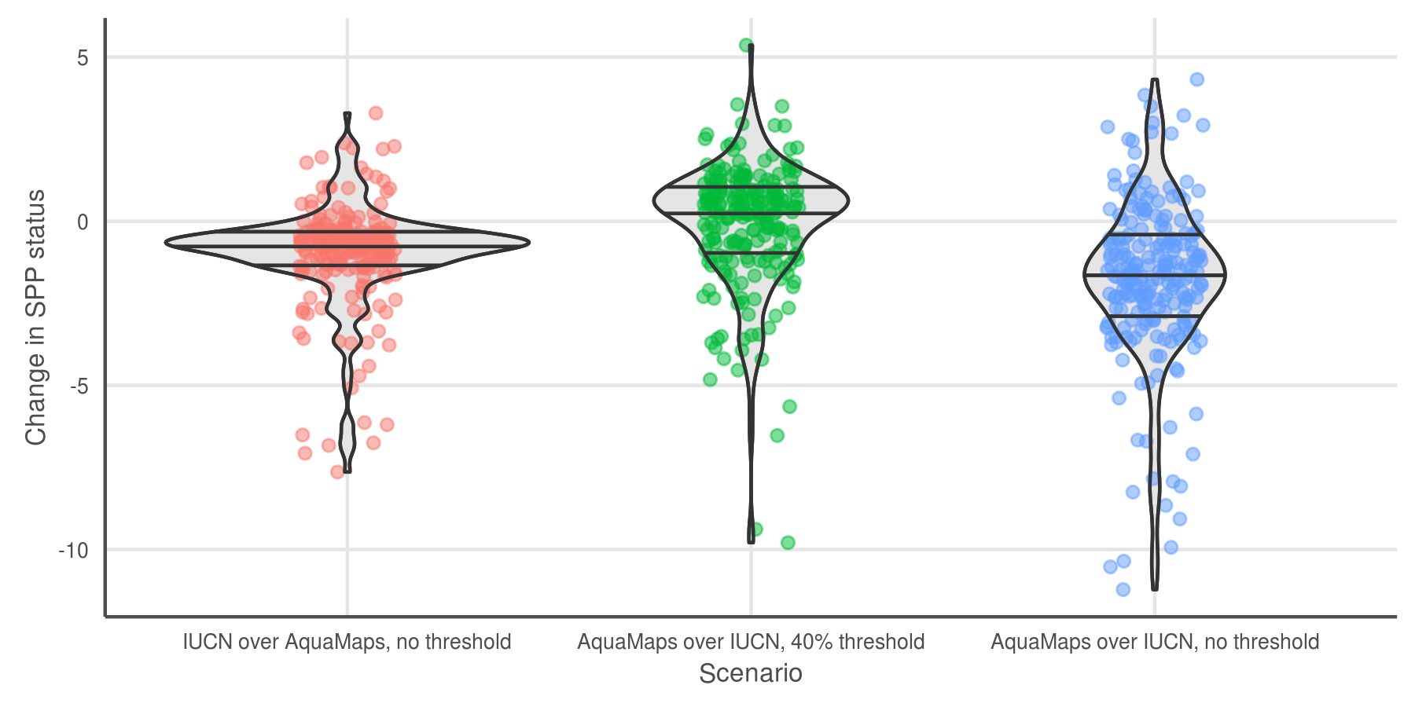

**Fig. 3.** Change in status score for the Species Subgoal within the global Ocean Health Index under three different scenarios. Scenario 1 shows the effect of reducing the probability threshold for AquaMaps presence to more accurately track the definition of IUCN “limits of distribution." Reducing the threshold increases the apparent range of a species; the slight decrease in average score suggests increased spatial representation of threatened species. Scenario 2 shows the effect of prioritizing AquaMaps data over IUCN, while maintaining the 40% presence threshold. In general, AquaMaps ranges are smaller than IUCN ranges, so most overlapping species will see a decrease in represented range. The slight bump in mean score may indicate a small increase in spatial representation of low-risk species, a small decrease in spatial representation of high-risk species, or a combination of both. Scenario 3 shows the effect of prioritizing AquaMaps data over IUCN, and simultaneously eliminating the presence threshold. The zero threshold in scenario 3 drives a decrease in scores relative to scenario 2. The large decrease indicates that a zero threshold greatly increases the spatial representation of high-risk species.

***NOTE: This figure still needs to be recreated using the latest and greatest data!*** *currently they use data generated in November or so, in ohiprep.*

### Figure 4

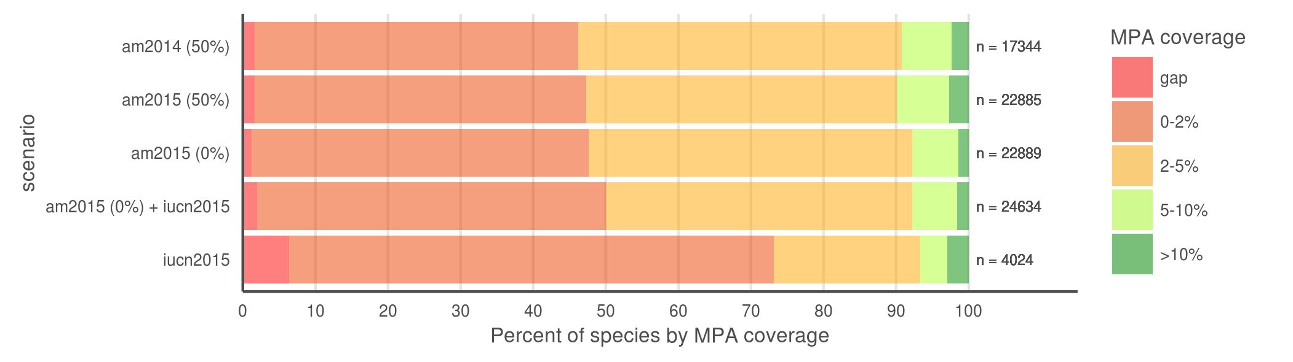

**Fig. 4.** Percent of species range covered by MPAs based upon methods in Klein et al. (2015). Scenario 1 replicates the original results, measuring protected range of species in AquaMaps 2014 dataset, with a 50% presence threshold, against the 2014 World Database of Protected Areas, filtered for IUCN categories I-IV that overlap marine areas. Scenario 2 updates the results using the 2015 AquaMaps dataset; the small changes despite the inclusion of an additional 5545 species demonstrates the robustness of the conclusions of Klein et al. (2015). Scenario 3, using 2015 AquaMaps data, drops the presence threshold to zero, showing an expected decrease in gap species, but also a decrease in species with 5% or greater protected range. Scenario 4 adds an additional 1745 species unique to the IUCN dataset, resulting in increases in gap species and species with less than 2% coverage. Scenario 5 examines species MPA coverage using only the IUCN dataset.

|  |  |  |  |  |  |  |
| --- | --- | --- | --- | --- | --- | --- |
| Scenario | n | gap | covered 0-2% | covered 2-5% | covered 5-10% | covered >10% |
| am2014 (50%) | 17344 | 1.6 | 44.6 | 44.6 | 6.8 | 2.4 |
| am2015 (50%) | 22885 | 1.7 | 45.7 | 42.7 | 7.2 | 2.7 |
| am2015 (0%) | 22889 | 1.2 | 46.5 | 44.5 | 6.4 | 1.5 |
| am2015 (0%) + iucn2015 | 24634 | 2.0 | 48.0 | 42.2 | 6.2 | 1.6 |
| iucn2015 | 4024 | 6.4 | 66.8 | 20.1 | 3.8 | 2.9 |

# References

***still need to check citations, format properly, put into order***

**Key AquaMaps publications:**

Kaschner, K., R. Watson, A. W. Trites, D. Pauly (2006). Mapping world-wide distributions of marine mammal species using a relative environmental suitability (RES) model. Marine Ecology Progress Series 316: 285–310. *check this citation journal name...* *This outlines the basic RES methodology - AM development*

Kaschner, K., D.P. Tittensor, J. Ready, T Gerrodette and B. Worm (2011). Current and Future Patterns of Global Marine Mammal Biodiversity. PLoS ONE 6(5): e19653. PDF *just what the title says - AM development, presence threshold 60%, also analyzes richness as a function of threshold*

Ready, J., K. Kaschner, A.B. South, P.D Eastwood, T. Rees, J. Rius, E. Agbayani, S. Kullander and R. Froese (2010). Predicting the distributions of marine organisms at the global scale. Ecological Modelling 221(3): 467-478. PDF *Presents AM; assessing AquaMaps against other presence-only species models*

**Papers based on AquaMaps:**

Jones, M.C., S.R. Dyeb, J.K. Pinnegar and W.W.L. Cheung (2012). Modelling commercial fish distributions: Prediction and assessment using different approaches. Ecological Modelling 225(2012): 133-145. PDF *comparison of species distribution models including AquaMaps, Maxent and the Sea Around Us Project*

Coll, M., C. Piroddi, J. Steenbeek, K. Kaschner, F. Ben Rais Lasram et al. (2010). The biodiversity of the Mediterranean Sea: estimates, patterns, and threats. PLoS ONE 5(8): e11842. PDF *used AquaMaps to predict Med biodiversity. Also: Threshold = 0.*

Martin C.S., Fletcher R., Jones M.C., Kaschner K., Sullivan E., Tittensor D.P., Mcowen C., Geffert J.L., van Bochove J.W., Thomas H., Blyth S., Ravillious C., Tolley M., Stanwell-Smith D. (2014). Manual of marine and coastal datasets of biodiversity importance. May 2014 release. Cambridge (UK): UNEP World Conservation Monitoring Centre. 28 pp. (+ 4 annexes totalling 174 pp. and one e-supplement). PDF *review of marine data sets and data gaps etc, incl both IUCN and AM as well as many others*

Hurlbert 2007 Species richness, hotspots, and the scale dependence of range maps in ecology and conservation. *mostly rasters of range maps? "The scale dependence of range-map accuracy poses clear limitations on braod-scale ecological analyses and conservation assessments. ... we provide guidance about the approriate scale of their use*

Jetz 2008 Ecological Correlates and Conservation Implications of Overestimating Species Geographic Ranges *EOO maps are usually highly interpolated and overestimate small-scale occurrence, which may bias research outcomes*

Pimm 2014 The biodiversity of species and their rates of extinction, distribtuion, and protection. *uses range maps to show biodiversity areas; may use IUCN range maps. Also discusses gaps and possible things that can be done about them.*

Rondinini 2006 Tradeoffs of different types of species occurrence data for use in systematic conservation planning *compares point locality, range maps, and distribution models in terms of omission and commission errors; also outlines Extent of Occurrence and Area of Occupancy distinctions.*

García Molinos, Jorge, Benjamin S. Halpern, David S. Schoeman, Christopher J. Brown, Wolfgang Kiessling, Pippa J. Moore, John M. Pandolfi, Elvira S. Poloczanska, Anthony J. Richardson, and Michael T. Burrows. “Climate Velocity and the Future Global Redistribution of Marine Biodiversity.” Nature Climate Change advance online publication (August 31, 2015). <doi:10.1038/nclimate2769>.

Halpern, Benjamin S., Catherine Longo, Darren Hardy, Karen L. McLeod, Jameal F. Samhouri, Steven K. Katona, Kristin Kleisner, et al. “An Index to Assess the Health and Benefits of the Global Ocean.” Nature 488, no. 7413 (August 30, 2012): 615–20. <doi:10.1038/nature11397>.

Klein, Carissa J., Christopher J. Brown, Benjamin S. Halpern, Daniel B. Segan, Jennifer McGowan, Maria Beger, and James E.M. Watson. “Shortfalls in the Global Protected Area Network at Representing Marine Biodiversity.” Scientific Reports 5 (December 3, 2015): 17539. <doi:10.1038/srep17539>.

Selig, Elizabeth R., Catherine Longo, Benjamin S. Halpern, Benjamin D. Best, Darren Hardy, Cristiane T. Elfes, Courtney Scarborough, Kristin M. Kleisner, and Steven K. Katona. “Assessing Global Marine Biodiversity Status within a Coupled Socio-Ecological Perspective.” PLoS ONE 8, no. 4 (April 11, 2013): e60284. <doi:10.1371/journal.pone.0060284>.

* IUCN reference:
  + <https://www.conservationtraining.org/course/view.php?id=217&lang=en>
  + <http://www.iucnredlist.org/technical-documents/red-list-training/iucnspatialresources>
  + IUCN Red List - accessed 12/21/2015
* AquaMaps reference, and accessed date?

Predicting the distributions of marine organisms at the global scale Ready, J., Kaschner, K., South, A. B., Eastwood, P. D., Rees, T., Rius, J., ... & Froese, R. (2010). Predicting the distributions of marine organisms at the global scale. Ecological Modelling, 221(3), 467-478. Cited by 75

[PDF] Mapping world-wide distributions of marine mammal species using a relative environmental suitability (RES) model K Kaschner, R Watson, AW Trites, D Pauly - Marine Ecology Progress …, 2006 - vliz.be ABSTRACT: The lack of comprehensive sighting data sets precludes the application of standard habitat suitability modeling approaches to predict distributions of the majority of marine mammal species on very large scales. As an alternative, we developed an ... Cited by 167 Related articles All 12 versions Web of Science: 86 Cite Save

[DOC] from aquamaps.org [DOC] AquaMaps K Kaschner, J Rius-Barile, K Kesner-Reyes… - Predicted range maps …, 2013 - aquamaps.org AquaMaps is an approach to generating model-based, large-scale predictions of currently known natural occurrence of marine species. Models are constructed from estimates of the environmental tolerance of a given species with respect to depth, salinity, temperature, ... Cited by 64 Related articles All 3 versions Cite Save More

[HTML] Current and future patterns of global marine mammal biodiversity K Kaschner, DP Tittensor, J Ready, T Gerrodette… - PLoS …, 2011 - journals.plos.org Abstract Quantifying the spatial distribution of taxa is an important prerequisite for the preservation of biodiversity, and can provide a baseline against which to measure the impacts of climate change. Here we analyse patterns of marine mammal species richness ... Cited by 73 Related articles All 20 versions Web of Science: 34 Cite Save More

# Supplemental Information

# Outline

## Data processing

All code is publicly available and freely downloadable [here on GitHub](link%20to%20github).

### AquaMaps

AquaMaps data was provided by AquaMaps directly via ftp. Three SQL files were sent that contained (1) list of all 22889 species and their taxonomic information, (2) information for all (292,000?) half degree cells used for range mapping and (3) the probability of occurrence per cell for all 22889 species. These were extracted into .csv form using R Statistical Software.

***Probably just cut, but maybe include in Suppl Materials. - BH***: The release of AquaMaps distribution maps is not limited to comprehensively-assessed taxa, and maps are available across a much larger range of taxonomic classes; however, there is no guarantee that the list of species included within each class is a representative cross section of the entire class.

#### Possible figures

* Map of all cells
* Map of # of species per cell
* Example aquamaps (one species range)

### IUCN

IUCN: While the polygons roughly define regions of presence/absence, additional attributes provide information on extant/extinct ranges, native/introduced ranges, and seasonality.

As of December 2015, IUCN had published species distribution maps for 8691 marine species across 24 taxonomic groups. For this analysis, we did not consider IUCN range maps for bird species, as those data are hosted separately by BirdLife International.

* which data sets are included?
* raster::extract() to convert polys to csvs
* which columns are included?

JA: I think here we only need a few sentences describing how we downloaded the data and on what date. Link to the IUCN spatial data website.

IUCN data is provided as polygon shapefiles. These vectors were rasterized to the same cell resolution as AquaMaps data (0.5 degrees).

#### Possible figures

#### Caveats

For example, as of this writing, IUCN has released no spatial data for class Elasmobranchii (cartilaginous fishes including sharks and rays); and while IUCN offers a large number of maps within class Actinopterygii (ray-finned bony fishes), the available maps include only a few primarily tropical taxonomic sub-groups, such as wrasses, damselfish, butterflyfish, tunas, and billfishes, but are missing economically important subgroups including salmon, rockfish, and clupeids. However, IUCN's criterion of comprehensive assessment greatly reduces the risk of sample bias within the bounds of the assessed taxonomic groups.

***Red List inclusion:***

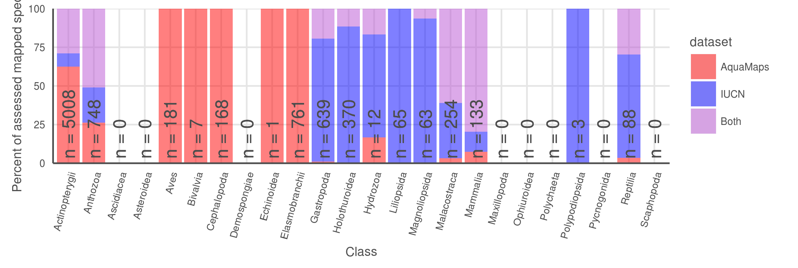

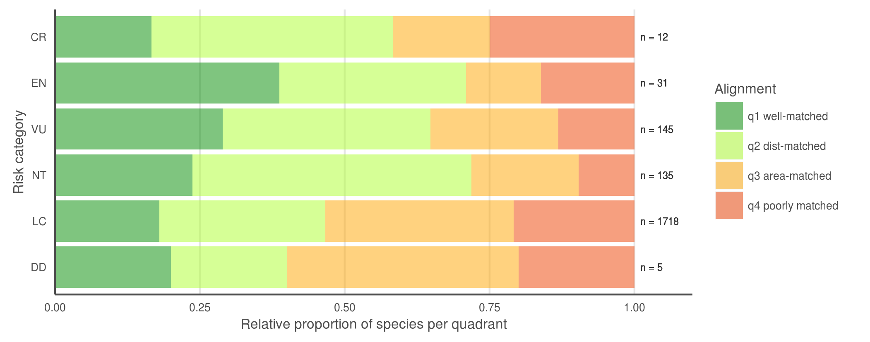

* Breaking down the quadrants by IUCN extinction risk categories (FIG 3c), we found that species with higher extinction risk tend to be better aligned between the two datasets, perhaps correlated to increased expert scrutiny. Does higher perceived risk lead to increased attention, and thus better understanding of species distribution? Or conversely, does increased attention to species distribution reveal more species at risk? Likely both mechanisms are at play on a case-by-case basis, depending on the species' taxon and region. *does this argument bear up to closer scrutiny? CR isn't dominated by Q1 any more*

***table to show data poor status and reviewed status for AquaMaps maps represented in the quadrant plot*** *- perhaps update the quadrant plot to reveal data-poor species (and reviewed species? little overlap of reviewed & data-poor) instead of, say, red-list category which doesn't get discussed in the body of the paper? then this table can go in SOM if we like it*

|  |  |  |  |  |
| --- | --- | --- | --- | --- |
| quadrant | n species | n data poor species | mean (median) data points | n reviewed species |
| all AM | 22889 | 8749 (38.2%) | 57.1 (16) | 1296 (5.7%) |
| AM&IUCN | 2166 | 457 (21.1%) | 89.9 (33) | 290 (13.4%) |
| q1 | 401 | 33 (8.2%) | 233.0 (78) | 100 (24.9%) |
| q2 | 682 | 151 (22.1%) | 77.4 (39) | 100 (14.7%) |
| q3 | 682 | 114 (16.5%) | 52.4 (29) | 65 (9.5%) |
| q4 | 410 | 159 (39.7%) | 32.1 (13) | 25 (6.2%) |

## illustrative maps for different quadrants and different mechanistic problems

Oculina varicosa - Ivory tree coral 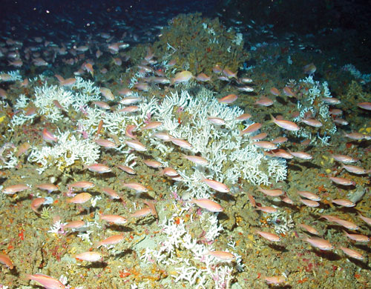

* from IUCN: Colonies are found to depths of 152 m depth on limestone rubble, low-relief limestone outcrops, high-relief, steeply sloping prominences, and soft-bottom sloping habitats. Colonies are semi-isolated, patchy and low-growing in shallow water, or they form larger, massive coalescing aggregates (thickets or coppices) with substantial topographic relief in 50-100 m depth. In shallow waters (2-30m) the form is zooxanthellate, inhabiting limestone ledges. In deeper waters, an azooxanthellate form is known from the shelf edge off eastern Florida, USA from Ft. Pierce to Daytona (Reed 1980, 1983, 2002; Brooke and Young 2003).

plotted against a 200 m bathymetry line: 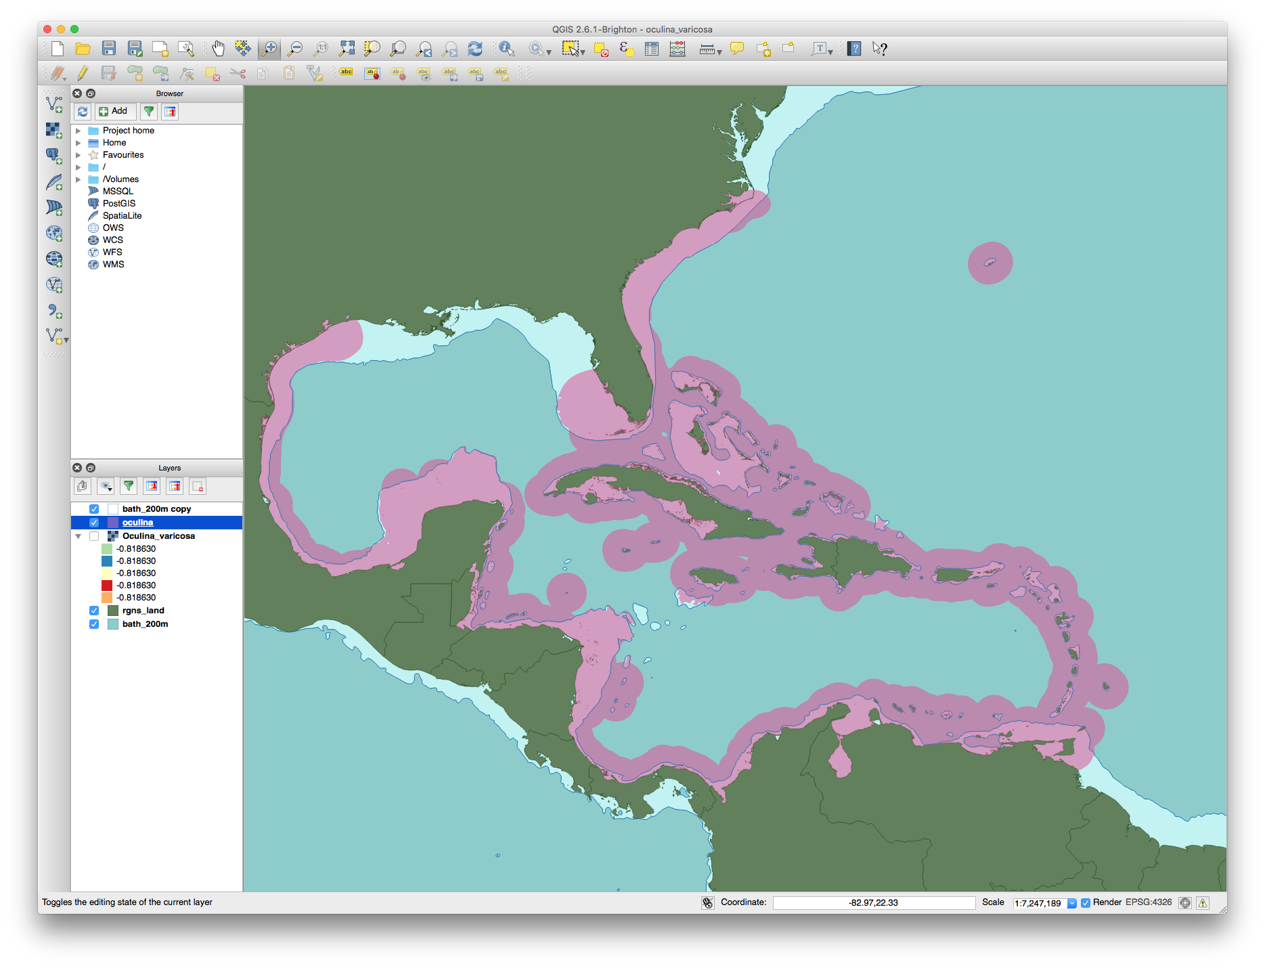

## AquaMaps: Effect of changing "presence" threshold on apparent distribution

### AquaMaps presence threshold analysis - move to SOM

For our comparisons of global distribution of represented biodiversity and spatial alignment between datasets, we considered "present" to be any cell with a non-zero probability of occurrence, to best approximate the "extent of occurrence" as generally indicated by IUCN maps. To examine the effect of different presence threshold selections on the represented range of a species, we varied the threshold from 0.05 to 1.00 and calculated the average species range relative to a zero threshold.

### Figure 5 (a, b):

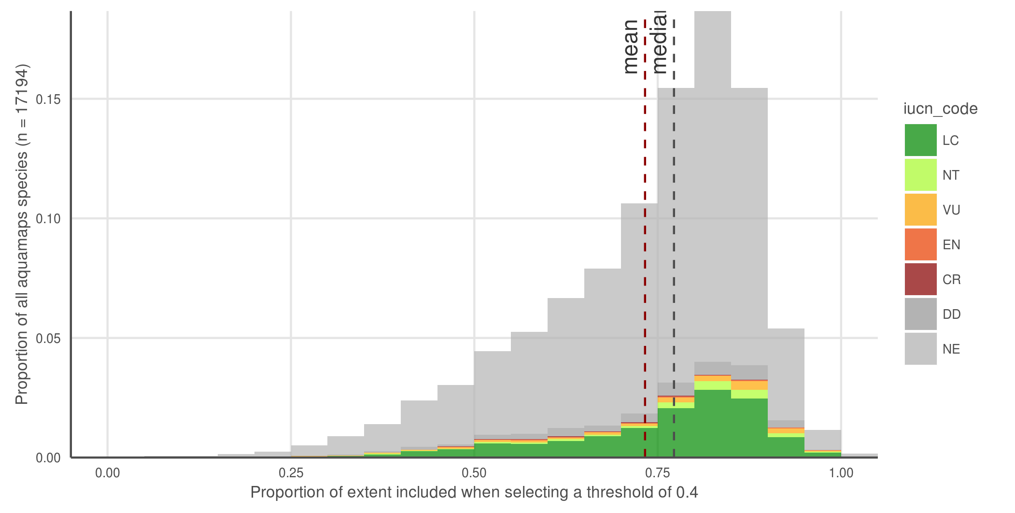

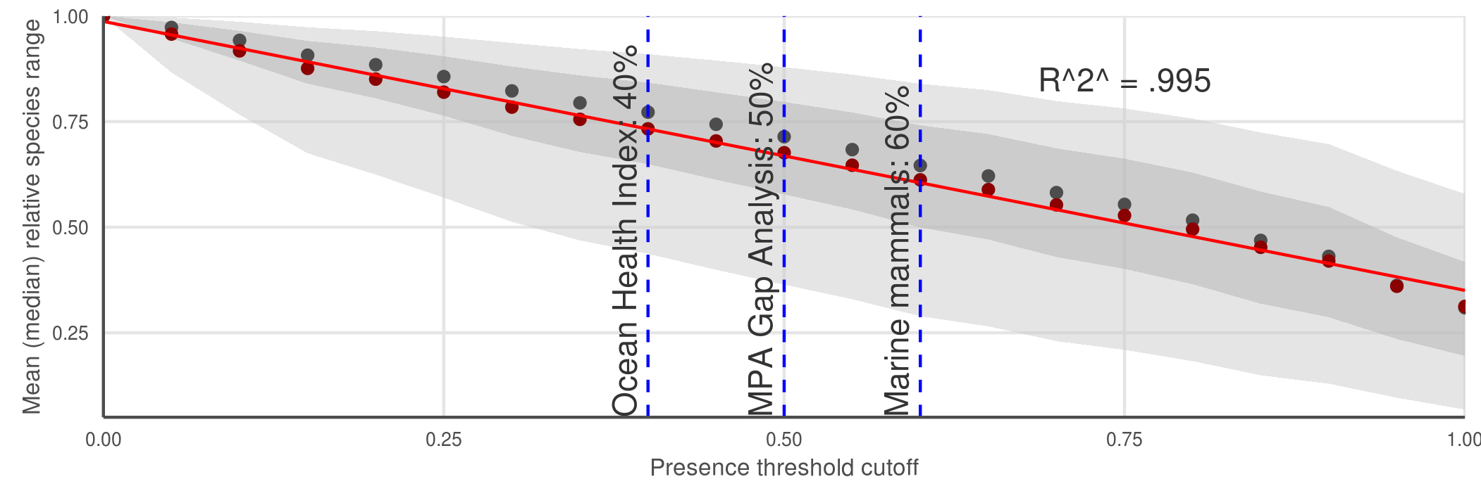

AquaMaps distribution map extent remaining after applying a presence threshold. (a) A 40% threshold applied to all species in the AquaMaps dataset shows a mean loss of XXX, with a wide distribution in which some species lose nearly all of their apparent range. (b) Mean (median) remaining extent at increments of presence threshold. Dark grey ribbon includes 25% to 75% quantiles, while light grey ribbon includes 9% to 91% quantiles.

AquaMaps distribution maps indicate "probability of occurrence" within each 0.5° cell, with values ranging from zero to one, rather than a simple present/absent value as indicated by IUCN maps. Many studies convert this AquaMaps probability to a simple presence value by assigning a threshold value (REF references here). A higher threshold constrains an analysis to cells with near certainty of occurrence, while a low threshold captures larger areas of increasingly marginal suitability.

At a presence threshold of 40%, as used in the Ocean Health Index Species subgoal, the bulk of AquaMaps species suffer a significant decrease in represented range, and some species lose nearly their entire range. Incrementing the presence threshold from 0.00 to 1.00 for the entire AquaMaps dataset, the shallow downward trend indicates a low but consistent sensitivity to threshold choice, with no surprising tradeoffs that could suggest an "optimal" threshold. This pattern may not hold true for all subsets of AquaMaps species, however, whether subsetting by taxa or by georegion.