Supplemental Information: Aligning marine species range data to better serve science and conservation

Casey O'Hara, Jamie C. Afflerbach, Courtney Scarborough, Benjamin S. Halpern

## S1. Representative maps from each quadrant

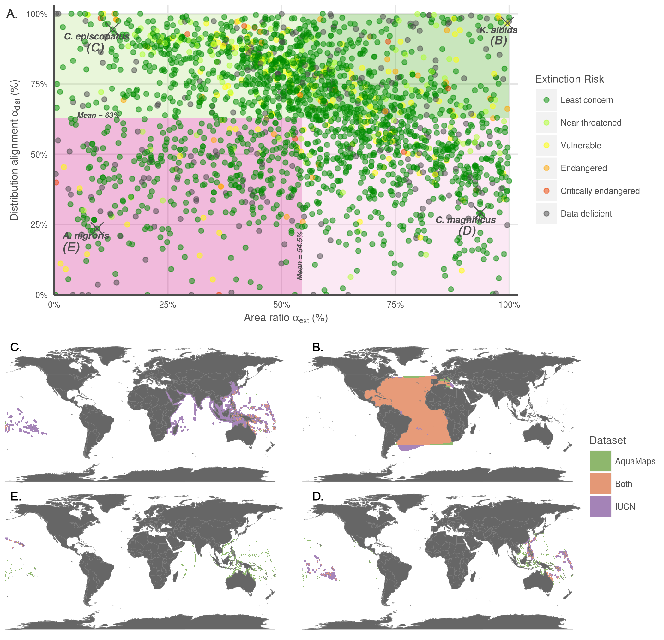

**Fig. S1.** Representative species maps to illustrate each quadrant from Fig. 2A. Note that B-E are arranged to match quadrants in Fig. S1A. (A) Alternative version of Figure 2A that includes extinction risk categories for each species. Four representative species, one from each quadrant, are mapped in (B-E). (B) Well-matched: Kajikia albida, the Atlantic white marlin. Ranges from each data set show nearly complete overlap, and very similar area of coverage. (C) Distribution-matched: Conus episcopatus, the dignified cone snail. Ranges shows excellent overlap in the western Pacific, though IUCN range extends beyond the bounds of the AquaMaps range. (D) Area-matched: Conus magnificus, the magnificent cone snail. Ranges overlap in the southern Pacific, but align poorly elsewhere. The total area for each range is similar. (E) Poorly-matched: Acanthurus nigroris, the blue-lined surgeonfish. IUCN predicts species range only near the Hawaiian islands; AquaMaps predicts extensive range throughout the central and western Pacific Ocean. The datasets align in neither distribution nor area of coverage.

## S2. Risk by quadrant

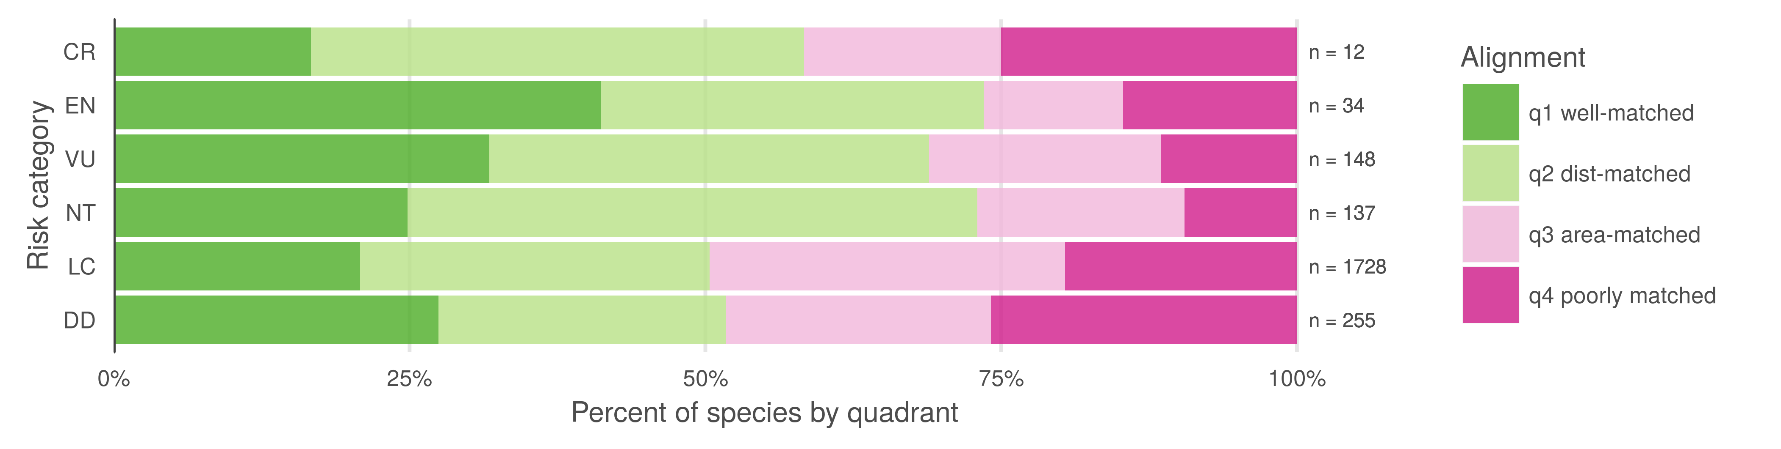

**Fig. S2.** Breakdown of quadrants (Fig. S1A) by IUCN extinction risk categories. IUCN and Aquamaps ranges were in better agreement (i.e., had a higher probability of being in the upper-right, "well-aligned" quadrant, Figure 2A/Figure S1A) for species at greater risk according to IUCN risk categories (p < 0.001, generalized linear model, family = binomial, Table S1). This suggests at-risk species may receive more attention in terms of data collection or model refinement.

**Table S1.** Generalized linear model (family = binomial) describing how the agreement between IUCN and Aquamap range maps (i.e., probability of occurring in quadrant 1, Figure 2A/S1A) increases for a species as its IUCN risk status increases. For this analysis, we excluded all species that had "data deficient" IUCN status (n = 255). We analyzed the IUCN risk categories as a continuous variable (LC = 0.0, NT = 0.2, VU = 0.4, EN = 0.6, CR = 0.8, EX = 1.0).

*Model: glm(quadrant 1 membership ~ IUCN category, family = binomial) n = 2,059*

|  |  |  |  |  |
| --- | --- | --- | --- | --- |
| Coefficients: | Estimate | Std. Error | z value | p value |
| Intercept | -1.32933 | 0.05804 | -22.902 | < 2e-16 *** |
| IUCN category | 1.18672 | 0.33469 | 3.546 | 0.000391 *** |

### 

### S3. Coral range vs. depth

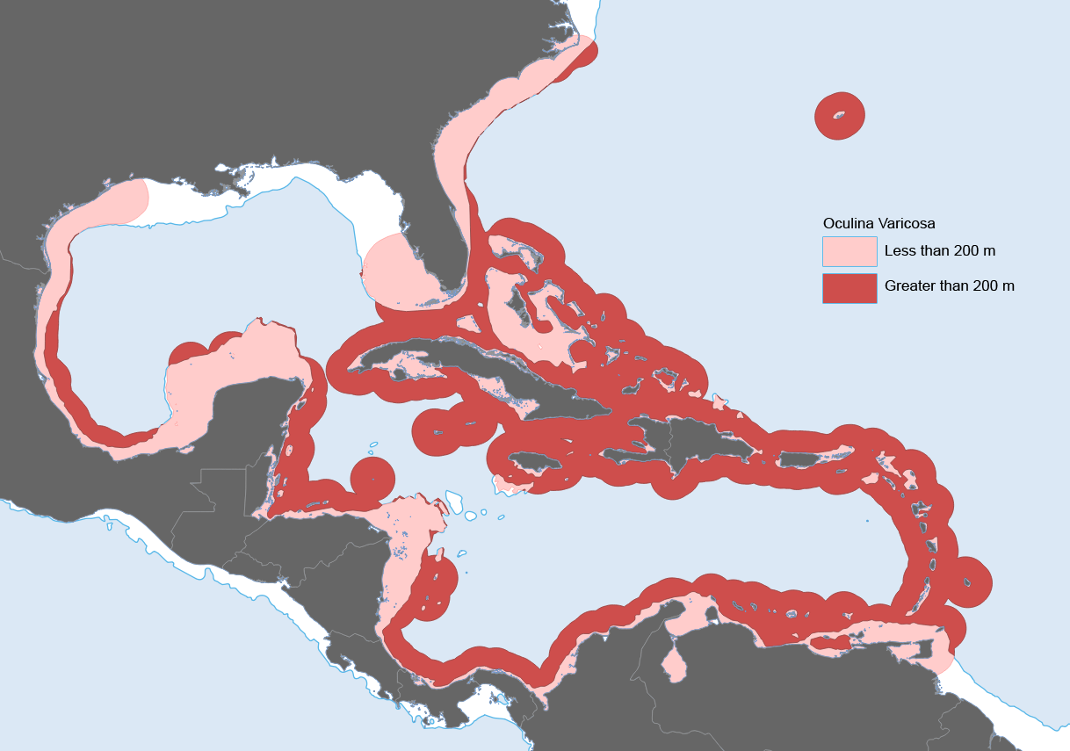

**Fig. S3.** IUCN-defined range of *Oculina varicosa*, a typical photosynthetic coral, plotted against a 200 m bathymetry contour. According to IUCN, *O. varicosa* can be found to depths of 152 m. Maps of many other coral species and other reef-associated organisms followed similar patterns.

### S4. AquaMaps threshold examination

AquaMaps distribution maps indicate "probability of occurrence" within each 0.5° cell, with values ranging from zero to one, rather than a simple present/absent value as indicated by IUCN maps. Many studies convert this AquaMaps probability to a simple presence value by assigning a threshold value.

To examine the effect of different presence threshold selections on the represented range of a species, we varied the threshold from 0% to 100% and calculated the average species range relative to a zero threshold.

1. 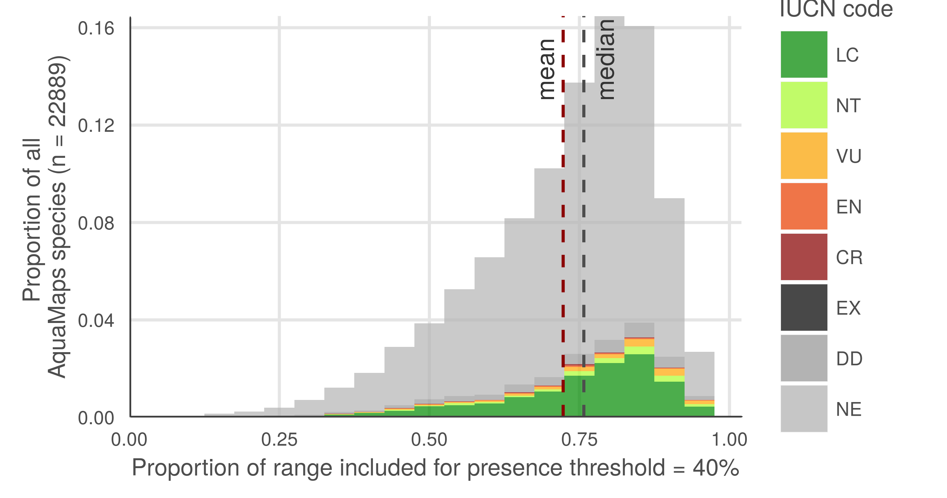
2. 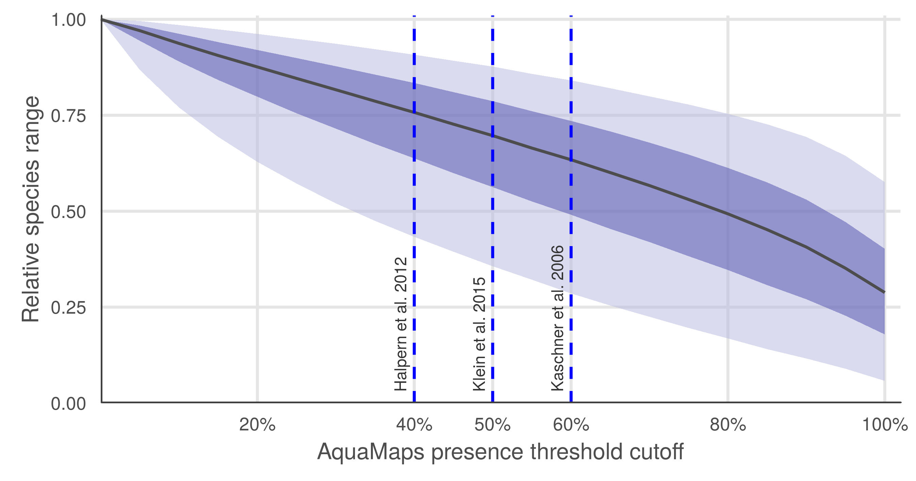

**Fig. S4.** AquaMaps distribution map extent remaining after applying a presence threshold. A higher threshold constrains an analysis to cells with near certainty of occurrence, while a low threshold captures larger areas of increasingly marginal suitability. (A) A 40% threshold applied to all species in the AquaMaps dataset shows a mean loss of 28% of total range compared to a 0% threshold, with a wide distribution in which some species lose nearly all of their apparent range. (B) Median remaining extent at increments of presence threshold. Dark green ribbon includes 25% to 75% quantiles of remaining species range, while lighter ribbon includes 5% to 95% quantiles. Incrementing the presence threshold from 0.00 to 1.00 for the entire AquaMaps dataset, the shallow downward trend indicates a low but consistent sensitivity of apparent species range to threshold choice, with no surprising tradeoffs that could suggest an "optimal" threshold.