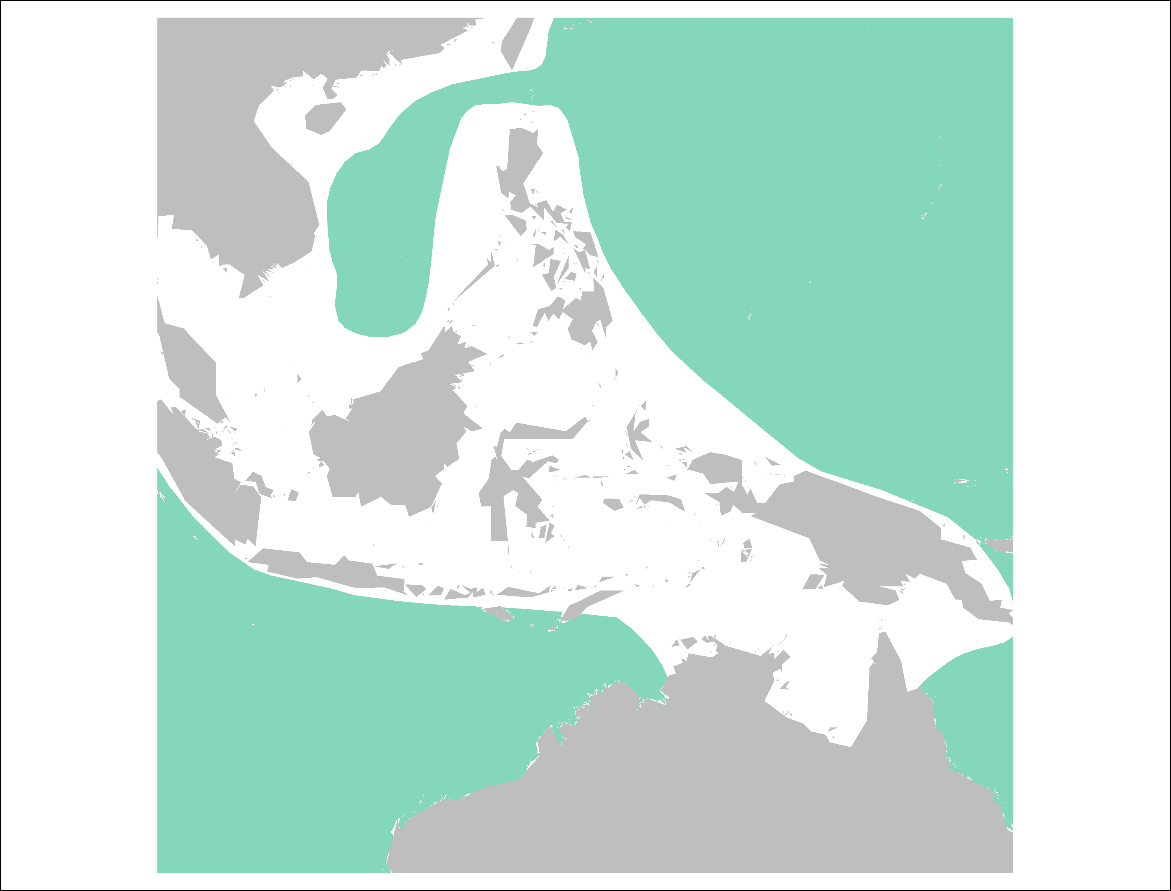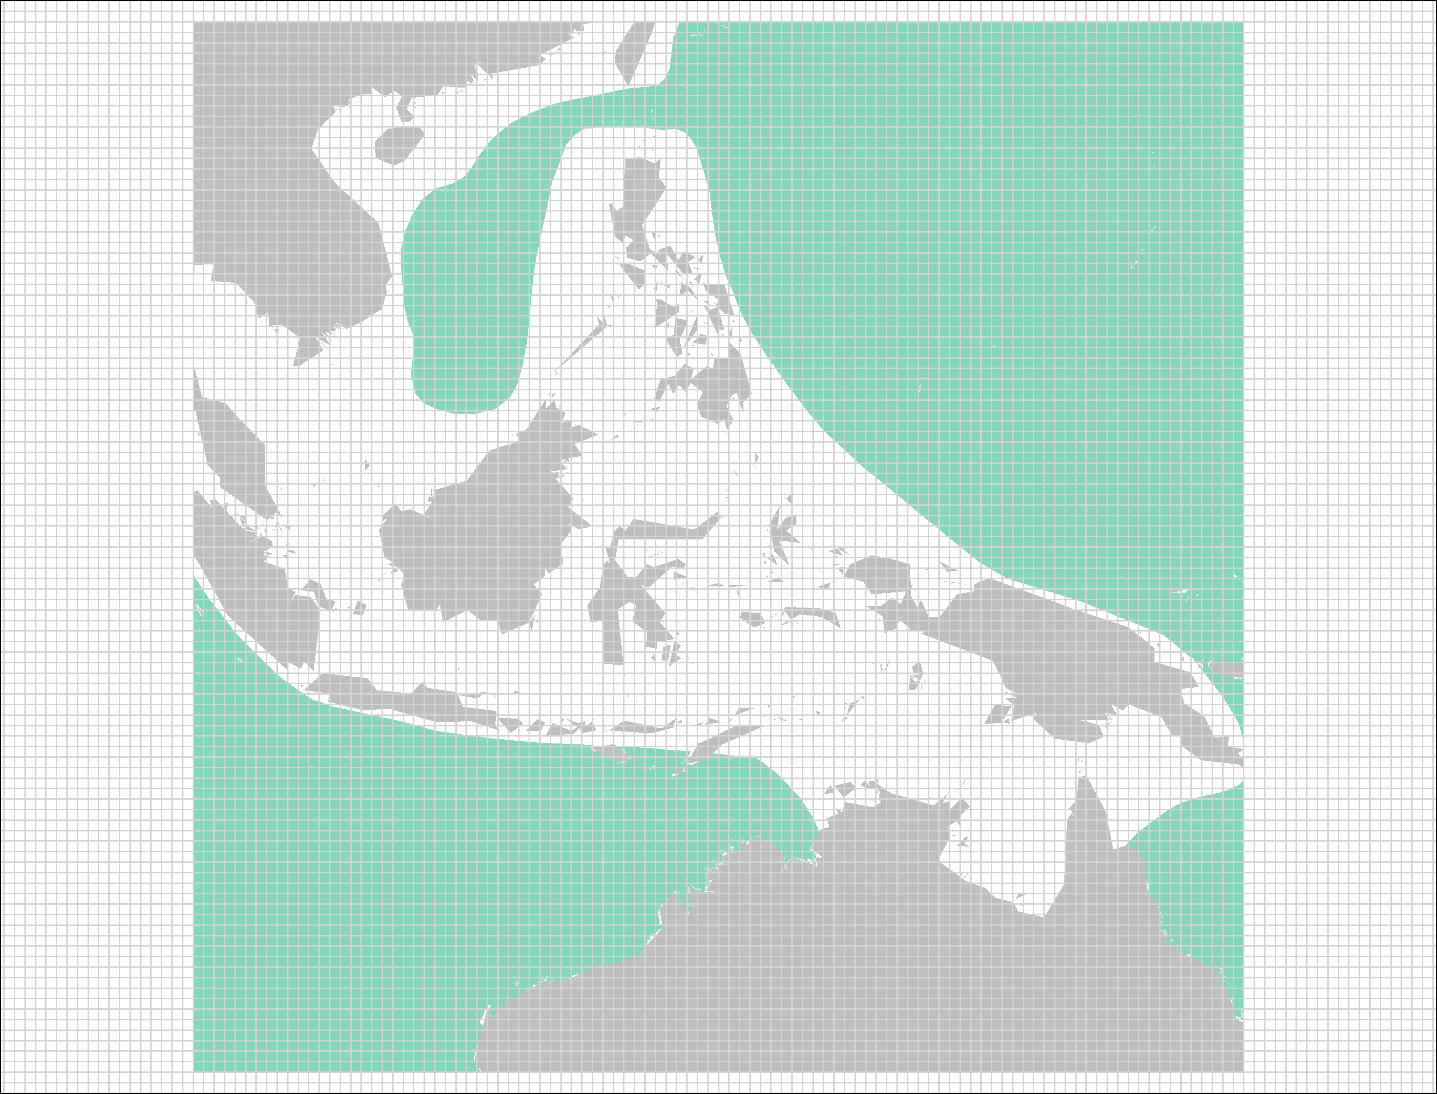

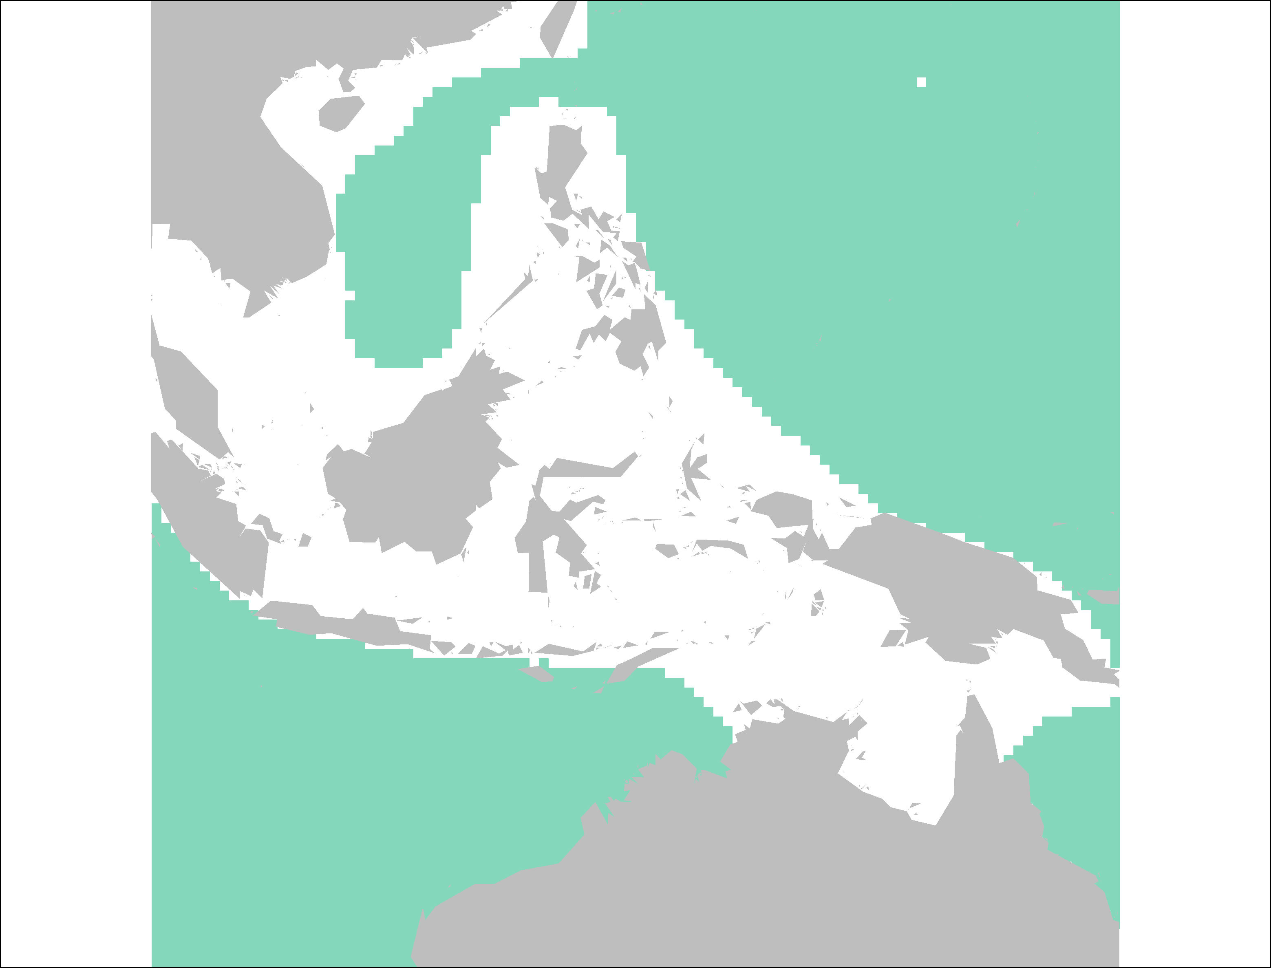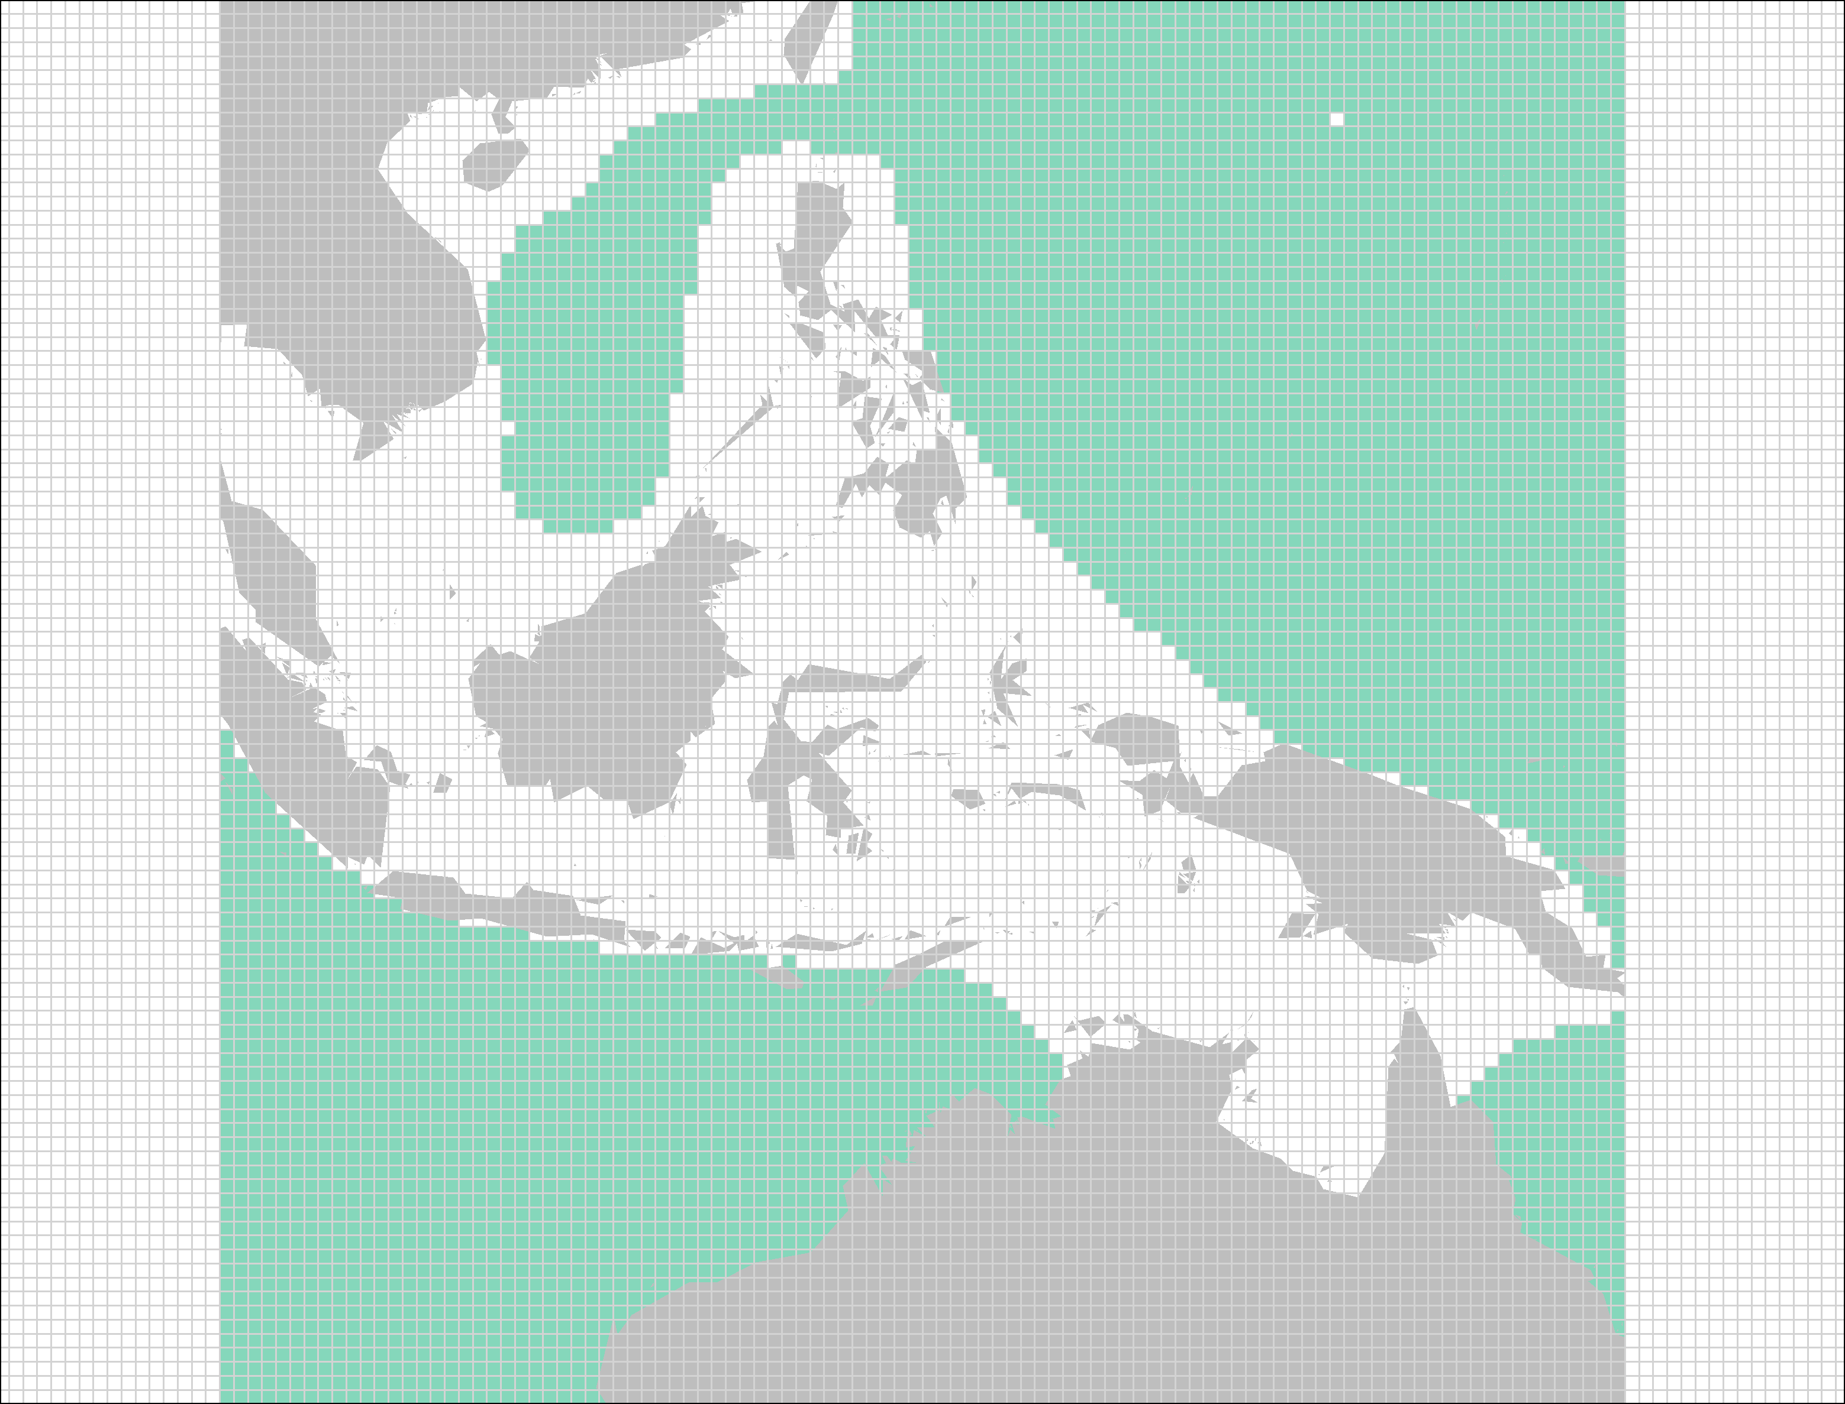

**Figure SX**: Rasterizing shapefiles provided by IUCN. A portion of the *Thunnus alalunga* (Albacore Tuna) range map is used to exemplify the raster process. The raw shapefile (top left) is rasterized to half-degree cells (grid overlaid on top right). Each overlapping cell is assigned a presence value of 1 (bottom two maps with and without half-degree grid).

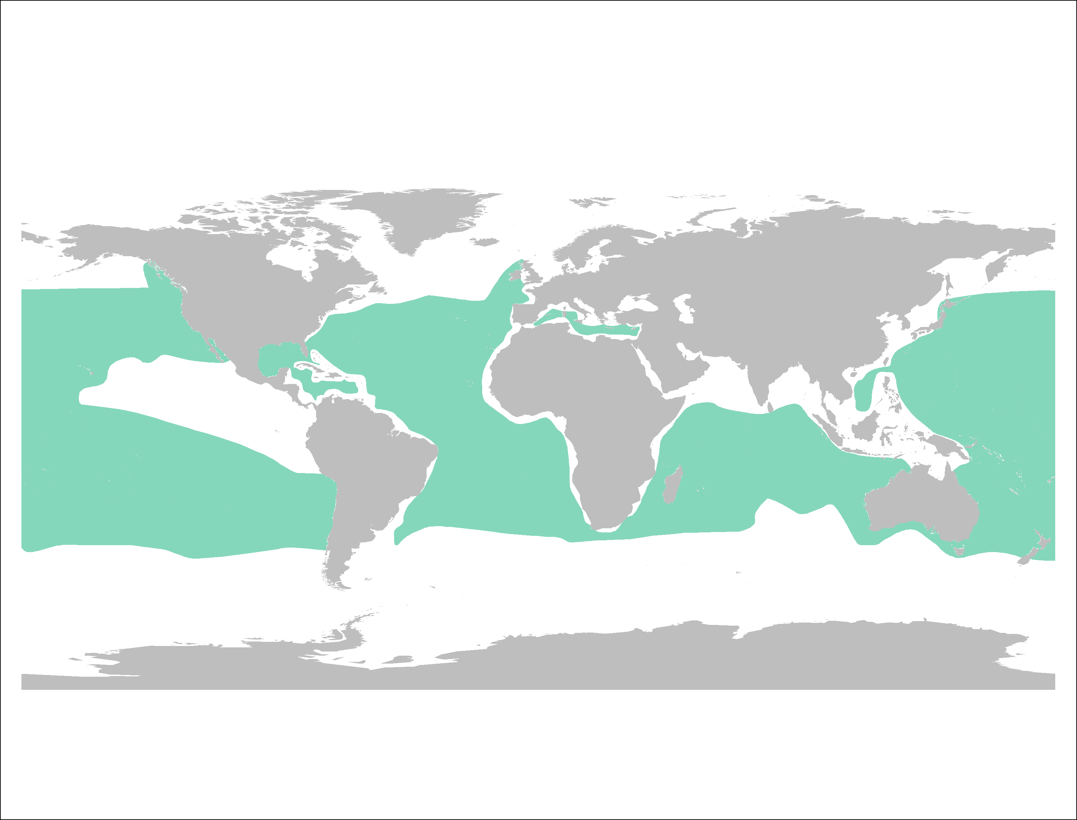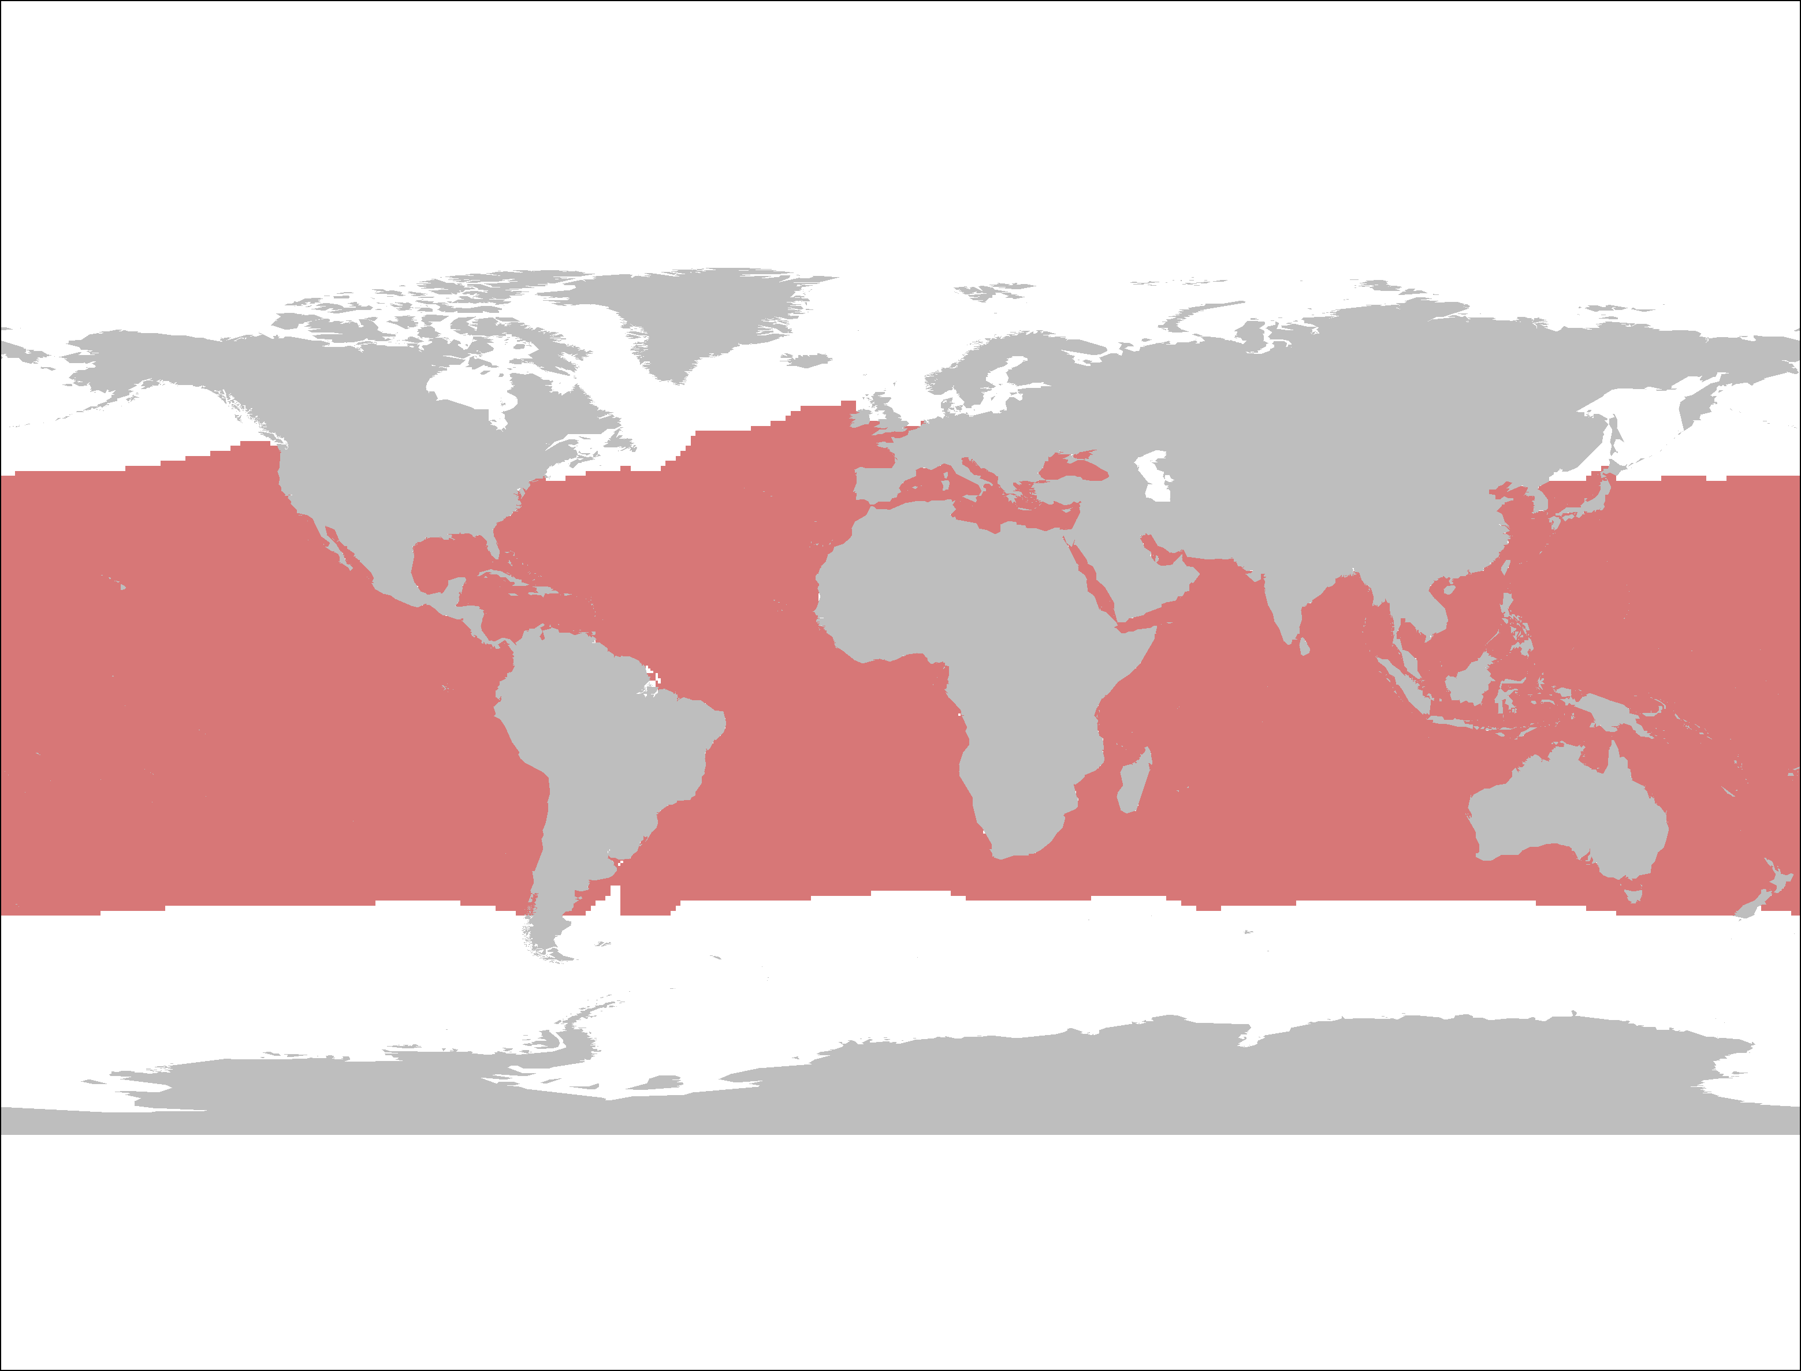

Figure SX: Species range map for *Thunnus alalunga* (Albacore Tuna) from AquaMaps in raster format (top) and the IUCN in a spatial polygon format (bottom).