Aligning species range data to better serve science and conservation

Casey O'Hara, Jamie Afflerbach, Ben Halpern

## Abstract

*get to this later...*

## Significance

*subset of the abstract*

# Introduction

Mapping and predicting species distributions is fundamental to the sciences of ecology, biogeography, and conservation, among many others. Knowing where individuals of a species exist, and what allows them to persist there, provides foundational information for understanding species ranges, how best to protect and manage species, and how they may respond to increasing human impacts and a changing climate. A rich literature tackles the many dimensions of these questions.

One very important outcome of this body of science is the various compiled databases of species distribution maps. In the oceans there are now two such global repositories *(if we define it narrowly; OBIS is global species distribution, but not quite range maps)* – Aquamaps predicted distribution maps (Kaschner et al. 2013) and International Union for Conservation of Nature (IUCN) range maps (REF) – that are used for a wide range of purposes, including assessing marine species status (Halpern et al. 2012, Selig et al. 2013), evaluating global biodiversity patterns (Coll et al. 2010, Martin et al. 2014), predicting range shifts (Molinos et al. 2015), and setting conservation priorities (Klein et al. 2015). The two data collections ostensibly describe the same information, but significant differences in methodology and intent could lead to dramatically different understandings of our marine ecosystems, with significant implications for policy and conservation recommendations.

Importantly, biases in taxonomic or spatial coverage of a dataset could shift management or conservation actions *towards places or species that aren’t actually the most in need (shift management or conservation actions away from places or species that are most in need?)*.(maybe Jetz 2008?) False indications of presence (commission errors) overestimate the protection afforded by a marine reserve, while false indications of absence (omission errors) reduce the adequacy of a reserve system by underestimating species distributions. (Rondinini et al. 2006)

To understand the implications of similarities and differences between the two datasets, we compared how each data set represents the global spatial distribution of species. For the relatively small number of species mapped in both datasets, we examined how well their spatial distribution maps align. *We then reanalyze two recent studies using these datasets based on different versions of the data to illustrate how and why decisions about which species range data to use affect our understanding of the status of marine biodiversity.*

# Overview of the datasets

***We may need to shorten this section to fit this paper into the format guidelines for PNAS. If so, some of this can be pushed to the Suppl. Materials. - BH***

The IUCN publishes species distribution maps as vector shapefiles, collected by taxonomic groups. Species experts outline polygons to represent a species' extent of occurrence, based on observation records and refined by the expert's understanding of the species' range and habitat preferences. IUCN publishes range map sets only for taxonomic groups that have been "comprehensively assessed," i.e. in which at least 90% of the species within the taxonomic group have been evaluated. While this mitigates sampling bias within taxa, it also means that entire taxonomic groups remain unavailable until they have met this threshold of comprehensive assessment.

AquaMaps develops species distribution maps based on modeled relative environmental suitability. For each modeled species, environmental preferences (e.g. temperature, depth, salinity) are deduced from occurrence records *such as OBIS and GBIF* ***(should we mention these, or leave out? I left them out when describing the IUCN data sets)***, published species databases such as FishBase, and expert knowledge. The AquaMaps model overlays these environmental preferences atop a map of environmental attributes on a 0.5 degree global grid, creating a global map of probability of occurrence.

* *How does AquaMaps select species? based on data available from OBIS/GBIF and Fishbase?*

# Results and Discussion

### Overlap between assessed species

IUCN maps are best categorized as geographic range data, while AquaMaps maps can be categorized as predicted distribution data (Rondinini et al., 2006 - the categories come from here, but not my categorizations of these particular datasets...); the two types of maps differ in methodology and intent, and these differences drive significant differences between the resulting species distribution maps (Fig. 1). Only 2455 species were included in both datasets (0.1% of total Aquamaps species; 0.6% of total IUCN species; Fig. 1, 2). *All IUCN-mapped species are also included in Red List species, but only 22.9% of AquaMaps species.*

### Taxonomic distribution between datasets

The distribution of IUCN-mapped species skews toward tropical latitudes and away from the Atlantic and Eastern Pacific compared to the distribution of AquaMaps-mapped species. This likely reflects the fact that the IUCN dataset focuses more heavily on coral reef-associated taxa than does the AquaMaps dataset (see fig. XXX).

Each dataset offers spatial distribution information for large numbers of species. However, the datasets vary in terms of taxonomic coverage and regional coverage. For spatial assessments of biodiversity, the choice of one dataset over the other is likely to create significantly different results. For studies confined to a narrow range of taxa or to a narrow spatial scale, one dataset may offer an advantage over the other in the number of species maps available. For global scale biodiversity studies, however, the selection of one dataset over the other will entail tradeoffs in spatial coverage, taxonomic breadth, and taxonomic depth. *find a reference that describes what makes a "good" dataset for global biodiversity, e.g. OHI* *or maybe species richness vs diversity vs "health" or whatnot*

## Analysis of spatial alignment by species

### Defining spatial alignment between the two datasets

The two datasets share 2166 species in common. If we were to examine each species' pair of maps side by side, we would hope to see spatial correlation both in the global pattern of species distribution (where on the map) and the extent of species range (how much of the map). Large discrepancies in distribution and range extent could indicate species that require further study to consolidate expert knowledge for IUCN range maps and improve the accuracy of AquaMaps species distribution models.

For each paired-map species, we calculated two dimensions of spatial alignment: *distribution alignment*, which we defined as the proportion of the smaller range intersecting the larger range (where on the map); and *extent alignment*, which we defined as the ratio of the smaller range to the larger range (how much of the map). For a species whose distribution is well understood and described in both datasets, we would expect to see a value near 100% for each dimension of alignment.

We found that for 69.8% of paired-map species, the IUCN distribution map indicated a larger species range than the AquaMaps map. This concurs with the general expectation that geographic range maps (e.g. IUCN) are more likely to over-predict presence than predicted distribution models (e.g. AquaMaps), while predicted distribution models are more likely to over-predict absence.(Rondinini et al., 2006) *errors of commission vs errors of omission, essentially type I and type II errors* Expecting such differences in extent alignment, we prioritized distribution alignment as the more valuable metric.

Dividing the map-paired species into quadrants based on median values for each dimension, we can examine the implications of four different qualities of alignment. (FIG 3a)

***could use some help on organizing this part... too much info? should some go in the caption, and some in the body? thinking this way: quickie description of quadrants in caption of figure; then use the bar charts in Fig 4 to help explain some mechanisms of quadrants***

* The upper right quadrant (quadrant 1) comprises species whose maps largely agree (better than median value) in both spatial distribution and the extent of described ranges, as we hoped for well-understood species. Excellent, but not particularly interesting.
* Species map pairs that fall within the upper left quadrant (quadrant 2) agree well in distribution, but disagree in extent.
  + For 630 of 682 species in this quadrant (92.4%), the IUCN extent is larger than the AquaMaps extent. By itself, this is not surprising; but for many of these species, a quick look at the maps (see SI for examples) shows that the IUCN range hews closely to the AquaMaps range, while including a wide buffer zone. We suspect that many of these extent-misaligned map pairs can be explained simply: most corals and reef-associated organisms prefer shallower waters; seafloor depth is explicitly modeled in AquaMaps, but not explicitly included in IUCN range considerations.
  + Occasionally, the AquaMaps map conformed to a regionalized subset of the IUCN map (see SI for examples), in some cases due to some point locality observations being rejected by AquaMaps experts (EXAMPLES) and in other cases due to differences in species identification. *bleh - this needs help.*
* The lower right quadrant (quadrant 3 ***note, "math" quadrant 3 would be lower left, not lower right, will this quadrant ID scheme be confusing?***) includes species for which the paired maps generally agree in range extent, but disagree on where those ranges lie - a more problematic mismatch than that indicated by quadrant 2.
* The lower left quadrant (quadrant 4) indicates species for which the map pairs fail to agree in both extent and distribution.

Examining spatial alignment by taxonomic group (FIG 3a), we found that certain taxa were far more likely than others to be spatially well-aligned; in particular, wide-ranging pelagic organisms such as marine mammals, tunas, and billfishes were more consistently well-aligned (quadrants 1 and 2) than demersal and reef organisms. Coral species are predominantly found in quadrant 2, indicating that while general global distribution trends seem to be consistent between the two datasets, predicted extents are not well-aligned. ***explained in Q2 description? or better to explain here?***

Breaking down the quadrants by IUCN extinction risk categories (FIG 3c), we found that species with higher extinction risk tend to be better aligned between the two datasets, perhaps correlated to increased expert scrutiny. Does higher perceived risk lead to increased attention, and thus better understanding of species distribution? Or conversely, does increased attention to species distribution reveal more species at risk? Likely both mechanisms are at play on a case-by-case basis, depending on the species' taxon and region.

Poorly-aligned rangemaps, regardless of taxon or extinction risk category, indicate species that could benefit from further expert study. ***is this just 'duh'? is there something more important I can say?***

*Other hypotheses/case studies to highlight other possible mechanistic differences?*

## AquaMaps: Effect of changing "presence" threshold on apparent distribution

AquaMaps distribution maps indicate "probability of occurrence" within each 0.5° cell, with values ranging from zero to one, rather than a simple present/absent value as indicated by IUCN maps. Many studies convert this AquaMaps probability to a simple presence value by assigning a threshold value (REF references here). A higher threshold constrains an analysis to cells with near certainty of occurrence, while a low threshold captures larger areas of increasingly marginal suitability. *For the comparisons above, thresh = 0*

At a presence threshold of 40%, as used in the Ocean Health Index Species subgoal, the bulk of AquaMaps species suffer a significant decrease in represented range, and some species lose nearly their entire range. Incrementing the presence threshold from 0.00 to 1.00 for the entire AquaMaps dataset, the shallow downward trend indicates a low but consistent sensitivity to threshold choice, with no surprising tradeoffs that could suggest an "optimal" threshold. This pattern may not hold true for all subsets of AquaMaps species, however, whether subsetting by taxa or by georegion.

# Implications

## Application to OHI

The global Ocean Health Index (OHI) (Halpern et al. 2012), an index made up of 10 goals, utilizes both of these datasets to inform the Species subgoal of the Biodiversity goal. As it is currently calculated, the Species subgoal uses species spatial distribution data and IUCN Red List conservation status to calculate an area-weighted mean species status in each of 221 exclusive economic zones. Spatial distributions were gleaned from both IUCN and AquaMaps datasets, preferring IUCN data for species represented in both data sets. OHI uses a probability threshold of 40% to determine presence for AquaMaps data. Species with no spatial data in either dataset were excluded, as were species with insufficient information to determine conservation status (including species listed as not evaluated or data deficient).

*Briefly summarize results*

Since the Ocean Health Index Species subgoal relies on spatial data from both datasets, the impacts of these threshold and preference changes will be somewhat muted. When IUCN data is the preferred data source, only the subset of AquaMaps-only species will be affected by threshold changes; and when AquaMaps is the preferred source, the IUCN-only species will dampen the effect of a threshold change. But

## Application to MPA Gap Analysis

*do the analysis...*

*Predictions: IUCN overestimates extent esp for coastal species? More species will be included in MPAs so fewer apparent gap species. Included range area inside MPAs will increase. Policy implications? Less pressure to carefully consider MPA design; less resolution on*

# Methods

*taxonomic distribution comparison*

***Either move to brief methods section above, and maybe even shorten - BH***: To examine the overall taxonomic distribution across the spatial datasets, we grouped species by taxonomic class and data source (IUCN, AquaMaps, or both), and examined the proportion of each class represented in each data source category. We then filtered the species list to those that have been evaluated for the IUCN Red List of Threatened Species.

***Either cut or move to data description section of methods above. - BH***: The IUCN releases spatial data sets when a taxonomic group (on the scale of order or family) has been comprehensively assessed, to guard against sample bias (though non-comprehensive datasets are available for reptiles and marine fish). As such, spatial data for many taxonomic classes remain unavailable, and within a class, the assessed sub-groups may not represent the entire class.

*global distribution spatial comparison*

To compare the spatial representation of the two datasets directly, we first rasterized the IUCN species polygons to the same 0.5° cells as the AquaMaps species maps; species presence within a cell was determined by any non-zero overlap of a species polygon with the cell, and species richness per cell was simply the sum of the species present. For the AquaMaps dataset, we determined per-cell species richness by summing all species with non-zero probability of occurrence. We represented relative distribution of species richness for each dataset by plotting average species count against latitude and longitude. To highlight the differences between the two datasets, we also examined the relative difference in per-cell species richness against latitude and longitude.

For our comparisons of global distribution of represented biodiversity and spatial alignment between datasets, we considered "present" to be any cell with a non-zero probability of occurrence, to best approximate the "extent of occurrence" as generally indicated by IUCN maps. To examine the effect of different presence threshold selections on the represented range of a species, we varied the threshold from 0.05 to 1.00 and calculated the average species range relative to a zero threshold.

*map pairs comparison*

Using genus and species binomials to identify paired maps, we selected the subset of marine species that have range maps in both IUCN and AquaMaps current native distribution (n = 2166).

***from results/discussion:*** Overlaying paired distribution maps for a given species, we calculated two dimensions of spatial alignment: *distribution alignment*, which we defined as the proportion of the smaller range intersecting the larger range; and *area alignment*, which we defined as the ratio of the smaller range to the larger range.

# Figures

### Figure 1 (a, b):

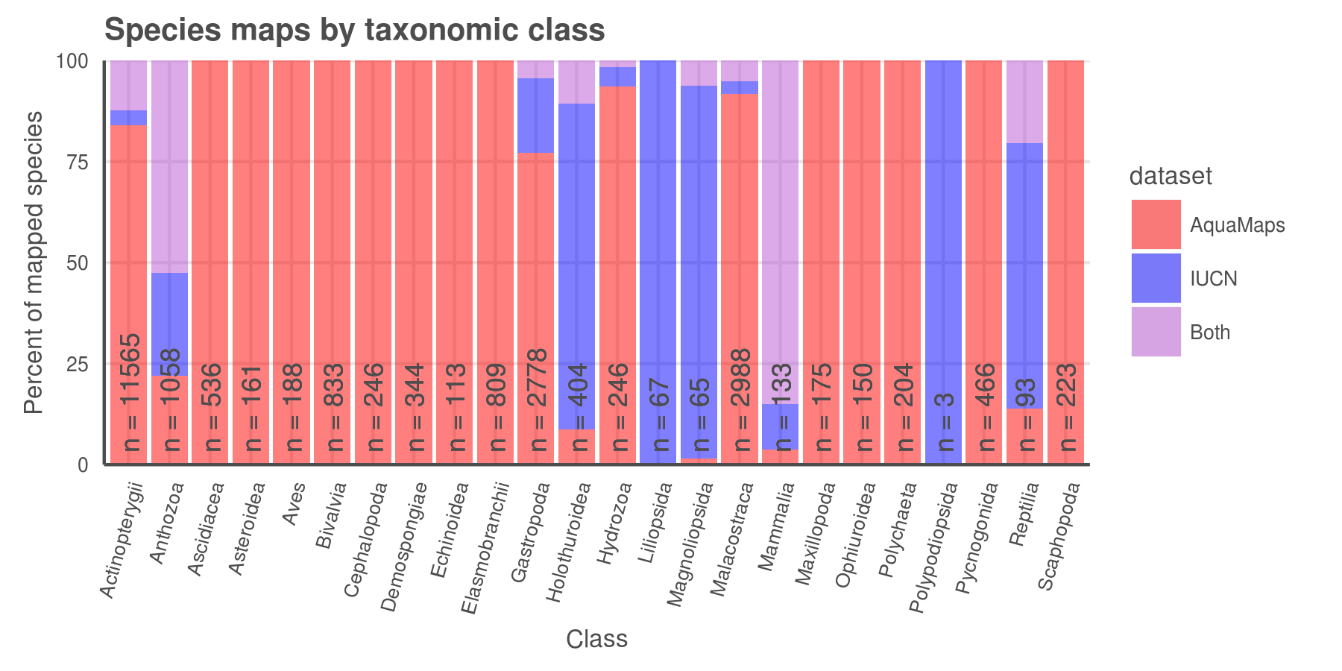

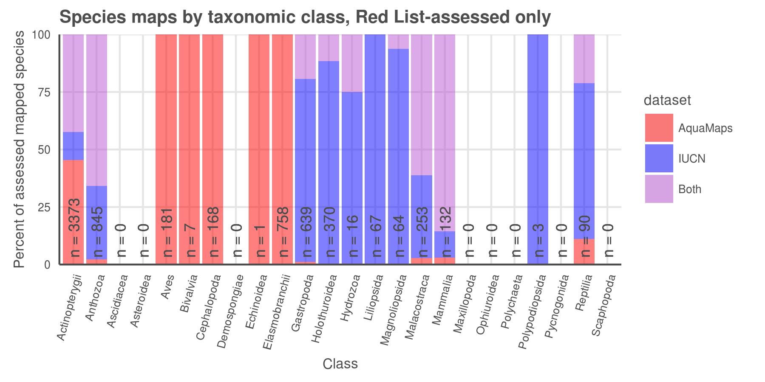

Number and proportion of species, listed by taxa, included in each dataset: IUCN, AquaMaps, or both. (a) All species with distribution maps; (b) IUCN Red List-assessed species with distribution maps.

### Figure 2 (a, b):

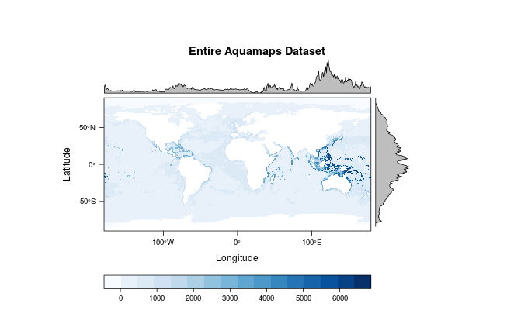

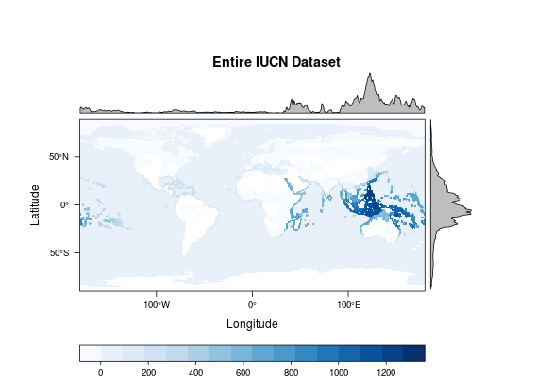

Global marine species richness according to (a) AquaMaps dataset and (b) IUCN dataset.

### Figure 3 (a):

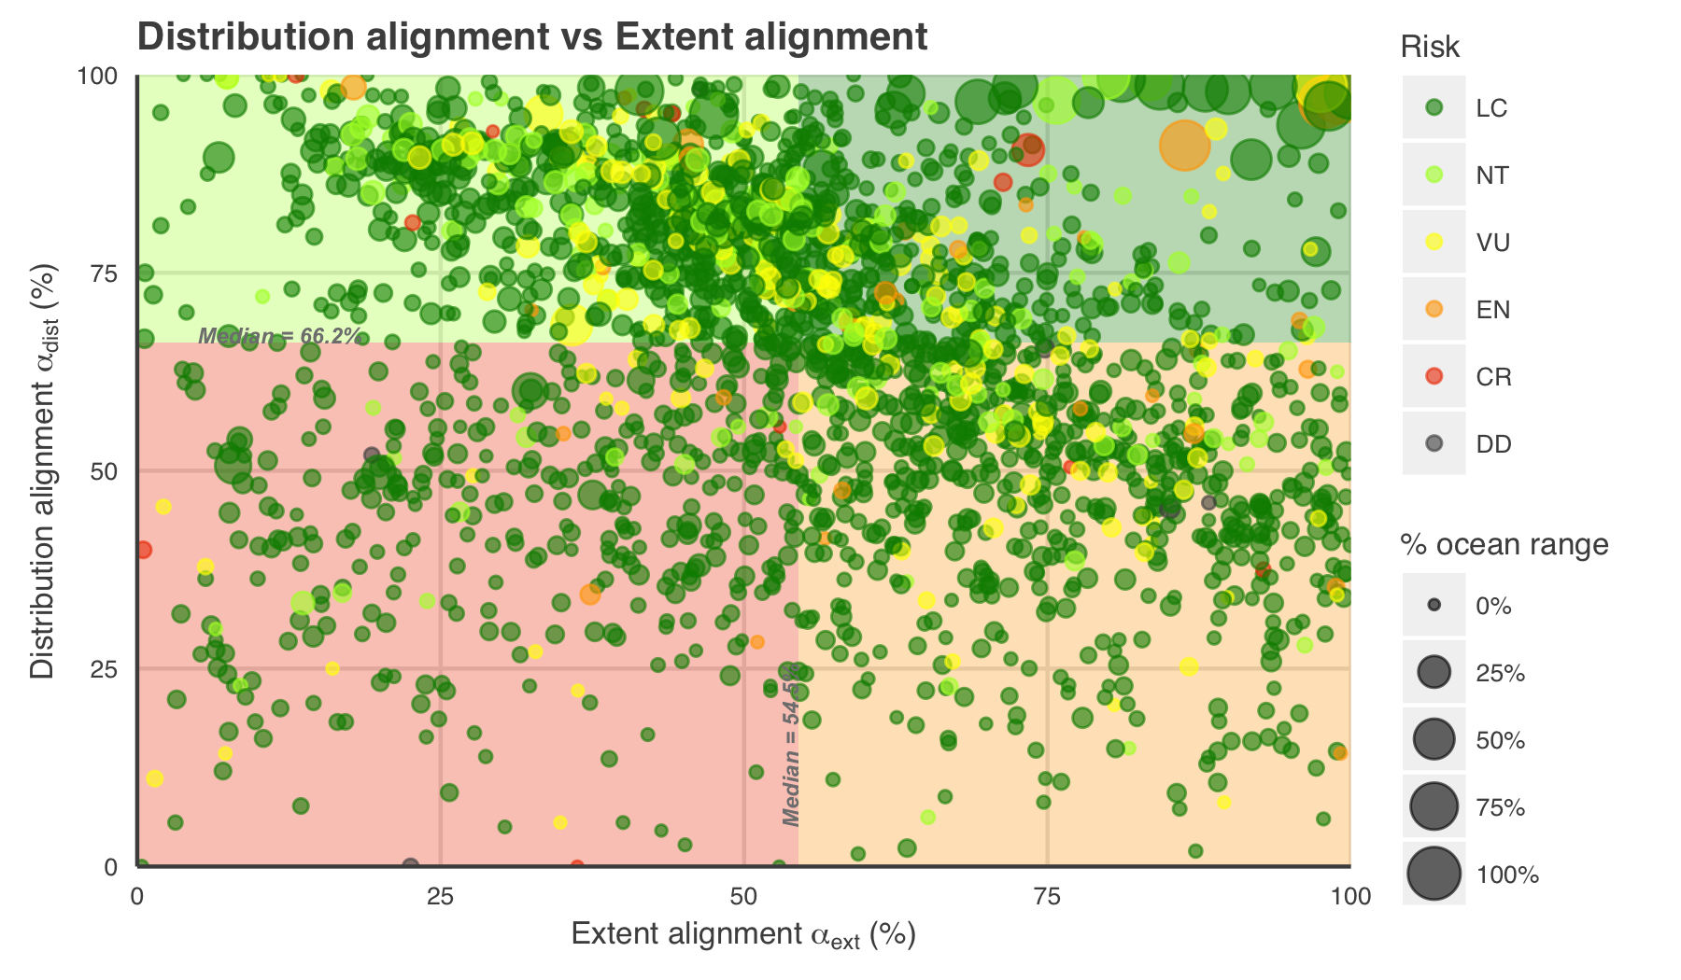

Distribution alignment vs Extent alignment for 2166 species mapped in both Aquamaps and IUCN datasets.

* The upper right quadrant (quadrant 1) comprises species whose maps largely agree (better than median value) in both spatial distribution and the area of described ranges. (n = 400; 18.5 %)
* The upper left quadrant (quadrant 2) comprises species whose maps agree well in distribution, but disagree in extent. (n = 684; 31.6 %)
* The lower right quadrant (quadrant 3) includes species for which the paired maps generally agree in range extent, but disagree on where those ranges lie - a more problematic mismatch than that indicated by quadrant 2. (n = 681; 31.4 %)
* The lower left quadrant (quadrant 4) indicates species for which the map pairs fail to agree in both area and distribution. (n = 401; 18.5 %)

### Figure 3 (b, c):

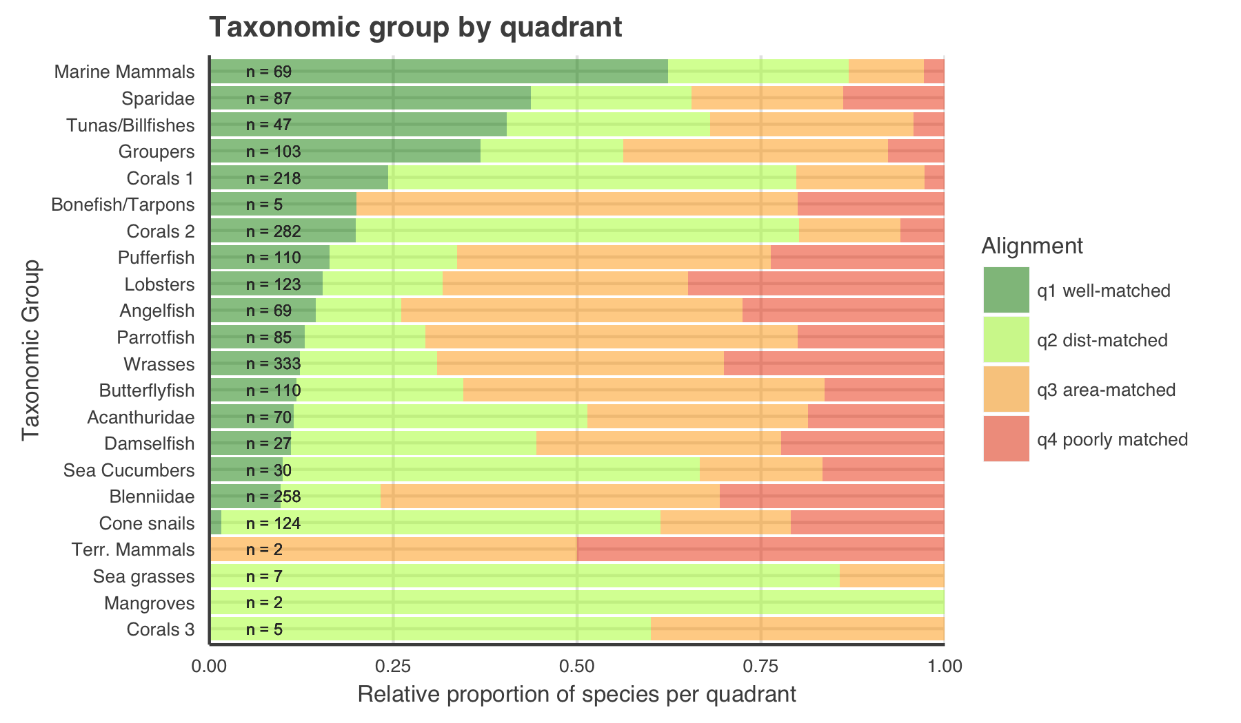

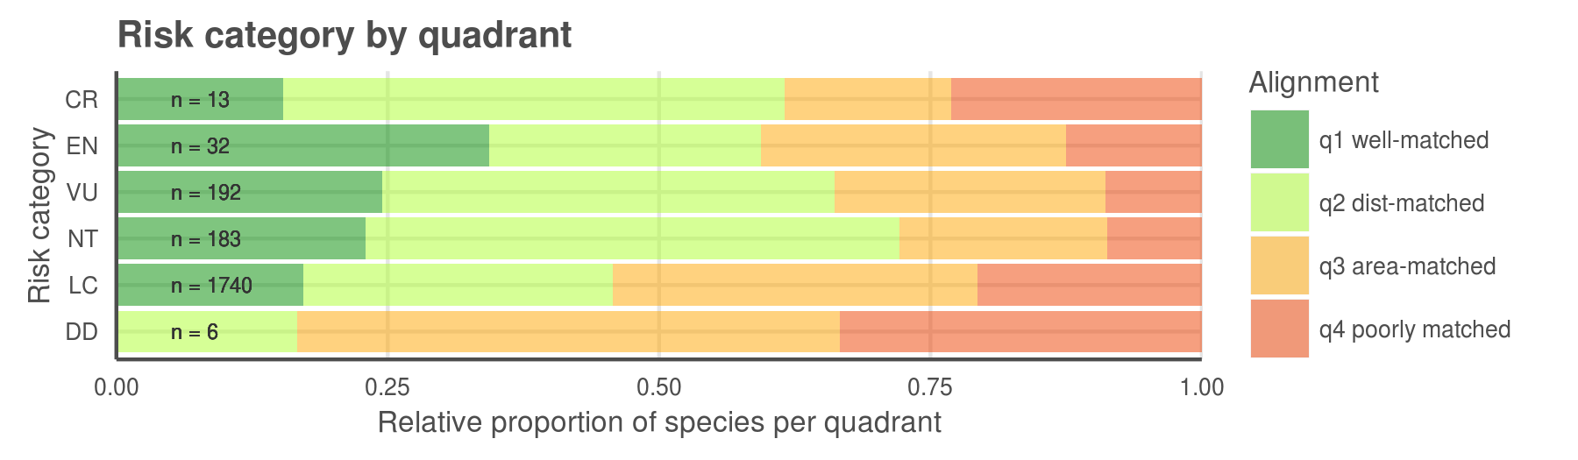

Spatial alignment of paired-map species by (a) taxonomic group and (b) extinction risk category.

### Figure 5 (a, b):

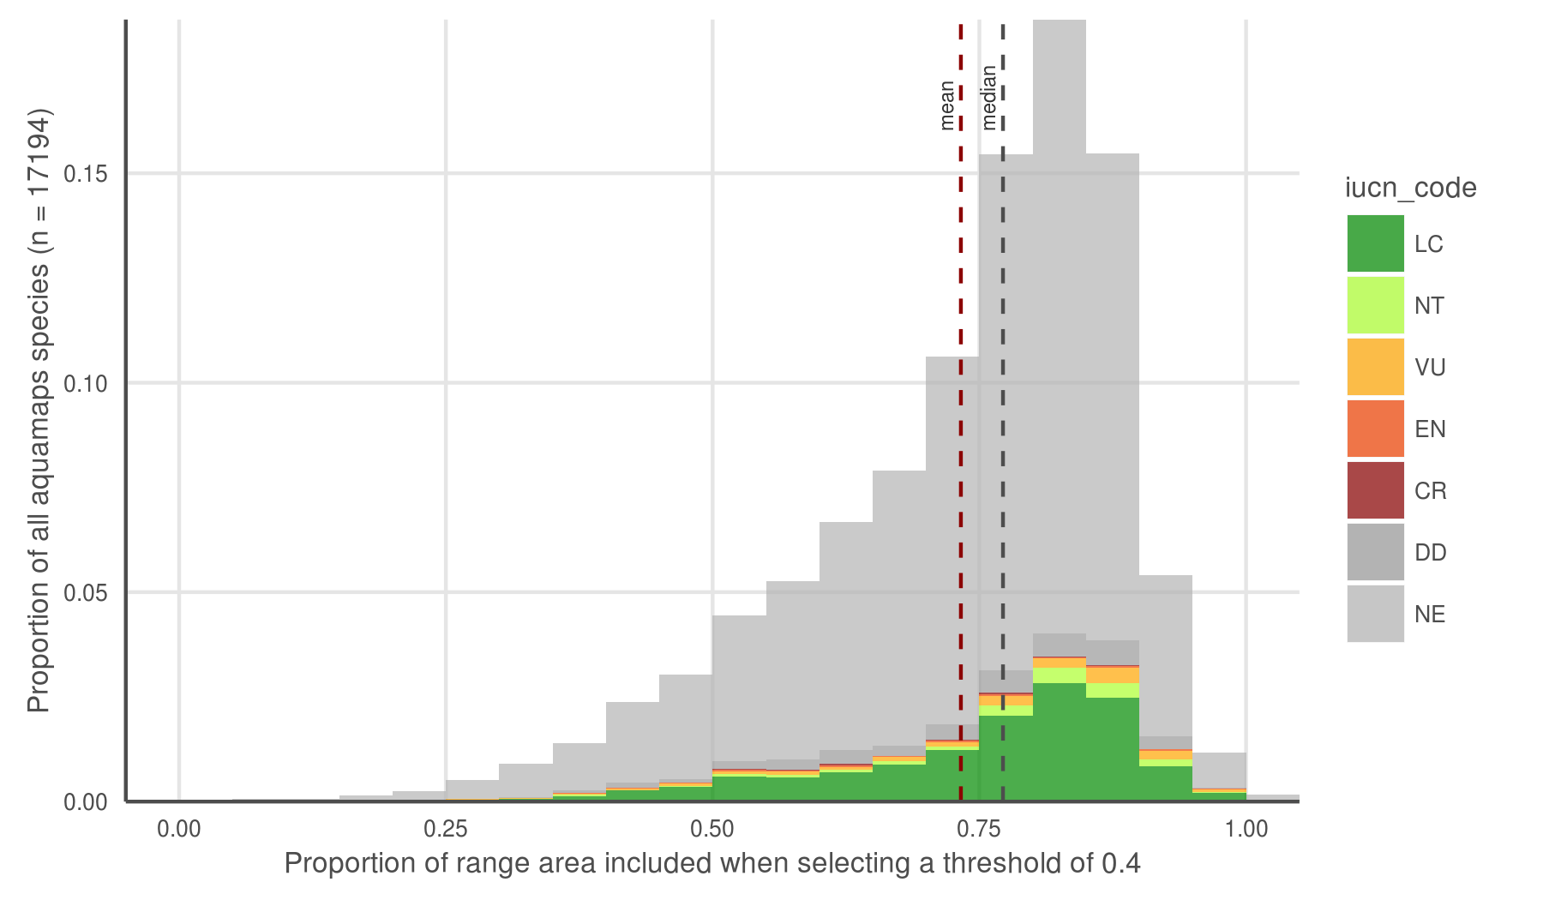

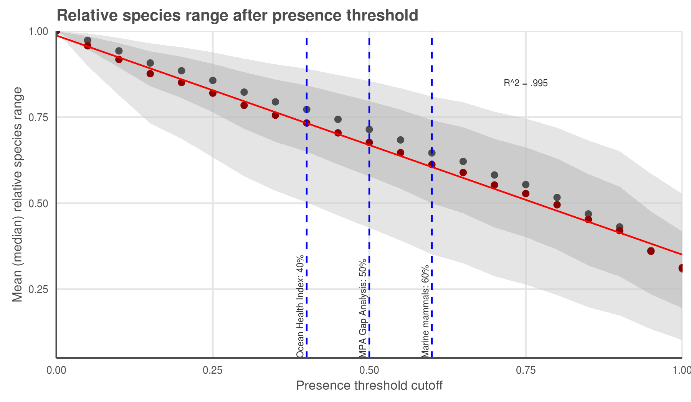

AquaMaps distribution map extent remaining after applying a presence threshold. (a) A 40% threshold applied to all species in the AquaMaps dataset shows a mean loss of XXX, with a wide distribution in which some species lose nearly all of their apparent range. (b) Mean (median) remaining extent at increments of presence threshold. Dark grey ribbon includes 25% to 75% quantiles, while light grey ribbon includes 9% to 91% quantiles.

### Figure 6

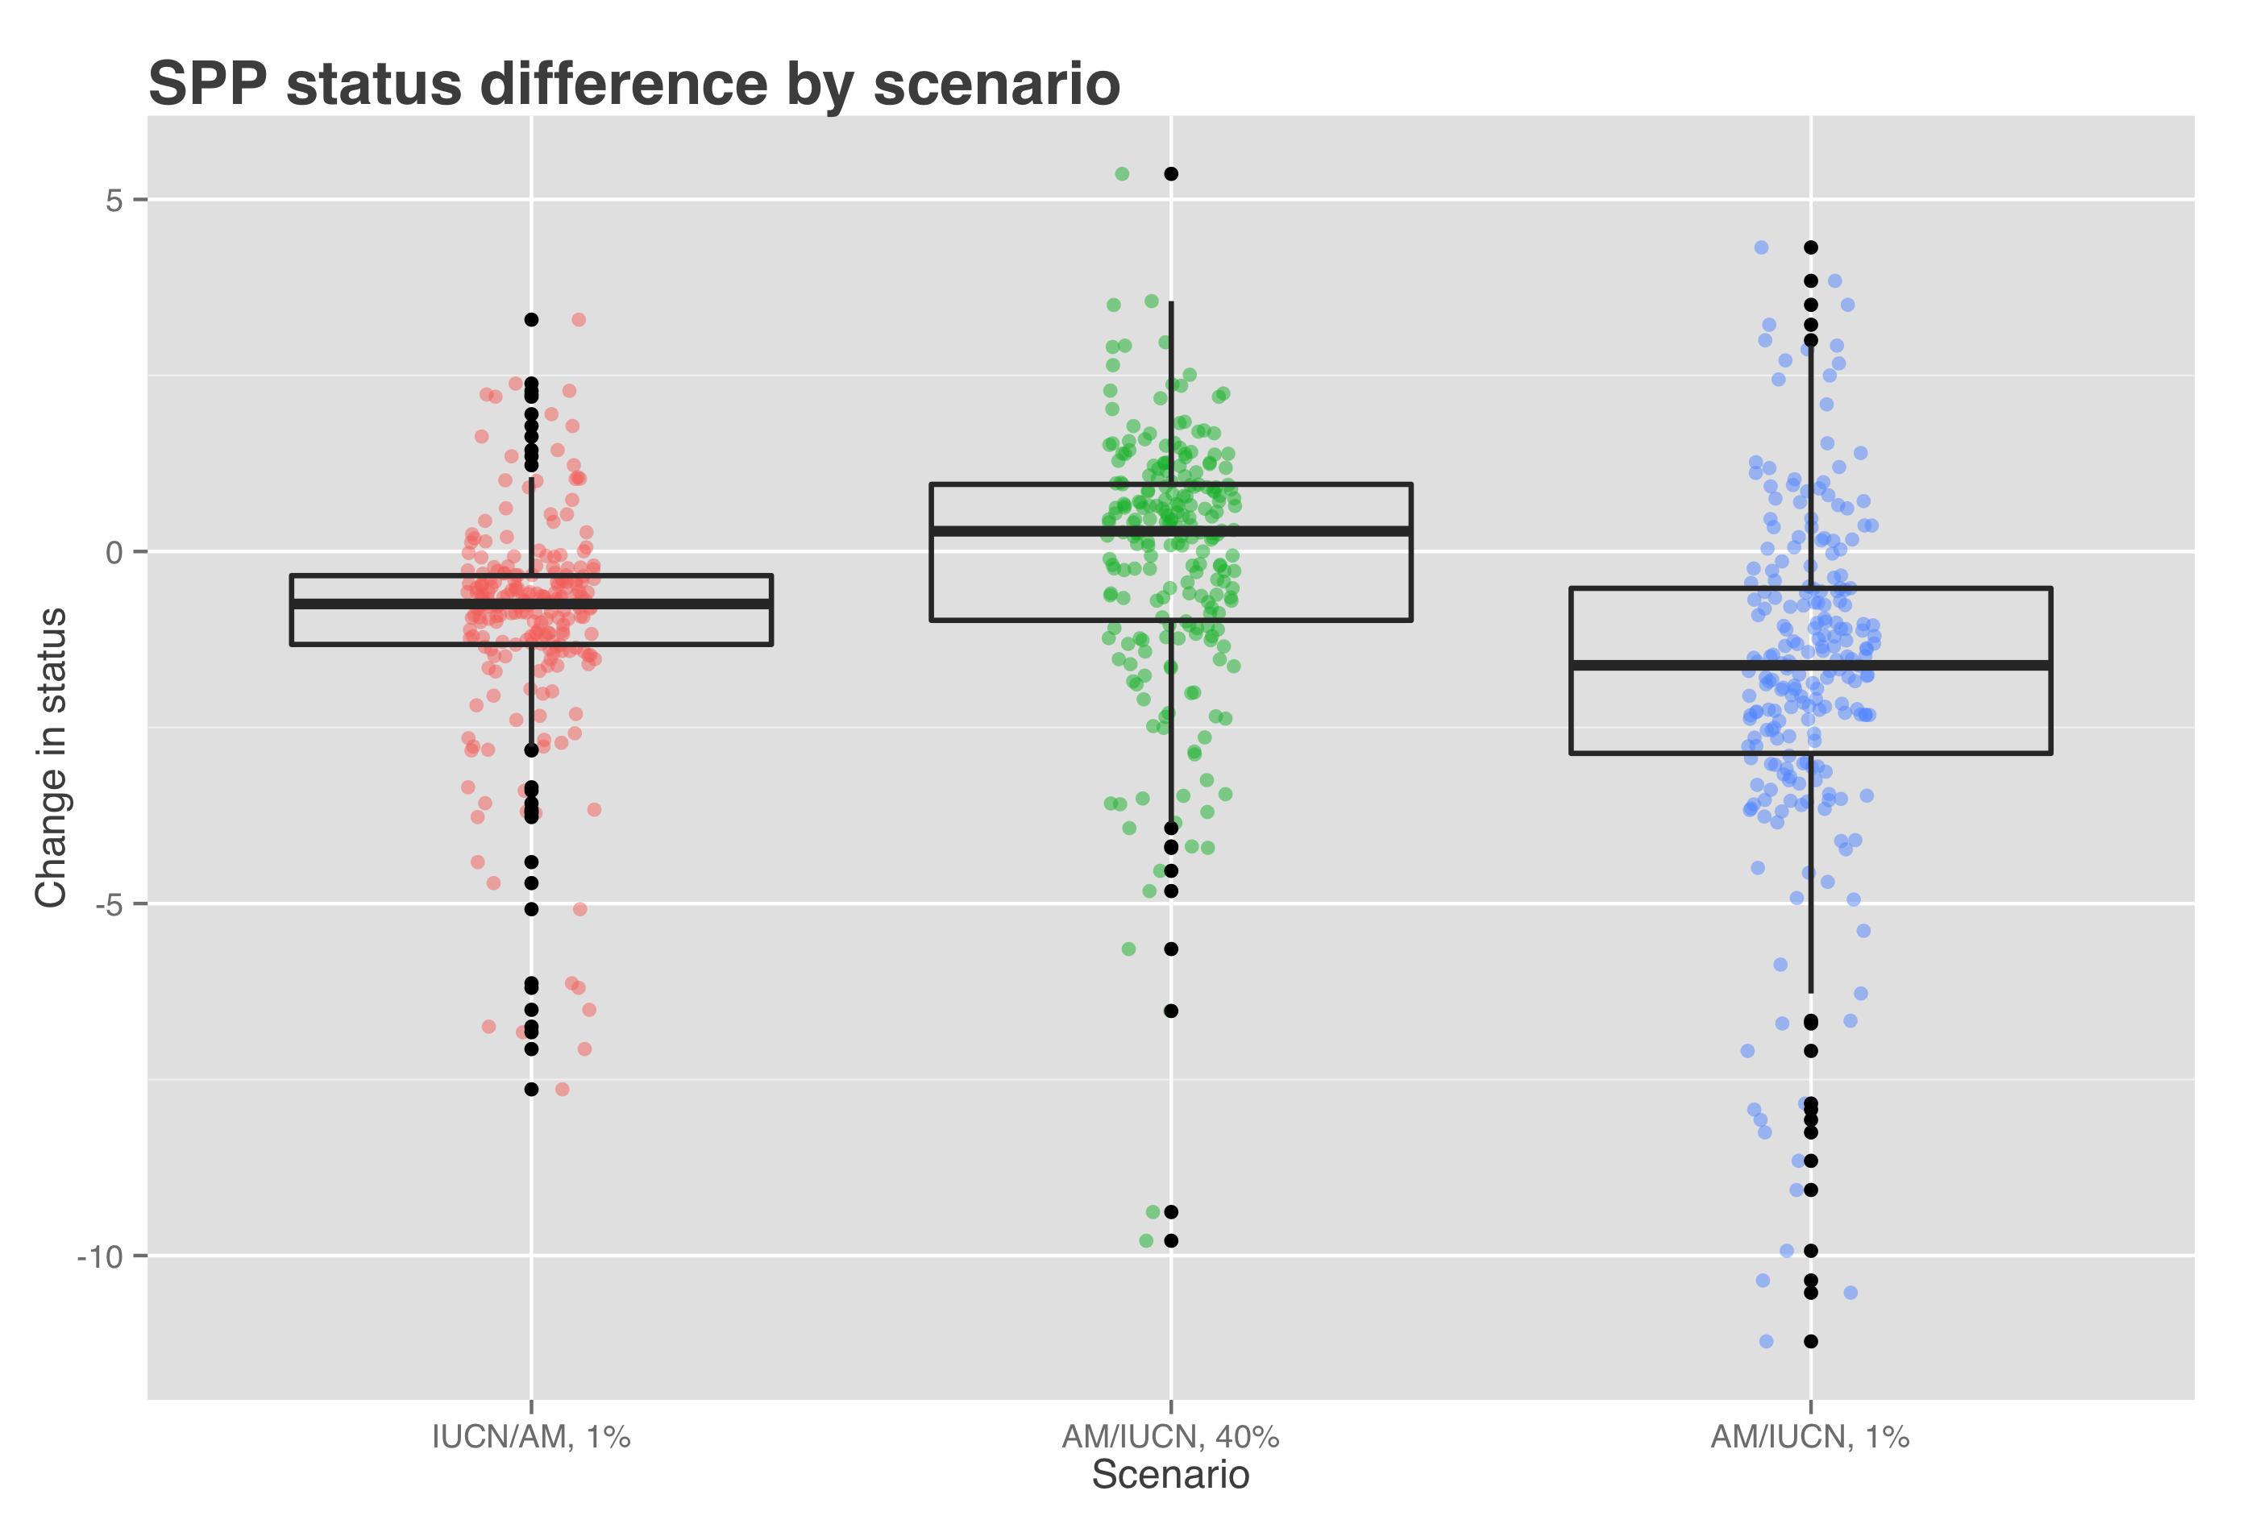

Figure [X] shows the change in status score for the Species Subgoal within the global Ocean Health Index under three different scenarios.

|  |  |  |
| --- | --- | --- |
| Scenario | Priority data source | AquaMaps presence threshold |
| Scenario 0 (current) | IUCN | >= 40% |
| Scenario 1 | IUCN | > 0% |
| Scenario 2 | AquaMaps | >= 40% |
| Scenario 3 | AquaMaps | > 0% |

* Scenario 1 shows the effect of reducing the presence threshold for AquaMaps presence. Reducing the threshold will always increase the apparent range of a species, therefore the slight decrease in average score suggests increased spatial representation of threatened species.
* Scenario 2 shows the effect of preferring AquaMaps data over IUCN, while maintaining the same presence threshold. This will have different effects depending on the species; in general, AquaMaps ranges are smaller than IUCN ranges, so many but not all overlapping species will see a decrease in represented range. The slight bump in mean score may indicate a small increase in spatial representation of low-risk species, a small decrease in spatial representation of high-risk species, or more likely a combination of both.
* Scenario 3 shows the effect of preferring AquaMaps data over IUCN, while eliminating the presence threshold. Just as a presence threshold of zero in scenario 1 drives a decrease in average score relative to the baseline, the zero threshold in scenario 3 drives a decrease in scores relative to scenario 2. The large decrease seems to indicate that within the set of paired-map species, a zero threshold greatly increases the spatial representation of high-risk species relative to low-risk species.

# References

**Key AquaMaps publications:**

Kaschner, K., R. Watson, A. W. Trites, D. Pauly (2006). Mapping world-wide distributions of marine mammal species using a relative environmental suitability (RES) model. Marine Ecology Progress Series 316: 285–310. *check this citation journal name...* *This outlines the basic RES methodology - AM development*

Kaschner, K., D.P. Tittensor, J. Ready, T Gerrodette and B. Worm (2011). Current and Future Patterns of Global Marine Mammal Biodiversity. PLoS ONE 6(5): e19653. PDF *just what the title says - AM development, presence threshold 60%, also analyzes richness as a function of threshold*

Ready, J., K. Kaschner, A.B. South, P.D Eastwood, T. Rees, J. Rius, E. Agbayani, S. Kullander and R. Froese (2010). Predicting the distributions of marine organisms at the global scale. Ecological Modelling 221(3): 467-478. PDF *Presents AM; assessing AquaMaps against other presence-only species models*

**Papers based on AquaMaps:**

Jones, M.C., S.R. Dyeb, J.K. Pinnegar and W.W.L. Cheung (2012). Modelling commercial fish distributions: Prediction and assessment using different approaches. Ecological Modelling 225(2012): 133-145. PDF *comparison of species distribution models including AquaMaps, Maxent and the Sea Around Us Project*

Coll, M., C. Piroddi, J. Steenbeek, K. Kaschner, F. Ben Rais Lasram et al. (2010). The biodiversity of the Mediterranean Sea: estimates, patterns, and threats. PLoS ONE 5(8): e11842. PDF *used AquaMaps to predict Med biodiversity. Also: Threshold = 0.*

Martin C.S., Fletcher R., Jones M.C., Kaschner K., Sullivan E., Tittensor D.P., Mcowen C., Geffert J.L., van Bochove J.W., Thomas H., Blyth S., Ravillious C., Tolley M., Stanwell-Smith D. (2014). Manual of marine and coastal datasets of biodiversity importance. May 2014 release. Cambridge (UK): UNEP World Conservation Monitoring Centre. 28 pp. (+ 4 annexes totalling 174 pp. and one e-supplement). PDF *report on marine data sets and data gaps etc, incl both IUCN and AM*

Hurlbert 2007 Species richness, hotspots, and the scale dependence of range maps in ecology and conservation. *mostly rasters of range maps? "The scale dependence of range-map accuracy poses clear limitations on braod-scale ecological analyses and conservation assessments. ... we provide guidance about the approriate scale of their use*

Jetz 2008 Ecological Correlates and Conservation Implications of Overestimating Species Geographic Ranges *EOO maps are usually highly interpolated and overestimate small-scale occurrence, which may bias research outcomes*

Pimm 2014 The biodiversity of species and their rates of extinction, distribtuion, and protection. *uses range maps to show biodiversity areas; may use IUCN range maps. Also discusses gaps and possible things that can be done about them.*

Rondinini 2006 Tradeoffs of different types of species occurrence data for use in systematic conservation planning *compares point locality, range maps, and distribution models in terms of omission and commission errors; also outlines Extent of Occurrence and Area of Occupancy distinctions.*

García Molinos, Jorge, Benjamin S. Halpern, David S. Schoeman, Christopher J. Brown, Wolfgang Kiessling, Pippa J. Moore, John M. Pandolfi, Elvira S. Poloczanska, Anthony J. Richardson, and Michael T. Burrows. “Climate Velocity and the Future Global Redistribution of Marine Biodiversity.” Nature Climate Change advance online publication (August 31, 2015). <doi:10.1038/nclimate2769>.

Halpern, Benjamin S., Catherine Longo, Darren Hardy, Karen L. McLeod, Jameal F. Samhouri, Steven K. Katona, Kristin Kleisner, et al. “An Index to Assess the Health and Benefits of the Global Ocean.” Nature 488, no. 7413 (August 30, 2012): 615–20. <doi:10.1038/nature11397>.

Klein, Carissa J., Christopher J. Brown, Benjamin S. Halpern, Daniel B. Segan, Jennifer McGowan, Maria Beger, and James E.M. Watson. “Shortfalls in the Global Protected Area Network at Representing Marine Biodiversity.” Scientific Reports 5 (December 3, 2015): 17539. <doi:10.1038/srep17539>.

Selig, Elizabeth R., Catherine Longo, Benjamin S. Halpern, Benjamin D. Best, Darren Hardy, Cristiane T. Elfes, Courtney Scarborough, Kristin M. Kleisner, and Steven K. Katona. “Assessing Global Marine Biodiversity Status within a Coupled Socio-Ecological Perspective.” PLoS ONE 8, no. 4 (April 11, 2013): e60284. <doi:10.1371/journal.pone.0060284>.

* IUCN reference:
  + <https://www.conservationtraining.org/course/view.php?id=217&lang=en>
  + <http://www.iucnredlist.org/technical-documents/red-list-training/iucnspatialresources>
  + IUCN Red List - accessed 12/21/2015
* AquaMaps reference, and accessed date?