Supplemental Information

## S1: sample maps from each quadrant

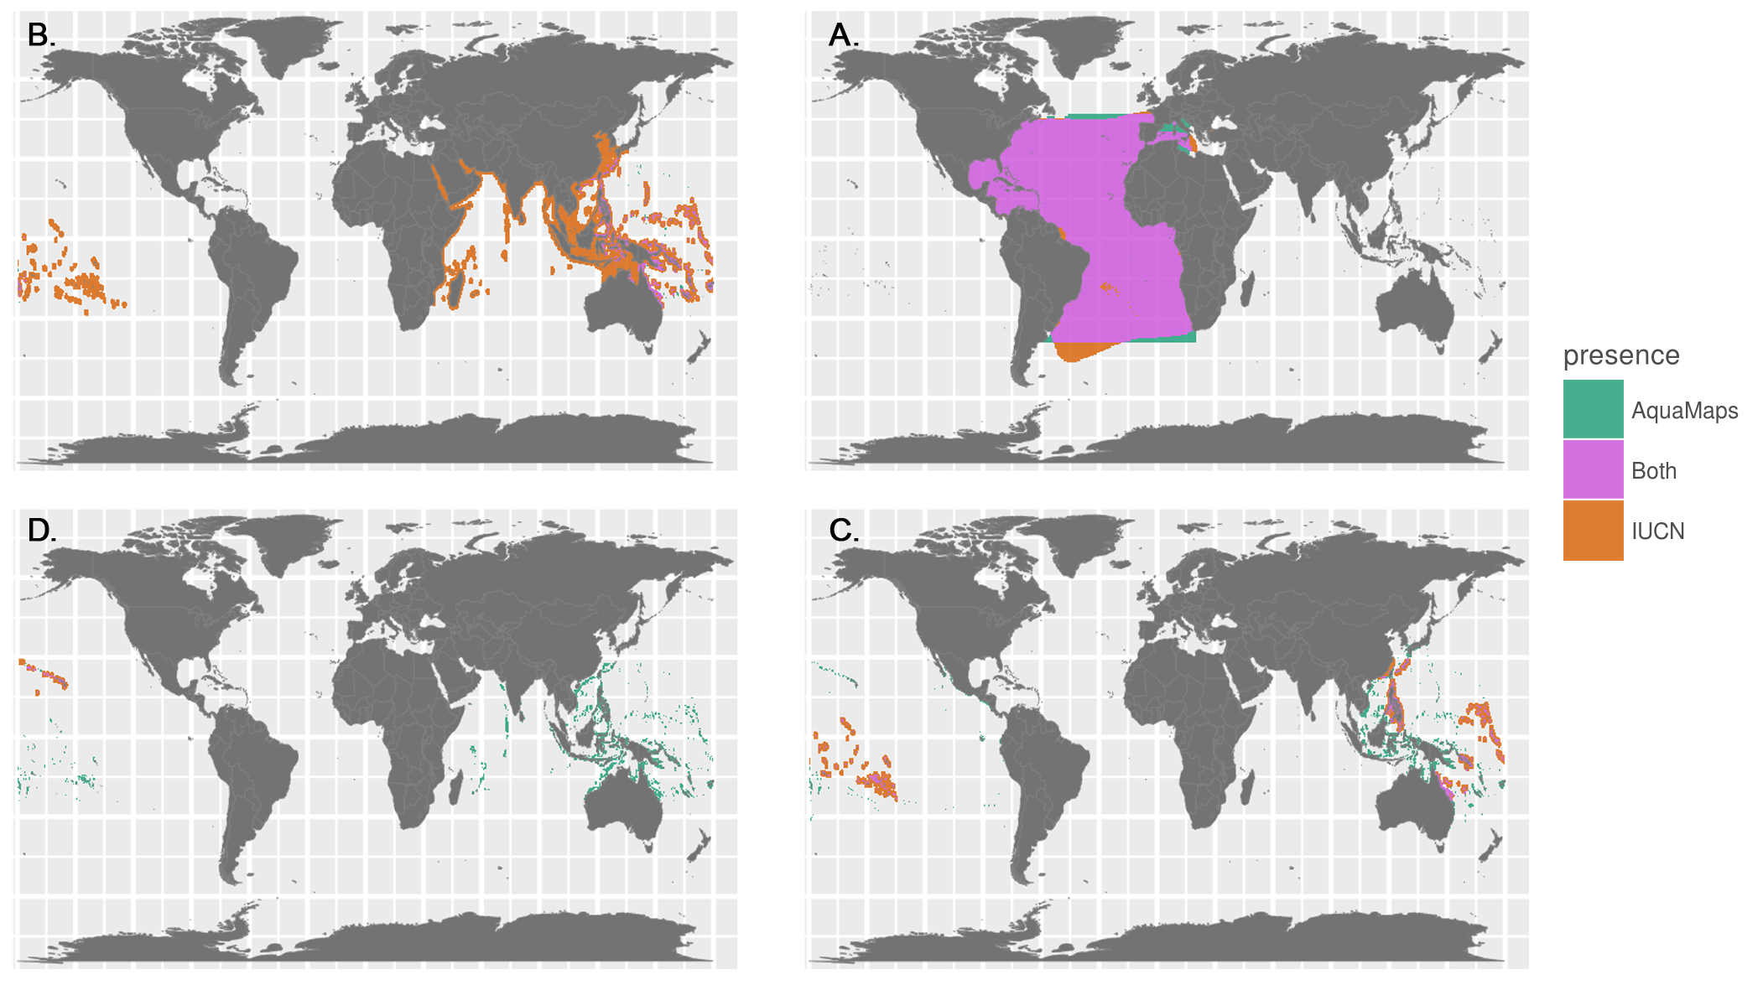

**Fig. S1.** Representative species maps to illustrate each quadrant from Fig. 2A. Note that A-D are arranged to match quadrants in Fig. 2A. (A: well-matched) Kajikia albida (B: distribution-matched) Conus episcopatus (C: area-matched) Conus magnificus (D: poorly-matched) Acanthurus nigroris

## S2: Risk by quadrant

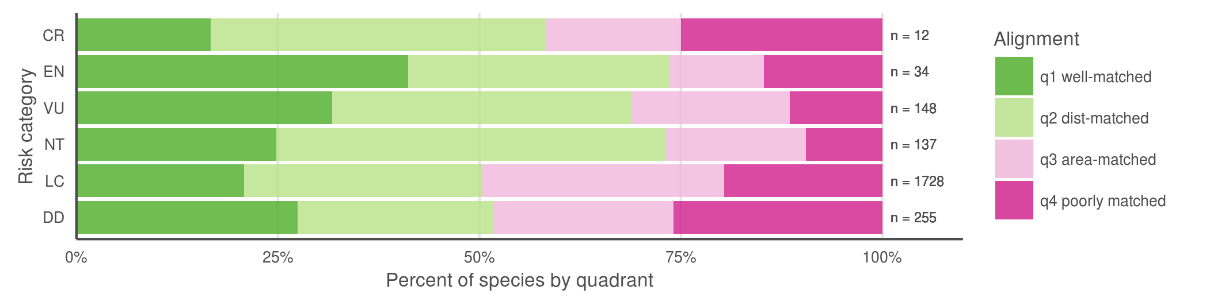

**Fig. S2.** Breaking down the quadrants by IUCN extinction risk categories (Fig. S2), we found little support for our hypothesis that maps for species with higher extinction risk tend to be better aligned between the two datasets, perhaps correlated to increased expert scrutiny. Does higher perceived risk lead to increased attention, and thus better understanding of species distribution? Or conversely, does increased attention to species distribution reveal more species at risk? Likely both mechanisms are at play on a case-by-case basis, depending on the species' taxon and region. *does this argument bear up to closer scrutiny? CR isn't dominated by Q1 any more*

### S3: Coral depth map

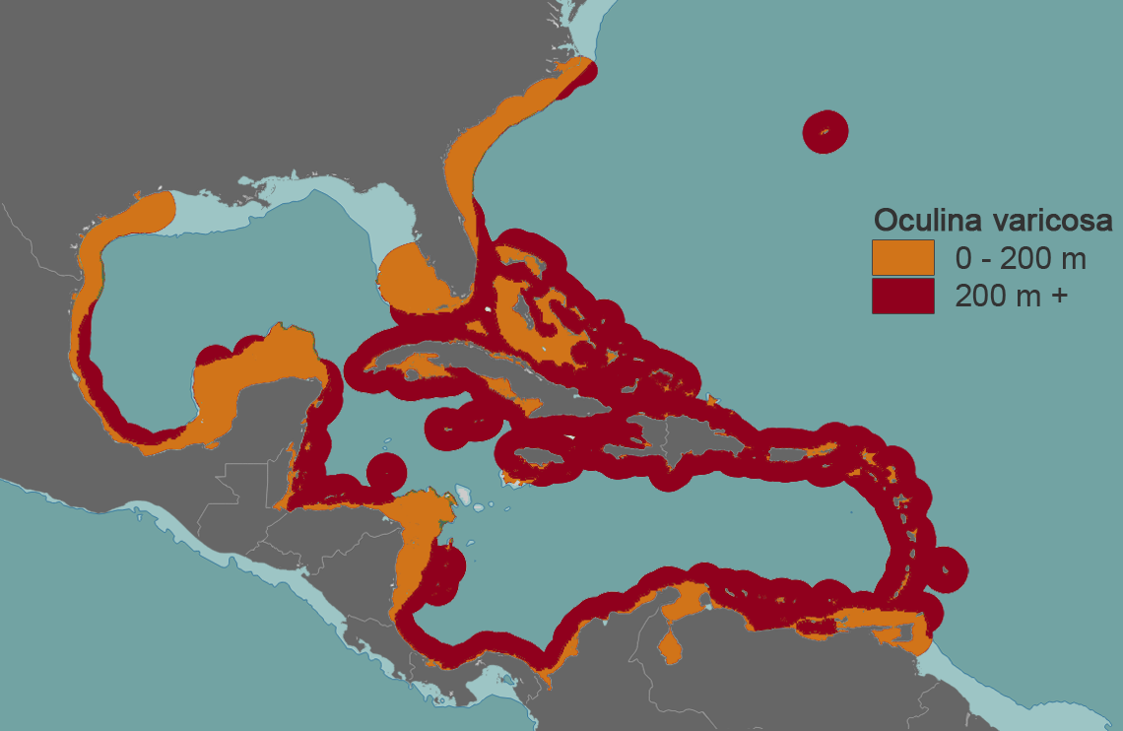

**Fig. S3.** IUCN-defined range of *Oculina varicosa*, a typical photosynthetic coral, plotted against a 200 m bathymetry contour. According to IUCN, *O. varicosa* can be found to depths of 152 m. In waters shallower than 30 m, *O. varicosa* is zooxanthellate, while an azooxanthellate form can be found in deeper waters.

### S4: AquaMaps threshold examination

AquaMaps distribution maps indicate "probability of occurrence" within each 0.5° cell, with values ranging from zero to one, rather than a simple present/absent value as indicated by IUCN maps. Many studies convert this AquaMaps probability to a simple presence value by assigning a threshold value. A higher threshold constrains an analysis to cells with near certainty of occurrence, while a low threshold captures larger areas of increasingly marginal suitability.

For our comparisons of global distribution of represented biodiversity and spatial alignment between datasets, we considered "present" to be any cell with a non-zero probability of occurrence, to best approximate the "limits of distribution" as indicated by IUCN maps. To examine the effect of different presence threshold selections on the represented range of a species, we varied the threshold from 0% to 100% and calculated the average species range relative to a zero threshold.

1. 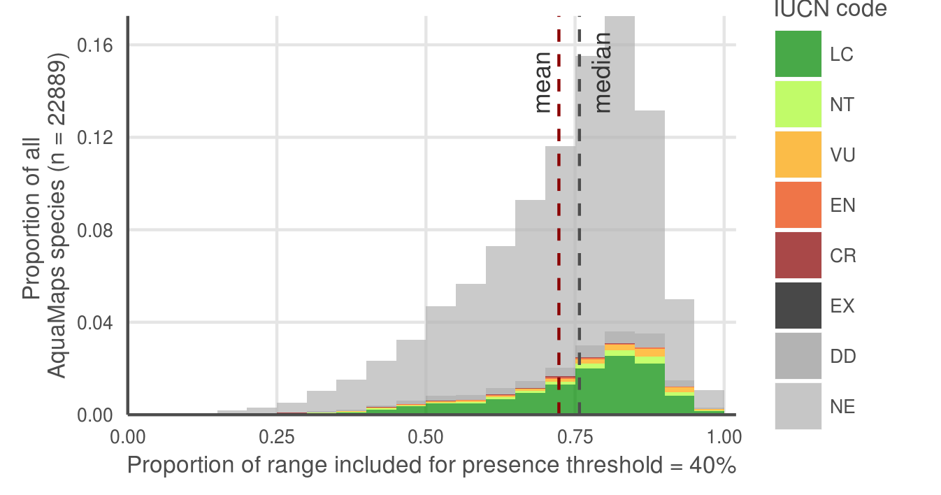
2. 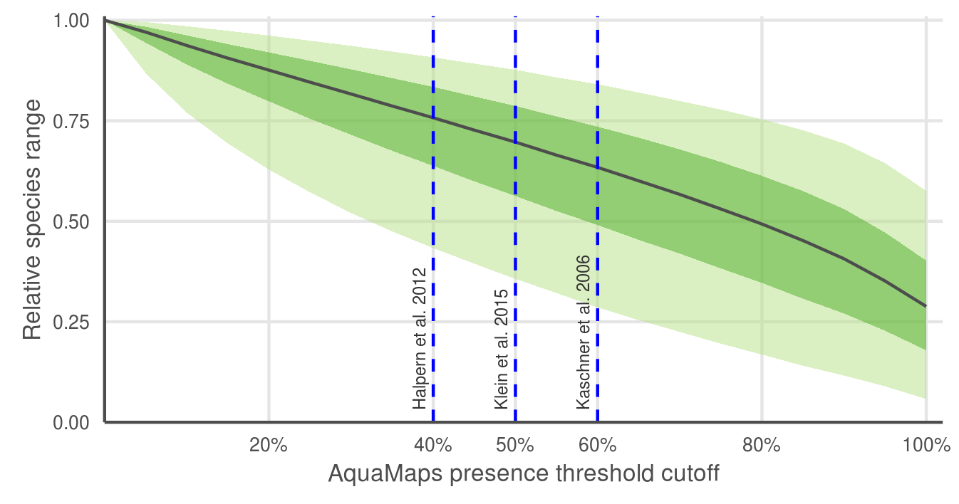

**Fig. S4.** AquaMaps distribution map extent remaining after applying a presence threshold. (A) A 40% threshold applied to all species in the AquaMaps dataset shows a mean loss of 28% of total range, with a wide distribution in which some species lose nearly all of their apparent range. (B) Median remaining extent at increments of presence threshold. Dark green ribbon includes 25% to 75% quantiles of remaining species range, while lighter ribbon includes 5% to 95% quantiles. Incrementing the presence threshold from 0.00 to 1.00 for the entire AquaMaps dataset, the shallow downward trend indicates a low but consistent sensitivity of apparent species range to threshold choice, with no surprising tradeoffs that could suggest an "optimal" threshold.