

NATIONAL CENTER FOR ECOLOGICAL ANALYSIS AND SYNTHESIS

SANTA BARBARA, CALIFORNIA 93101

PHONE: (805) 882-2523

FAX: (805) 892-2510

E-MAIL: ohara@nceas.ucsb.edu

April 4, 2016

Dear Editors,

Recognizing the cumulative impacts of human activity on our oceans, scientific and public attention are increasingly focusing on understanding and preserving marine species and ecosystems. However, the challenges in predicting and communicating distributions for marine species – presence as well as absence – create uncertainty in our understanding of global biodiversity, leading us to waste time, effort, and resources on inefficient and inadequate marine conservation efforts.

We submit for your review the enclosed paper, entitled “Aligning marine species range data to better serve science and conservation,” in which we expose substantial dissimilarities in species range predictions between two extensively-used databases of global marine species ranges. We then explore the implications of these differences in context of biodiversity assessment and marine protection. We found that such discrepancies in species range predictions:

* Drive considerable shifts in our understanding of marine biodiversity status at national and regional levels.
* Result in dramatically different estimates of species protection under our current global network of marine protected areas (MPAs), including a five-fold increase in our estimate of species left entirely unprotected by existing MPA boundaries.
* Can frequently be attributed to differences in methodology; these issues can be readily addressed, thus improving conservation outcomes.

Effective marine conservation depends crucially on understanding where the species exist that we hope to preserve. Given the general interest in ocean health, and national and international marine conservation efforts in particular, we anticipate the paper will appeal broadly to scientists and policy-makers as well as the conservation-minded public.

The research and results presented here are novel from any past work I or my colleagues have done. This work has not yet been published, has been approved for publication by all authors, and has only been submitted to *PNAS* for consideration. If additional information is needed, please feel free to contact me.

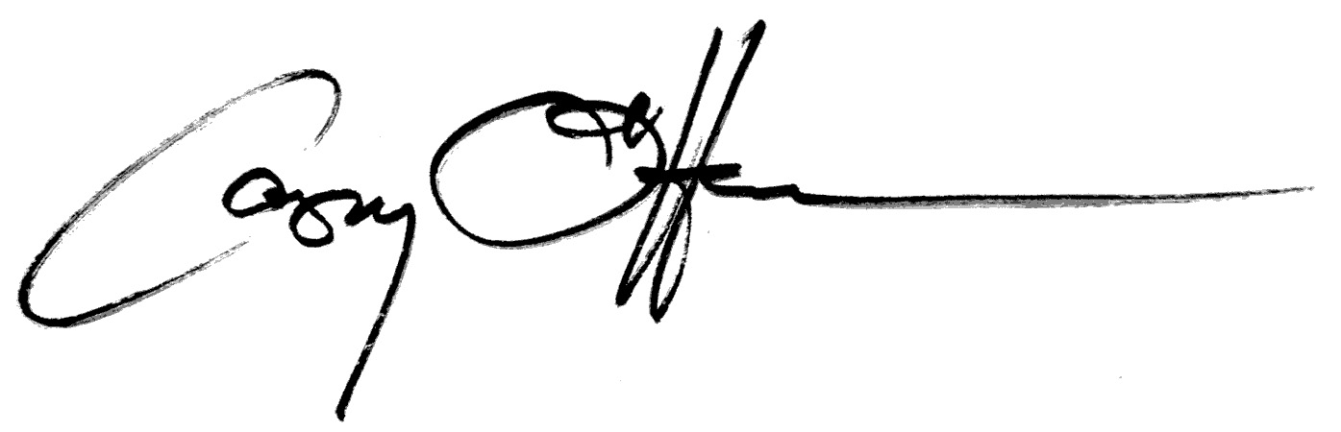Sincerely, on behalf of all coauthors,

Casey C. O’Hara

National Center for Ecological Analysis and Synthesis

735 State Street, Suite 300

Santa Barbara, CA 93101

ohara@nceas.ucsb.edu