Figures

# Figures

***NOTE:*** These images are all based on .png outputs, exported from .psd files; submit the .tif versions for publication.

### Fig. 1

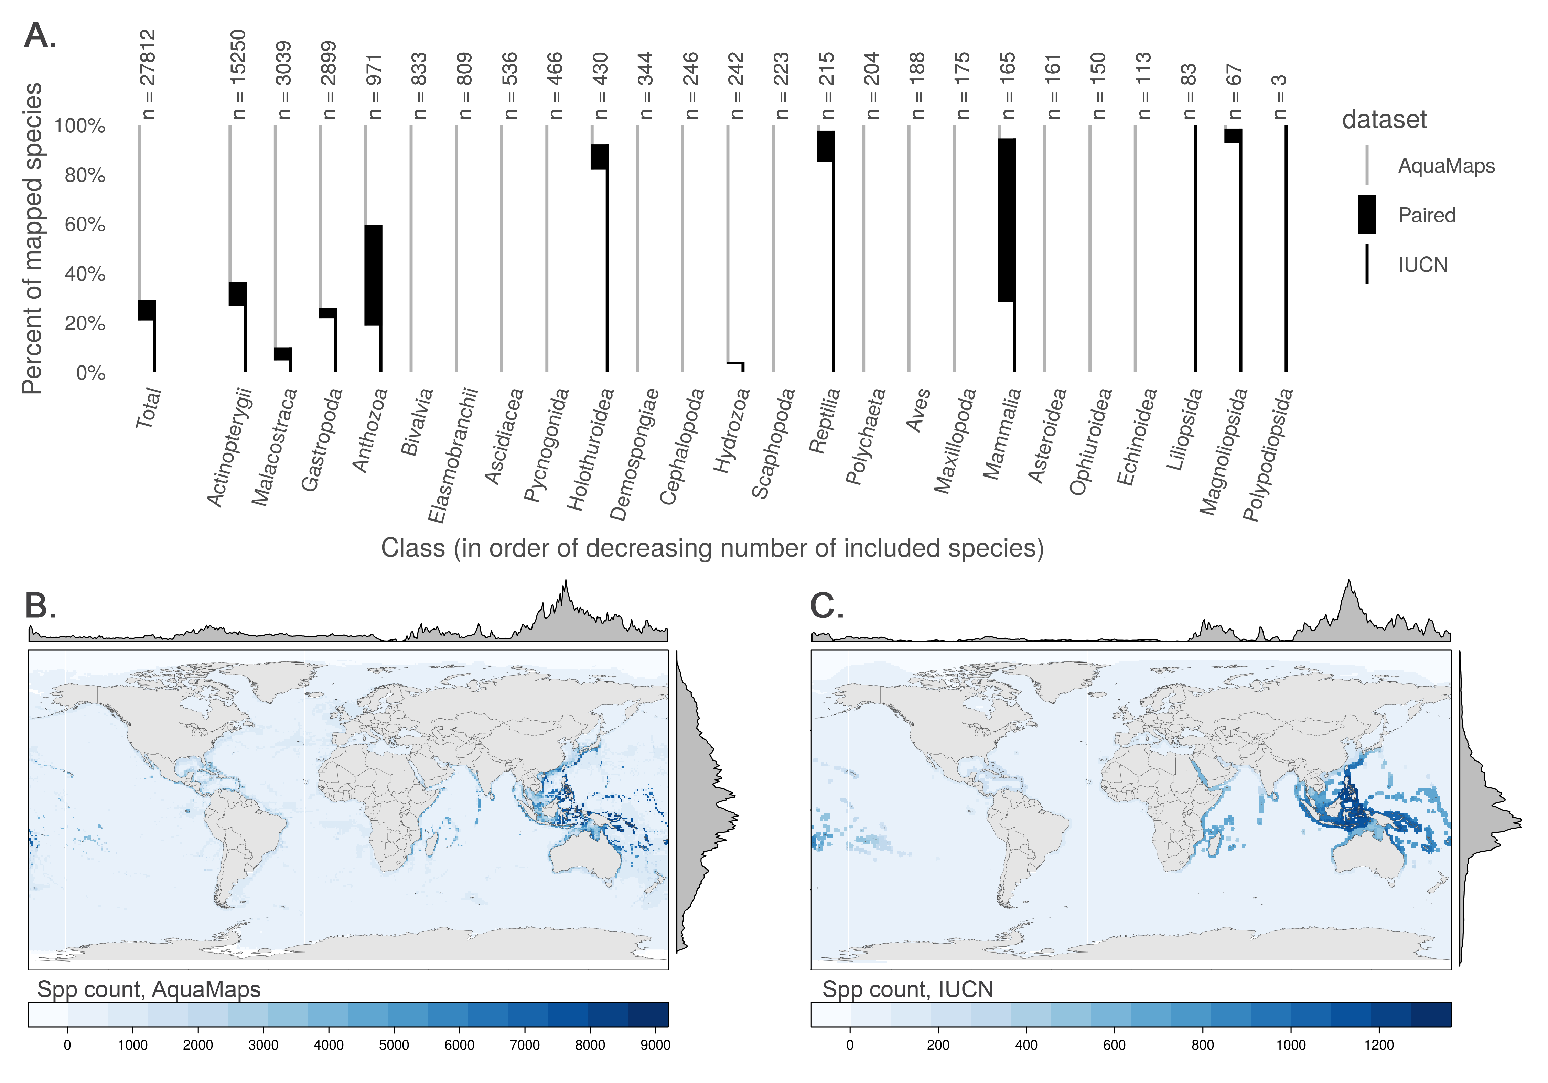

Taxonomic and geographic representation

### Fig. 2

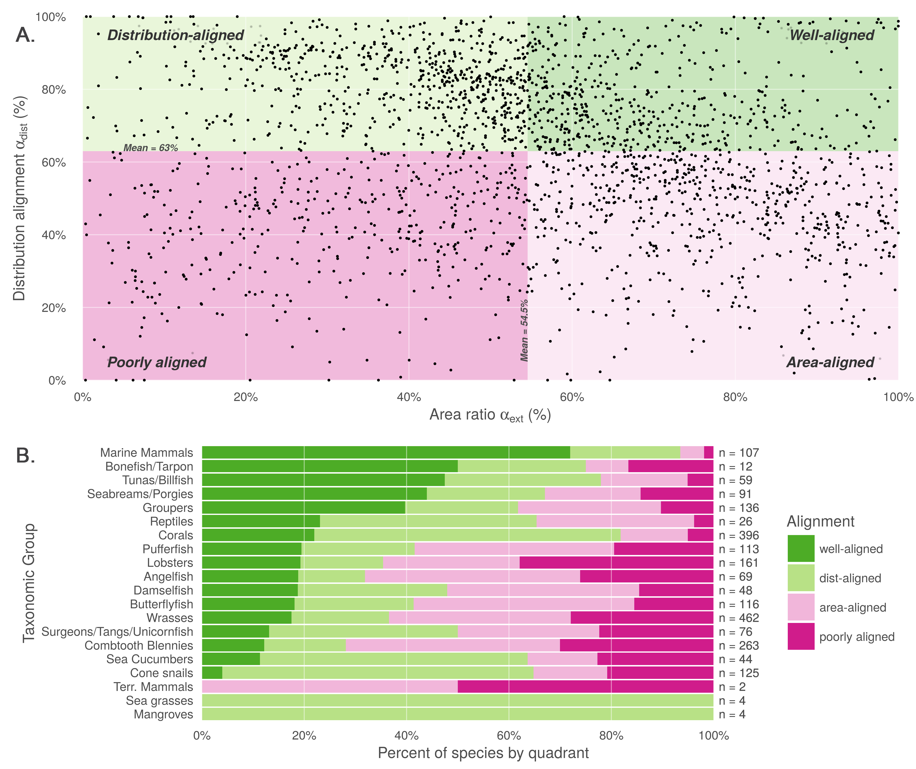

Quadrant plot and spp breakdown by quadrant

### Fig. 3

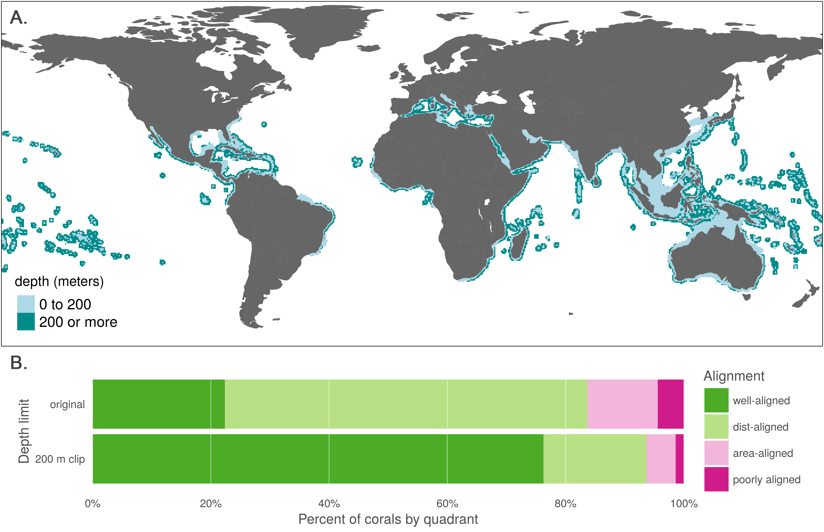

coral area subject to depth clipping

### Figure 4

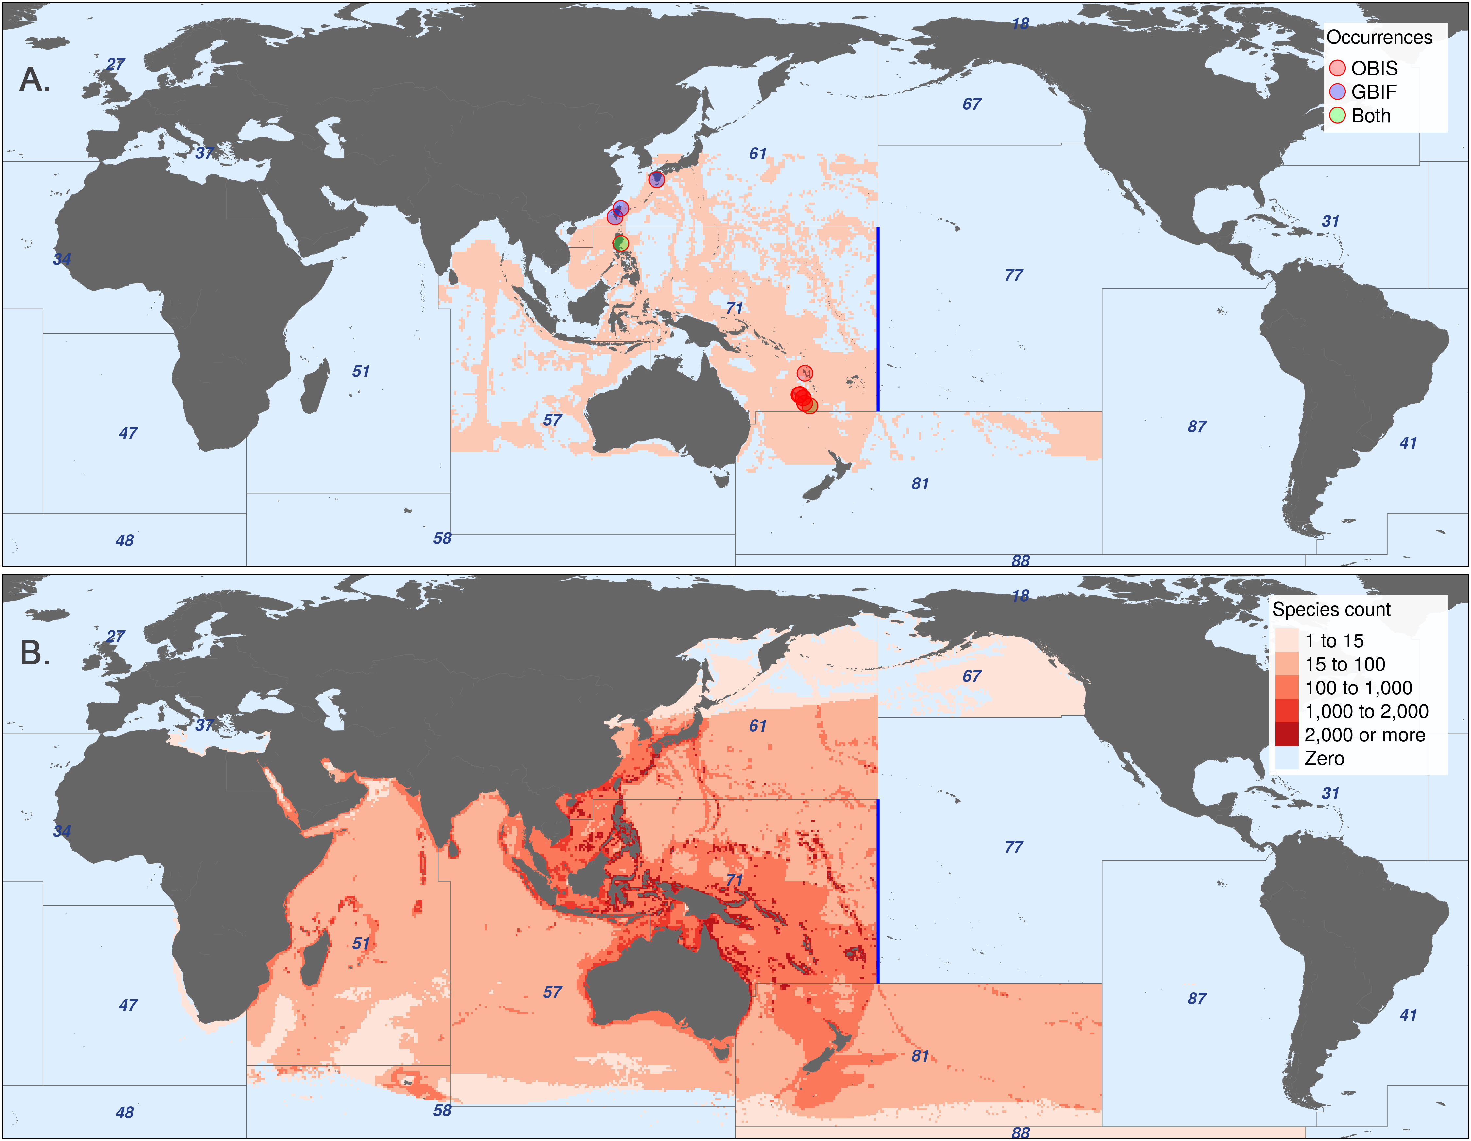

aquamaps edge comparison

### Figure 5

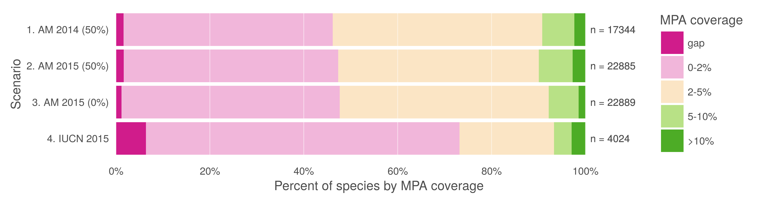

Change in MPA coverage