Figures for paper

Remi Daigle



**Figure 1**: Aboriginal Needs score over time



**Figure 2**: Normal OHI and Canadian modified OHI. Numbers indicate goal scores. Mariculture (MAR) and Fisheries (FIS) subgoals are part of Food Provision; Aboriginal Needs (AN); Natural Products (NP); Carbon Storage (CS); Coastal Protection (CP); Tourism & Recreation (TR); Livelihoods (LIV) and Economies (ECO) subgoals are part of Coastal Livelihoods; Iconic species (ICO) and Lasting Special Places (LSP) subgoals are part of Iconic Places & Species; Clean Waters (CW); Habitat (HAB) and Species Protection (SPP) subgoals are part of Biodiversity.



**Figure 3**: Canadian modified OHI with different weighting techniques. In all cases subgoals weights are half their parent weights except for Food Provision where subgoals are weighted relative to yield. In equal weighting, for all goals are weights = 1. For the Likert Importance, weights are derived from the relative importance (1-5) question. For the BW Rank and BW-DCE, the weights are derived from the answers of best/worst pairings. Thos answers were either simply ranked, or the weights were derived from the DCE model coefficients. Numbers indicate goal weights. Mariculture (MAR) and Fisheries (FIS) subgoals are part of Food Provision; Aboriginal Needs (AN); Natural Products (NP); Carbon Storage (CS); Coastal Protection (CP); Tourism & Recreation (TR); Livelihoods (LIV) and Economies (ECO) subgoals are part of Coastal Livelihoods; Iconic species (ICO) and Lasting Special Places (LSP) subgoals are part of Iconic Places & Species; Clean Waters (CW); Habitat (HAB) and Species Protection (SPP) subgoals are part of Biodiversity.



**Figure 4**: Canadian modified OHI with Best/Worst DCE coefficient weights from each province. Numbers indicate goal weights. Mariculture (MAR) and Fisheries (FIS) subgoals are part of Food Provision; Aboriginal Needs (AN); Natural Products (NP); Carbon Storage (CS); Coastal Protection (CP); Tourism & Recreation (TR); Livelihoods (LIV) and Economies (ECO) subgoals are part of Coastal Livelihoods; Iconic species (ICO) and Lasting Special Places (LSP) subgoals are part of Iconic Places & Species; Clean Waters (CW); Habitat (HAB) and Species Protection (SPP) subgoals are part of Biodiversity.



**Figure 5**: Canadian modified OHI with Best/Worst DCE coefficient weights from each age group. Numbers indicate goal weights. Mariculture (MAR) and Fisheries (FIS) subgoals are part of Food Provision; Aboriginal Needs (AN); Natural Products (NP); Carbon Storage (CS); Coastal Protection (CP); Tourism & Recreation (TR); Livelihoods (LIV) and Economies (ECO) subgoals are part of Coastal Livelihoods; Iconic species (ICO) and Lasting Special Places (LSP) subgoals are part of Iconic Places & Species; Clean Waters (CW); Habitat (HAB) and Species Protection (SPP) subgoals are part of Biodiversity.



**Figure 6**: Canadian modified OHI with Best/Worst DCE coefficient weights from each political affiliation. Numbers indicate goal weights. Mariculture (MAR) and Fisheries (FIS) subgoals are part of Food Provision; Aboriginal Needs (AN); Natural Products (NP); Carbon Storage (CS); Coastal Protection (CP); Tourism & Recreation (TR); Livelihoods (LIV) and Economies (ECO) subgoals are part of Coastal Livelihoods; Iconic species (ICO) and Lasting Special Places (LSP) subgoals are part of Iconic Places & Species; Clean Waters (CW); Habitat (HAB) and Species Protection (SPP) subgoals are part of Biodiversity.



**Figure 7**: Canadian modified OHI with Best/Worst DCE coefficient weights from different environmental engagement categories. Numbers indicate goal weights. Mariculture (MAR) and Fisheries (FIS) subgoals are part of Food Provision; Aboriginal Needs (AN); Natural Products (NP); Carbon Storage (CS); Coastal Protection (CP); Tourism & Recreation (TR); Livelihoods (LIV) and Economies (ECO) subgoals are part of Coastal Livelihoods; Iconic species (ICO) and Lasting Special Places (LSP) subgoals are part of Iconic Places & Species; Clean Waters (CW); Habitat (HAB) and Species Protection (SPP) subgoals are part of Biodiversity.

**Appendix**:

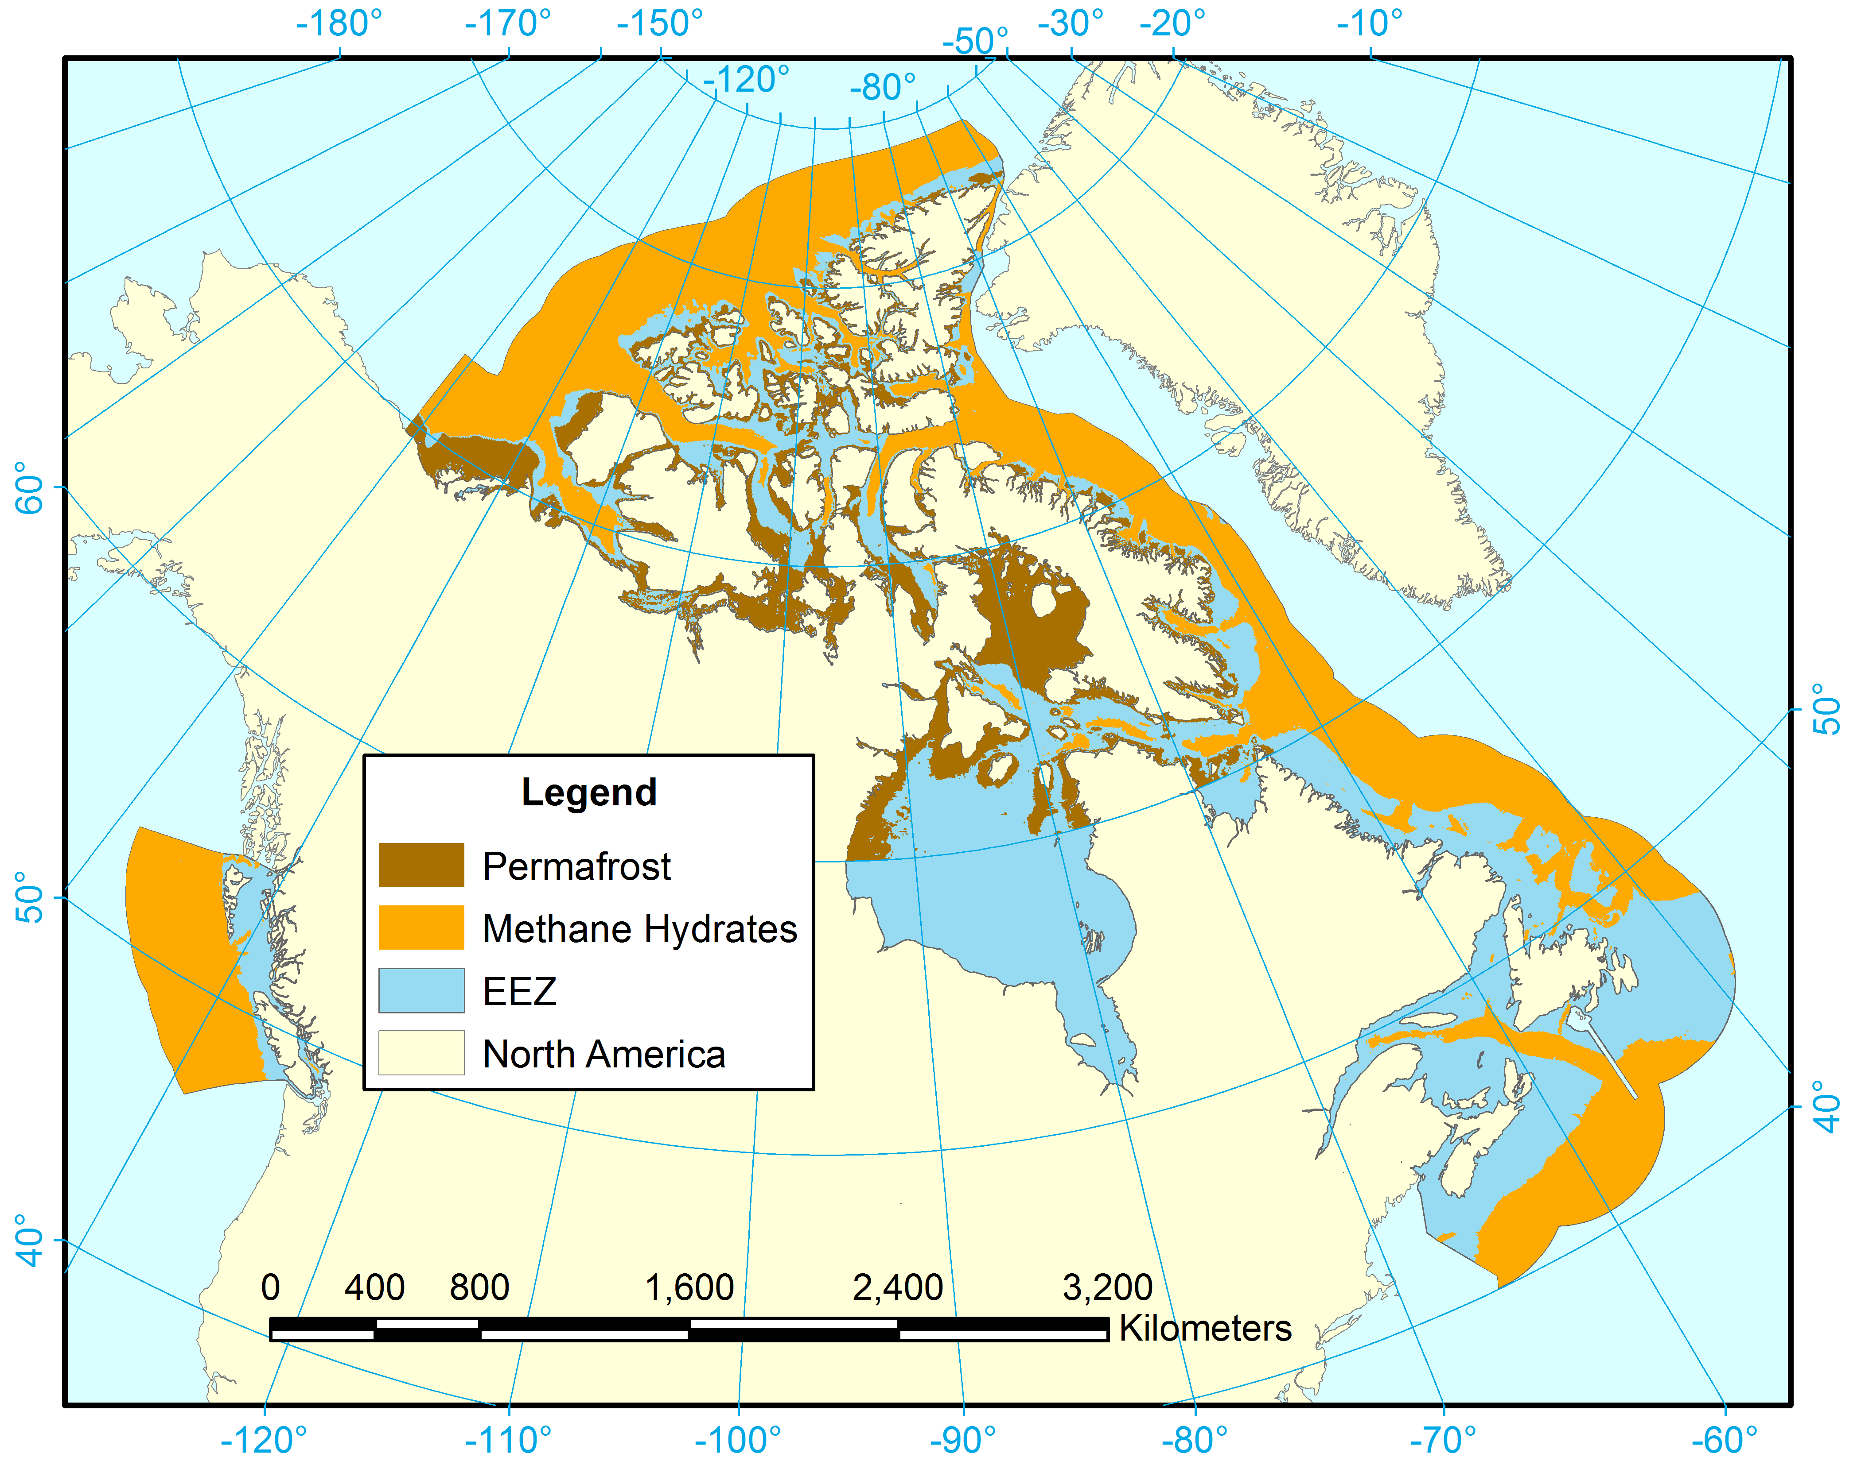

**Figure A1**: Map of carbon storage areas

**Table A1**: The score, current status, likely future state, trend, pressure and resilience for the Canadian Ocean Health Index.

|  |  |  |  |  |  |  |  |
| --- | --- | --- | --- | --- | --- | --- | --- |
| Goal | Subgoal | Score | Status | Future | Trend | Pressures | Resilience |
| Food Provision |  | 64.28 | 58.66 | 69.90 | 0.02 | NA | NA |
| Food Provision | FIS | 59.36 | 54.00 | 64.72 | 0.02 | 16.69 | 72.81 |
| Food Provision | MAR | 92.88 | 85.77 | 100.00 | 0.04 | 14.01 | 68.68 |
| Aboriginal Needs |  | 35.42 | 32.39 | 38.45 | -0.02 | 13.58 | 73.66 |
| Natural Products |  | 44.02 | 41.90 | 46.13 | -0.16 | 13.81 | 76.43 |
| Carbon Storage |  | 61.64 | 57.28 | 66.00 | -0.01 | 16.52 | 64.06 |
| Coastal Protection |  | 95.89 | 91.79 | 100.00 | -0.01 | 23.81 | 64.06 |
| Coastal Livelihoods |  | 89.87 | 86.74 | 93.00 | 0.03 | NA | NA |
| Coastal Livelihoods | LIV | 79.74 | 73.48 | 86.00 | 0.03 | 14.89 | 60.08 |
| Coastal Livelihoods | ECO | 100.00 | 100.00 | 100.00 | 0.02 | 14.87 | 73.55 |
| Tourism & Recreation |  | 25.19 | 23.93 | 26.45 | 0.00 | 30.64 | 62.97 |
| Iconic Places & Species |  | 84.91 | 80.00 | 89.81 | -0.10 | 16.99 | 74.46 |
| Iconic Places & Species | LSP | 33.89 | 25.27 | 42.52 | 0.78 | 22.84 | 72.06 |
| Iconic Places & Species | SP | 59.40 | 52.63 | 66.17 | 0.34 | NA | NA |
| Clean Waters |  | 78.70 | 84.31 | 73.09 | -0.32 | 38.19 | 62.97 |
| Biodiversity |  | 91.05 | 84.83 | 97.28 | -0.04 | NA | NA |
| Biodiversity | HAB | 92.72 | 85.43 | 100.00 | 0.00 | 14.73 | 75.38 |
| Biodiversity | SPP | 89.39 | 84.22 | 94.55 | -0.08 | 19.67 | 72.83 |
| OHI |  | 64.55 | NA | 67.65 | NA | NA | NA |