Supplementary Methods

1. Overview
The Ocean Health Index aims to assess the current status and likely future state of ten widely-held public goals for ocean ecosystems. The Index does this by assessing the present state of each goal relative to a reference point, recent trends in this current status, existing negative pressures that can stress the system and could thus make the future worse, and governance, institutional and ecological factors that provide ecosystem resilience to pressures. Methods for calculating the Index, and the conceptual framework and rationale for how it is constructed, are detailed extensively elsewhere (Halpern et al. 2012). Here we focus on methodological changes and data updates, but for clarity indicate all other cases where no changes were made.
To allow for more accurate comparisons to be made between Index scores for this year (2013) versus last year (2012), we applied methods and used data sources from the 2013 assessment to re-assess scores for 2012. Thus, comparisons between years will largely be due to actual changes in ocean health; differences between previous 2012 scores and recalculated 2012 scores represent changes due to methodological shifts. For a few data layers (noted in section 5), data sources and/or data processing methods changed between years, precluding the ability to recalculate past scores with current methods. As such, a small amount of difference in scores between 2012 and 2013 is due to methodological reasons.

2. Reporting Units
The previous global assessment (Halpern et al. 2012) focused on country-level EEZ results, but aggregated information from smaller regions and territorial holdings (where available data were particularly sparse) into larger reporting units. For the 2013 analysis we instead report these regions separately and thus preserve higher resolution information whenever possible (and apply coarser resolution information equally across all smaller regions when unavailable) to allow calculation of Index scores for as many regions as possible. Both approaches make assumptions about how well data represent reality across different scales, but reporting more regions separately preserves higher resolution data when they are available. One can easily reconstruct the coarser resolution approach by using our algorithms to aggregate across the finer-scale reporting units.
A full list of reporting units used in the current assessment is provided in Table S3. Table S1 lists the changes that were made from the previous assessment (Halpern et al. 2012) to this 2013 assessment to allow for easy comparison.

Table S1. Changes made to reporting units from the 2012 global assessment (Halpern et al. 2012) and this current 2013 assessment.
OHI 2012 region | OHI 2013 region
Australian Tropical Territories | Cocos Islands
 | Christmas Island
 | Norfolk Island
Australian Southern Territories | Macquarie Island
 | Heard and McDonald Islands
French Indian Ocean Territories | Mayotte
 | Glorioso Islands
 | Réunion
 | Juan de Nova Island
 | Bassas da India
 | Ile Europa
 | Ile Tromelin
French Southern Ocean Territories | Crozet Islands
 | Amsterdam Island and Saint Paul Island
 | Kerguelen Islands
British Southern Ocean Territories | Ascension
 | Saint Helena
 | Tristan da Cunha
 | South Georgia and the South Sandwich Islands
 | Falkland Islands
South Africa | Prince Edward Islands
 | South Africa
British Caribbean Territories | Bermuda
 | Turks and Caicos Islands
 | Cayman Islands
 | British Virgin Islands
 | Anguilla
 | Montserrat
Netherlands Caribbean Territories | Sint-Maarten
 | Curaçao
 | Bonaire
 | Saba
 | Sint-Eustasius
 | Aruba
French Caribbean Territories | Guadeloupe and Martinique
 | Northern Saint-Martin
French Polynesia | French Polynesia
 | Wallis and Futuna
USA Pacific Inhabited Territories | Northern Mariana Islands and Guam
 | American Samoa
 | Howland Island and Baker Island
USA Pacific Uninhabited Territories | Wake Island
 | Palmyra Atoll
 | Johnston Atoll
New Zealand | Cook Islands
 | Niue
 | Tokelau
 | New Zealand
Denmark | Faeroe Islands
 | Greenland
 | Denmark
United Kingdom | United Kingdom
 | Jersey
 | Guernsey
Spain | Canary Islands
 | Spain
Portugal | Azores
 | Madeira
 | Portugal
India | Andaman and Nicobar
 | India
Kiribati | Line Group
 | Phoenix Group
 | Kiribati
Norway | Bouvet Island
 | Jan Mayen
 | Norway
East Timor | East Timor
 | Oecussi Ambeno
(not present) | Brunei

3. Reference Points
Reference points define what a perfect score for each goal represents and are thus fundamental to interpreting each goal score as well as the overall Index score. The conceptual approach to defining reference points and the importance of such decisions is described, with examples, elsewhere (Samhouri et al. 2012). The types of reference points used for each goal and sub-goal in the 2013 analysis are consistent with those in (Halpern et al. 2012), but the way that reference points were defined changed in a few goals and sub-goals based on the availability of better data or a refined understanding of how to determine appropriate reference points. Table S2 below summarizes these changes; details for each change are provided in the goal model descriptions in section 4.

Table S2. Type of reference point used for each goal and sub-goal. Details for reference points that changed are provided in goal model descriptions in section 4. Additional information regarding selection of reference points can be found in Samhouri et al. (Samhouri et al. 2012)
Goal | Sub-goal: component | Reference point type (2012 assessment) | Reference point type (2013 assessment)
Food Provision | Fisheries | Functional relationship | Updated; functional relationship
Food Provision | Mariculture | Spatial comparison | Updated; spatial comparison
Artisanal Fishing Opportunities |  | Functional relationship | No change
Natural Products | Ornamental fish, shells, seaweeds & plants, sponges, corals§ | Temporal comparison (historical benchmark) | No change
Natural Products | Fish oil | Functional relationship | Updated; functional relationship
Carbon Storage |  | Temporal comparison (historical benchmark) | No change
Coastal Protection |  | Temporal comparison (historical benchmark) | No change
Coastal Livelihoods & Economies | Livelihoods: jobs | Temporal comparison (moving target) | No change
Coastal Livelihoods & Economies | Livelihoods: wages | Spatial comparison | No change
Coastal Livelihoods & Economies | Economies | Temporal comparison (moving target) | No change
Tourism & Recreation |  | Spatial comparison | Updated; spatial comparison
Sense of Place | Iconic Species | Known target | No change
Sense of Place | Lasting Special Places | Established target | No change
Clean Waters |  | Known target | No change
Biodiversity | Habitats | Temporal comparison (historical benchmark) | No change
Biodiversity | Species | Known target | No change
§ Scores are provided for this goal with and without corals included.

4. Goal Models
The approach (model) used to calculate the status and score for each goal are summarized in Table S4. Below we describe in detail only those cases where changes were made from previous approaches (Halpern et al. 2012). Details for goals not described below can be found in the Supplementary Information from the initial publication (Halpern et al. 2012).

4.1 Food Provision
Substantial changes were made to how the fisheries sub-goal was modeled and the data used to assess it, whereas the primary change to the mariculture sub-goal was to modify the approach to setting the reference point (see Table S2 above and (Kleisner et al. in review)). We note for clarity here as well that this goal includes food provided by artisanal scale fisheries, but we currently know little about how much food comes from these sources relative to commercial fisheries and mariculture and so it is not yet assessed in this goal. When such data are available, they would be included as a third (yield-weighted) component of the overall food provision goal, as a separate sub-goal.

4.1.1 Fisheries
Methods overview
This sub-goal aims to assess the amount of wild-caught seafood that can be sustainably harvested, with sustainability defined by multi-species yield, and with penalties assigned for both over- and under-harvesting. As such, one must establish a reference point at which harvest is (sustainably) maximized. Previously this reference point was derived from an estimate of multi-species maximum sustainable yield (mMSY; Halpern et al. 2012; Kleisner et al. 2013) based on an approach modified from Srinivasan et al. (2009) that was developed to provide estimates of mMSY by using catch data only (i.e., a ‘data-poor’ approach where variables generally required by formal stock assessment methods are unknown, as is the case for most commercially exploited species). Recently, several new data-poor approaches have been developed to assess fisheries that leverage globally-available information (Costello et al., 2012; Martell & Froese, in press; Thorson et al., in press). Building on these methodological advances, we developed a new approach to assessing food provision from wild caught fisheries that is based on estimating population biomass relative to the biomass that can deliver maximum sustainable yield (B/B_{MSY}) for each landed stock. The estimates of B/B_{MSY} were obtained by applying a model developed by Martell & Froese, (in press), and hereafter referred to as the “catch-MSY” method. The latter was chosen, among other data-poor methods available, based on simulation-testing showing that it most accurately predicted stock status for simulated stocks having a broad range of life history traits and different known sources of uncertainty (i.e., environmental stochasticity, length of available time-series, initial depletion, and temporal autocorrelation; FAO, “Developing new approaches to global stock status assessment and maximum sustainable production of the seas” working group report, in prep). The catch-MSY approach improves upon the previous method (Halpern et al. 2012) in that it leverages taxon-specific information regarding resilience to exploitation, can be applied to developing fisheries (whereas the previous approach assumed a perfect score in those cases), and is an indicator of stock abundance (B) rather than catch, which is more directly informative of stock heath.

Estimating B/B_{MSY} ratios
The catch-MSY method is based on the same assumptions (Schaefer, 1954) used in many stock assessment models, namely that the change in a population’s biomass depends on its biomass in the previous year and two population-specific parameters: the carrying capacity (K) and rate of population increase (r). The method estimates the status of a given population using landings time-series as proxies for biomass removals from the population, and using empirically-derived relationships of relative peak to current catch values to estimate depletion at the end of the time series (Martell & Froese, in press). Then, a sampling procedure is used to estimate the distribution of values of r and K that are compatible with the estimated current depletion levels, and are constrained within the range that maintains viable population abundance, and at the same time does not exceed the population’s carrying capacity. The estimated r and K pairs are then used as input in the Schaefer (1954) model and the mean of all the resulting values provide the estimated B/B_{MSY}. Although model performance is greatly improved by using “resilience” estimates as priors for r (Musick, 1999), given that we did not have access to a compiled list of values for most of the species in our analysis, a uniform prior was used instead.

Spatial allocation of catch to EEZs
FAO data reports commercial fishing landings (here used as a proxy for catch) by fishing country (i.e., for vessels, the flag state) and by major fishing area, but does not provide a finer spatial allocation. In order to assign scores to reporting regions for fisheries within their EEZ boundaries, previously, we used the catch allocated as in . This spatial allocation method distributes FAO catches globally within a grid with a half-degree cell resolution, using maps of spatial distribution of commercial taxa and allocations to fleets based on fishing access agreements. These half-degree resolution maps were then used to estimate the total catch per taxonomic group per Sea Around Us Project reporting regions, generally corresponding to EEZs, but in some cases to sub-regions of EEZs (Table S3). However, since the catch data and allocation rules have not been updated since 2006, we re-allocated FAO catch data from 2007-2011 into EEZs maintaining the relative proportion of stocks per EEZ per fishing area from 2006, but updating the values for total biomass per taxon per major fishing area and, where possible, updating the taxonomic resolution of the reporting (see data description in ‘5.69: Spatially-allocated catch data’ below)

Goal model calculations
The status of wild caught fisheries (x_{FIS}) for each reporting region (i) in each year was calculated as the geometric mean of the stock status scores, SS. These scores were derived from B/B_{MSY} for each taxon landed within each FAO major fishing area (A, noted below) and weighted by its relative contribution to overall catch (C), such that:

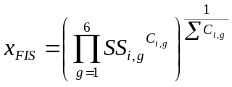 (Eq. S1)

where g is one of six levels of taxonomic grouping of catch derived from its ISSCAAP code (see below), and C was calculated as the average across the catch time-series since the first non-null record. We used the geometric weighted mean to account for the portfolio effect of exploiting a diverse suite of resources, such that small stocks that are doing poorly will have a stronger influence on the overall score than they would using an arithmetic weighted mean, even though their C contributes relatively little to the overall tonnage of harvested seafood within a given region. The behavior of the geometric mean is such that improving a well-performing stock is not rewarded as much as improving one that is doing poorly. We believe this indicator behavior is desirable because the recovery of stocks in poor condition requires more effort and it can have more important effects on the system than making a species that is already abundant even more abundant. In this way, the score is not solely driven by absolute tonnes of fish produced and accounts for preserving the health of a diversity of species.
Because many populations straddle the boundaries of EEZs, we applied the catch-MSY model to catch aggregated within each major fishing area A. These values of stock status were then assigned to our reporting regions, weighted by their relative abundance in that reporting region’s catch (note that for a geometric mean weights appear in the exponent). This differs from the previous iteration, where the catch stream from each Sea Around Us Project reporting region (or EEZ) was analyzed separately. Any aggregation method will be biased in some way; because populations with the largest catches are most often straddling stocks, a bias in assessments due to erroneous aggregation of catch should occur mostly with cosmopolitan species with small, sedentary populations that rarely play a dominant role in a country’s fisheries.
Based on the ISSCAAP convention for taxon codes (REF?), 6 levels of taxonomic aggregation (g) are defined, from 6 (species) to 1 (order or higher) (see ‘5.69. Spatially-allcoated catch data’ for more details). The catch-MSY model was only run when catch was reported at the species level, i.e., taxon group level 6, as the time-series of catch across miscellaneous taxa is unlikely to fit required model assumptions. Overall, we were able to assess a total of 1874 stocks. The estimated species level values of B/B_{MSY} were used to derive a stock score, SS, such that the best score is achieved for stocks at B/B_{MSY} = 1, with a 5% error buffer, and it decreases as the distance of B from B_{MSY} increases, be it due to under- or over-exploitation. For each species reported, within each major fishing area A, SS was calculated as:

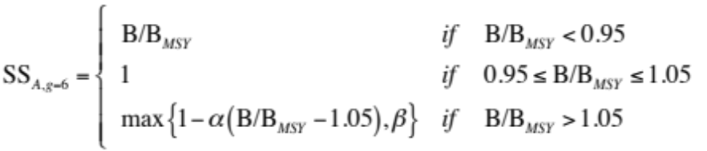 (Eq. S2)

where, for B/B_{MSY} < 1 (-5% buffer), SS declines with direct proportionality to the decline of B with respect to B_{MSY}, while for B/B_{MSY} > 1 (+5% buffer), SS declines at a rate α, where α = 0.5, so that as the distance of B from B_{MSY} increases, SS is penalized by half of that distance. For B/B_{MSY} > 1.05, β is the minimum score a stock can get, and was set at β = 0.25. The α value ensures that the penalty for under-harvested stocks is half of that for over-harvested stocks (α = 1.0 would assign equal penalty). The β value ensures stocks with B/B_{MSY} > 1.4 due to, for example, an exceptionally productive year, are not unduly penalized, and also recognizes that it is much easier to improve the goal score when stocks are under-harvested (i.e., increase fishing pressure) than it is when populations are over-harvested and need to be rebuilt. Both parameters α and β were chosen arbitrarily, since there is no established convention for this particular approach. In line with what was done previously (Halpern et al. 2012), countries are rewarded for having wild stocks at the biomass that can sustainably deliver the maximum sustainable yield, +/-5% to allow for measurement error, and are penalized for both over- or under-harvesting.
For taxa reported at a higher level than species, we developed a method to account for coarser resolution data. The distribution of the species-based estimates within the same fishing area and year was used to generate missing scores. An increasing penalty was applied for coarser taxonomic reporting, as this is considered a sign of poor monitoring and management, so that the score for a given taxonomic aggregation g (when g<6) was assigned as follows:

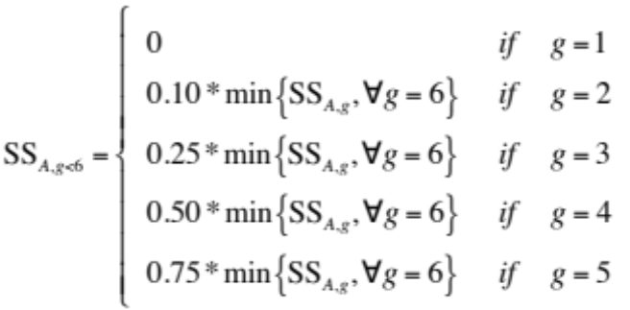 (Eq. S3)

Previously (Halpern et al. 2012), reporting quality was penalized with a taxonomic reporting coefficient, T_{c}; we do not use this parameter here as it would be a double-penalty for data reporting quality.

Model limitations
Both the current and previous (Halpern et al. 2012) methods are based on single-species assessments of stock status and thus cannot predict the effect of multi-species interactions. Previously, the sum of single-species MSY was reduced by 25% to obtain a more precautionary estimate of multi-species MSY that might account for the effect of these interactions. The current approach adopts B=B_{MSY} as a single-species reference point, which by various assessment frameworks is considered very conservative (e.g. MSC criteria, NOAA, Froese & Proelss paper), and the fact that the single-species values are aggregated using a geometric mean ensures that some multi-species effects may influence the scores. Nonetheless, a better understanding of the emerging effects of fishing various species at their reference levels would be desirable and will hopefully be possible in the future.
Despite the fact that invertebrates represent 12 of the top 17 species for global caught biomass, and represent the dominant stocks in many EEZs, stock assessment approaches for these taxa are poorly developed. The catch-MSY approach here was applied to invertebrates even though the model developers only tested it on fish (Martell & Forese, in press). Part of the challenge in broadly testing this approach on organisms other than fish is the lack of a large enough collection of invertebrate assessments to use for validation testing (e.g. <X assessments currently available in the RAM2 Legacy stock assessment database; Ricard et al. 2012).
Despite the openly accessible RAM Legacy database includes a large collection of B/B_{MSY} estimates from formal stock assessments across many FAO fishing areas, we were unable to include these in our calculations as there were <40 values for 2008 or later. When more updated versions of the database will be made public, we will most likely be able to replace data-poor estimates with values from formal assessments.
This approach captures whether stocks have been historically well managed, but it is worth noting that, contrary to the previous formulation that compared current catch to MSY, this calculation does not directly measure current food production.
It is also worth noting that, similarly to the previous version, current management does not influence the status, but it does influence the likely future state, through the resilience dimension and, at least for highly dynamic stocks with quick response to management, through the trend.

4.1.2 Mariculture
The same sub-goal model developed previously (Halpern et al. 2012) was used for this 2013 assessment, however a new reference point was used based on explorations and analyses described elsewhere (Kleisner et al. in press). The previous approach compared all areas to the highest observed production density after the sustainability coefficient was applied, based on the assumption that all coastal area in each country was developed for mariculture at the same production density as the reference country (i.e., China) and that maximum potential productivity per unit of area is similar across ecosystems and countries. Additionally, this approach assumed that production is independent of the presence of coastal communities that can provide the labor force, infrastructures, and economic demand to support the development and economic viability of mariculture facilities. This caused countries with extensive proportions of coastline but low population density, such as Canada, to be penalized. The new approach instead uses harvested tonnes per coastal inhabitant (i.e. within the 50 Km coastal strip) as a reference point, under the assumption that two regions with an equal number of coastal inhabitants harvesting an equal tonnage of cultured seafood should score the same, as the productivity is commensurate to each region’s socio-economic state. Stated another way, mariculture development is assumed to scale proportionally with coastal population as a proxy for local demand and potential logistic limitations to farm development, e.g., presence of infrastructures, coastal access, and locally available workforce. Updates to data used for this goal are detailed below in Section 5.

4.2 Artisanal Fishing Opportunities
No changes to the goal model were made. Updates in data used for this goal are detailed below in Section 5.

4.3 Natural Products
The sustainability component for fish oil was changed. All other products were calculated as before. Updates in data used for this goal are detailed below in Section 5.

4.4 Carbon Storage
No changes to the goal model were made. No updates for habitat data layers were possible; other data layers that were updated are detailed below in Section 5.

4.5 Coastal Protection
No changes to the goal model were made. The only habitat data layer that could be updated was sea ice; other data that were updated are detailed below in Section 5.

4.6 Coastal Livelihoods and Economies
No changes to the goal model were made.

4.6.1 Coastal Livelihoods
Updates in data used for this goal are detailed below in Section 5.

4.6.2 Coastal Economies
Updates in data used for this goal are detailed below in Section 5.

4.7 Tourism & Recreation
The tourism & recreation goal aims to capture the experience people have visiting coastal and marine areas and attractions. Coastal tourism industries can be important contributors to coastal economies, but this goal aims to assess participation in coastal tourism separately from the economic measures that are reported in the coastal livelihoods & economies goal. Few non-economic indicators of tourism and recreation exist at the global scale, and thus the original approach in 2012 approximated this goal by the number of international airline arrivals visiting coastal areas and their average length of stay. This approach was sub-optimal because it did not account for domestic tourism, which is a large part of tourism in many countries, especially large, developed countries such as Canada, Australia and the USA. Here we develop a different approach to capturing tourism and recreation experiences that better accounts for both international and domestic tourism.
It is very difficult to monitor the number of people that enjoy different tourism and recreation activities, precluding use of this direct measure of tourism and recreation in most cases. Instead, employment in the tourism sector is a good proxy measure for the number of people engaged in coastal tourism and recreation activities. Employment (within the sector) should respond dynamically to the number of people participating in tourist activities, based on the assumption that the number of hotel employees, travel agents and employees of other affiliated professions will increase or decrease with changing tourism demand within different regions.
Ideally there would be data available specifically for employment in coastal tourism industries, however the best data available at a global scale report total number of jobs, not just coastal jobs, within the travel and tourism industries (World Travel and Tourism Council (WTTC); www.wttc.org). These data include jobs for both leisure and business that are directly connected to the tourism industry, including accommodation services, food and beverage services, retail trade, transportation services, and cultural, sports and recreational services, and exclude investment industries and suppliers (www.wttc.org/research/economic-impact-research/methodology/). Unfortunately it was not possible to determine the proportion of jobs affiliated with strictly leisure tourism. However, some (unknown) proportion of business travelers also enjoy the coast for leisure during their visit to coastal areas, such that we assumed all travel and tourism employment was related to tourism and recreation values. Regional applications of the Ocean Health Index can make use of better-resolved data and more direct measures of tourism, as was the case within the California Current (Halpern et al. in review), where data for participation in coastal recreational activities across nineteen different sectors were available.
To best capture coastal travel and tourism employment using WTTC data, we calculated the amount of direct employment in the tourism industry relative to total employment (E_{t}) likely occurring in coastal areas based on coastal population (V_{t}) relative to total population (P_{t}), assuming that tourists are distributed throughout the country in a similar manner to local populations. As in 2012, we used the tourism competitiveness index (TTCI) from the World Economic Forum (http://www.weforum.org/issues/travel-and-tourism-competitiveness) to capture the sustainability (S_{t}) of the tourism industry.
Therefore, the status of the tourism & recreation (x_{TR}) is:

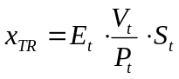, (Eq. S4)

where E_{t} is defined by the number of employees directly involved in the travel and tourism industry (E_{WTTC}), a country’s total labor force (L_{t}), and a country’s percent of the population that is unemployed (U_{t}), such that:

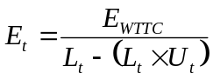. (Eq. S5)

4.8 Sense of Place
No changes to the goal model were made.

4.8.1 Iconic Species
Updates in data used for this goal are detailed below in Section 5.

4.8.2 Lasting Special Places
Updates in data used for this goal are detailed below in Section 5.

4.9 Clean Waters
No changes to the goal model were made. Updates in data used for this goal are detailed below in Section 5.

4.10 Biodiversity
No changes to the goal model were made.

4.10.1 Species
Updates in data used for this goal are detailed below in Section 5. Extinction risk estimates for significantly more species were released in the past year, such that changes in scores for this sub-goal (and therefore the biodiversity goal overall) reflect data reporting and quality much more than changes in species extinction risk, which tend to change much more slowly from year to year.

4.10.2 Habitats
The only habitat for which updated data were available was for sea ice. Other data that were updated are detailed below in Section 5.

5. Specific Data Layers
This section provides detailed descriptions for data layers updated or new to the 2013 analysis, and notes those that have not changed. In addition, Table S5 lists all data layers used in the 2013 analysis and indicates which were new variables or data sources, which were used previously (Halpern et al. 2012) and have been updated for the 2013 analysis (i.e., the source provided more recent data since those used previously (Halpern et al. 2012)), and which were used previously and had not been updated for the 2013 analysis. Also indicated in Table S5 are data used previously but not included in the 2013 analysis. In all cases the data have been updated to account for the new reporting regions used for the 2013 assessment.

5.1. Alien species
Update: no update possible; values from OHI 2012 used.

5.2. Artisanal fishing: high bycatch
Update: no update possible; values from OHI 2012 used.

5.3. Artisanal fishing: low bycatch
Update: no update possible; values from OHI 2012 used.

5.4. Artisanal fishing: management effectiveness and opportunity
Update: no update possible; values from OHI 2012 used.

5.5. Artisanal fishing: need
Update: additional year(s) data.
Description: This parameter is estimated by the per capita purchasing power parity (PPP) adjusted gross domestic product (GDP), i.e. GDPpcPPP, as described previously (Halpern et al. 2012). GDP is the value of all final goods and services produced within a nation in a given year. A nation's GDP at purchasing power parity (PPP) exchange rates is the sum value of all goods and services produced in the country valued at prices prevailing in the United States in the year noted. This is the measure most economists prefer when looking at per-capita welfare and when comparing living conditions or use of resources across countries. The measure is difficult to compute, as a US dollar value has to be assigned to all goods and services in the country regardless of whether these goods and services have a direct equivalent in the United States (for example, the value of an ox-cart or non-US military equipment); as a result, PPP estimates for some countries are based on a small and sometimes different set of goods and services. In addition, many countries do not formally participate in the World Bank's PPP project that calculates these measures, so the resulting GDP estimates for these countries may lack precision. For many developing countries, PPP-based GDP measures are multiples of the official exchange rate (OER) measure. The differences between the OER- and PPP-denominated GDP values for most of the wealthy industrialized countries are generally much smaller. Updated GDPpcPPP calculations were available from 1980-2012 from the World Bank (http://data.worldbank.org/indicator/NY.GDP.PCAP.PP.CD) and are reported in 2012 $USD.

5.6. B/B_{MSY}
Update: new data layer.
Description: [add description]

5.7. Chemical pollution: land-based inorganic
Update: no update possible; values from OHI 2012 used.

5.8. Chemical pollution: land-based organic
Update: additional year(s) available
Description: To allow for more direct comparison between assessments from last year (input data from 2003-2006, as was done previously) and this year (input data from 2007-2010, the most recent available), we recalculated this layer using updated data but the same methods as before. In particular, we used FAO data on annual country-level pesticide use, averaged over the time periods, with missing values filled in by regression between fertilizer (see nutrient pollution, below) and pesticides when possible, and when not possible with agricultural GDP as proxy (see Halpern et al. 2008 for methods details). These country-level values were then dasymetrically distributed over a country’s landscape using global landcover data from the years 2005 (for the 2003-2006 time period) and 2009 (for the 2007-2010 time period), derived from the MODIS satellite at ~500m resolution (following methods described in Halpern et al. 2008 but with updated MODIS data not available previously). These values were then aggregated by ~140,000 global basins (developed for and presented in Halpern et al. 2008), and diffusive plumes were modeled from each basin’s pourpoint. The final non-zero plumes (about ~76,000) were aggregated into ~1km Mollweide (wgs84) projection rasters to produce a single plume-aggregated pollution raster. These raw values were then log(x+1) transformed and normalized to 0-1. A simple visual and pixel-count comparison of the agriculture landcover classes shows that, globally, these classes have not changed much during the two time periods (at the 500m resolution of the data). However, global pesticide consumption has shown a small, but significant increase globally (roughly 4-8% over our time period).

5.9. Chemical pollution: ocean-based
Update: no update possible; values from OHI 2012 used.

5.10. Coastal human population
Update: additional year(s) available
Description: To calculate the impact of human population density on global coastlines, we used the LandScan dataset (http://web.ornl.gov/sci/landscan/index.shtml), which is not freely available online but can be accessed through most university libraries. The dataset is in 30 arc second (~1km or finer resolution) Geographic WGS84 format, spanning 360 degrees longitude and from -90 to 84 latitude. We calculated coastal population density for 2010 (the most recent year in the dataset) as well as 2006 (the same timeframe as most data used in previous analyses; Halpern et al. 2008) to allow for direct comparability using the same methods and dataset.
First we created a 1-pixel (~1-km) buffer around the land-ocean coastline. Then we reprojected the LandScan data into Mollweide so that pixels would represent equal areas. Next we ran a pixel-summing moving window around the coastline region, using two different circular buffer distances (5 and 25 km). The different buffer distances were used to produce two different versions of the data used within the Index. The narrower, 5km buffer represents direct human impact from coastal communities (as described previously; Halpern et al. 2008) and was used as a pressure for many of the goals. The wider, 25km buffer was used in all other cases where coastal population size was used for goal calculations (mariculture sub-goal, tourism & recreation goal, trash layer for clean waters?). We did not use a buffer distance narrower than 5km because there is not perfect overlap between the coastline boundary (obtained from the ocean mask developed and used previously; Halpern et al. 2008) and the shorelines in LandScan data. We then clipped the results to the coastline 1-pixel to allow summing by Index reporting region, and then for use as a pressure layer, log-transformed and normalized the resulting population values. For reference, per-pixel coastal population increased 4.6% (5km buffer) or 4.2% (25km buffer) between 2006 and 2010.

5.11. Coastal land and ocean area
Update:

5.12. Commercial fishing: high bycatch
Update: additional year(s) available
Description: The most recent spatially-explicit estimates of catch by gear type were developed and used in Halpern et al. (2008), where catch was allocated to 5 different gear types at half-degree resolution, and have not been updated since. To estimate changes in this pressure, we used the spatially-allocated catch data (see 5.69 below) and calculated the percent change in total annual catch per reporting region as the difference between the most recent reporting period (2009 to 2011) and the period (1999 to 2003) previously used by Halpern et al (2008), divided by the original period (1999 to 2003). Each of the three high-bycatch 1km raster layers (Halpern et al. 2008) were then multiplied by the percent change specific to each Sea Around Us reporting region to create estimates of current spatially-explicit catch by gear type. Although this calculation requires the unlikely assumption that the proportional amount of catch per Sea Around Us reporting region has remained the same over the past 10 years, we felt it better to make this assumption than to assume fishing pressure has not changed at all.
Overall pressure per gear class, per Ocean Health Index reporting region was then calculated as the mean of all 1km pixel values within the region for each of the two time periods. The maximum possible score (which is used to rescale all values 0-1) was then determined as 110% of the maximum regional score across either time period, such that all regions were rescaled to the same value. For each pressure layer the maximum came from the previous time period (1999-2003; Halpern et al. 2008; Halpern et al. 2012). As was done previously (Halpern et al. 2012), high bycatch commercial fishing was then measured as the average of demersal destructive (e.g., trawl), demersal non-destructive high bycatch (e.g., pots, traps) and pelagic high bycatch (e.g., long-line) gear.

5.13. Commercial fishing: low bycatch
Update: additional year(s) available
Description: Methods for this pressure layer were identical to those described above (5.12) for commercial fishing: high bycatch, except the two low bycatch commercial fishing were used (demersal low bycatch, e.g., hook and line, and pelagic low bycatch, e.g., purse seines) and averaged to create the single low bycatch pressure layer.

5.14. Convention on Biological Diversity (CBD) signatories
Update: no update possible; values from OHI 2012 used.

5.15. Convention on Biological Diversity (CBD) survey
Update: no update possible; values from OHI 2012 used.

5.16. Convention on International Trade in Endangered Species of Wild Fauna and Flora (CITES) signatories
Update: additional year(s) available
Description: An updated list of CITES signatories was accessed in April 2013 (http://www.cites.org/eng/disc/parties/chronolo.php). Three additional countries had joined as CITES signatories since the 2012 OHI assessment: Bahrain, Maldives, and Lebanon.

5.17. Coral reefs
Update: no update possible; values from OHI 2012 used.

5.18. Country land area
Update: updated data based on new OHI reporting units (EEZ boundaries).
Description: This value represents the total land area (not including inland lakes or EEZs) within each country. Updated coastline data for 2012 were extracted from ESRI (REF) and any gaps were filled using data for 2012 downloaded from the CIA World Factbook (https://www.cia.gov/library/publications/the-world-factbook/rankorder/rankorderguide.html).

5.19. Ecological integrity
Update: additional year(s) available
Description: This layer is based on the status score for the species sub-goal in the biodiversity goal. Details on updated data used here are provided in ‘5.49. Marine species’ below

5.20. Fertilizer trends
Update: additional year(s) available
Description: Updated fertilizer consumption data were available through 2010 from FAO’s statistical database FAOSTAT (faostat3.fao.org/home/index.html#DOWNLOAD). Data were summed across all fertilizer compounds and reported in metric tons, and then converted to tons per km² of total land area.

5.21. Fisheries catch data
Update: new data-layer
Description: Catch per taxon from the spatially allocated catch-data (layer 5.69) were summed within each FAO major fishing area (REF) to produce a single time-series for each taxon within a given fishing area. These are used to run the model estimating B/B_{MSY} (i.e., “catch-MSY”, as described in the fisheries sub-goal model above, section 4.11; Martell & Froese, in press).

5.22. Fisheries management effectiveness
Update: no update possible; values from OHI 2012 used.

5.23. Genetic escapes
Update: no update possible; values from OHI 2012 used.

5.24. Global Competitiveness Index (GCI)
Update: additional year(s) available
Description: Updated assessments of the GCI were accessed from the 2012-2013 Report (WEF 2013: http://reports.weforum.org/global-competitiveness-report-2012-2013/). There were 144 economies covered in 2012-2013, up from 142 in 2010-2011. Gabon, Guinea, Liberia, and Sierra Leone were added, Libya was readded (due to civil unrest in 2011), and Belize, Angola, Syria, and Tunisia were removed due to insufficient data.

5.25. Gross Domestic Product (GDP)
Update: additional year(s) available
Description: These data are used in the economies sub-goal of the coastal livelihoods and economies goal to [what]. Updated GDP data through 2012 (reported in 2012 $USD) were accessed from the World Bank (http://data.worldbank.org/indicator/NY.GDP.MKTP.CD).

5.26. Gross Domestic Product per capita, Purchasing Power Parity adjusted (GDPpcPPP)
Update: additional year(s) available.
Description: Updated GDPpcPPP calculations were available through 2012 from the World Bank (http://data.worldbank.org/indicator/NY.GDP.PCAP.PP.CD) and are reported in 2012 $USD for all years. The GDP at purchasing power parity (PPP) exchange rates is the sum value of all goods and services produced in a country valued at prices prevailing in the United States in a specified year. Economists use this metric when comparing per-capita welfare, living conditions, or resource use across countries. These data are used in the artisanal fishing opportunity goal as a measure of need.

5.27. Habitat destruction: intertidal
Update: additional year(s) available
Description: This data layer is derived from the 1km buffer coastal population data, described above.

5.28. Habitat destruction: subtidal hard bottom
Update: no update possible; values from OHI 2012 used.

5.29. Habitat destruction: subtidal soft bottom
Update: no update possible; values from OHI 2012 used.

5.30. Human Development Index (HDI)
Update: additional year(s) available
Description: Updated HDI assessments were available for 2012 to be used as multipliers for the coastal livelihoods and economies goal from the United Nations Development Programme Human Development Reports (UNDP HDR: hdr.undp.org/en/reports/global/hdr2013/). Countries were classified as developed (“very high human development” category) or developing (all others). In 2012, there were 32 countries in the "Developed" category. In 2013 there were 39. Added countries were Brunei, Chile, Lithuania, Latvia, Argentina, Seychelles, Croatia; Bahrain moved into the "Developing" category.

5.31. Iconic species list
Update: no update possible; values from OHI 2012 used.

5.32. International arrivals
Update: no longer used

5.33. Labor force
Update: new layer introduced in 2013
Description: Data for total labor force (number of people) was obtained from 1980-2012 from World Bank assessments (http://data.worldbank.org/indicator/SL.TLF.TOTL.IN). The World Bank defines total labor force based on the International Labour Organisation (ILO)’s definition of an economically active population: those 15years old and older who can supply labor for the production of goods and services, and includes those employed and unemployed, as well as those in the armed forces (and generally excludes homemakers and other unpaid caregivers and workers in the informal sector).

5.34. Mangroves
Update: no update possible; values from OHI 2012 used.

5.35. Mariculture Sustainability Index (MSI): mariculture sustainability and mariculture regulations
Update: no update possible; values from OHI 2012 used.

5.36. Mariculture yield
Update: additional year(s) available
Description: Updated mariculture yield data were available from 1950-2011 from FAO using FishstatJ 2.0.0 (www.fao.org/fishery/statistics/software/fishstatj/en; accessed in July, 2013). Mariculture was defined as the production of marine taxa from marine and brackish water environments as assigned by FAO, excluding seaweeds from these environments. If no mariculture yield was reported in the most recent year (2011), the value from the previous year (2010) was used to calculate status and trend; this does not penalize a country with recent mariculture yields without a value in 2011, potentially because of reporting issues. This one-year allowance does penalize the country if they have not reported in years previous. [How this affects trend]

5.37. Marine jobs: commercial fishing
Update: no update possible; values from OHI 2012 used.

5.38. Marine jobs: mariculture
Update: no update possible; values from OHI 2012 used.

5.39. Marine jobs: marine mammal watching
Update: no update possible; values from OHI 2012 used.

5.40. Marine jobs: tidal energy
Update: no update possible; values from OHI 2012 used.

5.41. Marine jobs: tourism
Update: additional year(s) available
Description: These job data are estimated from the travel and tourism total contribution to employment that are collated by the World Travel & Tourism Council (WTTC) (http://www.wttc.org/research/economic-data-search-tool/). Updated travel and tourism total contribution to employment data were available for 181 countries through 2012. Total contribution measures the number of jobs generated directly in the travel and tourism industries plus the indirect and induced contributions (investment industries and suppliers).

5.42. Marine and terrestrial protected areas
Update: additional year(s) available
Description: Updated data on protected areas through February, 2013 were accessed from the United Nations Environment Programme - World Conservation Monitoring Centre’s World Database on Protected Areas (WDPA) through http://www.protectedplanet.net/. [more information after processing—will assess if data have even been updated in the rerelease]

5.43. Marine revenue: aquarium trade fishing
Update: additional year(s) available
Description: Updated revenue data for ornamental fish were available through 2009 from FAO using FishstatJ 2.0.0 (accessed in July, 2013). Subcategory characterization has been updated with the March 2013 release of version 2.0.0 and within these new subcategories two of the three were included: ‘ornamental fish nei’ and ‘ornamental saltwater fish.’

5.44. Marine revenue: commercial fishing
Update: no update possible; values from OHI 2012 used.

5.45. Marine revenue: mariculture
Update: additional year(s) available
Description: Updated revenue data from mariculture exports were available through 2011 from FAO using FishstatJ 2.0.0 (accessed in July, 2013). With the updated release of version 2.0.0, we were able to filter to include marine and brackish environments (excluding freshwater environments). Data are reported in thousand of US dollars.

5.46. Marine revenue: marine mammal watching
Update: no update possible; values from OHI 2012 used.

5.47. Marine revenue: tidal energy
Update: additional year(s) available
Description: Updated tidal energy data through 2010 were accessed in July 2013 from the UN Energy Statistics Database (http://data.un.org/). Currently, France and Canada are the only countries that generate enough tidal energy to report. Production data were converted into revenue by multiplying by average yearly prices of electricity per Kilowatt-hour specific to Canada and France, provided by the US Energy Information Administration (http://www.eia.gov/countries/prices/electricity_industry.cfm) after conversion to 2010 USD. Data from the EIA were not updated for the 2013 assessment and were available from 2001-2006 for Canada and 2001-2008 for France.

5.48. Marine revenue: tourism
Update: additional year(s) available
Description: Updated total contribution to GDP data were available through 2012 from the World Travel and Tourism Council (WTTC: http://www.wttc.org/research/economic-data-search-tool/). Total contribution includes revenue from sectors directly and indirectly associated with travel and tourism. This is the sole measure used to inform marine revenue from tourism; the supplemental information in 2012 identified two other metrics that were not used to calculate the Economies subgoal.

5.49. Marine species
Update:

5.50. Marine wages
Update: additional year(s) available
Description: Updated Occupational Wages around the World (OWW) data were available through 2008 from the National Bureau of Economic Research (http://www.nber.org/oww/). As in the 2012 assessment, we used the calibration that was recommended by the database creators, but they have updated their calibration procedures used to normalize the data, and the updated version is now called "w3wl": "wage with country-specific calibration and imputation, lexicographic weighting". We multiplied their calculation of monthly wage in USD by 12 to get annual wages for the same industry and occupation classifications as reported in Tables S18 of Halpern et al. (2012). We then calculated the mean annual wage across all marine sectors.

5.51. Multispecies maximum sustainable yield (mMSY)
Update: no longer used

5.52. National percent unemployment
Update: additional year(s) available
Description: Updated unemployment data through 2012 were available from the World Bank (http://data.worldbank.org/indicator/SL.UEM.TOTL.ZS). These data are reported as the percent of the total labor force that is available to work and seeking employment but is without work

5.53. Natural Products exposure
Update: no update needed

5.54. Natural Products harvest
Update: additional year(s) available.
Description: Updated data were available from 1976-2009 for all Natural Products categories (sponges, fish oil, seaweed and plants, ornamental fish, corals, shells), which were accessed from FAO using FishstatJ 2.0.0 (http://www.fao.org/fishery/statistics/software/fishstatj/en).

5.55. Natural Products risk
Update: additional year(s) available.
Description: This data layer was previously labeled “Convention on International Trade in Endangered Species of Wild Fauna and Flora (CITES) listed species” but has been renamed here for clarity on how the data were used. Sustainability risk for each of the Natural Products commodities was assessed separately and was included in the sustainability equation when data were available. Risk assessment for corals was based on species identified by CITES; risk for all corals was set as 1 since species in both subclasses and multiple orders of extant corals in class Anthozoa are listed in CITES Appendices II and III (www.cites.org/eng/app/appendices.php). No sponges, algae or marine plants were listed in CITES and thus their risks were set at 0. Shells were also set as 0 since species were not listed individually in the FAO database and only one marine genus (Tridacnidae spp.) and one marine species (Lithophaga lithophaga) were identified in CITES Appendix II. Risk for ornamental fish was set based on assessments of cyanide or dynamite fishing by Reefs at Risk Revisited (REF) under the assumption that most ornamental fishes are harvested from coral reefs.
[insert updated sustainability coefficient for fish oil: i.e. weighted geometric mean B/Bmsy]

5.56. Nutrient pollution
Update: additional year(s) available
Description: To allow for more direct comparison between assessments from last year (input data from 2003-2006, as was done previously) and this year (input data from 2007-2010, the most recent available), we recalculated this layer using updated data but the same methods as before. In particular, we used FAO data on annual country-level pesticide use, averaged over the time periods, with missing values filled in by regression between fertilizer and pesticides (see chemical pollution: land-based organic, described above) when possible, and when not possible with agricultural GDP as proxy (see Halpern et al. 2008 for methods details). These country-level values were then dasymetrically distributed over a country’s landscape using global landcover data from the years 2005 (for the 2003-2006 time period) and 2009 (for the 2007-2010 time period), derived from the MODIS satellite at ~500m resolution (following methods described in Halpern et al. 2008 but with updated MODIS data not available previously). These values were then aggregated by ~140,000 global basins (developed for and presented in Halpern et al. 2008), and diffusive plumes were modeled from each basin’s pourpoint. The final non-zero plumes (about ~76,000) were aggregated into ~1km Mollweide (wgs84) projection rasters to produce a single plume-aggregated pollution raster. These raw values were then log(x+1) transformed and normalized to 0-1. A simple visual and pixel-count comparison of the agriculture landcover classes shows that, globally, these classes have not changed much during the two time periods (at the 500m resolution of the data). However, global fertilizer consumption has shown a small, but significant increase globally (roughly 4-8% over our time period).

5.57. Ocean acidification
Update: no update possible; values from OHI 2012 used.

5.58. Pathogen pollution
Update: additional year(s) available
Description: Updated percent of population with access to improved sanitation facilities data were available from 1990-2011from the World Health Organization and United Nations Children's Fund's Joint Monitoring Programme (WHO/UNICEF's JMP: www.wssinfo.org/data-estimates/table/,accessed May 2013). Processing included the function "na.locf" from the "zoo" package in R (Zeileis & Grothendieck 2005).

5.59. Pesticides trends
Update: additional year(s) available
Description: Updated pesticide consumption data were available through 2010 from FAO’s statistical database FAOSTAT (faostat3.fao.org/home/index.html#DOWNLOAD). Data were summed across all pesticide active ingredients and reported in metric tons, and then converted to tons per km² of total land area.

5.60. Relative stock biomass
Update: new layer introduced in 2013
Description: Mean relative proportion of biomass represented by each stock within a given region. These values were derived from previously developed catch data (Halpern et al. 2012).

5.61. Rocky reef
Update: no update possible; values from OHI 2012 used.

5.62. Salt marsh
Update: no update possible; values from OHI 2012 used.

5.63. Sea ice
Update: additional year(s) available
Description:

5.64. Sea level rise
Update: new data layer
Description: The sea level rise data are based on Nicholls and Cazenave, 2010, which can also be viewed at: http://www.aviso.oceanobs.com/en/news/ocean-indicators/mean-sea-level.html. The original data (MSL_Map_MERGED_Global_IB_RWT_NoGIA_Adjust.nc) were reprojected into Geographic WGS84, EPSG:4326 at 0.25x0.25 degree resolution (at the equator, 111 km/degree*0.25 degrees/pixel = ~785 km² pixels), and then the rate of sea level rise (mm/yr) per pixel was calculated across the time span of the dataset (Oct 1992 through Dec 2012). This produced a minimum value of -33.998 mm/yr and maximum value of 30.1 mm/yr. To produce a value of net change in sea level, these rates were then multiplied by the duration of the time series (20.167 yrs) to produce a net change in sea level, resulting in a minimum value of -685.63 mm and maximum value of 607.01 mm. For comparison to other pressure layers, these values were then rescaled to the largest absolute value, in this case preserving negative values such that the new values ranged -1.0 to 0.885. Note that this global data set does not take into account Glacial Isostatic Adjustment (GIA) of ~-0.3 mm/yr, although this does affect the normalized values (see
http://www.aviso.oceanobs.com/en/news/ocean-indicators/mean-sea-level/processing-corrections.html#c7323).

5.65. Sea surface temperature (SST) anomalies
Update: additional year(s) available
Description: Sea surface temperature (SST) data were obtained from the Coral Reef Temperature Anomaly Database (CoRTAD) , which was produced by the NOAA National Oceanographic Data Center using 4.6 km (nominally 21 km² at the equator) Advanced Very High Resolution Radiometer (AVHRR) Pathfinder Version 5.2 SST data from 1982-2010 (http://www.nodc.noaa.gov/SatelliteData/CoRTAD). Because SST measurements are less reliable where there is persistent ice, we created an ice mask to identify places near the poles that were almost always covered by significant sea ice. The ice mask was generated primarily from the OSI/SAF Global Daily Sea Ice Concentration Reprocessing Data Set (http://accession.nodc.noaa.gov/0068294), which was regridded and made available in the Pathfinder V5.2 dataset. In Pathfinder, when the OSI/SAF data are unavailable, the sea ice concentrations from the NCDC Daily OI SST data (Reynolds et al., 2007) are included. For each day of the climatological year (1 through 366), we read in the daily sea ice fraction for that day from all of the years and averaged them to create a daily, sea-ice fraction climatology. We then identified grid cells that always contained a sea ice fraction of greater than 0.15 and masked them out of the analysis.
We defined an anomaly as exceeding the standard deviation (SD) of SSTs from the climatology for that location (i.e. grid cell) and week of the year. The climatology was defined as a weekly average for each ~4 km grid cell from 1982-2010 . The frequency of anomalies was calculated for each year in the dataset. We then quantified the difference between the number of anomalies in the 5 most recent years (2005-2010) and the 5 oldest years in the dataset (1982-1986). We also recreated our metric of SST change from Halpern et al. , which measured the difference in anomaly frequency from 2000-2005 compared to 1985-1990.
There are two main differences between the dataset used previously and the one generated for this analysis. Since the publication, the Pathfinder data used to generate the CoRTAD has been updated to use a different and higher resolution reference dataset to help identify bad data (data is removed if it is +5/-2 from the reference dataset). The new version now more accurately resolves strong temperature gradients like those that occur along major boundary currents or near the coast. By adding in new years to the dataset, we also create a new climatology so the standard deviation thresholds will change. Because longer time series often have greater variability, the SD would generally be larger, potentially making it more difficult for an SST anomaly defined using this method to occur. The result could be a decrease in the overall frequency of anomalies compared to the older dataset.

5.66. Seagrass
Update: no update possible; values from OHI 2012 used.

5.67. Sector Evenness
Update: additional year(s) available
Description:

5.68. Soft-bottom subtidal
Update: no update possible; values from OHI 2012 used.

5.69. Spatially-allocated catch data
Update: additional year(s) available
Description: This data layer is derived from annual FAO fisheries wild caught statistics, which are reported by FAO major fishing areas rather than EEZs or countries, and represents total annual catch per Ocean Health Index reporting region for 2007-2011. The proportion of catch in each FAO major fishing area that was spatially allocated to each Sea Around Us Project reporting region (Watson et al. 2004) for 2006 (as in Halpern et al. 2008, Halpern et al. 2012) was used to spatially allocate the more recent FAO catch data. In other words, all the rules used to spatially allocate the 2006 catch data were presumed to have remained the same.
A key first step for doing this spatial re-allocation of catch data over time is to resolve differences in taxonomic reporting of catch across years and regions. In some cases, FAO taxon names are different because they differ from the most current scientific naming structure used by Sea Around Us and found in FishBase (www.FishBase.org), countries have started reporting new taxa to FAO, or coarse taxonomic groupings found in FAO country reports were assigned to finer taxa by the Sea Around Us Project based on inference rules developed as part of the spatial allocation process. For all non-matching taxa in FAO, we attempted to rectify the names so that each taxon name in the FAO data was linked to a corresponding official taxonomic name used by Sea Around Us in their 2006 spatially re-allocated data (hereafter SAU_data).
FAO reports catch at one of six different taxonomic levels. The coarsest level taxa (level one) are broad miscellaneous groups (e.g., ‘Finfishes’ or ‘Pelagic fishes’), level two consists of subphyla or subclasses (e.g., ‘Crustacea’ or ‘Elasmobranchii’), level three consists of orders (e.g., ‘Teuthida’ or ‘Rajiformes’), level four consists of families (e.g., ‘Serranidae’), level five consists of genera (e.g., ‘Thunnus’), and level six consists of species identified by their scientific binomen (e.g., ‘Thunnus obesus’). We examined (by FAO statistical area) the taxa that could not be matched and for all non-matching taxa at level six, we identified the taxon at the next closest lower taxonomic group. For example, if Clupea harengus was found in the FAO data and not in SAU_data, we first looked for the genus Clupea, and then the family Clupeidae, and so on. For non-matching taxa at level five, we first looked in SAU_data for species belonging to the genus in question. If we located species, we checked the FAO data to see if catch for those species had been reported. If not, we allocated proportionally the genus level catch in the FAO to the species in SAU_data. This mismatch occurred frequently with the genus ‘Thunnus’. In all FAO regions, relatively large quantities of ‘Thunnus’ were reported. Conversely, in SAU_data, there was much higher prevalence of individual ‘Thunnus’ species due to previous disaggregation of Thunnus genera by the Sea Around Us project. For taxa at levels 2-4, we assigned the taxa to the closest lower taxonomic group found in SAU_data. These corrections were performed based on a case-by-case inspection of mismatches, rather than an automated process, as it was not possible to generate broadly applicable rules. All taxa in the FAO data were matched to a SAUP taxon.
Once these naming inconsistencies were resolved, we summed the SAU_data from 2006 by species within each FAO major fishing area and matched these catches to the FAO catches in each of the most recent five years. We could then calculate the proportions of each species in the SAU_data within each EEZ in an FAO statistical area. We multipled these proportions by the recent (2007-2011) FAO catch statistics by FAO major fishing area in order to obtain updated values per taxon per EEZ within which it was caught. The result is a commercial fisheries catch time series from 1950 to 2011 at the resolution of the Sea Around Us reporting regions (i.e. EEZ or in some cases finer, see table S3)

5.70. Stock exploitation status
Update: no longer use??

5.71. Targeted harvest
Update: additional year(s) available
Description: Updated counts of marine mammals and sea turtles data were available through 2011 from FAO using FishstatJ 2.0.0 (accessed in July, 2013).

5.72. Total population
Update: additional year(s) available
Description: Updated population data were available through 2012 from the World Bank (http://data.worldbank.org/indicator/SP.POP.TOTL).

5.73. Tourist days per stay
Update: no longer used

5.74. Trash pollution
Update: additional year(s) available
Description: Updated International Coastal Cleanup data are available for 2011 from the Ocean Conservancy (www.oceanconservancy.org/our-work/marine-debris/check-out-our-latest-trash.html) and again we used the data to calculate density of trash (pounds/mile of total beach cleaned, from both land and sea). Exceptions were for Brunei and Finland where miles of beach clean were not reported; in these cases …. We rescaled the trash metric per country using a log-linear scale transformation with a maximum as the largest reported metric plus 10 percent. We then computed the Status score per oceanic region as 1-x,where x is the weighted average of the per country scores, weighted by the area of 3nmi inland for each coastal country in that region.
5.75. Travel and Tourism Competitiveness Index (TTCI)
Update: additional year(s) available
Description: Updated assessments of the TTCI were accessed from the 2012-2013 Report (WEF 2013, http://reports.weforum.org/travel-and-tourism-competitiveness-report-2013/). There were 140 economies covered in 2012-2013, up from 139 in 2010-2011. Seychelles, Guinea, Sierra Leone, Yemen and Haiti were added, Suriname was re-added (after being absent in the last edition because of a lack of data). Angola, Libya, Syria, Timor-Leste, and Tunisia were removed because of insufficient or unreliable data.

5.76. Travel and Tourism Direct Contribution to Employment
Update: new data layer
Description: These data were used in the tourism and recreation goal as an indicator of the number of tourists visiting the coast (assuming that employment in the travel and tourism sectors are dynamic and would change to reflect increases or decreases in tourism). These data measure employment that is directly linked to the travel and tourism sectors (such as hotels, airlines, airports, travel agents and leisure & recreation services that deal directly with tourists). Data are available for 181 countries from 1988-2012 (http://www.wttc.org/research/economic-data-search-tool/); here we use data for XXX years.

5.77. UV radiation
Update: additional year(s) available
Description: We followed but improved upon methods developed previously (Halpern et al. 2008). We used two satellites to obtain daily Local Noon Erythemal UV Irradiance (mW/m²) data for the last 17 years: the Earth Probe/TOMS and Aura/OMI satellites. Descriptions of these satellites can be found at http://disc.sci.gsfc.nasa.gov/data-holdings/PIP/erythemal_uv_irradiance.shtml. The EP/TOMS satellite provides data at 1x1.25 degree resolution from July 1996 through December 2005, spanning 180 degree latitude and 360 degrees longitude. The Aura/OMI satellite provides data at 1x1 degree resolution from September 2004 through present, spanning 180 degrees latitude and 360 degrees longitude. Raster data come in raw hdf4_eos (ep/toms) and he5/hdf5 (omi/aura) formats from NASA. For EP/TOMS data, we converted the hdf4 format to tif files through gdal_translate; for OMI/Aura, we used the NASA OpenDAP server capabilities to download the rasters in NetCDF format, which we then converted to tif files through gdal.
Both satellites record mW/m² (valid range: 0-500). However, the two satellites are not well calibrated relative to each other. We plotted daily mean global UV irradiance for the two satellites over the last 17 years. The irradiance values did not sync up between the two satellites. Furthermore, both satellites have missing dates (e.g. 11/1996 for TOMS/EP) and calibration issues. In particular, the EP/TOMS satellite has experienced calibration problems since 2002, so trend analysis is not advised after this date (for more details, see http://gcmd.gsfc.nasa.gov/KeywordSearch/Metadata.do?Portal=amd&KeywordPath=Locations|VERTICAL+LOCATION|STRATOSPHERE&EntryId=GES_DISC_TOMSEPL3dery_V008&MetadataView=Full&MetadataType=0&lbnode=mdlb5). Similarly, the Aura/OMI satellite has some poorly calibrated dates as well (e.g. the May 2013 solar eclipse; see http://disc.sci.gsfc.nasa.gov/Aura/data-holdings/OMI/index.shtml. To avoid these issues, we chose a few select dates for comparison of UV values across the time period: 1997/01/01->2001/12/31 from TOMS/EP and 2008/01/01->2012/12/31 from OMI/AURA. Days missing from above periods were: OMI/AURA (Sept. 27-30, 2008) and TOMS/EP (Nov. 16-18, 1997; Dec. 5-12, 1997; Dec. 13-31, 1998; Jan. 1, 1999; and Nov. 18, 2001).
This approach produced two 5-year time periods to compare changes in UV anomalies. Because the satellite values can not easily be compared relative to each other, we chose to create two mean baseline UV values against which to look for anomalies. We calculated two separate baseline means and standard deviations for the two 5-year time periods shown above. Daily irradiance values were averaged into 60 monthly mean UV values for each five year period. Mean monthly UV values exceeding the baseline mean plus one standard deviation were labeled as anomalous pixels. Both time periods had up to 19 anomalous values. Mean global number of anomalous pixels for both time periods were mean: 11.332, std dev: 2.96 (1997-2001 via ep/toms) and mean: 11.287, std dev: 3.06 (2008-2012 via aura/omi). For reference, this produced a 0.4% percent increase in global 5-year mean anomaly count.

5.78. Worldwide Governance Indicators (WGI)
Update: additional year(s) available
Description: Updated WGI data were available through 2011 (World Bank 2013: info.worldbank.org/governance/wgi/index.asp) and scores for the six World Governance Indicators were averaged together. The World Bank’s update includes revisions for two of the indicators: Rule of Law and Control of Corruption.

6. Data gap filling procedures
Many data layers had sufficiently global coverage to merit inclusion in the calculation of the Index, yet still had a few gaps that needed to be filled to allow use. Data used for calculation of goal status also required temporal replication over the previous five years (minimum), and this was not always the case. In both cases we attempted to do gap filling in a manner as simple and transparent as possible. In this current 2013 assessment, data gaps existed in many of the same places as previously and because new (small) reporting regions were used this time and several new data sets were included.

Temporal gap filling: This kind of gap filling involved two different situations. First, if a region did not have recent data reported but did report data in the past, the historic data could be used to predict current values (X times in Y data layers). Second, if recent data existed but not for all five of the most recent years, then the missing values (used for trend calculations) could be filled with simple regression (X times in Y data layers).

Spatial gap filling: For some reporting regions and/or certain data layers (especially small regions that remain territorial holdings of other countries), no data exist for certain data layers. Previously (Halpern et al. 2012) we used three different methods for filling these gaps. For habitat layers, we used ecoregional boundaries and averaged across existing values (explained in the Supplementary Information of Halpern et al. 2012; X times in Y data layers). Because no habitat data could be updated for this current assessment, we did not need to repeat this method, but its implications for results remain. Second, for the relatively few cases where only a few countries were missing data, we used nearest-neighbor averages to fill the gap (i.e., values for only neighboring countries were averaged). For the current assessment, we no longer used this method in favor of using a single (the third) method for all gap filling. This method used geopolitical boundaries defined by the United Nations to fill gaps by averaging all existing values for other countries within the geopolitical region (X times in Y data layers).

7. Supplementary Tables
Table S3. Full list of reporting regions used to report country-level OHI scores for 2013 as well as the Sea Around Us project (SAUP) region IDs that match to each OHI region.
OHI region ID | OHI region name | OHI region key | SAUP region ID
1 | Cocos Islands | CC | 166
2 | Christmas Island | CX | 162
3 | Norfolk Island | NF | 574
4 | Macquarie Island | MQ | 37
5 | New Caledonia | NC | 540
6 | Vanuatu | VU | 548
7 | Solomon Islands | SB | 90
8 | Palau | PW | 585
9 | Micronesia | FM | 583
10 | Nauru | NR | 520
11 | Marshall Islands | MH | 584
12 | Wake Island | WI | 872
13 | Northern Mariana Islands and Guam | MP | 316, 580
14 | Taiwan | TW | 157
15 | Philippines | PH | 608
16 | Australia | AU | 36, 38
17 | Papua New Guinea | PG | 598
18 | Fiji | FJ | 242
19 | Tuvalu | TV | 798
20 | South Korea | KR | 408
21 | North Korea | KP | 410
24 | Cambodia | KH | 116
25 | Thailand | TH | 764
26 | Andaman and Nicobar | AN | 357
28 | Comoro Islands | KM | 174
29 | Mayotte | YT | 175
30 | Glorioso Islands | GO | NA
31 | Seychelles | SC | 690
32 | RŽunion | RE | 638
33 | Juan de Nova Island | JN | NA
34 | Bassas da India | BI | NA
35 | Ile Europa | EU | NA
36 | Ile Tromelin | TE | 252
37 | Mauritius | MU | 480
38 | British Indian Ocean Territory | IO | 86
39 | Maldives | MV | 462
40 | Sri Lanka | LK | 144
41 | Mozambique | MZ | 251, 508
42 | Madagascar | MG | 450
43 | Kenya | KE | 404
44 | Somalia | SO | 706
45 | Eritrea | ER | 111
46 | Djibouti | DJ | 262
47 | Yemen | YE | 887
48 | Oman | OM | 512
49 | Sudan | SD | 736
50 | Saudi Arabia | SA | 682, 683, 684
51 | Kuwait | KW | 414
52 | Bahrain | BH | 48
53 | Pakistan | PK | 586
54 | United Arab Emirates | AE | 784
55 | Azores | AX | 622
56 | Cape Verde | CV | 132
57 | Madeira | MD | 621
58 | Canary Islands | CS | 723
59 | Belgium | BE | 56
60 | Gibraltar | GI | 292
61 | Tunisia | TN | 788
62 | Morocco | MA | 504
63 | Western Sahara | EH | 732
64 | Mauritania | MR | 478
65 | Gambia | GM | 270
66 | Senegal | SN | 686
67 | Libya | LY | 434
68 | Malta | MT | 470
69 | Latvia | LV | 428
70 | Estonia | EE | 233
71 | Bulgaria | BG | 100
72 | Romania | RO | 642
73 | Russia | RU | 643, 645, 647, 648, 649, 650, 651
74 | Georgia | GE | 268
75 | Ukraine | UA | 804
76 | Turkey | TR | 792, 793, 794
77 | Syria | SY | 760
78 | Lebanon | LB | 422
79 | Israel | IL | 376
80 | Greece | GR | 300
81 | Cyprus | CY | 196
82 | Albania | AL | 8
84 | Algeria | DZ | 12
85 | Ascension | AC | 855
86 | Saint Helena | SH | 654
88 | Tristan da Cunha | TA | 856
89 | South Georgia and the South Sandwich Islands | GS | 239
90 | Prince Edward Islands | PI | 711
91 | Crozet Islands | CZ | 896
92 | Amsterdam Island and Saint Paul Island | AM | 895
93 | Kerguelen Islands | KG | 897
94 | Heard and McDonald Islands | HM | 334
95 | Falkland Islands | FK | 238
96 | Sierra Leone | SL | 694
97 | Liberia | LR | 430
98 | Togo | TG | 768
99 | Benin | BJ | 204
100 | RŽpublique du Congo | CG | 178
101 | Namibia | NA | 516
102 | South Africa | ZA | 710
103 | Sao Tome and Principe | ST | 678
104 | Equatorial Guinea | GQ | 226
105 | Bouvet Island | BV | 74
106 | Ghana | GH | 288
107 | Clipperton Island | CP | 898
108 | Bermuda | BM | 60
110 | Bahamas | BS | 44
111 | Turks and Caicos Islands | TC | 796
112 | Cuba | CU | 192
113 | Cayman Islands | KY | 136
114 | Haiti | HT | 332, 843
115 | Dominican Republic | DO | 214
116 | Puerto Rico and Virgin Islands of the United States | PR | 630, 850
117 | British Virgin Islands | VG | 92
118 | Anguilla | AI | 660
119 | Saint Kitts and Nevis | KN | 659
120 | Antigua and Barbuda | AG | 28
121 | Montserrat | MS | 500
122 | Saint Lucia | LC | 662
123 | Dominica | DM | 212
124 | Barbados | BB | 52
125 | Grenada | GD | 308
126 | Trinidad and Tobago | TT | 780
127 | Saint Vincent and the Grenadines | VC | 670
129 | Panama | PA | 591
130 | Costa Rica | CR | 188
131 | Nicaragua | NI | 558
132 | Colombia | CO | 170
133 | Honduras | HN | 340
134 | El Salvador | SV | 222
135 | Mexico | MX | 484
136 | Guatemala | GT | 320
137 | Ecuador | EC | 218, 219
138 | Peru | PE | 604
139 | Venezuela | VE | 862
140 | Guadeloupe and Martinique | GX | 312, 474
141 | Faeroe Islands | FO | 234
143 | Iceland | IS | 352
144 | Jan Mayen | SJ | 579, 744
145 | Greenland | GL | 304
146 | Pitcairn | PN | 612
147 | French Polynesia | PF | 258
148 | Line Group | LG | NA
149 | Jarvis Island | JI | 845
150 | Palmyra Atoll | PY | 844
151 | American Samoa | AS | 16
152 | Samoa | WS | 882
153 | Cook Islands | CK | 184
154 | Niue | NU | 570
155 | Tonga | TO | 776
156 | Tokelau | TK | 772
157 | Phoenix Group | PX | NA
158 | Howland Island and Baker Island | HB | 846
159 | Johnston Atoll | JA | 396
161 | Wallis and Futuna | WF | 876
162 | New Zealand | NZ | 554, 555
163 | United States | US | 488, 840, 841, 842, 848, 851, 852
164 | Belize | BZ | 84
166 | Jamaica | JM | 388
167 | Guyana | GY | 328
168 | Suriname | SR | 740
169 | French Guiana | GF | 254
171 | Brazil | BR | 76, 77
172 | Argentina | AR | 32
173 | Uruguay | UY | 858
174 | Finland | FI | 246
175 | Denmark | DK | 208
176 | Germany | DE | 276
177 | Netherlands | NL | 528
178 | Poland | PL | 616
179 | France | FR | 250
180 | United Kingdom | GB | 826, 830
181 | Ireland | IE | 372
182 | Spain | ES | 724
183 | Portugal | PT | 620
184 | Italy | IT | 380
185 | Monaco | MC | 492
186 | Montenegro | ME | 891
187 | Croatia | HR | 191
188 | Slovenia | SI | 705
189 | Lithuania | LT | 440
190 | Qatar | QA | 634
191 | Iran | IR | 364
192 | Iraq | IQ | 368
193 | Guinea Bissau | GW | 624
194 | Guinea | GN | 324
195 | Ivory Coast | CI | 384
196 | Nigeria | NG | 566
197 | Cameroon | CM | 120
198 | Gabon | GA | 266
199 | Democratic Republic of the Congo | CD | 180
200 | Angola | AO | 24
202 | Tanzania | TZ | 834
203 | India | IN | 356
204 | Bangladesh | BD | 50
205 | Myanmar | MM | 104
206 | Malaysia | MY | 458, 459, 460, 461, 463
207 | Vietnam | VN | 704
208 | Singapore | SG | 702
209 | China | CN | 156, 344, 446
210 | Japan | JP | 390, 392, 393
212 | Kiribati | KI | 296
213 | Antarctica | AQ | NA
214 | Egypt | EG | 818
215 | Jordan | JO | 400
216 | Indonesia | ID | 360, 361, 362
218 | Canada | CA | 124
219 | Saint Pierre and Miquelon | PM | 666
220 | Sint Maarten | SX | 532, 533
221 | Northern Saint-Martin | MF | NA
222 | Sweden | SE | 752
223 | Norway | NO | 578
224 | Chile | CL | 152, 153, 154, 155
227 | Jersey | JE | NA
228 | Guernsey | GG | NA
231 | East Timor | TL | 626
232 | Bosnia and Herzegovina | BA | 70
237 | Oecussi Ambeno | OE | NA
244 | Curacao | CW | 275
245 | Bonaire | BO | 275
247 | Brunei | BN | 274
248 | Saba | SQ | 274
249 | Sint Eustatius | EQ | 274
250 | Aruba | AW | 275

Table S4. List of models and parameters used for each goal and sub-goal.
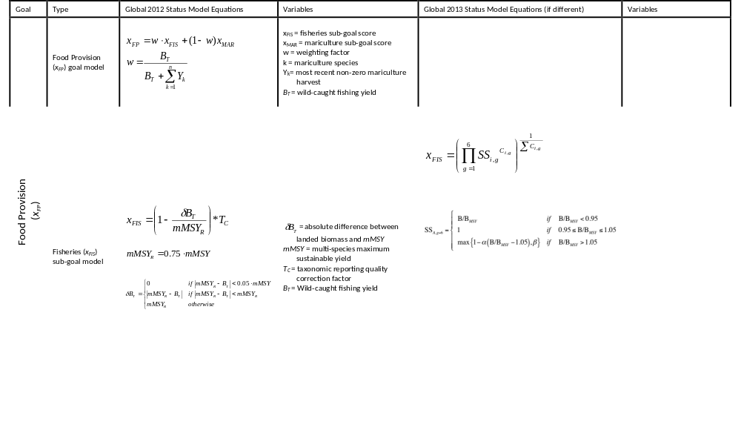
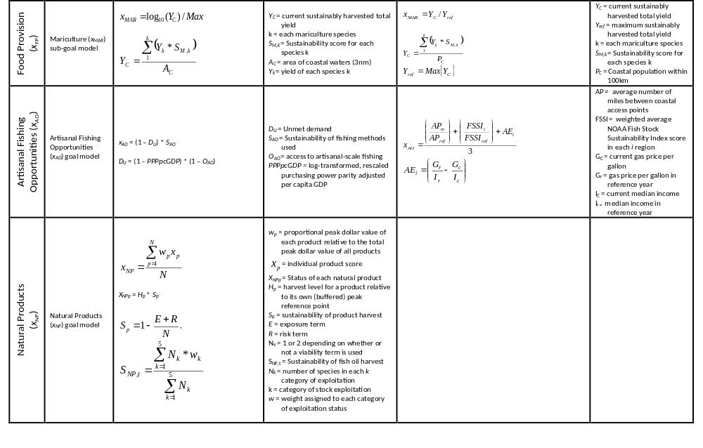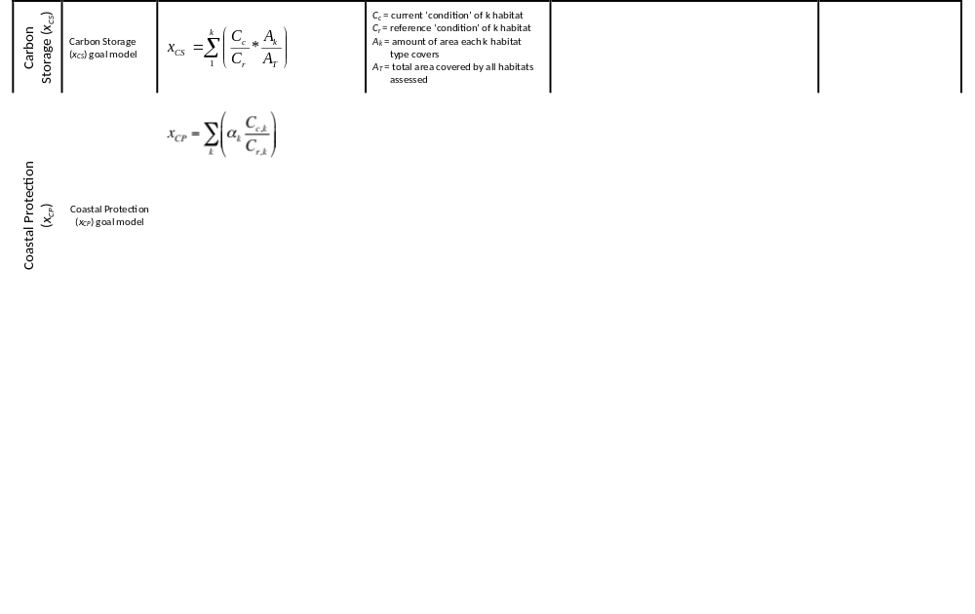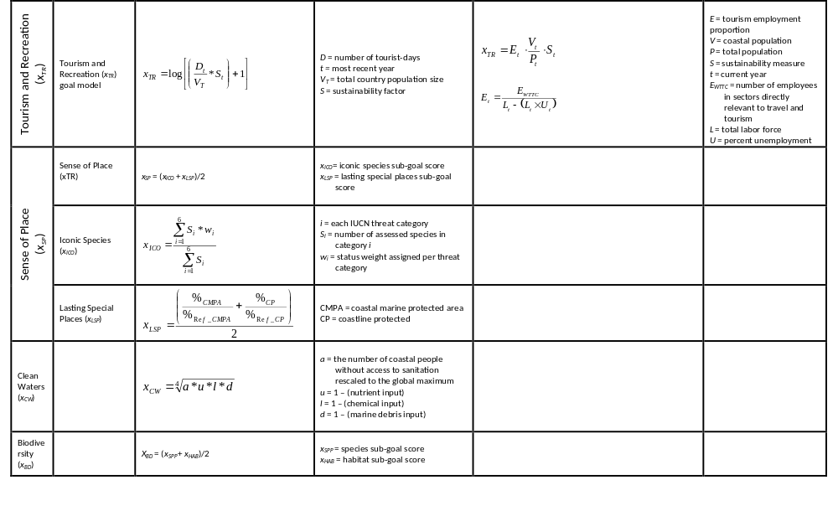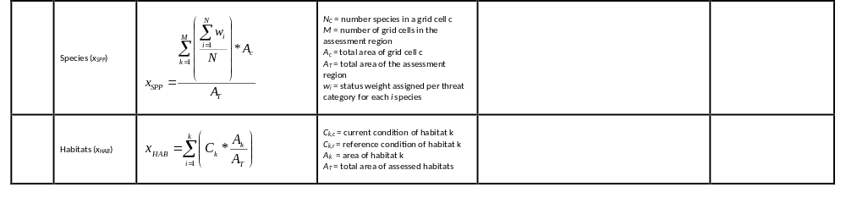
Table S5. Full list of data layers added, updated, unchanged, and removed for the 2013 analyses.

Data Layer | Brief Description | Dimension | Start Year | End Year | Native Resolution | Reference | Updated | New
Alien species | Number of alien species per marine ecoregion | Pressure | 2008 | 2008 | Ecoregion | Molnar et al. 2008 | n
Artisanal fishing: high bycatch | Presence of artisanal blast fishing practices | Status, Trend, Pressure | 2009 | 2009 | 10 km | Burke et al. 2011 | n
Artisanal fishing: low bycatch | Presence of artisanal poison fishing practices | Pressure | 2009 | 2009 | 10 km | Burke et al. 2011 | n
Artisanal fishing: management effectiveness and opportunity | Artisanal fishing opportunity for 206 countries | Status, Resilience | 2009 | 2009 | National | Mora et al. 2009, Fig. S4 | n
Artisanal fishing: need | Gross Domestic Product, per capita, adjusted by Purchasing Power Parity (PPPpcGDP) | Status, Trend | 1980 | 2012 | National | World Bank 2013 | y
Chemical pollution: land-based inorganic | Modeled pollution from urban runoff from impervious surfaces | Status, Pressure | 2000 | 2000 | 1 km | Halpern et al. 2008, USGS 2000
Chemical pollution: land-based organic | Modeled pollution from pesticides | Status, Pressure | 1992 | 2001 | 1 km | Halpern et al. 2008, FAO 2004
Chemical pollution: ocean-based | Modeled pollution from shipping and ports | Status, Pressure | 2002 | 2005 | 1 km | Halpern et al. 2008
Coastal human population | Human population density within 50 km from the shore | Status, Trend, Pressure | 1990 | 2012 | 2.5 arcmin | CIESIN 2013 | y
Coastal land and ocean area | Land area within a fixed distance from the shore (50 mi) and ocean area within a fixed distance from the shore (3 nmi and 10km) | All | 2008, 2011 | 2008, 2011 | 1 km | Halpern et al. 2008/ ESRI 2011
Coastline length | Length of boundary between land and sea (indcluding islands), in km |  |  |  |  | CIA World Factbook 2013 | y
Commercial fishing: high bycatch | Modeled demersal and pelagic high bycatch fishing pressure | Pressure | 1999 | 2003 | 0.5 deg | Halpern et al. 2008
Commercial fishing: low bycatch | Modeled demersal and pelagic low bycatch fishing pressure | Pressure | 1999 | 2003 | 0.5 deg | Halpern et al. 2008
Convention on Biological Diversity (CBD) signatories | List of 192 countries who signed CBD | Resilience | 2011 | 2011 | National | CBD 2011 | n
Convention on Biological Diversity (CBD) survey | Answers to questions relating to alien species, habitat, mariculture, tourism, and water | Resilience | 2005 | 2005 | National | CBD 2005 | n
Convention on International Trade in Endangered Species of Wild Fauna and Flora (CITES) signatories | List of 178 countries who signed CITES | Resilience | 2013 | 2013 | National | CITES 2013 | y
Coral reefs | Global coral habitat extent and change in condition | Status, Trend | 2002, 1980 | 2009, 2006 | 0.5 km; 1 km; Sites (points) | Burke et al. 2011, Bruno and Selig 2007, Schutte et al. 2010, Halpern et al. 2008
Country land area (Total land area?) | Total land area (km2) | Status, Trend | 2012 | 2012 |  | ESRI 2013/ CIA World Factbook 2013 | y/ y
Ecological integrity | Status of species biological diversity | Resilience | 2011 | 2011 | National (varies) | IUCN 2011 | y
Fertilizer trends | Nitrogen fertilizer consumption by agricultural industry | Trend | 2002 | 2010 | National | FAOSTAT 2013 | y
Fisheries catch data | Global fisheries catch statistics in yield per species | Status, Trend | 1953 | 2006 | 0.5 deg | Watson et al. 2004, FAO 2011 | y
Fisheries management effectiveness | Management effectiveness of the world’s marine fisheries | Resilience | 2009 | 2009 | National | Mora et al. 2009 | n
Genetic escapes | Mariculture Sustainability Index (MSI): native or introduced indicator | Pressure | 1994 | 2003 | National (varies) | Trujillo 2008 | n
Global Competitiveness Index (GCI) | Composite measure of 12 aspects of economic competitiveness | Pressure, Resilience | 2013 | 2013 | National | World Economic Forum: Schwab et al. 2013 | y
Gross Domestic Product (GDP) | Gross Domestic Product; Adjustment to all revenue data layers to factor out global economic fluctuations, in 2012 $USD | Status, Trend | 1960 | 2012 | National | World Bank 2013 | y
Habitat destruction: intertidal | Population density within 10 km of the shore | Pressure | 1990/ | 2012 | 2.5 arcmin (varies) | CIESIN 2013, Halpern et al. 2008 | y
Habitat destruction: subtidal hard bottom | Presence of blast and poison artisanal fishing practices | Pressure | 2009 | 2009 | 10 km | Burke et al. 2011 | n
Habitat destruction: subtidal soft bottom | Presence of trawling practices in soft bottom habitats | Status, Pressure | 1999 | 2003 | 0.5 deg | Halpern et al. 2008 | n
Iconic species list | WWF Priority and Flagship Species Lists | Status, Trend | 2011 | 2011 | Global; National | WWF 2011 | n
International arrivals | no longer used; see Tourism Economics
Labor Force | Number of people aged 15 and older who could contribute to the production of goods and services | Staus, Trend | 1990 | 2011 | National | World Bank 2013 |  | y
Mangroves | Global mangrove habitat extent, from remote sensing and assessments | Status, Trend | 2000, 1980 | 2000, 2005 | 1 arcsec; National | Giri et al. 2011, FAO 2007 | n
Mariculture Sustainability Index (MSI): mariculture sustainability and mariculture regulations | Mariculture Sustainability Index (MSI): Mariculture regulations include traceability and code of practice indicators. Mariculture sustainability includes fishmeal use, waste treatment, and seed and larvae origin indicators | Resilience, Status | 1994 | 2003 | National | Trujillo 2008 | n
Mariculture yield | Production of finfish and invertebrates | Status, Trend | 1950 | 2008 | National | FAO 2011 | y
Marine jobs: commercial fishing | Global Number of Fishers | Status, Trend | 1990 | 2008 | National | FAO Sources 2008 | n
Marine jobs: mariculture | Global Number of Fishers database, adjusted by proportion of a country's aquaculture production that is focused on marine species | Status, Trend | 1993 | 2008 | National | FAO Sources 2008, FishStat 2012 | n
Marine jobs: marine mammal watching | Jobs based on number of whale watchers in a country and a regional average number of whale watchers per employee. Includes all marine mammal watching. | Status, Trend | 1998 | 2008 | National | International Fund for Animal Welfare (IFAW): O'Connor 2009 | n
Marine jobs: tidal energy | La Rance and Annapolis tidal plants employment data | Status, Trend | 2003 | 2010 | Points (sites) | EDF 2010, Ruth Thorbourne, pers. comm. 2011 | n
Marine jobs: tourism | Total contribution of tourism to employment | Status, Trend | 1988 | 2012 | National | World Tourism and Travel Council (WTTC) 2013 | y
Marine and terrestrial protected areas | Relative area of MPAs within EEZ waters or within 3 nmi of shore, and relative area of designated protected areas (CP) within 1 km of shore | Status, Trend, Resilience | 2010 | 2010 | National (varies) | IUCN and UNEP 2010
Marine revenue: aquarium trade fishing | Revenue of Aquarium Trade Fishing derived from commodities database | Status, Trend | 1984 | 2009 | National | FAO FishStat 2013 | y
Marine revenue: commercial fishing | Total revenue from commercial marine fishing | Status, Trend | 1997 | 2007 | National | FAO FishStat 2011 | n
Marine revenue: mariculture | Total revenue from mariculture production of marine species | Status, Trend | 1977 | 2011 | National | FAO FishStat 2013 | y
Marine revenue: marine mammal watching | Total revenue from marine mammal watching | Status, Trend | 1998 | 2008 | National | O'Connor 2009 | n
Marine revenue: tidal energy | Total revenue from tide and wave electricity production | Status, Trend | 1990/ 2001 | 2010/ 2008 | National | UN Energy Statistics Database 2013, US Energy Information Administration 2011 | y/ n
Marine revenue: tourism | Total tourism revenue by country, adjusted by country's relative proportion of coastal area | Status, Trend | 1998 | 2012 | National | World Tourism and Travel Council (WTTC) 2013 | y
Marine species | IUCN threat category and spatial distribution of marine species | Status, Trend, Resilience | 2011 | 2011 | 0.5 deg | Carpenter et al. 2008, Schipper et al. 2008, Polidoro et al. 2010, Collette et al. 2011, Knapp et al. 2011, Kaschner et al. 2010
Marine wages | Occupations within commercial fishing, ports and harbors, ship and boat building, tourism, and transportation and shipping | Status, Trend | 1989 | 2008 | National | National Bureau of Economic Research 2012 | y
Multispecies maximum sustainable yield (mMSY) | Modeled sustainable yield from fisheries catch data | Status, Trend | 1953 | 2006 | National | Watson et al. 2004, FAO 2011
National percent unemployment | Percent of the labor force unemployed but able to and looking for work | Status, Trend | 1990 | 2011 | National | World Bank 2013 | y
Natural Products exposure | Intensity of harvest for coral, ornamental fish, sponges, shells, and seaweeds and plants | Status, Trend | 1950 | 2007/ 2008 | National/ National | FAO FishStat 2011/ Halpern et al. 2008 | n
Natural Products harvest | Export (in tons) of coral, ornamental fish, fish oil, sponges, shells, and seaweeds and plants | Status, Trend | 1976 | 2009 | National | FAO FishStat 2013 | y
Natural Products risk | Assigned risk for Natural Products based on references | Status, Trend | 2012 | 2012 | National | CITES 2013 / Reefs at Risk Revisited 2011 | y/ n
Nutrient pollution | Modeled N input from fertilizer use | Status, Pressure | 1993 | 2002 | 1 km | Halpern et al. 2008, FAO 2004
Ocean acidification | Change in aragonite saturation state (ASS) levels | Pressure | 1870/ 2000 | 2009 | 1 deg | Halpern et al. 2008
Pathogen pollution | Coastal population (within 50 km) density times % population without access to improved sanitation facilities | Status, Trend, Pressure | 1990/ 1990 | 2010/ 2011 | 5 km/ National | CIESIN 2013, WHO-UNICEF Joint Monitoring Programme 2013 | y/ y
Pesticide trends | Pesticide consumption by agricultural industry | Trend | 1990 | 2010 | National | FAOSTAT 2013 | y
Port volume | Number of containers handled per port in each country | Status, Trend, Pressure | 2008 | 2010 | National | UNCTAD 2013 | y
Rocky reef | Global rocky reef habitat extent | Status | 2005 | 2005 | 2 arcmin; Points | Halpern et al. 2008 | n
Salt marsh | Global salt marsh habitat extent | Status, Trend | 1975 | 2007 | National | Bridgham 2006,  Dahl 2006,  EEA Eionet 2008,  Environment New Zealand 2007,  JNCC 2004 | n
Sea ice | Sea ice change in extent, both edge and shoreline metrics | Status, Trend | 1979 | 2010 | 25 km | Fetterer et al. 2002
Sea level rise |  |  |  |  |  |  |  | y
Sea surface temperature (SST) anomalies | Sea surface temperature anomalies | Pressure | 1982 | 2010 | 4 km | Halpern et al. 2008 | y
Seagrass | Global seagrass habitat extent and change in condition | Status, Trend | 1975 | 2010 | 1 km; National | UNEP-WCMA 2005, Waycott et al. 2009, Short 2011 | n
Sector Evenness | Evenness of jobs from Shannon-Weaver diversity index | Resilience | 1990 | 2010 | National | FAO Sources 2008, WTTC 2011, O'Connor 2009, EDF 2010
Soft-bottom subtidal | Global soft-bottom subtidal habitat extent, and modeled status for change in condition | Status, Trend | 2001 | 2005 | 0.5 deg | Halpern et al. 2008, SAUP 2006 | n
Stock exploitation status | Exploitation status of fished stocks | Status, Trend | 1950 | 2006 | National | FAO 2011
Targeted harvest | Catch statistics for cetaceans and marine turtles | Pressure | 1950 | 2011 | National | FAO FishStat 2013 | y
Total land area | Total land area | Status, Trend, Pressure | 2013, 2011 | 2008, 2011 | National/ National | CIA World Factbook 2013, ESRI 2011 | y/
Total population | Census populations for 221 countries | Status, Trend | 2007 | 2007 | National | ESRI 2011
Tourist days per stay | no longer used; see XXX
Trash pollution | Trash collected on beaches (pounds/mile) | Status, Pressure | 2011 | 2011 | National | Ocean Conservancy 2012 | y
Travel and Tourism Competitiveness Index (TTCI) | Sustainability of the travel and tourism industry | Status, Trend | 2013 | 2013 | National | World Economic Forum 2013 | y
Travel and Tourism Direct Contribution to Employment | Employment directly linked to travel and tourism sectors (hotels, transportation, services) | Status, Trend | 1988 | 2012 | National | WTTC 2013 |  | y
Travel and Tourism Total Contribution to Employment | Employment directly and indirectly linked to travel and tourism sectors (including investment industriesa and sectors) | Status, Trend | 1988 | 2012 | National | WTTC 2013 | y
Travel and Tourism Total Contribution to GDP | GDP generated directly and indirectly from travel and tourism sectors | Status, Trend | 1988 | 2012 | National | WTTC 2013 |  | y
UV radiation | Anomalies in intensity of ultraviolet (UV) radiation | Pressure | 1996 | 2004 | 1 deg | Halpern et al. 2008 | y
Worldwide Governance Indicators (WGI) | Composite measure of Voice and Accountability, Political Stability and Absence of Violence, Government Effectiveness, Regulatory Quality, Rule of Law, and Control of Corruption | Pressure, Resilience | 1996 | 2011 | National | World Bank 2013 | y

Table S6. Updated pressures matrix. Changes are only for the addition of targeted harvest and sea level rise pressures.
 | ECOLOGICAL |  |  |  |  |  |  |  |  |  |  |  |  |  | PHYSICAL |  |  |  | SOCIAL
 | POLLUTION |  |  |  | Habitat Destruction |  |  | Spp Pollution |  | Fishing pressure |  |  |  |  | Climate change |  |  |  | Social
SUB-GOAL or SUB-COMPONENT | Chemicals (incl. Oil) | Human Pathogens | Eutrophication & hypoxia | Trash | HD subtidal softbottom  (trawling, benthic structures) | HD subtidal hardbottom  (destructive artisanal) | HD intertidal  (land-sea interface) | Alien invasives | Genetic Escapes | Targeted harvest  (cetaceans and turtles) | Commercial High bycatch  (D&P) | Commercial Low bycatch  (D&P) | Artisanal Low bycatch  (incl. cyanide) | Artisanal High bycatch  (blast fishing) | SST | pH | UV | Sea level rise | 1-WGI
Fishing | 1 |  | 1 |  | 2 | 2 | 1 | 1 | 1 |  | 3 | 1 | 1 | 2 |  |  |  |  | x
Mariculture | 2 |  | 3 |  |  |  |  |  |  |  |  |  |  |  |  |  |  | 1 | x
 | 1 |  | 1 |  | 1 | 3 | 1 | 1 |  |  | 2 | 1 |  | 3 |  |  |  |  | x
aq. trade | 2 |  | 1 |  |  | 3 |  | 1 |  |  |  |  | 1 | 3 | 1 |  |  |  | x
coral | 1 |  | 2 |  |  | 3 |  | 1 |  |  |  |  |  |  | 3 | 1 | 1 | 1 | x
fish oil | 2 |  | 1 |  | 2 |  |  | 1 |  |  |  | 2 |  |  | 1 |  |  |  | x
seaweed | 2 |  | 2 |  |  |  | 1 | 1 |  |  |  |  |  |  | 1 |  |  |  | x
sponges |  |  | 1 |  | 3 |  |  | 1 |  |  |  |  |  | 1 | 1 | 1 |  |  | x
Shells |  |  | 1 |  | 2 |  | 1 | 1 |  |  |  |  |  |  | 1 | 1 |  |  | x
Mangroves | 1 |  | 1 |  |  |  | 3 |  |  |  |  |  |  |  |  |  |  | 1 | x
Seagrasses | 2 |  | 3 |  |  |  | 3 | 1 |  |  |  |  |  |  | 2 | 1 |  | 2 | x
Salt marshes | 1 |  | 2 |  |  |  | 3 | 1 |  |  |  |  |  |  |  |  |  | 2 | x
Mangroves | 1 |  | 1 |  |  |  | 3 |  |  |  |  |  |  |  |  |  |  | 2 | x
Corals | 1 |  | 2 |  |  | 3 |  | 1 |  |  |  |  |  |  | 3 | 1 | 1 | 2 | x
Seagrasses | 2 |  | 3 |  |  |  | 3 | 1 |  |  |  |  |  |  | 2 | 1 |  | 3 | x
Salt marshes | 1 |  | 2 |  |  |  | 3 | 1 |  |  |  |  |  |  |  |  |  | 3 | x
Sea ice |  |  |  |  |  |  |  |  |  |  |  |  |  |  | 3 |  |  | 2 | x
 | 3 | 3 | 3 | 3 |  |  |  |  |  |  |  |  |  |  |  |  |  | 2 | x
Fishing (commercial) | 2 | 0 | 1 | 0 | 2 | 2 | 1 | 1 | 1 |  | 3 | 1 | 1 | 2 | 0 | 0 | 0 | 0
Mariculture | 2 | 0 | 3 | 0 | 0 | 0 | 0 | 0 | 0 |  | 0 | 0 | 0 | 0 | 0 | 0 | 0 | 1
Tourism | 3 | 3 | 3 | 3 | 0 | 0 | 0 | 0 | 0 |  | 0 | 0 | 0 | 0 | 0 | 0 | 0 | 2
Shipping & Transport | 0 | 0 | 0 | 0 | 0 | 0 | 0 | 1 | 0 |  | 0 | 0 | 0 | 0 | 0 | 0 | 0 | 0
Marine cetacean watching | 0 | 0 | 0 | 1 | 0 | 0 | 0 | 0 | 0 |  | 1 | 0 | 0 | 0 | 0 | 0 | 0 | 0
Aquarium trade | 2 | 0 | 1 | 0 | 0 | 3 | 0 | 1 | 0 |  | 0 | 0 | 1 | 3 | 1 | 1 | 0 | 0
Ports & Harbors | 0 | 0 | 0 | 0 | 0 | 0 | 0 | 1 | 0 |  | 0 | 0 | 0 | 0 | 0 | 0 | 0 | 2
Ship & Boat building | 0 | 0 | 0 | 0 | 0 | 0 | 0 | 0 | 0 |  | 0 | 0 | 0 | 0 | 0 | 0 | 0 | 0
Oil & Gas | 0 | 0 | 0 | 0 | 0 | 0 | 0 | 0 | 0 |  | 0 | 0 | 0 | 0 | 0 | 0 | 0 | 0
Energy (wave & tidal) | 0 | 0 | 0 | 0 | 0 | 0 | 0 | 0 | 0 |  | 0 | 0 | 0 | 0 | 0 | 0 | 0 | 1
Livelhoods AVE | 0.8 | 0.3 | 0.8 | 0.4 | 0.22 | 0.22 | 0.11 | 0.3 | 0.1 |  | 0.44 | 0.11 | 0.11 | 0.22 | 0 | 0 | 0 | 1
Economies AVE | 1.3 | 0.4 | 1.1 | 0.6 | 0.29 | 0.71 | 0.14 | 0.3 | 0.1 |  | 0.57 | 0.14 | 0.29 | 0.71 | 0.1 | 0.1 | 0 | 1
Special Places | 2 |  | 2 | 3 |  | 2 | 3 | 1 |  |  |  |  |  |  |  |  |  | 1 | x
Iconic Species | 3 |  | 1 | 1 |  | 2 | 3 | 1 |  | 2 | 2 |  |  | 2 | 1 | 1 |  |  | x
 | 3 | 3 | 3 | 3 |  |  |  |  |  |  |  |  |  |  |  |  |  | 0 | x
Habitats - Mangroves | 1 |  | 1 |  |  |  | 3 |  |  |  |  |  |  |  |  |  |  | 1 | x
Habitats - Seagrasses | 2 |  | 3 |  |  |  | 3 | 1 |  |  |  |  |  |  | 2 | 1 |  | 2 | x
Habitats - Salt marshes | 1 |  | 2 |  |  |  | 3 | 1 |  |  |  |  |  |  |  |  |  | 2 | x
Habitats - Soft bottom | 2 |  | 2 |  | 3 |  |  | 1 |  |  | 3 | 1 | 1 |  |  |  |  |  | x
Habitats - Corals | 1 |  | 2 |  |  | 3 |  | 1 |  |  |  |  |  | 3 | 3 | 1 | 1 | 1 | x
Habitats - Sea-ice |  |  |  |  |  |  |  |  |  |  |  |  |  |  | 3 |  |  | 1 | x
Species | 2 |  | 3 | 1 | 3 | 2 | 2 | 1 | 1 | 1 | 3 | 1 | 1 | 2 | 1 | 1 | 1 |  | x

Table S7. Resilience matrix. No changes were made from previous analyses (Halpern et al. 2012).

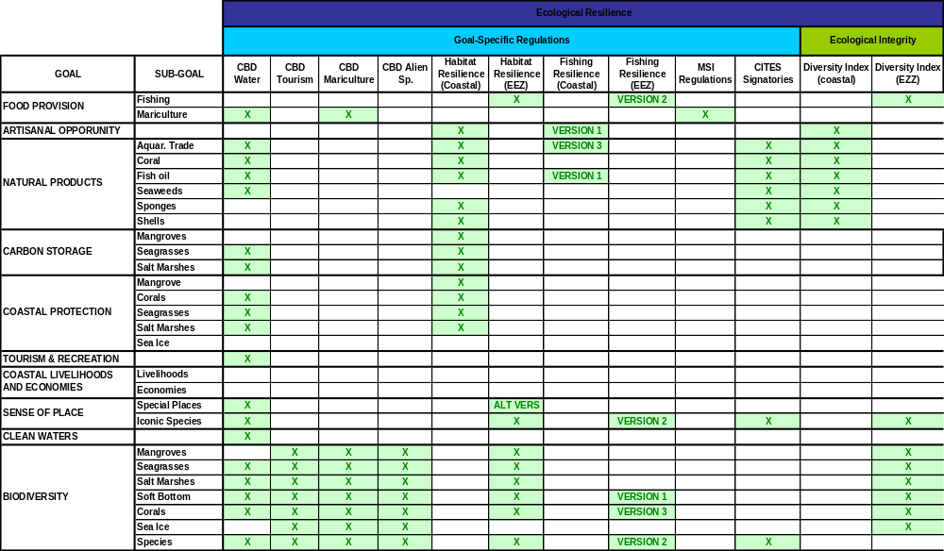

7. References
Casey, Kenneth S., Evans, Robert H., Baringer, Warner, Kilpatrick, Katherine A., Podesta, Guillermo P., Walsh, Susan, Williams, Elizabeth, Brandon, Tess B., Byrne, Deirdre A., Foti, Gregg, Li, Yuanjie, Phillips, Sheri A., Zhang, Dexin, and Zhang, Yongsheng (2011):AVHRR Pathfinder Version 5.2 Level 3 Collated (L3C) Global 4km Sea Surface Temperature for 1981-2011. National Oceanographic Data Center, NOAA. Dataset. doi:10.7289/V5WD3XHB [accessed 02 July 2013]

Casey K.S., Brandon T.B., Cornillon P. & Evans R. (eds.)
(2010). The past, present, and future of the AVHRR Pathfinder SST Program. Springer, New York.
Halpern B.S., Longo C., Hardy D., McLeod K.L., Samhouri J.F., Katona S.K., Kleisner K., Lester S.E., O'Leary J., Ranelletti M., Rosenberg A.A., Scarborough C., Selig E.R., Best B.D., Brumbaugh D.R., Chapin F.S., Crowder L.B., Daly K.L., Doney S.C., Elfes C., Fogarty M.J., Gaines S.D., Jacobsen K.I., Karrer L.B., Leslie H.M., Neeley E., Pauly D., Polasky S., Ris B., St Martin K., Stone G.S., Sumaila U.R. & Zeller D. (2012). An index to assess the health and benefits of the global ocean. Nature, 488, 615-620.
Halpern B.S., Longo C., Scarborough C., Hardy D., Best B.D., Doney S.C., Katona S.K., McLeod K.L., Rosenberg A.A. & Samhouri J.F. (in review). Assessing and improving the health of the California Current with a regional-scale application of the Ocean Health Index. Conservation Letters.
Halpern B.S., Walbridge S., Selkoe K.A., Kappel C.V., Micheli F., D'Agrosa C., Bruno J.F., Casey K.S., Ebert C., Fox H.E., Fujita R., Heinemann D., Lenihan H.S., Madin E.M.P., Perry M.T., Selig E.R., Spalding M., Steneck R. & Watson R. (2008). A global map of human impact on marine ecosystems. Science, 319, 948-952.
Kleisner K.M., Longo C., Coll M., Halpern B.S., Hardy D., Katona S.K., Le Manach F., Pauly D., Rosenberg A.A., Samhouri J.F., Scarborough C., Sumaila U.R., Watson R. & Zeller D. (in review). Exploring patterns of seafood provision revealed in the global Ocean Health Index. Ambio.
Reynolds R.W., Smith T.M., Liu C., Chelton D.B., Casey K.S. & Schlax M.G. (2007). Daily high-resolution-blended analyses for sea surface temperature. Journal of Climate, 20, 5473-5496.
Samhouri J.F., Lester S.E., Selig E.R., Halpern B.S., Fogarty M.J., Longo C. & McLeod K.L. (2012). Sea sick? Setting targets to assess ocean health and ecosystem services. Ecosphere.
Selig E.R., Casey K.S. & Bruno J.B. (2010). New insights into global patterns of ocean temperature anomalies: implications for coral reef health and management. Global Ecology and Biogeography, 19, 397-411.
Zeileis A. & Grothendieck G. (2005). zoo:S3 Infrastructure for regular and irregular time series. Journal of Statistical Software, 14, 1-27.

