**Advanced Zotero**

1. Add PDFs to your Zotero library and automatically import the article’s citation information.

First, enable PDF indexing on the Search tab of Zotero's preferences. Go to the "actions" icon on the Zotero toolbar, next choose preferences, then choose the "search" tab).  The PDF indexing download is in the second box on this tab.  Allow Zotero to download and install two small plugins called **pdftotext** and **pdfinfo**.  
  
Next, drag your PDF files from wherever you have them stored on your computer into a folder in Zotero.  You will see your PDFs listed in the center pane with the titles with which you have currently saved these PDFs.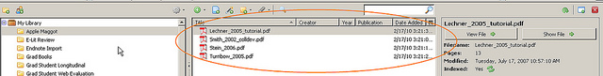  
  
Right-click on the PDFs in the center pane and choose "Retrieve Metadata for PDFs."  Zotero will retrieve the articles’ citation data from Google Scholar and turn them into cite-able items with PDF attachments.  
  
If Zotero can't find a match on Google Scholar, don't worry -- you can still save the citation from another catalog or article database search (the way you normally add items to your Zotero library), then drag the PDF onto the citation to make it an attachment to that citation.

1. Import and Export from EndNote
   1. Importing - Go to the "actions" icon on the Zotero toolbar, choose “import”. Navigate to where the EndNote file is saved on your computer and click “open.” The EndNote file (or any other bibliographic management software file) should be saved in the RefMan (RIS) export format; the file will have the file extension .txt. The file will be imported into your Zotero library as a new folder called “Imported Date XX, xxx”. You can then rename this file and distribute the articles to different folders.
   2. Exporting – Click on the folder you wish to export. Go to the "actions" icon on the Zotero toolbar, choose “export”. Select the RIS format to export your files. Save the exported file somewhere you can find it on your computer.
2. Add more citation styles

Zotero comes pre-loaded with 16 citation styles, including APA, Chicago, Harvard, and MLA.  However, many people need to work with citation styles that are specific to a particular journal.  To access more citation styles in Zotero, go to "actions" icon on the Zotero toolbar, choose preferences, then choose the styles tab.  The style manager box shows you what styles you currently have loaded.  To select more styles, click on "get additional styles" underneath the style manager box.

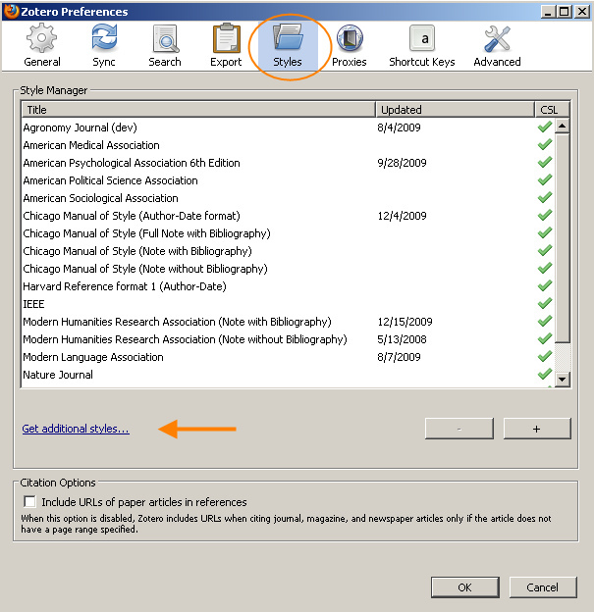

**Manual add**

This will open a website listing all of the styles Zotero currently has available.  To search for your style, hold down the control key and the letter F (the find command) on your keyboard, then enter the name of the style or journal you are interested in.  Once you find your style, click the "install" link, and the style will be added to your list of styles, both in the style manager window and in Word.

If your citation style is not in the longer list and you either find or are able to code a CSL file of your citation style, add it by clicking on the + button to manually add it to your list.

1. Syncing with other computers

You can use Zotero from other computers – you will just need to download Zotero to the other computer and login to your Zotero account. You can either create an account at Zotero’s website, <http://www.zotero.org/>, or by going to the "actions" icon on the Zotero toolbar, choosing “preferences”, then selecting the Sync tab. You can create an account from this screen.

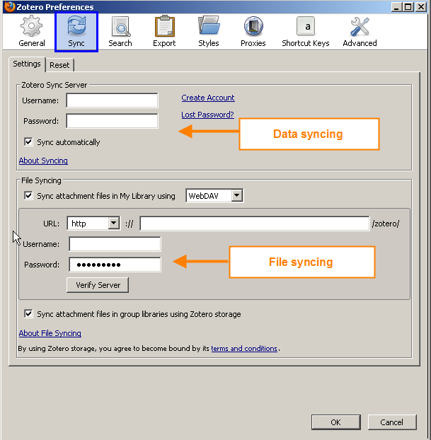

Once you have set up an account, just log on to your account to connect to your Zotero library from the new computer. The spinning arrow  in your Zotero toolbar will let you know that your Zotero library is being synced and will also indicate when your library was last synced.

Zotero saves the information in your library in two ways: data syncing and file syncing. Data syncing is free and is what happens when you login to your Zotero account. Data syncing ensures that all of your library items – citation information, notes, tags, links, etc…everything except attachment files are saved to Zotero’s servers.

File syncing requires using either Zotero file storage or WebDAV space (like that provided through OSU’s CN computing group). Zotero provides 100 MB of storage for free, and then charges for additional space, <http://www.zotero.org/support/storage>. There are several web services that offer some WebDAV space for free including JungleDisk and myDrive.ch.

1. Zotero Groups

Zotero allows you to set up group folders or libraries to collaborate with others. To start a Zotero group, click on the New Group icon  in the upper left-hand corner of the Zotero tool bar. Create a title for your group, then choose the group type. You will most likely want to create a “private” group. Next click “create group”. Add as much description as you think your group would find helpful. Extensive description is particularly helpful if your group is public and you want people to find your group on the open web. To add members to your group, choose the “members” tab, then click on “send more invitations” to add more members via their email addresses.

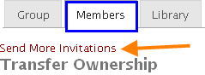

It will likely be helpful to let your group members know that you have sent them an invite. Invite emails come from a Zotero email address, not your email address. Also, depending on the way your group members have set up their Zotero accounts, the email may come to their Zotero inbox (check the upper right-hand corner of the Zotero website), rather than their regular email inbox.

Once you have set up your new group, you will see your group libraries listed below your personal libraries in your Zotero pane. You can now add to these libraries just like you would add to your regular Zotero libraries.

Group libraries must be deleted via the group library website. You cannot do it from within the Zotero pane.

To share files with members of your group library, you must have a file storage service set up.