**An Intro to Zotero**

Zotero is a free, open-source research tool that allows you to manage citations and build a searchable online research library. Using Zotero, you can annotate and organize your research documents. Zotero integrates with word processors, including Microsoft Word, so you can cite-as-you go.

|  |  |
| --- | --- |
|  | 1. Make sure you have the Firefox Web browser downloaded.   Zotero is a plug-in that extends what your Firefox browser can do. If you don’t use Firefox, you can download this free, open-source Web browser at:  http://www.mozilla.com/en-US/firefox/ |

|  |  |
| --- | --- |
|  | 1. Download Zotero and the Zotero Word plug-ins   To get started with Zotero, first click the red download button on the Zotero homepage to download and install the plug-in, <http://www.zotero.org/>. Next, install the Zotero Word plug-in, <http://www.zotero.org/support/word_processor_plugin_installation>.  You can also find tutorials and guides on the Zotero homepage, and a discussion forum where you can ask questions. |

1. Next, create a folder in Zotero to put your references in:



**Create a new folder**

1. Start downloading items to your Zotero library. Do a search in any database (including Google Scholar) or catalog. Then click on the folder or item icon in your URL location bar.

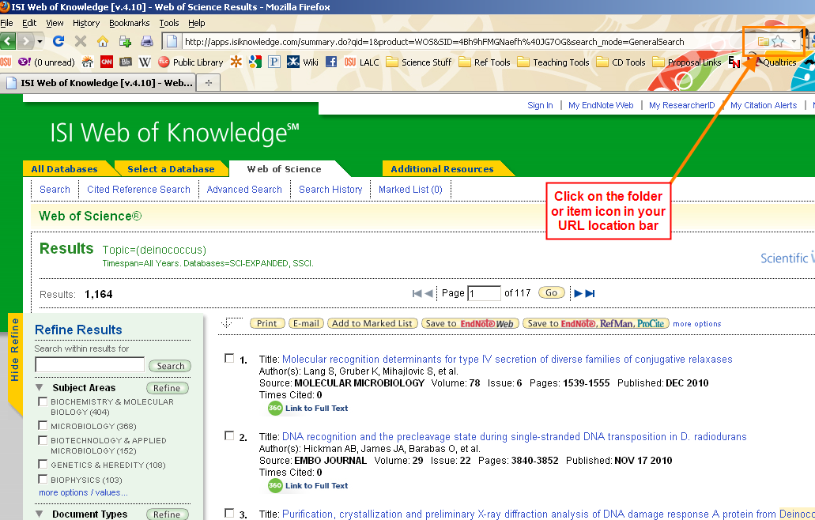

1. Select references from the pop-up list, or if you have clicked on a single book or article, just click on the  or  icon in the URL location bar.

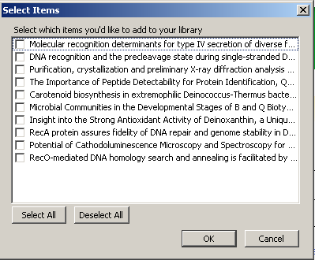

1. Get to know your library view in Zotero

**Note** – this icon will appear in the bottom corner of your Firefox browser once you have installed Zotero.

**If you don’t see a folder or item icon in the URL location bar, use the  to add new items manually.**

1. Create Your Bibliography While You Write

|  |  |
| --- | --- |
|  | Install the word processing plug-in to get started (http://www.zotero.org/support/word_processor_integration)  To add a citation, click the first button ("Insert Citation") on the toolbar in Word. Select the reference you want to cite and click OK. Zotero will add the citation at your cursor.  At the end of your paper, click the third button ("Insert Bibliography"). Your bibliography will appear, and new citations will be added automatically. Change bibliographic styles with the sixth button on the toolbar ("Set Doc Prefs"). |

1. Keep track of where Zotero is stored on your computer.

Choose the “actions” icon on your Zotero toolbar , then select “preferences from the menu. Go to the Advanced Tab:

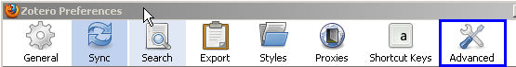

Click on Show Data Directory:

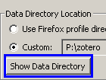

This will show you where your Zotero is saved on the C drive of your computer. Now you can back up your Zotero library to an external hard drive or another back up source of your choosing.