**Amazon Review - Annotation Guidelines**

Contents

1 Concepts 3

1.1 Cancer types 3

1.2 Indicated symptoms 4

1.3 Harmful outcome 5

1.4 Favorable outcome 5

1.5 Product 6

2 Annotation Tool 6

# Concepts

## Cancer types

If there is a mention of detailed cancer types, such as “breast cancer”, annotate “breast cancer” instead of “cancer”. Note, some cancer may not appear as “cancer”, for example, leukemia, lymphoma, melanoma.

*Class includes human or pet.*

*Certainty includes Positive, Negative, Hypothetical and Possible.*

**Example: Cancer_type, Hypothetical, Human**

**Example: Cancer_type, Positive, Human**

**Example: Cancer_type, Positive, Pet**

## Indicated symptoms

The symptoms that the Amazon product was used for.

*Class includes cancer related or other.*

*Certainty includes positive, negative, hypothetical, or possible.*

**Example: Indicated_symptom, Cancer_related, Positive**

**

**Example: Indicated_symptom, Other, Positive**

**Example: Indicated_symptom, Cancer_related, Hypothetical**

**Example: Indicated_symptom, Other, Negative**

## Harmful outcome

Adverse or harmful outcome after using the product.

*Class includes cancer related or other.*

*Certainty includes positive, negative, hypothetical, or possible.*

**Example: Harmful_outcome, Cancer_related, Positive**

**Example: Harmful_outcome, Cancer_related, Hypothetical**

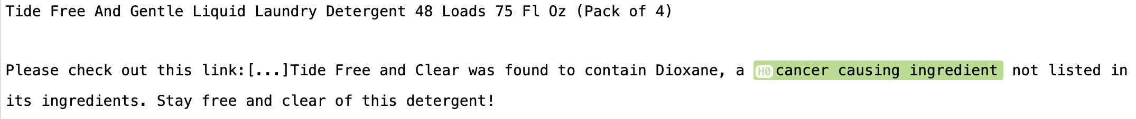

## Favorable outcome

Beneficial or favorable outcome after using the product.

*Class includes cancer related or other.*

*Certainty includes positive, negative, hypothetical, or possible.*

**Example: Favorable outcome, Positive**

**Example: Favorable outcome, Hypothetical**

**Example: Favorable outcome, Other, Positive/Negative**

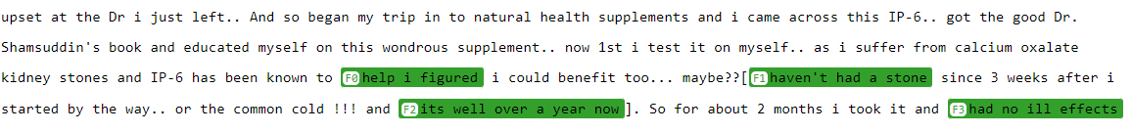

## Product

The mention of the product name or the co-reference of the product such as “this”.

*Type includes Itself or other.*

**Example: Product, Itself**

**Example: Product, Other**



# Annotation Tool

We used MedTator in this annotation task.

# Attributes:

## Certainty

Negative: the problem does not exist in the patient

* *Patient does not have infection.*
* *No history of infection*
* *His infection resolved*

Possible: patient may have a problem, but there is uncertainty expressed in the note. Possible takes precedence over negated, so terms like “probably not” or “unlikely” categorize problems as being possible just as “probably” and “likely” do

▪ *This is very likely to be an asthma exacerbation .*

▪ *Doctors suspect an infection of the lungs .*

▪ *Questionable / small chance of pneumonia .*

▪ *Pneumonia is possible / probable*

▪ *Suspicion of pneumonia*

▪ *We are unable to determine whether she has leukemia*.

▪ *It is possible / likely / thought / unlikely that she has pneumonia*

▪ *We suspect this is not pneumonia*

▪ *this is probably not cancer*

▪ *pneumonia unlikely*

Hypothetical: medical problems that the note asserts the patient may develop

* *If you experience wheezing or shortness of breath*
* *Ativan 0.25 to 0.5 mg IV q 4 to 6 hours prn anxiety*

Positive

* Patient has infection
* He has history of infection