**Appendices for**

**Title:** We Work with Them? Healthcare Workers Interpretation of Organizational Relations Mined from Electronic Health Records

**Authors:** You Chen1, Nancy Lorenzi1,2, Steve Nyemba1, Jonathan S. Schildcrout3,4, and Bradley Malin1,5

**Author Affiliations:**

1Dept. of Biomedical Informatics, School of Medicine, Vanderbilt University, Nashville, TN

2School of Nursing, Vanderbilt University, Nashville, TN

3Dept. of Biostatistics, School of Medicine, Vanderbilt University, Nashville, TN

4Dept. of Anesthesiology, School of Medicine, Vanderbilt University, Nashville, TN

5Dept. of Electrical Engineering and Computer Science, Vanderbilt University, Nashville, TN

**To Whom Correspondence Should be Addressed:**

You Chen, Ph.D.

2525 West End Ave, Suite 1030

Department of Biomedical Informatics

Vanderbilt University

Nashville, TN 37203 USA

Email: you.chen@vanderbilt.edu

Phone: +1 615 343 1939

Fax: +1 615 322 0502

**Appendix A: Survey Design and Analysis**

Each respondent in this study was provided with the same survey, such that all questions were presented in the same order. Table A1 provides a summary of the questions that were asked and the order in which the question were asked.

|  |  |
| --- | --- |
| **Table A1.** The questions asked in the online survey associated with this study. | |
| Someone from **Coding & Charge Entry - Vanderbilt Medical Group (VMG)** accessed the record of patient John Doe. How likely is it that someone from the following organizational area accessed the same patient's record? | |
| **Organizational Area** | **Respondent**  **Answer Options** |
| Dentistry | Not at all likely (1),  Slightly likely (2),  Moderately likely (3),  Very likely (4),  Completely likely(5) |
| Medical Information Services | … |
| Pediatric Dermatology | … |
| Professional Services Administration Vanderbilt University Hospital (VUH) | … |
| The Learning Center | … |
| General Surgery | … |
| Neuro-Epilepsy - 6 North | … |
| Vanderbilt Medical Group (VMG) Innovation | … |
| Orthopedic Trauma | … |
| Westhaven | … |
| Emergency Medicine | … |
| Admitting | … |
| Anesthesiology | … |
| First Assessment Center | … |
| Coding Abstraction - Vanderbilt Medical Group (VMG) | … |
| Division of Epidemiology | … |
| Pediatric Infectious Disease | … |
| Surgery-Oral & Maxillofacial | … |
| LifeFlight Event Medicine | … |
| The Burn Clinic | … |
| Dermatology Practice | … |
| Utilization Management | … |
| Laboratory Computer Operations | … |
| Junior League Unit | … |
| Vanderbilt Medical Group (VMG) Patient Representative | … |
| Endoscopy | … |
| Center for Human Nutrition | … |
| Medicine | … |
| Coding & Charge Entry - Vanderbilt Medical Group (VMG) | … |
| Adolescent Medicine | … |
|  | |
| Someone from **Psychiatry** accessed the record of patient John Doe. How likely is it that someone from the following organizational area accessed the same patient's record? | |
| **Organizational Area** | **Respondent**  **Answer Options** |
| Medical Information Services | … |
| Nursing Education - Vanderbilt Children's Hospital (VCH) | … |
| Psychiatric Hosp at Vanderbilt | … |
| Free-electron Laser Operating Room | … |
| Point Of Care Testing | … |
| Pediatric Hematology-Oncology | … |
| Children's Hospital Patient Care Center (PCC) | … |
| Admissions Office | … |
| Vanderbilt Brain Institute | … |
| Adult Psychiatry | … |
| Hillsboro Medical Group | … |
| Genetic Medicine | … |
| Neuro Care Unit | … |
| Emergency Medicine | … |
| Psychiatry | … |
| Perinatal Services | … |
| Mental Health Clinic Administration | … |
| Main OR - Trauma Renal Neonatology | … |
| Neonatology | … |
| School Of Nursing | … |
| Graduate Medical Education | … |
| Mental Health Center | … |
| Pediatric Neurology | … |
| Medical - 8 South | … |
| Coding & Charge Entry - Vanderbilt Medical Group (VMG) | … |
|  | |
| Someone from **Anesthesiology** accessed the record of patient John Doe. How likely is it that someone from the following organizational area accessed the same patient's record? | |
| **Organizational Area** | **Respondent**  **Answer Options** |
| Emergency Medicine Administration | … |
| Molecular Physiology & Biology | … |
| Hematology Stem Cell Clinic | … |
| Coding Abstraction - Vanderbilt Medical Group (VMG) | … |
| SPMC (Sports Medicine) | … |
| Coding & Charge Entry - Vanderbilt Medical Group (VMG) | … |
| Dentistry - Pediatrics | … |
| Pharmacology Cardiology | … |
| Outpatient Pharmacy - Vanderbilt Children's Hospital (VCH) | … |
| Neuro-Movement Disorder | … |
| Medicine | … |
| Anesthesiology | … |
| Addiction Psychiatry | … |
| Appeals - Vanderbilt Medical Group (VMG) | … |
| The Burn Clinic Emergency Medicine | … |
| Emergency Medicine | … |
| Nursing Administration - Pediatrics | … |
| Admitting | … |
| Medical Information Services | … |
| Orthopedics-Rehabilitation | … |
| General Surgery | … |
| Vanderbilt Heart - Murfreesboro | … |
| Renal Transplant | … |
| Medical Center East (MCE) Post-Anesthesia Care Unit (PACU) | … |
| Utilization Management | … |
| Main OR - Cardiac | … |
| Medical School Pediatrics | … |
| University Library | … |
| Emergency Administration | … |
| Medical Affairs | … |
|  | |
| Someone from **Medical Information Services** accessed the record of patient John Doe. How likely is it that someone from the following organizational area accessed the same patient's record? | |
| **Organizational Area** | **Respondent**  **Answer Options** |
| Emergency Medicine | … |
| Coagulation Thrombosis | … |
| Vanderbilt Home Care Service | … |
| Nursing Administration - Pediatrics | … |
| Women Infants & Children - Vanderbilt Medical Group (VMG) | … |
| Mental Health Center | … |
| Managed Care Sales & Services | … |
| Department of Surgery - Administration | … |
| Anesthesiology | … |
| Radiology - Vanderbilt Orthopaedics Institute (VOI) | … |
| General Surgery | … |
| Pod B - 6th Floor | … |
| Coding & Charge Entry - Vanderbilt Medical Group (VMG) | … |
| Dentistry | … |
| Coding Abstraction - Vanderbilt Medical Group (VMG) | … |
| Medical Center Post-Anesthesia Care Unit (PACU) | … |
| Dermatology MOHS (Micrographic Surgery) Center | … |
| Utilization Management | … |
| Physician Liaison | … |
| Pediatric Infectious Disease | … |
| Admitting | … |
| Psychology & Human Development | … |
| Pediatric Catheter Lab | … |
| Medical Information Services | … |
| Geriatric Psychiatry | … |
| Neuro-Epilepsy - 6 North | … |
| Orthopedic, Spine | … |
| Medicine | … |
| Neonatal Intensive Care Unit (NICU) - 4CN | … |
| Kennedy Center | … |

**Appendix B: Average Normalization Scores of All Respondent Types by all Rule Types**

The normalization was performed as follows. For the *j*threspondent, let *xij* be their likelihood for the *i*th rule, μj be their average likelihood, and σj be the standard deviation of their likelihoods. Then, the normalized values for this respondent is *yij* = (*xij* - μj) / σj. Thus, the reported values in Figure A1 correspond to the average of the respondents’ normalized values for this rule.

For instance, if the respondent type is CODE and we are considering the first rule associated with CODE rules, then the presented value in the top-right graph in Figure A1(b) is the average of the seven normalized respondent values, which is ~1.2 standard deviations from this group’s norm. This figure clearly shows high rules can be distinguished from medium and low rules, but distinguishing medium from low rules is very difficult.

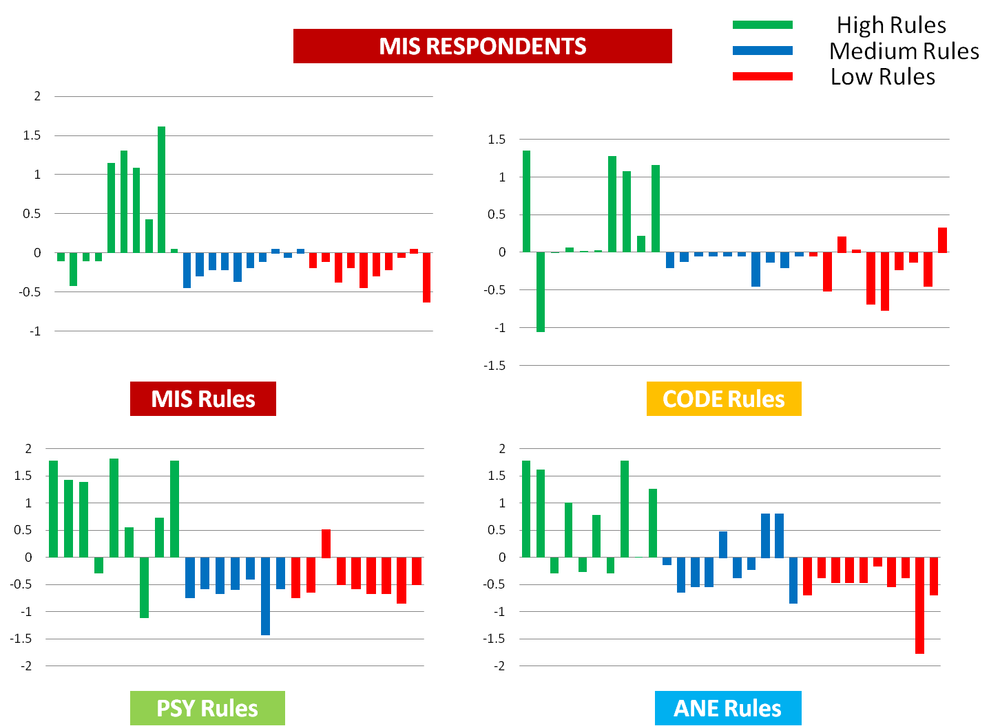

1. Normalization scores of respondents from MIS on all four types of rules

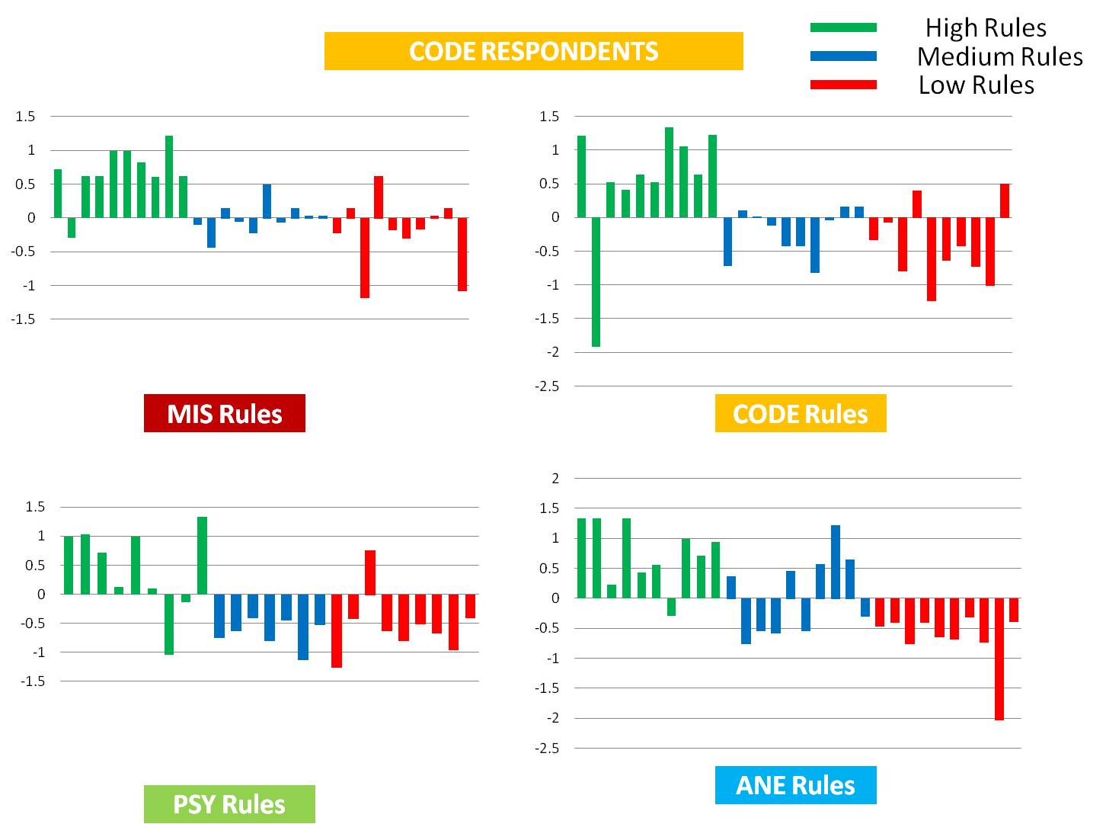

1. Normalization scores of respondents from CODE on all four types of rules

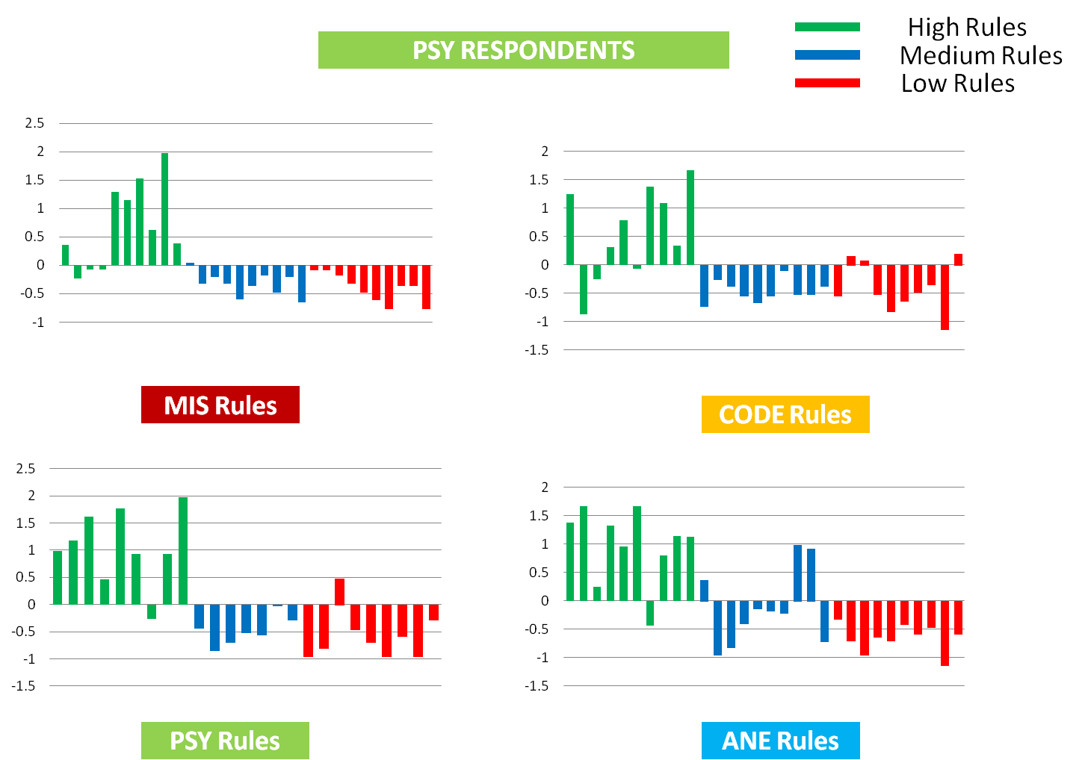

1. Normalization scores of respondents from PSY department on all four types of rules

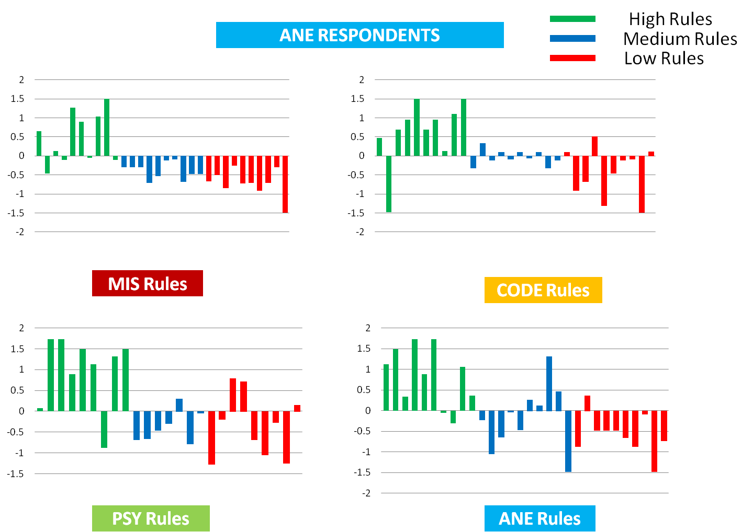

1. Normalization scores of respondents from ANE on all four types of rules

**Figure A1.** Average normalization scores of MIS rules, CODE rules, PSY rules and ANE rules on high (green), medium (blue) and low (red) classes. The average normalization scores shown for respondents from (a) MIS, (b) CODE, (c) PSY, and (d) ANE.

**Appendix C: Hypothesis Test Details**

As mentioned in the main manuscript, there are three primary hypotheses evaluated over the survey. For context, these hypotheses were stated as:

* **Hypothesis H1 (Locally Knowledgeable of Class):** Absolute and relative knowledge of rules from one’s own area:
  + **H1a) (Absolute)** HCO employees can distinguish between high, and non-high likelihood rules in their own HCO area.
  + **H1b) (Relative)** HCO employees can distinguish between high, and non-high likelihood rules in their own HCO area better than they can in other HCO areas.
* **Hypothesis H2 (Globally Knowledgeable of Class):** Absolute and relative knowledge of rules across all areas:
  + **H2a) (Absolute)** HCO employees can correctly distinguish between rules of high, and non-high likelihoods.
  + **H2b) (Relative)** HCO employees’ ability to distinguish between rules of high, and non-high likelihoods vary by HCO areas.
* **Hypothesis H3 (Locally Knowledgeable by Order):** Members of an HCO area are better at predicting the EHR-learned likelihoods of their own high rules than high rules of other organizational areas.

These are hypotheses in the general sense and that they need to be tested with respect to each organizational area (or pair of organizational areas). We recognize that it may be easier to understand how the hypotheses are specialized to each organizational area using a more explicit form than that presented in the main manuscript. Thus, we show how the hypotheses are specifically represented in Table A2.

To assess the goodness of fit for the linear mixed model with random intercepts (one for each specific hypothesis), we report the standardized residuals as QQ plots in Figure A2. The residuals are, for the most part, randomly distributed around the model, which suggests that models are not biased.

We recognize, however, that we our survey consists of a small number of respondents. So, to verify that the sample size is sufficiently large to answer our hypotheses, we provide the confidence intervals for the effects which were reported to be significant in the main manuscript in Figure A3 (as depicted). The confidence interval is calculated at the confidence level of 0.95. Through the figure, it can be seen that the confidence intervals associated with the significant effects are around 1.5. For instance, the average percentage of respondents correctly distinguishing rules of high from non-high likelihood is 94.2%. In other words, we have 95% confidence that if we had asked the question of the entire relevant population, somewhere between 92.7% (94.2-1.5) and 95.7% (94.2+1.5) would have correctly distinguished between rules of high and non-high likelihoods.

**Table A2.** The three primary hypotheses and their corresponding subtests (i.e., specialization to certain organizational areas).

|  |  |
| --- | --- |
| Hypothesis | Subtests |
|  |  |
|  |
|  |
|  |
|  |  |
|  |
|  |
|  |
|  |
|  |
|  |
|  |
|  |
|  |
|  |
|  |
|  |  |
|  |
|  |
|  |
|  |  |
|  |
|  |
|  |
|  |
|  |
|  |  |
|  |
|  |
|  |
|  |
|  |
|  |
|  |
|  |
|  |
|  |
|  |

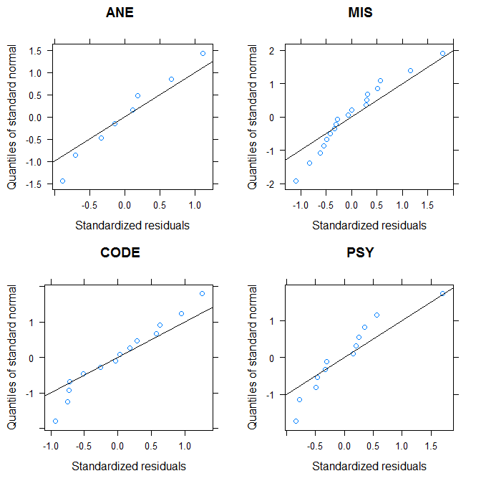

1. Plots of standardized residuals for hypothesis H1a

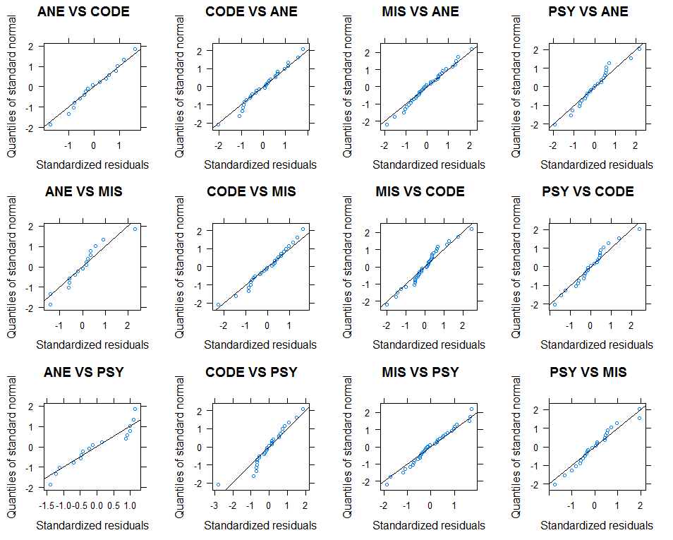

1. Plots of standardized residuals for hypothesis H1b

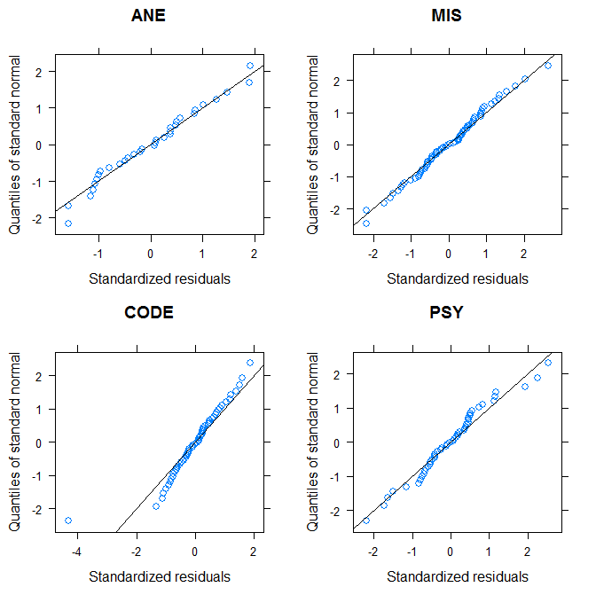

1. Plots of standardized residuals for hypothesis H2a

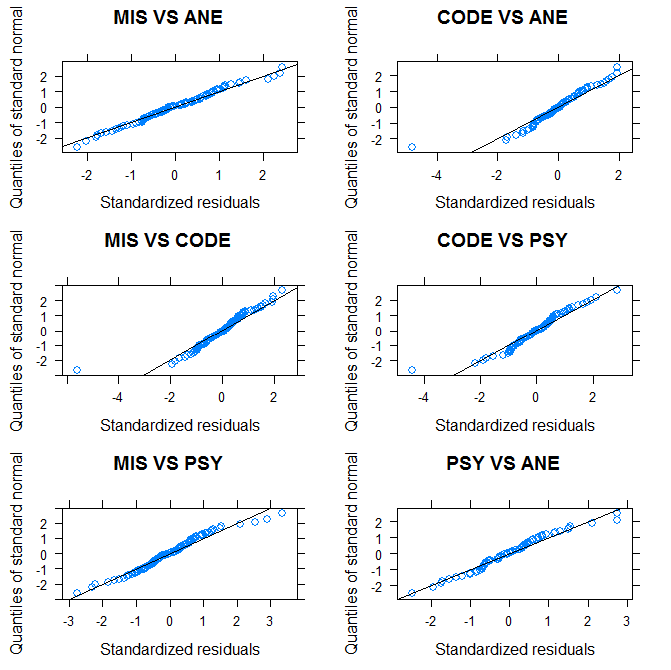

1. Plots of standardized residuals for hypothesis H2b

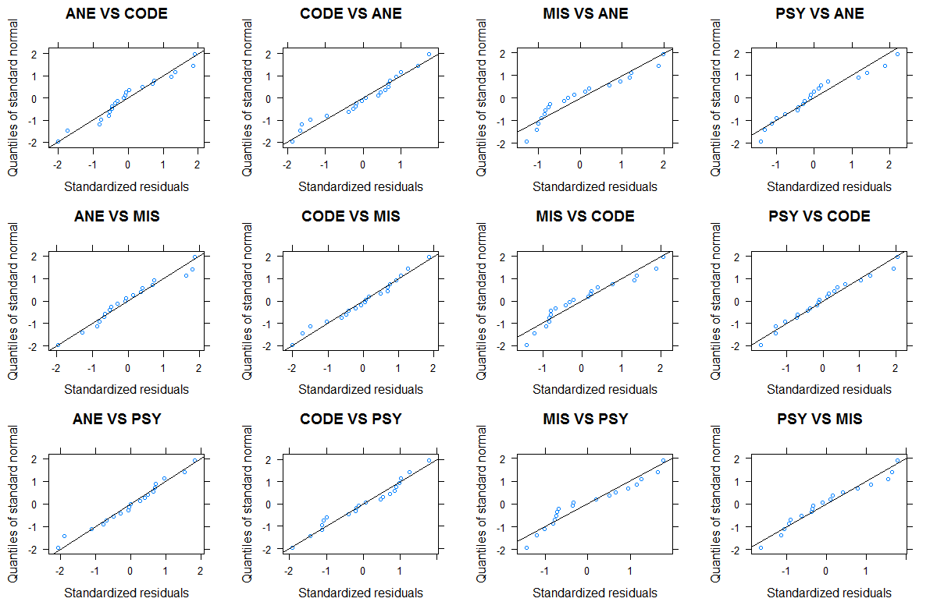

1. Plots of standardized residuals for hypothesis H3

**Figure A2.** Plots of standardized residuals for the models associated with each hypothesis test.

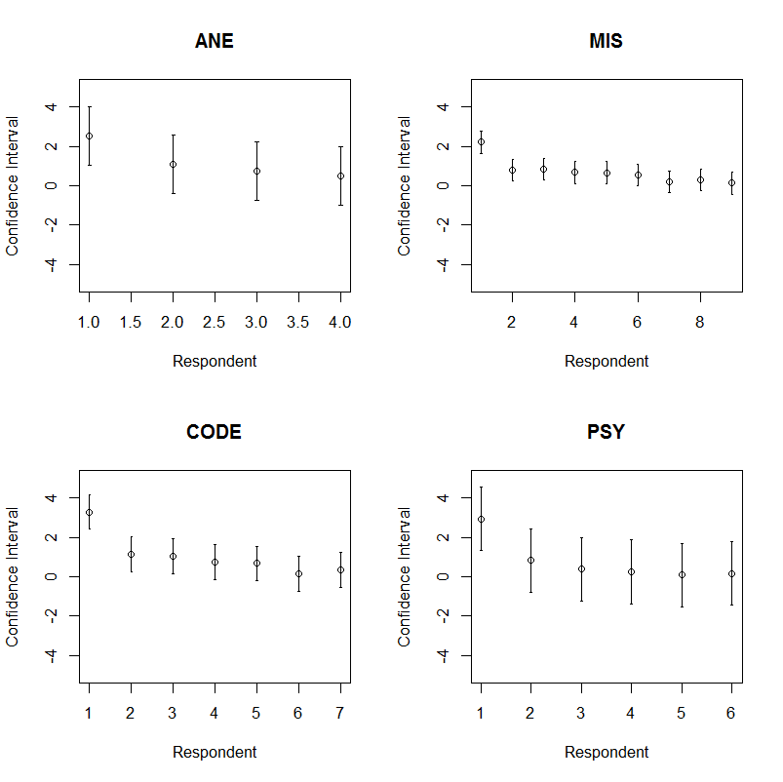

(a) The confidence intervals (based on the 26 respondents) for the four sub models associated with *H*1a -*H*0, as depicted in Table A2.

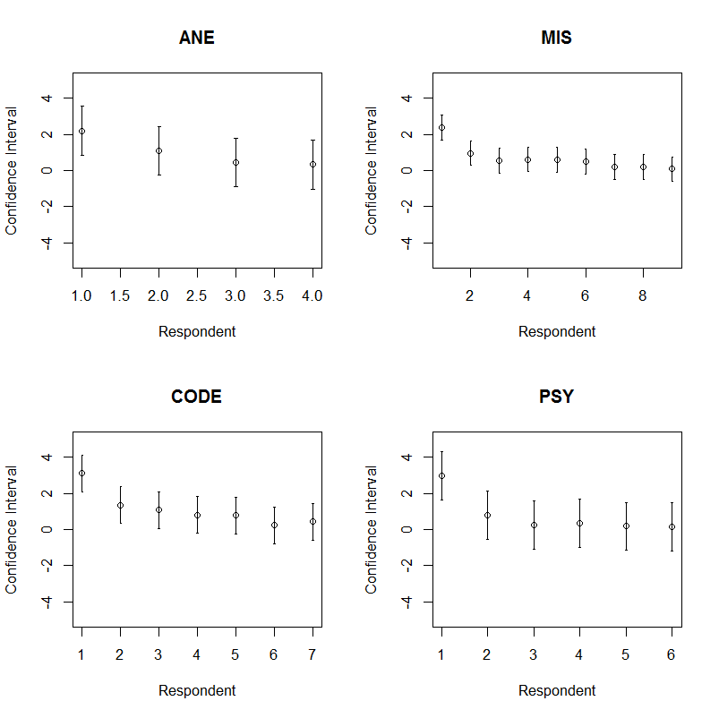

(b) The confidence intervals of 26 respondents for four sub models of **H2a -H0,** as depicted in Table A2

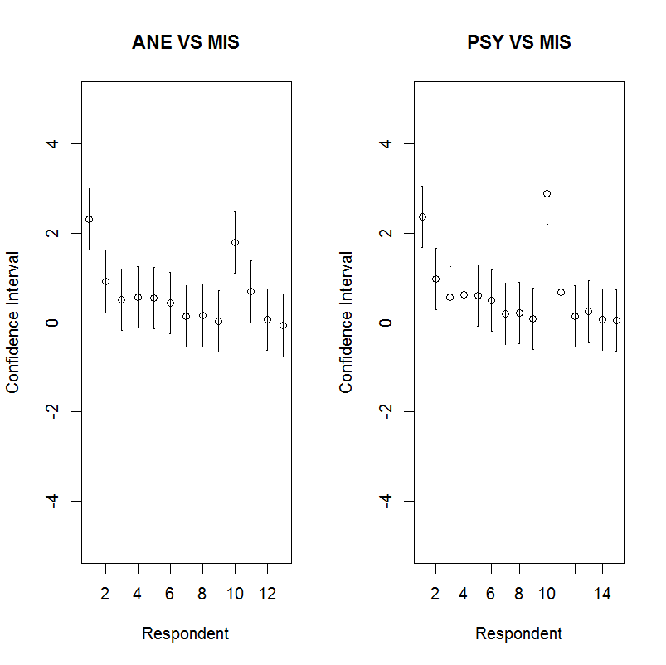

(c) The confidence intervals of 13 respondents for model **H2b,1-H0** (as depicted in the left); and the confidence intervals of 15 respondents for model **H2b,3-H0** (as depicted in the right)

**Figure A3.** Plots of confidence intervals for the models associated with hypothesis test H1a-H0 (Figure A3 (a)), H2a-H0 (Figure A3 (b)), and “H2b,1-H0 and H2b,3-H0” (Figure A3 (c)), which are all statistically significant.