 | GROUNDED AI PRACTICE  Home server build — decisions and reasoning

Building a home server: decisions and reasoning

What this is
A short account of building an always-on Linux server from an existing desktop PC — what it does, what was decided, and why each decision went the way it did.
It is published for two reasons. The build is the first practical infrastructure this project owns, and it is a worked example of the project's own method: decisions made explicitly rather than drifting into place, claims checked before they are written down, and the reasoning kept next to the conclusion so a reader can disagree with it.
The full step-by-step procedure is kept privately, because it carries a specific machine on a specific home network. This document is the part that generalises.

NOTE
This is a record of work in progress, not a finished case study. Where something is untested, it says so.

The machine and what it does
Existing hardware, repurposed rather than bought: a six-core Ryzen 5 5600X, 32 GB of memory, a mid-range GPU, a 500 GB SSD and two second-hand hard drives, in a mini-ITX case. It runs five roles at once — always-on server, remote-access workstation, media centre driving a projector, small network-attached storage, and a small website host.
Repurposing rather than buying is itself the first decision. A dedicated mini PC would use roughly a tenth of the electricity, and for the server roles alone it would be the better answer.
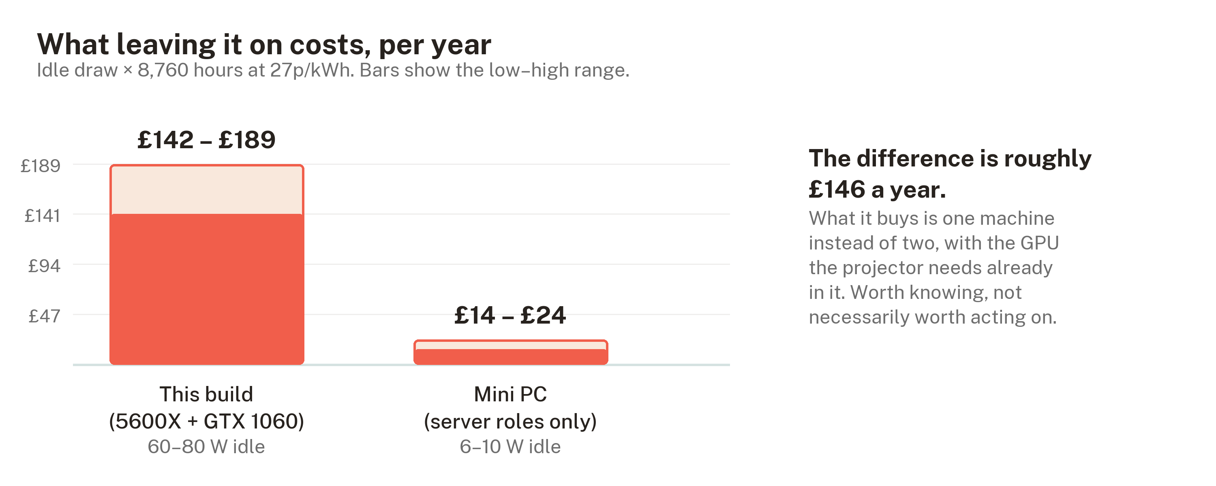
Annual running cost at 27p/kWh, this build against a mini PC doing only the server roles.
The difference is real money — around £146 a year. What it buys is one machine instead of two, with the graphics card the projector needs already in it. Worth knowing before committing, which is why it is stated up front rather than discovered later.

Four decisions worth explaining

No RAID
RAID keeps data across several disks so the array survives one failing. It is the obvious answer for a machine with multiple drives, and it was rejected for four independent reasons.
Mismatched capacities waste space, because RAID sizes itself to the smallest member. Motherboard RAID is firmware rather than a real controller, so a dead board makes the array awkward to read anywhere else. Drives bought at the same time fail at around the same time, and rebuilding an array stresses every surviving disk at exactly the wrong moment.
The fourth reason is the one that matters most. RAID is not backup. It survives a disk dying. It does nothing about deleting the wrong folder, ransomware, a failing power supply taking everything with it, or the building flooding. Treating one as the other is a common and expensive mistake.
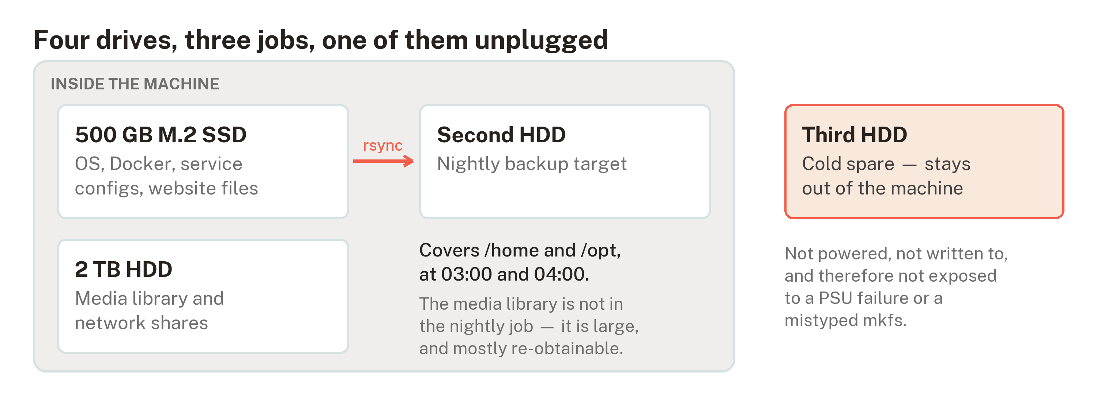
What each drive does, and what the nightly job actually copies.
What replaced it is deliberately simple: each drive has one job, one drive holds a nightly copy of the things that cannot be re-downloaded, and one stays out of the machine entirely as a cold spare. A drive that is not powered cannot be destroyed by the power supply that kills the others.
The media library is not in the nightly copy. That is a choice rather than an oversight — a library is large and mostly re-obtainable — but it means one drive has no second copy anywhere, and saying so plainly is the point.

Ubuntu Desktop rather than a server distribution
Counter-intuitive for a server, and the reasoning is about the operator rather than the software. The machine drives a projector, so it needs a graphical desktop regardless; adding one to a server installation afterwards is an unpleasant first Linux task. The proprietary graphics driver is a checkbox during installation rather than manual work with kernel modules. Long-term support gives five years of security updates with no forced upgrades.
The decisive factor is documentation. Pasting an error message into a search engine returns working answers for Ubuntu LTS more reliably than for any alternative, and for someone learning, that outweighs the technical merits of a leaner system. Proxmox, TrueNAS, Debian and Arch were each considered and rejected on that basis.
The cost is about 300 MB of memory out of 32 GB. It is not a real trade-off at this scale.

Nothing is exposed to the internet
The conventional way to reach a home server from outside is to forward a port on the router. Exposed SSH attracts thousands of automated login attempts a day, every one of them free to keep trying.
Both remote-access routes here are outbound connections instead. A mesh VPN joins the server to a private network shared with a laptop and phone; a tunnel service publishes the website by connecting out to the provider, which then serves visitors on the server's behalf. Neither requires an open port, and both sidestep the changing home IP address entirely.
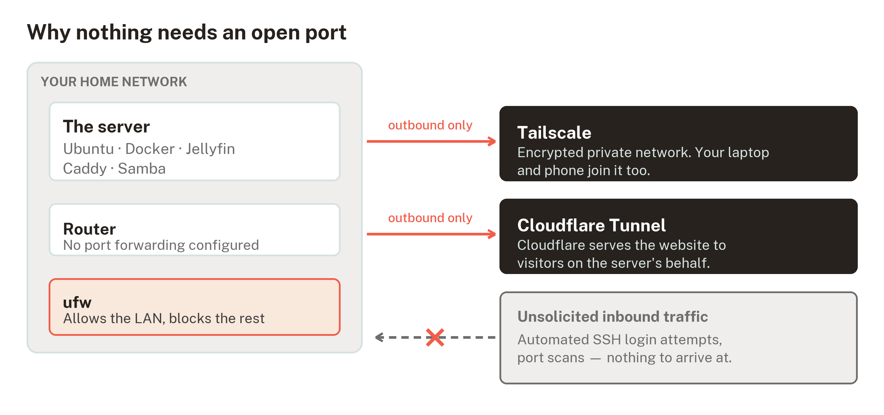
Both remote-access routes are outbound connections, so the router needs no forwarding rule.
This is the single highest-value decision in the build. It removes an entire category of attack — the kind that begins with someone scanning your address — rather than defending against it.

The media source is not the media player for everything
The server feeds an AV receiver over HDMI, which drives the speakers and passes video through to the projector. That works for a personal library. It does not work for UK live sport, and finding that out early saved an evening.
Neither major UK sports streaming service supports Linux, and it is an operating-system check rather than a browser one. Beyond either service's policy, content protection on Linux is software-only, which caps most premium services below high definition and rules out 4K entirely.
No configuration of the machine and no choice of provider changes that. The answer is a separate streaming device on the receiver's second input — which is what the extra inputs are for. Recognising when a problem should not be solved in software is part of the same discipline as solving one.

Two things that are easy to get wrong
Both are included because they are silent failures: the system reports success while not doing what you believe.
A container firewall gap. Docker publishes container ports by writing rules into a different part of the packet-filtering chain than the standard Ubuntu firewall manages. The consequence is that a published container port is reachable across the network while the firewall continues to report it as closed. There is no warning. The fix used here is to bind containers to the local machine only and reach them over the private network, and to verify what is genuinely listening rather than trusting the firewall's own summary.
Automatic updates cover less than people assume. Ubuntu's unattended upgrades ship configured for the official security pocket only. Software installed from its own repository — which, on this machine, includes the VPN, the container runtime and the web server — is never updated automatically. Believing you are patched when you are not is worse than knowing you are not, so the build treats a monthly manual update as part of the routine rather than assuming automation has it covered.

How the work was sequenced
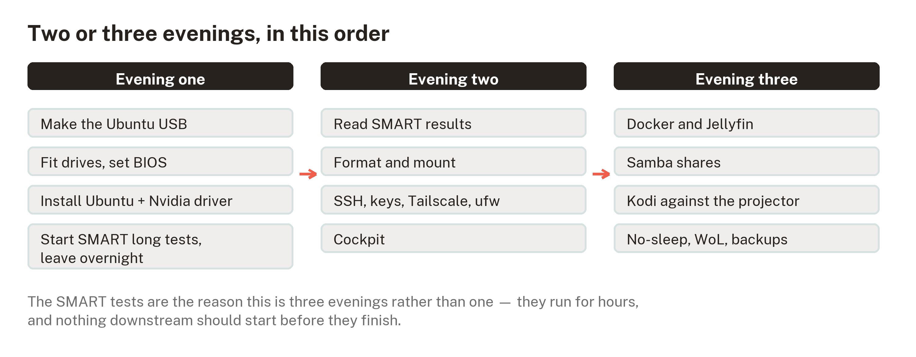
The sequence, and why the drive tests set the pace.
Two or three evenings, paced by one long-running task: the surface tests on the second-hand drives run for hours, and nothing that stores data should begin before they finish. Both drives came from a drawer with unknown history, and a drive that has begun reallocating sectors does not recover.
The same principle applies to the old data on them. One was a Windows system disk whose account passwords were long forgotten — which turns out not to matter, because a Windows account password controls login, not encryption. Absent full-disk encryption, the files are readable from another operating system. Checking that before erasing anything cost half an hour and is the only genuinely irreversible step in the build.

What is not finished
- The drives have not yet passed their surface tests, so nothing has been trusted with data.
- The power supply is from a 2015 line and is the least mitigated risk in the build. Nothing in the plan addresses it, and saying so is more useful than quietly hoping.
- Backups are two copies, one medium, zero offsite. The standard formulation is three, two, one. The gap is known and currently accepted.

Why this is in a research repository
Grounded AI Practice is about building practical capability through responsible, hands-on learning, and about the discipline that makes learning trustworthy — traceable claims, explicit decisions, and a clear line between what is evidenced and what is assumed.
This build is a small test of whether that discipline survives contact with a real task. Several claims in the original draft did not survive checking: an early diagram showed a backup that the actual scheduled job never performed; a widely repeated fact about which storage port a particular component disables turned out to rest on forum posts about a different circuit board, and was replaced with an instruction to read what the machine itself reports; and the assumption that live sport could be made to work with the right software was wrong in a way no amount of configuration would fix.
Each of those was found by checking rather than by failing later. That is the whole argument, demonstrated at small scale.
The procedure this summarises also serves as a structural prototype for the project's planned learning units — orientation before action, one idea per step, a stated way to confirm each step worked, and screenshots of what the learner should actually see, generated from the same data that produces the instructions so the two cannot drift apart.

