 | GROUNDED AI PRACTICE  Research document — draft for review, 11 August 2026

Budget VRAM for local AI: the Intel question

NOTE
Draft status: rough draft, research passes of 2026-08-11 (research_log.md Entries 068–073). Structure and evidence are in place; final prose is the creator's, per the project's outward-facing-documents rule. Every price in this document is a UK listing price retrieved on 2026-08-11 unless stated otherwise, and prices are currently moving fast — see "The market this lands in".
Running a language model on your own machine instead of through a paid API is the most direct route to three things: work that never leaves the building, a cost that stops scaling with usage, and an understanding of what these systems actually are. Whether it is worth doing depends mostly on one number on the hardware side. This document is about that number, and about the unusual position Intel has taken on it.

Why VRAM is the number that matters
A language model has to sit in memory to run at speed. Its size in memory is set by its parameter count and its precision: a 30-billion-parameter model at full precision wants roughly 60 GB, but the standard practice for local use is quantisation — storing the weights at reduced precision, which cuts memory to roughly 4–5 bits per parameter with a modest quality cost. Quantised, that same 30B model fits in about 18–20 GB.
The memory it has to fit into is the graphics card's own memory — VRAM. When a model does not fit, it either fails to load or spills into ordinary system RAM, which typically costs an order of magnitude in speed. So at purchase time, VRAM capacity decides which class of model you can run at all; every other specification only decides how fast.
What the tiers buy, at mid-2026 model sizes:
VRAM | What fits (quantised) | Measured example
12 GB | 7–9B dense models; small mixture-of-experts models | —
16 GB | 12–14B dense; 20B-class mixture-of-experts | —
24 GB | 27–32B dense at 4-bit | Gemma 4 31B at 18.6 tok/s on one card [BENTECH-ARC26]
32 GB | 27–32B at higher precision or longer context | Qwen3 Coder 30B served at scale [SR-B70-26]
48 GB+ (multi-card) | 70B-class dense; 120B-class mixture-of-experts | GPT-OSS 120B on a 4×32GB rig [SR-B70-26]

Two calibration points for the speeds quoted through this document: people read at roughly 5 tokens per second, so anything above ~10 tok/s is comfortable for interactive use; and batch throughput (hundreds or thousands of tokens per second across many simultaneous requests) is a different measurement that only matters when a machine serves many users or a queue of jobs.

TIP
The per-card number matters as much as the total. Mixture-of-experts models split across cards well; large dense models prefer one big pool of memory. Two 24 GB cards are not always worth one 48 GB card, and the software for splitting is where the friction lives.

The market this lands in
GPU prices normally drift downward over a product's life. In 2026 they are doing the opposite. Memory manufacturers have pivoted fab capacity toward the high-bandwidth memory that AI data centres buy, and the knock-on to the ordinary graphics memory in consumer cards has been severe: GDDR6 spot prices roughly tripled between late 2025 and mid-2026, DRAM contract prices rose about 90%, Nvidia has raised GeForce prices three times this year and AMD once, and industry reporting expects the shortage to run into 2028 ([MEMCRISIS26], search-level synthesis).
Two practical consequences. Any price in any document — including this one — is a snapshot, and needs its date attached. And the usual advice to wait for prices to settle currently has no evidence behind it; the published forecasts point the other way.

What Intel is selling
Intel's discrete GPU line began as a gaming product. What it has become is more specific: a workstation line whose selling point is VRAM capacity per pound, aimed squarely at local AI inference.
Card | VRAM | Board power | US list | UK street (2026-08-11)
Arc B580 (consumer) | 12 GB | ~190 W | $249 | £200–290, promotions below £200
Arc Pro B50 | 16 GB | 70 W | $349 | from ~£380 (one listing £310)
Arc Pro B60 | 24 GB | 120–200 W | ~$500–599 | ~£830
Arc Pro B60 Dual (partner boards) | 48 GB | ~400 W | ~$1,200 class | £1,699.99, pre-order (2–4 weeks)
Arc Pro B70 | 32 GB | 160–290 W | $949 | ~£1,290

([GPU-PRICES-UK26], [SR-B70-26]; the B70 launched 2026-03-25 and its US street price exceeded $1,100 within months, which the reviewers attribute to the memory market.)
The strategic signal matters as much as the cards. In April 2026 the technology press reported — from leaks, not from Intel — that the next generation of consumer gaming cards is cancelled, with the architecture redirected to data-centre and workstation parts ([ARC-ROADMAP-PRESS26]). What Intel has confirmed is "Crescent Island": a data-centre GPU that does inference only, carries 160 GB of deliberately cheap memory (LPDDR5X rather than high-bandwidth memory), runs air-cooled, and is pitched by Intel on "performance per dollar" and token economics, sampling late 2026 ([INTEL-CRESCENT26]).
Read together: capacity-per-pound over raw bandwidth is not a niche Arc happens to occupy. It is the bet Intel's GPU division is now built around — at the same time as its consumer gaming line appears to be winding down.

What it measures like
The independent measurements are thinner than for Nvidia hardware — five primary sources this pass, three of them run on vendor-supplied hardware — but they are consistent, and they are not small numbers.
At serving scale: a July 2026 professional review put four B70s (128 GB of VRAM, about $3,800 of GPU at list) in one server and measured Mistral Small 24B at 8,321 tokens per second at batch 32 — which it reports as roughly 65% ahead of an RTX Pro 6000, a single Nvidia card costing about double the four Intel cards together. The same rig reached ~12,000 tok/s on Llama 3.1 8B and 6,870 tok/s on GPT-OSS 120B, and against a consumer RTX 5070 showed up to 85% higher throughput and 6.2x faster time-to-first-token under load ([SR-B70-26]). A second serving test confirms the shape on the cheaper card: four B60s running a 30B-class mixture-of-experts model measured ~1,000 tokens per second aggregate, scaling near-linearly from 16 to 64 simultaneous requests — on stock vLLM built from source as well as Intel's own container, which matters below ([EMBEDDEDLLM-B60-26]).
On one card: a practitioner benchmark measured Gemma 4 31B (4-bit) at 18.6 tok/s and Qwen3.5-27B at 10.1 tok/s on a single B70 ([BENTECH-ARC26]) — three to four times reading speed for models in the class that handles serious drafting, summarisation and extraction work. The 35B-class mixture-of-experts models run quicker still: 37.2 tok/s on a single B60 ([L1T-B60-26], read directly this pass, replacing an earlier search-level figure that had mixed up the two cards) and 54.7 tok/s on a single B70, from a repository that also logged measured load power of 37–186 W depending on the model ([PMZFX-B70-26]).

The comparison, honestly
What the realistic options cost per gigabyte, at the dated prices — the span now runs about £20 to £131:
Option | VRAM | UK price (2026-08-11) | £/GB | Software path
Arc B580, new | 12 GB | ~£245 | ~£20 | llama.cpp (Vulkan/SYCL)
RTX 5070, new | 12 GB | ~£599 | ~£50 | Everything (CUDA)
RX 9060 XT 16GB, new | 16 GB | ~£330 | ~£21 | llama.cpp (Vulkan/ROCm)
Arc Pro B50, new | 16 GB | ~£380 | ~£24 | llama.cpp (Vulkan/SYCL)
RTX 5060 Ti 16GB, new | 16 GB | ~£450 | ~£28 | Everything (CUDA)
Arc Pro B60, new | 24 GB | ~£830 | ~£35 | llama.cpp; vLLM containers
RTX 3090, used | 24 GB | £750–1,129 (trackers conflict) | £31–47 | Everything (CUDA), no warranty
Radeon AI PRO R9700, new | 32 GB | ~£1,250 | ~£39 | llama.cpp; vLLM (ROCm)
Arc Pro B70, new | 32 GB | ~£1,290 | ~£40 | llama.cpp; vLLM containers
RTX 5090, new | 32 GB | ~£4,199 | ~£131 | Everything (CUDA)
Arc Pro B60 Dual, pre-order | 48 GB | ~£1,700 | ~£35 | llama.cpp; vLLM containers

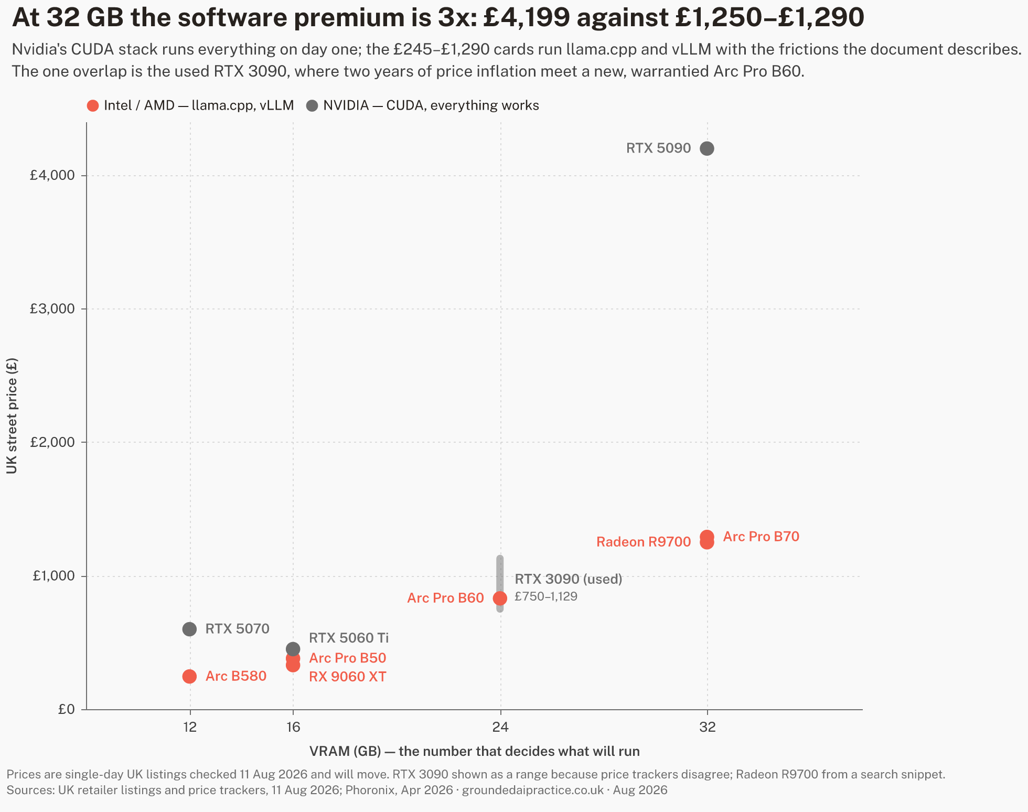
UK street price against VRAM for the realistic options, 11 August 2026 — the pre-order 48 GB board is in the table only. At every capacity the CUDA card costs more; at 32 GB about three times more.
Reading the table rather than just ranking it:
- Per gigabyte, the small cards win — but capability moves in steps, not gradients. 12 GB and 24 GB are different classes of machine, and the premium above ~£25/GB is buying one contiguous pool, which is what large dense models want.
- The B60's UK position is weaker than its design. At the US street price (~$599–658) it works out near £23/GB landed; at the current UK £830 it loses most of its price advantage over the used 24 GB Nvidia route. The card's case in the UK rises and falls with that premium.
- The used RTX 3090 — the standard budget answer to "24 GB" since 2023 — has roughly doubled in listed price in a year, to somewhere between £750 and £1,129 depending on the tracker (both listing-based; neither publishes sold prices). A new, warrantied B60 at £830 now overlaps it. That overlap did not exist when this project first logged the local-AI cost question (Entry 030).
- Nvidia's premium is not for the silicon; it is for CUDA — every tool, every new model, every tutorial works there first, usually on day one. But it is not one number: roughly £100 at 16 GB, 2.4x at 12 GB, and 3.3x at 32 GB, where the only new CUDA card carrying that much memory is a £4,199 gaming flagship that launched at £1,919. Whether the premium is worth paying depends on who is operating the machine — and on which tier they are buying at.
- The open stack is not only Intel's. AMD's Radeon AI PRO R9700 puts 32 GB at ~£1,250 — marginally under the B70 — and the one cross-vendor review to measure both judged the AMD card the better value at US prices, noting Intel's vLLM upstream support still trails AMD's ROCm ([PHORONIX-ARCPRO26]). At this tier the realistic comparison is two open-stack cards against one £4,199 CUDA card, not Intel against the field.
- The 48 GB single-slot answer exists but is not yet ordinary retail: the dual-GPU B60 board lists at £1,699.99 in the UK on pre-order — the same ~£35/GB as the single B60, for double the pool. The used CUDA route to 48 GB, the RTX A6000, tracks at ~$3,650 in the US used market and was the one falling price found in this entire pass ([GPU-PRICES-UK26]).
- Apple's unified-memory machines are the other genuine route to large local models and are deliberately out of scope of a GPU table; they price a whole computer, not a component. Worth a separate pass if the buyer does not already own the PC.

Where the software actually is
This is the section that decides whether the hardware prices above are real for a given buyer.
The polished experience is CUDA-only. On Arc, what exists in mid-2026:
- llama.cpp works on Arc today through two back-ends: Vulkan (universal, slower) and SYCL (Intel-optimised, roughly 2x faster on dense models when it works). "When it works" is doing real work in that sentence: the practitioner benchmark found a SYCL bug on one new model architecture where the second response answered the first question, and dropped to Vulkan for it ([BENTECH-ARC26]). The pace cuts both ways: one forum rig measured a 45% generation gain on the same card between the March and April SYCL builds ([L1T-B60-26]), while the April cross-vendor review still found GPT-OSS 20B underperforming on Intel under llama.cpp ([PHORONIX-ARCPRO26]).
- Intel archived its consumer path in January 2026. IPEX-LLM — the official route to Ollama and llama.cpp on Arc, the one most setup guides still lead with — is now read-only, with Intel stating it "will not provide or guarantee development of or support for this project" ([IPEXLLM-GH26]). Ollama itself has no native Arc support as of July 2026.
- The supported path is enterprise-shaped. Intel's active investment is LLM Scaler: a containerised vLLM distribution for Linux, aimed at multi-GPU workstations. It produced the serving numbers above and is updated regularly — and the same review that measured those numbers calls it "still a beta release at best", with limited model coverage ([SR-B70-26]). A measured alternative now exists: stock upstream vLLM, built from source, ran the same 4×B60 rig — Intel's container ~20–25% faster per output token, stock vLLM roughly half the time-to-first-token ([EMBEDDEDLLM-B60-26]) — though Intel's upstream position in vLLM still trails AMD's and Nvidia's ([PHORONIX-ARCPRO26]), and the upstream-support story is itself Intel-authored: the vLLM project's Arc post is written by the "Intel vLLM Team" ([VLLM-ARC25]). What operating the stack looks like in practice, from the one practitioner write-up to document the whole path: a kernel floor of 6.12+, a manual firmware step where the shipped and wanted GuC versions disagree, ~54 GiB of system RAM consumed by one quantisation conversion, and a backend split the operator must know (Vulkan for hybrid models, SYCL for dense) — summarised by its author as "maturing fast but not mature" ([BENTECH-ARC26]).

WARNING
The pattern across those three facts: Intel is supporting the deployment where a technical operator runs containers on Linux, and has withdrawn from the deployment where an individual installs an app. A buyer without that operator — and in a small organisation that is usually everyone — is depending on community software, on hardware whose vendor just demonstrated it will cut consumer tooling.
For day-one support of newly released models, quantisation tooling and fine-tuning, CUDA remains months ahead as a matter of routine; nothing found this pass suggests otherwise.

The break-even against just paying for the API
Cheap VRAM only matters if running locally beats renting intelligence by the token. The current API floor, from the vendor's own price list ([ANTHROPIC-PRICING26], 2026-08-11): the cheapest current Claude model costs $1 per million input tokens and $5 per million output tokens — half that in batch — and Anthropic's own worked example prices 10,000 support conversations at roughly $37.
Set the £830 B60 against that example: about two years of a 10,000-conversation-per-month workload, before counting electricity, the machine around the card, or anyone's time. This project logged the same shape of conclusion from weaker sources in July (Entries 030, 042): below a high usage threshold, the API route stays cheaper, and hybrid — local where volume, privacy or control demand it, API where capability does — is the practical answer.
What moves the arithmetic toward the box:
- Volume an order of magnitude higher — continuous classification/extraction pipelines, always-on agents, anything that runs all day rather than on demand.
- Work that cannot leave the building — where the comparison is not against $37 but against not doing the work at all, or doing it by hand.
- Predictability — a fixed cost an SME can capitalise, against a metered cost that scales with success.
- Learning value — the project's Priority 6 question. A local machine teaches what a metered API hides; that value is real but belongs in a different column from cost.

CHECK
The capability gap still applies. The best open-weight models lag the frontier by around four months on independent measurement (Entry 042, Epoch AI), with the gap widest on complex multi-step work. A workload has to be adequately served by a 27–32B-class local model for any of the above to matter — and that adequacy is task-specific and untested here.

The roadmap risk
A buyer in August 2026 is making a three-part bet: that the card keeps being driven (Arc Pro is current and extending — B70 arrived in March), that the software keeps improving (active, but "beta at best", and the consumer tier was just cut), and that the platform exists in three years (Intel's GPU division is now explicitly an inference-economics business with $18bn of fresh backing, including Nvidia's — and its consumer future is reported, not confirmed, to be ending; re-checked 2026-08-11, still no Intel statement either way). None of those three legs is settled the way CUDA is settled. The discount is not free money; it is payment for carrying that uncertainty.

What this document does not count
Stating the uncounted, per the project's bias checklist:
- People's time. Setup, maintenance and debugging on the less-trodden path — usually the largest real cost for a small organisation, and the one this document can least generalise.
- Electricity at idle. Load power is now measured at three points — 59 W average on a B50 across mixed workstation loads ([PHORONIX-ARCPRO26]), 153 W on a B60 and 231 W on a B70 under vLLM generation ([BENTECH-ARC26]), with 37–186 W by model under llama.cpp ([PMZFX-B70-26]) — but no idle figure was found anywhere, and the current Linux driver does not expose GPU power in software, so settling idle takes a wall meter on real hardware (flagged in Open Threads).
- Model churn. Local model files need replacing as the state of the art moves; the API route absorbs that invisibly.
- Sold prices. Every used-market figure here is a listing price; the two trackers conflict by ~£380 and neither publishes completed sales.
- Benchmark breadth. Seven primary sources now, every surfaced lead read — but three ran on vendor-supplied hardware, one is vendor-authored (the vLLM post), one declares a PCIe bottleneck, and two are individual rigs with published but unverified methodology. Independent replication on a rig nobody supplied remains the hands-on unit's job.
- Resale and warranty claims practice for a workstation line this young.

What would settle it
Desk research ends where this question actually gets decided. The step that would convert this document from assessment to evidence is small and concrete:
- One card — the £245 B580 to test the floor, or the £830 B60 to test the claim that matters — in the project's existing server.
- The two software paths as an ordinary technical user would find them: llama.cpp with Vulkan and SYCL, then the containerised vLLM route.
- A fixed task set shaped like SME work: batch classification, document extraction, long-document summarisation, retrieval-answering over a real folder.
- Three numbers per task — tokens per second, watts at the wall, minutes of human intervention — and a written record of everything that failed on the way.
Published with the failures left in, that is a document nobody else in the UK appears to be producing, and it is the project's method applied to its own subject matter.

Sources
Research basis: research_log.md Entries 068–073, 2026-08-11, and the source key rows they added — primary reads [SR-B70-26], [BENTECH-ARC26], [IPEXLLM-GH26], [ANTHROPIC-PRICING26], [EMBEDDEDLLM-B60-26], [PHORONIX-ARCPRO26], [L1T-B60-26], [PMZFX-B70-26], [VLLM-ARC25]; price snapshots [GPU-PRICES-UK26]; synthesis-level [MEMCRISIS26], [ARC-ROADMAP-PRESS26], [ARC-STACK-GUIDES26]; Intel-confirmed strategy [INTEL-CRESCENT26]. Every surfaced lead in this thread has been read. Earlier evidence relied on: Entries 030 and 042 (local-vs-cloud break-even and capability gap).

