 | GROUNDED AI PRACTICE

The pilot AI workstation
Proving the product on the desktop

NOTE
Draft status: rough draft, written 2026-08-13 on the laptop, before any software has been installed on the target machine. Every stack fact below is verified against vendor documentation and says so, with the date it was read. Steps are marked planned until they have been run on the desktop, and only then promoted to instruction, per the project's verify-before-teaching rule. Final wording is the creator's. Revised 2026-08-14 on the desktop itself: the hardware table now carries what the machine reports rather than what was remembered, and the Arc card's host is decided (project_log.md Entry 083). The software steps remain unrun.

What this pilot is for
The project now has a working product hypothesis, recorded in project_log.md Entry 080: an AI workstation installed on a small organisation's own premises, running models locally or in a local-plus-API hybrid, carrying workflows built for that organisation's actual work, with enough onboard guidance to teach its own proper use.
The last clause is the point of the whole thing. The machine carries a tutor layer: its own front-end, holding guidance on proper use, built eventually on self-populated user profiles. This is where real practical AI skills can be developed: the user learns by logging onto the workstation and asking questions. It makes people self-sufficient, able to improve and refine their own understanding and workflows independently, and nothing else found so far bundles it with the hardware. One small, custom deployed AI workstation could act as a realistic, grass-roots alternative to training that is currently centred around medium/large organizations and cloud computing.
Before that idea is put in front of anyone, it has to run. The project's existing desktop PC is the testbed, and the pilot answers three questions in order:
- Does hardware the project already owns serve a useful model at a usable speed? (Phase 1)
- Does the deployment shape work: the same thing, but as Linux containers that could be stood up on a customer's machine rather than hand-installed apps? (Phase 2)
- Is the capability adequate for the work a small organisation would actually give it? (Phase 3)
What phases 1–3 deliberately do not answer: the Intel question. The desktop currently carries an AMD card, so those phases exercise the AMD half of the open stack (ROCm and Vulkan). The Arc Pro line's own software story — SYCL, OMIX, the archived IPEX-LLM, LLM Scaler — can only be tested on an Arc card. That purchase is now made (project_log.md Entry 081) and the card goes in this same machine (Entry 083), which is why the AMD phases are sequenced first: the two cards share one usable slot. See "Where the Arc card goes" at the end.
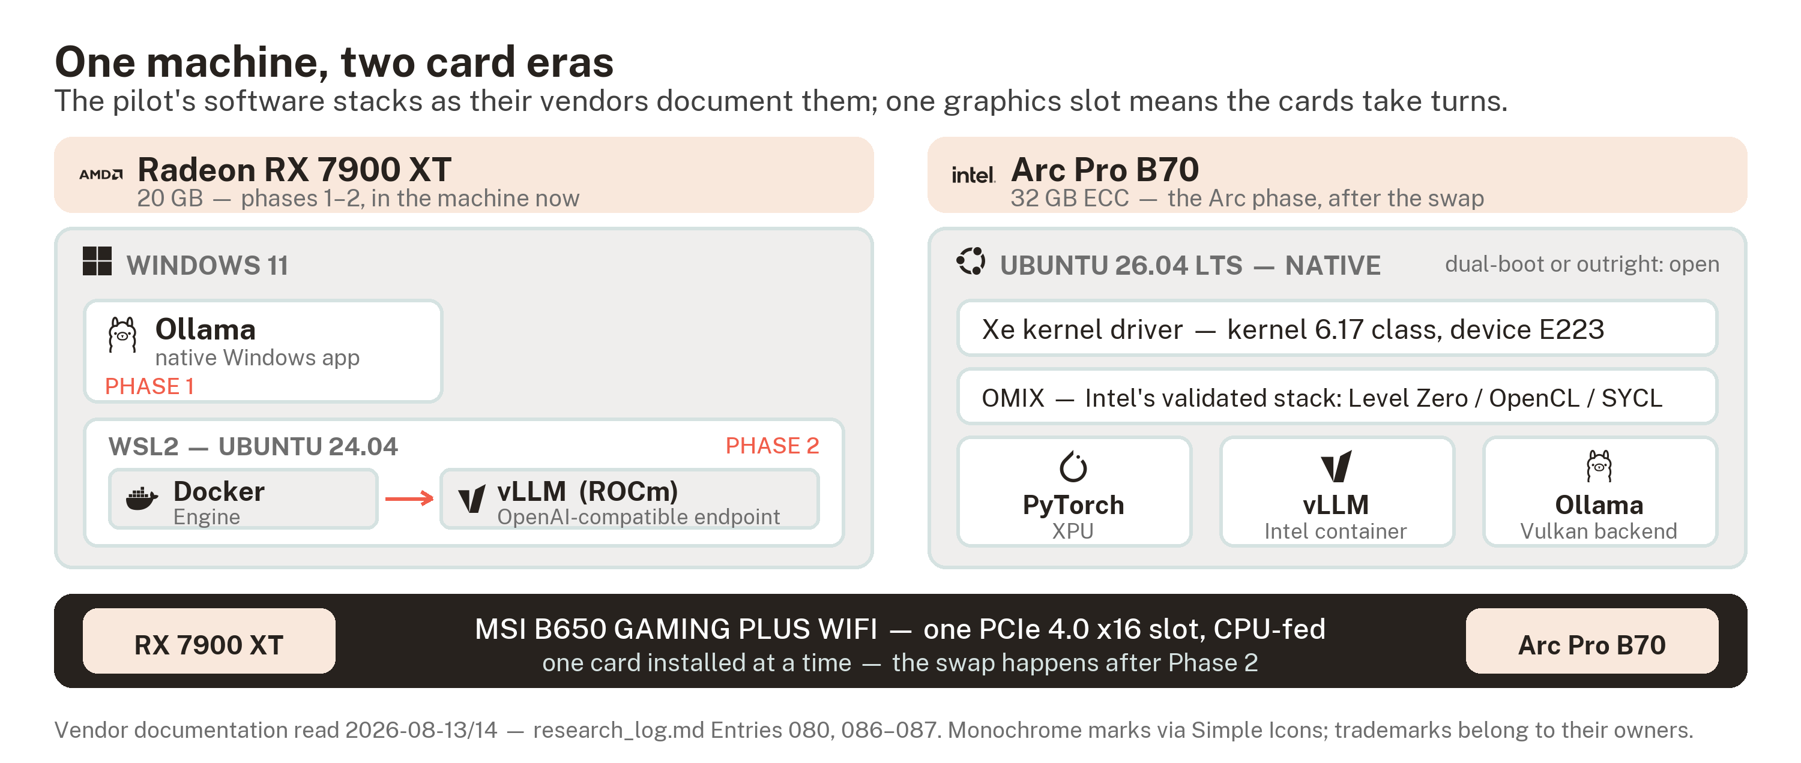
One machine, two card eras: the AMD phases run on Windows and WSL2, the Arc phase on native Linux, and the two cards share one PCIe 4.0 x16 slot — swap, not stack.

The machine
Part | Spec | What it means for the pilot
CPU | Ryzen 7 7800X3D (8 cores) | More than enough to feed one GPU. AM5, so Resizable BAR is available — which is the Arc cards' actual platform requirement.
RAM | 32 GB | Fine for running models. Not enough for converting them: one logged quantisation conversion consumed ~54 GiB of system RAM ([BENTECH-ARC26], via the VRAM document). Download pre-quantised files instead of converting locally.
Motherboard | MSI B650 GAMING PLUS WIFI (MS-7E26) | One graphics-usable slot. PCI_E1 runs PCIe 4.0 x16 from the CPU; PCI_E2 is Gen3 x1 from the chipset, which is not a graphics slot in any useful sense. Two GPUs therefore take turns rather than coexisting. Slot layout is from published specification, not yet confirmed by hand — MSI's site blocks automated reading.
GPU | Radeon RX 7900 XT, 20 GB VRAM | The number that decides everything else. See below. Confirmed negotiating Gen4 x16, which is this card's own ceiling.
PSU | Corsair RM1000x (2021), 1000 W, 80+ Gold, fully modular | Recorded 2026-08-14 from the unit. Ample headroom for either card — and the one-slot board means the ~315 W Radeon and the 230 W-TBP B70 never draw together. The swap-risk check from the first draft is closed.
Cooling | High efficiency air-cooled | Generation is a sustained load, not a burst; thermals get noted during measurement, not assumed.

20 GB sits between the two tiers the VRAM document prices and compares. Against its capacity table: the 16 GB class (12–14B dense models, 20B-class mixture-of-experts) fits with room to spare. The 24 GB class (27–32B dense at 4-bit) is potentially less viable; the largest of those will not leave enough free VRAM for a long context. The comfortable target class for this card is roughly 20–30B mixture-of-experts and up to ~24B dense at 4-bit, keeping 2–3 GB free for context.

TIP
Model names move fast, so this unit names classes and lets the operator pick current releases at install time. The models the project has already benchmarked from published sources — Mistral Small 24B, the 30–35B-A3B mixture-of-experts family — mark the classes worth starting with. A 24B dense pick has a bonus: it is the model the [SR-B70-26] review measured on Arc hardware, which keeps a like-for-like thread open if an Arc card arrives later.

Phase 1 — first tokens, native Windows
Goal: the GPU serving a current ~20–30B-class model on Windows, confirmed to be running on the GPU and not silently on the CPU, with first measurements recorded.
Verified against documentation (2026-08-13):
- Ollama's GPU documentation lists the Radeon RX 7900 XT as supported on Windows. They state the requirement as an AMD ROCm v7 / HIP7-capable driver stack. This just means the current Adrenalin driver, not a separate ROCm SDK install.
- Ollama also carries a Vulkan backend with its own controls. OLLAMA_VULKAN=0 disables it and GGML_VK_VISIBLE_DEVICES selects devices. Two backends on one card is the same shape as the Arc document's Vulkan/SYCL split, and worth remembering when a result looks odd: which backend served it is part of the result.
- AMD's own Windows compatibility matrix (ROCm 6.4.4 page) lists the 7900 series on Windows 11 and adds the honest caveat that the entire ROCm stack is not yet supported on Windows. That caveat is about the full SDK; it does not block Ollama's driver-level route.
Planned steps (run on the desktop; each one says what it does):
- Update the GPU driver first. AMD Adrenalin, current WHQL release. This is Ollama's stated dependency for AMD on Windows, and driver age is the first suspect in any backend failure.
- Check disk space before pulling models. Quantised files in the target class run 12–20 GB each, and a testing session accumulates several.
- Install Ollama for Windows from ollama.com. The installer adds a background service, the ollama command, and a tray app. No account, no telemetry decisions beyond the installer's own prompts — read them rather than clicking through.
- Pull one model sized to the card. Check the file size on the model page before pulling: it should sit well under 20 GB. One ~24B dense at 4-bit, one ~30B-A3B mixture-of-experts; nothing else until both are measured.
- First run with statistics on: ollama run <model> --verbose. The stats block after each reply is the phase's whole point — read it, don't skim it:
- prompt eval rate is how fast the model reads the input (tokens/second on the prompt);
- eval rate is how fast it writes — the number that decides whether it feels usable. Calibration from the VRAM document: people read at roughly 5 tokens/second, so above ~10 the machine is comfortably ahead of the reader.
- Confirm the GPU is doing the work. ollama ps shows how much of the loaded model sits on GPU versus CPU — the pass mark is 100% GPU. Cross-check in Task Manager → Performance → GPU: dedicated memory should jump by roughly the model file's size when it loads.
- Know what failure looks like before it happens. Single-digit eval rate, busy CPU, flat VRAM: that is CPU fallback, not a slow GPU. Check, in order: driver version against Ollama's requirement; whether the model file exceeded free VRAM (spill); the server log, which names the backend it loaded and the devices it found.

TIP
LM Studio is the no-terminal route to the same card, with ROCm and Vulkan runtimes on Windows, and it matters to this project for exactly that reason: it is the shape of tool a learner without a terminal habit would actually use, which is the audience the product serves. Its current 7900-series support is not yet verified by this unit — check its documentation at install time if this route is taken. Phase 1 measurements use Ollama either way, for comparability.

The measurement protocol
Every published number the VRAM document rests on was measured on someone else's rig — three of its five benchmark sources ran on vendor-supplied hardware. These are the project's first own-hardware measurements, so they are worth doing in a form that can be logged and repeated.
The fixed prompt set. Three prompts, shaped like the work the product claims, identical on every run and on every future card:
- Drafting: "Write a 150-word notice to customers announcing a two-day delay to all orders placed last week. Plain English, apologetic once, no excuses, no exclamation marks."
- Summarisation: "Summarise the following document in five bullet points for a manager who has not read it." — followed by a fixed test document chosen once and kept with the results (a public, ~2,000-word text; record its word count). The same document every run, or the numbers stop being comparable.
- Extraction: "Turn the following into a table with columns Name, Item, Quantity, Date." — followed by this fixed block:
jones - 3 boxes A4 paper, weds
Mrs Patel ordered two toner carts 14/8
K. O'Neill: 1x desk lamp + 2 x HDMI cable, monday
accounts (S Hughes) want 5 notepads and a stapler 15 aug
D Kowalski — six AA batteries, no date given

What to record per run, one row per run in a results table kept beside this file once measurement starts:
Field | Why
Date, driver version, Ollama version | Results move with software; undated numbers are the trap the VRAM document warns about.
Model, quantisation tag, context length | The three settings that change the result most.
Prompt eval rate / eval rate | The two speeds, kept separate to avoid conflation.
VRAM used (Task Manager) | Confirms placement and shows context headroom.
Notes | Thermals, noise, anything odd. By ear is fine at this stage.

Three runs per prompt; report the middle eval rate, which resists the odd stall better than an average.

WARNING
Published serving benchmarks are a different measurement. The [SR-B70-26] figures the VRAM document quotes are batch-32 serving throughput — many simultaneous requests. Single-stream numbers from this protocol will be far lower and are not comparable. Comparing across that line is the same three-tier confusion the project flagged as a teaching case in project_log.md Entry 078.

Phase 2 — the deployment shape (WSL2, Docker, vLLM)
Goal: the same card serving an OpenAI-compatible endpoint from a Linux container, with a web front-end in a second container — the form a deployed workstation would actually take, administered without touching the model runtime.

WARNING
This phase is the AMD card's route only. WSL2 works here because AMD's compatibility matrix supports the 7900 XT under it. No vendor documentation places a B-series Arc card under WSL2 — PyTorch's validated client-GPU list names Windows 11 and Ubuntu, and Intel's IPEX documentation explicitly excludes B-series from WSL2 (research_log.md Entry 087). The Arc half of this phase runs on native Linux instead; see the closing section.
Verified against documentation (2026-08-13):
- AMD's WSL compatibility matrix (ROCm 7.2.1) lists the Radeon RX 7900 XT as supported under WSL2, on Ubuntu 24.04 or 22.04, with PyTorch, ONNX and TensorFlow at official production support.
- vLLM supports the 7900 series' architecture (gfx1100) upstream, added without flash-attention — so some engine features are gated on this card class, and that is expected rather than a fault.
- Not yet verified: which current vLLM release/container actually serves gfx1100 out of the box, and whether the ROCm-under-WSL2 path runs vLLM specifically — AMD's matrix names the three frameworks above and stops. These two facts get settled against vLLM's own AMD installation documentation, on the machine, before this phase's steps are written up as instruction.
Planned steps (outline only, for the reason above):
- wsl --install — installs WSL2 and a default Ubuntu, needs virtualisation enabled in BIOS and one reboot.
- Cap WSL2's memory in .wslconfig (around 16 GB of the 32): WSL2 grows to take most of the host's RAM otherwise, and the host still needs to function.
- GPU access per AMD's WSL page: the Windows driver carries the GPU path into WSL; inside the distribution only user-space ROCm is added. No kernel driver gets installed in Linux, which surprises people who have done this on bare metal.
- Docker Engine inside the distribution, not Docker Desktop — closer to the deployment shape, and Docker Desktop carries per-seat licensing above a size threshold that a customer organisation would have to check; Engine does not.
- vLLM's ROCm route per its own docs; smoke-test the endpoint with a one-line request before any front-end; then a web UI container (Open WebUI class) pointed at the endpoint.

Phase 3 — the task set and the tutor layer (design only)
Not specified until phases 1–2 produce numbers. The shape, from the VRAM document's closing sketch and the product hypothesis:
- A fixed task set, run entirely locally and scored for adequacy against the late-2024-class capability ceiling the project logged for single-card models (research_log.md Entry 079). Two candidates, at different stages of maturity:
- Candidate one, ordinary SME work: batch classification, extraction, drafting against a house style. This is the one the measurement protocol above already fits.
- Candidate two, medical RAG workflows: what this means in practice is currently undecided.
- The tutor layer, whose purpose is stated in "What this pilot is for" above. What Phase 3 has to establish is narrower than the vision: whether guidance delivered at the moment of use, on a machine of this class, actually teaches anyone anything. It stays a sketch until the serving layer under it exists.

Where the Arc card goes
Phases 1–3 prove the product shape on hardware the project already owns, for nothing, and they exercise the AMD half of the open stack. The Intel stack — the VRAM document's central open question — needs Intel hardware, and that card is now decided: the Arc Pro B70, 32 GB, ~£1,290 at the 2026-08-11 price snapshot, chosen over the cheaper B580 and B60 because 32 GB is the tier the project's own findings converge on (project_log.md Entry 081).
It goes in this same desktop (project_log.md Entry 083), reusing the build above rather than the always-on server. The measurement protocol runs on it unchanged, which is what the protocol was built for, and the comparison the project has so far only read about becomes one it has measured. Buying the card settles nothing on its own; the numbers still have to be produced.

What the host decides, and what it does not
Three things were checked before this was written, because each was a plausible reason to spend money or change plan (research_log.md Entry 087):
- An Intel motherboard and CPU are not required. Resizable BAR is the cards' actual platform requirement, an AM5 Ryzen 7000 system provides it, and Intel's own documentation allows for non-Intel platforms with ReBAR or Smart Access Memory enabled. What a board change would buy is slot topology, not compatibility.
- The two cards take turns. One graphics-usable slot means the 7900 XT comes out when the B70 goes in. This sequences the work rather than changing it: finish phases 1–2 on the Radeon, then swap. It also rules out the two-card configurations discussed elsewhere — a board limit, not a vendor one.
- WSL2 is not a documented path for this card. Which makes the operating system, rather than the machine, the remaining open question.

The three OS routes
Two requirements converge here. Phase 2 needs native Linux for the Arc card, on the evidence above; the shared environment agreed with the external correspondent independently assumes Ubuntu 26.04. The route that satisfies the project's own next step is the one that keeps the two environments comparable. The three options, against that:
Route | What it gets | What it costs
Native Windows 11 | Validated PyTorch XPU; Ollama's Vulkan backend. Enough for Phase 1 numbers. | No OMIX, no Intel-validated containers, no Phase 2 deployment shape. Diverges from the shared environment agreed with the external correspondent, so results stop being comparable.
Dual-boot Ubuntu 26.04 | Everything: OMIX, the B70-validated containers, the full verification path, and an environment matching the collaboration. | A reboot between the AMD and Intel halves of the pilot.
Ubuntu outright | The same, without the reboot. | The desktop stops being a Windows desktop.

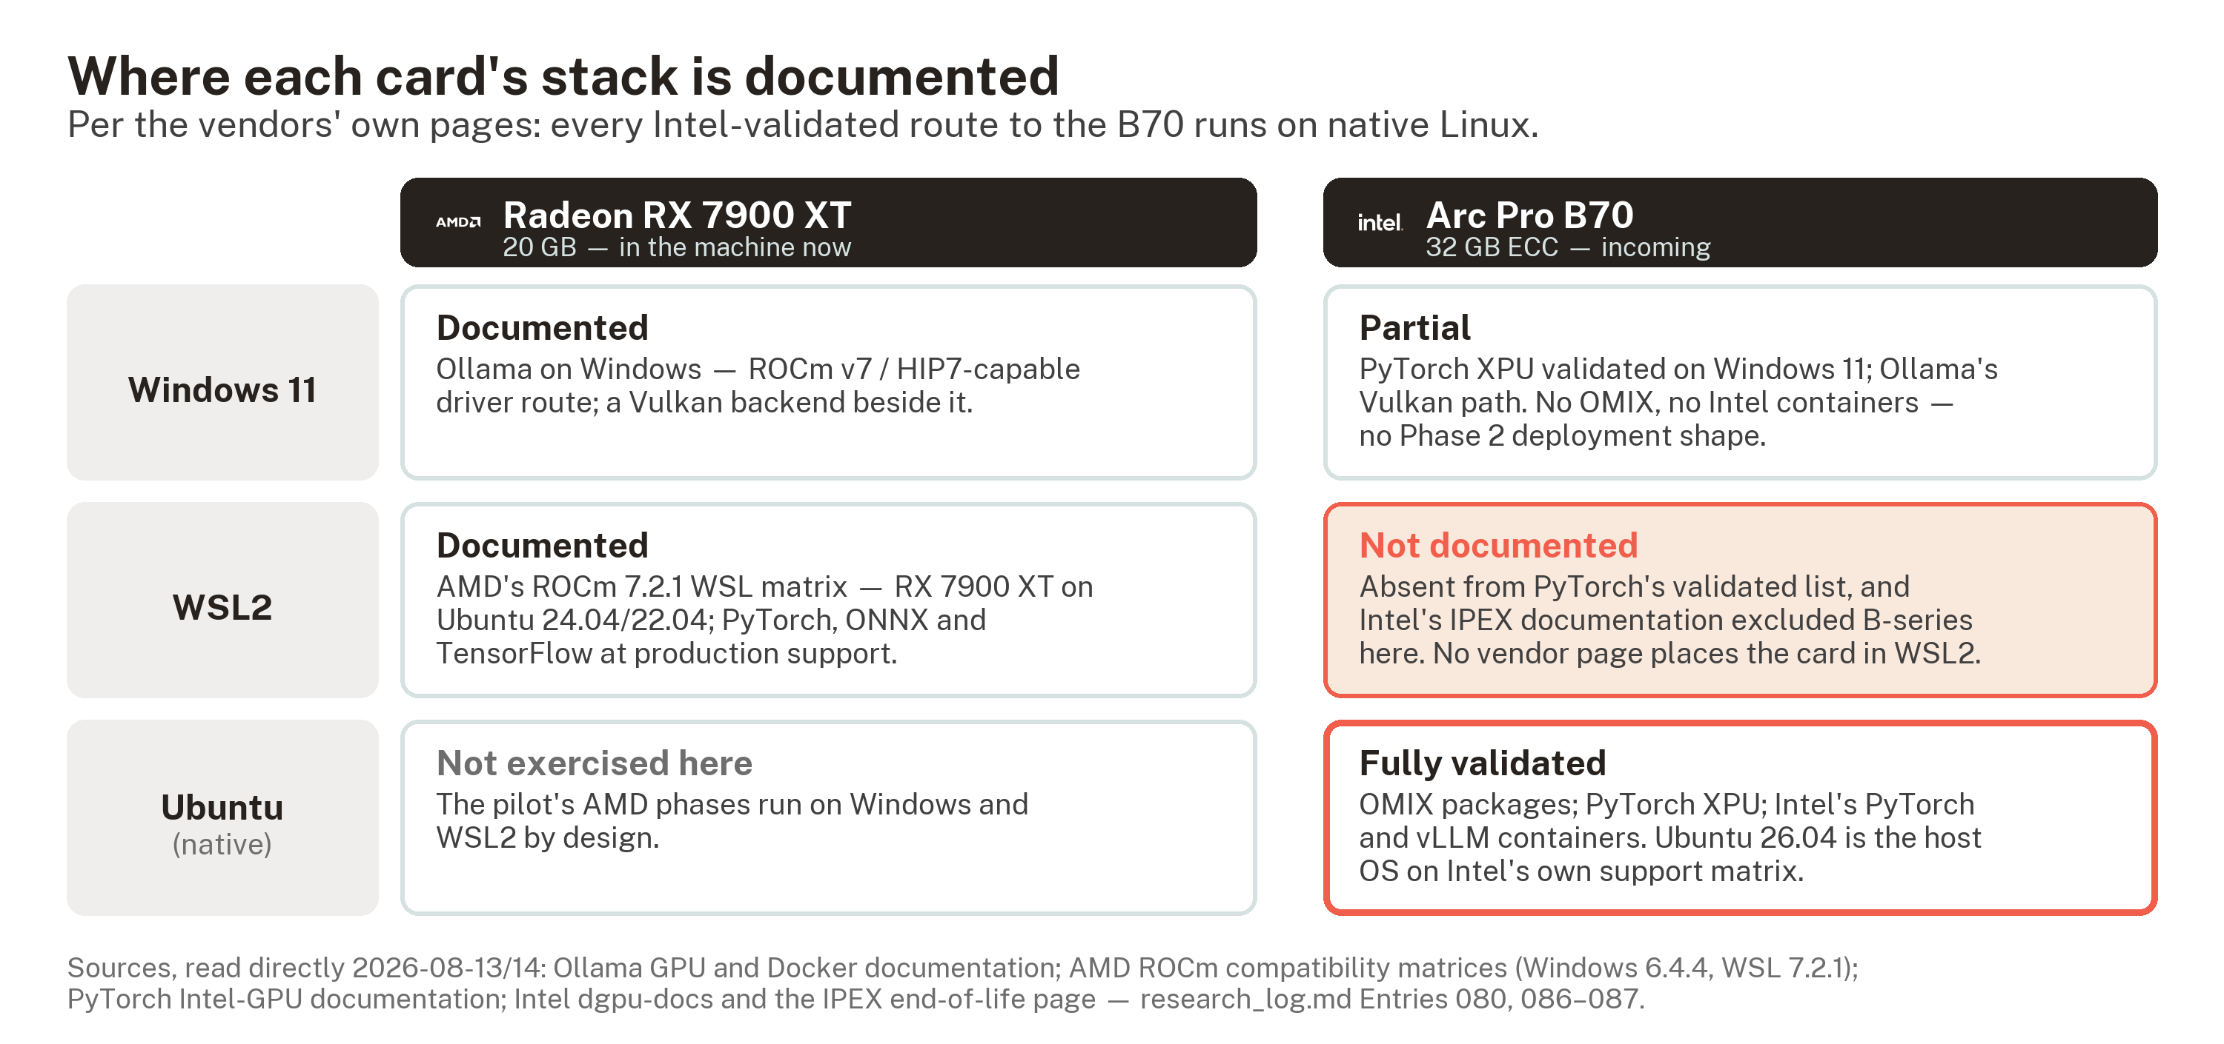
Where each card's stack is documented, per the vendors' own pages: every Intel-validated route to the B70 runs on native Linux — the OS the shared environment agreement already assumes.
Not decided.

Before the card arrives
Two checks remain, neither needing the card in hand:
- MSI's slot specification, read by hand. Their site blocks automated reading, so PCI_E2 and PCI_E3 are published-spec only.
- ReBAR and Above 4G Decoding confirmed in BIOS — enabled, not assumed.
The third from the first draft is closed: the PSU is a Corsair RM1000x (2021), 1000 W, 80+ Gold — read off the unit 2026-08-14, and not a constraint on any configuration this board allows.
Then the bring-up order, which the Intel documentation and the correspondent's checkpoint document agree on: confirm the board and its power requirement, confirm OS and a kernel 6.17-class Xe driver, verify the card enumerates (device E223) and binds, verify it through Level Zero and OpenCL, then prove real tensor work under torch.xpu — before any model is loaded and any number is believed.

Sources
Read directly 2026-08-13, official documentation only; the SEO-blog guides that surface on these search terms were used as leads and carry no claim in this unit:
- Ollama GPU documentation (docs.ollama.com/gpu) — RX 7900 XT on Windows; ROCm v7/HIP7 driver requirement; Vulkan controls.
- AMD ROCm compatibility matrix, Windows, ROCm 6.4.4 (rocm.docs.amd.com) — 7900 series on Windows 11; full-stack caveat.
- AMD ROCm compatibility matrix, WSL, ROCm 7.2.1 (rocm.docs.amd.com) — RX 7900 XT under WSL2; Ubuntu 24.04/22.04; framework support.
- vLLM upstream gfx1100 support (vllm-project PR #2768) — read at search level; confirm against current vLLM AMD docs at phase 2.
Read directly 2026-08-14, for the Arc host section (research_log.md Entries 086–087): PyTorch's Intel-GPU getting-started page (validated client OS list); Intel's dgpu-docs (OMIX install guide and support matrix, Xe driver table) and IPEX end-of-life page; Ollama's GPU and Docker pages; and the machine itself, read via CIM and PnP device properties. The figures carry these facts; their brand marks are identification, not endorsement.
Findings from running this unit land in research_log.md as normal dated entries; this file is procedure, not findings.

