Codebook for df_tidy

Autogenerated data summary from dataMaid

2018-11-14 14:02:33

# Data report overview

The dataset examined has the following dimensions:

|  |  |
| --- | --- |
| Feature | Result |
| Number of observations | 44 |
| Number of variables | 21 |

# Codebook summary table

|  |  |  |  |  |  |
| --- | --- | --- | --- | --- | --- |
| Label | Variable | Class | # unique values | Missing | Description |
|  | **age** | numeric | 14 | 0.00 % |  |
|  | **education_level** | numeric | 3 | 0.00 % |  |
|  | **nationality** | numeric | 2 | 0.00 % |  |
|  | **postpartum_depression** | numeric | 2 | 0.00 % |  |
|  | **employed** | numeric | 2 | 0.00 % |  |
|  | **occupation** | numeric | 8 | 0.00 % |  |
|  | **sport** | numeric | 2 | 0.00 % |  |
|  | **pet** | numeric | 2 | 0.00 % |  |
|  | **dyed_hair** | numeric | 2 | 0.00 % |  |
|  | **first_pregnancy** | numeric | 2 | 0.00 % |  |
|  | **wanted_pregnancy** | numeric | 2 | 0.00 % |  |
|  | **pregnancy_method** | numeric | 2 | 0.00 % |  |
|  | **previous_miscarriage** | numeric | 2 | 0.00 % |  |
|  | **fetus_sex** | integer | 2 | 0.00 % |  |
|  | **epds** | numeric | 16 | 0.00 % |  |
|  | **depression_tri1** | numeric | 31 | 0.00 % |  |
|  | **depression_tri2** | numeric | 26 | 0.00 % |  |
|  | **depression_tri3** | numeric | 24 | 0.00 % |  |
|  | **cortisol_tri1** | numeric | 40 | 0.00 % |  |
|  | **cortisol_tri2** | numeric | 43 | 0.00 % |  |
|  | **cortisol_tri3** | numeric | 44 | 0.00 % |  |

# Variable list

## age

|  |  |
| --- | --- |
| Feature | Result |
| Variable type | numeric |
| Number of missing obs. | 0 (0 %) |
| Number of unique values | 14 |
| Median | 32 |
| 1st and 3rd quartiles | 30; 36 |
| Min. and max. | 24; 39 |

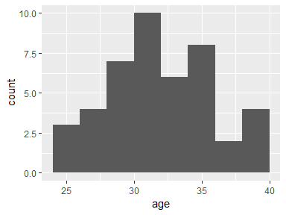

## education_level

|  |  |
| --- | --- |
| Feature | Result |
| Variable type | numeric |
| Number of missing obs. | 0 (0 %) |
| Number of unique values | 3 |
| Median | 3 |
| 1st and 3rd quartiles | 3; 3 |
| Min. and max. | 1; 3 |

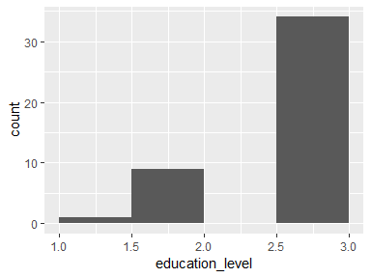

## nationality

|  |  |
| --- | --- |
| Feature | Result |
| Variable type | numeric |
| Number of missing obs. | 0 (0 %) |
| Number of unique values | 2 |
| Median | 1 |
| 1st and 3rd quartiles | 1; 1 |
| Min. and max. | 0; 1 |

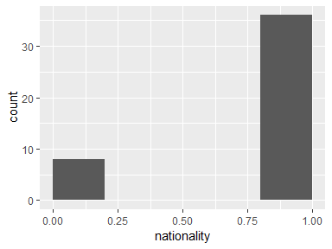

## postpartum_depression

|  |  |
| --- | --- |
| Feature | Result |
| Variable type | numeric |
| Number of missing obs. | 0 (0 %) |
| Number of unique values | 2 |
| Median | 1 |
| 1st and 3rd quartiles | 1; 2 |
| Min. and max. | 1; 2 |

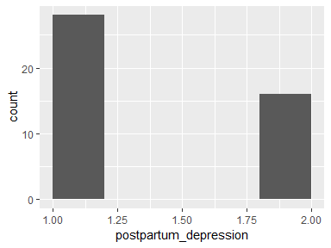

## employed

|  |  |
| --- | --- |
| Feature | Result |
| Variable type | numeric |
| Number of missing obs. | 0 (0 %) |
| Number of unique values | 2 |
| Median | 1 |
| 1st and 3rd quartiles | 1; 1 |
| Min. and max. | 0; 1 |

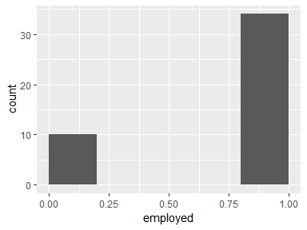

## occupation

|  |  |
| --- | --- |
| Feature | Result |
| Variable type | numeric |
| Number of missing obs. | 0 (0 %) |
| Number of unique values | 8 |
| Median | 4 |
| 1st and 3rd quartiles | 1.75; 6.25 |
| Min. and max. | 1; 12 |

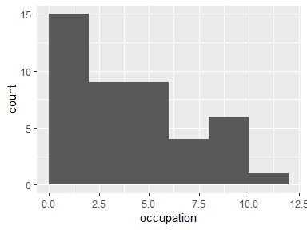

## sport

|  |  |
| --- | --- |
| Feature | Result |
| Variable type | numeric |
| Number of missing obs. | 0 (0 %) |
| Number of unique values | 2 |
| Median | 1 |
| 1st and 3rd quartiles | 0; 1 |
| Min. and max. | 0; 1 |

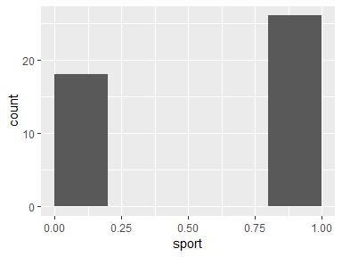

## pet

|  |  |
| --- | --- |
| Feature | Result |
| Variable type | numeric |
| Number of missing obs. | 0 (0 %) |
| Number of unique values | 2 |
| Median | 0 |
| 1st and 3rd quartiles | 0; 1 |
| Min. and max. | 0; 1 |

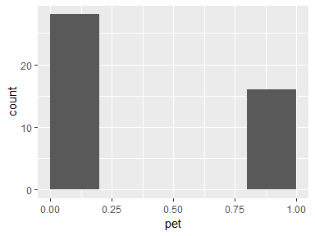

## dyed_hair

|  |  |
| --- | --- |
| Feature | Result |
| Variable type | numeric |
| Number of missing obs. | 0 (0 %) |
| Number of unique values | 2 |
| Median | 0 |
| 1st and 3rd quartiles | 0; 1 |
| Min. and max. | 0; 1 |

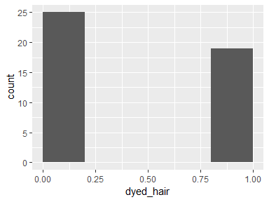

## first_pregnancy

|  |  |
| --- | --- |
| Feature | Result |
| Variable type | numeric |
| Number of missing obs. | 0 (0 %) |
| Number of unique values | 2 |
| Median | 1 |
| 1st and 3rd quartiles | 0; 1 |
| Min. and max. | 0; 1 |

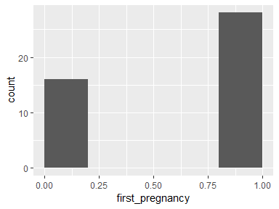

## wanted_pregnancy

|  |  |
| --- | --- |
| Feature | Result |
| Variable type | numeric |
| Number of missing obs. | 0 (0 %) |
| Number of unique values | 2 |
| Median | 1 |
| 1st and 3rd quartiles | 1; 1 |
| Min. and max. | 0; 1 |

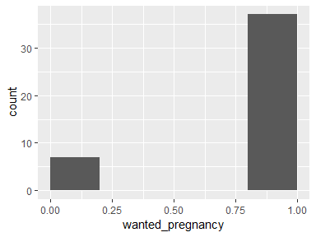

## pregnancy_method

|  |  |
| --- | --- |
| Feature | Result |
| Variable type | numeric |
| Number of missing obs. | 0 (0 %) |
| Number of unique values | 2 |
| Median | 1 |
| 1st and 3rd quartiles | 1; 1 |
| Min. and max. | 0; 1 |

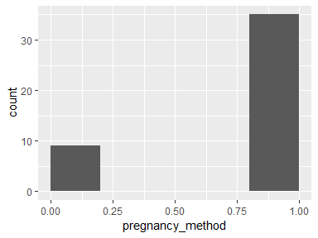

## previous_miscarriage

|  |  |
| --- | --- |
| Feature | Result |
| Variable type | numeric |
| Number of missing obs. | 0 (0 %) |
| Number of unique values | 2 |
| Median | 0 |
| 1st and 3rd quartiles | 0; 0.25 |
| Min. and max. | 0; 1 |

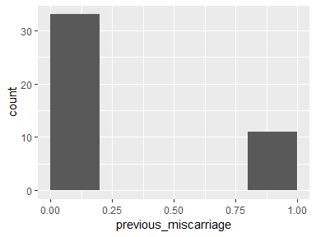

## fetus_sex

|  |  |
| --- | --- |
| Feature | Result |
| Variable type | integer |
| Number of missing obs. | 0 (0 %) |
| Number of unique values | 2 |
| Median | 0 |
| 1st and 3rd quartiles | 0; 1 |
| Min. and max. | 0; 1 |

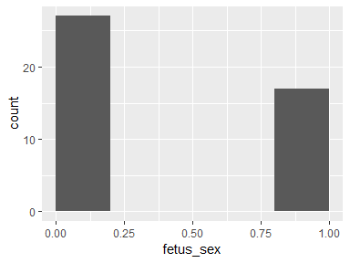

## epds

|  |  |
| --- | --- |
| Feature | Result |
| Variable type | numeric |
| Number of missing obs. | 0 (0 %) |
| Number of unique values | 16 |
| Median | 6 |
| 1st and 3rd quartiles | 4; 11 |
| Min. and max. | 2; 24 |

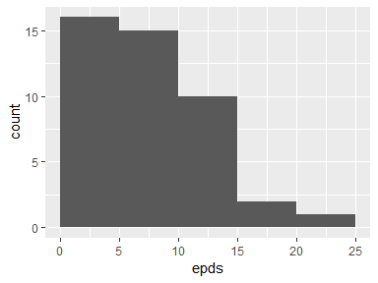

## depression_tri1

|  |  |
| --- | --- |
| Feature | Result |
| Variable type | numeric |
| Number of missing obs. | 0 (0 %) |
| Number of unique values | 31 |
| Median | 40.28 |
| 1st and 3rd quartiles | 33.75; 48.71 |
| Min. and max. | 5; 97 |

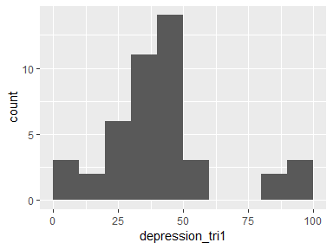

## depression_tri2

|  |  |
| --- | --- |
| Feature | Result |
| Variable type | numeric |
| Number of missing obs. | 0 (0 %) |
| Number of unique values | 26 |
| Median | 30.75 |
| 1st and 3rd quartiles | 24.03; 43.14 |
| Min. and max. | 5; 90 |

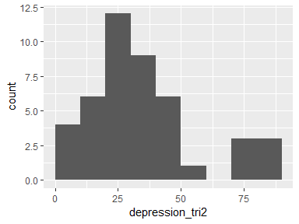

## depression_tri3

|  |  |
| --- | --- |
| Feature | Result |
| Variable type | numeric |
| Number of missing obs. | 0 (0 %) |
| Number of unique values | 24 |
| Median | 51.95 |
| 1st and 3rd quartiles | 28.75; 66.25 |
| Min. and max. | 5; 97 |

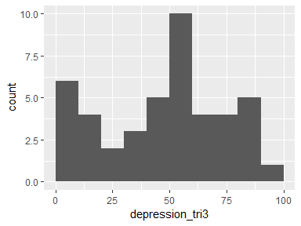

## cortisol_tri1

|  |  |
| --- | --- |
| Feature | Result |
| Variable type | numeric |
| Number of missing obs. | 0 (0 %) |
| Number of unique values | 40 |
| Median | 194.5 |
| 1st and 3rd quartiles | 112.2; 281.43 |
| Min. and max. | 51.68; 1649 |

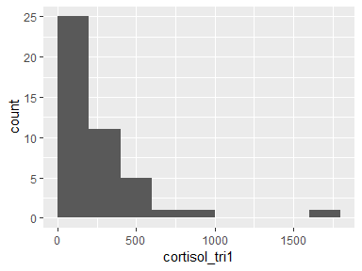

## cortisol_tri2

|  |  |
| --- | --- |
| Feature | Result |
| Variable type | numeric |
| Number of missing obs. | 0 (0 %) |
| Number of unique values | 43 |
| Median | 225 |
| 1st and 3rd quartiles | 165.53; 302.57 |
| Min. and max. | 78.64; 636.1 |

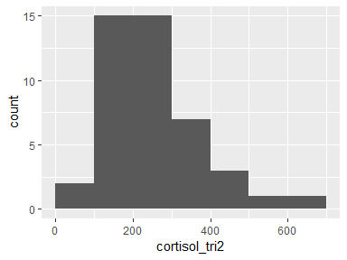

## cortisol_tri3

|  |  |
| --- | --- |
| Feature | Result |
| Variable type | numeric |
| Number of missing obs. | 0 (0 %) |
| Number of unique values | 44 |
| Median | 316.3 |
| 1st and 3rd quartiles | 228.01; 429.1 |
| Min. and max. | 96.5; 1213 |

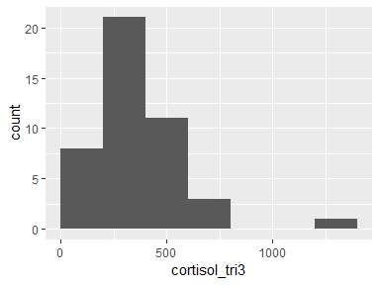

Report generation information:

* Created by Nathaniel Evans (username: natha).
* Report creation time: Wed Nov 14 2018 14:02:34
* Report was run from directory: C:/Users/natha/Documents/MATH630/FINAL_PROJECT/postpartum_depression_prediction/P2
* dataMaid v1.2.0 [Pkg: 2018-10-03 from CRAN (R 3.5.1)]
* R version 3.5.1 (2018-07-02).
* Platform: x86_64-w64-mingw32/x64 (64-bit)(Windows >= 8 x64 (build 9200)).
* Function call: makeDataReport(data = df_tidy, mode = c("summarize", "visualize", "check"), smartNum = FALSE, file = "codebook_df_tidy.Rmd", checks = list( character = "showAllFactorLevels", factor = "showAllFactorLevels", labelled = "showAllFactorLevels", haven_labelled = "showAllFactorLevels", numeric = NULL, integer = NULL, logical = NULL, Date = NULL), listChecks = FALSE, maxProbVals = Inf, codebook = TRUE, reportTitle = "Codebook for df_tidy")