Senior Software Engineering Project
Date: November 23, 2025
Team Name: SkillTrack ; Team ID: CS.011
Student Names and Emails: Elizabeth Stahlke (stahlkee@oregonstate.edu), Antonio Rodriguez (rodriant@oregonstate.edu), Russell Hueso (huesor@oregonstate.edu), Aaron Pina (pinarama@oregonstate.edu), Benjamin Kono (konob@oregonstate.edu)

System Context & High-Level Architecture
The first important concept to understand of our system architecture is users and logging in. A user is verified with their email+password combination. Correctly identifying a user is supremely important, as it ensures we can get them their information (ie. what tasks has this student completed) and that they can’t access other people’s data.
Figure 1
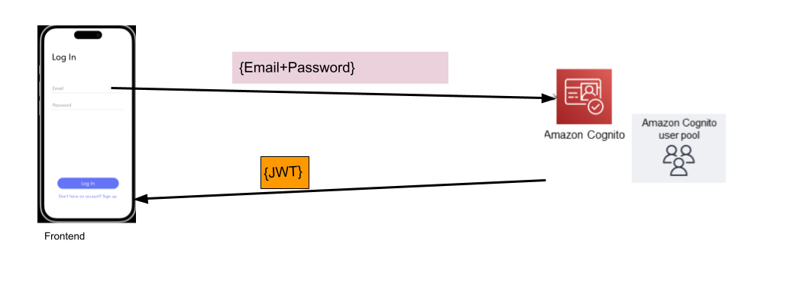
The above diagram describes the login process, or a more technical term, the authentication process. A user first provides their email and password on the frontend app interface, this information is then forwarded to AWS Cognito (a backend service that we use to manage all accounts for our app). Cognito verifies these credentials match an account, and if they do, Cognito issues a JSON Web Token (JWT). This token uniquely identifies the logged in user, and is impossible to fabricate without the signing key that is hidden in AWS cognito, that not even we can view.
With that concept in mind, we can now understand the rest of our app architecture, see the below image. Note that the purple circles are part of that same API Gateway node, they were just placed there to make it easier to understand the order in which operations are conducted.

Figure 2
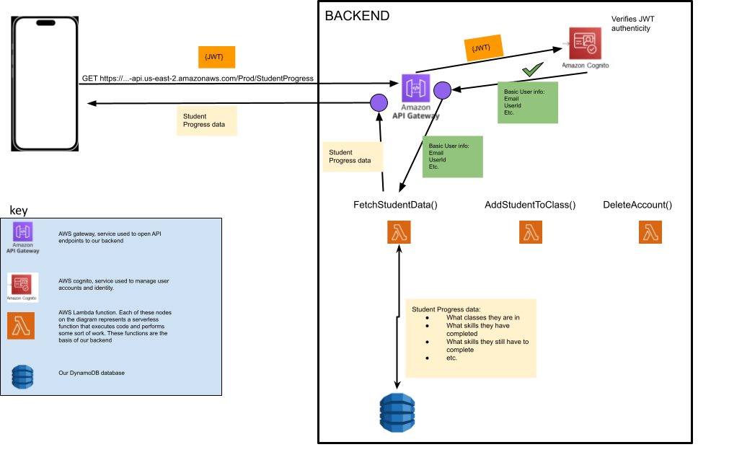
The fundamental architecture can be understood by understanding how data is fetched after logging in. After logging in as a student, a HTTP GET request is made, with the aforementioned obtained JWT token passed in as a header.
The request is sent to a URL that is managed by our AWS Gateway instance. When our gateway receives a request, it verifies the authenticity of the JWT by passing that value to AWS Cognito. If the JWT key value is valid, gateway is able to derive basic user info, most importantly the user email. From there the gateway passes invokes the appropriate lambda function based on which api endpoint was called, accesses the database for the requested data, and returns it to the frontend.
And that is the basic tech stack. Our frontend app (based on react native)makes requests for data from the backend via API endpoints controlled by AWS Gateway, gateway verifies that the caller of the api endpoint has a valid logged in JWT token, and if so calls the appropriate lambda function to do some sort of business logic, such as fetching data from the database; and any relevant data is returned back to the frontend.
One more aspect of the architecture not portrayed in the above diagrams is our approach to user roles. We plan on having three roles, Student, Teacher, and Admin. Each with varying permissions. For example, a student should not be able to make a successful invocation to the AddStudentToClass() lambda function. Our dynamoDB table will keep track of user roles and any invocation for a restricted action will check a user’s role to check if they are able to do this action or not and act accordingly.
Interfaces/APIs and data contracts
We use AWS DynamoDB as our primary database. Our current schema design uses the user’s email address as the partition key which is hashed to ensure uniqueness.
Each item in the table includes the following attributes:
- First name
- Last name
- Authentication level (student or administrator)
- Individual certifications the user has earned
Our API for user validation is through AWS Cognito User Pools integrated with API Gateway to provide secure authentication and authorization. Users authenticate through Cognito which is connected to our login page, and Cognito returns a set of JWT tokens. The tokens are then sent to AWS Gateway to validate the JWT token using the configured Cognito User Pool. This validates the tokens signature, confirming its not expired, and verifying the client id. If the token passes all validations checks, the request is forwarded to the backend. If not, Gateway responds with an authentication error.
An example of the login page API is as follows: the user enters their email address and password, and the request is sent to Cognitio for authentication, with verification handled by Gateway. If the password is incorrect, the user receives a response indicating invalid credentials and not allowing access to the application.
Consolidated Risk Register
Figure 3
ID | Risk | Impact | Likelihood | Owner(s) | Due Date | Mitigation
001 | Weak Password Policy (REQ-002) | HIGH | Somewhat Likely | Aaron + Antonio | 11/25/25 | Enforce minimum length, character rules, potentially a password strength meter
002 | Username is email-only (REQ-002) | HIGH | Likely | Aaron + Antonio | 11/25/25 | Consider consistent usernames (rodriant, etc), restrict where usernames appear
003 | Only client-side input validation | HIGH (REQ-019) | Somewhat Likely | Russell | 12/02/25 | Add server-side input validation before writing to database and reject requests that may be malicious/don’t match expected schemas
004 | Excessive API Calls | MEDIUM  (REQ 015) | Not Likely (1 million free calls/month) | Antonio | 12/12/25 | Reduce how often the app makes requests, group together requests, set AWS alerts
005 | Lack of loading states | LOW  (REQ-016) | Somewhat Likely | Ben + Elizabeth | 1/09/25 | Add loading indicators so that users don’t think the app is frozen, dependant on user testing feedback

Individual Components

Component: Backend Endpoints based on Lambda Functions - Aaron Pina
Purpose and Responsibilities
The backend is a very important component of any application that requires data processing, secure storage, many users with varying levels of permissions, and the general protection of certain information that only certain users should be able to access. The choice of how to design this backend that must be able to communicate with the app on users phones is important.
My job has been to design this exact backend architecture. And since our team has opted to use AWS for compute resources, it has been my job to figure out the best resources to make it possible for the frontend to make these requests to the backend. I have gone with a serverless backend development model based upon a basic Gateway+Lambda pattern. Continue reading for more information on this
Interfaces and Data Contracts
This serverless backend is based upon a basic Gateway+Lambda pattern. We create endpoints to the backend with a URL managed by our AWS Gateway instance. Gateway then forwards the request to the correct Lambda function (Lambda simply being a serverless function that does whatever task we tell it to do.).
Of course, an API endpoint that runs a function in itself can’t do much without being able to connect to other resources. So there are two main interfaces/data contracts that the Gateway/Lambda endpoints interact with:
- Our AWS Cognito User Pool instance
- Our DynamoDB database table
Every single request sent into our gateway is verified checked with our AWS Cognito instance to make sure that the request has the valid credentials (ie. a logged in user is making the request) before allowing the lambda function to be run. Gateway will reject the request if it finds that invalid credentials were provided.
And in order to actually be able to do meaningful work, Our lambda functions have CRUD access to our DynamoDB database table. That way they can fetch any data needed (ie. the name of the skills that a student has completed) and write any data as needed (ie. teacher checking off student for newly acquired skill)
Dependencies
AWS - Our entire serverless backend runs on the services AWS provides.
AWS and SAM CLI - Needed to successfully use our infrastructure as code development model. In which we simply write code to our repo, and can instantly deploy resources and lambda code onto AWS.
Key Design Decisions
1. Usage of a serverless backend (Lambda based) rather than a traditional backend with something like EC2.
This choice let us create our backend much quicker and allows us to worry about managing a lot less. As there was no need for us to worry about properly provisioning server resources. Since the serverless lambda model takes care of all the server provisioning behind the scenes. We just have to worry about writing the code to get stuff done.

2. Usage of the Gateway+Lambda pattern rather than just Lambda alone.
Although it is ideal to use less resources if possible, it became clear that if we were going to use lambda we would have to use gateway as well, as the only way to create a complex enough authentication (log in) system as we need, we would need to use gateway. As lambda only allows for simple authentication, not proper user authentication as we needed, more info here: https://docs.aws.amazon.com/lambda/latest/dg/apig-http-invoke-decision.html
Risk, Assumptions, and Mitigation
1. Frontend can successfully obtain access to JWT tokens via a valid user authentication (login flow)
This is a risk and assumption. If the frontend has trouble getting the JWT tokens, then they won’t be able to interact with the backend at all, which is very bad. Mitigation is based on working together to ensure the back and frontend connect correctly. So far, it looks like things are in order and the frontend will have a login that should work well with no problem
Small Evidence Artifact
Live AWS deployment showing one of our current mock lambda functions, which has a trigger based upon a Gateway API call:
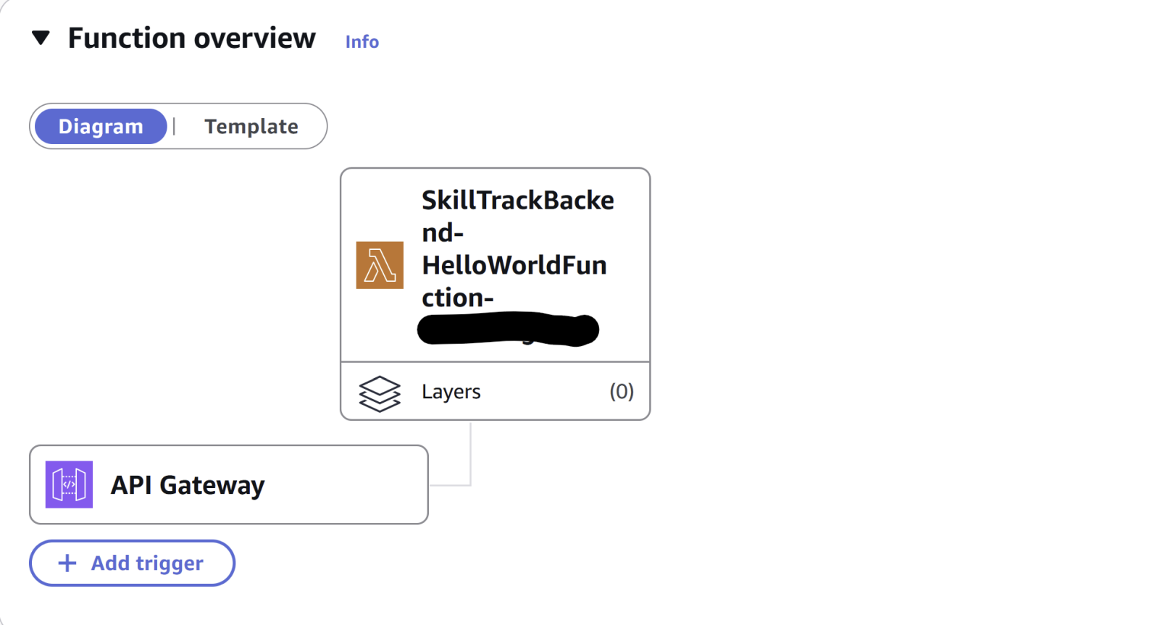
Another view from the live AWS deployment, showing the specific URL ending with /hello that calls the lambda function:
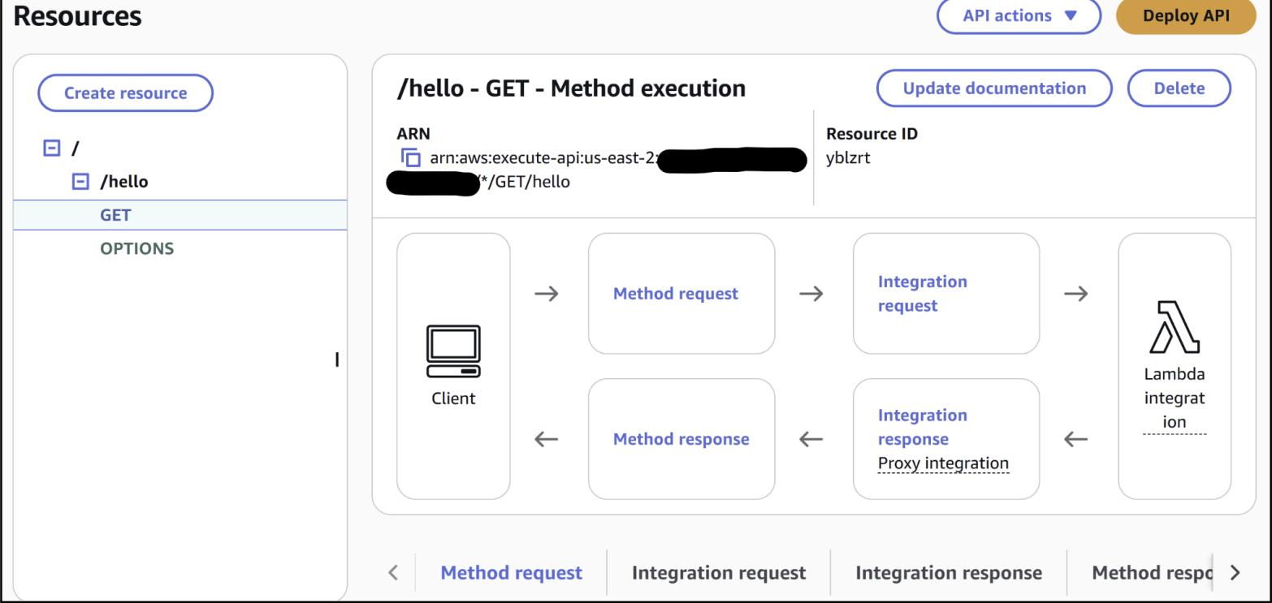
Link Design Decisions
All these decisions have been adopted and can be found in this PR: https://github.com/OHSU-SkillTrack/OHSU-SkillTrack/pull/4
ADR Status:
This corresponds to ADR-Lambda: Use AWS Lambda + Gateway pattern as the basis for our backend, and for making endpoints to make requests to the backend
The ADR I authored, and which has been fully adopted into our architecture. See the above PR link to see the adopted stuff.

Component: User Interface and Design - Elizabeth Stahlke
Purpose and Responsibilities
The user interface component defines all user interactions and experiences within our mobile application. Both students and instructors will be using this interface. The UI must support easy interaction with features such as viewing skills (completed and incomplete), accessing resources related to skills and coursework, displaying unique QR codes, and checking off skill proficiency for students (on the instructor's end).
My responsibility is to design the entire appearance of the application including the color palette, typography, icons, spacing, and layout. I also need to design an intuitive navigation flow for both student and instructor users. I also created the prototype of the UI to streamline the development process of the frontend and create standards for various UI elements. I have to consider usability and accessibility with all the design choices. I must ensure consistency of the final implementation, not just in the prototype, but the finished product. I also need to collaborate with the rest of the frontend team to ensure the UI is designed correctly and as intended.
Interfaces and Data Contracts
The user interface will use API endpoints to communicate with the backend. It will send requests given a student’s ID and retrieve various information such as a list of completed skills, a key to be generated into a QR code, a list of drug cards that the student has created as a resource. It will also retrieve information non-specific to the student, such as a list of all skills, courses, and resources.
Dependencies
React Native - framework for cross-platform mobile development
Expo - development tool for viewing frontend implementation
react-native-camera - library that provides QR code scanning functionality for instructors
react-native-qrcode-svg - library for generating unique QR codes on student devices
Key Design Decisions
1. Color Scheme - #4972FF, #9FB5FF, #E3EAFF, #919191, #EFEFEF, #F5F5F5
This color scheme was inspired by healthcare environments (lighter blues and soft greys). It creates a modern look, but remains simple and not overwhelming.
2. Typography - Afacad Normal Weight Semi Bold
This font is legible, consistently spaced, and professional. It is san seriffed to keep a clean and aesthetically-pleasing look. The font remains normal weight across nearly the entire application. Although, on more information-heavy pages such as skill details and drug information, a semi bold weight is used to highlight sections while keeping a consistent font size for visual appeal. Font sizes vary across the application. Main page headers are size 35, while subheadings are size 25. The majority of other fonts are size 20, with a couple of exceptions that can be seen in the Figma prototype.
3. Spacing
Spacing is always consistent. There is no uneven spacing between common elements. Most elements are spaced 25 pixels apart, but others are 12 pixels apart. Similar to the font size, there are some exceptions based on visual weight of certain elements.
4. Icons
The current icons in the prototype are from a free icon source on Figma. We may have to design our own icons based on licensing. I chose icons that have universal meaning for simplicity and ease of navigation. For example, a circle with a checkmark in it is used to indicate the skills section, as it represents a checklist. A book is used for the resources section to represent a textbook. The industry standard user icon is used for the account page, as well as other common icons such as the back arrow, search icon and plus symbol for adding something to a list.
5. Layout
The layout of the application is meant to be simple for use by people from a wide range of demographics, while remaining appealing to the eye. Elements are centered and spaced not too close where the interface becomes cluttered, but not too far where it becomes hard to navigate by hand on a phone.
6. Navigation
Once the user logs in, they land on their main skill page. From here, users can select a specific year of their curriculum. Then, they can sort by the courses offered in that year of education. Within each course is a list of skills associated with that course. Each course can be selected to view the details of it. There is a navigation bar at the bottom of the application. The middle icon navigates to the main skill page, since this is where most of the app interaction will take place. The left user icon goes to the profile page, where the user can see their progress through the curriculum in their current year as well as their QR code to be scanned by instructors. The right book icon navigates to the resources page, which lets the user access resources based on the year of curriculum, or view their drug cards, which contain information on the various drugs they learn about. The drug cards section also has an option to add a drug card. The skills and resources pages contain searching functionality for improved navigation.
Risk, Assumptions, and Mitigation
1. Accessibilty
Our app is likely not accessible towards every group. We will be prepared to change the design choices accordingly based on feedback from user testing with OHSU students and faculty.
2. Custom vs. Free Icons
Free icons may have licensing issues and inconsistencies. Custom icons take time and none of our team members are familiar with creating them. For now, we will find a trustworthy free icon source and research the terms of their usage.
3. Backend API Integration
The API to communicate with the backend is incomplete. This may impose changes on our UI design depending on what information we are able to retrieve and how quickly we are able to do so. We will work closely with the backend team to encourage seamless integration of the frontend and backend.
Evidence Artifact
Figure 4
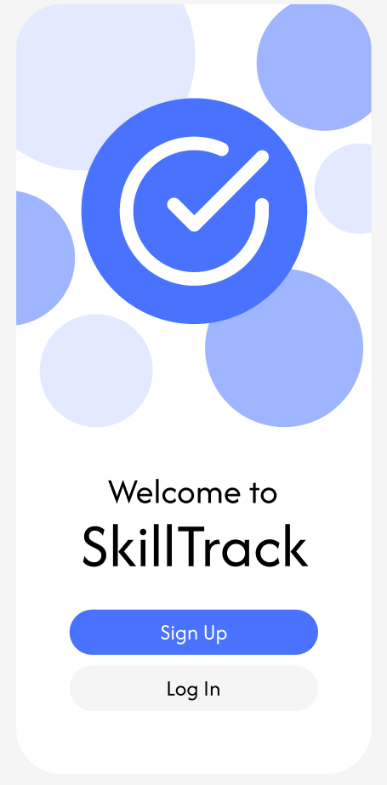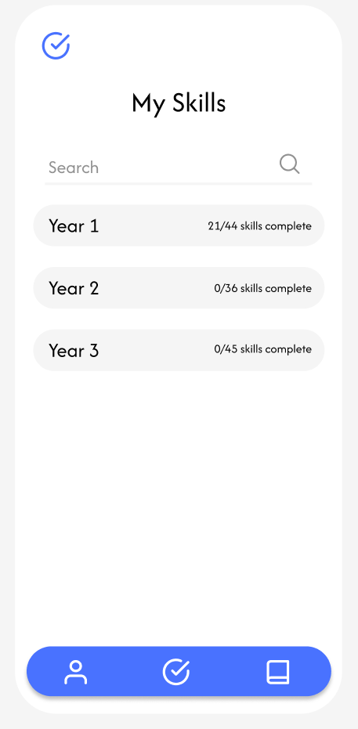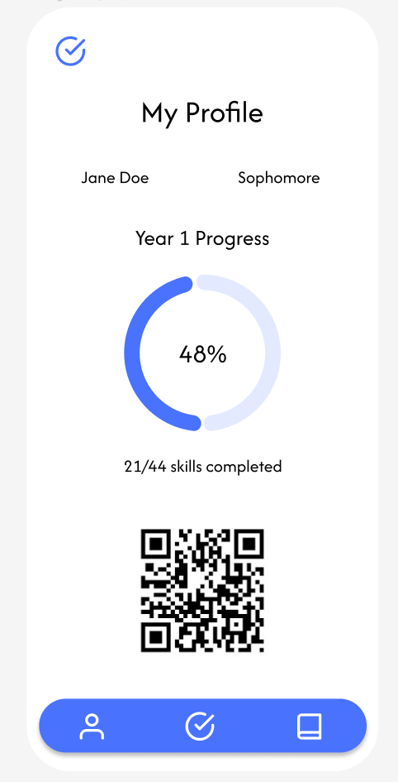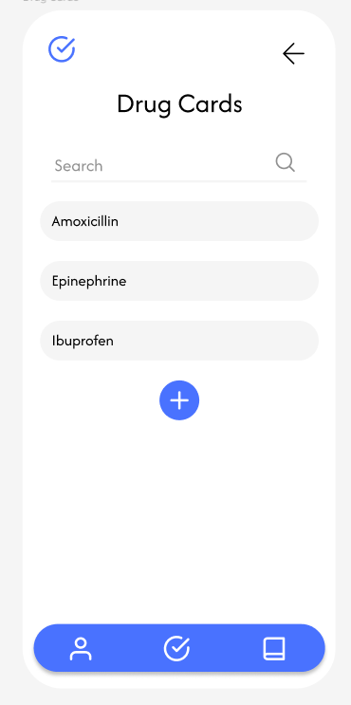
These are some of the pages included in the Figma prototype.

Component: QR code generation - Russell Hueso
Purpose and Responsibilities
The purpose of this component is to generate a QR code that provides quick and convenient access to each student’s skills and competences. Its primary responsibility is to support efficient workflows in clinical and educational settings. This enables instructors to sign off on gained skill sets and hospital nurses to look up each student's approved competencies. This component ensures that competency data is presented securely and accurately.
Interfaces and Data Contracts
The QR code component interfaces with the student competency database to retrieve the relevant student data, such as name, skills, and certification status using API calls to the backend. The generated QR code either embeds a URL with time limited access or encodes a secure URL that links to the students records. The data contract for the time limited URLincludes fields such as student name, skills, and certifications. For administrator-level access, the QR code will allow the authorized user to interact with the student’s account to sign off gained skills or certifications. The contract defines the expected format and access rules to guarantee secure interactions.
Dependencies
React Native - framework for cross-platform mobile development
Expo - development tool for viewing frontend implementation
react-native-qrcode-svg - library for generating unique QR codes on student devices
Key Design Decisions
Chose to use the reactive-native-qrcode-svg library to handle QR code generation. It is a well-maintained and lightweight library that integrates well in React native applications. It provides consistent QR code generation across both IOS and Android. The library scales evenly at any size so it won't lose quality in displaying QR codes on different screen resolutions. It has flexibility in embedding data, styling and is compatible with many standard QR code scanners.
Risk, Assumptions, and Mitigation
- Unauthorized access: QR code links could be shared with unintended users
- Mitigation: Use limited time, tokenized links and have read only access for non-administrator
- Mitigation: Verify access token for administer access from the Cognito user pool
- Device compatibility: May not have a device capable of scanning QR codes
- Provide short URL for quick look up on a browser

Evidence Artifact
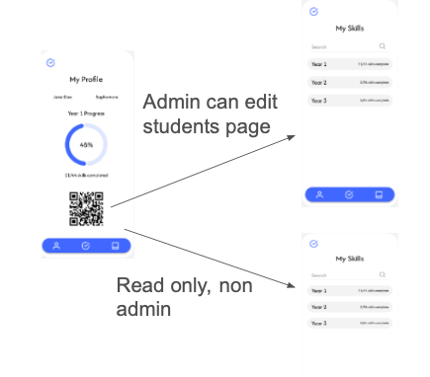
QR code diagram of presented access based on authorization

Component : Login Page - Ben Kono
Purpose and Responsibilities
The Login Page is the entry point of the SkillTrack mobile application and is responsible for authenticating users using their email/username and password. Its core purpose is to provide a clean, reliable, and accessible interface for returning and newly registered users to sign in. Because authentication underpins multiple system requirements, including multi-level access (REQ-001), secure login (REQ-002, REQ-004), persistent login (NFR-005), and FERPA-aligned privacy requirements, the Login Page must reliably capture user credentials, validate them, and trigger AWS Cognito authentication flows.
The login component is also responsible for communicating login errors clearly, providing visual feedback during authentication calls, and handing off navigation to the rest of the application after successful sign-in.
Interfaces and data contracts
- UI Interface
  - Inputs
    - username: string
    - password: string
  - Outputs
    - Calls authentication handler on “Log in” press
    - Displays validation or error messages
- Authentication Contract (AWS Cognito via Amplify Auth)
The Login Page interacts with the Amplify Auth API, which wraps AWS Cognito User Pools.
Request:
Auth.signIn(username: string, password: string)
Expected Response:
{
"username": "user@example.edu",
"signInUserSession": {
"idToken": { "jwtToken": "<JWT>" },
"accessToken": { "jwtToken": "<JWT>" },
"refreshToken": { "token": "<refresh>" }
}
}
Example Errors:
{ "code": "NotAuthorizedException", "message": "Incorrect username or password." }
Dependencies
- AWS Amplify: Provides the Auth API used for Cognito login.
- Amplify Configuration File
- Expo Router: Used for post-login navigation
- React Native Core Components: TextInput, View, Pressable, etc.
- Device Secure Storage (future extension): Supports persistent sessions aligned with NFR-005 and REQ-012.
Key Design Decisions and Rationale
- Using AWS Cognito for Authentication
Rationale:
- Meets REQ-002, REQ-004, and NFR-001 for secure, encrypted authentication.
- Provides automatic security mechanisms (password policies, token handling).
- Integrates cleanly with AWS Lambda and DynamoDB for backend calls.
- Reduces security risk by avoiding implementing custom authentication.
- Custom Login UI Instead of Amplify’s Pre-Built Authenticator
- Gives the app a consistent branded UX.
- Allows full control over accessibility, layout, and navigation.
- Simplifies matching the UI to design guidelines required by NFR-004 and REQ-016.
Risks, Assumptions, and Mitigations
Risk 1 — Incorrect handling of Cognito edge cases (like MFA, unconfirmed accounts)
- Impact: Users may be unable to log in even with valid accounts.
- Mitigation: Inspect err.code responses and surface friendly messages; add future flows for MFA and account confirmation.
Risk 2 — Network failure breaks sign-in flow
- Impact: Users with poor connectivity may experience login failures.
- Mitigation: Provide clear offline messaging and leverage REQ-012’s offline caching to at least show cached content after prior successful login.
Risk 4 — Tokens stored insecurely
- Impact: Violates FERPA-aligned privacy (REQ-004, NFR-001).
- Mitigation: Use Amplify's secure storage integration or Expo SecureStore during persistent login implementation.
Figure 5
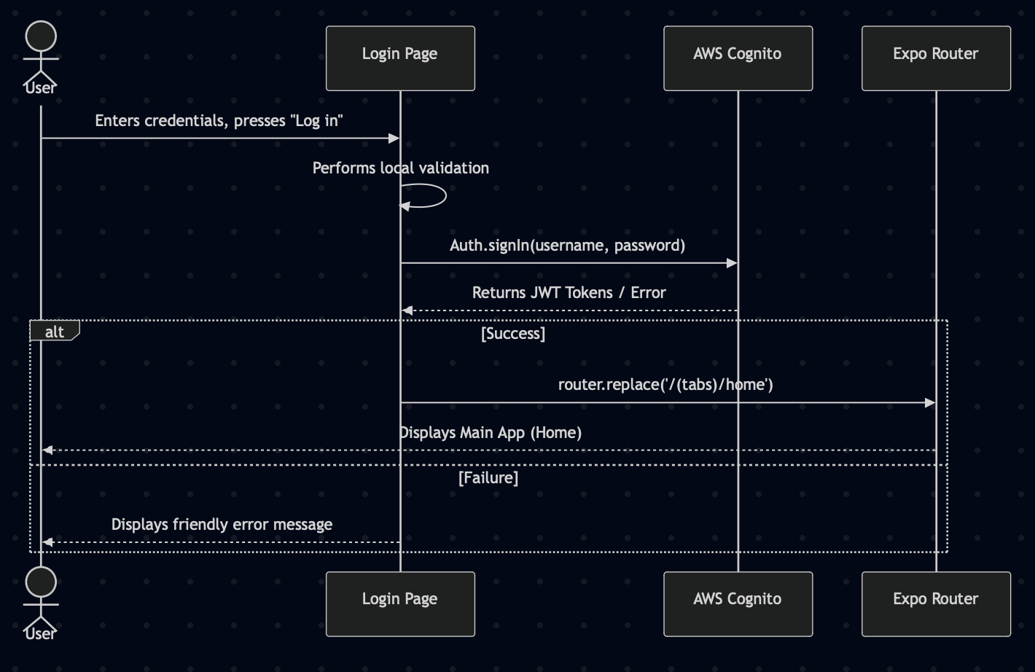
Component: Automated Testing user Maestro - Antonio Rodriguez
Purpose and Responsibilities
The purpose of this component is to provide automated end-to-end tests that run whenever a commit is made. These tests will launch Expo, verify user flows, and ensure the app loads correctly on iOS and Android. Responsibilities include maintaining and updating test scripts, defining expected outcomes, and integrating tests into our development.
Interfaces and data contracts
Maestro communicates with our application using YAML test files. These buttons use button labels, screen IDs, and navigation paths provided by the frontend group and that serve as our data contract. The tests rely on expected and consistent UI elements and can also use dummy data to further test user flows.
Dependencies
- React Native-Expo
- Maestro CLI and test runner
- Stable and consistent UI components/navigation routes
- Backend functionality to test dummy data with expected outcomes
Key Design Decisions and Rationale
- We chose to use Maestro for its simplicity and mobile-friendly + web app testing availability
- Maestro uses easy YAML-based test scripts that are easy to write, review, and update
- Maestro can be used to ensure consistency across iOS and Android devices
- Can focus on core functionality with critical user flows like login, skill-checking, and navigation
- Can be integrated with GitHub CI
Risks, Assumptions, and Mitigations
Risk 1: UI changes could potentially break tests
Mitigation 1: Use stable IDs and update the tests along with any UI updates. Antonio will help others write testing scripts.
Risk 2: Devices (iOS and Android) tests may behave differently
Mitigation 2: Create simple, consistent IDs for buttons and screens and make sure to run tests on both iOS and Android during development
Risk 3: Hard to debug failing tests without screenshots
Mitigation 3: Enable Maestro screenshot capture so that we may reference the point where the test failed and debug
Assumptions:
- Proper dependencies are installed
- Expo app starts/builds without errors consistently
- Screens load within a reasonable amount of time
- Test accounts are available on everyone’s devices
Evidence Artifact:
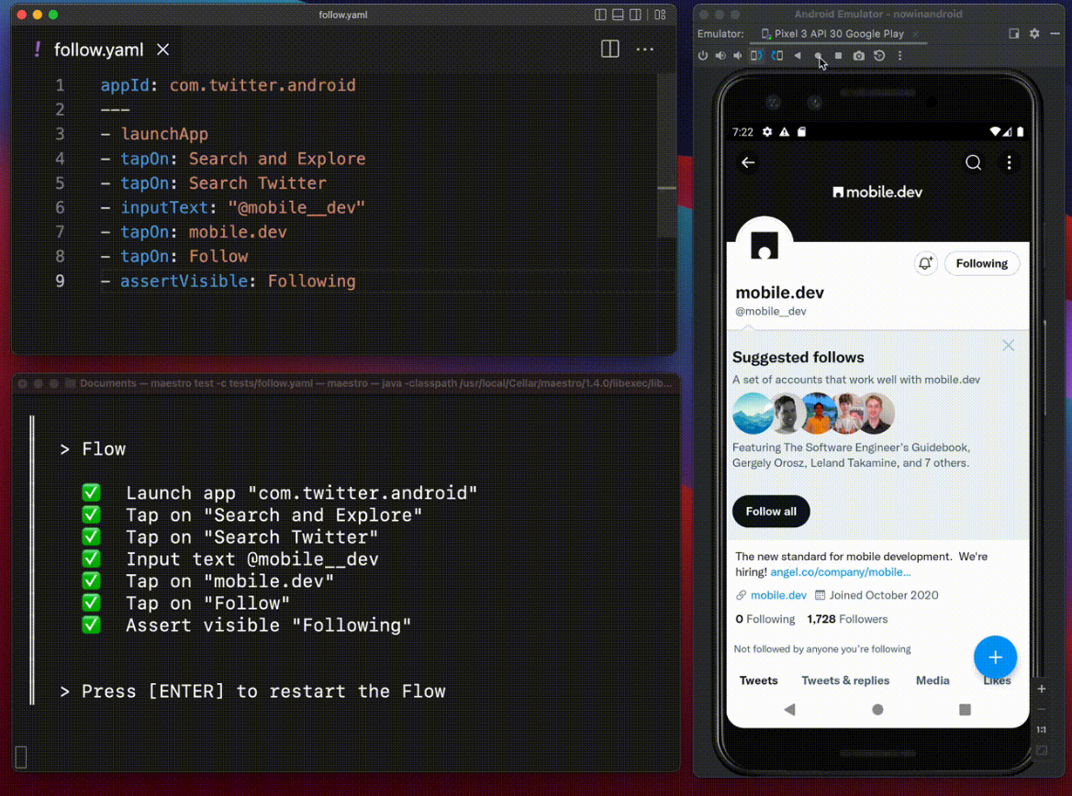
Traceability Aid
Figure 1 - Log in process diagram
Figure 2 - Backend diagram including API call to the frontend
Figure 3 - Risk register
Figure 4 - User interface examples, Figma prototype pages
Figure 5 - Login page front and backend integration

