Data Visualization

# BDK18-1 | Introduction to Visualization

## Charles Minard: Figurative Map

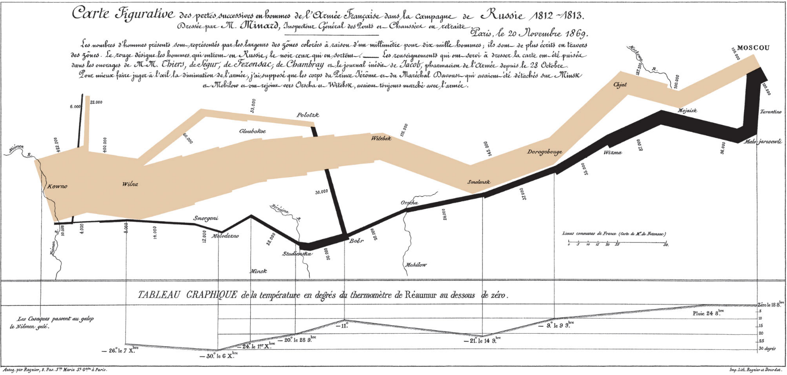

The map's French caption reads as follows:

**Figurative Map** of the successive losses in men of the French Army in the Russian campaign 1812-1813.  
Drawn up by M. Minard, Inspector General of Bridges and Roads in retirement. Paris, November 20, 1869.

The numbers of men present are represented by the widths of the colored zones at a rate of one millimeter for every ten-thousand men; they are further written across the zones. The red [now brown] designates the men who enter into Russia, the black those who leave it. —— The information which has served to draw up the map has been extracted from the works of M. M. Thiers, of Segur, of Fezensac, of Chambray, and the unpublished diary of Jacob, pharmacist of the army since October 28th. In order to better judge with the eye the diminution of the army, I have assumed that the troops of prince Jerome and of Marshal Davoush who had been detached at Minsk and Moghilev and have rejoined around Orcha and Vitebsk, had always marched with the army.

The scale is shown on the center-right, in "lieues communes de France" (common French league) which is 4,444m (2.75 miles).

The lower portion of the graph is to be read from right to left. It shows the temperature on the army's return from Russia, in degrees below freezing on the [Réaumur scale](https://en.wikipedia.org/wiki/en:R%C3%A9aumur_scale" \o "w:en:Réaumur scale). (Multiply Réaumur temperatures by 1¼ to get [Celsius](https://en.wikipedia.org/wiki/en:Celsius), e.g. −30°R = −37.5 °C) At Smolensk, the temperature was −21° Réaumur on November 14th.

## Visualization Critique

Charles Minard's 1869 chart is considered one of the greatest visualizations of all time, in part because he effectively presents many data sets elegantly in a single infographic. Please critique Minard’s chart in each of the following areas:

1. Depiction of the number of men in Napoleon’s 1812 Russian campaign army
   * How did Minard display this information?
   * Which pre-attentive process is he using to effectively convey this information?
   * How could this be improved?
2. The army movements (invading, retreating)
   * How did Minard display this information?
   * Which pre-attentive process is he using to effectively convey this information?
   * How could this be improved?
3. The geographic information (map, annotation of key locations, etc)
   * How did Minard display this information?
   * Which pre-attentive process is he using to effectively convey this information?
   * How could this be improved?
4. The temperature the army encountered on the return path
   * How did Minard display this information?
   * Which pre-attentive process is he using to effectively convey this information?
   * How could this be improved?

Minard painted this graphic himself. In the era of digital imagery, how would you produce *separate* graphs on each of the four topics discussed above? How would you produce an *integrated* graph combining all four topics?