**MSRE One-Region Model Description with Heat Exchanger(s)**

T.-s. Oh

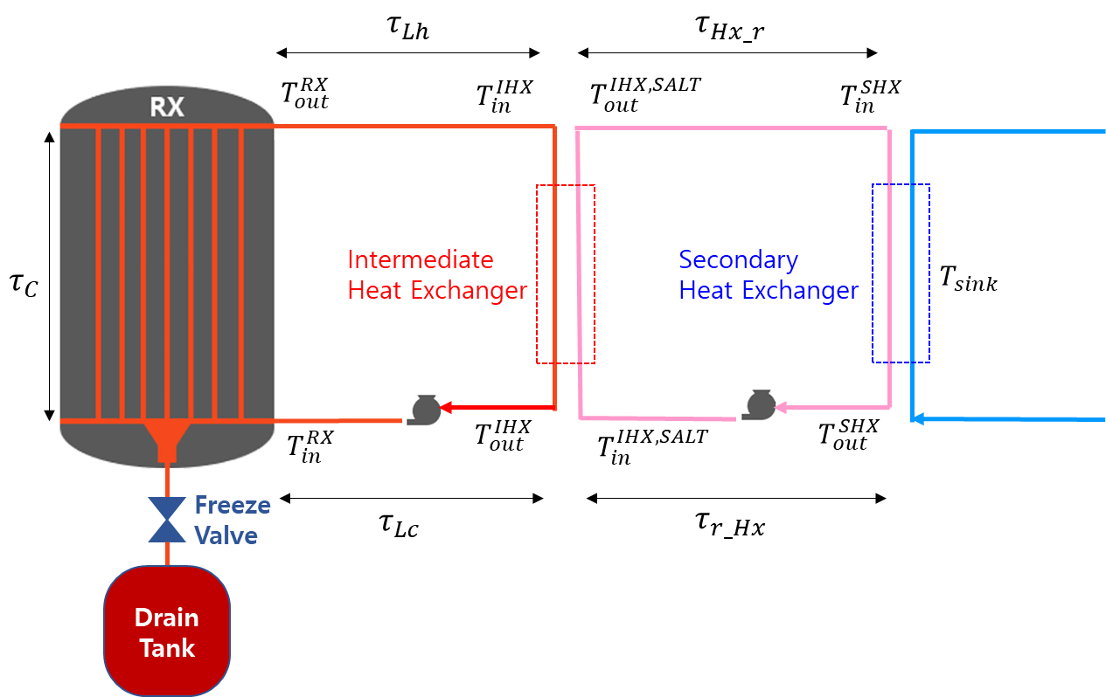

$τ_{C}$: time spent in the reactor core

$τ_{Lh}$: time spent in hot leg of the primary loop (from reactor core to the IHX)

$τ_{Lc}$: time spent in cold leg of the primary loop (from IHX to the reactor core)

$τ_{L}=τ_{Lh}+τ_{Lc}$: time spent in the primary loop

$τ_{Hx_r }$: time spent in secondary loop (from IHX to the SHX)

$τ_{r_Hx }$: time spent in secondary loop (from SHX to the IHX)

For the reactor core, one-region-model alongside flow-considered PKE are envisioned. The outlet temperature of the salt $T_{out}^{RX}$ (from the RX core) is determined, which is then used to determine the inlet temperature $T_{in}^{RX}$. Three difference cases are considered:

* Constant temperature drop between $T_{out}^{RX}$ and $T_{in}^{RX}$
* Modelling only IHX (constant $T_{out}^{IHX,SALT}+T_{in}^{IHX,SALT}$ value)
* Modelling both IHX & SHX (constant $T_{sink}$ value)

**Advection term included PKE**

$$\frac{dn}{dt}=\left[\frac{ρ\left(t\right)- β}{Λ}\right]n\left(t\right)+\sum_{k}{λ_{k}C_{k}\left(t\right)}$$

$$\frac{dC_{k}}{dt}=\frac{β_{k}}{Λ}n\left(t\right) -λ_{k}ξ_{k}\left(t\right)-\frac{C_{k}\left(t\right)}{τ_{C}}+\frac{C_{k}\left(t-τ_{L}\right)e^{-λ_{k}τ_{L}}}{τ_{C}}$$

Implementing Implicit Euler scheme yields (for 6ix delayed neutron precursor groups):



$$n\left(∆t\right)∙\left\{\frac{1}{∆t}-\left(\frac{ρ\left(t\right)- β}{Λ}\right)\right\}=n\left(0\right)∙\left(\frac{1}{∆t}\right)+\sum_{k}{λ_{k}C_{k}\left(∆t\right)}$$

$$C_{k}\left(∆t\right)∙\left\{\frac{1}{∆t}+λ_{k}+\frac{1}{τ_{C}}\right\}+n\left(Δt\right)∙\left(-\frac{β_{k}}{Λ}\right)=C_{k}\left(0\right)∙\left(\frac{1}{∆t}\right)+\frac{e^{-λ_{k}τ_{L}}}{τ_{C}}∙C_{k}\left(∆t-τ_{L}\right)$$

Can be easily solved using GE method. With out losing generality, *n*(0) = 1 is considered, where initial steady state is met with non-zero reactivity due to the flow of fuel:

$$C_{k}\left(0\right)={\frac{β_{k}}{Λ}}/{\left(λ_{k}+\frac{1}{τ_{C}}-\frac{e^{-λ_{k}τ_{L}}}{τ_{C}}\right)}$$

$$ρ\left(0\right)=β-\sum_{k}{\frac{β_{k}}{\left(1+\frac{1}{λ_{k}τ_{C}}\left[1-e^{-λ_{k}τ_{L}}\right]\right)}}$$

The feedback reactivity (for MSRE system) is calculated as

$$ρ_{fb}\left(t\right)=α_{f}\sum_{i=1}^{n}{I_{fi}}\left[T_{f,0}-T_{f}(t)\right]+α_{g}\sum_{i=1}^{n}{I_{gi}}\left[T_{g,0}-T_{g}(t)\right]$$

where subscripts *f* and *g* represent fuel and graphite respectively. For each region, the following relation holds.

$$\sum_{i=1}^{n}{I_{fi}}=1.0$$

$$\sum_{i=1}^{n}{I_{gi}}=0$$

The temperature coefficients are given as $α_{f}$ and $α_{g}$.

The reactivity during transient simulation is then calculated as

$$ρ\left(t\right)=ρ\left(0\right)+ρ_{fb}\left(t\right)$$

**One-region-model Heat Balance**

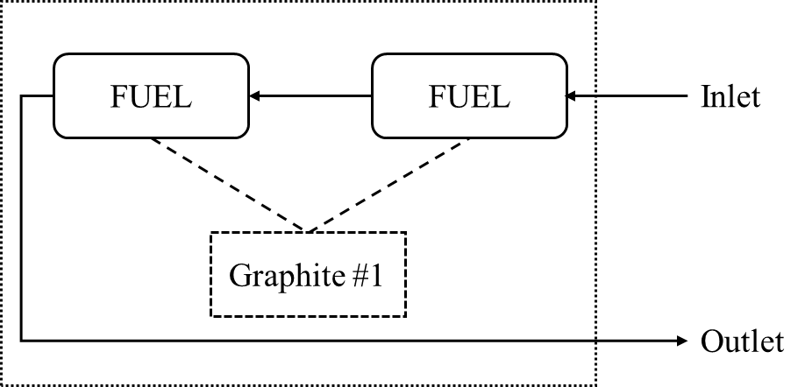

Governing equations are given as followings:

$$\frac{dT_{f1}}{dt}=\frac{W_{f}}{m_{f1}}∙\left(T_{fin}-T_{f1}\right)+\frac{K_{f1}P\left(\frac{n}{n_{0}}\right)}{m_{f1}c_{pf}}+\left(\frac{K_{g→f1}}{K_{g→f1}+K_{g→f2}}\right)∙\frac{hA_{fg}}{m_{f1}c_{pf}}∙\left(T_{g}-T_{f1}\right)$$

$$\frac{dT_{f2}}{dt}=\frac{W_{f}}{m_{f2}}∙\left(T_{f1}-T_{f2}\right)+\frac{K_{f2}P\left(\frac{n}{n_{0}}\right)}{m_{f2}c_{pf}}+\left(\frac{K_{g→f2}}{K_{g→f1}+K_{g→f2}}\right)∙\frac{hA_{fg}}{m_{f2}c_{pf}}∙\left(T_{g}-T_{f2}\right)$$

$$\frac{dT_{g}}{dt}=K_{g}∙\frac{P\left(\frac{n}{n_{0}}\right)}{m_{g}c_{pg}}+\frac{hA_{fg}}{m_{g}c_{pg}}∙(T_{f}-T_{g})$$

where

$W_{f}$: mass flow rate in the core [kg/sec]

$K_{f1,2}$: Portion of heat deposited in fuel node

$K_{g}$: Portion of heat deposited in graphite node

$P\left(\frac{n}{n_{0}}\right)$: Nominal power multiplied with fractional neutron density

$K_{g→f1,2}$: Fraction of power generated in the graphite transferred to each fuel node

$hA_{fg}$: product of area and heat transfer coefficient for the fuel-graphite interface

(all the other notations are that of the convention)

※For convenience, recommend to normalize $K_{g→f1,2}$ so that $K_{g}=K_{g→f1}+K_{g→f2}$

The average fuel node temperature is determined as:

$$T_{f}=\left(\frac{K_{g→f1}}{K_{g→f1}+K_{g→f2}}\right)∙T_{f1}+\left(\frac{K_{g→f2}}{K_{g→f1}+K_{g→f2}}\right)∙T_{f2}$$

The initial inlet temperature $T_{fin}(0)$ is provided. By neglecting the time-derivative terms, one yields the initial values for $T_{f1}$, $T_{f2}$, and $T_{g}$

(Solve the following set of 3x3 matrix equation)

$$T_{f1}∙\left\{-\frac{W_{f}}{m_{f1}}-\left(\frac{K_{g→f1}}{K_{g→f1}+K_{g→f2}}\right)∙\frac{hA_{fg}}{m_{f1}c_{pf}}\right\} \\ +T_{f2}∙0 \\ +T_{g}∙\left\{\left(\frac{K_{g→f1}}{K_{g→f1}+K_{g→f2}}\right)∙\frac{hA_{fg}}{m_{f1}c_{pf}}\right\}=-\left(\frac{W_{f}}{m_{f1}}\right)∙T_{fin}-\frac{K_{f1}P_{0}}{m_{f1}c_{pf}}$$

$$T_{f1}∙\left(\frac{W_{f}}{m_{f2}}\right) \\ +T_{f2}∙\left\{-\frac{W_{f}}{m_{f2}}-\left(\frac{K_{g→f2}}{K_{g→f1}+K_{g→f2}}\right)∙\frac{hA_{fg}}{m_{f2}c_{pf}}\right\} \\ +T_{g}∙\left\{\left(\frac{K_{g→f2}}{K_{g→f1}+K_{g→f2}}\right)∙\frac{hA_{fg}}{m_{f2}c_{pf}}\right\}=-\frac{K_{f2}P_{0}}{m_{f2}c_{pf}}$$

$$T_{f1}∙\left(\frac{K_{g→f1}}{K_{g→f1}+K_{g→f2}}∙\frac{hA_{fg}}{m_{g}c_{pg}}\right) \\ +T_{f2}∙\left(\frac{K_{g→f2}}{K_{g→f1}+K_{g→f2}}∙\frac{hA_{fg}}{m_{g}c_{pg}}\right) \\ +T_{g}∙\left(-\frac{hA_{fg}}{m_{g}c_{pg}}\right)=-K_{g}∙\frac{P_{0}}{m_{g}c_{pg}}$$

For time-dependent calculation, apply Implicit Euler scheme, which yields:

$$T_{f1}\left(∆t\right)∙\left\{\frac{1}{∆t}+\frac{W_{f}}{m_{f1}}+\left(\frac{K_{g→f1}}{K_{g→f1}+K_{g→f2}}\right)∙\frac{hA_{fg}}{m_{f1}c_{pf}} \right\}+T_{fin}\left(∆t\right)∙\left(-\frac{W_{f}}{m_{f1}}\right) \\ +T_{g}\left(∆t\right)∙\left\{-\left(\frac{K_{g→f1}}{K_{g→f1}+K_{g→f2}}\right)∙\frac{hA_{fg}}{m_{f1}c_{pf}}\right\}=T_{f1}\left(0\right)∙\left(\frac{1}{∆t}\right)+\frac{K_{f1}P\left(\frac{n\left(∆t\right)}{n_{0}}\right)}{m_{f1}c_{pf}}$$

$$T_{f2}\left(∆t\right)∙\left\{\frac{1}{∆t}+\frac{W_{f}}{m_{f2}}+\left(\frac{K_{g→f2}}{K_{g→f1}+K_{g→f2}}\right)∙\frac{hA_{fg}}{m_{f2}c_{pf}} \right\}+T_{f1}\left(∆t\right)∙\left(-\frac{W_{f}}{m_{f2}}\right) \\ +T_{g}\left(∆t\right)∙\left\{-\left(\frac{K_{g→f2}}{K_{g→f1}+K_{g→f2}}\right)∙\frac{hA_{fg}}{m_{f2}c_{pf}}\right\}=T_{f2}\left(0\right)∙\left(\frac{1}{∆t}\right)+\frac{K_{f2}P\left(\frac{n\left(∆t\right)}{n_{0}}\right)}{m_{f2}c_{pf}}$$

$$T_{g}\left(∆t\right)∙\left\{\frac{1}{∆t}+\frac{hA_{fg}}{m_{g}c_{pg}}\right\}+\left\{\left(\frac{K_{g→f1}}{K_{g→f1}+K_{g→f2}}\right)∙T_{f1}\left(∆t\right)+\left(\frac{K_{g→f2}}{K_{g→f1}+K_{g→f2}}\right)∙T_{f2}\left(∆t\right)\right\}∙\left(-\frac{hA_{fg}}{m_{g}c_{pg}}\right)=T_{g}\left(0\right)∙\left(\frac{1}{∆t}\right)+K_{g}∙\frac{P\left(\frac{n\left(∆t\right)}{n_{0}}\right)}{m_{g}c_{pg}}$$

Re-arrange the above set of equations:



where

$$a_{11}=\frac{1}{∆t}+\frac{W_{f}}{m_{f1}}+\left(\frac{K_{g→f1}}{K_{g→f1}+K_{g→f2}}\right)∙\frac{hA_{fg}}{m_{f1}c_{pf}} \\ a_{12}=0 \\ a_{13}=-\left(\frac{K_{g→f1}}{K_{g→f1}+K_{g→f2}}\right)∙\frac{hA_{fg}}{m_{f1}c_{pf}} \\ a_{21}=-\frac{W_{f}}{m_{f2}} \\ a_{22}=\frac{1}{∆t}+\frac{W_{f}}{m_{f2}}+\left(\frac{K_{g→f2}}{K_{g→f1}+K_{g→f2}}\right)∙\frac{hA_{fg}}{m_{f2}c_{pf}} \\ a_{23}=-\left(\frac{K_{g→f2}}{K_{g→f1}+K_{g→f2}}\right)∙\frac{hA_{fg}}{m_{f2}c_{pf}} \\ a_{31}=-\left(\frac{K_{g→f1}}{K_{g→f1}+K_{g→f2}}\right)∙\left(\frac{hA_{fg}}{m_{g}c_{pg}}\right) \\ a_{32}=-\left(\frac{K_{g→f2}}{K_{g→f1}+K_{g→f2}}\right)∙\left(\frac{hA_{fg}}{m_{g}c_{pg}}\right) \\ a_{33}=\frac{1}{∆t}+\frac{hA_{fg}}{m_{g}c_{pg}}$$

$$b_{1}=T_{fin}\left(∆t\right)∙\left(\frac{W_{f}}{m_{f1}}\right)+T_{f1}\left(0\right)∙\left(\frac{1}{∆t}\right)+\frac{K_{f1}P\left(\frac{n\left(∆t\right)}{n_{0}}\right)}{m_{f1}c_{pf}} \\ b_{2}=T_{f2}\left(0\right)∙\left(\frac{1}{∆t}\right)+\frac{K_{f2}P\left(\frac{n\left(∆t\right)}{n_{0}}\right)}{m_{f2}c_{pf}} \\ b_{3}=T_{g}\left(0\right)∙\left(\frac{1}{∆t}\right)+K_{g}∙\frac{P\left(\frac{n\left(∆t\right)}{n_{0}}\right)}{m_{g}c_{pg}}$$

When $T_{fin}\left(∆t\right)$ is determined, could solve coupled PKE + one-region-model heat balance equations for the reactor core, which in turn yields $T_{f2}\left(∆t\right)$. Newly updated $T_{f2}\left(∆t\right)$ is then given as an inlet condition for the primary loop regarding IHX.

**Heat Balance of the MSRE System**

The simplest way to update $T_{fin}\left(∆t\right)$ from $T_{f2}\left(∆t\right)$ is imposing a constant temperature drop with a given time lag ($τ_{L}=τ_{Lh}+τ_{Lc}$). After initialization, store the $T_{f2}\left(0\right)-T_{fin}\left(0\right)$ value and update $T_{fin}\left(∆t\right)$ as

$$T_{fin}\left(∆t\right)=T_{f2}\left(∆t-τ_{L}\right)$$

We may only model the IHX, in which the average temperature of the coolant salt ($T_{avg}^{IHX,SALT}$) is fixed during the simulation.

$$T_{avg}^{IHX,SALT}=\frac{1}{2}∙\left(T_{out}^{IHX,SALT}+T_{in}^{IHX,SALT}\right)$$

The following notations are considered:

$M_{IHX}$: mass of primary salt residing in the IHX

${\dot{m}}_{IHX}$: mass flow rate of primary salt (kg/sec)

$Γ_{IHX}$: heat removal rate from primary to the secondary loop in the IHX (W/K)

The value of $Γ_{IHX}$ is determined from flow rate of secondary loop, heat transfer coefficient between the primary and secondary loops, and heat transfer area. In lieu of detailed modelling, we may subsume aforementioned values into $Γ_{IHX}$. The rate of heat removal is controlled via adjusting the $Γ_{IHX}$ value.

The IHX can be modelled into a single node:

$$M_{IHX}c_{pf}\frac{dT_{pr}}{dt}={\dot{m}}_{IHX}c_{pf}∙\left(T_{in}^{IHX}-T_{out}^{IHX}\right)-Γ_{IHX}∙\left(T_{pr}-T_{avg}^{IHX,SALT}\right)$$

where

$$T_{pr}=\frac{1}{2}∙\left(T_{in}^{IHX}+T_{out}^{IHX}\right)$$

Initial value for $Γ_{IHX}$ can be obtained from

$$P_{0}=Γ_{IHX}∙\left(T_{pr}-T_{avg}^{IHX,SALT}\right)$$

Implementing Implicit Euler scheme yields:

$$\left[1+\frac{Γ_{IHX}Δt}{M_{IHX}c_{pf}}+\frac{2{\dot{m}}_{IHX}Δt}{M_{IHX}}\right]T_{pr}\left(Δt\right)=\frac{2{\dot{m}}_{IHX}Δt}{M_{IHX}}T_{in}^{IHX}\left(Δt\right)+T_{pr}\left(0\right)+\frac{Γ_{IHX}Δt}{M_{IHX}c_{pf}}T_{avg}^{IHX,SALT}$$

After updating $T_{pr}\left(Δt\right)$, the outlet temperature from the IHX is determined $T_{out}^{IHX}\left(Δt\right)$. Considering the time lag, the following relations hold:

$$T_{in}^{IHX}\left(∆t\right)=T_{f2}\left(∆t-τ_{Lh}\right)$$

$$T_{fin}\left(∆t\right)=T_{out}^{IHX}\left(∆t-τ_{Lc}\right)$$

Several axial nodes can be fathomed for IHX primary side (see the cartoon below) where constant $T_{avg}^{IHX,SALT}$ is assumed for each node. It is assumed that every node shares the same $Γ_{IHX}$ value.

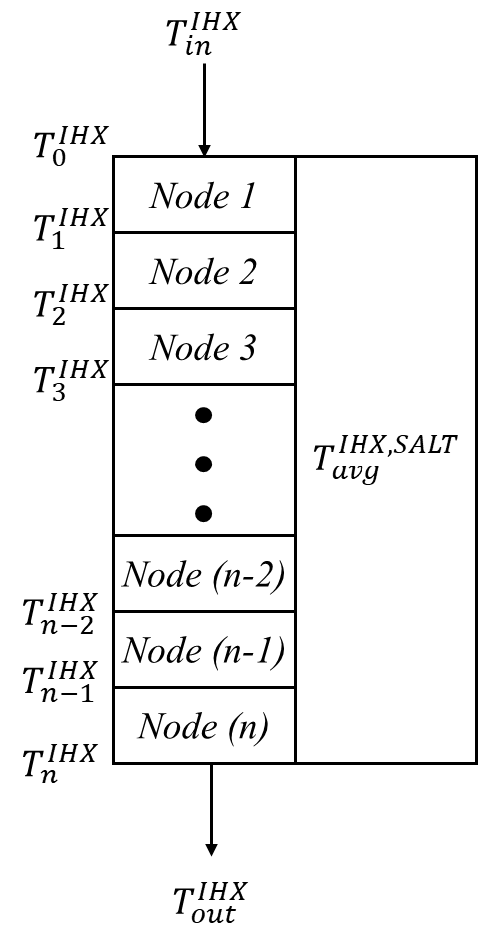

One approach is to express the heat balance within the node using the upwind scheme:

$$M_{IHX,i}c_{pf}\frac{dT_{i}^{IHX}}{dt}={\dot{m}}_{IHX}c_{pf}∙\left(T_{i-1}^{IHX}-T_{i}^{IHX}\right)-Γ_{IHX}∙\left(T_{i}^{IHX}-T_{avg}^{IHX,SALT}\right)$$

From Implicit Euler scheme, one yields:

$$T_{i}^{IHX}\left(∆t\right)∙\left(\frac{M_{IHX,i}c_{pf}}{∆t}+{\dot{m}}_{IHX}c_{pf}+Γ_{IHX}\right)=T_{i}^{IHX}\left(0\right)∙\left(\frac{M_{IHX,i}c_{pf}}{∆t}\right)+{\dot{m}}_{IHX}c_{pf}T_{i-1}^{IHX}\left(∆t\right)+Γ_{IHX}∙T_{avg}^{IHX,SALT}$$

Neglecting time-derivative term, each point-wise temperature distribution can be obtained successively when $Γ_{IHX}$ value is given.

$$T_{i}^{IHX}=\frac{{\dot{m}}_{IHX}c_{pf}T_{i-1}^{IHX}+Γ_{IHX}∙T_{avg}^{IHX,SALT}}{{\dot{m}}_{IHX}c_{pf}+Γ_{IHX}}$$

Then, by comparing $T_{n}^{IHX}$ with initial $T_{out}^{IHX}$, one may determine the $Γ_{IHX}$ value (use secant method)

Similarly, the node-wise balance can be written as

$$M_{IHX,i}c_{pf}\frac{dT_{pr,i}}{dt}={\dot{m}}_{IHX}c_{pf}∙\left(T_{i-1}^{IHX}-T_{i}^{IHX}\right)-Γ_{IHX}∙\left(T_{pr,i}-T_{avg}^{IHX,SALT}\right)$$

where

$$T_{pr,i}=\frac{1}{2}∙\left(T_{i-1}^{IHX}+T_{i}^{IHX}\right)$$

The above expression can be expressed as:

$$\left[1+\frac{Γ_{IHX}Δt}{M_{IHX,i}c_{pf}}+\frac{2{\dot{m}}_{IHX}Δt}{M_{IHX,i}}\right]T_{pr,i}\left(Δt\right)=\frac{2{\dot{m}}_{IHX}Δt}{M_{IHX,i}}T_{i-1}^{IHX}\left(Δt\right)+T_{pr,i}\left(0\right)+\frac{Γ_{IHX}Δt}{M_{IHX,i}c_{pf}}T_{avg}^{IHX,SALT}$$

For determining $Γ_{IHX}$ value, analogous approach to that of upwind scheme method can be applied.

$$T_{pr,i}=\frac{2{\dot{m}}_{IHX}c_{pf}T_{i-1}^{IHX}+Γ_{IHX}∙T_{avg}^{IHX,SALT}}{2{\dot{m}}_{IHX}c_{pf}+Γ_{IHX}}$$

The secondary heat exchanger can be further modelled. In this document, a single node representation is applied for both IHX and SHX. The following (additional) notations are used:

$M_{IHX}^{SALT}$: mass of coolant residing in the IHX

$M_{SHX}$: mass of coolant residing in the SHX

${\dot{m}}_{SHX}$: mass flow rate of coolant salt (kg/sec)

$Γ_{SHX}$: heat removal rate from secondary to the tertiary loop in the SHX (W/K)

$c_{pHx}$: Specific heat of coolant salt

Now, the inlet and outlet temperature of the coolant salt in the IHX are not fixed. Rather the final heat sink, e.g., air radiator for MSRE, is provided with a constant temperature.

$$M_{IHX}c_{pf}\frac{dT_{pr}}{dt}={\dot{m}}_{IHX}c_{pf}∙\left(T_{in}^{IHX}-T_{out}^{IHX}\right)-Γ_{IHX}∙\left(T_{pr}-T_{avg}^{IHX,SALT}\right)$$

$$M_{IHX}^{SALT}c_{pHx}\frac{dT_{avg}^{IHX,SALT}}{dt}={\dot{m}}_{SHX}c_{pHx}∙\left(T_{in}^{IHX,SALT}-T_{out}^{IHX,SALT}\right)+Γ_{IHX}∙\left(T_{pr}-T_{avg}^{IHX,SALT}\right)$$

$$M_{SHX}c_{pHx}\frac{dT_{sr}}{dt}={\dot{m}}_{SHX}c_{pHx}∙\left(T_{in}^{SHX}-T_{out}^{SHX}\right)-Γ_{SHX}∙\left(T_{sr}-T_{sink}\right)$$

where

$$T_{sr}=\frac{1}{2}∙\left(T_{in}^{SHX}+T_{out}^{SHX}\right)$$

The first two equations are solved together to update $T_{pr}$ and $T_{avg}^{IHX,SALT}$ from provided $T_{in}^{IHX}$ and $T_{in}^{IHX,SALT}$

$$\left[\frac{M_{IHX}c_{pf}}{Δt}+2{\dot{m}}_{IHX}c_{pf}+Γ_{IHX}\right]∙T_{pr}\left(Δt\right)+\left(-Γ_{IHX}\right)∙T_{avg}^{IHX,SALT}\left(Δt\right)=\left(\frac{M_{IHX}c_{pf}}{Δt}\right)∙T_{pr}\left(0\right)+2{\dot{m}}_{IHX}c_{pf}T_{in}\left(∆t\right)$$

$$\left(-Γ_{IHX}\right)∙T_{pr}\left(Δt\right)+\left[\frac{M_{IHX}^{SALT}c_{pHx}}{Δt}+2{\dot{m}}_{SHX}c_{pHx}+Γ_{IHX}\right]∙T_{avg}^{IHX,SALT}\left(Δt\right)=\left(\frac{M_{IHX}^{SALT}c_{pHx}}{Δt}\right)∙T_{avg}^{IHX,SALT}\left(0\right)+2{\dot{m}}_{SHX}c_{pHx}T_{in}^{IHX,SALT}\left(∆t\right)$$

By forming 2x2 matrix equation, $T_{out}^{IHX}$ and $T_{out}^{IHX,SALT}$ are updated.

The value for $Γ_{IHX}$ is determined as the same as before. Similar approach is taken for $Γ_{SHX}$

$$Γ_{SHX}=\frac{P_{0}}{T_{sr}-T_{sink}}$$

${\dot{m}}_{SHX}$ value is determined to preserve the power:

$${\dot{m}}_{SHX}=\frac{P_{0}}{c_{pHx}∙\left(T_{in}^{IHX,SALT}-T_{out}^{IHX,SALT}\right)}$$

$T_{out}^{IHX,SALT}$ is provided as $T_{in}^{SHX}$ with a time delay of $τ_{Hx_r }$.

$$T_{in}^{SHX}\left(∆t\right)=T_{out}^{IHX,SALT}\left(∆t-τ_{Hx_r}\right)$$

Solution to the heat balance between the secondary and tertiary loops can be easily obtained:

$$\left[1+\frac{Γ_{SHX}Δt}{M_{SHX}c_{pHx}}+\frac{2{\dot{m}}_{SHX}Δt}{M_{SHX}}\right]T_{sr}\left(Δt\right)=\frac{2{\dot{m}}_{SHX}Δt}{M_{SHX}}T_{in}^{SHX}\left(Δt\right)+T_{sr}\left(0\right)+\frac{Γ_{SHX}Δt}{M_{SHX}c_{pHx}}T_{sink}$$

The outlet temperature of the SHX is then updated and provided to the IHX with a time delay of $τ_{r_Hx }$

$$T_{in}^{IHX,SALT}\left(∆t\right)=T_{out}^{SHX}\left(∆t-τ_{r_Hx}\right)$$

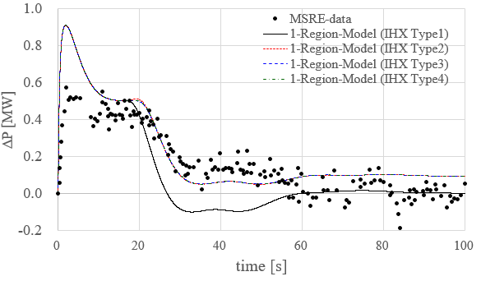

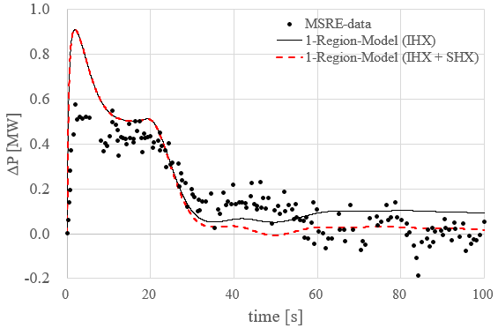

IHX TYPE1: Constant temperature drop

IHX TYPE2: Lumped model (NQE510 model)

IHX TYPE3: Upwind scheme

IHX TYPE4: Box scheme