**FitPet: Gamification of Wearable Health Trackers to Motivate Chronic Pain Patients’ Physical Activity Level,**

Xin Tong, MSc candidate, SFU SIAT

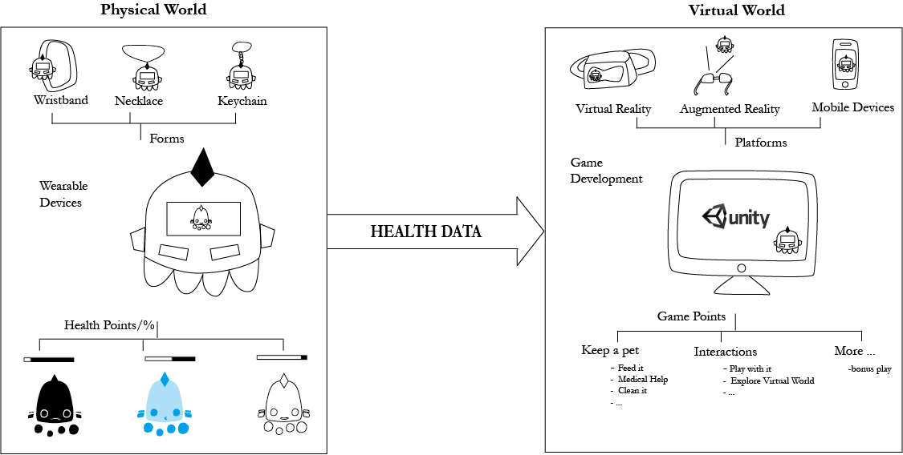

1. **Goal:** Develop a virtual-pet keeping game with input data from wearable health trackers* to motivate girls who undergo scoliosis surgery to track their activity right after surgery, to meet post-surgical goals re: activity, and to self-reflect* about their health status more frequently.
2. **Hypothesis:** By transferring health data to game input and output data based on literature reviews, we believe such gamification method would provide users — especially patients who may want or need to track their personal health data — with a stronger motivation and better means for self-reflection, and thereafter to maintain a higher physical activity level.
3. **Approach:** Users could have access to raw data (numbers), but a virtual pet’s well-being and growth will be associated with (and highly dependent upon) their physical activity level (AR, VR or mobile platform). By connecting users’ health data with their virtual pets’ well-being and other gameplay, we would like to build an association of patients’ self-care with their virtual pets.
4. **Gameplay Design:** Many impact factors could be considered regarding the gameplay design for different purposes. For example, users could only interact with their pet and maintain their pet in a healthy status when they meet the pre-set goals, such as post-surgical activity goals.

*Health trackers: commercial products like Nike+, FitBit, Basis, Jawbone UP, Mint, DailyBurn, Moves and so on.

**Self-reflection: capacity of humans to exercise introspection and the willingness to learn more about their fundamental nature, purpose and essence.