**December 02, 2022**

**KENDI B. ARSITIO**

OSAS - Coordinator

University of Southeastern Philippines – Tagum Unit

Thru:

**MAEVEL ERIN O. ASUMBRADO**

Tagum Student Council - President

Ma’am:

Greetings!

I, Adrian C. Juntilla**, from BSIT 3IT**, would like to ask for a sincere consideration to excuse myself for this coming Paskuhan **2022** due to the reason that I'm not feeling well.

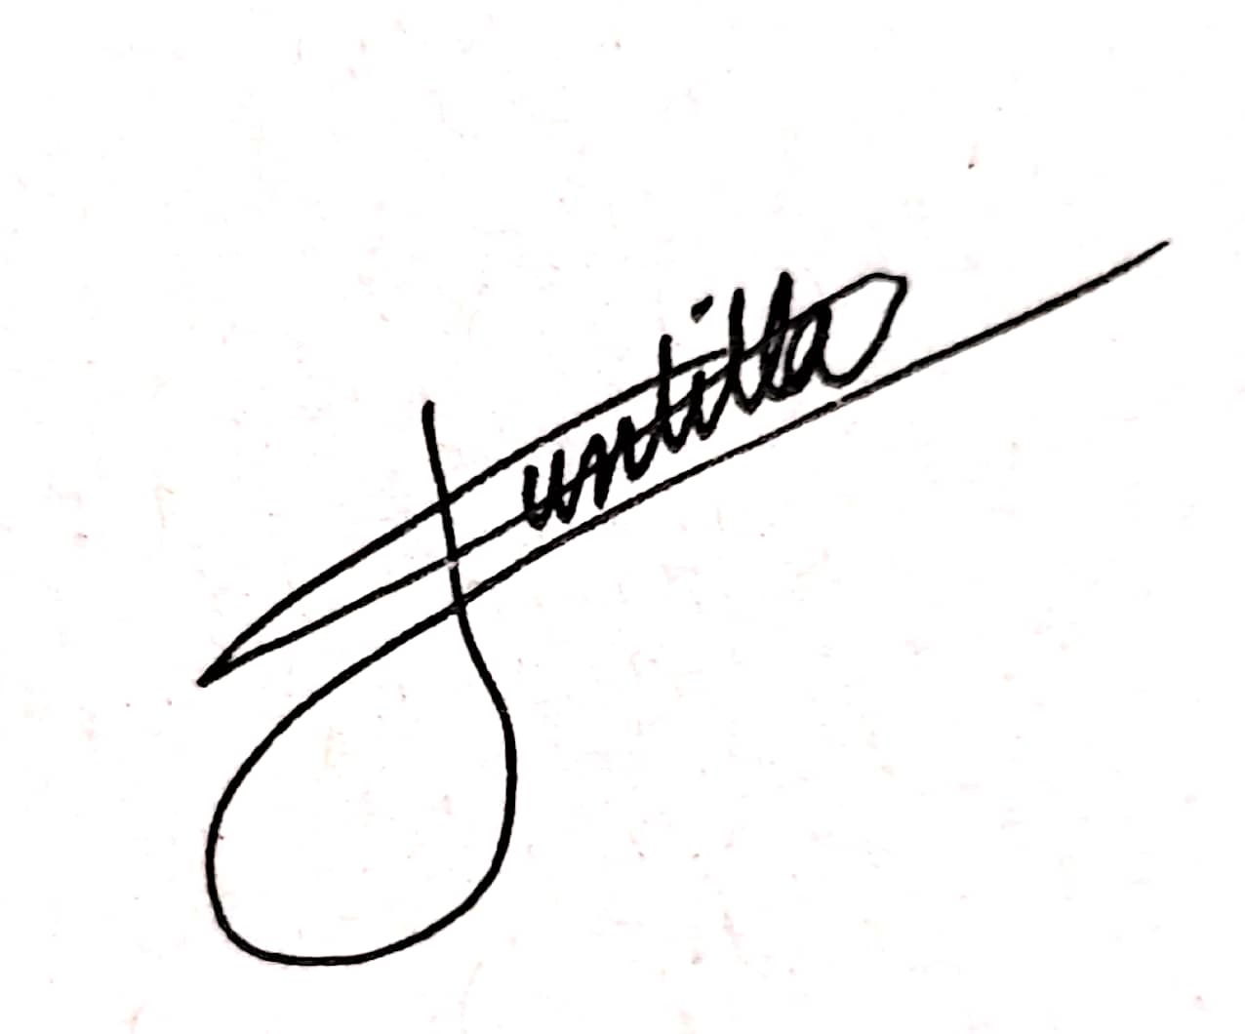Respectfully,

**Adrian Juntilla**Student 3IT

Noted by:

**Bhritney Fearl Munoz**

Student, Mayor (3IT)