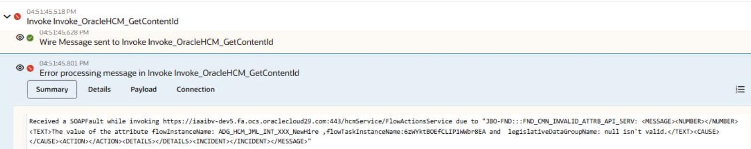

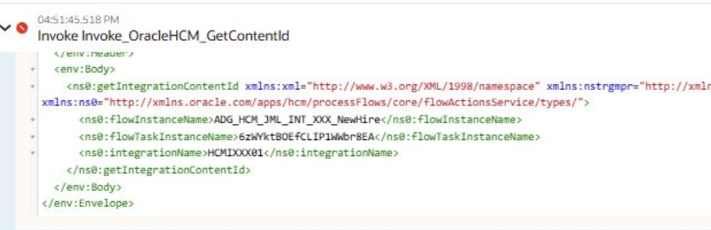

Date: 04 Dec, 2025
