


CS4051NI/CC4059NI Fundamentals of Computing
70% Indivudual Courserwork
Milestone 2
2024/25 Spring
Student Name: Ojaswi Sharma
London Met I D: 23048618
College ID: NP01AI4A230043
Assignment Due Date: Sunday, May 2025
Assignment Submission Date: May 4 2025
GitHub Link

I confirm that I understand my coursework needs to be submitted online via MST Classroom under the relevant module page before the deadline in order for my assignment to be accepted and marked. I am fully aware that late submissions will be treated as non-submission and a marks of zero will be awarded.

Contents
1. Algorithm 1
2. Program 3

Figures

Figure 1 Show Products 8
Figure 2 message when no products 8
Figure 3 sold products with invoice 9
Figure 4 sold invoice details 10

Algorithm

The algorithm is follows:

- Start the program
- Load Products
  - Check if the products.txt exists
  - If exists, extract data
  - Store data in list of directories called products
- Display main menn
  - Show Options:
    - Display Products
    - Sell Products
    - Purchase from vendor
    - Exit
- If Show Products
  - Display products details
  - The selling price is the double of the original price
- If selects sell products
  - Prompt customer name
  - Prompt number of different products to sell
  - Check if products exist with enough stock
    - For every 3 items sold, give 1 free
    - Deduct 4 items from stock
    - If enough stock
      - Deduct total stock quantity
      - Calculate amount
      - Update procust list
    - Else return “stock not availble”
  - If product not found, “display products not found”
  - After sale success
    - Generate a unique invoice file
    - Provide customer name , sold products details in invoice
    - Save updated products list to products.txt
  - Return to main menu
- If selects purchase product
  - Prompt vendor name
  - For each product
    - Get name, brand, quantity, cost country
    - If products exists
      - Add quantity to stock
      - Update cost
    - Else
      - Add a new product entry
    - Generate a unique restock filename
    - Save updated product list to products.txt
  - Return to main menu
- If selects exit
  - Print exit message and stop the program
- End

Program

The program is as follows:

import os
from datetime import datetime

PRODUCTS_FILE = "products.txt"

# Load products from file
def load_products():
products = []
if os.path.exists(PRODUCTS_FILE):
with open(PRODUCTS_FILE, "r") as file:
for line in file:
parts = line.strip().split(", ")
if len(parts) == 5:
name, brand, qty, cost, country = parts
products.append({
"name": name,
"brand": brand,
"qty": int(qty),
"cost": float(cost),
"country": country
})
else:
print("⚠️ Note: 'products.txt' not found.")
return products

# Save products to file
def save_products(products):
with open(PRODUCTS_FILE, "w", encoding="utf-8") as file:
for p in products:
file.write(f"{p['name']}, {p['brand']}, {p['qty']}, {p['cost']}, {p['country']}\n")

# Display product list
def show_products(products):
if not products:
print("\n⚠️ No products available (products.txt not found or empty).\n")
return
print("\nAvailable Products:")
print("Name | Brand | Stock | Cost | Sell Price | Country")
for p in products:
sell_price = p['cost'] * 2
print(f"{p['name']} | {p['brand']} | {p['qty']} | Rs.{p['cost']} | Rs.{sell_price} | {p['country']}")

# Unique filename generator
def generate_filename(prefix):
return f"{prefix}_{datetime.now().strftime('%Y%m%d_%H%M%S')}.txt"

# Sell products to customer
def sell_product(products):
name = input("Enter customer name: ")
while True:
try:
n = int(input("How many types of products? "))
break
except ValueError:
print("Invalid number. Try again.")

total = 0
sold_items = []

for _ in range(n):
pname = input("Product name: ")
while True:
try:
qty = int(input("Quantity to buy: "))
break
except ValueError:
print("Please enter a valid number.")

found = False
for p in products:
if p['name'].lower() == pname.lower():
found = True
free = qty // 3
total_needed = qty + free
if p['qty'] >= total_needed:
sell_price = p['cost'] * 2
amount = qty * sell_price
p['qty'] -= total_needed
sold_items.append((p['name'], p['brand'], qty, free, amount))
total += amount
else:
print("Not enough stock!")
break
if not found:
print("Product not found!")

if sold_items:
filename = generate_filename("invoice")
with open(filename, "w", encoding="utf-8") as f:
f.write(f"Customer: {name}\nDate: {datetime.now()}\n\n")
for item in sold_items:
f.write(f"Product: {item[0]}, Brand: {item[1]}, Qty: {item[2]}, Free: {item[3]}, Subtotal: Rs.{item[4]}\n")
f.write(f"\nTotal: Rs.{total}\n")
print(f"Invoice saved as {filename}")
save_products(products)

# Purchase products from vendor
def restock_products(products):
vendor = input("Enter vendor name: ")
while True:
try:
n = int(input("How many products to purchase? "))
break
except ValueError:
print("Please enter a valid number.")

restocked = []

for _ in range(n):
name = input("Product name: ")
brand = input("Brand: ")

while True:
try:
qty = int(input("Quantity: "))
break
except ValueError:
print("Enter a valid quantity.")

while True:
try:
cost = float(input("Cost Price: "))
break
except ValueError:
print("Enter a valid cost.")

country = input("Country: ")

for p in products:
if p['name'].lower() == name.lower():
p['qty'] += qty
p['cost'] = cost
break
else:
products.append({
"name": name,
"brand": brand,
"qty": qty,
"cost": cost,
"country": country
})

restocked.append((name, brand, qty, cost))

filename = generate_filename("restock")
with open(filename, "w", encoding="utf-8") as f:
f.write(f"Vendor: {vendor}\nDate: {datetime.now()}\n\n")
for item in restocked:
total = item[2] * item[3]
f.write(f"Product: {item[0]}, Brand: {item[1]}, Qty: {item[2]}, Cost: Rs.{item[3]}, Total: Rs.{total}\n")
print(f"Purchase note saved as {filename}")
save_products(products)

# Main loop
def main():
products = load_products()

while True:
print("\n--- WeCare Product System ---")
print("1. Show Products")
print("2. Sell Products to Customer")
print("3. Purchase Products from Vendor")
print("4. Exit")

choice = input("Choose an option (1-4): ")
if choice == "1":
show_products(products)
elif choice == "2":
sell_product(products)
elif choice == "3":
restock_products(products)
elif choice == "4":
print("Exiting program.")
break
else:
print("Invalid choice. Try again.")

if __name__ == "__main__":
main()

Load products:

The products will be shown if only the products.txt exist
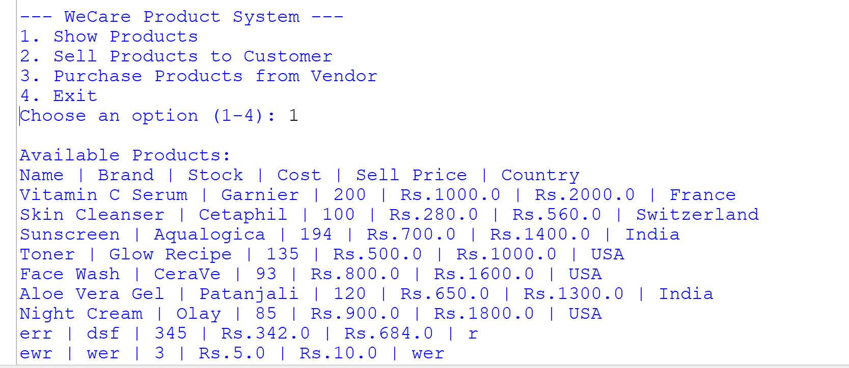

Figure 1 Show Products

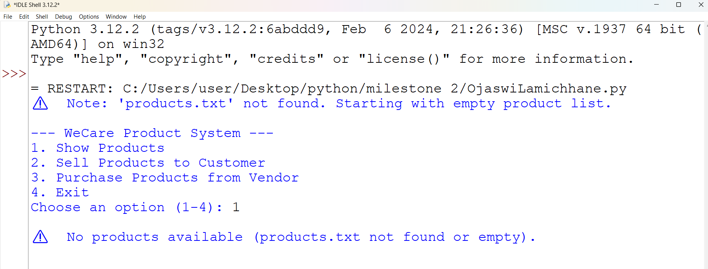
Figure 2 message when no products

Sell Products

The sold products will be recorded and the invoice is created

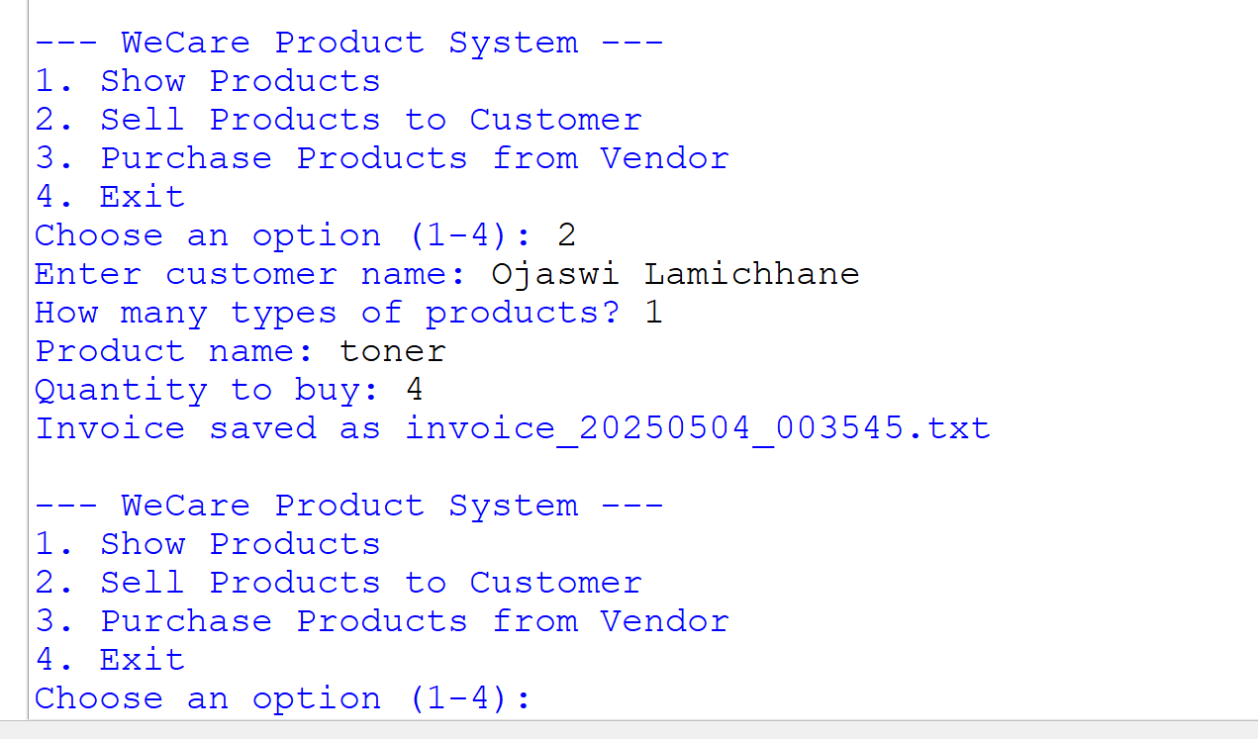

Figure 3 sold products with invoice

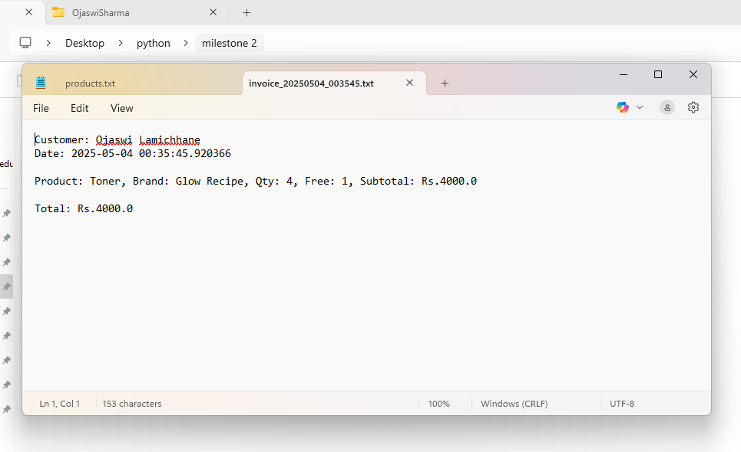
Figure 4 sold invoice details

