

**CONFERENCE**

**12-13TH SEPTEMBRE 2019.**

**SPEAKERS**

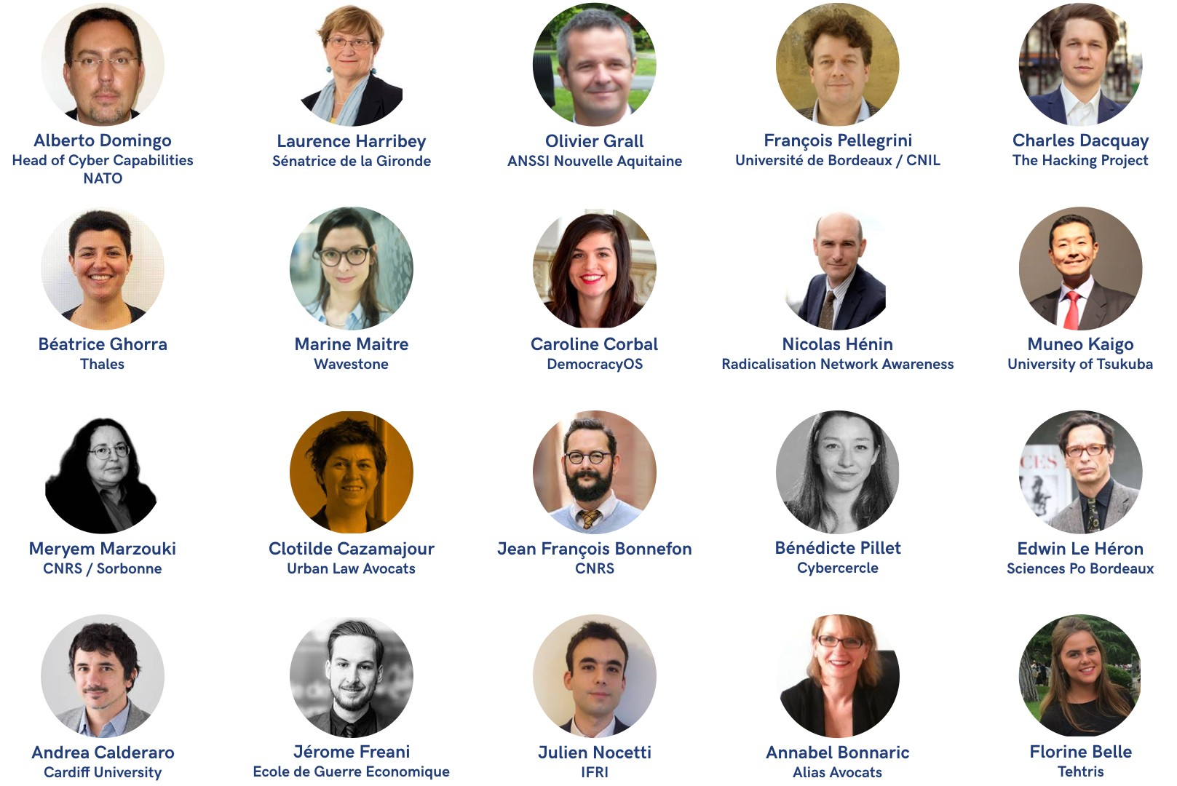

**PARTNERS**

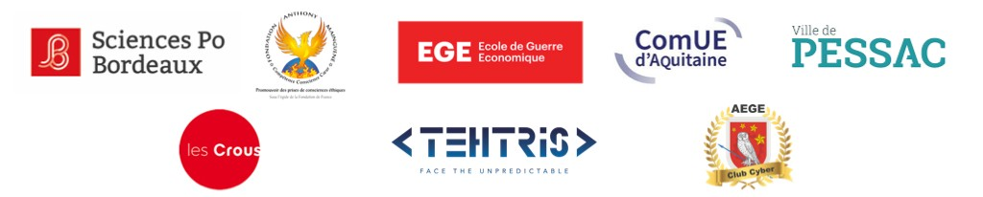

**THURSDAY 12TH SEPTEMBER**

**9H30 - 17H30**

**OPENING : 9h30 - 9h55**

● Presentation of the conference - why cybersecurity ?

■ Verity Masterson & Margaux Girard, founders of BIICS

■ Yves Déloye, Directeur de Sciences Po Bordeaux

● Sponsors :

■ Fondation Anthony Mainguené

**REGULATION, SECURITY & CYBERSPACE :**

**INNOVATION AND NEW PARADIGMS**

**MORNING PART 1 : SWITCHED ON, ONLINE AND CONNECTED: THE INTERNET AND ITS**

**REGULATORY CHALLENGES**

● ***10h - 10h45 : Roundtable :*** Internet Governance in the 21st century: the challenges and opportunities of regulating a cross-border platform

○ Mediator:

■

○ Speakers:

■ Julien Nocetti (Internet Governance IFRI)

■ Florine Belle (Tehtris)

■ Meryem Marzouki (Lab. LIP6 - CNRS & Sorbonne Université - Paris,

France)

■ *Annabelle Bonnaric (IP Lawyer at Alias)*

**MORNING PART 2: CYBERSECURITY IN THE WORKPLACE**

**● 10h45 - 11h15 : Coffee break**

● ***11h15 - 12h15 : Roundtable:*** The future of business: exploring new solutions for a secure workplace

○ Mediator:

■ Marine Maitre (Wavestone)

■ *Annabelle Bonnaric (IP Lawyer at Alias)*

**12h - 13h15 : LUNCH BREAK**

**AFTERNOON - NEW POLITICAL CHALLENGES: INNOVATION AND TECHNOLOGY BEYOND THE INTERNET**

● ***13h15 - 14h : Inaugural conference*:** New political challenges: innovation

and technology beyond the internet

■ Jérôme Freani (Cyberologue)

● ***14h15 - 15h15 : Workshop*s:**

○ IoT - connected cities

■ Clotilde Cazamajour (Urban-Law lawyer)

○ AI - Philosophy - what it is to be human - transhumanism

■ Jean François Bonnefon (CNRS)

○ Blockchain & bitcoin

■ Edwin Le Héron (Sciences Po Bordeaux)

○ E-democracy

■ Caroline Corbal (DOS - Democracy Open Source)

○ Coding *:*

■ Bureau Régional des Etudiants Ingénieurs

● ***15h30 - 16h15 : Summarising Roundtable***

■ Mediator :

**● 16h15 - 16h45 : Coffee break**

● ***16h45 - 17h45 : Q&A sessions :*** Privacy V Security (threats and solutions)

■ François Pellegrini (CNIL)

**● *17h45 - 18h : Closing remarks on the day***

**FRIDAY 13TH SEPTEMBER**

**9H - 13H**

**CYBERSECURITY & INTERNATIONAL RELATIONS**

**MORNING PART 1 : CYBERSECURITY & INTERNATIONAL RELATIONS**

**● *9h - 10h : Opening speech :*** Cybersecurity & International relations

■ Alberto Domingo (NATO HQ Norfolk, head of cyber capabilities)

**MORNING PART 2 : CYBERSECURITY & GEOPOLITICS**

**● *10h15 - 11h: Roundtable :*** National and International digital divides

■ *Andrea Calderaro (Cardiff University)*

■ Bénédicte Pilliet (Cybercercle)

■ Olivier Grall (ANSSI)**

**● 11h - 11h30 : Coffee break**

**● *11h30 - 12h15*** *:* ***Workshops :***

○ How does state control of tech infrastructure shape international relations and conflicts *?*

■ Béatrice Ghorra (Thales)

○ Fake news and online propaganda

■ Nicolas Hénin (Radicalisation expert)

○ Tech war & cybercrime

■ Olivier Grall (ANSSI)

○ Environment - Are the environmental threats associated to technology

(electricity and lithium) enough to unite countries in the fight against climate

change?

■

● ***12h30 - 13h : Closing conference* :** Summary of workshops + concluding remarks on geopolitics

■ Laurence Harribey (Sénat)

● ***13h - 13h30 - Keynote speech closing the conference***

● ***13h30 - 13h45 - Keynote speech closing the conference***

■ Margaux Girard & Verity Marsterson

