**CDD – NIPAS & PAMB Management System manuscript:**

Welcome to the new DENR PAMB and NIPAS management database. This will serve as your guide on how to use the website properly.

**Main Page:**

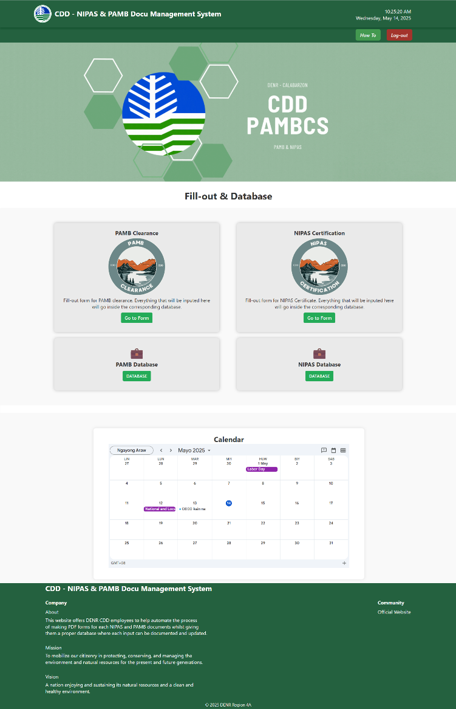In here you can see all of the functions that this website offers. It can tell you the Time & Date, Mission & Vision, About page, Calendar and the Database and Input form for NIPAS and PAMB. The calendar allows users to view and manage important dates, events, and deadlines. Users can click on a date to see event details, add or edit entries, and receive reminders for upcoming activities. Lastly, when clicked "how to" button, this displays a helpful user guide explaining how to navigate and use the website. The guide typically includes step-by-step instructions, illustrations, and explanations of each feature to assist first-time or returning users.

**PAMB:**

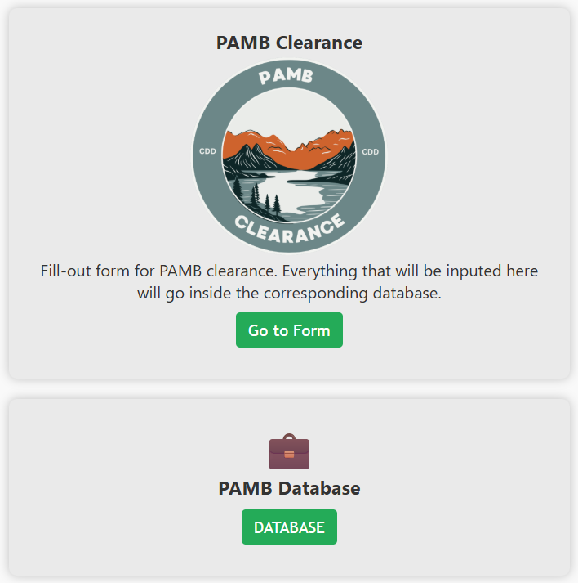Here we can see 2 buttons, PAMB and Database. By clicking PAMB, you will be redirected to another page that enables you to input information to put in the database.

After filling-up the form just click submit and the page will refresh and you will see the ID change to indicate that you have successfully added new data for the database.

To check the database, click the "back" button then click the "Database" button.

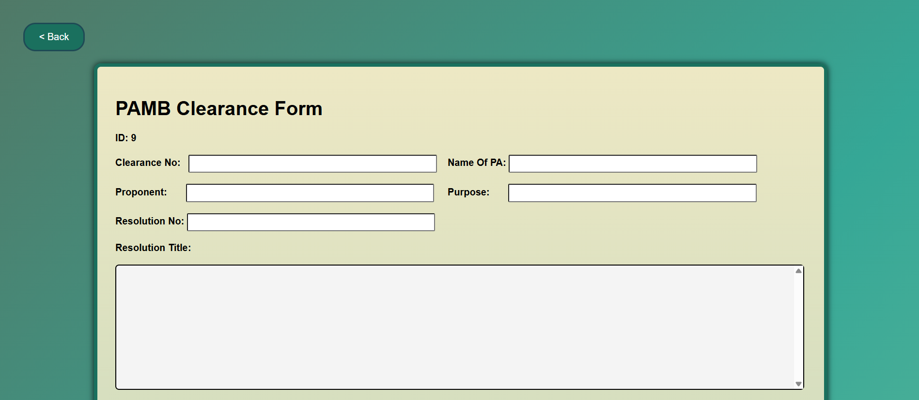In here you can see the search bar, download all (PDF or XLSX) button, delete all button, Edit, and Download PDF or button.

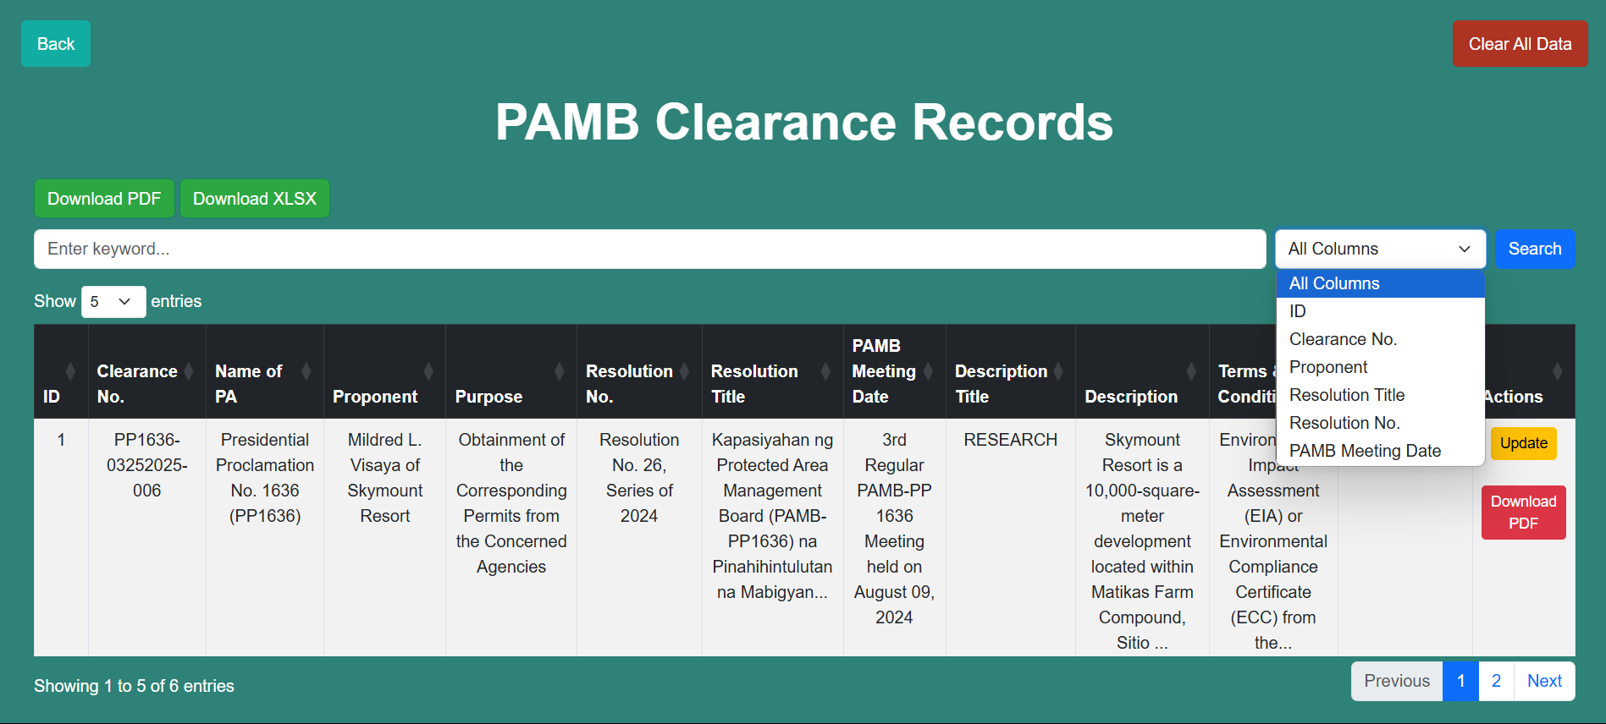

[Grab your reader’s attention with a great quote from the document or use this space to emphasize a key point. To place this text box anywhere on the page, just drag it.]

**⚪️ Search Bar**

The search bar allows you to search Id, Clearance Number, Proponent, Resolution Title, Resolution Number, and PAMB Meeting Date of a specific data that you want to see. Another feature of the search bar is its filter function where you can filter out the specific attribute that you want to search. For example, if you want to search laguna specifically on "location" you can just click the location on the filter so that it will only show laguna on the location category.

**⚪️ Download All (PDF or XLSX)**

By clicking this, you will be able to download all the data from this database in a PDF and XLSX format. Plus, with the filter function you can filter out which data you want to be downloaded in bulk.

**⚪️ Edit**

This will allow you to edit each information inside the database. This will help you whenever you enter the wrong data or things change in the future.

**⚪️ Download PDF**

This will download the specific row of data inside the database and turning it into the PAMB Clearance format. *Note: whenever you want change the format inside the pdf, you can convert it into word by using PDF to Word websites.

**NIPAS:**

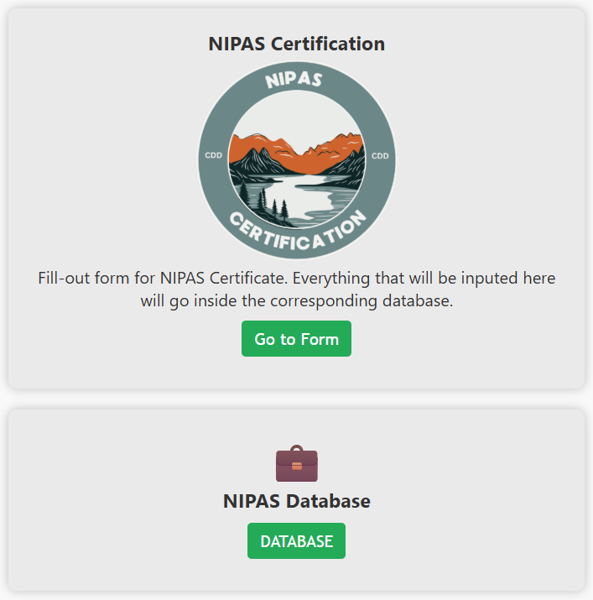This is the same as the PAMB where we have 2 buttons, the NIPAS and Database. They serve the same way at the previous buttons but now it leads you to the NIPAS fill-up form and the NIPAS database.

After filling-up the form just click submit and the page will refresh and you will see the ID change to indicate that you have successfully added new data for the database.

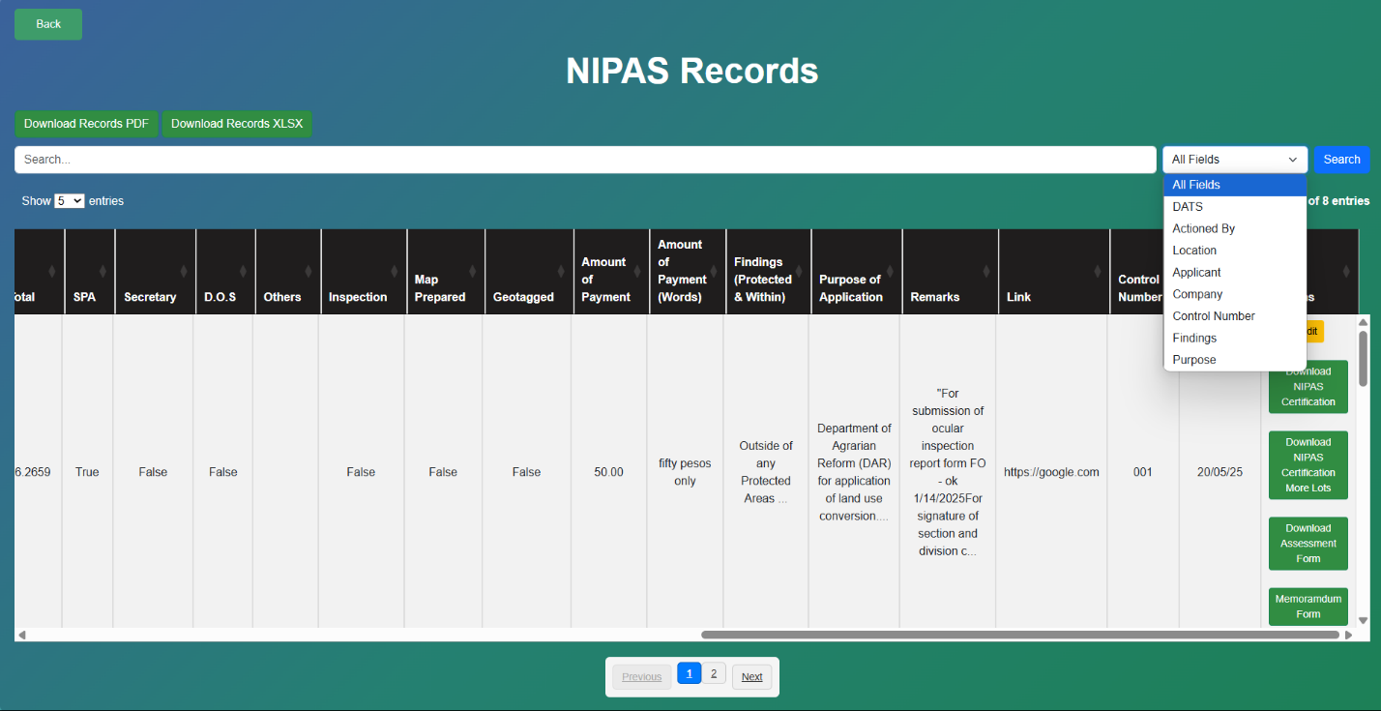to check the database, click the "back" button then click the "Database" button.

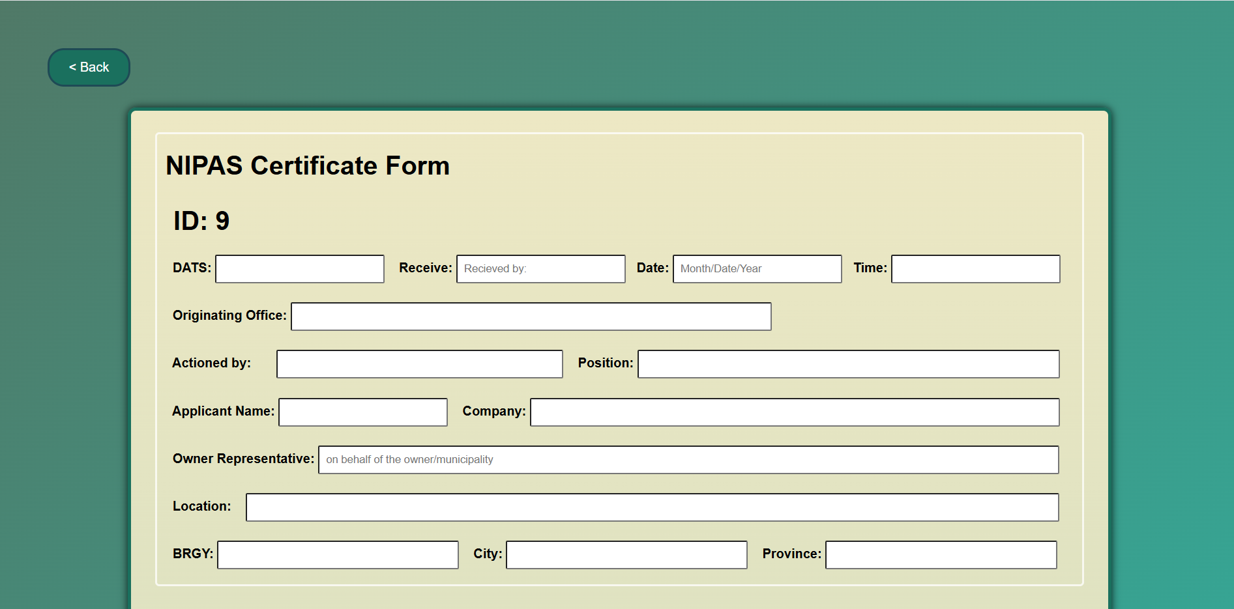

In here you can see the search bar, download all (PDF or XLSX) button, delete all button, Edit, Download Nipas Cert, Download Nipas Cert More, Download Assessment, and Download Memorandum.

**⚪️ Search Bar**

The search bar allows you to search DATS, Actioned By, Location, Applicant, Company, Control Number, Findings, and Purpose of a specific data that you want to see. Another feature of the search bar is its filter function where you can filter out the specific attribute that you want to search. For example, if you want to search number specifically on "DATS" you can just click the DATS on the filter so that it will only show number on the DATS category.

**⚪️ Download All (PDF or XLSX)**

By clicking this, you will be able to download all the data from this database in a PDF and XLSX format. Plus, with the filter function you can filter out which data you want to be downloaded in bulk.

**⚪️ Download NIPAS Certification**

By clicking this, you will be able to download the data from the row and it will automatically create a NIPAS Certificate for single lot in a PDF format.

**⚪️ Download NIPAS Certification More Lots**

By clicking this, you will be able to download the data from the row and it will automatically create a NIPAS Certificate for more lots in a PDF format.

**⚪️ Download Assessment Form**

This will create an Assessment form based on the data inside the specific row and turns it into a PDF.

**⚪️ Download Memorandum Form**

This will create a Memorandum form based on the data inside the specific row and turns it into a PDF.

**⚪️ Edit**

This will allow you to edit each information inside the database. This will help you whenever you enter the wrong data or things change in the future.