**Simple Network Design Project for CCNA Exam Preparation**

**Project Description**

This is a network design project for a medium company of 100 employees.

******Design requirements******

• Each department should contain at least 10 PCs, one printer.

• Appropriate number of switches and routers should be used in the network.

• Using the given network 192.168.1.0/24 for LAN and 10.0.1.0/24 & 10.0.2.0/24 for WLAN, 10.0.3.0/24 for VOIP. All interfaces shall be configured with correct IP addresses, subnet mask and gateways.

• All devices in the network should be connected using appropriate cables.

• Test communication between devices in both SALES, administrative (HR and Finance) and ENGINEERING department.

• Users can also connect wirelessly with the help of an Access Points. Access Points should have a central controller (WLC) with different light weight access points (LAPs).

• There should be one central web server, DNS server, the multilayer switch for inter VLAN routing and as a DHCP server for each VLAN.

• There should be a file server that only accounting department and finance department can have full access.

* Employees should be able to securely connect remotely to the company resources via Remote access VPN.
* Employees can use VoIP to make and receive calls between departments.

**Step 1:**

Review of the network devices, tools and equipment needed for this network design

1. Cisco 4331 router - Aggregate throughput of 100Mbps – 300Mbps. Default @100Mbps while performance license @300Mbps. This is the total ingress and egress of the router. Well, boost license get to push over 2Gbps.
2. Cisco Multilayer switch 3560 24PS (L3)
3. Cisco Switch WS 2960 (L2)
4. Network Controller
5. Cisco WLC 3504
6. Cisco Light weight Access Point
7. Cisco IP PHONE 7960
8. Dell PC running windows 10
9. Cisco Rack
10. Cisco Power distribution device
11. Copper patch panel
12. Category 5 & 5e UTP LAN cable access connection while cat 6 for router – switch, switch – switch connection
13. RJ-45 plug
14. Cisco 4331 /K9 Router

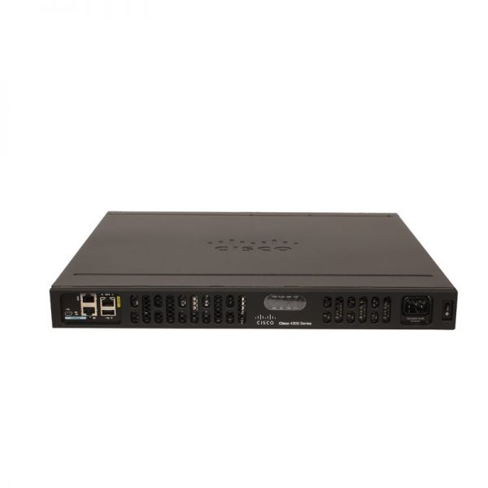

<https://www.router-switch.com/cisco-isr4331-k9-p-16544.html#tab-download>

Other vendors to consider

1. Juniper router SSR130 (for medium branch), <https://www.juniper.net/documentation/us/en/hardware/ssr130/topics/topic-map/ssr130-overview.html>, for more about juniper routers visit
2. Mikrotik Routers, <https://www.router-switch.com/mikrotik-routers.html>, <https://mikrotik.com/products/group/ethernet-routers>
3. Others,
4. Cisco 2811 v/k9 Voice Bundle router

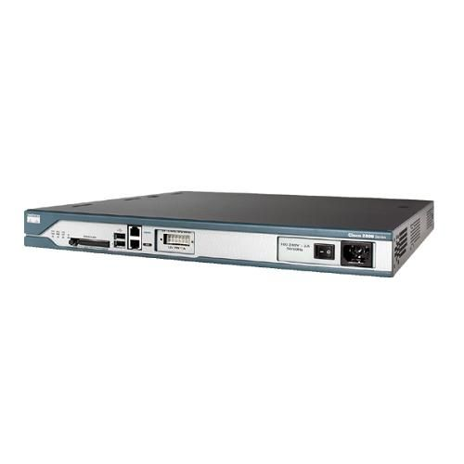

https://www.router-switch.com/cisco2811-v-k9-p-209.html

Other cisco voice bundle routers

1. ISR 4331 V/K9, note that the 4331 in Packet tracer is does not have the voice feature.
2. 2911 V/K9
3. 2901 V/K9
4. 2921 V/K9, etc.,
5. **CISCO CATALYST 2960-24TC-S Switch**

Major Specification

1. 24 Ethernet 10/100 Ports
2. dual-purpose ports (10/100/1000 or SFP)

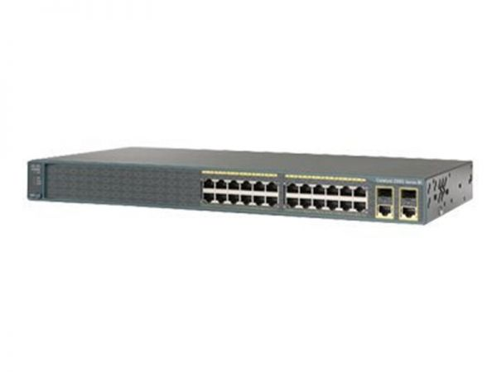

You can find out more about this device using the link below. Note: It doesn’t have PoE capability.

<https://www.router-switch.com/ws-c2960-24tc-s-p-5255.html>

Also, you can read more about all the Cisco Catalyst 2960 series switches here <https://www.cisco.com/c/en/us/products/collateral/switches/catalyst-2960-series-switches/product_data_sheet0900aecd806b0bd8.html>

<https://floralimited.com/products/cisco-catalyst-2960-24-port-10100-switch-ws-c296024tc-s-i1302.html>

Some other vendor switches that we can use

1. Juniper Networks EX2200-24T-4G Ethernet Switch

<https://www.networkscreen.com/EX2200-24T-4G.asp> . However, this product is no longer available but can be replaced with EX2300-24T with which has advanced capabilities.

1. Huawei S3700-28TP-SI-AC ethernet switch, <https://www.router-switch.com/s3700-28tp-si-ac-p-5573.html>
2. Netgear ProSales 24-Port 10/100 Mbps L2 Managed Switch, <https://www.bhphotovideo.com/c/product/514463-REG/Netgear_FSM726NA_ProSafe_24_Port_10_100_Mbps.html>
3. D-Link 24-Port Gigabit Smart Managed Switch DGS 1100-24, <https://www.dlink.com/en/products/dgs-1100-24-24-port-gigabit-smart-managed-switch>
4. TP-link switches, <https://www.tp-link.com/us/business-networking/all-switch/>

**CISCO CATALYST 2960-24TC-S Switch Interfaces**

|  |  |  |  |
| --- | --- | --- | --- |
| INTERFACE | VLAN ID | CONNECTED DEVICES | ETHERNET CABLE USED |
| F0/1 | 50 | Packet Tracer (PT) DNS Server | Copper Straight-through (Cat6) |
| F0/2 | 50 | PT-Server 1 | Copper Straight-through (Cat6) |
| F0/3 | 50 | PT-Server 2 | Copper Straight-through (Cat6) |
| F0/4 | 50 | None |  |
| F0/5 | 50 | None |  |
| F0/6 | 20 | IP Phone 4/PC7 | Copper Straight-Through (Cat5e) |
| F0/7 | 20 | IP Phone 5/PC8 | Copper Straight-Through (Cat5e) |
| F0/8 | 20 | Sales Printer | Copper Straight-through (Cat5e) |
| F0/9 | 20 | None |  |
| F0/10 | 20 | None |  |
| F0/11 | 20 | None |  |
| F0/12 | 20 | None |  |
| F0/13 | 20 | None |  |
| F0/14 | 20 | None |  |
| F0/15 | 5 | LAP-SALES | Copper Straight-Through (Cat6) |
| F0/16 | 10 | IP Phone 6/PC9 | Copper Straight-Through (Cat5e) |
| F0/17 | 10 | IP Phone 7/PC10 | Copper Straight-Through (Cat5e) |
| F0/18 | 10 | Admin Printer | Copper Straight-Through (Cat5e) |
| F0/19 | 10 | None |  |
| F0/20 | 10 | None |  |
| F0/21 | 10 | None |  |
| F0/22 | 10 | None |  |
| F0/23 | 10 | None |  |
| F0/24 | 5 | LAP-ADMIN | Copper Straight-Through (Cat6) |
| G0/1 | Trunk | Multilayer switch | Copper Cross-over (Cat6) |
| G0/2 | Trunk | Multilayer switch | Copper Cross-over (Cat6) |

1. **Cisco WS-C3650-24PS (Multilayer Switch)**

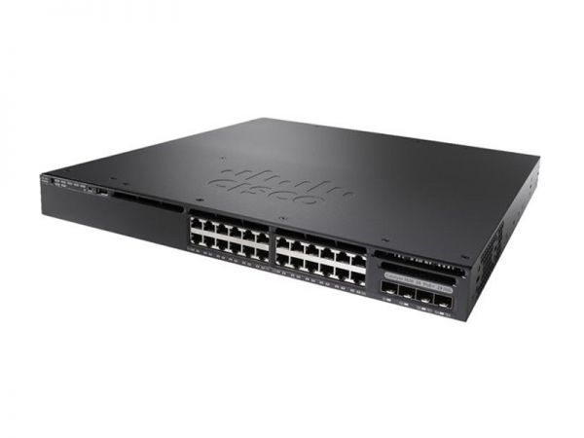

You can find out more about this device using the link below. Note: It has PoE capability.

[**https://www.router-switch.com/ws-c3650-24ps-s-p-5426.html**](https://www.router-switch.com/ws-c3650-24ps-s-p-5426.html)

Also, you can read more about all the Cisco WS-C3650 series switches here

<https://www.cisco.com/c/en/us/products/collateral/switches/catalyst-3650-series-switches/data_sheet-c78-729449.html>

Some other vendor L3 switches that we can use

1. Juniper Networks EX3300 -24P Ethernet Switch, <https://www.networkscreen.com/EX3300-48P.asp>
2. Huawei S5720-32X-EI24S-AC, <https://www.router-switch.com/s5720-32x-ei-24s-ac-p-15943.html>
3. Netgear M4350 -24X4V Fully Managed switch, <https://www.netgear.com/business/wired/switches/fully-managed/xsm4328cv/>
4. D-link 28-Port layer 3 stackable Managed Gigabit Switch DGS-3630-28TC, <https://www.dlink.com/en/products/dgs-3630-28tc-28-port-layer-3-stackable-managed-gigabit-switch>

**Multilayer switch interface 3650 24P SWITCH (NOTE: This is a PoE switch)**

|  |  |  |  |
| --- | --- | --- | --- |
| INTERFACE | VLAN ID | CONNECTED DEVICES | ETHERNET CABLE USED |
| G1/0/1 | 10 | WLC-3504 | Copper Cross-over (Cat6) |
| G1/0/2 | 10 | LAP-PT (AP1) | Copper Straight-Through (Cat6) |
| G1/0/3 | 10 | LAP-PT (ENGINEERING) | Copper Straight-Through (Cat6) |
| G1/0/4 | 10 | Management PC1 | Copper Straight-Through (Cat5) |
| G1/0/5 | 30 | IP Phone 0/PC3 | Copper Straight-Through (Cat5e) |
| G1/0/6 | 30 | IP Phone 1/PC4 | Copper Straight-Through (Cat5e) |
| G1/0/7 | 30 | IP Phone 2/PC5 | Copper Straight-Through (Cat5e) |
| G1/0/8 | 30 | IP Phone 3/PC6 | Copper Straight-Through (Cat5e) |
| G1/0/9 | 30 | Engr-Printer | Copper Straight-Through (Cat5e) |
| G1/0/10 | 30 | None |  |
| G1/0/11 | 30 | None |  |
| G1/0/12 | 30 | None |  |
| G1/0/13 | 30 | None |  |
| G1/0/14 | 10 | None |  |
| G1/0/15 | Trunk | 2960 switch | Copper Cross-over (Cat6) |
| G1/0/16 | Trunk | 2960 switch | Copper Cross-over (Cat6) |
| G1/0/17 | 1 | None |  |
| G1/0/18 | 1 | None |  |
| G1/0/19 | 1 | None |  |
| G1/0/20 | 1 | None |  |
| G1/0/21 | 1 | None |  |
| G1/0/22 | 10 | Network Controller | Copper Straight-Through (Cat5e0 |
| G1/0/23 | Routed-port (Uplink) | 4331 ISR | Copper Straight-Through (Cat6) |
| G1/0/24 | Trunk | 2811-Router | Copper Straight-Through (Cat6) |
| G1/1/1 | 1 | None |  |
| G1/1/2 | 1 | None |  |
| G1/1/3 | 1 | None |  |
| G1/1/4 | 1 | None |  |

1. **Network Controller**

A network controller is a software that orchestrates network functions. It serves as an intermediary between the business and the network infrastructure. Read more via the link <https://www.cisco.com/c/en/us/solutions/enterprise-networks/what-is-a-network-controller.html>, <https://www.cisco.com/c/en/us/products/collateral/cloud-systems-management/crosswork-network-automation/datasheet-c78-743456.html>

1. **Cisco WLC 3504**

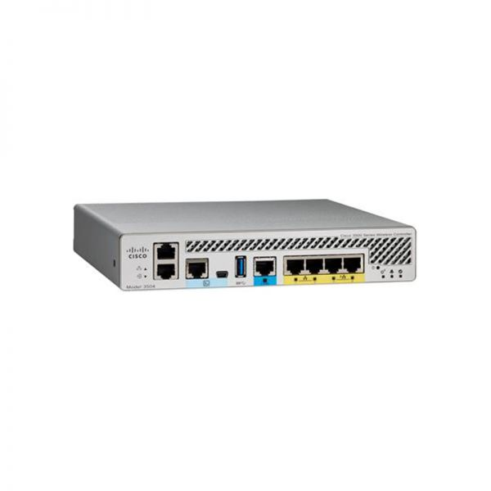

<https://www.router-switch.com/air-ct3504-k9.html>

Cisco Light weight access points

FAQ: <https://www.cisco.com/c/en/us/support/docs/wireless/aironet-1200-series/70278-lap-faq.html>

For use later, <https://www.secureitstore.com>

1. **Cisco IP PHONE 7960**

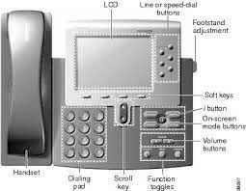

<https://www.cisco.com/c/en/us/td/docs/voice_ip_comm/cuipph/7960g_7940g/sip/1_0/english/administration/guide/ver1_0/overview.html>

<https://www.youtube.com/watch?v=YWv608W7O1Y&t=6485s>

1. **Cisco Rack**

<https://www.youtube.com/watch?v=QQmoZ1GrgA0>

<https://www.youtube.com/watch?v=-y02T1Vt0RU>

1. **Power distribution unit (PDU)**

<https://www.cisco.com/c/en/us/td/docs/unified_computing/ucs/R_Series_Racks/Cisco_R42612_Rack_and_PDU_Installatiion_Guide/Cisco_R42612_Rack_and_PDU_Installatiion_Guide_chapter_0101.html>

1. **Copper Patch Panel**

<https://community.fs.com/blog/how-to-select-the-suitable-copper-patch-panel.html>

<https://community.fs.com/blog/modular-patch-panel-basics-usage.html>

<https://community.fs.com/blog/should-we-choose-punch-down-or-feed-through-patch-panel.html>

<https://www.youtube.com/watch?v=w74M7F4wfxc>

1. **Network Cabling**

Cat5, Cat5e and Cat6

<https://www.mse-uk.com/services/data-networks/guide-network-cabling-installation/>

Beginners guide to network cabling, <https://www.youtube.com/watch?v=-uVubQlLiI0>

<https://www.youtube.com/watch?v=bMr-z6TUmWQ>,

<https://www.youtube.com/watch?v=qcET-OgrCCY>

<https://www.youtube.com/watch?v=ba7kUICmLhs>

Cable Management, <https://www.youtube.com/watch?v=qlwCYkx8h8o>

How to terminate ethernet cable, <https://www.youtube.com/watch?v=2OLeNqsNATQ>

<https://www.youtube.com/watch?v=Ur03qCHXxbw>

**Step 2: Creating subnets and vlans**

We will have a total of 9 VLANs.

|  |  |  |  |  |  |
| --- | --- | --- | --- | --- | --- |
| Department | No of Users | Pool Range | Usable Available IP | VLAN ID |  |
| Administrative | 30 | 192.168.1.0/26 | 62 | 5 |  |
| Sales | 20 | 192.168.1.64/26 | 62 | 20 |  |
| Engineering | 30 | 192.168.1.128/26 | 62 | 30 |  |
| Management vlan (WLC, ROUTERS, SWITCH) |  | 172.16.1.0/24 | 254 | 10 |  |
| Server room | 20 | 192.168.1.192/24 | 62 | 50 |  |
| VoIP | 100 | 10.0.3.0/24 | 254 | 100 |  |
| WLAN | Internal  Guess | 10.0.1.0/24  10.0.2.0/24 | 254  254 | 200  300 |  |
| Native vlan |  |  |  | 10 (untagged) |  |

**Step 3: Implementation**

We shall follow the below config process

1. Setup the physical topology
2. Using console log on to configure the vlans on the switches
3. Configure a working LAN first using the L3 switch for inter vlan routing.
4. Introduce voice vlan using 2811 router and verify it is working
5. Introduce Light weight APs and WLC and verify it is working
6. Configure the edge router 4331 as the gateway to the external network, use NAT overload.
7. Configure static route to our internal network on the internet router
8. Configure the DNS Server, file server
9. Configure all layer 2 and layer 3 security protocols
10. Configure remote access vpn
11. The last should be password config on network devices/remote login config

No 1: Physical Topology

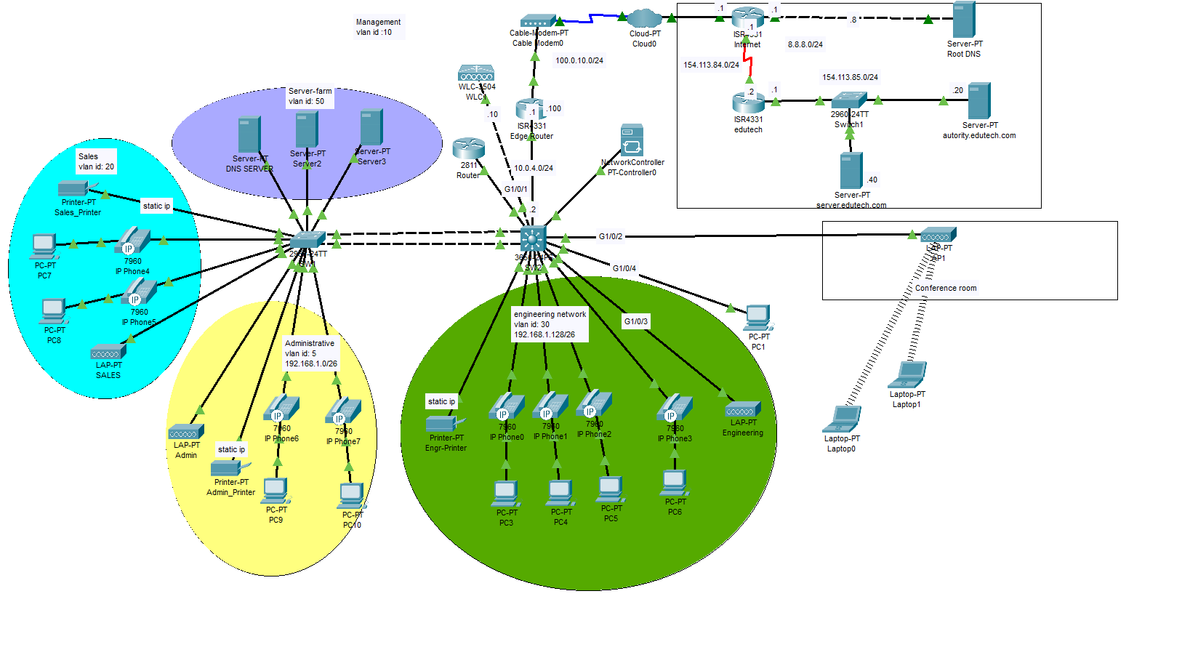

No 2: Using console to log on vlans on switches.

On 2960 switch

Switch>en

Switch# conf t

Switch(config)# hostname SWI

SW1(config) int range f0/1-5

SW1(config-if-range) switchport mode access

SW1(config-if-range) switchport access vlan 50

SW1(config-if-range) spanning-tree portfast ##Enabling portfast of these interface helps them to by-pass STP

SW1(config-if-range) spanning-tree bpduguard enable

SW1(config-if-range) switchport port-security mac-address sticky

SW1(config-if-range) int range f0/6-14

SW1(config-if-range) switchport mode access

SW1(config-if-range) switchport access vlan 20

SW1(config-if-range) spanning-tree portfast ##Enabling portfast of these interface helps them to by STP

SW1(config-if-range) spanning-tree bpduguard enable

SW1(config-if-range) switchport port-security mac-address sticky

SW1(config-if-range) int range f0/15, f0/24

SW1(config-if-range) switchport mode access

SW1(config-if-range) switchport access vlan 5

SW1(config-if-range) spanning-tree portfast ##Enabling portfast of these interface helps them to by STP

SW1(config-if-range) spanning-tree bpduguard enable

SW1(config-if-range) switchport port-security mac-address sticky

SW1(config-if-range) int range f0/16-23

SW1(config-if-range) switchport mode access

SW1(config-if-range) switchport access vlan 10

SW1(config-if-range) spanning-tree portfast ##Enabling portfast of these interface helps them to by STP SW1(config-if-range) spanning-tree bpduguard enable

SW1(config-if-range) switchport port-security mac-address sticky

SW1(config-if-range) int range g0/1-2

SW1(config-if-range) switchport mode trunk ##trunk mode on is used, no trunking protocol

SW1(config-if-range) switchport trunk allowed vlan 5,10,20,50,30,100,200,300

SW1(config-if-range) switchport trunk native vlan 10

#creating vlan and port assignment to vlan

SW1(config-if-range) vlan 30

SW1(config-vlan) name Engr

SW1(config-vlan) vlan 100

SW1(config-vlan) name Internal_WLAN

SW1(config-vlan) vlan 200

SW1(config-vlan) name Guest_WLAN

SW1(config) int range f0/6-7, f0/16-17

SW1(config-range) switchport voice vlan 300

SW1(config-range) vlan 300

SW1(config-vlan) name VOIP

SW1(config-vlan)

SW1(config-vlan) vlan 300

SW1(config-vlan) name VOIP

SW1(config-vlan) vlan 5

SW1(config-vlan) name Admin

SW1(config-vlan) vlan 10

SW1(config-vlan) name Management

SW1(config-vlan) vlan 20

SW1(config-vlan) name Sales

SW1(config-vlan) vlan 50

SW1(config-vlan) name Server-farm

SW1(config-vlan)

SW1(config-if-range) do write

SW1(config-if-range) do copy running-config startup-config

**On 3650 switch**

Switch>en

Switch# conf t

Switch(config)# hostname SW2

SW2(config) int range g1/0/1-4

SW2(config-if-range) switchport mode access

SW2(config-if-range) switchport access vlan 10

SW2(config-if-range) spanning-tree portfast ##Enabling portfast of these interface helps them to by STP

SW2(config-if-range) spanning-tree bpduguard enable

SW2(config-if-range) switchport port-security mac-address sticky

SW2(config-if-range) int range g1/0/5-13

SW2(config-if-range) switchport mode access

SW2(config-if-range) switchport access vlan 30

SW2(config-if-range) spanning-tree portfast ##Enabling portfast of these interface helps them to bypass learning/listening STP

SW2(config-if-range) spanning-tree bpduguard enable

SW2(config-if-range) switchport port-security mac-address sticky

SW2(config-if-range) int range g1/0/15-16

SW2(config-if-range) switchport mode trunk

SW2(config-if-range) switchport trunk allowed vlan 5,10,20,30,50,100,200,300 ##allowing all the vlans that we will be using on the network

SW2(config-if-range) switchport trunk native vlan 10

#creating vlans

SW2(config-vlan) vlan 100

SW2(config-vlan) name Internal_WLAN

SW2(config-vlan) vlan 200

SW2(config-vlan) name Guest_WLAN

SW2(config-vlan) vlan 300

#Creating voice vlan

SW2(config) int range g1/0/5-8

SW2(config-range) switchport voice vlan 300

SW2(config-range) vlan 300

SW2(config-vlan) name VOIP

SW2(config-vlan) vlan 5

SW2(config-vlan) name Admin

SW2(config-vlan) vlan 10

SW2(config-vlan) name Management

SW2(config-vlan) vlan 20

SW2(config-vlan) name Sales

SW2(config-vlan) vlan 50

SW2(config-vlan) name Server-farm

SW2(config-if-range) vlan 30

SW2(config-vlan) name Engr

SW2(config-vlan) do wr

SW2(config-vlan) do copy running-config startup-config

No 3: Inter VLAN Routing

This is done using the L3 switch

SW2>en

SW2#conf t

SW2(config) ip routing

**#Creating virtual interfaces and giving them an ip address**

SW2(config) interface vlan 5

SW2(config-if) ip address 192.168.1.1 255.255.255.192

SW2(config-if) no shut

SW2(config) interface vlan 10

SW2(config-if) ip address 172.16.1.1 255.255.255.0

SW2(config-if) no shut

SW2(config) interface vlan 20

SW2(config-if) ip address 192.168.1.65 255.255.255.192

SW2(config-if) no shut

SW2(config) interface vlan 30

SW2(config-if) ip address 192.168.1.129 255.255.255.192

SW2(config-if) no shut

SW2(config) interface vlan 50

SW2(config-if) ip address 192.168.1.193 255.255.255.192

SW2(config-if) no shut

SW2(config) interface vlan 100

SW2(config-if) ip address 10.0.0.1 255.255.255.0

SW2(config-if) no shut

SW2(config) interface vlan 200

SW2(config-if) ip address 10.1.0.1 255.255.255.0

SW2(config-if) no shut

SW2(config-if) exit

**#Creating DHCP Pool for our vlans**

SW2(config) ip dhcp pool VLAN10

SW2(dhcp-config) network 172.16.1.0 255.255.255.0

SW2(dhcp-config) default-router 172.16.1.1

SW2(dhcp-config) dns-server 192.168.1.194

SW2(dhcp-config) exit

SW2(config) ip dhcp pool VLAN100

SW2(dhcp-config) network 10.0.0.0 255.255.255.0

SW2(dhcp-config) default-router 10.0.0.1

SW2(dhcp-config) dns-server 192.168.1.194

SW2(dhcp-config) exit

SW2(config) ip dhcp pool VLAN200

SW2(dhcp-config) network 10.1.0.0 255.255.255.0

SW2(dhcp-config) default-router 10.1.0.1

SW2(dhcp-config) dns-server 192.168.1.194

SW2(dhcp-config) exit

SW2(config) ip dhcp pool administrative

SW2(dhcp-config) network 192.168.1.0 255.255.255.192

SW2(dhcp-config) default-router 192.168.1.1

SW2(dhcp-config) dns-server 192.168.1.194

SW2(dhcp-config) exit

SW2(config) ip dhcp pool Sales

SW2(dhcp-config) network 192.168.1.64 255.255.255.192

SW2(dhcp-config) default-router 192.168.1.65

SW2(dhcp-config) dns-server 192.168.1.194

SW2(dhcp-config) exit

SW2(config) ip dhcp pool engineering

SW2(dhcp-config) network 192.168.1.128 255.255.255.192

SW2(dhcp-config) default-router 192.168.1.129

SW2(dhcp-config) dns-server 192.168.1.194

SW2(dhcp-config) exit

SW2(config) ip dhcp pool server-farm

SW2(dhcp-config) network 192.168.1.192 255.255.255.192

SW2(dhcp-config) default-router 192.168.1.193

SW2(dhcp-config) dns-server 192.168.1.194

SW2(dhcp-config) exit

SW2(config) do wr

SW2(config) do copy running-config startup-config

SW2(config)

SW2(config)

**No 4: Introduce voice vlan using 2811 router and verify it is working**

Router>en

Router# conf t

Router(config) hostname VOIP-Router

VOIP-Router(config)int f0/1.300

VOIP-Router(config-subif) encapsulation dot1q 300

VOIP-Router(config-subif) ip address 10.0.3.1 255.255.255.0

VOIP-Router(config-subif) no shut

VOIP-Router(config-subif)exit

VOIP-Router(config) ip dhcp excluded-address 10.0.3.1

VOIP-Router(config) ip dhcp pool VOIP

VOIP-Router(dhcp-config) network 10.0.3.0 255.255.255.0

VOIP-Router(dhcp-config) default-router 10.0.3.1

VOIP-Router(dhcp-config) dns-server 192.168.1.194

VOIP-Router(dhcp-config) option 150 ip 10.0.3.1

VOIP-Router(dhcp-config) exit

VOIP-Router(config) do wr

VOIP-Router(config)

#Creating Telephony service

VOIP-Router(config) telephony-service

VOIP-Router(config-telephony) max-ephones 10

VOIP-Router(config-telephony) max-dn 10

VOIP-Router(config-telephony) ip source-address 10.0.3.1 port 2000

To manually register the phones

VOIP-Router(config-telephony) exit

VOIP-Router(config) ephone-dn 1

VOIP-Router(config-ephone-dn) number 1000

VOIP-Router(config-ephone-dn) exit

VOIP-Router(config)

VOIP-Router(config) ephone-dn 2

VOIP-Router(config-ephone-dn) number 1001

VOIP-Router(config-ephone-dn) exit

VOIP-Router(config)

VOIP-Router(config) ephone-dn 3

VOIP-Router(config-ephone-dn) number 1002

VOIP-Router(config-ephone-dn) exit

VOIP-Router(config)

VOIP-Router(config) ephone-dn 4

VOIP-Router(config-ephone-dn) number 1003

VOIP-Router(config-ephone-dn) exit

VOIP-Router(config)

VOIP-Router(config) ephone-dn 5

VOIP-Router(config-ephone-dn) number 1004

VOIP-Router(config-ephone-dn) exit

VOIP-Router(config)

VOIP-Router(config) ephone-dn 6

VOIP-Router(config-ephone-dn) number 1005

VOIP-Router(config-ephone-dn) exit

VOIP-Router(config)

VOIP-Router(config) ephone-dn 7

VOIP-Router(config-ephone-dn) number 1006

VOIP-Router(config-ephone-dn) exit

VOIP-Router(config)

VOIP-Router(config) ephone-dn 8

VOIP-Router(config-ephone-dn) number 1007

VOIP-Router(config-ephone-dn) exit

VOIP-Router(config)

VOIP-Router(config) ephone-dn 9

VOIP-Router(config-ephone-dn) number 1008

VOIP-Router(config-ephone-dn) exit

VOIP-Router(config)

VOIP-Router(config) ephone-dn 10

VOIP-Router(config-ephone-dn) number 1009

VOIP-Router(config-ephone-dn) exit

VOIP-Router(config)

VOIP-Router(config) ephone 1

VOIP-Router(config-ephone) button 1:1

VOIP-Router(config-ephone) exit

VOIP-Router(config)

VOIP-Router(config) ephone 2

VOIP-Router(config-ephone) button 1:2 Note: button 1 is only allowed on packet tracer

VOIP-Router(config-ephone)

VOIP-Router(config) ephone 3

VOIP-Router(config-ephone) button 1:3

VOIP-Router(config-ephone)

VOIP-Router(config) ephone 4

VOIP-Router(config-ephone) button 1:4

VOIP-Router(config-ephone) ephone 5

VOIP-Router(config-ephone) button 1:5

VOIP-Router(config-ephone) ephone 6

VOIP-Router(config-ephone) button 1:6

VOIP-Router(config-ephone) ephone 7

VOIP-Router(config-ephone) button 1:7

VOIP-Router(config-ephone) ephone 8

VOIP-Router(config-ephone) button 1:8

VOIP-Router(config-ephone) ephone 9

VOIP-Router(config-ephone) button 1:9

VOIP-Router(config-ephone) ephone 10

VOIP-Router(config-ephone) button 1:10

VOIP-Router(config-ephone) do wr

VOIP-Router(config-ephone) exit

VOIP-Router(config)

**No 5 : Introduce Light weight APs and WLC and verify it is working**

* The WLC is already plugged into 3650 switch on g1/0/1 interface.
* The WLC and the Light weight Aps are put in the same vlan 10.
* The interfaces have been properly configured as shown on vlan config.
* Remember that the 3650 switch is configured as the dhcp-server for this vlan. The subnet is 172.16.1.0 where
* WLC 3504 is assigned a static 172.16.1.10 on its management interface.
* LAP-SALES AP, LAP-ADMIN AP, AP1, and Engineering AP, all got their IPs dynamically using CAPWAP technology to connect to the WLC.

Also a management PC is added to this vlan on 3650 switch g1/0/4 interface to be used in accessing the web interface of the WLC using 172.16.1.10

No 6: Configure static route to our internal network on the internet router

We will configure a default static route to 4331 router. We will configure the 3650 switch g1/0/23 interface with 10.0.4.2 address

SW2(config)ip route 0.0.0.0 0.0.0.0 10.0.4.1 (default route)

SW2(config) router rip

SW2(config-router) no auto summary

SW2(config-router) version 2

SW2(config-router) network 192.168.1.0

SW2(config-router) network 10.0.0.0 255.255.255.0

SW2(config-router) network 172.16.1.0

SW2(config-router)

On 4331 router

We will configure g0/0/0 int with 10.0.4.1

Router>en

Router# conf t

Router(config) hostname Edge-Router

Edge-Router(config) int g0/0/0

Edge-Router(config-if) no shut

Edge-Router(config-if) ip address 10.0.4.1 255.255.255.0

Edge-Router(config-if) exit

Edge-Router(config) router rip

Edge-Router(config-router) version 2

Edge-Router(config-router) no auto summary

Edge-Router(config-network) network 10.0.0.0

Edge-Router(config-network) exit

Edge-Router(config) int g0/0/1

Edge-Router(config-if) no shut

Edge-Router(config-if) ip address 100.0.100.10 255.255.255.0

Edge-Router(config-if) exit

Edge-Router(config) ip route 0.0.0.0 0.0.0.0 100.0.100.1

Edge-Router(config)

No 7: Configure the edge router 4331 as the gateway to the external network, use NAT overload

Configuring NAT (PAT)

Edge-Router(config) int g0/0/0

Edge-Router(config-if) ip nat inside

Edge-Router(config-if) int g0/0/1

Edge-Router(config-if) ip nat outside

Edge-Router(config-if) exit

Edge-Router(config)

Creating access list

Edge-Router(config) access-list 1 permit any

Edge-Router(config) ip nat inside source list 1 interface g0/0/1 overload

Edge-Router(config) do wr

Edge-Router(config)

1. Configure the DNS Server, file server
2. Configure all layer 2 and layer 3 security protocols
3. Configure remote access vpn
4. The last should be password config on network devices/remote login config

Multi-layer Switch Config

Hostname  
secret password

Console

Line vty

User login

telnet

ssh

exec timeout

****Employee Network Bandwidth Usage calculation****

This network is designed for 30 users.

User: Heavy

No: Employee: 10

Bandwidth: 100kbps

Total Bandwidth: 10 * 1000 = 10Mbps

User: Medium

No of employee: 15

Bandwidth: 500kbps

Total Bandwidth: 15 * 500kbps = 7.5Mbps

User: Light

No of employees: 5

Bandwidth: 200kbps

Total Bandwidth: 5 * 200kbps

= 1Mbps

Total Employee Bandwidth requirement = 10Mbps + 7.5Mbps + 1Mbps = 16.6Mbps

Required Bandwidth + Additional bandwidth for growth (3.5Mbps) = 20Mbps

Conversion of Bits to Byte to get the network speed.

Network Bandwidth / 8

20Mbps/8 = 2.5MBps network speed.

Hence, the minimum network bandwidth required for efficient operating of this network setup is 20Mbps.