title: "MSF / MBF / Board-Foot & Volume Calculation Guide" version: "1.0" topic_key: "volume_calculations" date: "2025-10-09"

Introduction & Purpose
Builders FirstSource (BFS) is a large building‑products distributor and component manufacturer (NYSE: BLDR). In BFS operations you will regularly encounter lumber measured in board feet, thousand board feet (MBF) or thousand square feet (MSF). Accurately estimating material volumes is critical for pricing, ordering, panel cutting and framing. This guide explains what the units mean, how they relate to each other, and demonstrates step‑by‑step calculations for common scenarios. It is aimed at engineers, estimators and sales staff who need to convert between linear lengths, board footage, MBF and MSF.

Definitions: Board‑Foot, MBF, MSF, Linear Foot vs Board Foot

Board‑foot (BF)
A board foot is a volume unit used for lumber in the United States and Canada. It represents the volume of a board 1 foot long, 1 foot wide and 1 inch thick[1]. Equivalently:
- 12 in × 12 in × 1 in = 144 cubic inches[2].
- 1⁄12 of a cubic foot[2] or roughly 0.0833 ft³[3].
- ≈ 0.00236 m³ (≈ 2.36 litres)[4].
When purchasing planed lumber (S4S – surfaced on four sides) the nominal dimensions (for example 2 × 4) are still used for board‑foot calculations even though the actual dimensions are smaller. Standard softwood sizes subtract roughly 1/4 in for thicknesses under 2 in, 1/2 in for widths up to 8 in and 3/4 in for widths over 8 in[5]. The board‑foot convention assumes the original rough size[6]; for hardwoods the actual measurements are used.

Thousand board feet (MBF)
MBF stands for thousand board feet and represents 1 000 board feet. It is commonly abbreviated MBF, MFBM or MBFT[7]. In forestry and lumber pricing MBF expresses the yield of sawn lumber; it measures the gross volume (before shrinkage and planing) of rough boards[8]. MBF can be converted to cubic feet or cubic metres using the board‑foot conversions above. For example, 1 MBF ≈ 83.33 ft³ (1 000 × 0.08333 ft³) or ≈ 2.36 m³.

Thousand square feet (MSF)
MSF means thousand square feet[9]. It is used for panel products such as plywood, oriented strand board (OSB) and composite wood products. MSF measures area, not volume; to specify the volume of panels the thickness is assumed (e.g., MSF 3/8 denotes thousand square feet at 3/8‑inch thickness). The U.S. Environmental Protection Agency notes that panel square footage is usually measured on a thickness basis to define the total volume[9].

Linear foot vs board foot
A linear foot is simply a measurement of length. According to the Knotty Lumber Company, a linear foot tells you “how long a board is, regardless of its width or thickness”[10]; 1 linear foot equals 12 inches[11]. In contrast, a board foot measures volume (length × width × thickness). The linear foot is appropriate when buying trim, moulding or pre‑dimensioned boards where only the length matters, whereas board feet are used when pricing rough lumber of varying widths and thicknesses[12]. Because board feet include thickness and width, two boards of the same linear length can have very different board‑foot values[13].

Board foot vs square foot
A square foot measures area (length × width). One board foot is equivalent to one square foot of 1‑inch‑thick material. For thinner panels (e.g., 1/2 in), square footage is typically used instead of board footage; MSF expresses thousands of square feet at a specified thickness.

Conversion Formulas & Relationships

Board‑foot formula
The Engineering ToolBox states that board feet can be calculated by multiplying the nominal thickness (in inches), width (inches) and length (feet) and dividing by 12[14]:
$$\text{Board Feet}=\frac{\text{Thickness (in)}×\text{Width (in)}×\text{Length (ft)}}{12}$$
Alternatively, if all dimensions are expressed in inches, divide by 144[14]:
$$\text{Board Feet}=\frac{\text{Thickness (in)}×\text{Width (in)}×\text{Length (in)}}{144}$$
Quick approximations: For common lumber sizes, the Engineering ToolBox provides simple multipliers[15]:
- 1 × 4: board feet ≈ linear length (ft) ÷ 3.
- 1 × 6: board feet ≈ linear length (ft) ÷ 2.
- 1 × 8: board feet ≈ linear length (ft) × 0.66.
- 2 × 4: board feet ≈ linear length (ft) × 0.66.
- 2 × 6: board feet ≈ linear length (ft) × 1.0.
- 2 × 8: board feet ≈ linear length (ft) × 1.33.
- 2 × 12: board feet ≈ linear length (ft) × 2.0.

MBF (thousand board feet) formula
For bundles of sawn lumber, MBF is calculated using nominal dimensions[16]:
$$\text{MBF}=\frac{\text{Thickness (in)}×\text{Width (in)}}{12}×\text{Length (ft)}×\frac{\text{Number of pieces}}{1,000}$$
Equation (3) multiplies the board‑foot volume of a single piece by the number of pieces and divides by 1 000 to express the result in MBF. All dimensions should use the nominal (rough) sizes[17].

MSF (thousand square feet) formula
For panel products such as plywood or OSB, MSF is based on area and does not include thickness. The Putnam Lumber guidance states that MSF is calculated by multiplying panel width and length (in feet), dividing by 1 000 and then multiplying by the number of pieces[18]:
$$\text{MSF}=\frac{\text{Width (ft)}×\text{Length (ft)}}{1,000}×\text{Number of pieces}$$
If you need to convert between thickness bases (e.g., MSF 3/8 to MSF 1/2), use the ratio of the thicknesses. The U.S. EPA notes that panel square footage is “usually measured on a thickness basis”[9].

Converting board feet to cubic and metric units
- Board feet ↔ cubic feet: 1 board foot equals 0.08333 ft³[3]. Therefore 12 board feet = 1 ft³. The Idaho cubic‑scaling guide notes that a common conversion ratio is 6 board feet per cubic foot for log volume[19] (this ratio varies with log size).
- Board feet ↔ cubic metres: 1 board foot ≈ 0.00236 m³[4], so 1 MBF ≈ 2.36 m³.
- Board feet ↔ litres: 1 board foot ≈ 2.36 litres[4].

Board feet per linear foot
For a board of nominal thickness $t$ (inches) and nominal width $w$ (inches), the board feet per linear foot is simply $t×w/12$ . For example, a 2 × 6 board ($t=2$ in, $w=6$ in) has $\left(2×6\right)/12=1$ board foot per linear foot. See the exemplar table later for more sizes.

Sample Worked Examples
To aid understanding the following worked examples show step‑by‑step arithmetic. Nominal sizes are used unless otherwise noted.

Example 1 – board‑feet of a 2 × 4 × 10 ft board
- Identify dimensions: Thickness = 2 in, width = 4 in, length = 10 ft.
- Apply equation (1): $\text{Board Feet}=\left(2×4×10\right)/12$ .
- Compute numerator: $2×4=8$ in²; $8×10=80$ .
- Divide by 12: $80/12≈6.67$ board feet.
Thus a nominal 2 × 4 that is 10 ft long contains 6.67 board feet. If instead we used the actual finished size (1½ in × 3½ in), the calculation becomes $\left(1.5×3.5×10\right)/12=4.375$ board feet—showing how planing reduces volume[6].

Example 2 – how many boards make 200 board feet of 2 × 6 × 12 ft lumber?
- Board feet per piece: For a 2 × 6 board, board feet per linear foot = $\left(2×6\right)/12=1$ . With a 12 ft length the piece has $1×12=12$ board feet.
- Total pieces needed: Total board feet / board feet per piece = 200 BF ÷ 12 BF/piece ≈ 16.67 pieces.
- Choose integer: You cannot order a fraction of a board, so you would order 17 boards to exceed 200 board feet.

Example 3 – calculating MBF for a bundle of 1 × 6 × 16 ft boards
Suppose a bundle contains 256 pieces of surfaced 1 × 6 lumber 16 ft long. According to Putnam Lumber, MBF uses nominal sizes[16]:
- Compute board feet per piece: $\text{BF/piece}=\left(1×6×16\right)/12=8$ board feet.
- Find total board feet: $8$ BF/piece × 256 pieces = 2 048 board feet.
- Convert to MBF: $\text{MBF}=2,048/1,000=2.048$ MBF.

Example 4 – MSF calculation for OSB panels
A contractor orders eighty 4 × 8 sheets of 7/16‑inch OSB. MSF uses only area[18]:
- Panel area: Width × length = 4 ft × 8 ft = 32 sq ft.
- Per‑sheet MSF: 32 sq ft ÷ 1 000 = 0.032 MSF.
- Total MSF: 0.032 MSF/sheet × 80 sheets = 2.56 MSF (matches the example values[18]).
If the price list quotes MSF on a 3/8‑inch basis, adjust by the ratio of thicknesses (0.4375 / 0.375 ≈ 1.17) before comparing prices.

Example 5 – converting board footage to cubic metres
To convert 500 board feet into cubic metres:
- Use conversion factor: 1 board foot ≈ 0.00236 m³[4].
- Multiply: 500 BF × 0.00236 m³/BF ≈ 1.18 m³.
Conversely, to convert 2 m³ of lumber into board feet, divide by 0.00236: 2 m³ ÷ 0.00236 ≈ 847 board feet.

Exemplar Table – Nominal vs Actual Sizes and Board‑Feet per Linear Foot
The table below summarizes common nominal softwood sizes, their approximate finished (actual) dimensions[20] and board‑feet per linear foot (using nominal thickness and width). Board‑feet per linear foot is given by $t×w/12$ . The board‑feet per 16‑ft board column shows the volume of a typical 16‑ft piece.
Nominal size | Typical finished size (approx.) | BF per linear foot | BF per 16‑ft board
1 × 4 | ¾ in × 3½ in | 0.33 BF | 5.33 BF
1 × 6 | ¾ in × 5½ in | 0.50 BF | 8.00 BF
1 × 8 | ¾ in × 7¼ in | 0.67 BF | 10.67 BF
1 × 10 | ¾ in × 9¼ in | 0.83 BF | 13.33 BF
1 × 12 | ¾ in × 11¼ in | 1.00 BF | 16.00 BF
2 × 4 | 1½ in × 3½ in | 0.67 BF | 10.67 BF
2 × 6 | 1½ in × 5½ in | 1.00 BF | 16.00 BF
2 × 8 | 1½ in × 7¼ in | 1.33 BF | 21.33 BF
2 × 10 | 1½ in × 9¼ in | 1.67 BF | 26.67 BF
2 × 12 | 1½ in × 11¼ in | 2.00 BF | 32.00 BF
Note: Finished sizes can vary slightly by manufacturer. For board‑foot calculations always use nominal sizes[6] unless the contract specifies net tallies.

Worked‑bundle table (Putnam examples)
The following values are reproduced from Putnam Lumber’s conversion examples for 16‑ft lumber bundles[16]. They illustrate how MBF changes with the number of pieces and whether the lumber is surfaced or rough.
Nominal size | # pieces | MBF result (surfaced) | MBF result (full rough)
1 × 6 × 16 ft | 256 (S4S) | 2.048 MBF | —
1 × 6 × 16 ft | 140 (rough) | — | 1.120 MBF
2 × 6 × 16 ft | 128 (S4S) | 2.048 MBF | —
2 × 6 × 16 ft | 84 (rough) | — | 1.344 MBF
These examples use equation (3) to calculate MBF for the bundle. Note that surfaced boards and rough boards are sold in different bundle sizes.

Use Cases in Framing / Truss / Panels

Framing lumber
Framing and truss builders use nominal lumber sizes (e.g., 2 × 4 or 2 × 6). Because projects often require hundreds of pieces, ordering in MBF simplifies quoting and inventory. For example, an order for 3 MBF of 2 × 6 × 14 ft lumber represents 3 000 board feet; dividing by the board feet per piece tells you how many boards to order.
When reading truss shop drawings, check whether material lists specify board feet or linear feet. For rafters and studs cut to standard lengths, linear feet may be appropriate. For example, deck fascia uses pre‑surfaced boards of uniform width; only the total length matters, so linear feet is the unit of choice[21]. Conversely, a custom built‑up beam with varying thicknesses should be calculated in board feet.

Wall panels and roof sheathing
Panel products such as plywood, OSB and structural composite panels are sold by square footage, commonly in MSF. Because panel thicknesses vary (3/8 in, 7/16 in, 1/2 in, 5/8 in, 3/4 in), price lists often specify the thickness basis. For example, a 4 × 8 sheet has an area of 32 sq ft, so each sheet contributes 0.032 MSF. Large orders may be quoted as a certain MSF at a given thickness; to compare prices across thicknesses adjust by the thickness ratio. Equation (4) provides the calculation[18].

Engineered components (trusses/panels)
Complex components such as floor trusses, roof trusses and wall panels often combine lumber and sheathing. Estimating board feet for the lumber and MSF for the sheathing allows you to price both materials accurately. When generating bids, always specify whether MBF or MSF is used to avoid confusion. For engineered beams or LVL/PSL members the manufacturer may quote in cubic metres or linear metres; convert using the board‑foot relationships above.

Tips, Common Pitfalls & Validation Checks
- Use nominal dimensions: Board‑foot calculations are based on nominal (rough) dimensions[17], not the finished size. Using actual sizes underestimates volume.
- Match units consistently: Ensure thickness and width are in inches and length in feet when using equation (1). Mistakenly mixing inches and feet will give incorrect results.
- Check quick approximations: For quick estimates use the multipliers listed above[15], but verify with the exact formula for orders.
- Distinguish linear vs board footage: Remember that linear footage measures length only[11]. For uniform trim or fascia, linear feet is appropriate; for varying widths and thicknesses use board feet[12].
- Convert bundles to MBF carefully: When ordering bundles, confirm the number of pieces and the nominal length. Multiply the board‑foot volume per piece by the number of pieces and divide by 1 000 to get MBF[16].
- Panel thickness basis matters: MSF assumes a particular thickness[9]; do not compare MSF prices across different thicknesses without adjusting.
- Cubic conversions: A quick check is that 12 board feet ≈ 1 cubic foot and 6 BF ≈ 1 cubic foot for log scaling[19]. Convert large orders to cubic metres using 1 BF ≈ 0.00236 m³[4].

SCAMPER Perspectives and Future Innovations
The SCAMPER creativity framework (Substitute, Combine, Adapt, Modify, Put to another use, Eliminate, Reverse) can inspire improvements in volume measurement:
- Substitute: Instead of manually measuring board feet, adopt cubic measurements. Logs and rough boards can be scanned with 3‑D sensors to compute cubic volume directly, then converted to board feet using 1 BF = 0.0833 ft³[3].
- Combine: Integrate digital measurement tools with ordering systems so linear lengths, board footage and MSF are computed automatically from a BIM model.
- Adapt: Automated scanners used in sawmills could be adapted for on‑site framing. For example, handheld LiDAR could capture the dimensions of cut lumber and verify board‑foot calculations in real time.
- Modify: Instead of quoting MBF or MSF alone, provide both metric (m³ or m²) and imperial units, allowing international suppliers to compare quotes easily.
- Put to another use: Volume data can be used to estimate carbon content of wood products. Since a board foot corresponds to ~2.36 litres of wood[4], carbon sequestration calculations could be tied directly to board‑foot invoices.
- Eliminate: For standardized products like 2 × 4s cut to standard lengths, quoting by linear foot eliminates unnecessary volume calculations.
- Reverse: Instead of deriving board feet from linear dimensions, start with a target volume in cubic metres or MBF and design components to use that volume efficiently, reducing waste.

Likely User Questions
Below are questions frequently encountered by BFS personnel and customers.
- How many board feet are in a 2 × 4 that is 10 ft long? Using equation (1), $\left(2×4×10\right)/12=6.67$ board feet (Example 1). Using the finished size (1½ × 3½ in) gives 4.38 BF[6].
- What’s the difference between MBF and MSF? MBF stands for thousand board feet, a volume measure used for sawn lumber[7]; MSF means thousand square feet and is used for panel products, with a specified thickness basis[9].
- If I have 200 board feet, how many 2 × 6 × 12 ft boards can I buy? Each board contains 12 BF, so 200 BF ÷ 12 ≈ 16.7 boards. You would order 17 boards (Example 2).
- How do I convert board feet to cubic feet? Multiply by 0.08333 ft³/BF[3]. For example, 120 BF = 10 ft³. Twelve board feet equals one cubic foot[2].
- Why do planed boards have less actual volume than nominal? Planed boards are smaller than their nominal size; a 2 × 4 actually measures about 1½ × 3½ in[6]. Board‑foot calculations use nominal sizes to account for milling losses.
- How many board feet are in a cord of wood? A cord is 128 ft³. Using 1 BF = 1/12 ft³, a theoretical cord would contain about 1.5 MBF (1 500 BF). In practice, yield is lower because logs are round; one rule of thumb estimates ~500 BF per cord[22].
- Can I convert MSF to board feet? Yes, if you know the panel thickness. Multiply MSF by 1 000 to get square feet, multiply by thickness (inches), and divide by 12. For example, 2.56 MSF of 7/16‑in OSB = 2.56 × 1 000 × 0.4375 ÷ 12 ≈ 93.3 board feet.

Related Topics / Crosslinks
- Dimensional Lumber Sizes: Explains nominal vs actual lumber dimensions and how S4S differs from rough lumber[20].
- Log Scaling & Rules: Describes Doyle, Scribner and International log rules for estimating log yield and how board feet relates to cubic volume[19].
- Cubic Scaling vs Board‑Foot Scaling: Overview of the Smalian cubic log rule and why cubic measurements may replace board‑foot measurements[23].
- Plywood & Panel Basics: Guide to panel grades, thicknesses and MSF pricing.

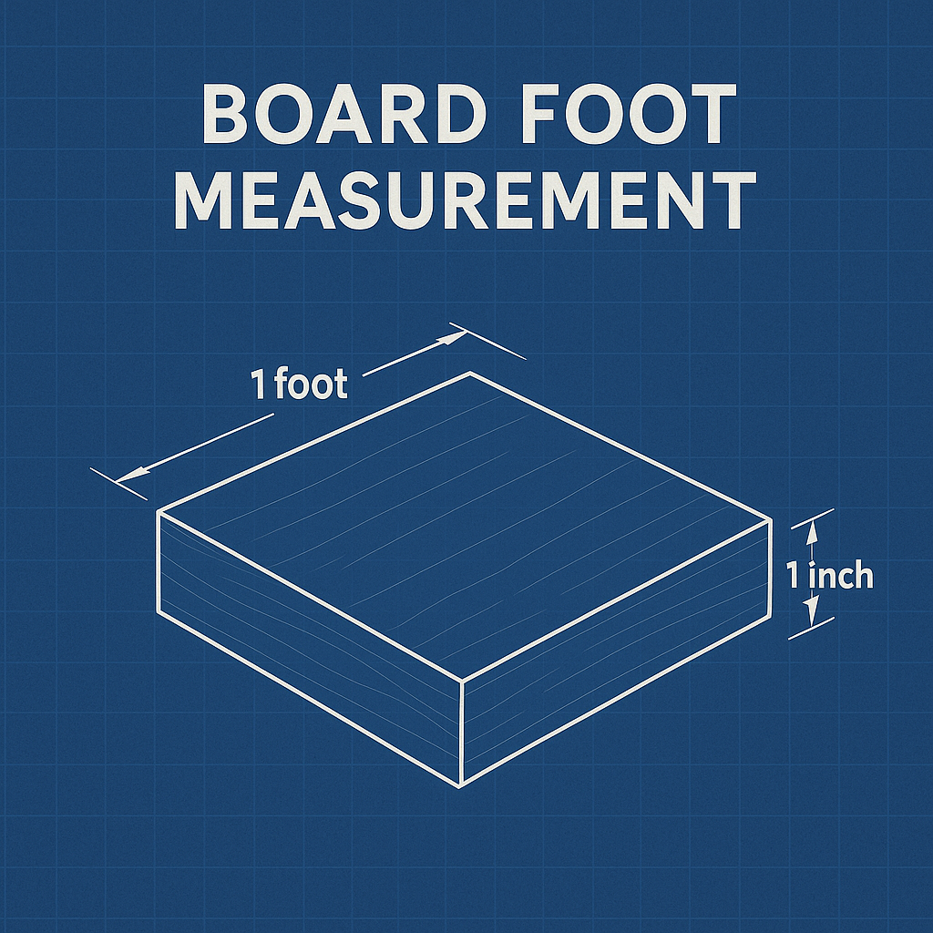
Figure: A blueprint‑style diagram of a board that is 1 ft long, 1 ft wide and 1 in thick. This visualises the definition of a board foot.

[1] [4] [6] Board foot - Wikipedia
https://en.wikipedia.org/wiki/Board_foot
[2] [14] [15] Board Feet Chart and Calculator
https://www.engineeringtoolbox.com/board-foot-d_1453.html
[3] Convert Board Feet to Cubic Foot
https://www.unitconverters.net/volume-lumber/board-feet-to-cubic-foot.htm
[5] [20] Softwood Lumber - Dimensions
https://www.engineeringtoolbox.com/softwood-lumber-dimensions-d_1452.html
[7] Hardwood Lumber Education | NHLA | Pennsylvania Hardwood Lumber
https://www.ronjoneshardwood.com/education
[8] [22] What is MBF? Thousand Board Feet Explained -
https://thetimberlandinvestor.com/what-is-mbf-thousand-board-feet-explained/
[9] 40 CFR § 63.2292 - What definitions apply to this subpart? | Electronic Code of Federal Regulations (e-CFR) | US Law | LII / Legal Information Institute
https://www.law.cornell.edu/cfr/text/40/63.2292
[10] [11] [12] [13] [21] Board Foot vs Linear Foot | The Knotty Lumber Co.
https://theknottylumberco.ca/blogs/hardwoods-101/board-foot-vs-linear-foot
[16] [17] [18] Lumber and Panel Calculations
https://www.putnamlumber.com/conversions.html
[19] [23] BASIC-INFORMATION-ABOUT-CUBIC-SCALING.pdf
https://ibsp.idaho.gov/wp-content/uploads/2018/06/BASIC-INFORMATION-ABOUT-CUBIC-SCALING.pdf

