title: "Multi-Family & Volume Millwork / Turnkey Solutions" version: "1.0" topic_key: "multifamily_millwork" date: "2025-10-09"

Introduction & Market Context
Multi‑family construction refers to buildings with five or more dwelling units such as apartments, student housing and senior living complexes. After surging during the pandemic, the sector is now navigating a more volatile landscape. The National Association of Home Builders noted that multifamily construction starts dropped 25 % in 2024, falling to a rate of about 355 000 units while roughly one million apartments were still under construction, the highest level since 1973. Economists expect the sector to remain soft in the first half of 2025 because of supply‑chain issues and high interest rates, but a return to long‑term trends is projected as the existing pipeline is absorbed. Independent forecasts also highlight the push and pull factors: the U.S. multi‑unit housing forecast has been revised downward by 18–20 %, reflecting rising vacancies and elevated interest rates[1], yet ConstructConnect estimates that total construction starts could rise 8.5 % with multi‑family starts growing 9.5 % after two years of decline[2]. These opposing trends mean that developers are under pressure to control cost, compress schedules and deliver units quickly.
Builders FirstSource (BFS) is uniquely positioned to help developers meet these challenges. BFS is the largest supplier of building products and value‑added services in the United States[3]. Its national footprint spans over 135 millwork locations[4] and more than 585 total locations[5], giving it unparalleled capacity and geographic reach. The company has invested heavily in automation and has increased its overall millwork capacity by more than 50 % through the installation of 21 high‑speed door lines[6]. BFS continues to expand installation and turnkey services, noting that millwork installation sales grew 8 % in FY 2024 and that there is room to add capacity in key markets[7].

What “Volume Millwork / Turnkey” Means
Volume millwork refers to manufacturing doors, mouldings, cabinets, casework and other millwork components at high output to serve hundreds or thousands of units. Automation and process engineering allow BFS to produce consistent units quickly[8]. Turnkey describes a service model in which one partner supplies, loads out, delivers and installs millwork packages so the builder receives a “ready‑to‑use” solution. BFS’s brochure highlights this end‑to‑end approach: it offers pre‑hung doors and mouldings to amenity packages and custom casework[9], provides project expertise and support from estimate to install[10] and ensures that each package is fully inspected, carefully loaded and delivered ready to install[11]. Once on site, BFS crews can perform installation so that developers need not coordinate multiple subcontractors[12].

Trade‑offs: Volume vs. Customization (CoT)
- Volume advantages: High‑volume production reduces unit cost, streamlines scheduling and ensures consistent quality. BFS’s automated lines and standardized processes deliver repeatable results across hundreds of units[8]. Standard packages simplify loadouts and minimize errors.
- Customization trade‑offs: Unique door styles or trim profiles can differentiate a project but often increase lead time and cost. Custom components may require manual manufacturing and additional quality checks. BFS mitigates this by offering both stock and custom options while value‑engineering solutions to meet budgets[10].
- Scheduling vs. lead time: Developers must balance the desire for early delivery (to maintain schedule) against the risk of storing materials on site. Volume millwork typically allows “just‑in‑time” delivery coordinated by BFS’s logistics teams[11], reducing site clutter and damage risk. Custom items may lengthen lead times, so early coordination is critical.

Product Scope (doors, trim, casework, amenity packages)
BFS’s multi‑family catalog encompasses interior and exterior doors, mouldings, cabinets, closets & shelving, door hardware, beams and hollow metal doors[13]. The table below summarizes common millwork components, typical standard sizes and installation considerations. When high volume is required, components are manufactured to standard sizes; for custom projects, BFS can build to specification.
Millwork type | Standard size range (approx.) | Tolerances / Notes | Installation considerations
Interior doors (pre‑hung) | Widths 2ʹ0ʺ–3ʹ0ʺ; heights 6ʹ8ʺ–7ʹ0ʺ; thickness 1⅜ʺ | Squareness tolerance ±¹⁄₁₆ in; hinge prep ±¹⁄₆₄ in | Delivered pre‑hung and labeled by unit; verify floor plumb before setting; shim jambs; specify fire‑rated units where required
Exterior doors | Widths 3ʹ0ʺ–3ʹ6ʺ; heights 6ʹ8ʺ–8ʹ0ʺ; thickness 1¾ʺ | ±¹⁄₁₆ in on width and height; weather‑seal alignment ±¹⁄₃₂ in | Pre‑hung units include threshold and hardware; coordinate swing direction; ensure proper flashing
Trim & mouldings | Baseboard 3½ʺ–5½ʺ, casing 2¼ʺ–3½ʺ, crown moulding 3″–5″ | Length tolerance ±⅛ in; cut accuracy ±¹⁄₃₂ in | Delivered in bundled lengths; cut and cope on site; ensure moisture acclimation before install
Cabinets / casework | Base cabinet widths 12ʺ–48ʺ in 3″ increments; wall cabinet heights 30″, 36″, 42″ | ±¹⁄₁₆ in width and height; finish thickness ±¹⁄₃₂ in | Factory‑assembled or knock‑down; specify ADA compliance for accessible units; coordinate with MEP rough‑ins
Closets & shelving | Wire or melamine shelves; lengths 24″–96″ | ±⅛ in length; bracket spacing as per load rating | Delivered cut‑to‑length; install after drywall; allow ventilation for HVAC closets
Amenity packages | Clubhouse bars, mailroom millwork, built‑in seating | Project specific | Typically custom‑built; BFS collaborates on design and value engineering to meet aesthetics and budget
Tree‑of‑Thought (ToT): functional modules
- Doors: Standard interior and exterior doors produced on high‑speed lines for volume. Specialty doors (fire‑rated, acoustic or architectural) require custom fabrication and longer lead times.
- Trim & mouldings: Baseboards, casing, crown and panel mouldings are stocked in common profiles for rapid shipment. Custom profiles or exotic species involve knife‑grinding and small‑batch runs.
- Cabinets & casework: Volume projects often use modular cabinets in standard widths; custom casework for amenity spaces or luxury units may be fabricated by BFS partner shops.
- Hardware & accessories: Hinges, locks and bath accessories can be bundled with doors and cabinets. Smart locks or ADA hardware may require special order.

Scaling, Consistency & Quality Controls
Multi‑family projects demand consistent fit and finish across hundreds of units. BFS addresses this by combining automation with skilled craftsmanship, delivering consistent quality at high output[8]. Automated door and moulding lines produce repeatable cuts while craftsmen perform final assembly and quality checks. BFS’s network of over 135 millwork locations ensures that products are manufactured close to job sites, reducing transit damage and lead times[4].
Quality control extends beyond manufacturing. The brochure emphasizes one point of contact backed by a team that understands the complexity of multi‑family jobs[14]. Dedicated account reps coordinate value engineering, code compliance and accurate estimating[15]. During production, BFS conducts full inspections before loadout[11], and the company stands behind its workmanship on all value‑add millwork products[16]. BFS has also invested in digital platforms that allow builders to view schedules, approve submittals and monitor delivery in real time[17].
Scaling capacity is a central focus. BFS plans to add millwork capacity in key markets to meet growing demand[18] and has increased overall millwork capacity by more than 50 % through the installation of 21 new high‑speed door lines[6]. The company integrates millwork with its broader off‑site fabrication and installation services, offering bundled solutions that address labor shortages and improve project timelines[19].

Logistics, Loadout, Delivery for Multi‑Family Jobs
Logistics are critical when hundreds of units must be finished on a tight schedule. BFS’s national network provides on‑time delivery anywhere in the U.S.[20]. For multi‑family projects, loadouts are typically staged by building, floor or even unit. Each package is fully inspected, carefully loaded and delivered ready to install[11]. Materials are labelled to match unit numbers, and pre‑hung doors arrive with hardware kits and frame shims. Deliveries can be sequenced to coincide with drywall completion, preventing storage damage and reducing jobsite congestion. BFS’s logistics teams also coordinate return loads for unused material to minimize waste.
Scheduling vs. lead time (CoT) – Early delivery can reduce the risk of production delays but increases the chance of on‑site damage and ties up capital. Conversely, just‑in‑time delivery reduces storage needs but relies on accurate forecasting. BFS mitigates these risks by offering flexible delivery windows and using digital scheduling tools. Builders can adjust delivery times via myBLDR.com and track shipments in real time[17].
The following diagram illustrates BFS’s multi‑family supply chain, from manufacturing to jobsite installation:
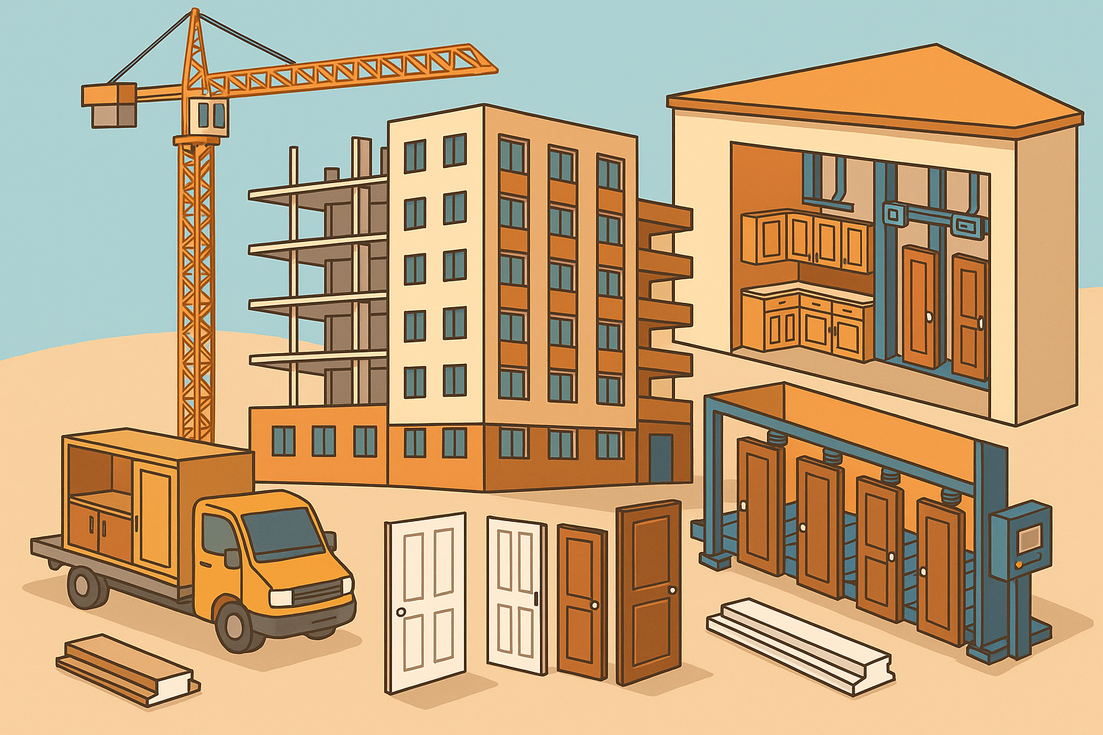

Example Use Cases
- Apartment complex (200 units) – A mid‑rise development requires pre‑hung interior doors, exterior entry units, baseboard and casing, kitchen cabinets and closet shelving. With an average of 7–8 interior doors per unit, the job demands approximately 1 600 doors. BFS’s high‑speed door lines produce thousands of pre‑hung units daily, enabling the supplier to manufacture and stage the entire order within weeks. Each floor receives palletized door and trim packages labeled by unit. Cabinet modules are delivered after plumbing and electrical rough‑ins and installed by BFS crews. The turnkey approach compresses schedule and reduces waste.
- Student housing with amenity spaces – A university residence hall includes study lounges, fitness rooms and a café. In addition to standard unit millwork, the project requires custom cabinets, countertops and built‑in seating. BFS’s millwork shops build the amenity casework while high‑volume lines handle the doors and trim. The combination of volume production and custom fabrication demonstrates BFS’s ability to balance cost and design.
- Affordable housing with compressed timelines – A nonprofit developer partners with BFS to value‑engineer door and trim packages to meet strict budget targets. Standard hollow‑core doors and MDF mouldings are selected for cost and durability. BFS bundles installation labor into the package so that units can be turned over quickly. Using just‑in‑time delivery, the developer avoids storing materials on site and reduces theft risk.

Future Opportunities (SCAMPER ideas)
Applying the SCAMPER framework can reveal innovations in multi‑family millwork and turnkey services:
- Substitute – Replace solid wood door panels with modular panel inserts that allow developers to swap finishes without removing the entire door. Substitute traditional MDF casing with more durable, recycled‑content composites.
- Combine – Package smart locks, hinges and doors together so that units arrive wired for electronic access control. Combine kitchen casework with prefitted countertops and appliances to create plug‑and‑play kitchen pods.
- Adapt – Integrate prefinished units, such as pre‑painted doors and stained trim, to eliminate on‑site finishing and reduce labor. Adapt cabinet designs to use universal carcasses with interchangeable fronts, balancing customization and standardization.
- Modify/Magnify – Increase productivity by deploying robotic sanding and finishing lines. Offer magnified service bundles where BFS manages not only millwork but also plumbing fixtures, lighting and flooring, creating a broader turnkey package.
- Put to Another Use – Repurpose off‑cuts from moulding operations into acoustic wall panels or decorative slats, reducing waste and generating new revenue streams. Use BFS’s logistics expertise to handle reverse logistics, reclaiming unused materials for resale or recycling.
- Eliminate – Reduce packaging waste by transitioning to reusable door and cabinet racks. Streamline the number of profiles offered (SKU consolidation) to simplify inventory and improve throughput[21].
- Reverse/Rearrange – Explore on‑site micro‑factories for very large projects, where portable CNC machines produce trim and casework adjacent to the jobsite. Reverse the sequence of installation by delivering finished bathroom pods before framing, enabling plug‑and‑play mechanical connections.

Likely User Questions
- How many doors are typically required per unit? A typical two‑bedroom unit needs 5–8 doors (entry, bedroom, bathroom, closets), so a 200‑unit building may require 1 000–1 600 doors.
- Can BFS provide pre‑hung doors and trim packages at volume? Yes. BFS manufactures pre‑hung doors, mouldings and trim packages at high output[9] and can scale to thousands of units[6].
- What is the typical lead time for millwork in a multi‑family project? Standard products can often be produced within 4–6 weeks, whereas custom casework may require 8–12 weeks. Early coordination helps avoid schedule impacts.
- How is millwork labeled and loaded out for multi‑family jobs? Materials are inspected, bundled by building/floor, labeled with unit numbers and delivered ready to install[11].
- Does BFS offer installation services? Yes. BFS’s turnkey approach includes professional installation teams who handle everything from framing to interior trim[12].
- Can I value‑engineer millwork packages to meet budget constraints? BFS collaborates to find cost‑effective options without compromising design, quality or timelines[22].
- Are fire‑rated or ADA‑compliant components available? BFS offers code‑compliant products, including fire‑rated doors and ADA‑compliant hardware, and provides estimating services to ensure compliance[15].
- How can I track orders and deliveries? BFS’s digital portal (myBLDR.com) and project management tools allow customers to view schedules, track shipments and approve estimates online[17].

Related Topics / Crosslinks
- Doors & Door Hardware – deeper dive into door construction, fire ratings and hardware selections.
- Trim & Mouldings – profiles, materials and finishing options for base, casing and crown.
- Cabinetry & Casework – modular vs. custom cabinets, countertop integration and ADA considerations.
- Ready‑Frame® & Off‑Site Fabrication – BFS’s engineered wall and roof systems and how they complement millwork packages[7].
- Logistics & Delivery – strategies for scheduling, loadouts and just‑in‑time delivery.
- Digital Tools & Estimating – myBLDR.com portal, 3D modeling and digital twins used for design and takeoffs[17].
- Installation Services – BFS’s turnkey installation offerings across framing, millwork and finishes.

[1] [2] The 2025 Outlook for Multi-Family Construction | L.E. Smith
https://www.lesmith.com/the-2025-outlook-for-multi-family-construction/
[3] [6] [7] [17] [18] [19] [21] Builders FirstSource Corporate Presentation
https://s202.q4cdn.com/867695273/files/doc_presentations/2025/May/01/BLDR-Corporate-Presentation-May-2025.pdf
[4] [8] [9] [10] [11] [12] [13] [14] [15] [16] [20] [22] 2015-25-BFS-MultiFamily_Brochure_11x8.5-Final.indd
https://bmc.a.bigcontent.io/v1/static/BLDR_BFS_Multi-Family_Brochure_2025
[5] Builders-FirstSource-Announces-Two-Acquisitions-in-Turnkey-Millwork-Solutions-2025.pdf
https://s202.q4cdn.com/867695273/files/doc_news/Builders-FirstSource-Announces-Two-Acquisitions-in-Turnkey-Millwork-Solutions-2025.pdf

