Customer Requirement Specification

Smart Wi-Fi Lock Specification

Ver 1.0

30 November, 2017

Document History

|  |  |  |  |
| --- | --- | --- | --- |
| Date | Version | Author | Changes |
| 30/11/2017 | 1.0 | SUN Wentao | Draft version for internal approve |
|  |  |  |  |
|  |  |  |  |
|  |  |  |  |

Table of Contents

# INTRODUCTION

## Purpose

This document describes the “Smart Wi-Fi Lock” device intended to be developed for XXXXX.

This document contains

* General product description
* Customer requirements for this product.

## Scope

The topics covered in these requirements represent the commercial expectations from the product.

These expectations include: product feature description, power supply, user interface, connectivity, mechanics design and product testing.

## Definitions, Acronyms, Symbols and Abbreviations

| Abbreviation | Comment |
| --- | --- |
|  |  |
|  |  |
|  |  |
|  |  |
|  |  |
|  |  |
|  |  |
|  |  |
|  |  |
|  |  |
|  |  |
|  |  |
|  |  |
|  |  |
|  |  |
|  |  |
|  |  |
|  |  |
|  |  |
|  |  |
|  |  |
|  |  |
|  |  |
|  |  |
|  |  |
|  |  |
|  |  |
|  |  |

# 2. General Product Description

## Feature

* Power Supply
* DC +12V power adapter
* Wi-Fi Protocols Support
* 802.11 b/g/n support.
* Wi-Fi Direct (P2P) support.
* P2P Discovery, P2P Group Owner mode, P2P Power Management.
* Infrastructure BSS Station mode / P2P mode / softAP mode support.
* Easy Wi-Fi Pairing
* Support Smart Config feature. User can pair the set with a router by a 3rd party APP with its source code from Wi-Fi module supplier.
* Can integrate the Smart Config feature with our own APP.

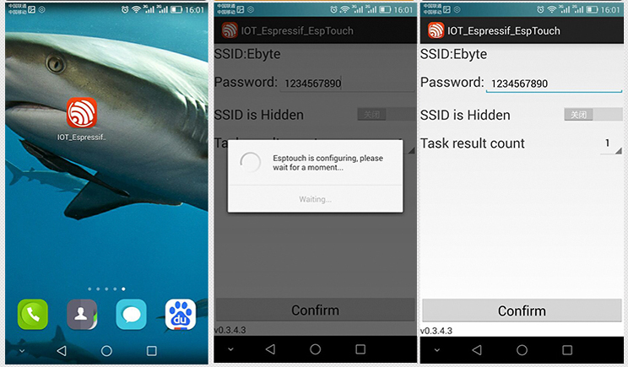

* No Power Mode & No Network Mode
* When the lock is out of power or cannot connect to server through Wi-Fi, user can open the door by traditional mechanical ways (by using the key).

## Top level block diagram

Wi-Fi Module

MCU

Lock Drive Circuit

Door Contact Sensor

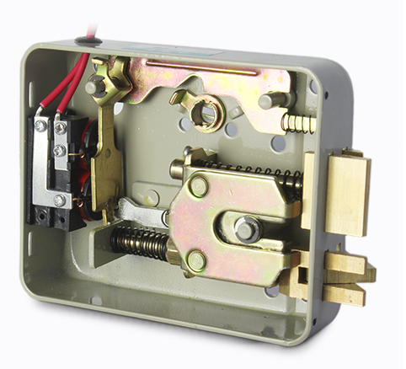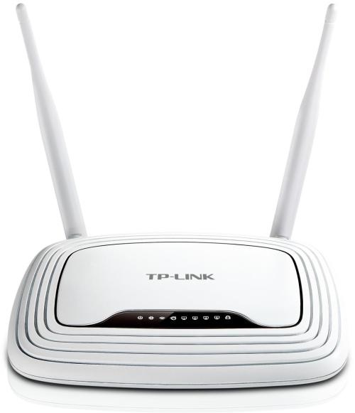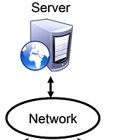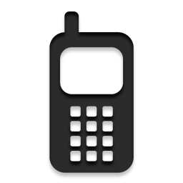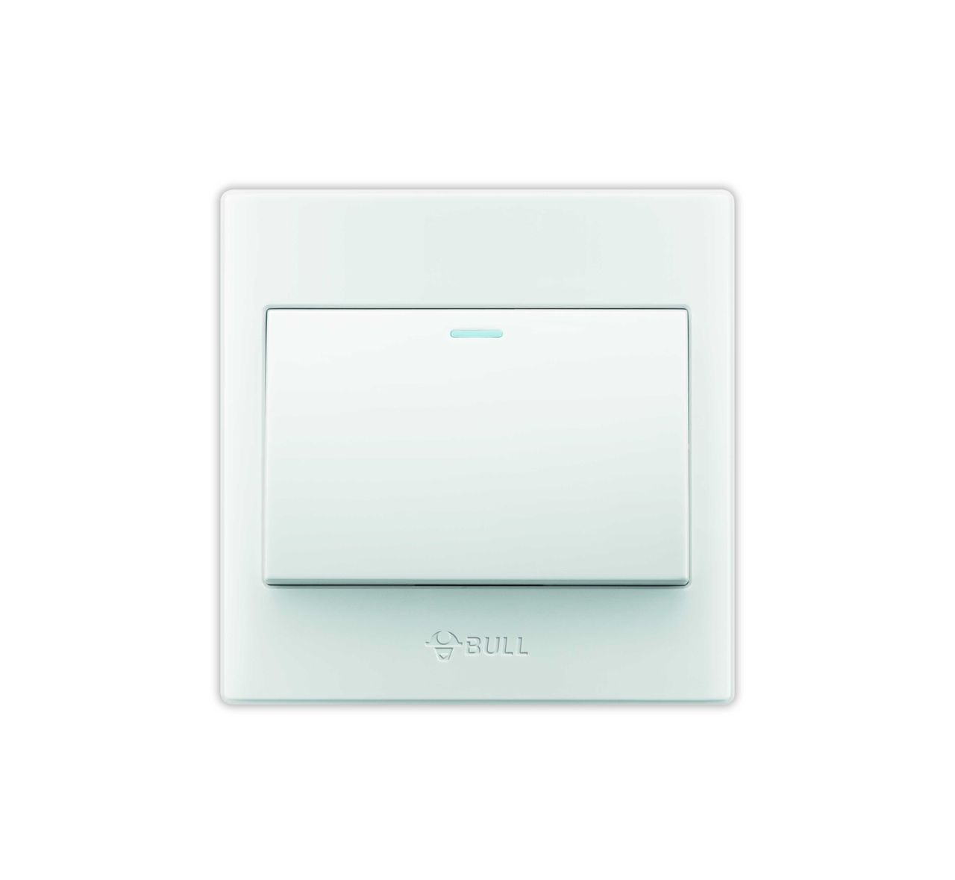

## User Interface

i) Buttons

The set has one button for entering Wi-Fi pairing mode.

ii) LEDs

The set had two LEDs (Red & Blue).

* Red LED, indicating the power status.
* Blue LED, indicating the Wi-Fi status.

# Technical Specifications

## Wi-Fi Specifications

### 3.2.1 Operation Distance

Operation distance >= 30 meters (Outdoor)

### 3.2.2 Security

* Irreversible random HASH encryption algorithm (Anti-sniffing).
* No plain text password will be transmitted over the internet.

## Mechanics

### 3.4.1 PCB Shape & Size

* + Shape: Rectangle
  + Length: <= 100 mm
  + Width: <= 100 mm
  + Height: <= 50 mm

### 3.4.2 Position of Button & LEDs

* Refer to section 3.4.4.

### 3.4.3 Position of DC Power Jack

* Refer to section 3.4.4.

### 3.4.4 Product Appearance



Power Status

Button

DC +12V

Connect to the lock

Wi-Fi Status

Connect to contact switch

# Device Operations

This section describes control and behaviour for the set.

### Button Operations & Finite States Machine

* SP – Short Press (< 2 sec)
* LP – Long Press (>= 2 sec & < 4 sec)
* VLP – Very Long Press (>= 4 sec)

Power OFF

Power On

(Auto connect to router)

Wi-Fi

Connected

Wi-Fi

Pairing

VLP

LP

SP

### Visual Indicators

|  |  |  |
| --- | --- | --- |
| LED Status | | |
| Device Status | Wi-Fi LED Status (Blue) | Power LED Status (Red) |
| OFF | OFF | OFF |
| Connected | Solid ON | Solid ON |
| Pairing | 1Hz Blinking | Solid ON |

# Apps Control

* APP can send commands such as “lock” or “unlock” to the server.
* APP can get the door status from server.
* Device can receive the “lock” or “unlock” command from the server.
* Device can update the door status to the server.

# Hardware Testing

* The 3rd-party software named “TCP/IP Debugger” will be used for hardware sanity test and internal demo at product development stage.
* The “Smart Config” APP from Wi-Fi module supplier will be used for Wi-Fi pairing demo.

# Design Release

* Hardware: Schematic & PCB layout files. 2 sets of PCB boards with locks and adapters for demo.
* Firmware: All source code and SDKs/Compilers involved in the project.
* Documents:
  + - Firmware release notes
    - All the original documents from module suppliers
    - Introduction of Irreversible random HASH encryption algorithm

# Open Points

|  |  |
| --- | --- |
| Section/Chapter | Description |
|  |  |
|  |  |
|  |  |
|  |  |
|  |  |
|  |  |
|  |  |
|  |  |
|  |  |
|  |  |
|  |  |
|  |  |
|  |  |

# Commercial

## Planning

|  |  |  |
| --- | --- | --- |
| **Milestone** | **Items working on** | **Days**  **(8 hours)** |
| Hardware Development | * Schematic design * PCB layout * PCB fabrication * PCBA * Hardware Sanity Test | 15 |
| Firmware Development | * Wi-Fi communication * Lock/unlock * Door contact switch * Password encryption algorithm implement & test | 10 |
| Co-Development | * Co-debug with APP and Server | 10 |

## Quotation

|  |  |  |
| --- | --- | --- |
| **Items** | **Cost** | **Remark** |
| NRE | HK$20,000 | Including 2 sets of sample boards with locks and adapters |
| Design Files | HK$4,000 | Including schematics, PCB layout, firmware projects and source code, source code of 3rd party libraries if involved, and key algorithm documents, etc. |
| **Total** | **HK$24,000** |  |
| Extra sample boards | N × HK$300  +  N × HK$200  +  HK$200 | Including PCBA, adapters and e-locks.  Price of PCBA: HK$300 per set  Price of adapter & e-lock: HK$200 per set  MOQ: 5 sets  Engineering fee: HK$200  e.g. Ordering 5 sets, cost = 5*300+5*200+200 = HK$2,700  e.g. Ordering 10 sets, cost = 10*300+5*200+200 = HK$4,200 |

## Certifications

All necessary certification obtaining procedures including but not limited to RoHS, FCC, CE will be conducted by customer.