Weak prompts:
a) Explain regression
b) Help me understand SQL
c) Create a dataset

Improved prompts:
I am sharing the improved prompts and their results below.
I added specific details, specified limitations and gave AI a role to produce better results.
A1)I am learning basics of statistics. Explain regression with simple in real life examples. My goal is learning the basics of regression and how I can interpret results and use them for my professional life.
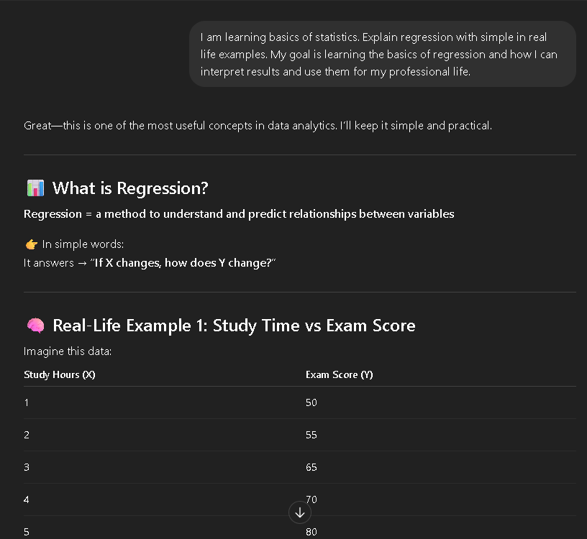
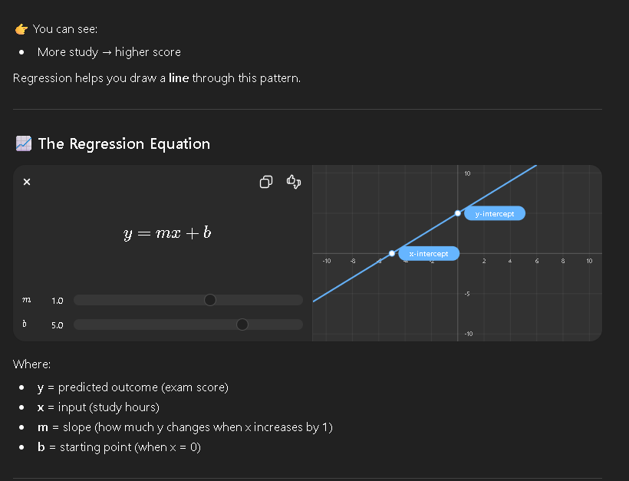
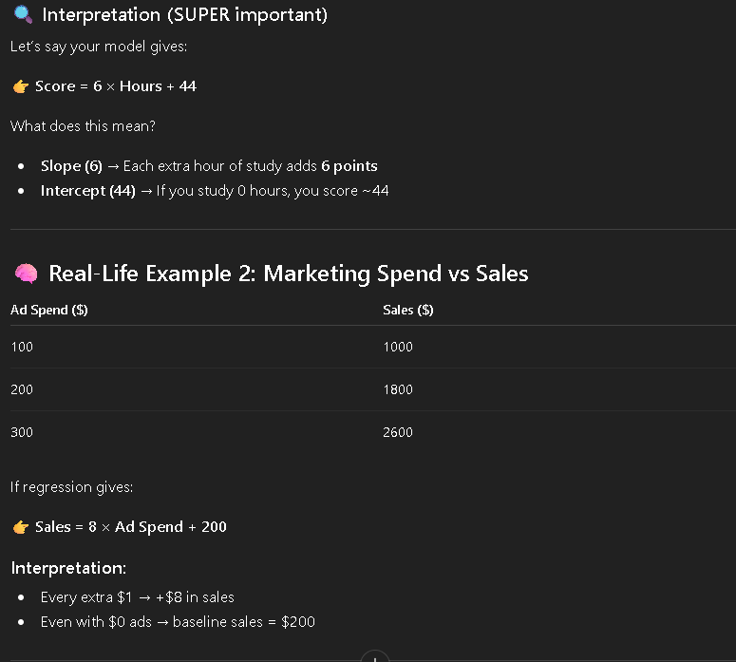
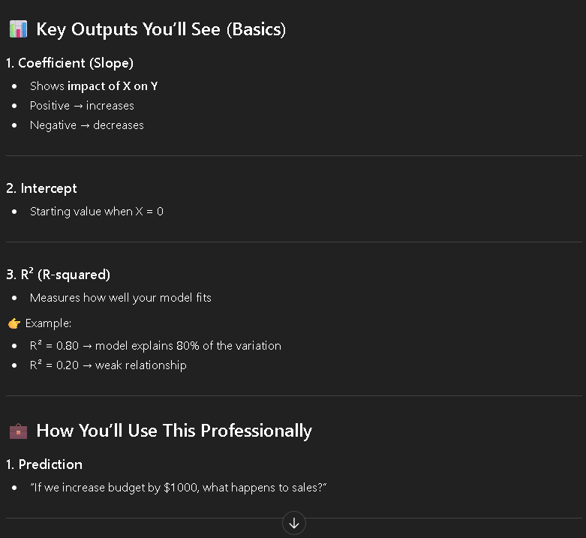
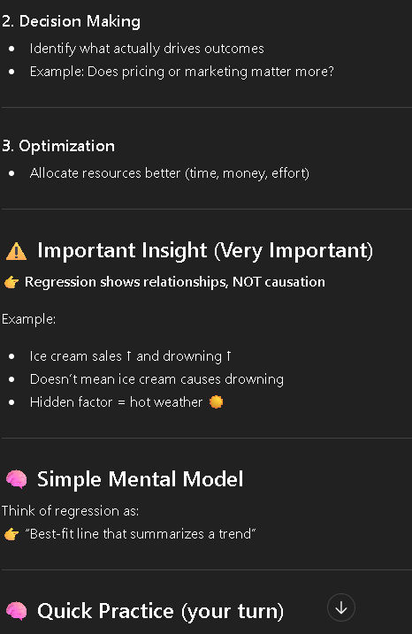

2B) I want to learn the basics of SQL. Explain the basics and logic of SQL for a beginner. Show real life examples and explain how can I utilize SQL as a beginner data analyst.
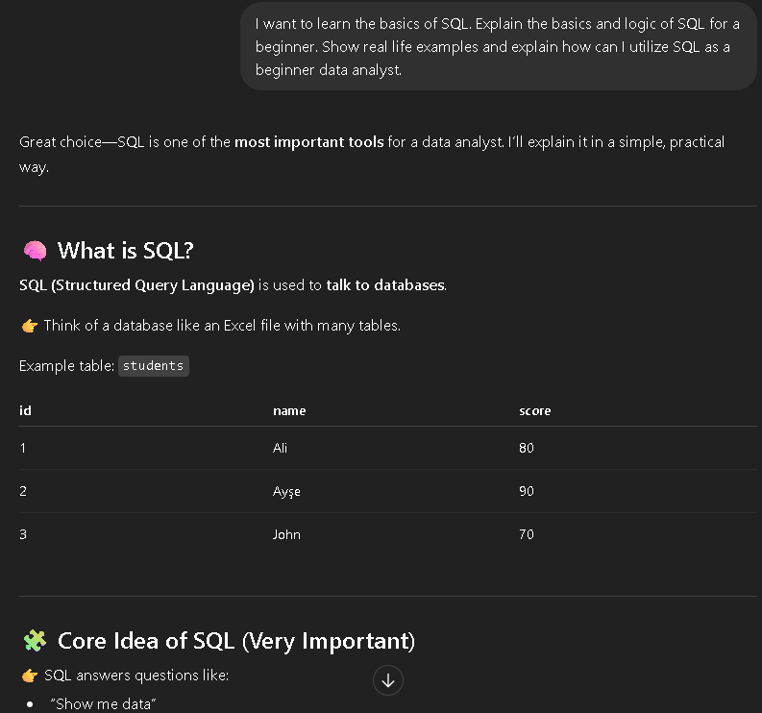
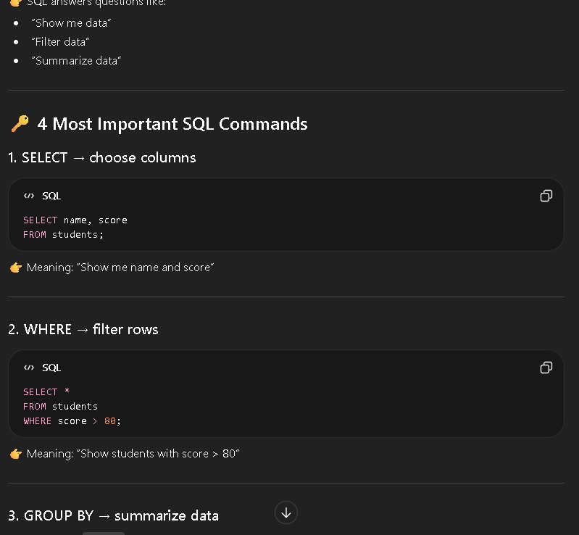
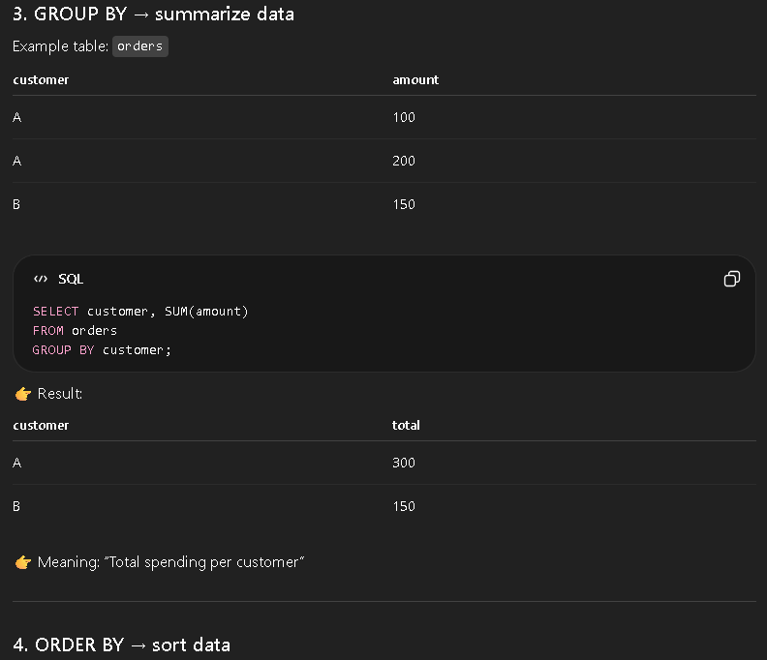
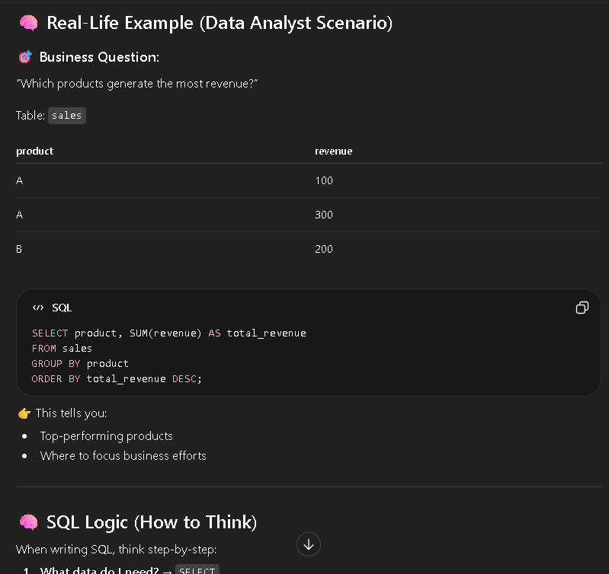
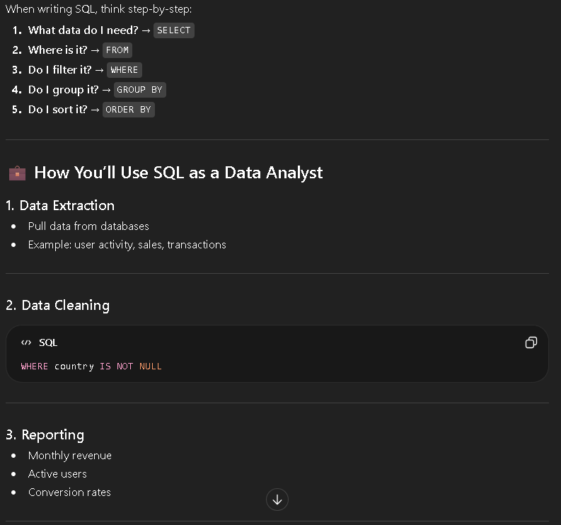
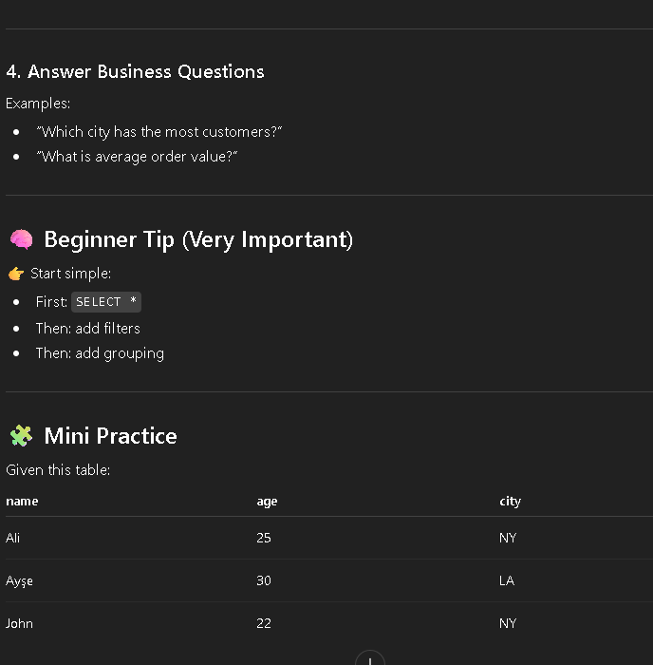

3B) Create me a dataset. My goal is practicing the basics of statistics and excel on this dataset. Add 10-15 columns and 100-125 rows. Name columns according to a real life example.
