Software Requirements Specification (SRS)

SIM — Security Incident Mapping System
SEN202 Weekend Development Assignment — Weekend 1
Prepared for: Dr. O. O. Ajayi
Version 1.0 — July 2026

1. Introduction

1.1 Purpose
This document specifies the software requirements for SIM (Security Incident Mapping), a web-based platform that allows students, staff, and off-campus landlords/property agents to quickly and safely report security incidents occurring on or around campus (e.g. theft, stabbing, sexual assault, murder, kidnapping). It is intended to guide the design, development, and evaluation of the SIM system, and to communicate the functional and non-functional requirements to developers, campus security administration, and academic assessors.

1.2 Scope
SIM will allow authenticated community members to submit incident reports with a category, description, location, and optional photo/video evidence, with the option to report anonymously. Reports are visible on a live incident map/feed to help others stay aware of nearby risks. Campus Security Administrators can verify submitted reports, escalate serious cases to Law Enforcement, broadcast safety alerts to the community, and generate basic incident statistics. A System Administrator manages user accounts and roles.
The first release (this assignment) is a functional mini web application demonstrating the core reporting and viewing workflow; it is not a production-hardened system. Payment processing, native mobile apps, and integration with external police databases are out of scope for this version.

1.3 Definitions, Acronyms and Abbreviations
Term | Definition
SIM | Security Incident Mapping — the system described in this SRS
SRS | Software Requirements Specification
Community Member | Generalized actor covering Student, Staff, and Landlord/Property Agent
Incident | A single reported security event, with category, description, location and status
Admin | Campus Security Administrator or System Administrator role
SOS | Emergency "one-tap" distress signal feature

1.4 References
- SEN202 Weekend 1 Assignment Brief, Dr. O. O. Ajayi (01/07/2026)
- IEEE Std 830-1998 — Recommended Practice for Software Requirements Specifications (structure reference)
- SIM Google Form Needs-Assessment Questionnaire (this repository, /docs)
- SIM Ishikawa (Fishbone) Diagram (this repository, /docs)

1.5 Overview
Section 2 gives an overall description of the product and its users. Section 3 lists detailed functional requirements. Section 4 covers external interface requirements. Section 5 specifies non-functional requirements. Section 6 explains system architecture and how major components interact. Section 7 summarizes the use case model. Section 8 defines the core data entities.

2. Overall Description

2.1 Product Perspective
SIM is a new, standalone web-based system. It is composed of a browser-based client (HTML/CSS/JavaScript), which in this prototype persists data locally for demonstration purposes and is designed to be backed by a REST API and database in a full production build. Conceptually it interacts with four surrounding elements: (1) the Community Member's device/browser, (2) a Campus Security back office, (3) an external Law Enforcement Agency for escalation, and (4) a mapping/geolocation service.

2.2 Product Functions (Summary)
- Account registration and login for Students, Staff, and Landlords
- Submit a security incident report (category, description, location, optional evidence, optional anonymity)
- View a live feed / map of recent verified incidents
- Receive safety alerts and notifications broadcast by Campus Security
- Campus Security: verify, triage and escalate incident reports to Law Enforcement
- Campus Security: generate simple incident statistics/reports
- System Admin: manage user accounts and roles

2.3 User Classes and Characteristics
User Class | Description | Technical Skill
Student | Lives on/off campus; primary reporter of incidents | Moderate–high (smartphone-native)
Staff | Works on campus, may move around after dark | Moderate
Landlord/Property Agent | Houses students off-campus; reports incidents near their property | Low–moderate
Campus Security Admin | Verifies reports, escalates cases, broadcasts alerts | Moderate
System Admin | Manages accounts, roles, and system configuration | High

2.4 Operating Environment
- Client: any modern desktop or mobile web browser (Chrome, Edge, Firefox, Safari)
- No native app install required — mobile-responsive web interface
- Designed to run over campus Wi-Fi and mobile data networks, including low-bandwidth conditions

2.5 Design and Implementation Constraints
- Submission deadline constraint (Friday 10th July 2026) limits scope to a mini, low-complexity web interface
- No paid third-party services (maps, SMS gateways) assumed available for the prototype
- Must be version-controlled and hosted on GitHub

2.6 Assumptions and Dependencies
- Users have access to a smartphone or computer with internet connectivity
- Campus Security office is willing to adopt and monitor the platform
- A real deployment would require a backend database and hosting; this prototype simulates persistence in the browser for demonstration

3. Functional Requirements
Each requirement is uniquely identified, described, and assigned a priority (H = High/Must-have, M = Medium/Should-have, L = Low/Nice-to-have) for this prototype phase.
ID | Requirement | Priority
FR-01 | The system shall allow a new user to register with name, role (Student/Staff/Landlord), and contact details. | H
FR-02 | The system shall allow a registered user to log in and log out securely. | H
FR-03 | The system shall allow a logged-in user to submit an incident report specifying category, description, date/time, and location. | H
FR-04 | The system shall allow a user to optionally attach photo/video evidence to a report. | M
FR-05 | The system shall allow a user to submit a report anonymously, hiding their identity from other community members. | H
FR-06 | The system shall display submitted incidents on a live feed/map visible to authenticated users. | H
FR-07 | The system shall allow Campus Security Admin to review, verify, or reject a submitted report. | H
FR-08 | The system shall allow Campus Security Admin to escalate a verified report to the Law Enforcement Agency. | M
FR-09 | The system shall allow Campus Security Admin to broadcast a safety alert to all community members. | M
FR-10 | The system shall allow Campus Security Admin to generate a basic summary of incident statistics (counts by category, status, location). | M
FR-11 | The system shall allow System Admin to create, edit, deactivate, or delete user accounts and assign roles. | M
FR-12 | The system shall notify a reporting user when the status of their report changes (e.g. Verified, Escalated, Resolved). | L
FR-13 | The system shall allow users to filter the incident feed by category, date range, or status. | L

4. External Interface Requirements

4.1 User Interfaces
- Responsive web pages: Home/Landing, Report Incident, Incident Feed/Map, Login/Register, About/Emergency Contacts
- Clear, high-contrast "Report Incident" call-to-action reachable within one click/tap from any page
- Category icons and color-coding (e.g. red = violent crime, amber = theft) for quick visual scanning of the feed

4.2 Hardware Interfaces
- Device camera (optional, for evidence capture) and GPS/location services (optional, for auto-filling incident location)

4.3 Software Interfaces
- Prototype: browser local storage simulates the data layer
- Production target: REST API over HTTPS, relational/NoSQL database, and a map/geocoding service (e.g. OpenStreetMap or Google Maps API)

4.4 Communication Interfaces
- HTTPS for all client–server communication in a production deployment
- Push notifications / SMS gateway integration for real-time alerts in a future release

5. Non-Functional Requirements
Category | Requirement
Performance | The incident feed shall load and display the most recent 50 reports within 3 seconds under normal network conditions.
Security | Personally identifying information of anonymous reporters shall never be exposed to other Community Members or displayed in the public feed.
Security | Passwords/credentials shall not be stored or transmitted in plain text in a production deployment.
Usability | A first-time user shall be able to submit an incident report in 3 steps or fewer without training.
Reliability | The system shall not lose a submitted report due to a client-side error; a confirmation shall be shown on successful submission.
Availability | The reporting feature shall be accessible on-demand, aligning with the time-critical nature of security incidents.
Scalability | The system architecture shall allow the client to be re-pointed to a real backend/database without redesigning the UI.
Maintainability | Code shall be modular (separate concerns for reporting, feed, auth, and admin) and version-controlled on GitHub.
Portability | The web interface shall render correctly on both desktop and mobile browsers (responsive design).
Accessibility | Text shall maintain sufficient color contrast, and interactive elements shall be reachable via keyboard navigation.
Legal/Ethical | The system shall include a clear disclaimer that it supplements, but does not replace, emergency services (e.g. Police), and shall display emergency contact numbers prominently.

6. System Architecture and Component Interaction
SIM follows a layered client-facing architecture. In this prototype, all logic runs in the browser; the same structure maps directly onto a full client–server build.

6.1 Major Components
Component | Responsibility
Presentation Layer (Web UI) | Renders pages: Home, Report Incident, Incident Feed/Map, Login/Register, About. Captures user input and displays data.
Reporting Module | Validates and packages a new incident report (category, description, location, evidence, anonymity flag).
Feed/Map Module | Retrieves and renders the list of incidents, supports filtering.
Auth Module | Handles registration, login/logout, and role assignment (Student/Staff/Landlord/Admin).
Admin Module | Supports verification, escalation, alert broadcast, and statistics generation for Campus Security Admin.
Data Store | Prototype: browser local storage. Production: database (e.g. PostgreSQL/MongoDB) accessed via a REST API.

6.2 Component Interaction Flow (Report Submission)
- 1. Community Member opens the Report Incident page (Presentation Layer).
- 2. Reporting Module validates required fields (category, description, location) client-side.
- 3. If "Report Anonymously" is checked, the Reporting Module strips identifying fields before saving.
- 4. The report is persisted to the Data Store and a confirmation is shown to the user.
- 5. The Feed/Map Module reads from the Data Store and displays the new report to other authenticated users.
- 6. Campus Security Admin (Admin Module) reviews the report, marks it Verified/Rejected, and may trigger escalation, which would notify the Law Enforcement Agency in a full deployment.

7. Use Case Model
The full use case diagram is provided in the repository (/docs/UseCase_Diagram.drawio) and reproduced below. It covers three actor groups — Community Member (generalized from Student, Staff, Landlord), Campus Security Admin, System Admin — and an external Law Enforcement Agency actor.
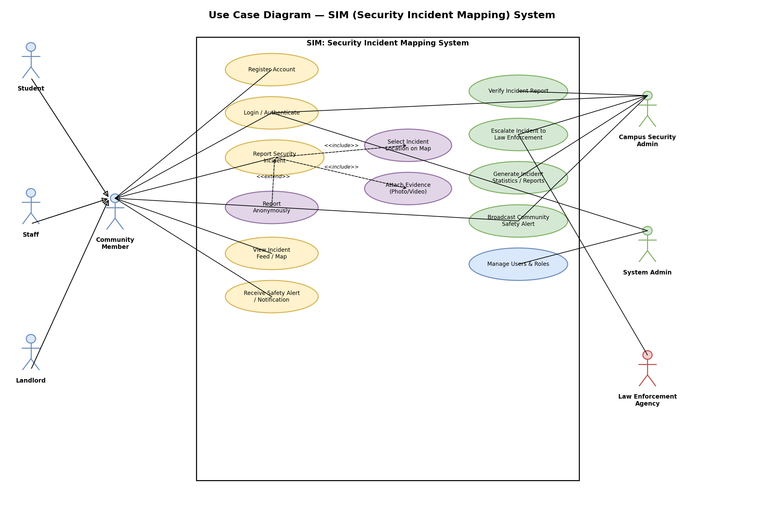

7.1 Key Use Case: Report Security Incident
Field | Description
Actor(s) | Community Member (Student, Staff, Landlord)
Precondition | User is logged in (or chooses anonymous reporting)
Main Flow | 1) User selects "Report Incident". 2) User selects category and enters description. 3) User selects/confirms location on map (include). 4) User optionally attaches evidence (include). 5) User optionally toggles anonymous reporting (extend). 6) User submits; system confirms receipt.
Alternate Flow | If required fields are missing, the system highlights them and blocks submission until corrected.
Postcondition | A new incident record with status "Pending Verification" is created and visible to Campus Security Admin.

7.2 Key Use Case: Verify and Escalate Incident
Field | Description
Actor(s) | Campus Security Admin, Law Enforcement Agency
Precondition | At least one report has status "Pending Verification"
Main Flow | 1) Admin opens report queue. 2) Admin reviews details/evidence. 3) Admin marks report Verified or Rejected. 4) For serious incidents, Admin escalates to Law Enforcement Agency.
Alternate Flow | If evidence is inconclusive, Admin may request more information from the reporter (if not anonymous).
Postcondition | Report status is updated and reflected on the public incident feed; escalated cases are flagged for external follow-up.

8. Data Requirements (Data Dictionary)
Entity | Key Attributes
User | user_id, name, role (Student/Staff/Landlord/Admin), contact_info, password_hash
Incident | incident_id, category, description, location (lat/lng or text), datetime, status, is_anonymous, reporter_id (nullable)
Evidence | evidence_id, incident_id, file_type, file_url
Alert | alert_id, message, issued_by, datetime, audience
Category | category_id, name (Theft, Assault, Rape, Murder, Kidnapping, Other)

9. Appendices
- Appendix A — Ishikawa (Fishbone) Root-Cause Analysis: /docs/Ishikawa_Fishbone_Diagram.drawio
- Appendix B — Google Form Questionnaire Design: /docs/Google_Form_Questionnaire_Design.md
- Appendix C — Simulated Survey Responses: /docs/simulated_survey_responses.csv
- Appendix D — Use Case Diagram: /docs/UseCase_Diagram.drawio
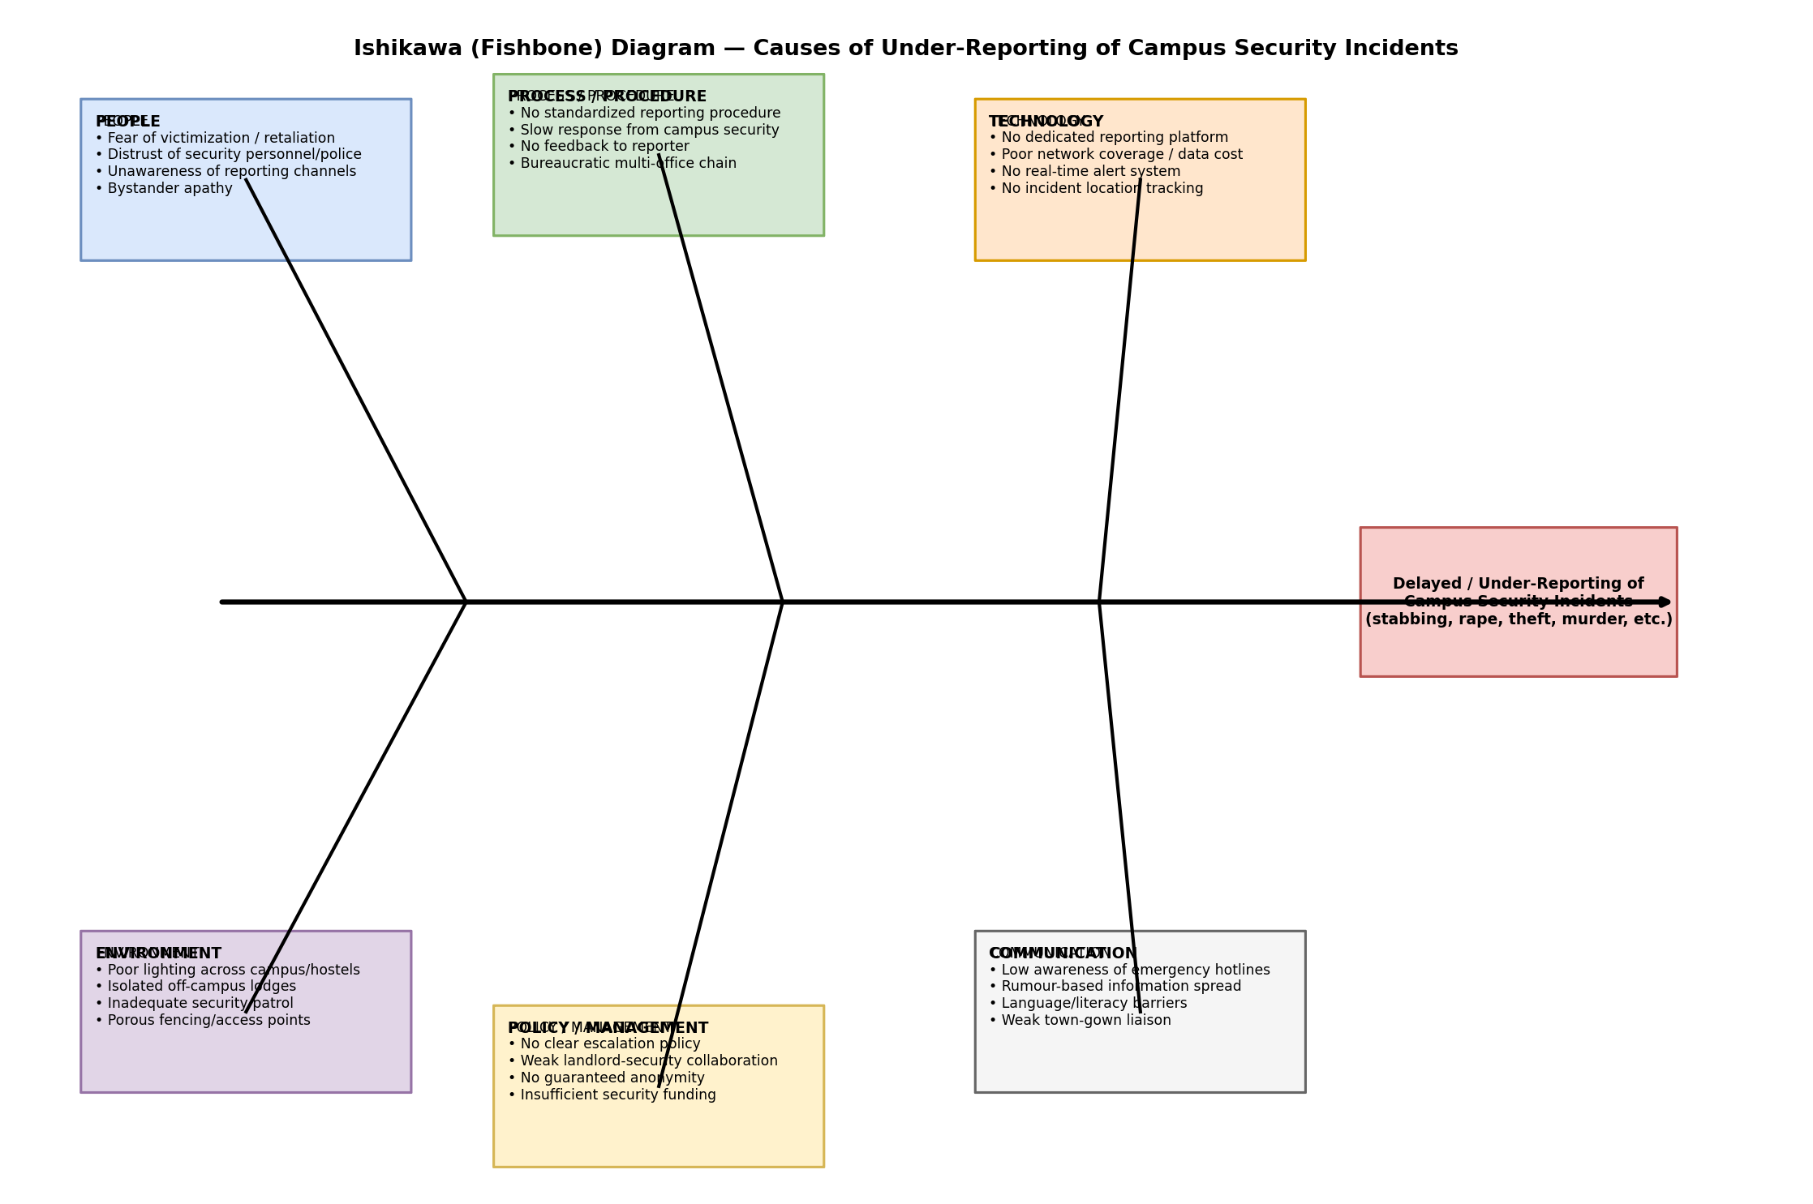
Figure A.1 — Root-cause (Ishikawa) analysis of under-reporting of campus security incidentsFigure A.1 — Root-cause (Ishikawa) analysis of under-reporting of campus security incidents

