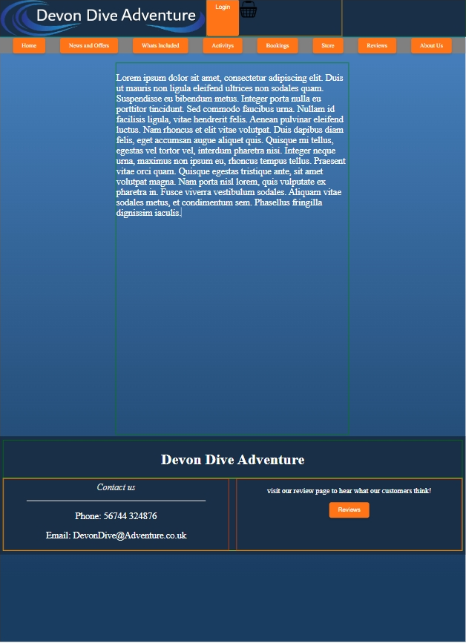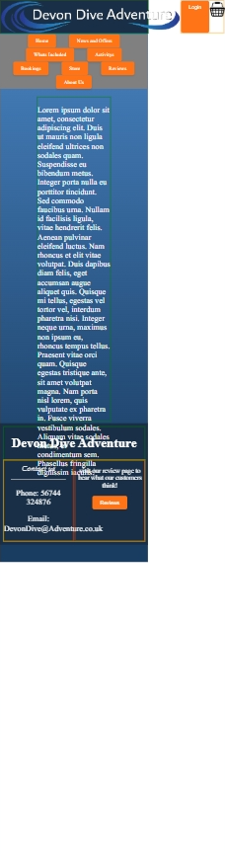
Screen aria wont resise properly so making objects in line and felx then make the dividers shrink when resizing screen.


Weird blue line between the banner and the nav bar

There was an extra div that was not needed

