***PROJECT 1***

PSEUDOCODE

SET Aminat at coordinate (0,0)

MOVE Aminat to coordinate (3,0)

SELECT Flower

MOVE Aminat to coordinate (3,2)

COMPUTE Aminat plants the flower

MOVE Aminat one space east.

FLOWCHART

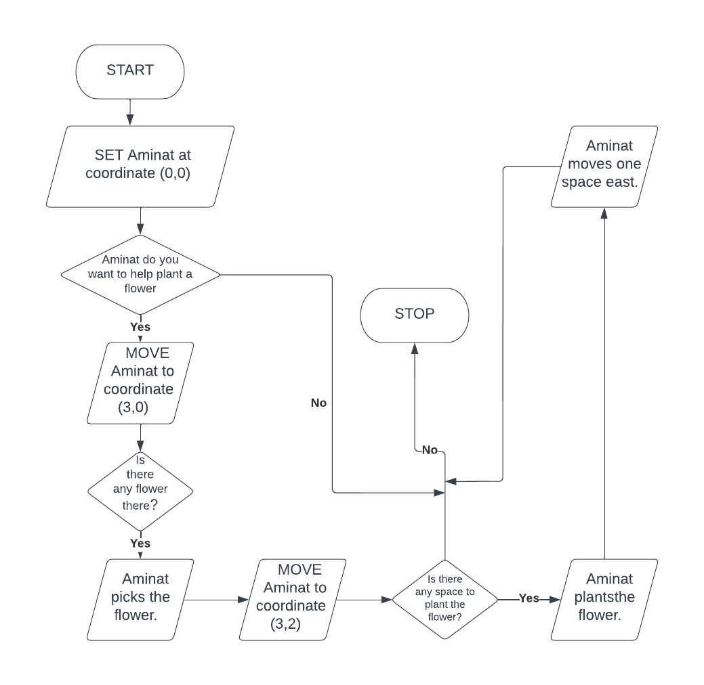

***PROJECT 2***

PSEUDOCODE

COMPUTE name = INPUT What is your name?

IF name is in employee database:

PRINT Welcome! + name:

ELSE:

PRINT Get out!

FLOWCHART

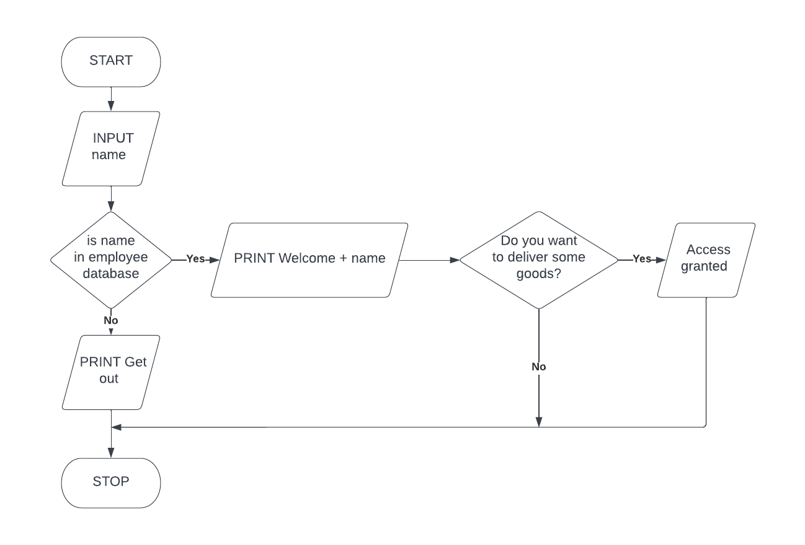

***PROJECT 3***

PSEUDOCODE

COMPUTE weight = INPUT What is the weight of your package?

COMPUTE location = INPUT Where do you want your package to be delivered to?

IF weight >= 10 and location = PAU:

PRINT The cost price on delivery and weight of package is #2000

ELIF weight < 10 and location = PAU:

PRINT The cost price on delivery and weight of package is #1500

ELIF weight >= 10 and location = Epe:

PRINT The cost price on delivery and weight of package is #5000

ELIF weight < 10 and location = Epe:

PRINT The cost price on delivery and weight of package is #4000

ELSE:

PRINT If you need help with delivery options please contact our customer care service.

FLOWCHART

