Steps to do Poresippr analysis ( You can wait for the data to be written on a drive and start the GUI like after 45 mins when you started the nanopore sequencing run)

1. Open the terminal and go to the PoreSippr folder in the home area by following command the package is located in home area

cd /PoreSippR-GUI

2. run the python script (this should open the GUI)

python main.py
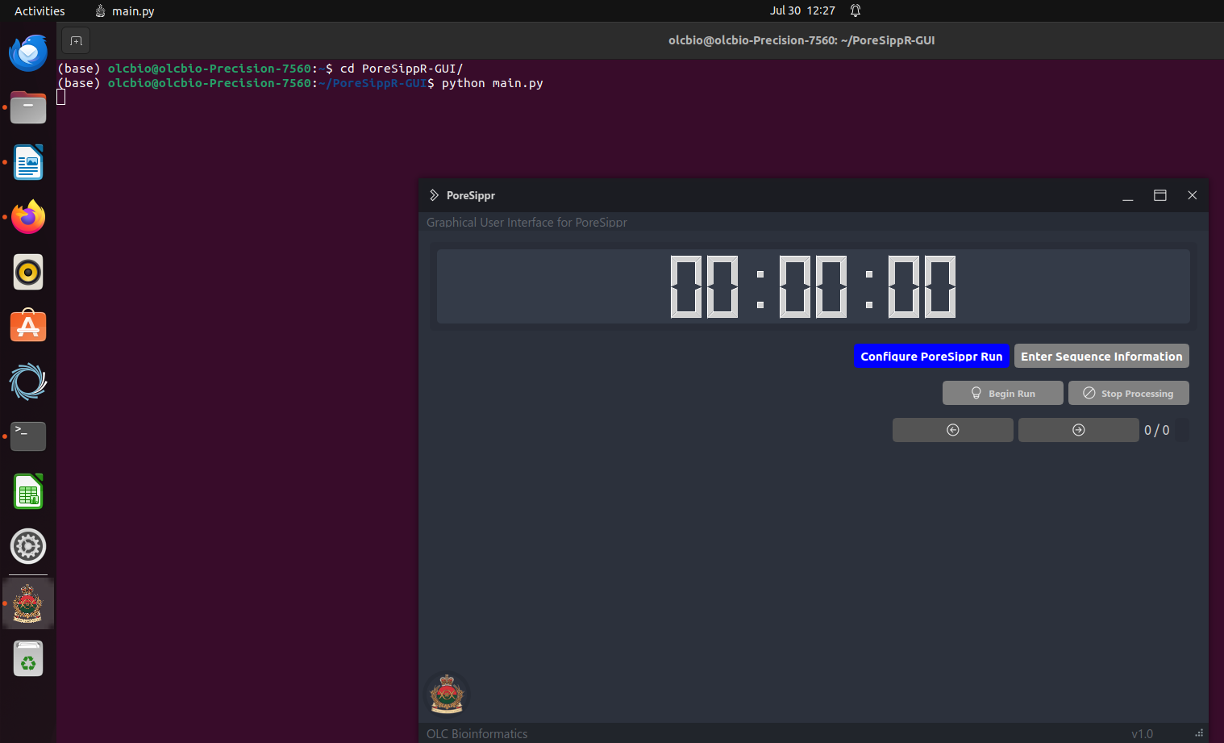
3. click on configure Poresippr run and fill the following information and reference file is the stx db file which is there inside the PoreSippr-GUI folder and name of the reference file is PoreSippRDB_240509.fasta and click validate

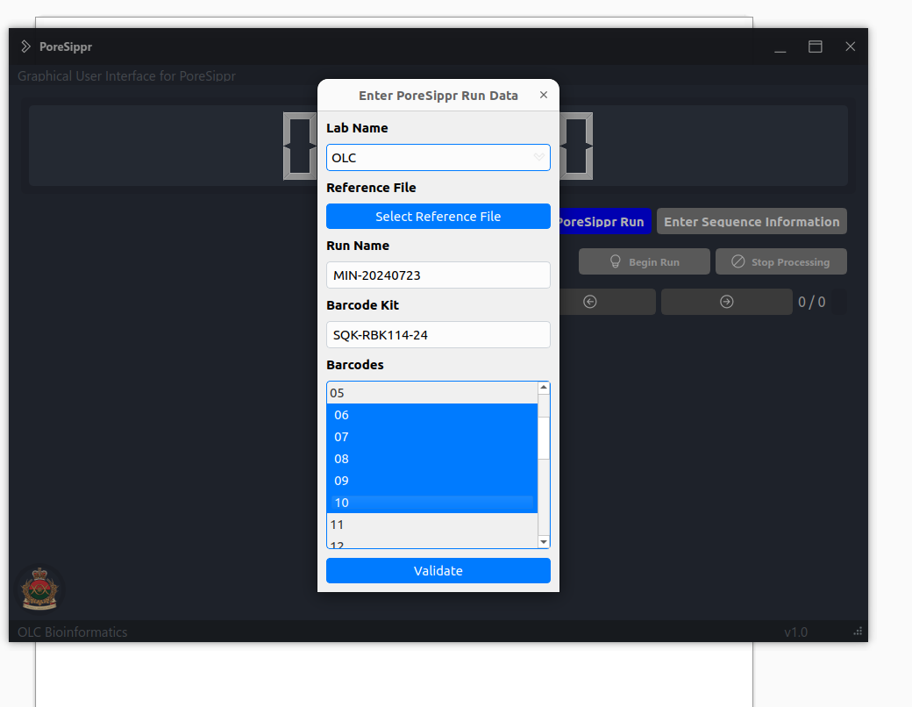

4. click on the sequence information and fill the seq id etc sample is attached here and click validate and begin run

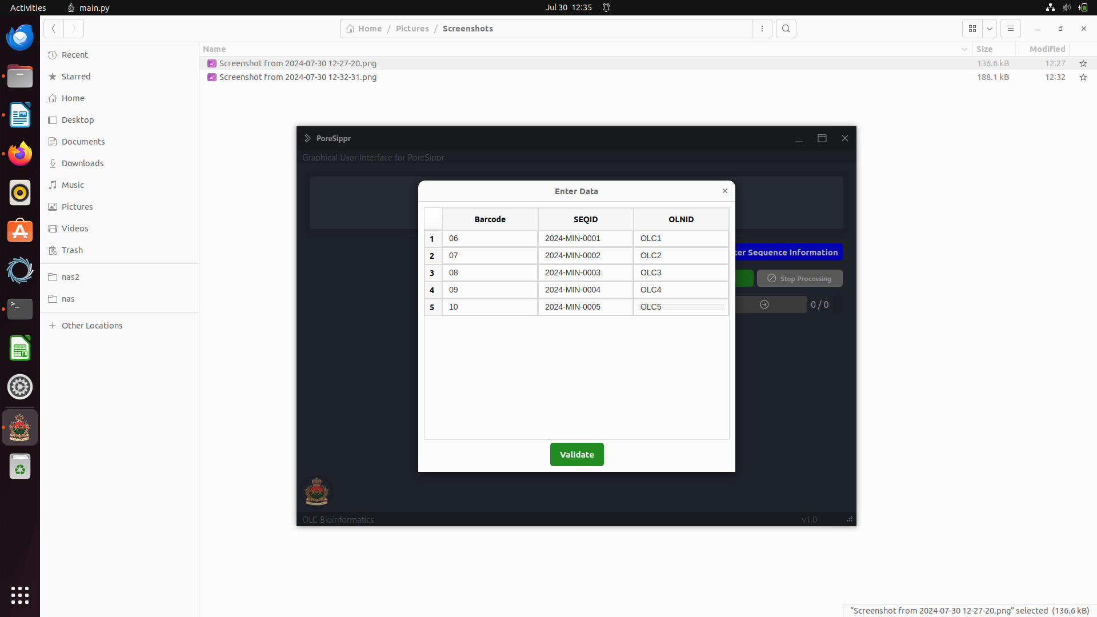
5. GUI terminal should look like this , when it starts processing and we consider GDCS number to be 325/325 to say that we covered all the core genes and you can end processing by stop processing button
