Facilities
Peakhurst Lodge

Peakhurst Lodge has been operated by The Sisters of Our Lady of China since 1984. The facility provides nursing and personal care and diversional activities to anyone requiring high care and low care nursing placement, regardless of race, religion, color or creed.  After going through major renovations and new construction in the past few years, Peakhurst Lodge now cares for 71 high care residents and 39 low care residents in a safe, comfortable and home like environment with a team of caring and dedicated staff.  The 71 bed high care section has been extended and fully renovated including a 14 bed secured Dementia specific section. All our 39 low care hostel rooms are single with ensuite. Each room has quality furnishing, built-in wardrobe, bar fridge and tea making facility. Most general section rooms have a balcony opening to the courtyard. A 12 bed Dementia section offers secured environment to cater for special needs of dementia residents.  The courtyard and gardens have been beautifully landscaped, it provides safe, peaceful outdoor environment for resident to enjoy with family and other residents. Lifts provides easy access to both levels of the building. There are a number of activity rooms, lounge rooms, dining rooms in each of the sections. A spacious general activity room and a chapel are built for all residents to enjoy activities, church service and prayers. | 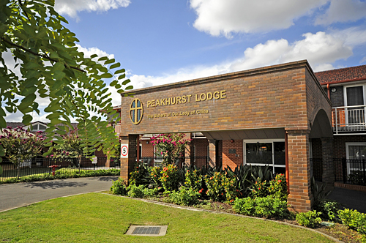
Peakhurst Lodge
16-18 Henry Lawson Drive
Peakhurst NSW 2210
Phone: (02) 9533 4089
Fax: (02) 9533 4068
info@ourladyofchina.org.au
Virtual Tour: Click Here
More Photos

Pembroke Lodge

Located in Campbelltown shire, the 108 bed modern facility was established in 2005. It provides a full spectrum of services with 26 high care beds and 82 low care beds including two secured dementia units. The modern facility is specially designed and built to ensure a safe, comfortable and home like environment for our residents and is built with quality and high standard. Respite Care is also available at the facility.  The building is fully air-conditioned. In low care section, there are 56 single rooms with ensuite, 18 single rooms with shared ensuite and 4 double rooms with shared ensuite. In high care section, there are 13 spacious double rooms with shared ensuite. Each room has quality furnishing, built-in wardrobe and tea-making facility.  Set in pleasant surrounds, there are three wings on each floor of the two-storey Lodge. Each has it’s own comfortable lounge, sitting and dining areas. There are also spacious activity area, public balconies, a Chapel, a pray room and hairdressing salon. Lifts provide easy access to both levels. The design allows for small communities to exist without feeling lost in the Lodge.  The beautifully landscaped gardens and water feature provide outdoor areas for residents to enjoy with relatives and other residents. | 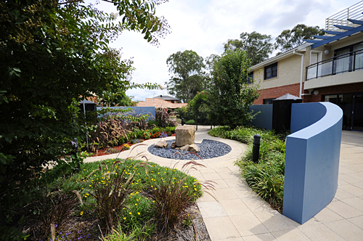
Pembroke Lodge
57-61 Pembroke Road
Minto NSW 2566
Phone: (02) 9603 7911
Fax: (02) 9603 7900
info@ourladyofchina.org.au
Virtual Tour: Click Here
More Photos

Ruby Manor

The 90 bed modern hostel was established in 2007. Set amidst beautifully landscaped gardens, the facility provides 90 low care beds with Ageing in Place including a 30 bed unit specialising in care for Dementia sufferers. Respite Care is also available. It is close to public transport and local amenities, can be easily accessed via M5.  The building is fully air-conditioned. There are 60 single rooms with ensuite and 15 double rooms with shared ensuite. Each room has quality furnishing, built-in wardrobe and general rooms all have tea-making facility.  Set in pleasant surrounds, there are three wings on each floor of the four-storey Manor with the top three floors being resident floors. Each resident wing has it’s own comfortable lounge and each resident floor has a large lounge, its own spacious dining area and two balconies. A spacious multi-function room, hairdresser, administration office and service facilities are located on the ground floor. 2 lifts provide easy access to each level of the Manor. The design allows for small communities to exist without feeling lost in the Manor.  The beautifully landscaped gardens and dedicated BBQ area provide outdoor areas for residents to enjoy with relatives and other residents. | 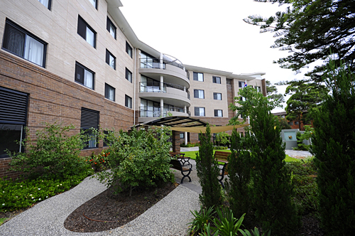
Ruby Manor
10 Ruby Street
Carramar NSW 2163
Phone: (02) 9723 7166
Fax: (02) 9723 7455
info@ourladyofchina.org.au
Virtual Tour: Click Here
More Photos

