Home
The Sisters of Our Lady of China Group provides high quality residential aged care across three facilities in Metropolitan Sydney. We pride ourselves on the individualised quality care we provide to our residents by our highly qualified and professional staff.

Promoting the dignity and respect for human life at all stages, extending the hand of a Samaritan and caring with love, hope and faith, are all integral elements of our work.

Our residents enjoy a friendly, caring, community atmosphere that is fostered by the caring philosophy of the management and staff, enhanced by the modern design and amenities of our facilities. Our three fully accredited facilities offer residential aged care accommodation including low care, high care and respite care. Residents with dementia are also catered for.

Our facilities provide a range of social, recreational and educational activities to meet the needs and interests of all residents. We encourage the involvement of relatives and friends in all activities and welcome them as equal partners in our care family.

Learn More (about us)

Contact Us
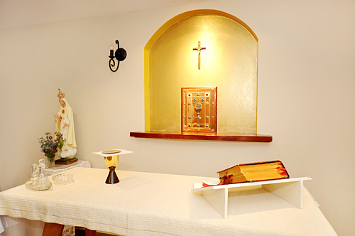

Head office: 27 JACQUES AVENUE, Peakhurst nsw 2210

Phone: (02) 9153 0965 or 9533 3073
Fax: (02) 9153 9261
Email: info@ourladyofchina.org.au
Web: www.ourladyofchina.org.au

